# DC Motors

Our prototype requires 2 DC Motors, in order to accomplish the given tasks. Electrical DC motor is an element, which converts electrical power into mechanical energy. Its action is created by the behavior of electromagnetism. Unlike other electronic components, the DC Motors needs, E.g. High Voltage, are beyond the capabilities of our microcontrollers, which can only provide the rotation or acceleration instructions. Therefore, an external module is needed, to produce the needed power for the motors.

# Motor Control

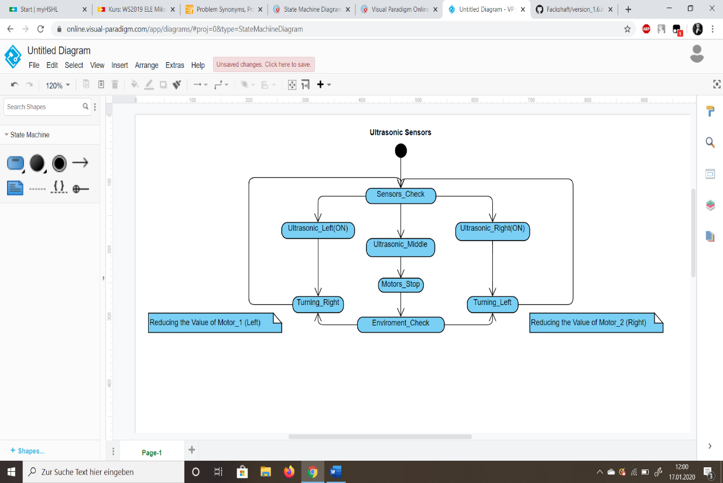The L298 is a high voltage, high current dual full bridge driver, that can drive the DC Motors. It drives the motors with 3 input for each, which are; EnA (Enable A) In1 & In2 (Inputs 1/2) and EnB (Enable B) In3 & In4 (Input 3/4), where EnA or EnB allow us to enable and disable the motors independent of the input signals. This means in order to start the motor, we first need to bring the Enable pins to a ‘High’ state. To archive this, we used the PWM (Pulse Width Modulation) pins on the “Arduino Uno”. PWM pins allow us a better speed stability, reasoned by the fact, that the switching transistor has a much reduced power dissipation, giving it a linear type of control. For the inputs, we used the regular Analog pins on the microcontroller, so we can control and also set specific limits on the speed of the motors.

## H-Bridge

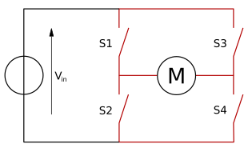An H-Bridge is a circuit, that allows a voltage to be applied across a load in either direction. H-Bridges are built with four switches, where the states of the switches decide the rotation of the motor. For instance, if the switches S1 and S4 (Figure 1) are closed, the current can travel from left lead of the motor to the ground, which makes the motor start spinning. On the other hand, if the switches S3 and S2 are closed the current travels from right lead of the motor to the ground, which makes the motor start spinning in the reverse direction. However, the H-Bridge must be used with caution, since if the switches S1 and S2 or S3 and S4 are closed at the same time, a short circuit is created, which could damage the electronic parts in the circuit. This situation is called “shoot-through “.

*Figure 1, wikipedia.org/wiki/H_bridge*

# Motors in context of Microcontroller

Since there are different directions a car can go, with the help of “If “statements, the jump between the different directions became genuinely uncomplicated. For every direction a different speed or rotation of the motor is needed. Such as driving reverse or driving diagonally right.

## Ultrasonic Sensors

The prototype should be able to recognize and avoid objects. For that reason, the communication and the relationship between the motors and the ultrasonic sensors are essential. In our system if one of the sensors on the sides detects any obstacle, the car will avoid it by slightly reducing the speed of the motor on the opposite side, which is done with the help of the Analog inputs, where the value of the signal to the motor is reduced compared to the other one. If an object is in front of the vehicle, we force the motors to stop by disabling the PWM pins and depending on the availability of the environment, it drives to the left or right.

## Infrared Sensors

Another assignment, which the prototype should fulfill, is to recognize a path and follow it. Therefore, the infrared sensors are used. As a result, if a path is recognized by the sensors, instructions are sent to the motors to move to left, that if the infrared sensor on the right side is turned on. Or the opposite way, to right, if the sensor on the left is turned on. Therefore, the car replaces itself in the center on the path.

## QT Interface

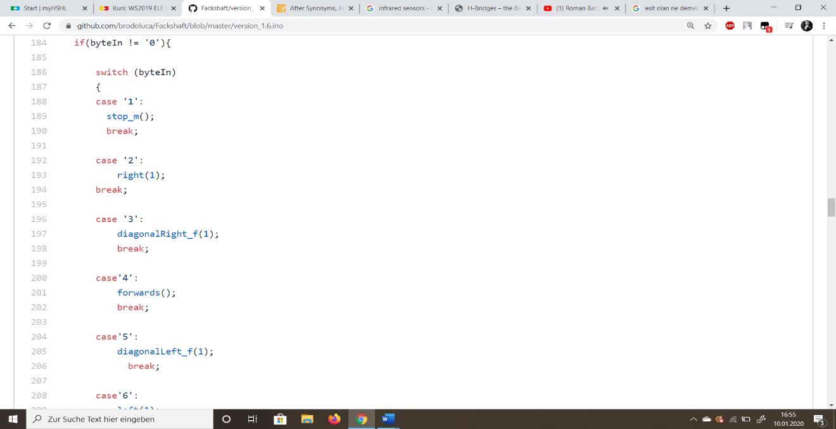With the created interface, the user is able to control the vehicle in desired directions. In order for the system to work efficiently, every possible direction is treated as a separate case. Therefore, we tried to operate the motors with the Switch case structure (Figure 3). This enables us to bounce between the different cases really quick and in a reliable way. Every move of the “Joystick” in the interface sends a variable to the microcontroller, which then directs it to the ‘Switch’ case, where it is checked for the state in which the variable equals. So, the motors can adjust themselves to the instructed rotations and speed.

*Figure 3*

# Complications

## Motors

The first two motors *(Modelcraft RB35)*, which we got, were not working properly. They were, in context of power, really low and made unusual noises. For that reason, we decided to unscrew the motors, to see if there was a problem with the components. Following that, we found out that the motors were severely damaged inside, so the motors could not fulfill the requested instructions. The metal circle inside was bend abnormally (Figure 4) and it limited other parts to execute their functions. After this discovery, we requested two new motors to continue the project. However, also the new motors had the same problem. In our third and final attempt, we managed to get two fully functional motors.

*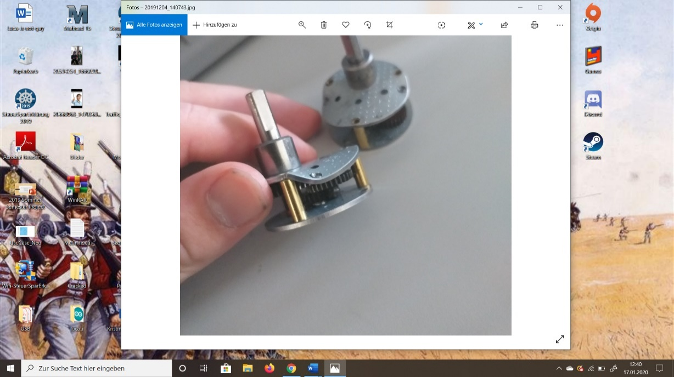Figure 4*

## Construction

The main structure of the prototype is based on wood. Therefore, it is essential to work cautiously with the components. Since the materials were fragile, there were couple of issues with the construction. Unfortunately, some pieces were damaged or cracked in the process of screwing. However, as an alternative solution to the screws, we improved the critically important areas with hot glue. This made the components stay stable and solid. Also, the motors made the car drive unreliable, since they were heavy for the screws and caused unbalance. Also, those areas were reinforced with hot glue.

# Outcome

## Perspective

As a team, our perspective was to work together and share our ideas without any hesitation. It was possible to accomplish this with first creating a GitHub repository, so all team members could contribute regularly. Additionally, also multiple meetings, during the developing period, improved our relationships individually. The equal task distribution caused the whole project to be more organized and efficient.

## Results

The assignement, as the project work of 3th Semester Electronic Engineering course, was a favorable outcome. All requirements were fulfilled completely, including an usable interface, created with ‘QT’. Besides that, the live steam from the camera, mounted on top of the vehicle, performs pleasently.