ILLINOIS LEGISLATIVE
TREND REPORT
2020-2026 | Executive Briefing and Political R&D Baseline

Executive thesis
Illinois policy has moved from creating clean-energy programs to governing the physical and financial consequences of implementation. The 2026 agenda centers on deployment, utility governance, emissions, affordability, storage, cybersecurity, transmission, and large-load growth. The governing question is no longer simply whether to decarbonize; it is who builds, who pays, who bears risk, and who controls the transition.

Portfolio indicator | Result | Executive meaning
Tracked records | 792 bill-year records | Sufficient scale to identify multi-year directional signals
2026 volume | 160 bills (+37.9% YoY) | Agenda expansion and greater issue fragmentation
Persistent subjects | 58 of 609 (9.5%) recur | Most filings are episodic; durable agenda is much smaller
2026 Senate share | 55.6% | Chamber mix has shifted toward Senate-originated measures
Top-five concentration | 47.5% in 2026 vs. 65.0% in 2020 | Leadership attention must cover more simultaneous issue fronts
Internal source: 2026 Bill Trends Report 2.xlsx, Executive Brief, Issue Transitions, and Bill Dataset. Counts are unique by year and bill number.
Prepared for executive consumption | August 10, 2026

1. Executive Summary
Bottom line
The portfolio is expanding, but not simply accumulating. Volume doubled from 80 bills in 2020 to 160 in 2026, while only a small share of subjects reappear across years. This combination - high churn plus rapid growth - makes early issue detection more valuable than retrospective bill counting.

2026 is an implementation-governance year. Clean Energy Deployment leads the refined taxonomy with 24 bills, followed by Utility Operations & Governance with 17. Cybersecurity, Privacy & AI and Decarbonization, Emissions & Climate each reach 12, while Utility Rates, Affordability & Cost Recovery reaches 11.
The fastest accelerators are not all mature policy families. Energy Storage rose from 2 bills in 2025 to 9 in 2026; Cybersecurity/Privacy/AI rose from 6 to 12; Data Centers & Large Loads rose from 5 to 8; and Natural Gas & Future of Gas rose from 1 to 5. These areas are being shaped in real time and offer the greatest opportunity for proactive positioning.
The national comparison supports the Illinois signal. Across states, data-center policy has shifted from incentives toward cost allocation, special tariffs, water and energy disclosure, siting, and ratepayer protection. Storage policy is similarly moving from procurement targets to siting, safety, ownership, and interconnection. Climate Superfund proposals are diffusing from New York and Vermont while facing significant litigation risk.
For enterprise strategy, the issues should be treated as a connected system: large loads drive generation and grid needs; grid investment drives cost recovery; cost recovery drives affordability politics; affordability pressures alter regulatory and legislative risk; and siting, environmental justice, cybersecurity, and local authority can become deployment constraints.
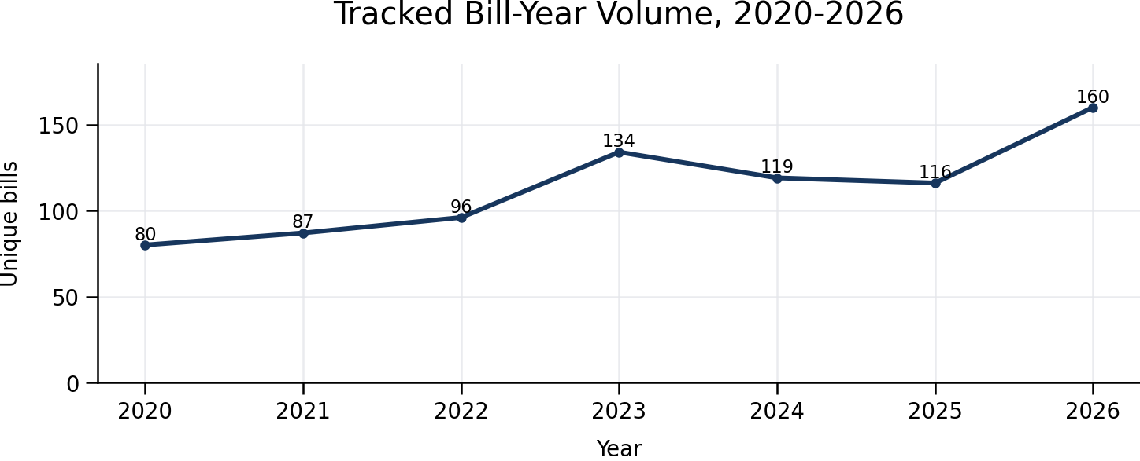
Internal analysis of unique bill-year records in 2026 Bill Trends Report 2.xlsx.

1A. What Matters Most
Reader focus
The report should be read less as a bill-counting exercise and more as an early-warning system for where infrastructure growth, affordability, reliability, local control, and political legitimacy are beginning to collide.

1. The strategic fight has shifted from clean-energy ambition to governance of consequences.
Illinois policy has moved beyond whether to advance clean energy and into the harder questions of who builds, who pays, who bears risk, and who controls implementation. The 2026 issue mix makes that clear: Clean Energy Deployment leads with 24 bills, Utility Operations & Governance follows with 17, Cybersecurity/Privacy/AI and Decarbonization each reach 12, and Utility Rates, Affordability & Cost Recovery reaches 11. That mix signals a transition from aspiration to operational governance.
2. Rising volume masks a fragmented agenda.
The portfolio reaches 160 bills in 2026, up 37.9% year over year, but only 58 of 609 subjects recur and only 13 recurring subjects remain active in 2026. The implication is that leadership should not treat every filing as equally meaningful. The real value is separating durable policy signals from episodic proposals before attention and advocacy resources are spread too thin.
3. Large loads may become the organizing issue behind several policy conflicts.
Data Centers & Large Loads increased from 5 bills in 2025 to 8 in 2026, but the category matters more because it connects multiple pressures at once: generation need, transmission buildout, water use, siting, tariffs, cost allocation, and customer affordability. Nationally, more than 40 states considered 267 data-center-related bills in 2025, and 25 utilities across 19 states had filed data-center-specific tariffs by March 2026. This is likely to become a durable utility-policy category rather than a narrow technology issue.
4. Affordability is the pressure point that can redefine infrastructure strategy.
The report shows affordability moving from a customer-program topic to a central political constraint on investment. 2026 bills include cost recovery, low-income rates, rate caps, freezes, hearings, and recovery limits. The tension is direct: utilities need financeable investment for load growth, reliability, storage, and transmission, but legislative tolerance may weaken if those costs are perceived as shifted to households. The company’s policy posture should therefore connect investment, customer protection, and cost causation before rate pressure becomes the dominant public narrative.
5. Low-precedent categories are where proactive positioning matters most.
Energy Storage grew from 2 bills in 2025 to 9 in 2026, Cybersecurity/Privacy/AI rose from 6 to 12, and Natural Gas & Future of Gas rose from 1 to 5. These categories have limited settled precedent, which means a triggering event such as a cyber incident, local storage opposition, summer bill shock, reliability failure, or data-center controversy could harden policy quickly. Early model language, principles, coalition strategy, and scenario planning are therefore higher-value than waiting for final bill text.

2. Seven-Year Evolution of the Agenda
Period | Policy phase | What legislators were really debating | Enterprise implication
2020-2021 | Foundation building | Clean energy, workforce transition, consumer protection, environmental justice | Build policy legitimacy and implementation pathways
2022-2023 | Electrification and infrastructure | EVs, reliability, hydrogen, carbon transport, thermal energy | Translate goals into assets, standards, and market rules
2024 | Grid buildout | Transmission, storage, building decarbonization, climate and AI governance | Capacity, siting, ownership, and reliability become central
2025 | New demand and technology | Data centers, quantum, geothermal, utility data, transmission planning | Prepare for concentrated load and new customer classes
2026 | Affordability and load management | Cost recovery, low-income rates, large-load standards, siting and interconnection | Prove growth is reliable, financeable, and fair
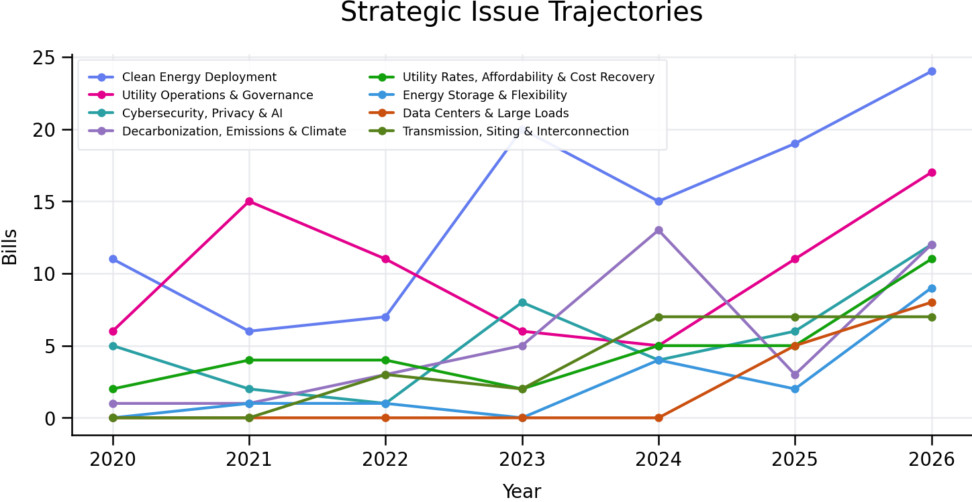
Internal source: refined issue taxonomy in 2026 Bill Trends Report 2.xlsx. Each bill is assigned one primary strategic issue to avoid double counting.

The structural shift
Early-year policy concentrated on program creation and social license. By 2024, legislative attention moved into transmission, storage, codes, and implementation. By 2025-2026, demand growth and customer economics joined deployment as core political questions. This is a transition from policy aspiration to system governance.

3. 2026 Issue Map and Key Risks
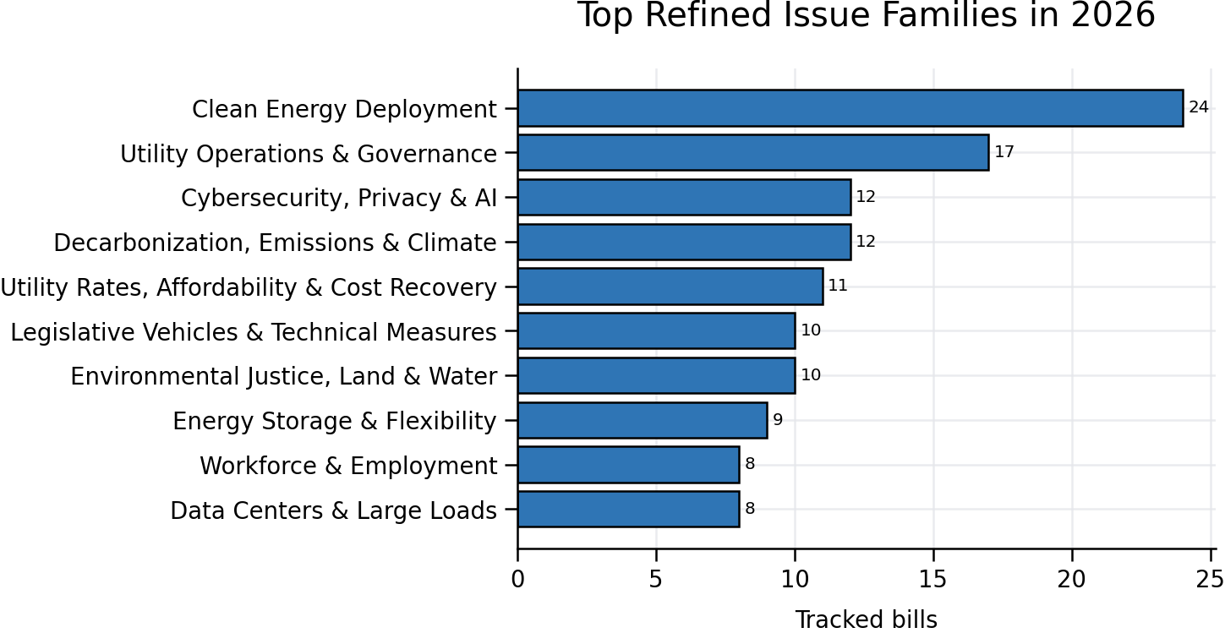
Refined issue | 2026 | YoY | Signal | Executive lens
Clean Energy Deployment | 24 | +5 | Accelerating | Permitting, procurement, domestic content, local control, end-of-life rules
Utility Operations & Governance | 17 | +6 | Accelerating | ICC authority, transparency, RTO activity, property and operating rules
Decarbonization, Emissions & Climate | 12 | +9 | Accelerating | GHG limits, federal backstops, climate liability, deadline flexibility
Cybersecurity, Privacy & AI | 12 | +6 | Accelerating | Customer data, OT security, AI disclosures, biometric and drone rules
Utility Rates, Affordability & Cost Recovery | 11 | +6 | Accelerating | Rate caps, low-income rates, freezes, hearings and recovery limits
Environmental Justice, Land & Water | 10 | +2 | Rising | Wetlands, setbacks, cumulative impact and CCR management
Legislative Vehicles & Technical Measures | 10 | +4 | Accelerating | Monitor for substantive amendments and omnibus use
Energy Storage & Flexibility | 9 | +7 | Accelerating | Ownership, local siting, bonds, backup systems and technology scope
Workforce & Employment | 8 | -2 | Cooling | Prevailing wage, equal pay, worker protection and AI displacement
Data Centers & Large Loads | 8 | +3 | Rising | Tariffs, self-supply, water/cooling, ownership, siting and firm capacity
Transmission, Siting & Interconnection | 7 | +0 | Flat | Who builds, owns, pays and receives approval
Economic Development & Industrial Policy | 7 | +0 | Flat | Incentives, megaprojects and advanced technology policy
Internal source: Issue Transitions matrix. Refined categories replace the broad Government Administration, Legal Affairs & Cross-Cutting Policy bucket.

4. Trend Bills That Define the Shift
Year | Defining measures | Why they matter
2020 | HB 5330 - Advanced Metering | Utility modernization begins to move beyond traditional regulation.
2021 | HB 1472 - Climate Union Jobs Act; HB 3090 - Environmental Justice Act | Clean-energy transition becomes linked to labor and equity.
2022 | HB 3243 - EV Infrastructure Act; SB 1104 - Reliability Task Force | Electrification creates explicit infrastructure and reliability needs.
2023 | HB 2202 - Underground CO2 Storage; HB 2875 - Thermal Energy Network | Carbon and thermal infrastructure broaden the transition toolkit.
2024 | SB 3949 - High Voltage Transmission; HB 5243 - Utility-Scale Storage | Grid capacity and flexibility become legislative priorities.
2025 | HB 3131 - Transmission Projects; SB 2181 - Data Center Reporting | Planning shifts toward major buildout and concentrated new demand.
2026 | HB 5513/SB 4016 - Hyperscale Data Centers; HB 4172 - Cost Recovery; HB 4456/SB 3717 - Low-Income Rates | Large loads, financing, and affordability converge into one political system.
Internal source: TrendDefBilYear and 2026 Focus sheets in 2026 Bill Trends Report 2.xlsx. Bill descriptions are based on workbook subject lines, not a legal interpretation of enrolled text.

5. National Comparison: Where Illinois Fits
National read-through
Illinois is not an outlier. It is an early, concentrated expression of a national convergence around data centers, ratepayer protection, storage and transmission siting, climate liability, and local control.

Issue | Cross-state pattern | Illustrative states/actions | Illinois implication
Data centers / large loads | Shift from incentives to special tariffs, cost allocation, water and energy disclosure, and local siting controls | More than 40 states considered 267 related bills in 2025; South Carolina and Maryland enacted rate-negotiation laws; 2026 activity spans energy, water, zoning and taxes | Expect large-load conditions to become a durable utility-policy category, not a one-session issue
Affordability / tariffs | Regulators and legislators seek minimum-demand contracts, construction contributions, special rate classes and consumer protections | 25 utilities across 19 states had filed data-center-specific tariffs by March 2026 | Develop cost-causation and customer-protection principles before project-specific disputes
Storage / flexibility | Policy is broadening from targets to permitting authority, safety codes, local moratoria, ownership and interconnection | 13 states have enacted storage targets; siting authority remains fragmented, and local opposition can delay projects | Pair storage advocacy with safety, local-government and cost-recovery frameworks
Climate Superfund | Polluter-pays models move climate adaptation costs to major fossil-fuel producers, with major constitutional and preemption litigation | Vermont and New York enacted laws in 2024; implementation and court challenges continue | Treat Illinois proposals as part of a broader diffusion pathway with high legal uncertainty
Transmission / siting | States consolidate or preempt siting to reduce delays while balancing local authority | 15 states have enacted consolidated siting/permitting authority meeting the dashboard definition | Ownership and siting bills can determine pace, cost and competitive position of grid expansion
External sources: MultiState, State Data Center Policy 101 (updated July 17, 2026), https://www.multistate.us/resources/state-data-center-policy-101; The Terms of Power (March 2026), https://44409563.fs1.hubspotusercontent-na1.net/hubfs/44409563/Terms%20of%20Power_White%20Paper_260316.pdf; Climate XChange dashboards, https://www.climatepolicydashboard.org/policies/electricity/energy-storage-targets and /siting-permitting-authority; Georgetown Environmental Law Review, January 29, 2026, https://www.law.georgetown.edu/environmental-law-review/blog/the-pending-fate-of-climate-superfund-statutes/.

Data centers are the clearest cross-state leading indicator
The national policy architecture is settling around five recurring questions: (1) should large loads pay all directly attributable generation and grid costs; (2) should they accept minimum-demand or long-term service commitments; (3) what energy, water, emissions and cooling data must be disclosed; (4) who controls siting and local conditions; and (5) whether tax incentives should be conditioned on jobs, efficiency, clean supply and community benefits. Illinois bills already touch nearly all five.
Sources: MultiState, July 17, 2026, https://www.multistate.us/resources/state-data-center-policy-101; ArentFox Schiff, April 13, 2026, https://www.afslaw.com/perspectives/alerts/state-regulation-data-centers-2026-shifting-landscape.

6. Persistence, Churn, and Early-Warning Value
Persistence is the key corrective to raw volume. Only 58 of 609 distinct subjects appear in more than one year, and only 13 recurring subjects remain active in 2026. The durable agenda is therefore much smaller than the headline count, but the low-persistence high-growth categories matter precisely because policy templates are still unsettled.
Issue family | Total bills | Recurring bills | Persistence | Strategic interpretation
Environmental Justice, Land & Water | 59 | 25 | 42.4% | Mature and predictable; implementation details remain important
Utility Rates, Affordability & Cost Recovery | 33 | 12 | 36.4% | Persistent and becoming more politically salient
Transmission, Siting & Interconnection | 26 | 7 | 26.9% | Growing with a partially established policy history
Clean Energy Deployment | 102 | 17 | 16.7% | Large but highly varied; many proposals are one-off
Data Centers & Large Loads | 13 | 2 | 15.4% | Emerging; high leverage for early model development
Energy Storage & Flexibility | 17 | 2 | 11.8% | Fast-growing with limited precedent
Utility Operations & Governance | 71 | 5 | 7.0% | Rapid innovation in governance and operating requirements
Cybersecurity, Privacy & AI | 38 | 2 | 5.3% | Agenda is being written now; incident risk can accelerate mandates
Internal source: Executive Brief persistence analysis and Brief Data sheet in 2026 Bill Trends Report 2.xlsx.

7. Political R&D Priorities
Priority |  | Research question |  | 30-90 day output |  | Trigger to escalate
1. Large-load compact |  | What conditions make new load additive rather than cost-shifting? |  | Model tariff principles; self-supply and firm-capacity scenarios; water/cooling and CBA options |  | Major project announcement, tariff filing, or omnibus amendment
2. Affordability architecture |  | Which protections preserve recovery while addressing household burden? |  | Stress test low-income rates, caps, freezes, bill credits and cost-benefit mandates |  | Rate case, summer bill shock, or high-profile disconnection data  Affordability implications: Affordability should be treated as a strategic risk, not only a customer issue. If household bills rise while large-load projects, grid upgrades, or clean-energy investments advance, opponents can frame necessary infrastructure as unfair cost shifting. National rate pressure reinforces this risk: utilities requested $18.6 billion in electric and gas rate increases in the first half of 2026, and consumer-policy groups are increasingly linking rate hikes to data-center demand, infrastructure spending, and household burden. For Illinois, the practical implication is that cost recovery proposals need a clear fairness architecture: direct assignment of large-load costs where appropriate, transparent benefits for all customers, targeted low-income protections, and a narrative that explains how investment supports reliability and long-term affordability rather than simply increasing bills.
Affordability implications | How does rising household burden change the politics of otherwise necessary investment? |  | Build a rate-impact narrative, customer segmentation view, and cost-causation framework for large-load and grid investments |  | Public bill shock, affordability campaign, data-center cost shift claim, or proposed rate freeze/cap
3. Transmission governance |  | Who should build, own, site and pay for expansion? |  | Ownership and siting map; RTO and state authority scenarios; stakeholder matrix |  | Reliability event, regional plan, or eminent-domain controversy
4. Storage deployment |  | What state/local framework accelerates safe, financeable storage? |  | Model siting code; safety standards; ownership and revenue-bond options |  | Local moratorium, incident, or large procurement proposal
5. Climate and gas transition |  | How do emissions rules, gas authority and reliability backstops interact? |  | Scenario map for peakers, appliance rules, GHG limits, extensions and municipal authority |  | Federal rule change, winter reliability event, or local gas restriction
6. Cyber/AI governance |  | Which customer-data and OT standards are likely to converge? |  | Crosswalk privacy, AI, biometric, drone and critical-infrastructure proposals |  | Cyber incident, AI workforce controversy, or federal preemption move

Recommended operating model
- Maintain a monthly signal dashboard that combines bill volume, persistence, sponsor/committee strength, stakeholder mobilization, external events, and business exposure.
- Create model legislative language and red-line positions before a proposal becomes a leadership issue.
- Use cross-state analogs as real-world experiments: identify what passed, what failed, how costs were allocated, and which coalitions formed.
- Separate monitoring from foresight. Monitoring asks what is moving; Political R&D asks what is likely to emerge next and what position creates optionality.

8. Leadership Decisions and Watchlist
One-sentence executive takeaway
Illinois legislative activity is signaling a move from clean-energy policy creation to contested governance of load growth, infrastructure, affordability, and risk - making proactive model development more valuable than reactive bill-by-bill engagement.

Appendix A. Methodology and Limitations
- The internal dataset contains 792 unique year-plus-bill-number records for 2020-2026. Counts are directional and represent the tracked portfolio, not the universe of all legislation introduced in Illinois.
- Each record is assigned one primary refined strategic issue to prevent double counting. The original broad Government Administration, Legal Affairs & Cross-Cutting Policy category is not used as a substantive trend because it combined unrelated domains.
- Subject persistence is based on normalized subject labels. Companion measures, reintroductions, omnibus vehicles and materially similar concepts with different titles may cause persistence to be understated or overstated.
- Bill subject titles are not substitutes for legal review of bill text, amendments, fiscal notes, sponsor intent, committee posture, or enactment status. Before using this report for formal advocacy, validate priority measures against official legislative records.
- Cross-state examples are illustrative, not a complete 50-state legal survey. External sources were selected to establish directional comparability and should be refreshed as sessions and litigation evolve.

Appendix B. Selected Source List
Source area | Reference
Internal workbook | 2026 Bill Trends Report 2.xlsx - Executive Brief, Issue Transitions, 2026 Focus, Bill Dataset, TrendDefBilYear and Brief Data.
National energy legislation | National Conference of State Legislatures, State Energy Legislation Database, updated February 10, 2026: https://www.ncsl.org/energy/state-energy-legislation-database
Data-center legislation | MultiState, State Data Center Policy 101, updated July 17, 2026: https://www.multistate.us/resources/state-data-center-policy-101
Data-center regulation | ArentFox Schiff, State Regulation of Data Centers in 2026, April 13, 2026: https://www.afslaw.com/perspectives/alerts/state-regulation-data-centers-2026-shifting-landscape
Large-load tariffs | The Terms of Power, March 2026: https://44409563.fs1.hubspotusercontent-na1.net/hubfs/44409563/Terms%20of%20Power_White%20Paper_260316.pdf
Storage targets | Climate XChange, Energy Storage Targets, updated March 5, 2026: https://www.climatepolicydashboard.org/policies/electricity/energy-storage-targets
Siting authority | Climate XChange, Consolidated State Siting and Permitting Authority, updated March 5, 2026: https://www.climatepolicydashboard.org/policies/electricity/siting-permitting-authority
Climate Superfund | Georgetown Environmental Law Review, The Pending Fate of Climate Superfund Statutes, January 29, 2026: https://www.law.georgetown.edu/environmental-law-review/blog/the-pending-fate-of-climate-superfund-statutes/
Affordability context | Center for American Progress, Electric and Natural Gas Utility Rate Hikes Tracker, updated August 5, 2026: https://www.americanprogress.org/article/electric-and-natural-gas-utility-rate-hikes-tracker/

