**Auto repair shop manager**

2. Brody

3. Fall18, CIT130, CCAC West Hills

4. Access instructions:

Link to GitHub URL –

5. This programs job is to print out the individual status of the things inside a repair shop that involves inside a single work bay. A manager would be the one to view this program if he or she wanted to see the overall status of the shop as a whole to maximize its profit for sales.

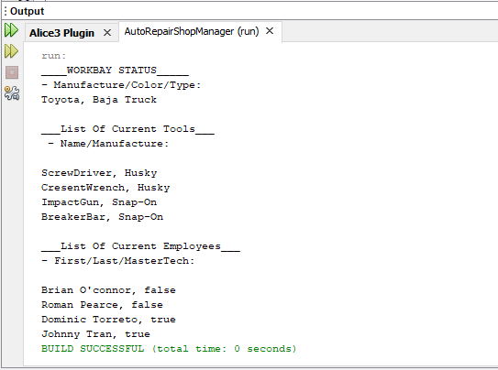6. Screen shots

7. Java 8 API - <https://docs.oracle.com/javase/8/docs/api/>

8. I ran out of time to incorporate a proper display of a gui interface. Some components that could be made more efficient or clear would be the printed out display of the things inside the work bay. With the gui interface that would help make it more clear and visually appealing. Some cool ideas for possible extension of this program would be to incorporate a cost efficient scale for the overall repair shop as a whole. For example if employees are on the clock but haven’t been completing jobs in a timely manner then it would drop the profit of the repair shop as its costing the shop money. Another example for possible expansion would also be to add another instance of a work bay such as work bay 2 and work bay 3 etc.