A+ Computer Science MOVE LEFT ACTOR Lab Value - 110

Lab Goal : This lab was designed to teach you more about the GridWorld case study, more about the methods of the Actor class, and how to use if statements.

Lab Description : Make a new actor that will only move left ( WEST ). Once the actor reaches the left most column, the actor will move to the right most column ( EAST ) and restart its march to the WEST.

Sample Output :
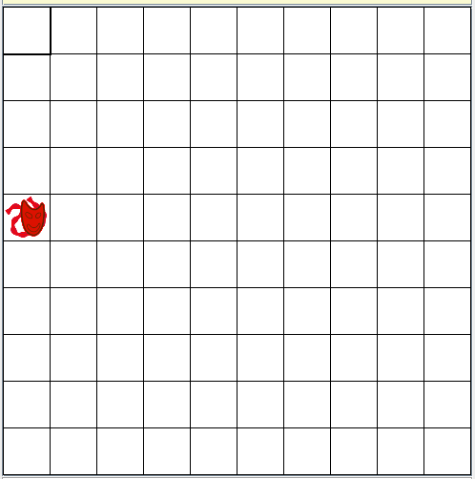

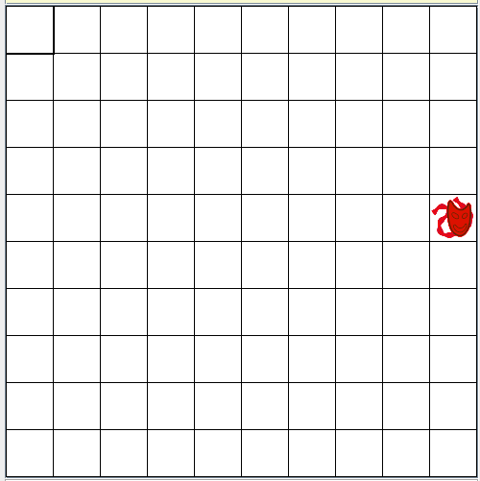
Files Needed ::
MoveLeftActor.java
MoveLeftActorRunner.java
GridWorld project

Image Information
You can create an image for any class you create in GridWorld.
The image must have the exact same name as the class. Case matters!
Save the image in the same folder as the class.

public class FlyingActor .....
FlyingActor.gif

The best size for an image would be 48X48.

To make your own image for the MoveLeftActor class, you would have to name the image MoveLeftActor.gif and save the image in the same folder as the MoveLeftActor class.

