A+ Computer Science SPINNING ACTOR Lab Value - 100

Lab Goal : This lab was designed to teach you more about the GridWorld case study and more about the methods of the Actor class.

Lab Description : Extend the Actor class to make a SpinningActor that will not move, but simply sit in the same location forever and spin. SpinningActor will rotate in 45 degree increments.

Files Needed ::
SpinningActor.java
SpinningActorRunner.java
GridWorld Project

Sample Data :
none

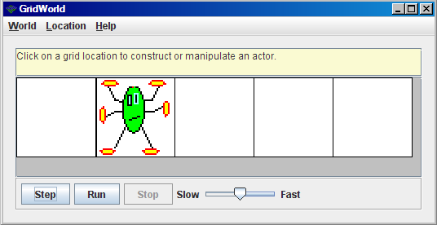
Sample Output :

