A+ Computer Science TELEPORTER ACTOR Lab Value - 100

Lab Goal : This lab was designed to teach you more about the GridWorld case study and more about the methods of the Actor class.

Lab Description : Extend the Actor class to make a TeleporterActor that will more from its current spot to any open spot in the grid. You must generate random locations. You will need to use the Math.random() method.

Files Needed ::
TeleporterActor.java
TeleporterActorTester.java
GridWorld Project

Sample Data :
none

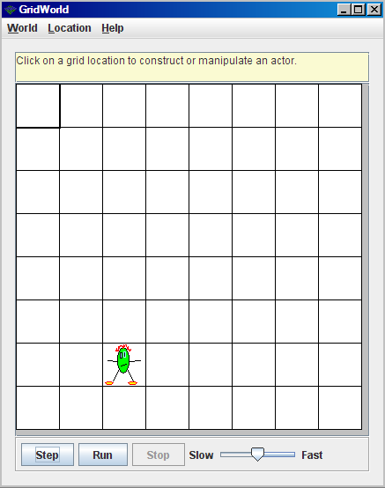
Sample Output :
