A+ Computer Science ANIMATED CAR Lab Value - 110

Lab Goal : This lab was designed to teach you more about the GridWorld case study, more about the methods of the Actor class, and how to use if statements.

Lab Description : Draw some type of car on the screen and then move that car across the screen over and over again. Once the car reaches the far right side of the grid, the car must restart on the left side of the grid in the same row and continue to move EAST.

BONUS :: Make it so that the car hops over any other objects in its way.

Sample Output :
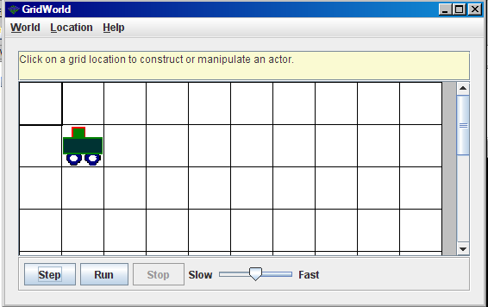

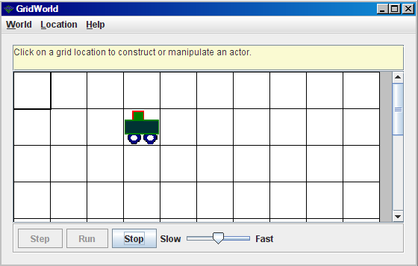
Your car has to move → across the screen.

Files Needed ::
Car.java
CarRunner.java
Car.gif
GridWorld project

Image Information
You can create any image you want for your car.
The best size for the image would be 48X48.
Make sure to name the image Car.gif as the class associated with the image is the Car class.

