A+ Computer Science MOVE NORTH ACTOR Lab Value - 110

Lab Goal : This lab was designed to teach you more about the GridWorld case study, more about the methods of the Actor class, and how to use if statements.

Lab Description : Make a new actor that only moves NORTH. If the actor reaches the top most row, it will move to the bottom most row. The actor will not move from row to row. The actor should only move to empty cells that are in the grid. If the actor’s path is obstructed, the actor should hop over the obstruction if it is possible to do so. If the actor cannot hop over the obstruction, the actor will move to the bottom most row.

Sample Output :
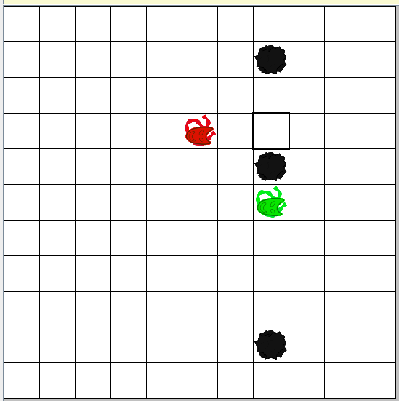
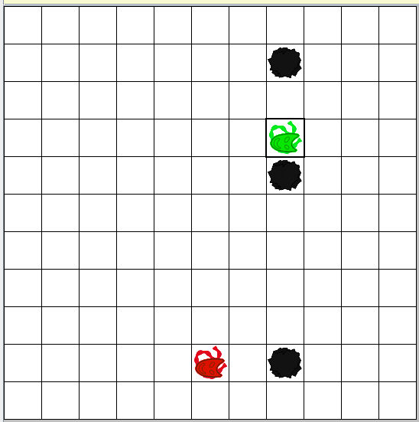
Files Needed ::
MoveNorthActor.java
MoveNorthActorRunner.java
GridWorld project

