A+ Computer Science Nested Loops - COLORED BOXES Lab Value - 100

Lab Goal : This lab was designed to teach you how to use nested loops. You will also learn how to make some cool shapes.

Lab Description : Use nested loops to print out the square pattern show below.

Sample Output :
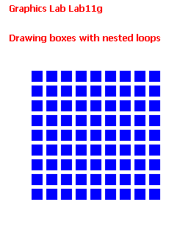
Files Needed ::
GraphicsRunner.java
ColoredBoxes.java

