A+ Computer Science ACTOR BOX 1 Lab Value - 100

Lab Goal : This lab was designed to teach you how to use nested loops. You will also learn how to make some cool shapes use the GridWorld case study.

Lab Description : Use nested loops to print out the box of actors shown below.

Sample Data :
3
Files Needed ::
ActorBoxOne.java
ActorBoxOneRunner.java
GridWorld project

6

Sample Output :
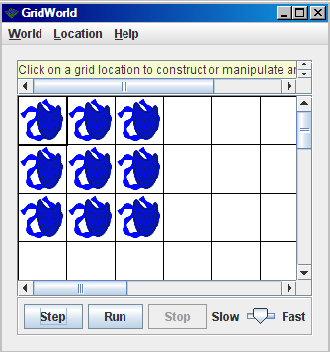
algorithm help

loop i = 0 to size
{
loop j = 0 to size
{
put an Actor in the grid at spot i,j
}
}

