A+ Computer Science TRIANGLE LETTERS 2 Lab Value - 100

Lab Goal : This lab was designed to teach you how to use nested loops. You will also learn how to make some cool shapes using the GridWorld case study.

Lab Description : Use nested loops to print out the triangle letter pattern shown below.

Files Needed ::
TriangleLettersTwo.java
TriangleLettersRunner.java
GridWorld project

Sample Data :
5 X
3 A
1 R
5 T
4 W

algorithm help

loop i = 0 to size
{
loop j = 0 to size-i
{
put a letter in the grid at spot i,j
}
}

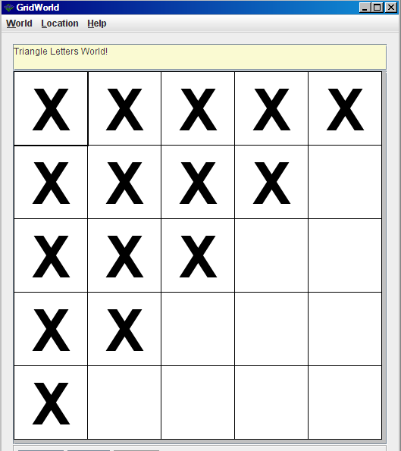
Sample Output :

