Computer Science ANNOYING CRITTER Lab Value - 100

Lab Goal : This lab was designed to teach you more about the Critter.

Lab Description : Extend the Critter class to make a new AnnoyingCritter. AnnoyingCritter will pick an actor at random to be its best friend forever (bFF) – the actor chosen must be an actor that will move. AnnoyingCritter will follow / move towards its bFF in hopes of being near its bFF – it LOVES its BFF! AnnoyingCritter will eat ONLY rocks and flowers as it does not like to eat things that can move. AnnoyingCritter will always move one cell in the direction of its bFF. If AnnoyingCritter cannot move to the cell in the direction of its BFF, it will move to any of its empty adjacent cells just like a normal critter.

Sample Data :
See the main in AnnoyingCritterRunner

Sample Output :

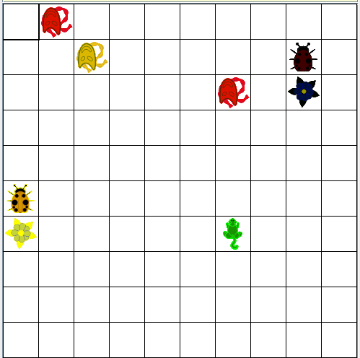
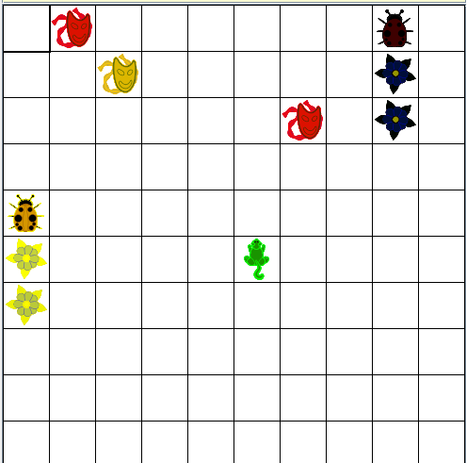
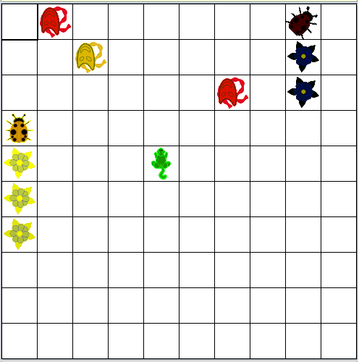

Actor at (0,1) selected as bFF
Moving towards (0,1)
Moving towards (0,1)

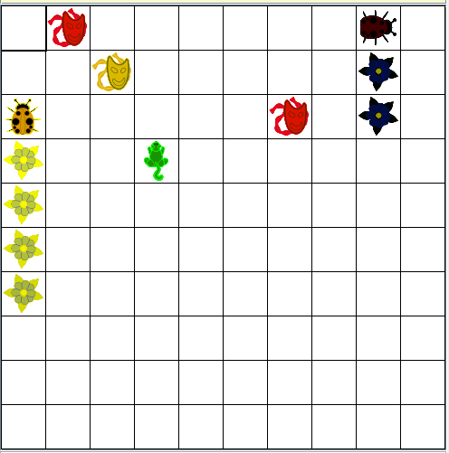
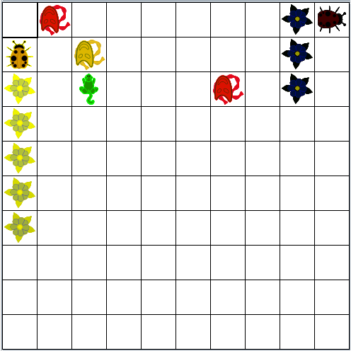

Moving towards (0,1)
Moving towards (0,1)

