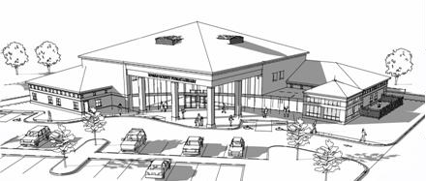

***Rowan County Public Library***

***175 Beacon Hill Drive***

***Morehead, KY 40351***

***Phone 606-784-7137***

TEEN VOLUNTEER APPLICATION

(12-17 YEARS OLD)

Name________________________________________________ Date of Birth _________________

Address ____________________________________________________________________________

City _______________________________________________________ State __________ Zip ______

Email address _________________________________________ Phone number ___________________

Emergency Contact ______________________________________ Phone _________________________

What extracurricular activities are you involved in? ________________________________________________

Please circle the days of the week and hours that fit best with your availability:

M T W Th F Sat 9am-12pm 12pm- 2pm 3pm-5pm 5pm-7pm

Release of Liability

To be signed by the volunteer ***and also*** the parent or legal guardian for volunteers age 12-17 years old.

I understand that the library does not provide worker’s compensation, medical coverage, or liability for volunteers. I will not hold the library staff or board members responsibility for any physical or mental injury that may incur while on library property. I have medical coverage.

Volunteer signature Parent signature

_________________________________________ ___________________________________________

Date__________________ Date________________

Please return this form to the Rowan County Public Library or mail to: Megan Harmon, Teen Services Librarian RCPL, 175 Beacon Hill Drive, Morehead, KY 40351.