**Document 04 – Sprint 2 Report**

CS 4321 – Summer 2022

Contents

1 Completed User Stories 1

2 Buggy User Stories 1

3 Incomplete User Stories 1

4 Class Diagram 2

5 System Tests 2

6 Video Demo 2

Appendix 1 Grading Criteria 3

# Completed User Stories

|  |
| --- |
| **Deliverable**  List the User Stories (including both sprints) that are complete, tested, and correct. |

|  |  |
| --- | --- |
| **Num** | **User Story** |
| 1 | As a key office administrator, I want to be able to add buildings, suites, rooms, and employees. |
| 2 | As a key office administrator, I want to be able to remove buildings, suites, rooms, and employees. |
| 3 | As a key office administrator, I want to be able to add access to buildings, suites, and rooms |
| 4 | As a key office administrator, I want to be able to remove access to buildings, suites, rooms |
| 5 | As a key office administrator, I want to be able to save and load company information to a text file. |
| 6 | As a key office administrator, I want to be able to record an employee’s successful attempt to access a door. (Success) |
| 7 | As a key office administrator, I want to be able to record an employee’s unsuccessful attempt to access a door. (Denied) |
| 8 | As a key office administrator, I want to be able to record a non-employee's unsuccessful attempts to access a door. (Security Alert [record invalid ID #]) |
| 9 | As a key office administrator, I want to be able to generate a list of all employees showing their name and ID. (Report A) |
| 10 | As a key office administrator, I want to be able to generate a list of all employees showing their name, ID, and rooms with their corresponding building name and code, and corresponding suite name and code. (Report B) |
| 11 | As a key office administrator, I want to be able to generate a list of all employees showing their name, ID, and access levels. (Report C) |
| 12 | As a key office administrator, I want to be able to generate a list of all buildings and corresponding building codes. (Report D) |
| 13 | As a key office administrator given a building code, I want to be able to generate a list of all suites and corresponding suite codes along with a list of rooms inside that suite. (Report E) |
| 14 | As a key office administrator given a building code and suite code, I want to be able to generate a list of all rooms inside that suite. Report F) |
| 15 | As a key office administrator given an employee ID, I want to be able to generate a list of rooms (with their corresponding suite and building) successfully accessed by date and time in reverse chronological order by that employee, across all time. (Report H) |
| 16 | As a key office administrator given and employee ID, I want to be able to generate a list of rooms (with their corresponding suite and building) where the employee was denied access, by date and time in reverse chronological order by that employee, across all time. (Report I) |
| 17 | As a key office administrator given a building code and room number, I want to be able to generate a list of employees and ID by date and time in reverse chronological order, who have been denied access to the room, across all time. (Report J) |
| 18 | As a key office administrator given a building code and room number, I want to be able to generate a list of employees and ID by date and time in reverse chronological order, who have been denied access to the room, across all time. (Report K) |
| 19 | As a key office administrator given a building code and room number, I want to be able to generate a list of IDs by date and time in reverse chronological order, who have been denied access to the room because of an invalid ID (*e.g.* “Security Alert” from the log) (Report L) |
| 20 | As a key office administrator given a building code, room number, date, begin time, and end time, I want to be able to generate a list of rooms (with their corresponding suite and building) that the employee has accessed or been denied access to, by time in reverse chronological order. (Report M) |

# Buggy User Stories

|  |
| --- |
| **Deliverable**  List the User Stories that are complete, tested, but have bugs. After the User Story, use square braces to briefly describe the symptoms and/or the suspected problem. For example: “As a human, I want to eat so that I won’t be hungry [Not all foods consumed are converted to calories correctly]” |

|  |  |
| --- | --- |
| **Num** | **User Story** |
| 1 | As a key office administrator, I want to be able to generate a list of all employees who have access to a room, using the given room’s building code and room number. (Report G) [Doesn’t find rooms when given building access or suite access.] |

# Incomplete User Stories

|  |
| --- |
| **Deliverable**  List the User Stories that are incomplete. These are User Stories where you have written some code but are incomplete for any number of reasons. After the User Story, use square braces to briefly describe what works and/or what is missing. |

|  |  |
| --- | --- |
| **Num** | **User Story** |
| 1 | As a key office administrator, I want to be able to change employee access to buildings, suites, and rooms. |
| 2 | As a key office administrator, I want to be able to generate a list of all employees who have access to a room, using the given room’s building code and room number in a certain time window. (Report N) |

# Class Diagram

|  |
| --- |
| **Deliverable**  At the conclusion of this sprint, you should make a class diagram using StarUML. You can make multiple diagrams at different levels of granularity, or just break it up. Include a brief narrative. Your objective is to convey your design to me. The diagram(s) must be readable. Also include the digrams saved as image files in your docs folder on GitHub. |

**DOMAIN**

As we can see in our UML diagram the relationship that is being portrayed is a “has-a” relationship. The CompanyManager class has many Employees and Buildings. The Building class has many Suites, and the Suite class has many Rooms.

The CompanyManager class is the hub of where most of our adders, getters, and removers are. Employee is a class that represents company employees. The class is responsible for storing employee names, IDs, and areas they have access to. The Room class represents the rooms that can be found inside the company's suites. Each Room stores room numbers and tracks what suite and building a room belongs to. The Suite class represents the suites of a building. Each suite stores its name, suite code, and the building it is inside. The Building class represents buildings which everything is within. Each building stores a building’s name and building code.

**SYSTEM/GUI**

Moving forward, in our second UML diagram, we have an MVC which demonstrates all our systems classes. This technique implements the single responsibility principle so that our software is more understandable, flexible, and maintainable.

The Main class is composed of our GUI and event handlers that execute certain buttons. Our event handlers then call the CompanyController class where we validate all codes being passed with the CompanyValidator class. This allows us to add or remove any object that has passed the validator. We also have a CompanyCodeStatus class which returns a class object of whether the code is valid along with any error message that may have been encountered. Lastly, there is a CompanyPersistence class that builds from / writes to text files and builds our reports.

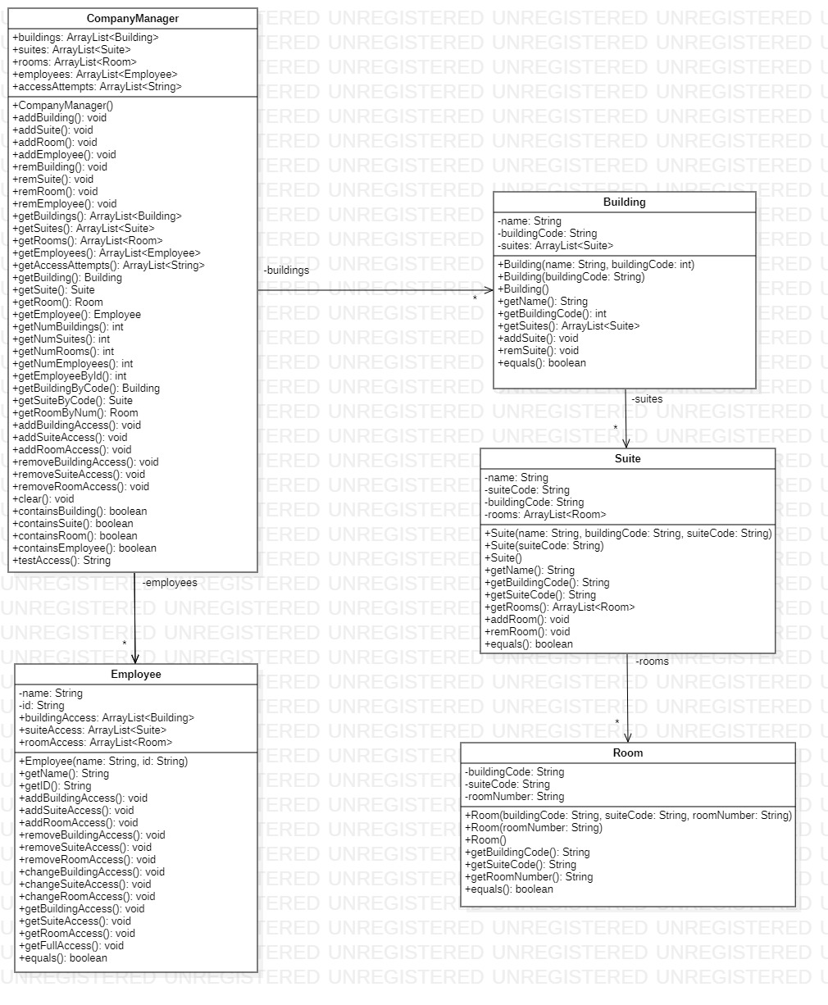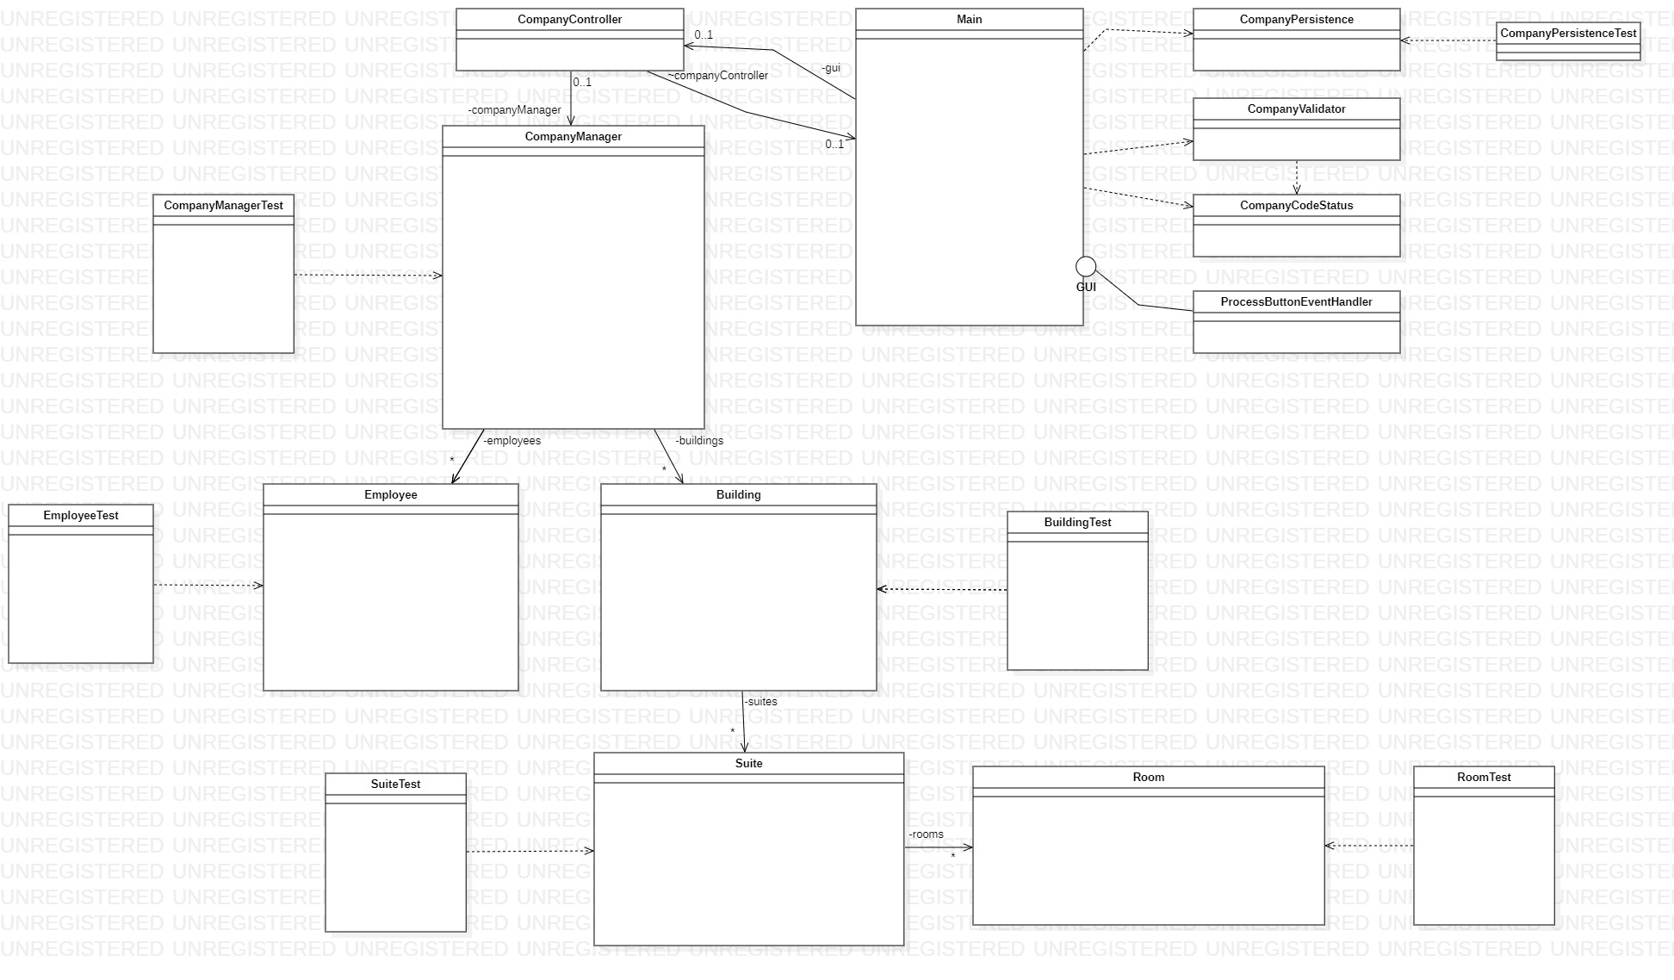

# System Tests

|  |
| --- |
| **Deliverable**  You probably will have multiple System Tests for each user story. |

|  |  |
| --- | --- |
| Test Number | 1 |
| US Number | 1 |
| Description | Tests the ability to fetch a building’s name |
| Status | Success |

|  |  |
| --- | --- |
| Test Number | 2 |
| US Number | 1 |
| Description | Tests the ability to assign a building code under normal circumstances |
| Status | Success |

|  |  |
| --- | --- |
| Test Number | 3 |
| US Number | 1 |
| Description | Tests the ability to assign a building code when the code is too long |
| Status | Success |

|  |  |
| --- | --- |
| Test Number | 4 |
| US Number | 1 |
| Description | Tests the ability to assign a building code when the code is too short |
| Status | Success |

|  |  |
| --- | --- |
| Test Number | 5 |
| US Number | 1 |
| Description | Tests the ability to assign a building code when the code contains letters |
| Status | Success |

|  |  |
| --- | --- |
| Test Number | 6 |
| US Number | 1 |
| Description | Tests the ability to add a building to the system and get its name |
| Status | Success |

|  |  |
| --- | --- |
| Test Number | 7 |
| US Number | 1 |
| Description | Tests the ability to add a suite to the system and get its name |
| Status | Success |

|  |  |
| --- | --- |
| Test Number | 8 |
| US Number | 1 |
| Description | Tests the ability to assign a room to the system and get its room code |
| Status | Success |

|  |  |
| --- | --- |
| Test Number | 9 |
| US Number | 1 |
| Description | Tests the ability to add an employee to the system and get the employee’s name |
| Status | Success |

|  |  |
| --- | --- |
| Test Number | 10 |
| US Number | 2 |
| Description | Tests the ability to remove a building from the system |
| Status | Success |

|  |  |
| --- | --- |
| Test Number | 11 |
| US Number | 2 |
| Description | Tests the remove to remove a suite from the system |
| Status | Success |

|  |  |
| --- | --- |
| Test Number | 12 |
| US Number | 2 |
| Description | Tests the ability to remove a room from the system |
| Status | Success |

|  |  |
| --- | --- |
| Test Number | 13 |
| US Number | 2 |
| Description | Tests the ability to remove an employee from the system |
| Status | Success |

|  |  |
| --- | --- |
| Test Number | 14 |
| US Number | 2 |
| Description | Test the ability to totally clear all lists |
| Status | Success |

|  |  |
| --- | --- |
| Test Number | 15 |
| US Number | 1 |
| Description | Tests the ability to check the buildings list for a specific building |
| Status | Success |

|  |  |
| --- | --- |
| Test Number | 16 |
| US Number | 1 |
| Description | Tests the ability to check the suites list for a specific suite |
| Status | Success |

|  |  |
| --- | --- |
| Test Number | 17 |
| US Number | 1 |
| Description | Tests the ability to check the rooms list for a specific room |
| Status | Success |

|  |  |
| --- | --- |
| Test Number | 18 |
| US Number | 1 |
| Description | Tests the ability to check the employees list for a specific employee |
| Status | Success |

|  |  |
| --- | --- |
| Test Number | 19 |
| US Number | 1 |
| Description | Tests the ability to find if an employee exists using its ID in a case where the employee with input ID does exist |
| Status | Success |

|  |  |
| --- | --- |
| Test Number | 20 |
| US Number | 1 |
| Description | Tests the ability to find if an employee exists using its ID in a case where the employee with input ID does not exist |
| Status | Success |

|  |  |
| --- | --- |
| Test Number | 21 |
| US Number | 6 |
| Description | Tests the ability to verify if an employee has access to a room (the return should be true) |
| Status | Success |

|  |  |
| --- | --- |
| Test Number | 22 |
| US Number | 7 |
| Description | Tests the ability to verify if an employee has access to a room (the return should be false) |
| Status | Success |

|  |  |
| --- | --- |
| Test Number | 23 |
| US Number | 8 |
| Description | Tests the ability to verify if an employee has access to a room with an access code that doesn’t exist (security alert) |
| Status | Success |

|  |  |
| --- | --- |
| Test Number | 24 |
| US Number | 5 |
| Description | Tests the ability to create a file with the file writer |
| Status | Success |

|  |  |
| --- | --- |
| Test Number | 24 |
| US Number | 5 |
| Description | Tests the ability to create a company using an existing file with objects |
| Status | Success |

|  |  |
| --- | --- |
| Test Number | 25 |
| US Number | 6,7,8 |
| Description | Tests the ability to create a file that stores attempted accesses |
| Status | Success |

|  |  |
| --- | --- |
| Test Number | 26 |
| US Number | 15 |
| Description | Tests the ability to create report H |
| Status | Success |

|  |  |
| --- | --- |
| Test Number | 27 |
| US Number | 16 |
| Description | Tests the ability to create report I |
| Status | Success |

|  |  |
| --- | --- |
| Test Number | 28 |
| US Number | 17 |
| Description | Tests the ability to create report J |
| Status | Success |

|  |  |
| --- | --- |
| Test Number | 29 |
| US Number | 18 |
| Description | Tests the ability to create report K |
| Status | Success |

|  |  |
| --- | --- |
| Test Number | 30 |
| US Number | 19 |
| Description | Tests the ability to create report L |
| Status | Success |

|  |  |
| --- | --- |
| Test Number | 31 |
| US Number | 20 |
| Description | Tests the ability to create report M |
| Status | Success |

|  |  |
| --- | --- |
| Test Number | 32 |
| US Number | 1 |
| Description | Tests the ability to create an employee if there is no name input |
| Status | Success |

|  |  |
| --- | --- |
| Test Number | 33 |
| US Number | 1 |
| Description | Tests the ability to create an employee if there is no ID input |
| Status | Success |

|  |  |
| --- | --- |
| Test Number | 34 |
| US Number | 1 |
| Description | Tests the ability to create an employee when the ID is shorter than it was supposed to be |
| Status | Success |

|  |  |
| --- | --- |
| Test Number | 35 |
| US Number | 1 |
| Description | Tests the ability to create an employee when the ID is larger than it was supposed to be |
| Status | Success |

|  |  |
| --- | --- |
| Test Number | 36 |
| US Number | 1 |
| Description | Tests the ability to use the getter methods for employees |
| Status | Success |

|  |  |
| --- | --- |
| Test Number | 37 |
| US Number | 3 |
| Description | Tests the ability to add building access |
| Status | Success |

|  |  |
| --- | --- |
| Test Number | 38 |
| US Number | 3 |
| Description | Tests the ability to add suite access |
| Status | Success |

|  |  |
| --- | --- |
| Test Number | 39 |
| US Number | 3 |
| Description | Tests the ability to add room access |
| Status | Success |

|  |  |
| --- | --- |
| Test Number | 40 |
| US Number | 4 |
| Description | Tests the ability to remove building access |
| Status | Success |

|  |  |
| --- | --- |
| Test Number | 41 |
| US Number | 4 |
| Description | Tests the ability to remove suite access |
| Status | Success |

|  |  |
| --- | --- |
| Test Number | 42 |
| US Number | 4 |
| Description | Tests the ability to remove room access |
| Status | Success |

|  |  |
| --- | --- |
| Test Number | 43 |
| US Number | Incomplete Story 2 |
| Description | Tests the ability to change building access |
| Status | Success |

|  |  |
| --- | --- |
| Test Number | 44 |
| US Number | Incomplete Story 2 |
| Description | Tests the ability to change suite access |
| Status | Success |

|  |  |
| --- | --- |
| Test Number | 45 |
| US Number | Inomplete Story 2 |
| Description | Tests the ability to change room access |
| Status | Success |

|  |  |
| --- | --- |
| Test Number | 46 |
| US Number | 1 |
| Description | Tests adding a room without a building code |
| Status | Success |

|  |  |
| --- | --- |
| Test Number | 47 |
| US Number | 1 |
| Description | Tests adding a room without a suite code |
| Status | Success |

|  |  |
| --- | --- |
| Test Number | 48 |
| US Number | 1 |
| Description | Tests adding a room without a room number |
| Status | Success |

|  |  |
| --- | --- |
| Test Number | 49 |
| US Number | 1 |
| Description | Tests adding a room with a building code that is too large |
| Status | Success |

|  |  |
| --- | --- |
| Test Number | 50 |
| US Number | 1 |
| Description | Tests adding a room with a suite code that is too large |
| Status | Success |

|  |  |
| --- | --- |
| Test Number | 51 |
| US Number | 1 |
| Description | Tests adding a room with a room number that is too large |
| Status | Success |

|  |  |
| --- | --- |
| Test Number | 52 |
| US Number | 1 |
| Description | Tests adding a room with too little numbers in a building code |
| Status | Success |

|  |  |
| --- | --- |
| Test Number | 53 |
| US Number | 1 |
| Description | Tests adding a room with too little numbers in the suite code |
| Status | Success |

|  |  |
| --- | --- |
| Test Number | 54 |
| US Number | 1 |
| Description | Tests adding a room with too little numbers in the room number |
| Status | Success |

|  |  |
| --- | --- |
| Test Number | 55 |
| US Number | 1 |
| Description | Tests all getter methods for rooms |
| Status | Success |

|  |  |
| --- | --- |
| Test Number | 56 |
| US Number | 1 |
| Description | Tests the creation of a suite with missing arguments |
| Status | Success |

|  |  |
| --- | --- |
| Test Number | 57 |
| US Number | 1 |
| Description | Tests the creation of a suite under normal circumstances |
| Status | Success |

|  |  |
| --- | --- |
| Test Number | 58 |
| US Number | 1 |
| Description | Tests get suite name |
| Status | Success |

|  |  |
| --- | --- |
| Test Number | 59 |
| US Number | 1 |
| Description | Tests using a normally sized suite code to create a suite |
| Status | Success |

|  |  |
| --- | --- |
| Test Number | 60 |
| US Number | 1 |
| Description | Tests using a suite code that is too long to create a suite |
| Status | Success |

|  |  |
| --- | --- |
| Test Number | 61 |
| US Number | 1 |
| Description | Tests using a suite code that is too short to create a suite |
| Status | Success |

|  |  |
| --- | --- |
| Test Number | 62 |
| US Number | 1 |
| Description | Tests using a suite code that contains letters to create a suite |
| Status | Success |

|  |  |
| --- | --- |
| Test Number | 63 |
| US Number | 1 |
| Description | Tests using a building code that is normal to create a suite |
| Status | Success |

|  |  |
| --- | --- |
| Test Number | 64 |
| US Number | 1 |
| Description | Tests using a building code that is too long to create a suite |
| Status | Success |

|  |  |
| --- | --- |
| Test Number | 65 |
| US Number | 1 |
| Description | Tests using a building code that is too short to create a suite |
| Status | Success |

|  |  |
| --- | --- |
| Test Number | 66 |
| US Number | 1 |
| Description | Tests using a building code that contains letters to create a suite |
| Status | Success |

# Video Demo

|  |
| --- |
| **Deliverable**  Create a video that demo’s your User Stories and provide the link(s) here. **Preferably, post your video(s) on Youtube**. You can make a single video, or, if needed, several. For each User Story, state the number of the User Story, and then state the User Story itself, then demonstrate it with your software. |

|  |  |
| --- | --- |
| Video Link(s) | [**Sprint 2 Video**](https://www.youtube.com/watch?v=_-WuVFTEPfU) |

Appendix

1. Grading Criteria

The final project will be evaluated on these criteria:

|  |
| --- |
| **Sprint 2 Report** |
| User Stories |
| Class diagram |
| System Test Descriptions |
| Video |
| **Code** |
| Number of User Stories Implemented |
| Unit Tests |
| Quality of design |
| Use of MVC |
| Wow factor of GUI |
| **GitHub** |
| Use of GitHub Project & Issues |
| Use of Pull Requests |
| **Individual Effort** |
| Hours |
| Code Review via Pull Requests |
| Contributions to code base |