Project Proposal
Problem Statement

Challenge Description
One of the main complaints with browsing the popular video sharing and streaming service YouTube is the quality of it’s recommendations. Many users of the website complain that the recommendations can be distracting and irrelevant, especially when trying to use the service in an educational or professional environment. Furthermore it can be very difficult to “train” the algorithm to produce a certain category of video consistently like for example educational physics videos. Many high school teachers have to result to downloading the videos they would like to show in class ahead of time to minimize students getting distracted by irrelevant recommendations.

Stakeholders Identification
According to Google (YouTube’s parent company) “7 in 10 YouTube viewers use the platform for help with their work, studies or hobbies” [1]. Such users would be constitute the primary stakeholders of this project. YouTube can be an invaluable resource in many fields such as IT where administrators can learn how to transfer fields between databases and mechanics can likely find a video of someone disassembling a drum brake of the exact model they’re trying to repair. Needless to say YouTube is almost like a second Google Search and empowering such uses would only further the platform’s success. Additional stakeholders include Content Creators that specialize in particular video categories that aren’t mainstream enough to be picked up by a recommendation algorithm that prioritizes watch time over everything. Finally ad campaigns can be very expensive to run on the platform, therefore Advertisers need to ensure the right ads are shown to the right audience and advertising car insurance in the middle of a grade school physics demonstration is the just about the opposite of money well spent. The stakeholders issues can be summarized into three pain points; distractions, failure of the algorithm to recommend high quality niche content and wasted advertising.

Proposed Solution
The proposed solution is split into two features. The first feature is a set of controls that allow pausing and resetting the YouTube recommendation learning algorithm. Pausing the algorithm wouldn’t disable recommendations but freezes it’s learning data in place, ensuring no matter what is searched the recommendations remain fixed on whatever the algorithm learned before being paused. This feature would allow users to “train” the algorithm to their interests or professional field and enjoy consistent recommendations from that category. The second proposed feature is a set of controls that allow both logged in and guest users to create multiple profiles withing their accounts or sessions respectively. This expands upon the first proposed feature by allowing users to “train” multiple instances of the algorithm and seamlessly switch between them without the hassle of creating multiple Google accounts.
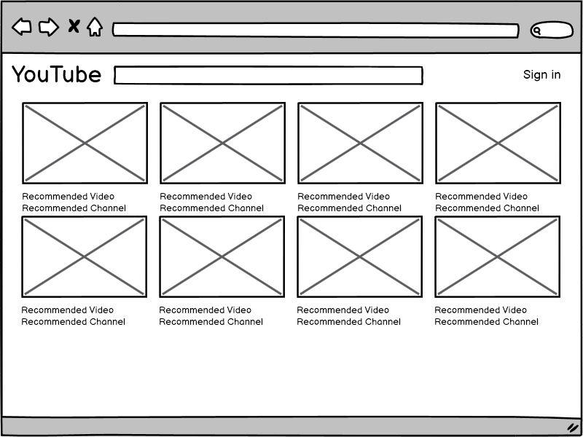Figure 1: Home Page (Signed out)
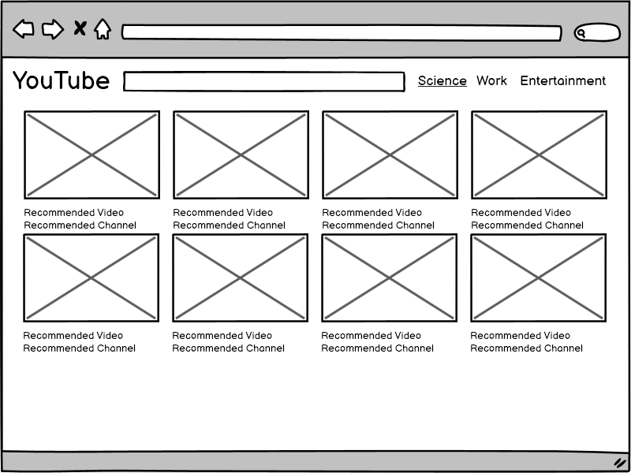Figure 2: Home Page (Signed in)
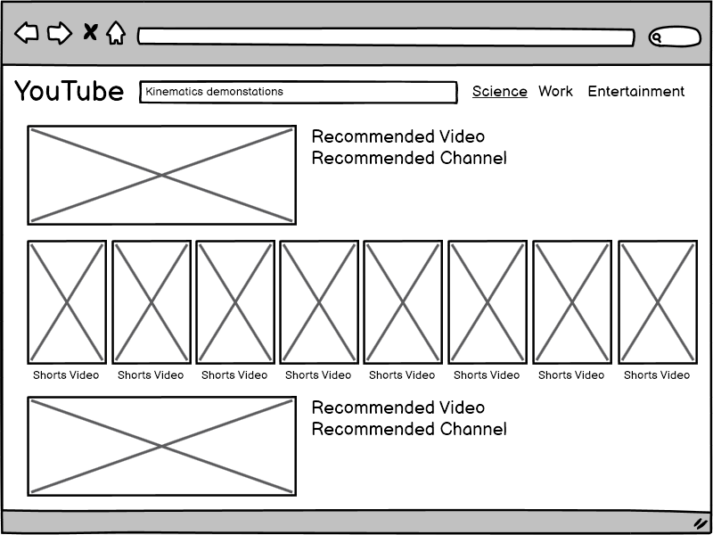Figure 3: Search Results (Science profile)
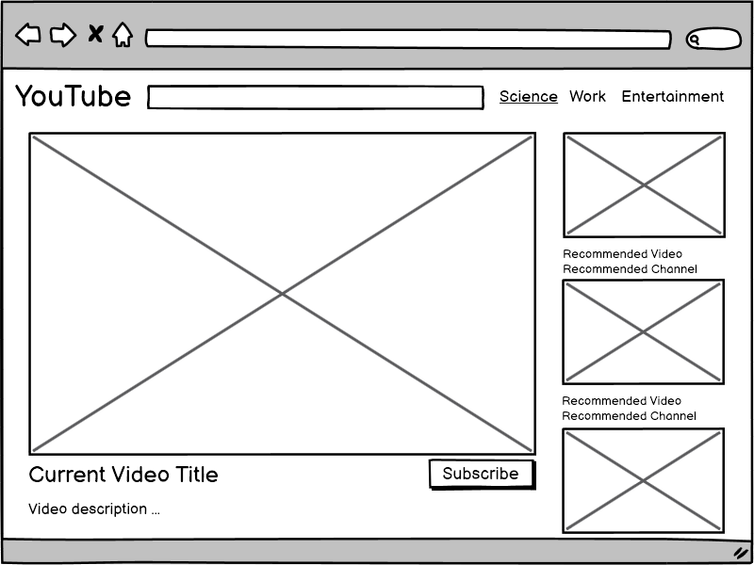Figure 4: Video Player (Science profile)
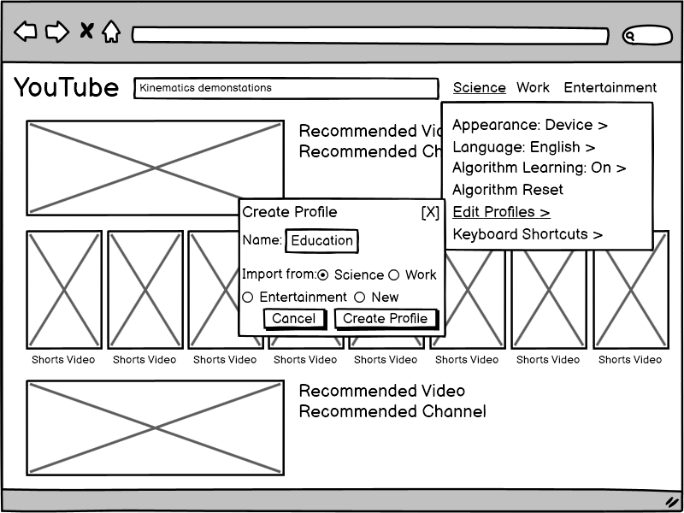Figure 5: Profile Creation
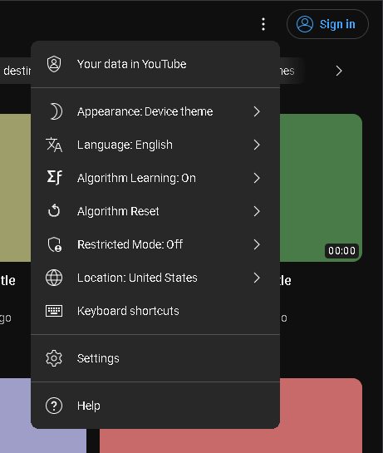Figure 6: Proposed Solution Location
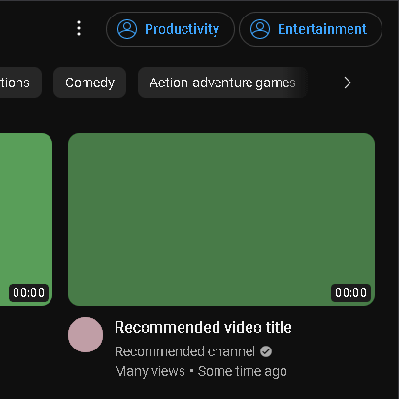Figure 7: Profile Selection Buttons

Expected Outcomes
The expected outcome of this project is simplifying the use of YouTube in educational and professional environments. Students will find the multiple profile feature very useful for looking up tutorials and guides on YouTube without getting distracted from working on homework and projects. Instructors and Teachers will find it easier to browse videos on the actual website without needing to download them beforehand to minimize distractions. Finally content creators and advertisers will find it easier to promote their content and products to genuinely interested viewers.

Milestone 2 Documentation
The focus of Milestone 1 was the overall layout a design while Milestone 2 focused on the HTML/CSS/JS implementation of the proposed features. Some slight visual changes were made to accommodate a wider variety of screen sizes while also allowing users to freely resize their browser window. Sample content was added to the home page and “logged in / profile-aware” homepage to demonstrate the alternative algorithm recommendations. Since there is no backend support in Milestone 2 and the search function doesn’t take into account the typed text the “results” and video player recommendations were left generic to fit any scenario. Clicking on the 3 dots next to the “Sign in” or profile buttons triggers a JavaScript event that displays a drop down menu from which the profile creation menu can be accessed which is considered the “5th page” for the purposes of the assignment.

Sources
- 2and2/Google, “The Values of YouTube Study,” U.S., Oct. 2017 (n of 1,006 consumers between the ages of 18-54, with 918 monthly YouTube users).
- Jargon, J. (2022, March 19). YouTube is a huge classroom distraction. teachers are reluctant to banish it. The Wall Street Journal. https://www.wsj.com/articles/youtube-is-a-huge-classroom-distraction-teachers-are-reluctant-to-banish-it-11647656643
- Mark, G., Iqbal, S., & Czerwinski, M. (2017). How blocking distractions affects workplace focus and productivity. Proceedings of the 2017 ACM International Joint Conference on Pervasive and Ubiquitous Computing and Proceedings of the 2017 ACM International Symposium on Wearable Computers. https://doi.org/10.1145/3123024.3124558
- Inc, J. D. G., Davidson, J., Inc, G., Inc, B. L. G., Liebald, B., Inc, J. L. G., Liu, J., Inc, P. N. G., Nandy, P., Inc, T. V. V. G., Vleet, T. V., Inc, U. G. G., Gargi, U., Inc, S. G. G., Gupta, S., Inc, Y. H. G., He, Y., Inc, M. L. G., Lambert, M., … Metrics, O. M. A. (2010, September 1). The YouTube video recommendation system. ACM Conferences. https://dl.acm.org/doi/abs/10.1145/1864708.1864770
- Zhou, R., Khemmarat, S., Gao, L., Wan, J., & Zhang, J. (2016, January 28). How youtube videos are discovered and its impact on video views - multimedia tools and applications. SpringerLink. https://link.springer.com/article/10.1007/s11042-015-3206-0

