Working with RFID input
RFID stands for Radio Frequency Identification. A small black RFID receiver captures the code of any RFID swipe card that comes near it. Each swipe card has a 'unique' identification code – something like “1500D001B”. We can use these codes to drive aspects of our programs.
Here is a messy Innovation ID 12 RFID circuit (much more clearly sketched in the eLearning Week 10 notes).
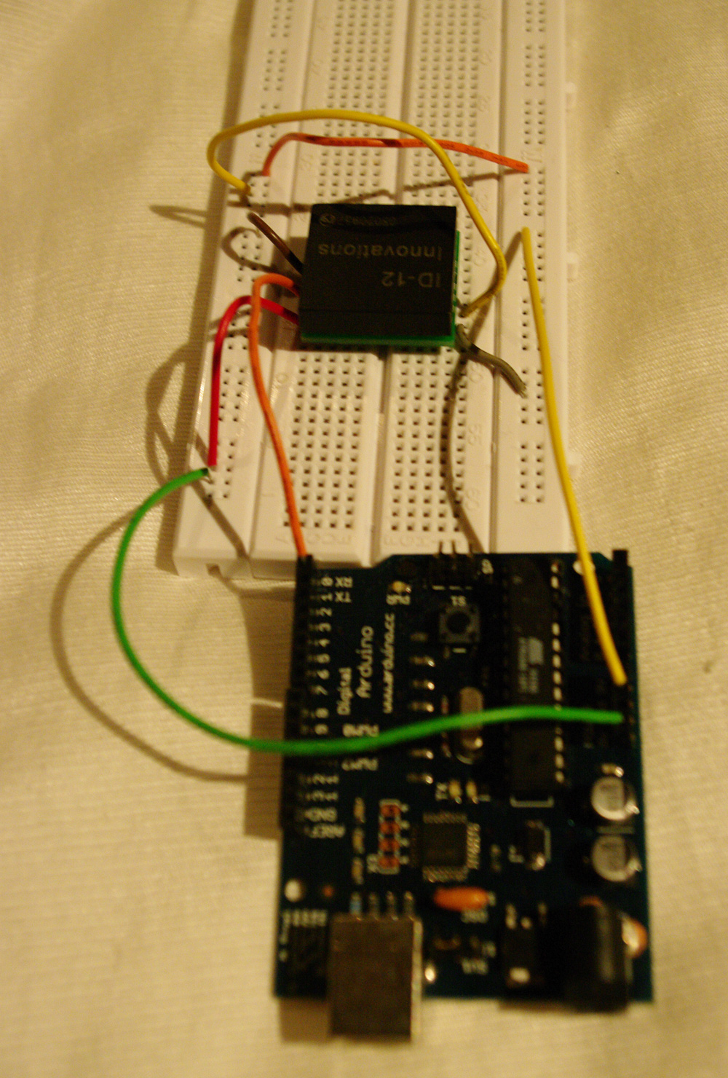

What could this control? Any number of things. You could make it so that a specific RFID code determines the rendering mode (points, lines or filled) or selects a different image loop. It's up to the production groups to consider the various possibilities.
Here are some step by step instructions to get you up and running.
- Begin by checking out the Loom engine. It is a bit different than the old Scala drawing/animation engine. You need to read the Loom.pdf and consult the API documentation.
- This should give you the skills necessary to run the two sample programs - HeightMap and ImageLoop. HeightMap now includes a spinning ground plane, a semi-transparent scull image and some depth dependent sound. It demonstrates how 3D display, images and sound can be linked. The other sketch is a new version of ImageLoop. In default mode it just shows an endlessly repeated squiggle, but later in serial input mode it can swap to different image sequence animations. Having looked at these two examples you need to decide as a group what you would like to do with either photo-resistor input. We will discuss the possibilities in class.
- Having come up with your groups creative concept the next step is to create an Arduino circuit based on RFID input. See the weekly notes for week 10 on eLearning. You can use either an Innovation ID12 or ID20 RFID reader. Please speak to our technical support officer, Glenn Alexander, if you need assistance putting together the circuit. Here are Glenn’s contact details: (extn: 5847, email: glenn_alexander@uow.edu.au). He is based on the IC campus so you may need to travel over there for help. Alternatively, he will be attending class over the next few weeks.
- Having created the circuit you need to test it with the RFID based Arduino sketch provided in the Loom directory. Compile and upload the sketch to your circuit and see how it works. Worth turning on Serial Monitor to check and record the card codes. You will need these when you write your Scala control code.
- Having built and tested your circuit the next step is to link it up to the Loom graphics engine. Go into the authoring directory. You will find versions of the HeightMap and ImageLoop sketches. Select the one that you’d like to work with/adapt. The HeightMap example uses RFID input to modify the rendering mode. The ImageLoop sketch does something similar but instead of adjusting the renderer it switches the image sequence currently displayed. Make sure that your circuit is running and attached via USB to the computer. Then go to the config directory in your selected sketch. There should be three files:
- config_default.xml (plays without serial input)
- config_photoresistor.xml (works with photo-resistor circuit)
- config_rfid.xml (works with RFID circuit).
- You need the third one. Open up the RFID configuration file and check the settings. It should not need to be changed.
- Go into your sketch directory and open up the MySketch.scala file. Read it thoroughly to get an understanding of how it works. Pay particular heed to the serialEventNotify method. This is the place where you do things on the basis of RFID readings. You will need to uncomment the relevant code if it is currently commented. You will also need to comment out any currently uncommented photo-resistor related code into the sketch (you will find this in the update() method). Try building and running the code. Test the cards and see if it updates aspects of the display.
- Now you need to modify the MySketch code to do whatever you want to accomplish. You also need to build a compelling interaction framework. A black box is a bit dull and obvious. What can you design that creates an interesting relationship between user interaction and screen display?
- Now copy the photo-resistor build files in your sketch directory into the main loom directory. Use these to build and test your project. Consult the Loom pdf for more information.
- PLEASE NOTE THAT YOU CANNOT RUN THE SERIAL VERSIONS OF HEIGHTMAP AND IMAGELOOP IF YOU DO NOT HAVE SERIAL DEVICES CONNECTED AND SET TO THE CORRECT PORT – MISTAKES HERE WILL CAUSE A CASCADE OF ERROR MESSAGES.

