Loom Technical Development [for those interested.]

Geometric Subdivision
During Spring session of 2010 I built a simple 2D and 3D animation and drawing engine for a first year computational media class. I called it Loom in recognition of the Jacquard Loom, which served as an early model for the computer and which was fundamentally concerned with managing the replication of graphic textile patterns. The aim was to enable students to look beneath the hood of computer graphic processes and to indicate the potential for creative tinkering and reconstruction. The engine provided basic functions for producing regular polygonal shapes. All the points on regular polygons are equidistant from the centre and all the sides are of equal length. A cube and an equilateral triangle provide examples. The points that make up these basic shapes can then be transformed in various ways – translated, scaled and rotated - to produce other, more complex shapes. I began this project with the thought of adding one more feature – the capacity to subdivide a regular polygonal shape into a finer polygonal mesh. Subdivision is a conventional means for lending 3D shapes a more curved and organic feel.

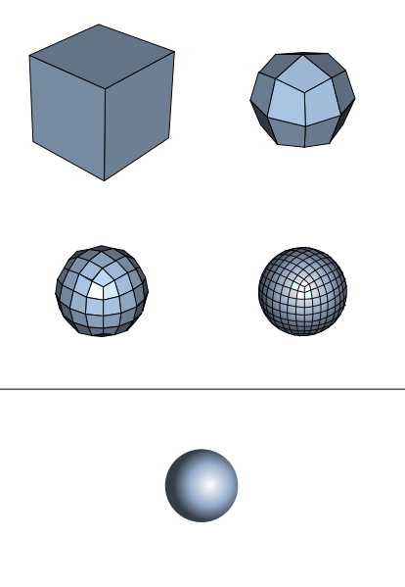

The image above displays Catmull-Clark quadrilateral subdivision of a basic cube into something that approximates a sphere. Note that the Catmull-Clark process involves both subdividing the shape and repositioning the new points to produce the impression of natural curvature. I could have attempted to implement the Catmull-Clark formula within the graphics engine, however, I was keen to work things out for myself. I expected to spend perhaps a couple of days mucking around with the problem, but things became more complicated and absorbing. Some simple experiments suggested other possibilities. Very swiftly issues of smoothly curved 3D geometry slipped into the background and I became more concerned with the potential for 2D recursive pattern-making.

Subdivisions Modes
Straight away I realised that it was easier to deal with subdivision in two dimensions rather than three, so I considered how to subdivide 2D regular polygons. I started with a simple square and recognised 4 major types of subdivision: quadralinear, triangular, bifurcated and echoed.

Quadralinear | Triangular | Bifurcated | Echoed
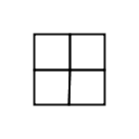 | 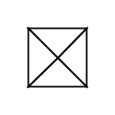 | 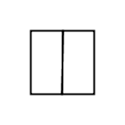 | 

Quadralinear subdivision breaks a square into four smaller squares. The process involves the following steps:

- calculating the centre of the square by averaging the existing points (the four corners)
- calculating the set of mid-points on each of the lines between the existing points
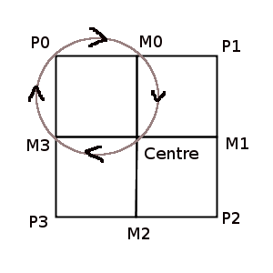
- proceeding in sequence from the first corner point (P0) to the last (P3), composing a new polygon from the current corner (P0) to the next mid-point (M0), then to the centre and finally to the mid-point given by the number of sides minus one added to the current corner point index (M3 in this case).

Triangular subdivision is simpler. There is no need to calculate mid-points. The triangles are built from the existing corners and the centre. Bifurcation appears simple but actually ends up being a bit more complex. Echo is arguably not a form of subdivision at all, but a mode of internal doubling. Nonetheless, it is convenient for my purposes to treat it as a form of subdivision. It involves scaling the corner points around a notional center to produce a smaller (or larger, if you prefer) polygon.

To make things clear, what happens with subdivision is that the initial shape gets passed in as an input parameter to the relevant subdivision function and a set of subdivision shapes gets calculated and returned. The original shape is lost, except in terms of its implicit status within the new set of shapes.

Very importantly, we are not only dealing with squares. The subdivision functions need to work with regular polygons that have any number of sides. The modes of subdivision defined above work on any regular polygon that has at least 3 sides. Here, for instance, are the same functions applied to equilateral triangles and pentagons.

Quad | Tri | Bi | Echo
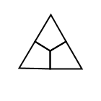  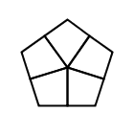 | 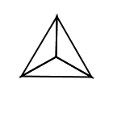  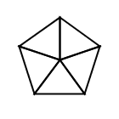 | 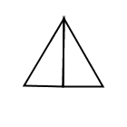  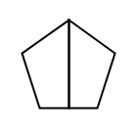 | 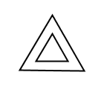  

I should note that typically, once subdivision has passed through a couple of generations, regular polygons become irregular polygons, but the functions still work.

Subdivision Functions
On the following two pages are the full set of subdivision functions incorporated in the Loom engine.
Subdivision Mode | Info | Triangle | Square | Pentagon
Quad | Subdivide into a set four sided polygons equal to the total number of original sides
Quad_Bord | Subdivide into a set of four side border polygons equal to the total number of original sides | 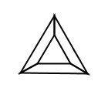 | 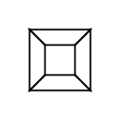 | 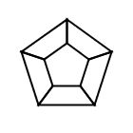
Quad_Bord_Echo | Same as Quad_Bord but also includes echoed centre polygon | 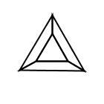 | 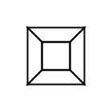 | 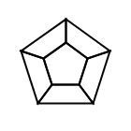
Quad_Bord_Double | Subdivide into a set four sided polygons equal to double the total number of original sides | 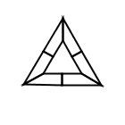 | 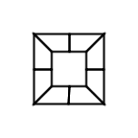 | 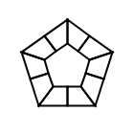
Quad_Bord_Double_Echo | Same as Quad_Bord_Double but also includes echoed centre polygon | 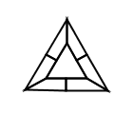 | 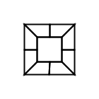 | 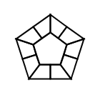
Tri | Subdivide into a set triangular polygons equal to the total number of original sides (built from centre and corners)
Tri_Bord_A | Subdivide into a set triangular polygons equal to the total number of original sides (built from line mid-points and corners) | 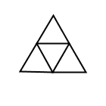 | 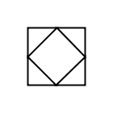 | 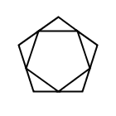
Tri_Bord_A_Echo | Same as Tri_Bord_A but also includes echoed centre polygon | 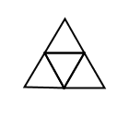 | 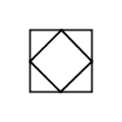 | 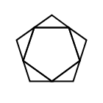
Tri_Bord_B | Subdivide into a set triangular polygons equal to the total number of original sides (built from the corners of a rotated internal echo and the original corner points) | 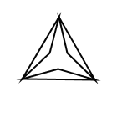 | 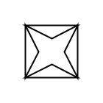 | 
Tri_Bord_B_Echo | Same as Tri_Bord_B but also includes echoed centre polygon | 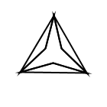 | 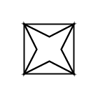 | 
Tri_Star | Similar to Tri_Bord_B but builds internal triangles rather than borders. | 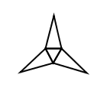 |  | 
Tri_Star_Fill | Same as Tri_Star but also includes border polygons | 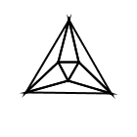 | 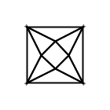 | 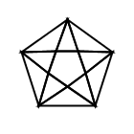
Tri_Bord_C | Similar to Tri_Star and Tri_Bord_B but calculates three triangular subdivision for each original side | 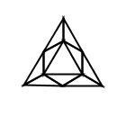 | 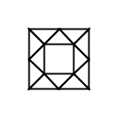 | 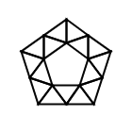
Tri_Bord_C_Echo | Same as Tri_Bord_C but also includes echoed centre polygon | 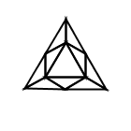 | 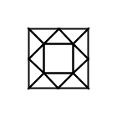 | 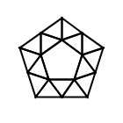
Split_Vert | Splits the shape into two polygons that have the same number of sides as the original shape
Split_Horiz | Splits a polygon horizontally. Only implemented for squares at this stage. | Not implemented yet | 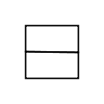 | Not implemented yet
Split_Diag | Only implemented for even sided polygons at this stage, odd sided polygons just return a Split_Vert. |  | 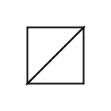
Echo | Scales the original shape. Returns both the original shape and the echoed shape. Centre is calculated relative to this shape. Central image shows Quad subdivision followed by Echo subdivision. |  | 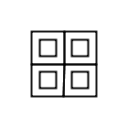
Echo_Abs_Center | Same as above but center calculated relative to the whole image. Central image shows Quad subdivision followed by Echo_Abs_Centre subdivision. |  | 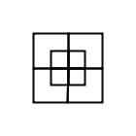

Joining the Dots

These functions are all stitching functions. They link together sets of points. These sets include:

- the original corner points (black)
- the center of the shape (red)
- the mid-points along each original side (grey)
- the scaled corner points (blue), which can also be transformed (purple – here rotated)

Additional Parameters
There are a range of additional parameters that complicate the basic subdivision operations.

Parameter | Description
Randomised centre point value | The centre point can be randomised slightly or greatly depending on the value supplied. Low values (e.g. 2) produce high variability. High values (e.g. 12) produce less variability. | 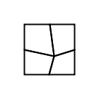  Quad subdivision with value 6 randomisation of the centre
Line ratios | So called 'mid-points' can be positioned anywhere along the line depending upon the pair of values supplied. Values are typically between 0 and 1 to keep inside the existing line. | 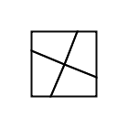  Quad subdivision with line ratios set to 3 and 7
Echo transformations | Echoed shapes can have their width, height, scale, rotation and translation specified. |   Echo with width and height independent scaling | 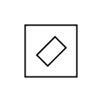  Echo with scaling and rotation | 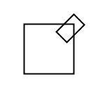  Echo with scaling, rotation and translation
Align shapes after subdivision | Due to the way many subdivision operations proceed in sequence from first corner point to the last, shapes can be built with awkward alignments. You can line everything up (if you like) with the align command. | 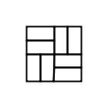  Quad subdivision followed by Split_Vert subdivision | 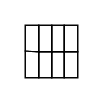  Quad subdivision followed by align command and then Split_Vert subdivision. (Also employs rotate command – a standard polygon transform. | 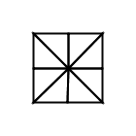  Quad and then Split_Diag  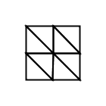  Same but with the align command after the initial Quad subdivision
Continuous | Works with line ratios to ensure adjacent polygons line up. | 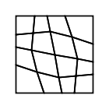  Two generations of quad subdivision with continuity set to true | 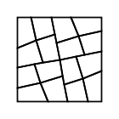  The same but with continuity set to false
Polygon visibility | You can define which polygons in a subdivision are visible (every third, random 1 in 10, etc.). Only affects the last generation of subdivision. | 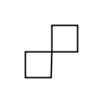  Quad subdivision with alternate-even visibility rule (note quad subdivision proceeds clockwise from top left) | 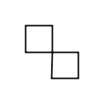  Quad subdivision with alternate-odd visibility rule

Recursive Subdivision
The key creative pattern-making potential lies not in any specific motion of subdivision but in their capacity to be stacked one on top of the other. Subdivision is typically arranged recursively. One generation of subdivision is followed by another, producing a rapidly more finely tessellated mesh and emergent dimension of pattern related to the interplay between generations. Only the final generation ever appears but it reveals the structure of all the generations that preceded it. Some simple examples.

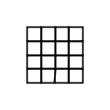  Two simple Quad subdivisions | 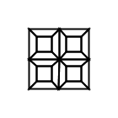  Quad subdivision followed by Quad-Bord_Echo subdivision | 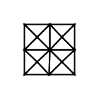  Quad subdivision followed by Tri subdivision | 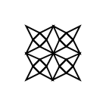  Quad subdivision followed by Tri-Star subdivision | 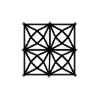  Quad subdivision followed by Tri-Star_Fill subdivision

Here are some slightly more complex examples that involve a mixture of quadralinear and triangular subdivision.

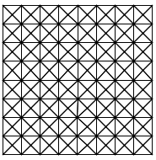  Sequence: Quad, Quad, Quad, Tri | 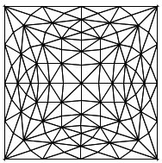  Sequence: Quad, Quad, Tri, Tri | 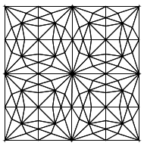  Sequence: Quad, Tri, Quad, Tri
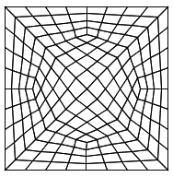  Sequence: Tri, Quad, Quad, Quad | Sequence: Tri, Quad, Quad, Tri | 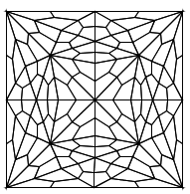  Sequence: Tri, Quad, Tri, Quad
Folds, Peaks and Troughs
I mentioned earlier that one of the program parameters specifies the extent of randomisation of subdivision centres. Over a number of generations this produces terrain like effects. Bits of the mesh get stretched, folded and scrunched up. This is very similar to how Perlin noise produces ordered randomisation in a range of media – although my version was discovered by accident. I was not aware how the work of recursive subdivision would lend structure to random processes, shaping tendencies, peaks and troughs rather than uniformly distributed effects.

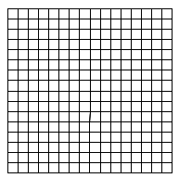  Sequence: Quad, Quad, Quad, Quad. No randomisation of subdivision centres. | 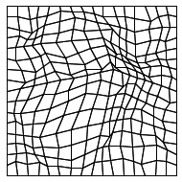  Sequence: Quad, Quad, Quad, Quad. Randomisation of subdivision centres (value 6). | 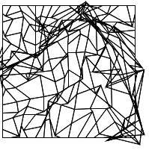  Sequence: Quad, Quad, Quad, Quad. Randomisation of subdivision centres (value 1.2).

Final Notes
The subdivision operations and overall graphics engine lack any kind of graphic user interface (GUI). The program enables only programmatic control. I have left it this way for a number of reasons. The aim is to expose dimension of code, not hide them. Building a GUI tends to take at least as long, if not much longer, than building the underlying logical system and tends to slow and constrain further development of the software. Having built a number of GUI graphics applications in the past, I know that they rarely get used, even by myself, once the original body of work is completed.

The engine is written in Scala and reads a range of configuration and data files. It outputs either single images or sequences of images. These images can be output at any resolution depending up machine RAM limits.

The Loom project is open-source. An original command line version resides on git-hub (http://github.com/brogan/Loom). Since then I have shifted the project to the Eclipse integrated development environment (IDE) and plan to update the git-hub site soon.

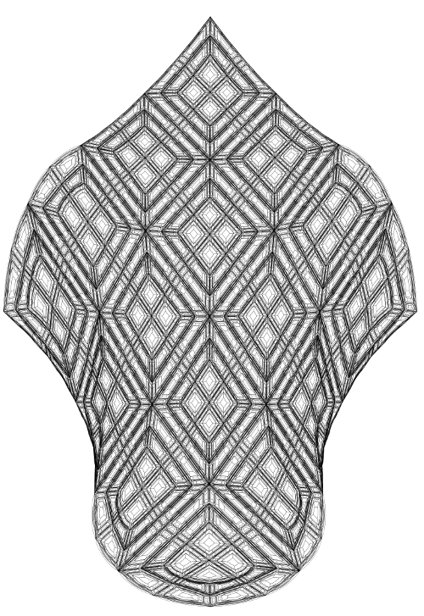
One last thing. I have experimented with subdividing bezier curve shapes. This is a bit more complex because it involves calculating mid-points on curved lines. I have the basic system working but it needs to be carefully integrated within the subdivision code base. Here is an example of a subdivided bezier curve shape.

