 PEOPLE’S DEMOCRATIC REPUBLIC OF ALGERIA

MINISTRY OF HIGHER EDUCATION AND SCIENTIFIC RESEARCH

**IBN KHALDOUN UNIVERSITY - TIARET**

DISSERTATION

Presented to:

FACULTY OF MATHEMATICS AND COMPUTER SCIENCE

DEPARTEMENT OF COMPUTER SCIENCE

In order to obtain the degree of:

License

Specialty: Information Systems and Software Engineering

By:

**ELHABASH Fares**

**GHELLAB Seyf ElIslam**

On the theme

**Creating a Website for CV Presentation and Job Offer Management**

|  |  |  |  |
| --- | --- | --- | --- |
|  |  |  |  |
| Ms BENATHMANE Lalia | MAA | Tiaret University | Supervisor |
| Ms HAMDANI Abdia | MAA | Tiaret University | Examiner |

**2024-2025**

## **Reparations**

At the onset we express sincere gratitude to Almighty God for bestowing upon us both perseverance and health as well as patience to reach this accomplishment.

Our deepest appreciation goes to [BENATHMANE Lalia] who provided his valuable guidance and support with endless availability and moderate encouragement throughout this project. The wise guidance that he provided strengthened our comprehension and enabled us to develop this site.

## **Absract**

In today’s digital world, finding a job or recruiting the right candidate is still a challenge, especially for students, fresh graduates, and small businesses. Existing job websites are often too complex, not user-friendly, or lack important features. Our project, CareerConnect, is a simple and free web site designed to connect job seekers and recruiters more efficiently. It includes useful features like job filtering, CV management, and dashboards to make the job search and hiring process easier. This project also helps us apply what we learned in software engineering, modeling with UML, and web development.

**Keywords**

Job search, recruitment, site, cv, recruiter, candidate.

**Résumé**

Dans le monde numérique d'aujourd'hui, trouver un emploi ou recruter le bon candidat reste un défi, en particulier pour les étudiants, les nouveaux diplômés et les petites entreprises. Les sites Web d'emploi existants sont souvent trop complexes, peu conviviaux ou manquent de fonctionnalités importantes. Notre projet, CareerConnect, est une site Web simple et gratuite conçue pour connecter plus efficacement les demandeurs d'emploi et les recruteurs. Il comprend des fonctionnalités utiles telles que le filtrage des emplois, la gestion des CV et des tableaux de bord pour faciliter la recherche d'emploi et le processus d'embauche. Ce projet nous aide également à appliquer ce que nous avons appris en génie logiciel, en modélisation avec UML et en développement Web.

**Mots Clés**

Recherche d’emploi, recrutement, site, cv, recruteur, candidat.

**Table of contents**

Reparations 2

Absract 3

General introduction 8

Chapter 1 General Context and Project Definition 10

1. Introduction 10

2. The importance of Work 10

4. Job Sites 11

4.1. LinkedIn 11

4.2. Indeed 11

4.3. Glassdoor 11

Emploitic 11

4.4. Comparative 12

5. General criticism 12

6. The Idea of site 13

7. Conclusion 13

Chapter 2 Modeling 14

1. Introduction 14

2. UnifiedModeling Language (UML) 14

2.1. Definition 14

2.2 . Types of UML Diagrams 14

3. Functional and Non-Functional Tasks 15

4. Diagrams 16

4.1. Use case Diagram 16

4.2. Sequence Diagram 17

4.3. Class diagram 19

5. Conclusion 20

Chapter 3: Implementation 21

1. Introduction 21

2. Development Tools and Technologies 21

3. Experimentation 22

General conclusion 29

References 30

**Liste of tables**

Table 1 :job sites comparaison 12

Table 2 :Functional and Non-Functional Tasks 15

Table de figures

Figure 1:use case diagram -general- 16

Figure 2:use case diagram -candidat- 16

Figure 3:use case diagram -recruiter- 17

Figure 4:Login sequence diagram 17

Figure 5:Apply job sequence diagram 18

Figure 6:Post a job sequence diagram 18

Figure 7:Upload cv sequence diagram 19

Figure 8:Class diagram 19

Figure 9:Registration Page 22

Figure 10:Login Page 23

Figure 11 : main page 23

Figure 12:Post Job Form 24

Figure 13:Job Listing View 24

Figure 14 : companies search page 25

Figure 15: Application Confirmation & recruiter View 25

*Figure 16: Edit Profile Page* 26

Figure 17:upload cv page 26

Figure 18 : candidate dashboard 27

Figure 19:Admin Dashboard 27

# **General introduction**

1. **Context**

In today's world, finding a job or hiring the right candidate is no longer in print ads or oral recommendations. The job market has taken a digital turn, as they rely on online sites. However, the process is still difficult. Job seekers often struggle to find relevant opportunities in a sea of listings, as do recruiters.

Due to the growing demand for accessible and focused job search tools, especially for students, recent graduates and local recruiters, there is a need for a simple, efficient and free website that supports job matching without unnecessary complexity.

1. **Problematic**

In spite of many internet job websites, there are still many issues to the users. Job applicants particularly students, graduates, and applicants with little experience do not have a means to see relevant vacancies matching their skills and location. recruiters, however, consisting primarily of small businesses or local communities, are plagued by an excess of unsuitable applicants or find it difficult to match with suitable ones without paying expensive services.

Most existing sites are either too general, not user-friendly, or lack functionality that facilitates job searching, application tracking, or recruiter-candidate direct communication more easily. There is also little support for managing CVs or keeping track of application history.

These failures of existing sites highlight the need for an efficient and purposeful solution that bridges job seekers and recruiters more effectively, especially in local or educational environments.

1. **Proposed solution and report structure**

To address the specific issues in the job search process, in particular the difficulty of connecting job seekers with recruiters efficiently and intuitively, we propose to create a web-based site called CareerConnect. This site aims to provide a practical and modern job matching solution, specially designed for young professionals and recruiters who need a user-friendly and user-friendly interface.

**The purpose of the work**

The main goal of this project is:

* Developing a digital site that simplifies the job application and recruitment process.
* Presentation features are often missing in local or traditional sites, such as real-time job filtering, resume management, and dashboard-based user interaction.
* Providing a tool that can benefit both job seekers and recruiters by improving visibility, communication and efficiency in the recruitment process.

From an academic perspective, the purpose is also:

* Application of software engineering methodologies and modeling.
* Gain practical experience in full-fledged web development.
* Design a complete software solution from load to deployment.

**Proposed solution**

Our proposed site, CareerConnect, will allow:

* Job seekers to register, log in, manage their profiles, upload resumes and apply for jobs.
* recruiters to post job offers, manage applications and access candidate profiles through a secure dashboard.
* Managers supervise the activities of the site and ensure data consistency and user control.
* The system is designed to be scalable, intuitive and responsive, meeting the basic and extended needs of both types of users.

**Report structure**

This report is organized in several chapters to reflect the logical development of the project:

* Chapter 1: problematic and definition of the project

It covers the context and importance of recruitment, traditional and modern job search methods, analysis and comparison of existing sites, general observations, idea and definition of our solution.

* Chapter 2: modeling

It explains the modeling process using UML diagrams (use case, class, sequence), lists both functional and non-functional requirements for the system.

* Chapter 3: implementation

It describes the tools used during development and details the technical implementation of the site, followed by a performance assessment.

# **Chapter 1 General Context and Project Definition**

1. **Introduction**

Work has always been central to human life. Work was all about survival in the past. With the progression of time, the character of work evolved with the industrial revolution and digital revolution, leading to specialized occupations and the emergence of formal labor markets. The job market is today dynamic, competitive, and technology-based. Effective digital solutions are required to match the right job or candidate.

## **The importance of Work**

Work, besides being an economic tool for the generation of income and upkeep of livelihood, plays a crucial function in personal identity, belonging, and mental well-being. Work makes a person productive, skillful, and purposeful and fulfilling. Work is attached to security and access to health care, shelter, and education in modern economies. Work plays a vital function in the eradication of poverty and inclusive development. To governments, full employment is both a policy target and an indicator of national prosperity. Socially, employment ensures harmony, communication, and creativity. It is also a highly potent tool of empowerment bringing youth independence, integration and respect to ethnic minorities, social acceptance and individual advancement to all.

1. **Ways to get a jobs**

Previously, finding work was very simple people often relied on personal connections, family ties, or community reputation to secure a job, with no need for formal applications or interviews.

With the growth in cities, more formal methods appeared. Work agencies started playing the matchmaker's role for recruiters and workers, and schools began conducting job fairs and campus interviews in order to equip students for working life.

The arrival of the internet changed all this. Websites made job seeking and applying accessible anywhere globally. Social media even participates in aiding people in their employment or in getting noticed by businesses.

Our site CareerConnect, doesn't fall behind in offering an uncomplicated, modern, and convenient resource both for recruiters as well as candidates.

1. **Job Sites**

Several online sites have been created over the years to streamline the process of job hunting. These sites offer a range of features such as job listings, candidate resumes, application tracking, and recruiter access. Here we present a comparative study of four large site that are similar to our project: LinkedIn, Indeed, Glassdoor, and Emploitic.

### **LinkedIn**

LinkedIn is a well-known professional networking and job search web site on which users are able to construct in-depth profiles, connect with companies, and apply for jobs. While of use to recruiters and career progress, some specific features only exist for premium users [1].

### **Indeed**

Indeed is one of the world's biggest job search engines. Indeed aggregates job postings from company websites, job boards, and recruitment firms. Users are able to filter their searches by location, salary, job category, etc. While Indeed is appreciated for its high volume of offers and user-friendliness, users have complained about the presence of stale or duplicate postings [2].

### **Glassdoor**

Glassdoor combines job search functionality with employee reviews and salary data. This transparency allows applicants to be aware of company culture and pay before applying. Reviews are subjective and therefore might not always portray the overall reality of an organization [3].

### **Emploitic**

Emploitic is an Algerian hiring website tailored to the local employment market. It offers job vacancies, CV uploading, and recruitment solutions for recruiters. Emploitic is widely used throughout Algeria and features French and Arabic language content. Though pertinent, its user interface and user experience are frequently considered to be less user-friendly than similar international websites [4].

* 1. **Comparative**

|  |  |  |
| --- | --- | --- |
| Site | Strengths | Weaknesses |
| LinkedIn | Professional networking, wide reach | Most of the features require premium subscription |
| Indeed | Large job pool, simple interface | Duplicate/old postings |
| Glassdoor | Salary transparency and company ratings | Biased or unverified user reviews |
| Emploitic | Local focus, bilingual interface | limited modern features |

Table 1:job sites comparaison [5].

1. **General criticism**

While existing job sites like LinkedIn, Indeed, and Glassdoor offer a range of tools for job hunting and recruitment, they also have several limitations:

* Occupied Marketplaces: These sites are full of job vacancies and job seekers, and it becomes difficult for job hunters to get noticed and for companies to filter through good candidates efficiently.
* Limited Personalization: Most sites offer generic suggestions rather than truly personalized job postings relying on user behavior, interests, or career goals.
* Limited Access: Many helpful features such as enhanced visibility, direct messaging, or detailed analytics are only available to premium (paid) users, creating unequal access.
* Spam and Irrelevant Offers: Users often lament getting spam messages or unsolicited job suggestions that fill the site and erode trust in its utility.
* Bad User Experience for Beginners: New job hunters or small businesses may find these sites difficult to navigate, due to technical jargon or overly advanced settings.

These issues point to the need for a more streamlined and user-friendly site like CareerConnect that attempts to bridge the gap between job hunters and recruiters with an accessible, easy-to-use, and effective design.

1. **The Idea of site**

The idea of CareerConnect was conceived by the growing need for an easy-to-use, accessible, and streamlined site that unites job seekers with recruiters in one virtual spot. new graduate and even experienced professionals struggle to find suitable job opportunities due to the dearth of guidance, and limited access to professional networks and job advertisements.

CareerConnect is a site designed to simplify the hiring and job searching process. Its overall aim is to provide job seekers with a way to search for employment opportunities by category, domain, or keyword, to post their resumes, and directly apply for employment. Similarly, it provides recruiters with a way to list openings, manage applications, and search for candidates that meet their requirements.

Unique from broad approaches or standard sites, CareerConnect has attempted to offer a more localized, tailored solution that is feasible and free and is focused on usability and ease of access. It is minimalist in form and function, with the thought that users from every background will be easily able to navigate through and access the site.

By offering such services, the site bridges the demand-supply gap in the job sector, helping individuals secure appropriate jobs and helping companies find appropriate candidates.

1. **Conclusion**

In this first chapter, we elaborated the idea and importance of work and thereafter various modern methods of job searching. Thereafter, we also went over such popular sites such as LinkedIn and Indeed and comparing their features and identifying their limitations. These evaluations arose evincing the need for more accessible and easier site in favour of genuine user needs. thus, we introduced CareerConnect, our proposed solution that would bridge the gap between job seekers and recruiters. Our project aims to offer an easy and useful job-matching experience.

The next Chapter explains the modeling phase of our project. We will present the structural and behavioral aspects of Career Connect through UML diagrams and define functional as well as non-functional tasks.

**Chapter 2 Modeling**

1. **Introduction**

Modeling is a critical phase in the software development life cycle in which stakeholders and developers can visualize a system's behavior and processes prior to coding. In this manuscript, the use of UML (Unified Modeling Language) to define the CareerConnect site with details on the models used and the functional and non-functional requirements needed for the project to be implemented is explored.

1. **UnifiedModeling Language (UML)**
   1. **Definition**

UML (Unified Modeling Language) serves as the standardized visual language which developers use to design the structure of software systems from the architecture down to designs. The visual language serves as a clear communication channel between developers and designers and project stakeholders [6] .

* 1. **. Types of UML Diagrams**

UML diagrams are generally divided into two main categories:

* **Structural Diagrams**: These describe the static aspects of a system, such as:
  + Class Diagrams
  + Component Diagrams
  + Deployment Diagrams
* **Behavioral Diagrams**: These capture the dynamic behavior of a system, including:
  + Use Case Diagrams
  + Sequence Diagrams
  + Activity Diagrams
  + State Diagrams

Different UML diagrams exist to serve unique goals while demonstrating different elements of an application design.

**2.3. UML Diagrams Used in CareerConnect**

For the modeling of CareerConnect, we used the following diagrams:

* **Use Case Diagram**: The diagram illustrates how system users (job seekers and recruiters) interact with each other through the site. The diagram presents an elevated outline which shows all available features related to user roles.
* **Class Diagram**: The Class diagram displays system entities and their interconnecting associations with user records as one example (users, jobs, applications, CVs). The diagram represents both data modeling and object-oriented structural elements.
* **Sequence Diagram**: The sequence diagram visualizes the chronological operations that occur between system elements through time such as the application process when users seek employment.

The diagrams establish fundamental components needed to create an expandable architecture that maintains stability within the system design**.**

1. **Functional and Non-Functional Tasks**

Our work separates functional system requirements (what tasks need execution) from non-functional requirements (the system's performance levels under specified constraints). Below is a summary in tabular form:

|  |  |
| --- | --- |
| **Functional Tasks** | **Non-Functional Tasks** |
| User registration and login  (job seeker/recruiter) | System security  (authentication, session control) |
| CV upload and profile management | Responsive design  (works on desktop, tablet, mobile) |
| Job posting and listing | Performance  (fast loading time, optimized queries) |
| Job application submission and tracking | Scalability  (ability to support more users in the future) |
| Search jobs with filters  (location, category, contract type, etc.) | Usability  (intuitive and easy-to-use interface) |
| recruiter dashboard and candidate management | Data integrity and backup management |

Table 2:Functional and Non-Functional Tasks

1. **Diagrams**
   1. 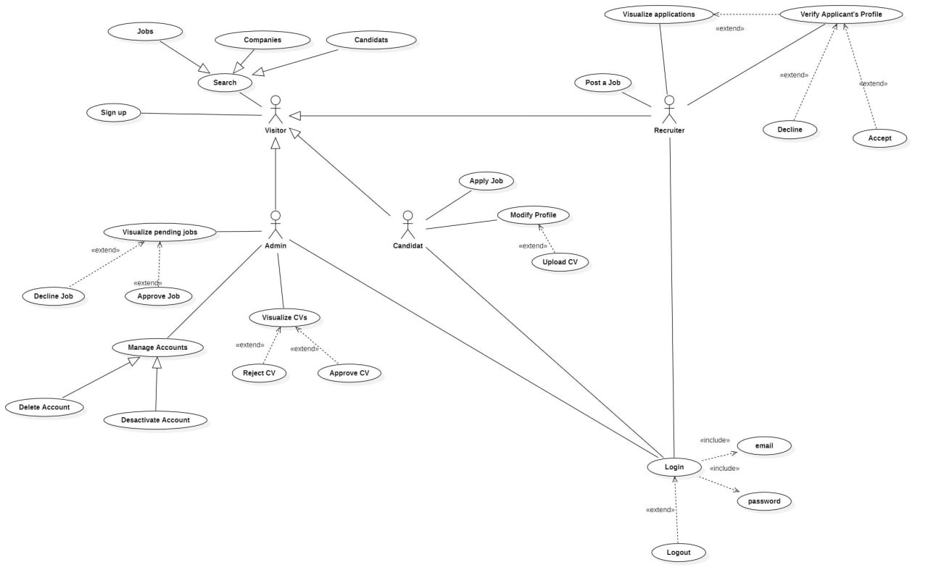**Use case Diagram**

Figure 1:use case diagram -general-

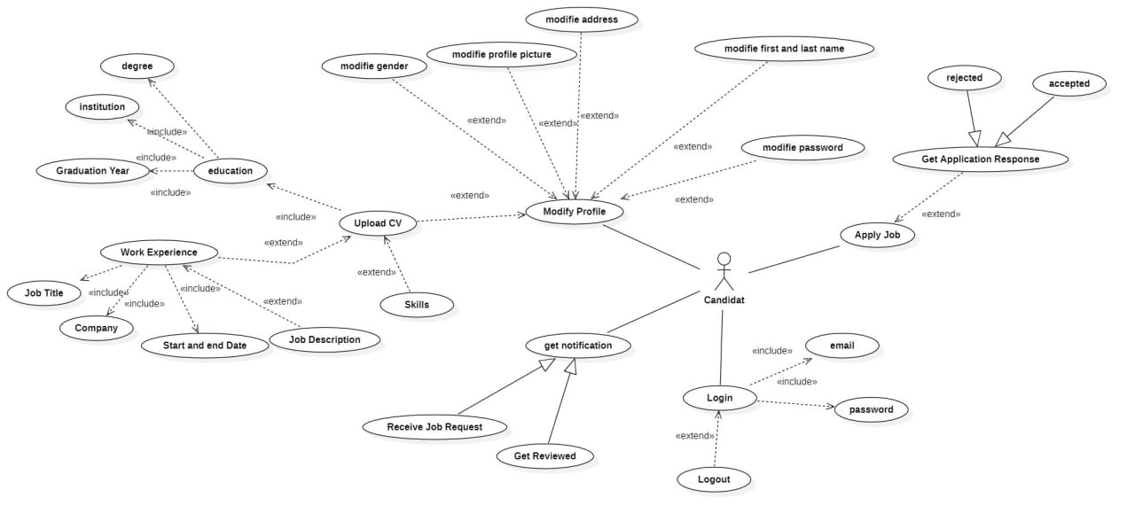

Figure 2:use case diagram -candidat-

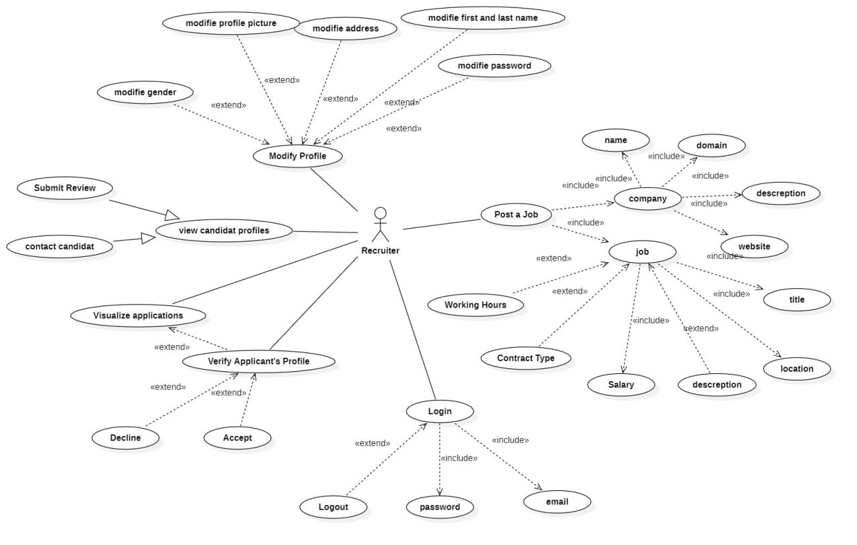

Figure 3:use case diagram -recruiter-

* 1. **Sequence Diagram**

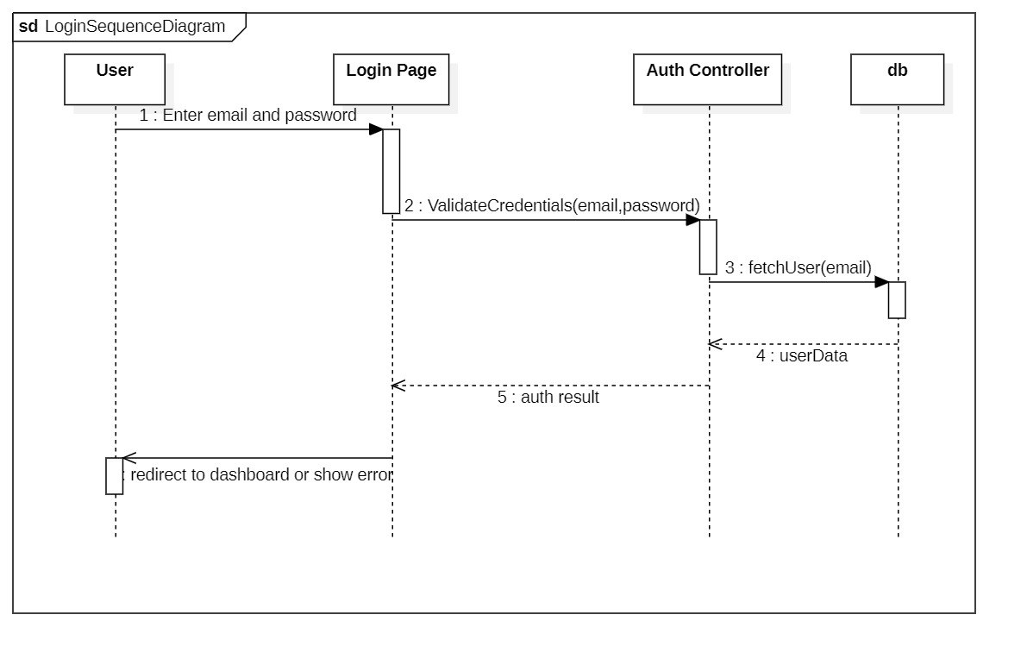

Figure 4:Login sequence diagram

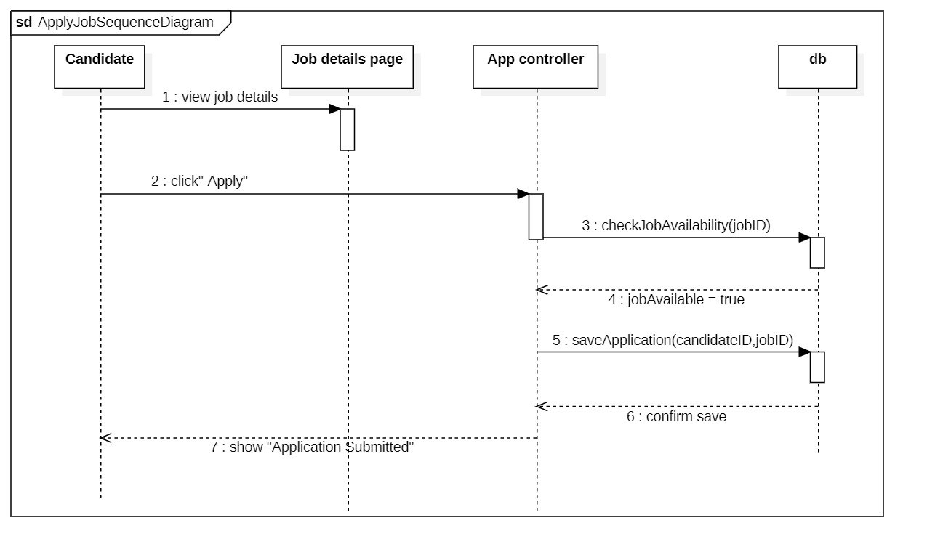

Figure 5:Apply job sequence diagram

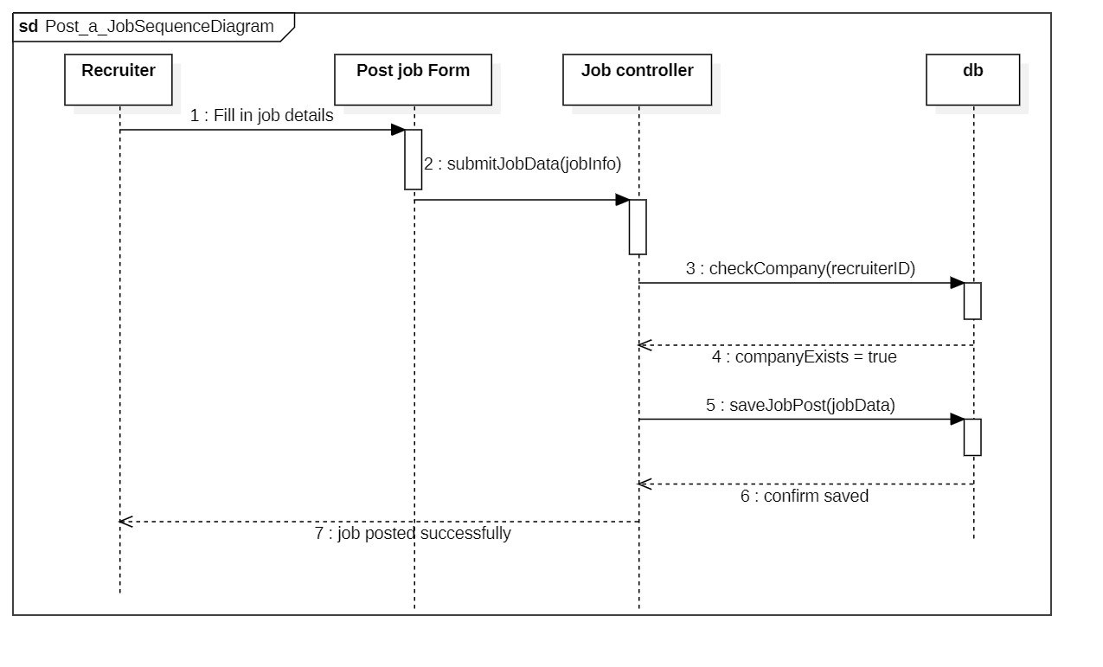

Figure 6:Post a job sequence diagram

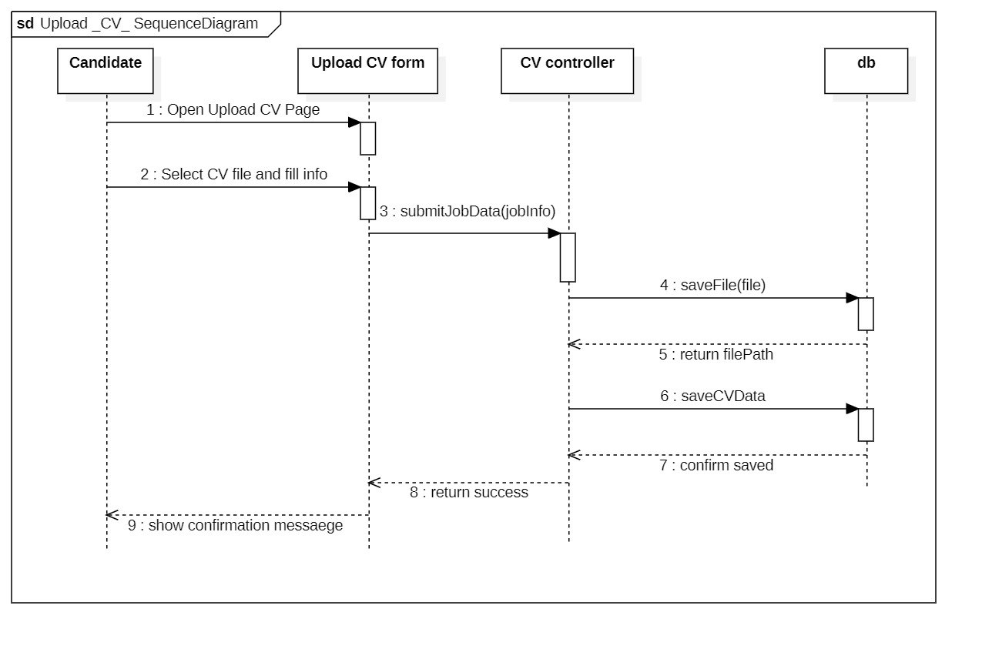

Figure 7:Upload cv sequence diagram

* 1. **Class diagram**

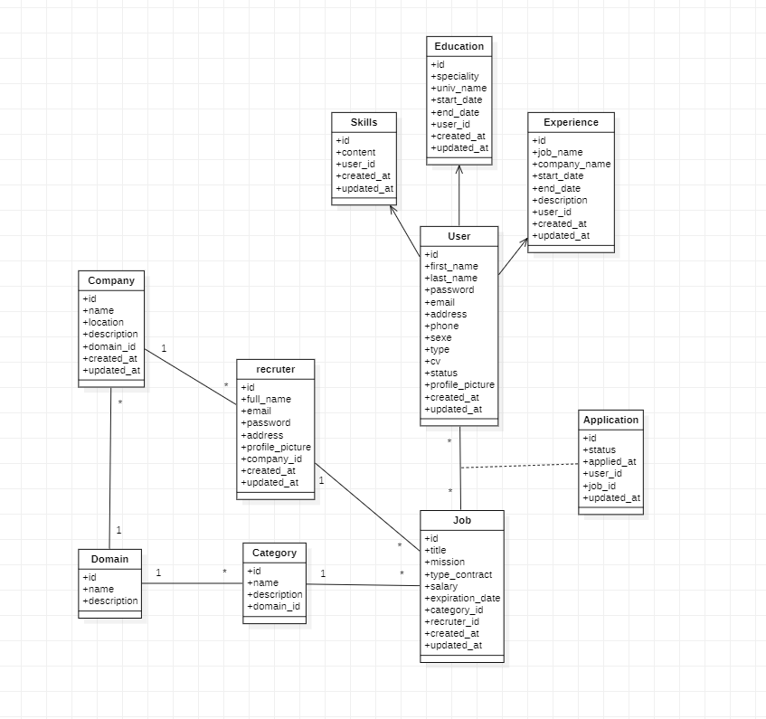

Figure 8:Class diagram

1. **Conclusion**

This chapter introduces CareerConnect's Modeling phase. We delivered an explanation about UML concepts and diagram types and their role in application understanding and development. The core functionalities and supporting requirements of the system were defined through functional and non-functional requirements.

Our upcoming chapter examines the implementation phase which includes descriptions about development process and technological choices and functional and architectural designs for backend integration with frontend components.

# **Chapter 3: Implementation**

1. **Introduction**

The implementation phase represents the transition from design to implementation. The diagrams developed in the previous stages are converted into working code and functional interfaces. This chapter introduces the development tools and techniques used to build a professional connection, followed by a general assessment of the system's performance, functionality and user experience.

1. **Development Tools and Technologies**

We selected well-documented technologies that were both compatible and easy to use along with being open-source for implementing CareerConnect site development.

* **Frontend Tools**
* HTML5: Web pages receive their structure from this tool. HTML5 stands as the most recent versions which enable semantic elements and plug-in-free multimedia support [6].
* CSS3 + Bootstrap 5: The combination of CSS for styling and Bootstrap 5 allowed responsive design features with prebuilt UI components to be incorporated [7].
* JavaScript: JavaScript handles dynamic user interactions as well as form validation and enhances frontend user interfaces.
* **Backend Tools**
* PHP: The foundation language for backend systems carries out authorization processing and operates business functions and serves pages. The development team selected it because of its adaptable nature as well as its compatibility with web servers [8].
* MySQL: Job listings together with user profiles and CVs and applications reside within the relational database. This database solution enables defined query execution along with table relationships [9].
* **Other Tools:**
* Apache (XAMPP): The development system features an Apache server serving alongside a MySQL database installation.
* VS Code: The main code editor enables PHP HTML and JavaScript extensions through its available extensions package.
* Postman: This tool verifies the functionality of API routes as well as server/client communication.

1. **Experimentation**
   1. **Creating an Account and Logging In**

We tested the user registration and login process. After filling out the registration form, users received confirmation and were redirected to the login page. Incorrect credentials triggered error messages, confirming the authentication system worked.

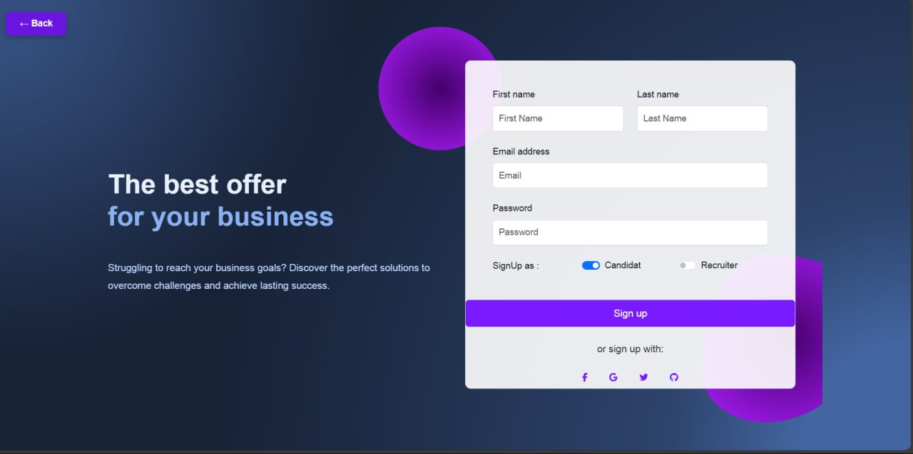

Figure 9:Registration Page

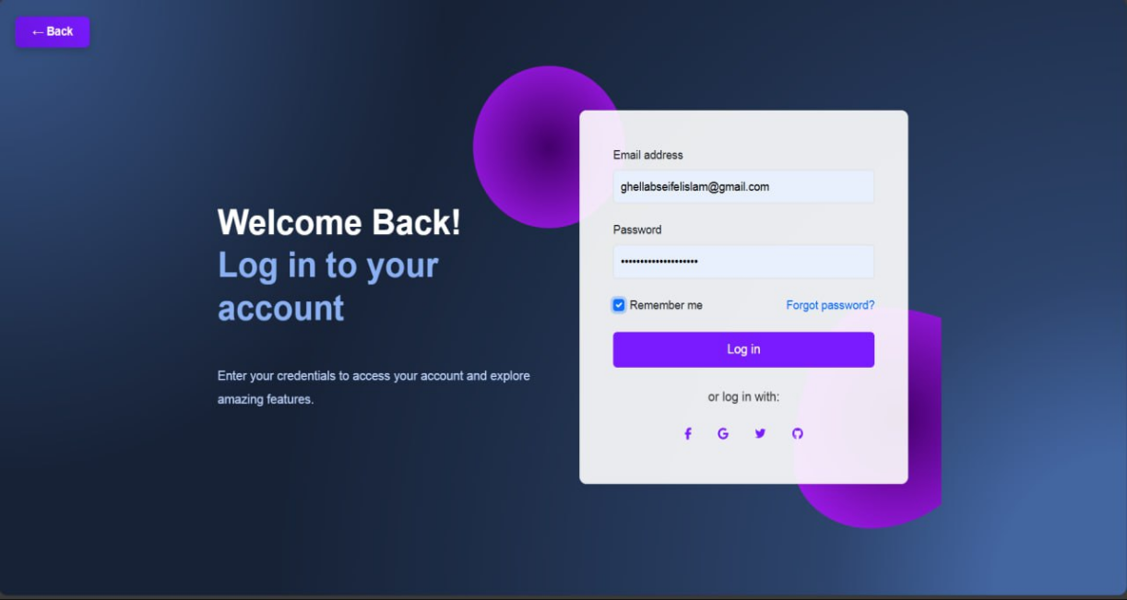

Figure 10:Login Page

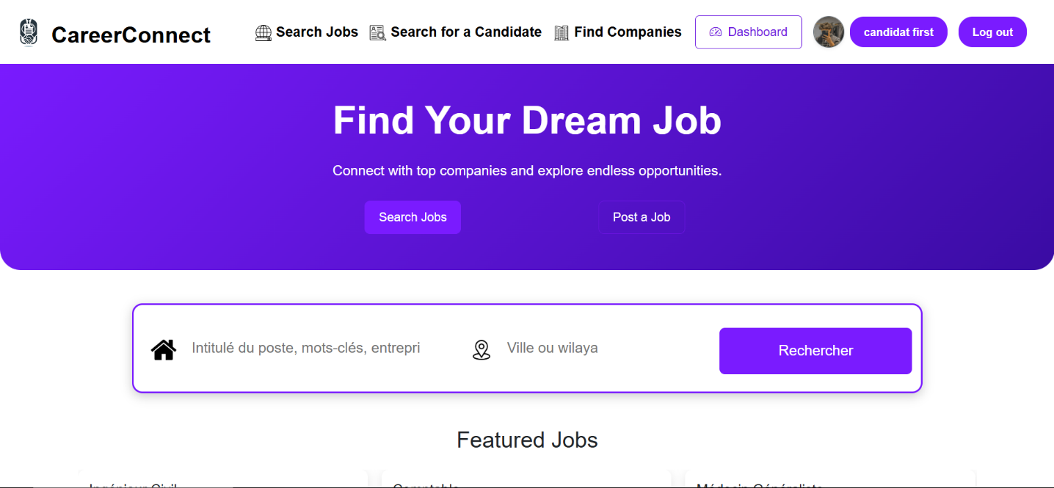

Figure 11 : main page

* 1. **Posting and Applying for a Job**

As an employer, we posted a job with required details such as title, experience, and domain. The form was intuitive and submitted data successfully to the database.

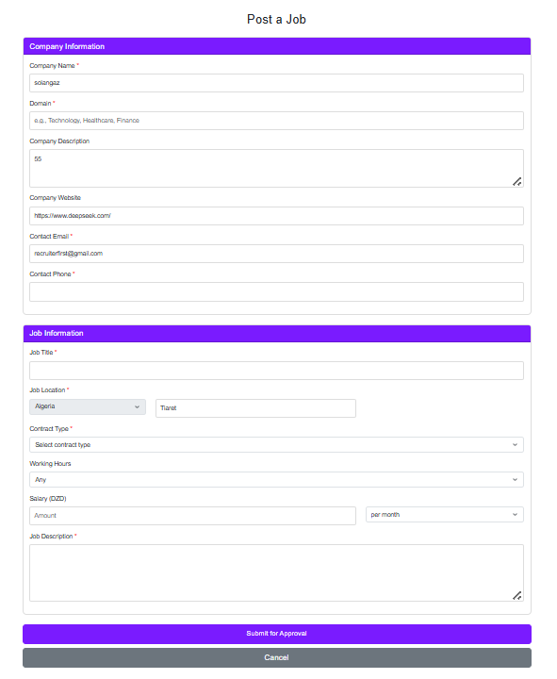

Figure 12:Post Job Form

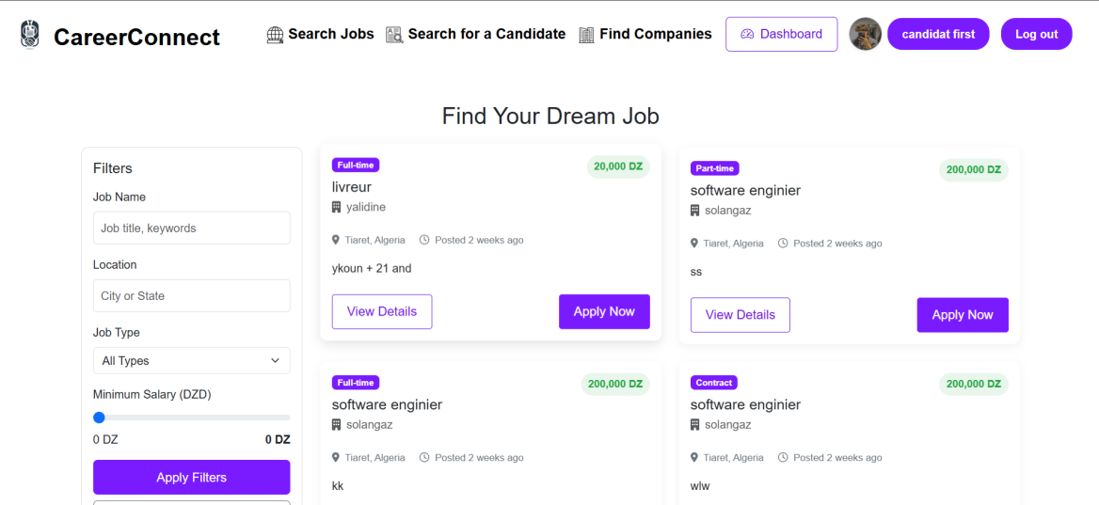The job instantly appeared on the public job list, confirming real-time database interaction.

Figure 13:Job Listing View

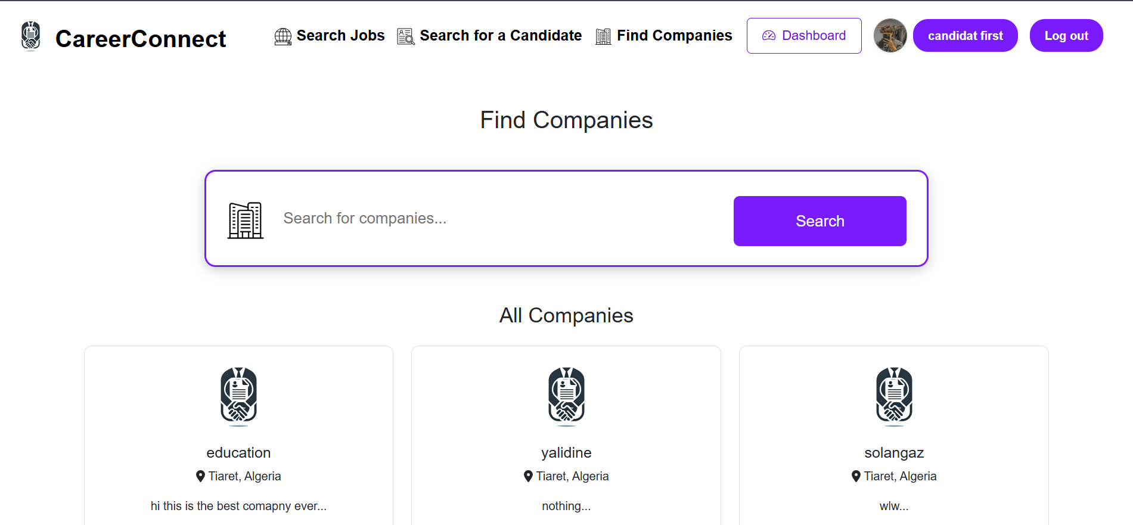

Figure 14 : companies search page

As a job seeker, we applied to the job, and the application was recorded in the employer’s dashboard.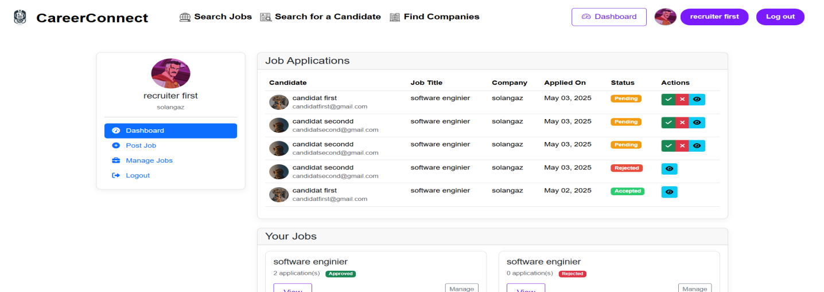

Figure 15: Application Confirmation & recruiter View

* 1. **Managing Profiles and CVs**

Job seekers were able to edit their profiles, upload CVs, and view updates in real-time.

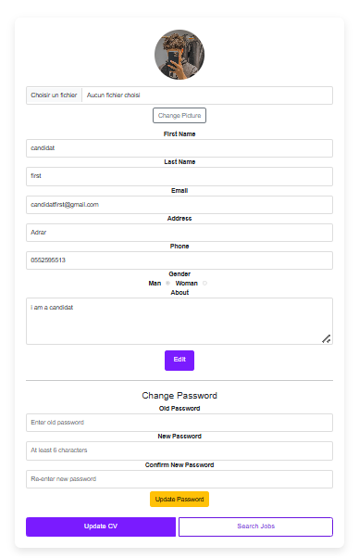

*Figure 16: Edit Profile Page*

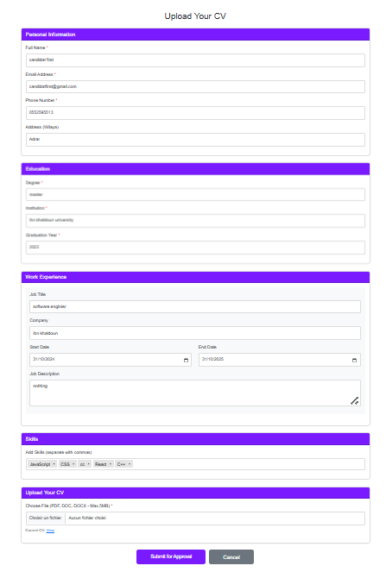

Figure 17:upload cv page

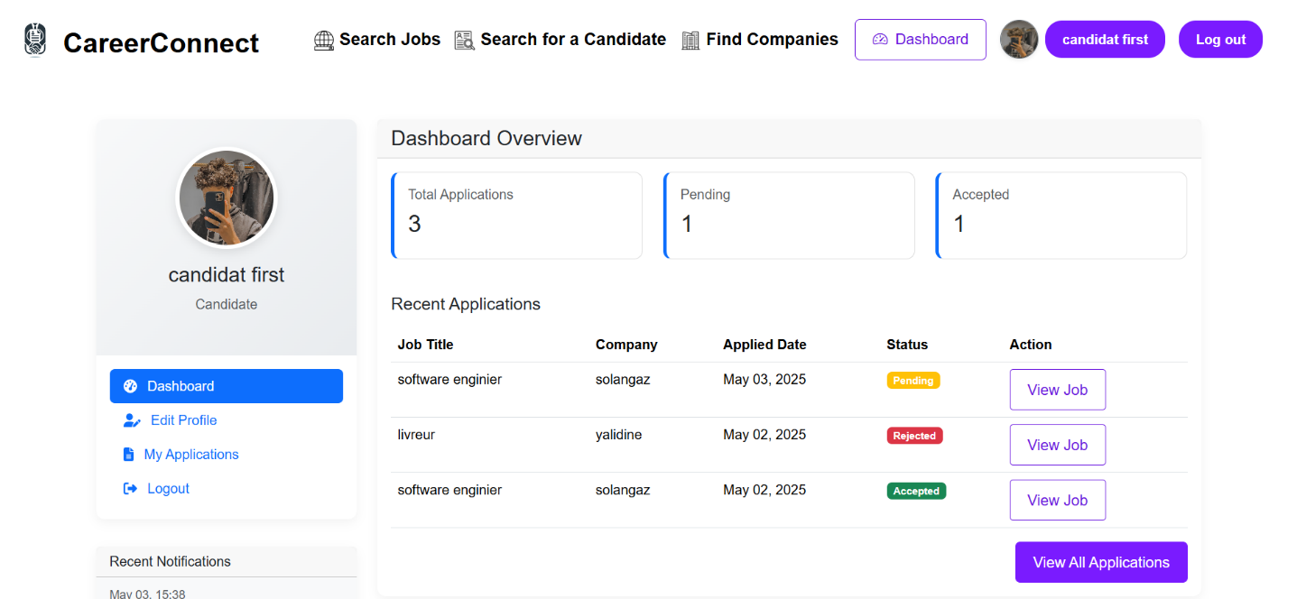

Figure 18 : candidate dashboard

Employers could access CVs through the dashboard, verifying the smooth integration of profile management and data storage.

* 1. **Admin Dashboard Management**

The admin dashboard provides access to manage users, job listings, and overall platform health. Admins can delete accounts, review job applications, and track system activity.

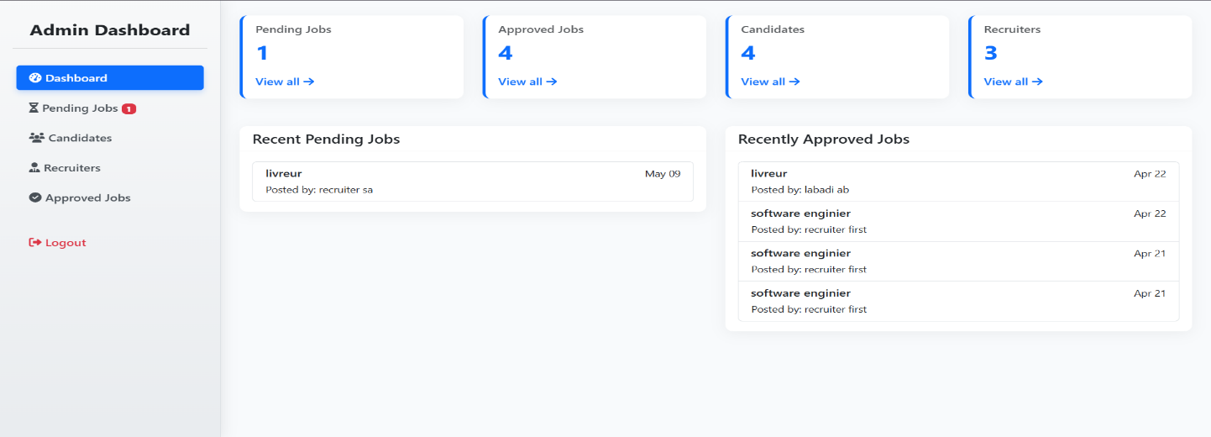

Figure 19:Admin Dashboard

1. **Conclusion**

This chapter delivered an overview of the Career Connect site's implementation stage. We explored the development tools for both frontend and backend development while discussing our selection rationale and conducting a performance review of the system's features.

# **General conclusion**

Across this project, we sought to solve a practical problem of many job seekers and recruiters alike: having an accessible, user-friendly, and reliable site for work. Having weighed the advantages and disadvantages of current solutions like LinkedIn and Indeed, we found a number of constraints more specifically on accessibility, paid features, and usability. These observations led us to create a more flexible and accessible solution via our site, CareerConnect.

CareerConnect offers critical functionalities like posting jobs, CV uploading, candidate search, and profile management on an easy interface. It's all about being easy to use, efficient, and usable notably for customers who may not be technologically savvy or are unable to afford paying for quality services. While our system is not yet competitive with large sites in terms of size or feature complexity, it gives a good foundation for future expansion and is a proof of concept that satisfies local needs.

Though the project proved successful, we understand that scope for development exists in the future such as adding AI-suggesting recommendations, mobile access, and a strengthened security package. All things considered, the project not only facilitated our actual implementation of software modeling and development techniques that were conceptual to date, but we learned how beneficially important creating software that's socially pertinent alongside its functional existence could be.

# **References**

|  |  |
| --- | --- |
| [1] | "LinkedIn, “LinkedIn: Log In or Sign Up,” [Online].," [Online]. Available: https://www.linkedin.com. [Accessed 7 may 2025]. |
| [2] | "Indeed, “Job Search | Indeed,”," [Online]. Available: https://www.indeed.com. . [Accessed 7 May 2025]. |
| [3] | "Glassdoor, “Glassdoor Job Search,”," [Online]. Available: https://www.glassdoor.com. . [Accessed 7 may 2025]. |
| [4] | “. d. e. A. Emploitic. [Online]. Available: https://www.emploitic.com. [Accessed 7 May 2025]. |
| [5] | "Indeed vs LinkedIn Job Board Comparison," [Online]. Available: https://dripify.io/linkedin-vs-indeed-job-board-comparison/.. |
| [6] | Booch, G., Rumbaugh, J., & Jacobson, I. (2005). The Unified Modeling Language User Guide (2nd ed.). Addison-Wesley.. |
| [7] | "Freeman, E., & Robson, E. (2014). Head First HTML and CSS. O'Reilly Media.". |
| [8] | "Bootstrap. (2024). Bootstrap 5 Documentation.," [Online]. Available: https://getbootstrap.com/. |
| [9] | "Lerdorf, R. (2020). PHP Manual," [Online]. Available: . https://www.php.net/. |
| [10] | "MySQL. (2024). MySQL Reference Manual.," [Online]. Available: https://dev.mysql.com/doc/. |