1 Cover Page

COVID-19 Spread

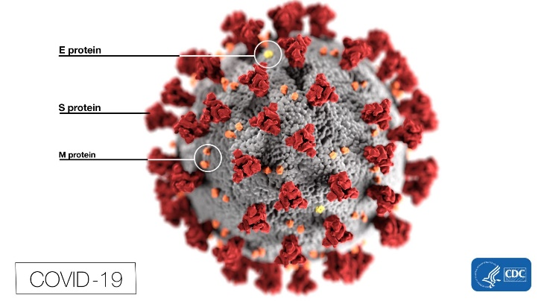[1]

Global statistics of infection and mortality over the last

Student:

Rohit Bhingare

Teacher:

Alex Aklson

Course:

IBM Data Science Professional Certificate - Data Science Capstone

# 2 Table of Contents

|  |  |  |
| --- | --- | --- |
| 1 Cover Page  2 Table of Contents 2  3 Executive Summary 3  Background 3  Description of the problem 3  4 Introduction of Data 4  List of datasets used 4  Scope of analysis 4  5 Methodology 5  Use of Foursquare API 5  6 Results 6  7 Discussion 7  8 Conclusion 8 |  |  |

# 3 Executive Summary

## Background

Coronavirus disease (COVID-19) is an infectious disease caused by a new virus. The disease causes respiratory illness (like the flu) with symptoms such as a cough, fever, and in more severe cases, difficulty breathing. The new variant 2019-nCoV was first identified in Wuhan, the capital of China's Hubei province. People developed pneumonia without a clear cause and for which existing vaccines or treatments were not effective. The virus has shown evidence of human-to-human transmission

## Description of the problem

A new coronavirus designated 2019-nCoV was first identified in Wuhan, the capital of China's Hubei province. People developed pneumonia without a clear cause and for which existing vaccines or treatments were not effective. The virus has shown evidence of human-to-human transmission. Transmission rate (rate of infection) appeared to escalate in mid-January 2020. As of 30 January 2020, approximately 8,243 cases have been confirmed.

Transmission rate (rate of infection) appeared to escalate in January 2020 and as of 22nd of March, cases of new coronavirus infections have been confirmed in more than 160 countries or regions. Italy has over 50’000 individuals infected, while globally we have over 300’000 individuals infected. There is now a risk of becoming infected with new coronavirus in almost all parts of the world.

# 4 Introduction of Data

## List of datasets used

1. We use the **COVID-19 Complete Dataset** from Kaggle[2]. This file contains the cumulative count of confirmed, death and recovered cases of COVID-19 from different countries from 22nd January 2020.
2. We will also use the world’s good country index ranking[3]
3. We will use the world population counts published by United Nations.[4]
4. Further, we will use the world nominal GDP index[5] data.

## Scope of analysis

* Since the Kaggle data is repeated as a time series for each country for the last 2 months, we will use specific data points (e.g. start of recording and last recorded date) to visualise the rate of change in global outbreak at specific times.
* We will look into the outbreak on specific regions and try to explain whether there are specific areas of world where the spread is increasing faster/slower.
* We will attempt to combine the COVID-19 spread with world’s good country index statistics, population as well as nominal GDP index to see whether we can explain some of the outbreaks against population/GDP of countries. For this part, we will attempt to use a machine learning model to see how these factors affect the outbreak spread rate and whether we can predict the rate of increase/decrease in the near future.

# 5 Methodology

To be completed

## Use of Foursquare API

We will use Foursquare location data to locate specific areas of infection spread on a global scale and highlight/colour code specific areas depending upon the spread as well as mortality rate. We will leverage the Folium mapping functionality in Python to display the terrains globally and show the spread of outbreak at specific data points.

# 6 Results

|  |  |
| --- | --- |
| To be completed |  |

# 7 Discussion

To be completed

# 8 Conclusion

To be completed

1. Source – CDC <https://www.cdc.gov/coronavirus/2019-ncov/index.html>
2. https://www.bag.admin.ch/bag/en/home/krankheiten/ausbrueche-epidemien-pandemien/aktuelle-ausbrueche-epidemien/novel-cov.html downloaded on 23.March.2020 at 16:31.
3. https://en.wikipedia.org/wiki/Good_Country_Index
4. https://en.wikipedia.org/wiki/List_of_countries_by_population_(United_Nations)
5. https://en.wikipedia.org/wiki/List_of_countries_by_GDP_(nominal)