TRƯỜNG ĐẠI HỌC BÁCH KHOA HÀ NỘI  
Viện Công nghệ thông tin và Truyền thông

Tài liệu đặc tả yêu cầu phần mềm  
(Software Requirement Specification – SRS)  
Phiên bản 1 **Phân tích và thiết kế hệ thống EcoBikeRental**  
Môn: Thiết kế và xây dựng phần mềm

Giảng viên hướng dẫn:  
TS. Nguyễn Thị Thu Trang

Nhóm 01  
Hồ Anh - MSSV: 20190037  
Nguyễn Trọng Bằng - MSSV: 20190038  
Hoàng Bá Công - MSSV: 20190039

*Hà Nội, ngày 24/12/2022*

**Table of contents**

1.Introduction............................................................................................................3  
1.1. Purpose...............................................................................................................3  
1.2. Project Scope .....................................................................................................3  
1.3 Terminology.........................................................................................................4

2. Overall Description ...............................................................................................5  
2.1. Actors…………..................................................................................................5  
2.2. Overview Usecase Diagram...............................................................................5  
2.3. Decomposition Usecase Diagram.......................................................................5

3. Usecase Specification ...........................................................................................6  
3.1. Usecase UC001 “View docking stations information”.......................................6  
3.2. Usecase UC002 “View bike information”..........................................................9  
3.3. Usecase UC003 “Rent bike”.............................................................................12  
3.4. Usecase UC004 “Return bike”.........................................................................15  
3.5. Usecase UC005 “View rented bike information” ............................................18  
3.6. Usecase UC 006 “Deposit”...............................................................................20

4. External Requirements...........................................................................................................23  
4.1. Functionality ....................................................................................................23  
4.2. Usability............................................................................................................23  
4.3. Other.................................................................................................................23

**1. Introduction**

1.1. Purpose

Detailed description for the User Management Module, user groups and their functions available at run time. Document describing the purpose and features of the system, the interfaces and constraints the system needs to implement in response to external stimuli.

Documentation for stakeholders and software developers

1.2. Project Scope

In fact, any software needs to have features to manage users, user groups, and needs to dynamically assign permissions to use functions in the system. The purpose of the software is to create a user management module (user), user roles and functions that the user/user role can use at run time. Users can register to create their own account, then can log in to use the system's functions. Users can log in using the system's account, or log in using their Facebook account. Any user can update his or her personal information. When a user forgets his password, he can ask the system to allow him to reset his password via the link with the token sent via the registered email.

Administrators can disable an account, or require users to change their passwords at any time, or periodically. Administrators can assign user roles to a certain user. A user can have multiple roles in the software. Each user role is set up to be able to use certain functions. Each function can be used by multiple user roles. Every time a new function is added, the administrator needs to put information about this function into the software for management. After a user successfully logs in, depending on the user roles he or she has, the software automatically creates a menu containing the functions that those user roles are allowed to use. Every time the user selects a function on the menu, the interface corresponding to the function will be displayed.

1.3. Terminology

|  |  |  |  |  |
| --- | --- | --- | --- | --- |
| No. | Terminology | Explaination | Example | Note |
| 1 | token | A piece of data generated on the output server side contains information about the user and the token. Token is used to authenticate users when they want to log in with the provided token without having to use the account and password directly. | JSON Web Token (JWT) | Compact design, safe |

**2. Overall description**

2.1. Actors

Client and Payment System.

Client is user when successfully logs in

2.2. Overview Usecase Diagram

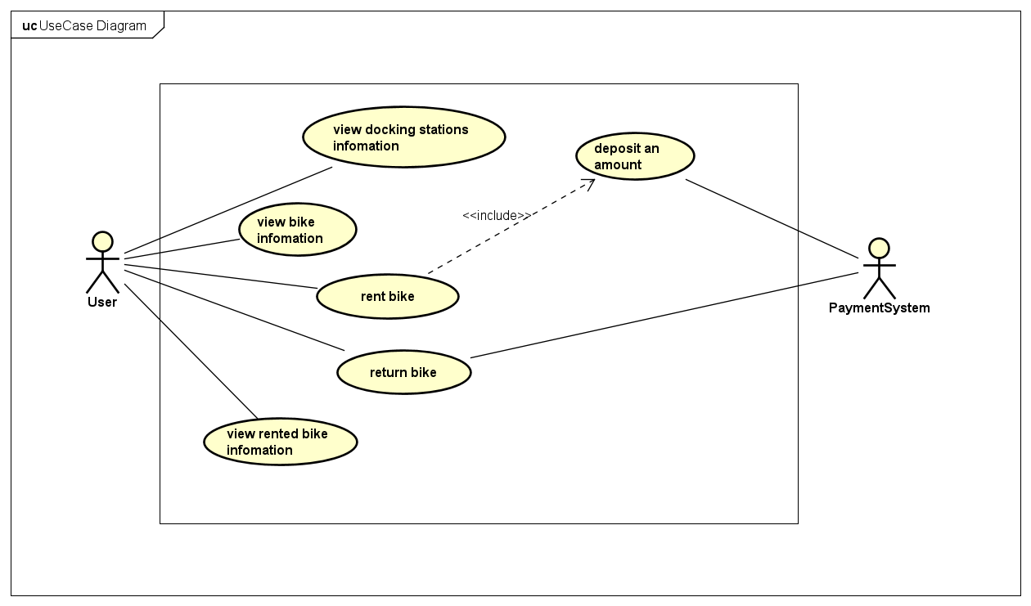

2.3. Decomposition Usecase Diagram

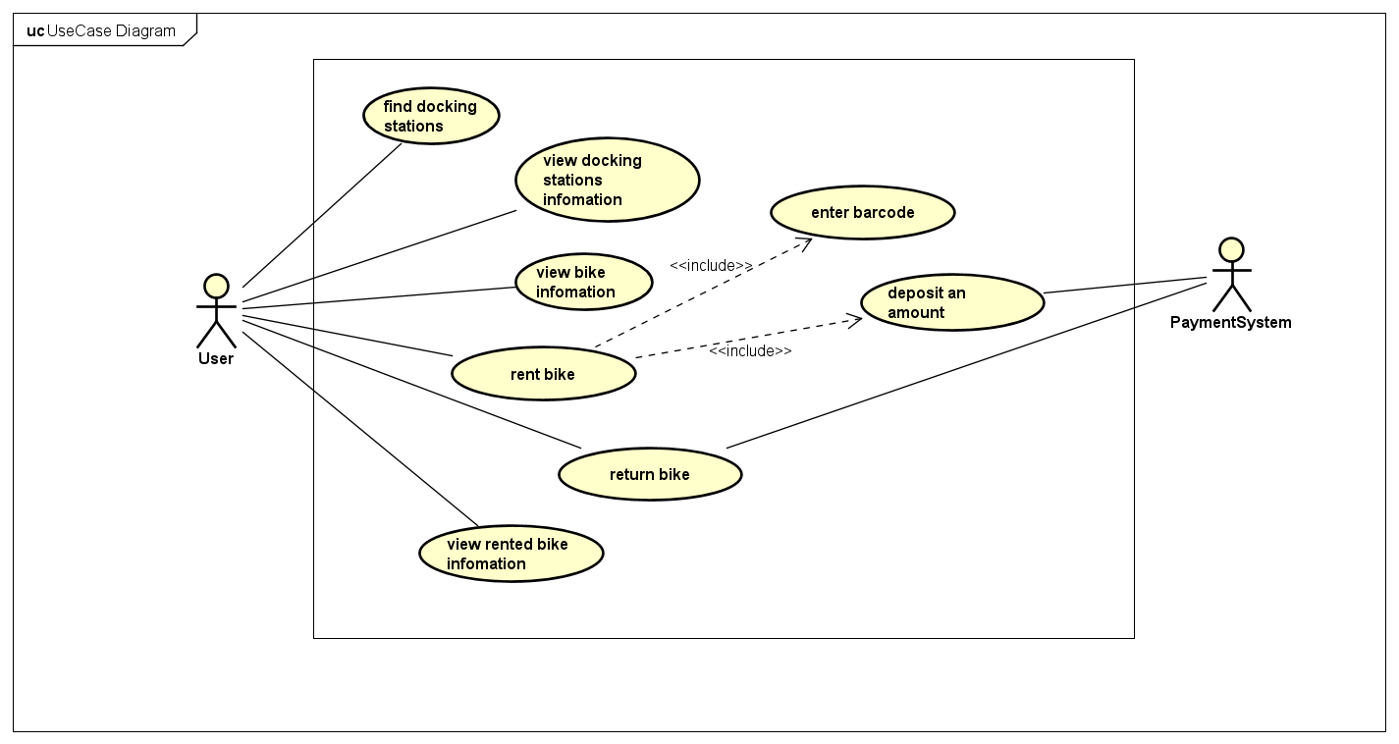

**3. Usecase Specification**

3.1. Usecase UC001 “View docking stations information”

1. Usecase code

UC001

2. Introduction

Use case describes the function which allows client to see details of the docking stations

3. Actor

1. Client

4. Pre-condition

5. Basic flow of main scenario

1. Client selects docking station
2. System displays details of selected docking station

6. Extension of alternate flows

7. Activity diagram

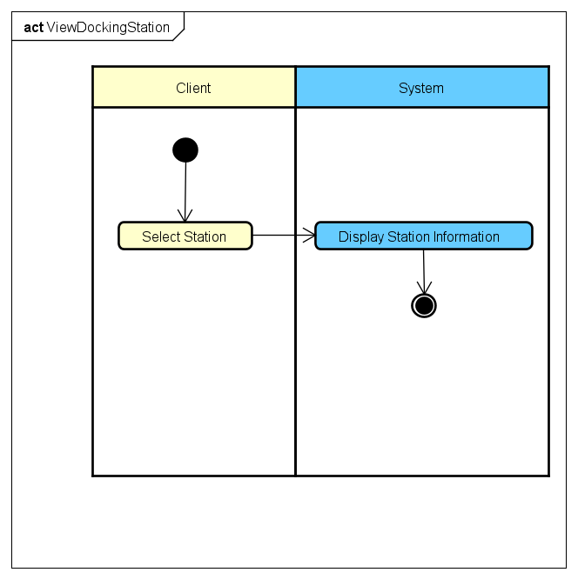

8. Input

9. Output

|  |  |  |  |  |
| --- | --- | --- | --- | --- |
| No. | Field | Description | Format | Example |
| 1 | Name | Name of station |  | Giai Phong Station |
| 2 | Address | Location of station |  | 123 Giai Phong, Hai Ba Trung, Hanoi |
| 3 | Distance | Distance from client to station (km) | Non-negative real number (km) | 4.9 km |
| 4 | Area | Area of station (km2) | Non-negative real number (km2) | 1 km2 |
| 5 | Number of current vehicle | Total number of vehicles of all types in station | Non-negative integer | 490 |
| 6 | Vacant position of each vehicle type |  |  | Bike: 1A, 2B |
| 7 | Time | Time to get to station | Positive integer (minute) | 15 minutes |

10. Post condition

3.2. Usecase UC002 “View bike information”

1. Usecase code

UC002

2. Introduction

Use case describes the function which allows client to see details of the bike

3. Actor

4. Pre-condition

Screen displaying list of bikes in station

5. Basic flow of main scenario

1. Client selects bike
2. System displays details of selected bike

6. Extension of alternate flows

7. Activity diagram

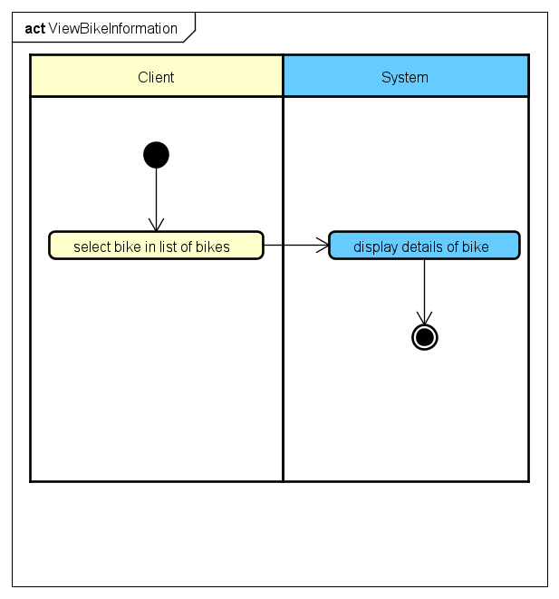

8. Input

9. Output

|  |  |  |  |  |
| --- | --- | --- | --- | --- |
| No. | Field | Description | Format | Example |
| 1 | License plate |  |  | 37A46543 |
| 2 | Bike value |  | Non-negative integer (VND) | 5,000,000VND |
| 3 | Remaining battery |  | Non-negative integer (%) | 60% |

10. Post condition

3.3. Usecase UC003 “Rent bike”

1. Usecase code

UC003

2. Introduction

Use case describes the interaction between the client and the system when the client wants to rent a bike

3. Actor

1. Client

4. Pre-condition

5. Basic flow of main scenario

1. Client enters barcode

2. System converts barcode to bike code

3. Display details of bike

4. Client selects payment method

5. System computes and displays amount to be paid

6. Client confirms amount

7. Call usecase ‘Deposit’

8. Unlock bike

6. Extension of alternate flows

|  |  |  |  |  |
| --- | --- | --- | --- | --- |
| No. | Step | Condition | Action | Next step |
| 1 | Step 2 | Incorrect barcode | Display message “Barcode is not correct” | Step 1 |

7. Activity diagram

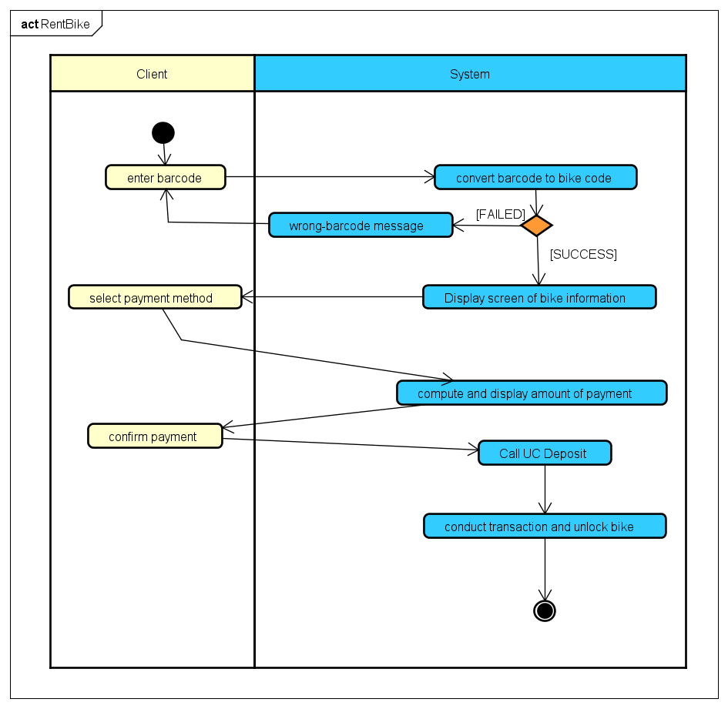

8. Input

|  |  |  |  |  |  |
| --- | --- | --- | --- | --- | --- |
| No. | Field | Data type | Obligatory? | Valid condition | Example |
| 1 | Barcode | int | Yes | Exist in list of barcode | 012346543 |

9. Output

|  |  |  |  |  |
| --- | --- | --- | --- | --- |
| No. | Field | Description | Format | Example |
| 1 | Client name |  |  | Nguyen Van A |
| 2 | ID Card |  |  | BI123 |
| 3 | Expiration date |  |  | 07/04/2024 |
| 4 | Bike name |  |  | Mountain Bike MTB  GIANT Talon 29 3 |
| 5 | Deposit |  | Non-negative integer (VND) | 400,000 VND |
| 6 | Station to get bike |  |  | Giai Phong Station |
| 7 | Time to get bike |  |  | 9:00 a.m 15/12/2022 |

10. Post condition

3.4. Usecase UC004 “Return bike”

1. Usecase code

UC004

2. Introduction

Use case describes the interaction between the client and the system when the client wants to return a bike

3. Actor

1. Client

4. Pre-condition

Client rented a bike

5. Basic flow of main scenario

1. Client selects ‘return bike’

2. System displays list of docking stations

3. Client selects docking station

4. System displays screen to enter barcode

5. Client enter barcode

6. System convert barcode to bike code

7. The system calculates the cost and sends the request to the payment system

8. The payment system executes the transaction

9. Show successful car return

10. System record transaction

6. Extension of alternate flows

|  |  |  |  |  |
| --- | --- | --- | --- | --- |
| No. | Step | Condition | Action | Next step |
| 1 | Step 6 | Incorrect barcode | Displays the message “barcode is incorrect” | Step 5 |

7. Activity diagram

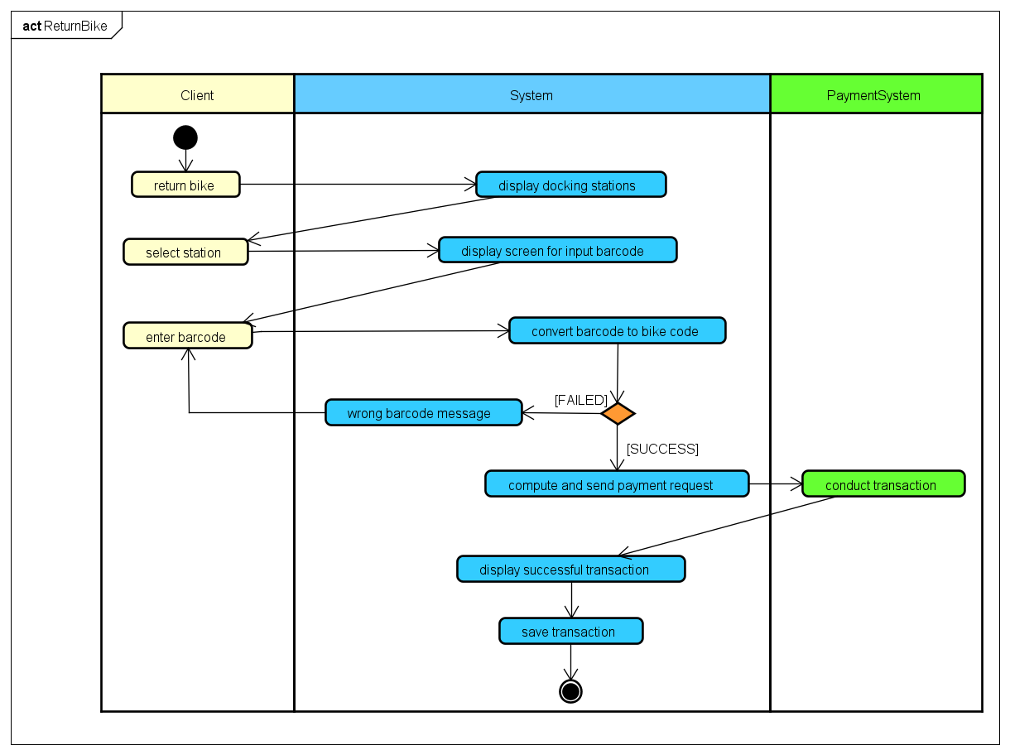

8. Input

|  |  |  |  |  |  |  |
| --- | --- | --- | --- | --- | --- | --- |
| No. | Field | Description | Data type | Obligatory? | Valid condition | Example |
| 1. | Barcode |  | int | YES | Length less than 255 | 123004567 |

9. Output

|  |  |  |  |  |
| --- | --- | --- | --- | --- |
| No. | Field | Description | Display format | Example |
| 1 | Client name |  |  | Nguyen Van A |
| 2 | ID Card |  |  | KH12001 |
| 3 | Expiration date |  |  | 22/2/2023 |
| 4 | Bike name |  |  | Mountain Bike MTB  GIANT Talon 29 3 |
| 5 | Deposit |  | Non-negative integer (VND) | 2,000,000 VND |
| 6 | Rental cost |  | Non-negative integer (VND) | 400,000 VND |
| 7 | Station to get bike |  |  | Giai Phong Station |
| 8 | Station to return bike |  |  | Phuong Mai Station |

10. Post condition

3.5. Usecase UC005 “View rented bike information”

1. Usecase code

UC005

2. Introduction

Use case describes the interaction between the client and the system when he wants to see the rented bike information

3. Actor

1. Client

4. Pre-condition

Client rented a bike

5. Basic flow of main scenario

1. Client select ‘view details of rented bike’

2. Display details of rented bike

6. Extension of alternate flows

7. Activity diagram

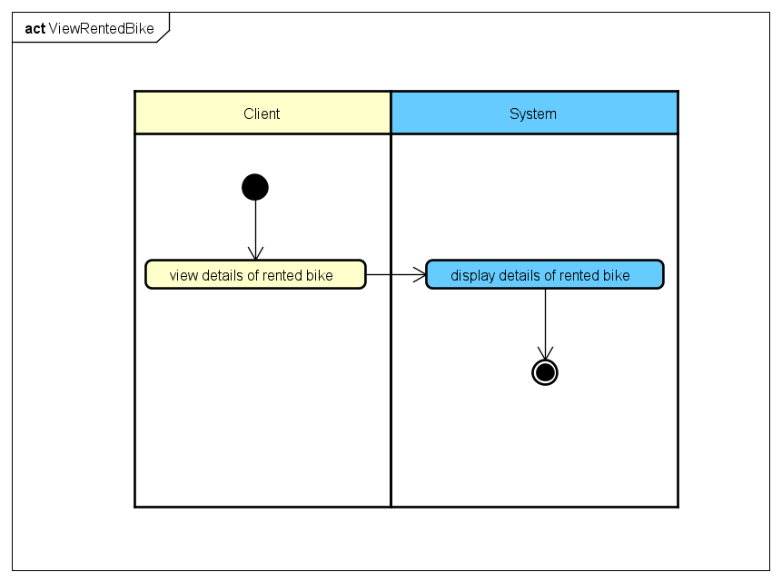

8. Input

9. Output

|  |  |  |  |  |
| --- | --- | --- | --- | --- |
| No. | Field | Description | Format | Example |
| 1 | License plate |  |  | 37A46543 |
| 2 | Bike value |  | Non-negative integer (VND) | 5,000,000VND |
| 3 | Remaining battery |  | Non-negative integer (%) | 60% |

10. Post condition

3.6. Usecase UC006 “Deposit”

1. Usecase code

UC006

2. Introduction

The use case describes the interaction between the client and the payment system and the system when making a deposit

3. Actor

1. Client

2. Payment System

4. Pre-condition

Client confirms the deposit

5. Basic flow of main scenario

1. System displays payment screen

2. Client enter payment information

3. System sends payment request to payment system

4. The payment system executes the transaction

5. System save the transaction

6. Extension of alternate flows

|  |  |  |  |  |
| --- | --- | --- | --- | --- |
| No. | Step | Condition | Action | Next step |
| 1 | Step 5 | Incorrect card information | The system displays failed transaction "Incorrect card information" | Step 2 |
| 2 | Step 5 | Unavailable amount | The system displays failed transaction "Insufficient funds available in the account" | Step 2 |

7. Activity diagram

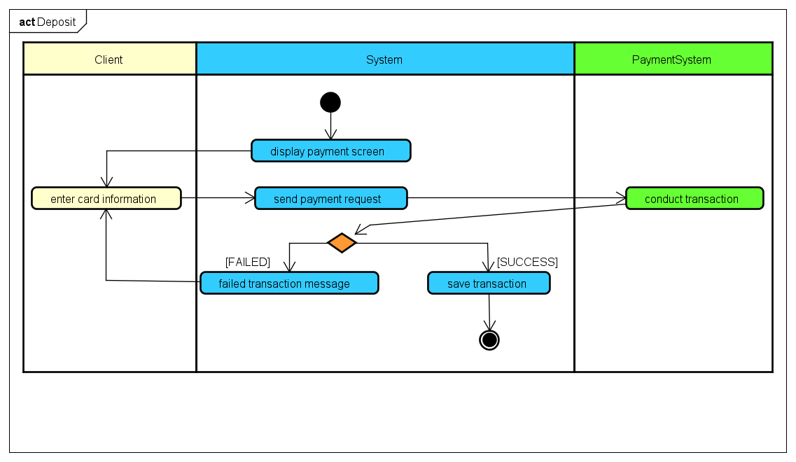

8. Input

|  |  |  |  |  |  |
| --- | --- | --- | --- | --- | --- |
| No. | Field | Data type | Obligatory? | Valid condition | Example |
| 1. | Account name | String | YES | Length does not exceed 255 | Nguyen Van A |
| 2. | ID Card | String | YES | Card code exists | 0123764521123 |
| 3. | Bank | String | YES | Bank linked to the system | BIDV |
| 4. | Expiration date | Date | YES |  | 20/10/2030 |
| 5. | Security code | String | YES |  | 0x23cd223 |
| 6. | Transaction content | String | YES |  |  |

9. Output

10. Post condition

**4. External Requirements**

4.1. Functionality

- In the sequence of events of use cases, all the steps that manipulate the database, if there is an error during the connection or operation, there should be a corresponding error message so that the agent knows that the error is related to the database, unrelated to user error

- Usecase used by Admin and User, Guest need to login with respective role

- The general display format is as follows:

o Right number

o Left aligned letters

o Font: Arial 14, black

o White background

4.2. Usability

Functions should be designed to be easy to operate. There should be specific instructions for the user's error so that the user knows where the error is located, what the error is, and how to correct it.

4.3. Other

– Efficiency/Performance

– Reliability

– Maintainability

– Portability