**Name:** wannaPlay

**Description:** Social application for playing different games arrangements

**Technologies:**

1. Frontend: React, Redux, Flow, Bootstrap, CSS modules, SCSS, CRA (that uses Webpack, autoprefixer)
2. Backend: Node, Express, Mongoose
3. Additional: Facebook API

**Site map:**

1. Main Page (all games)
2. User games
3. Places
4. About

**Layout:**

1. Main Page

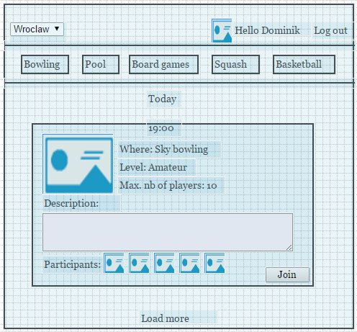

1. User games

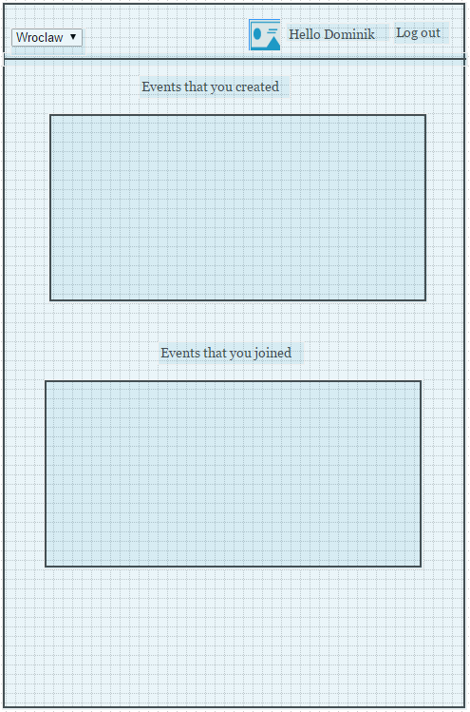

1. Places

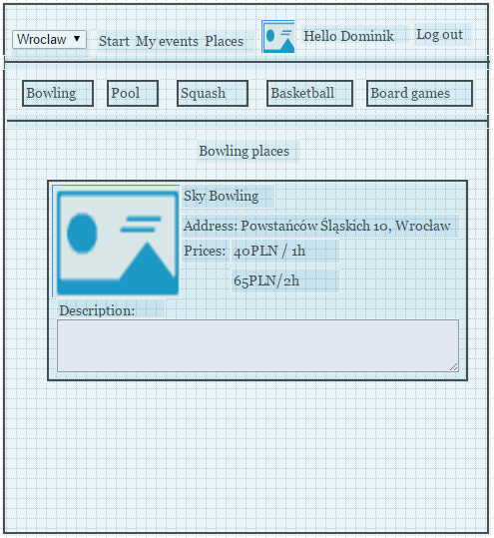

**Mongoose Models:**

1. Game

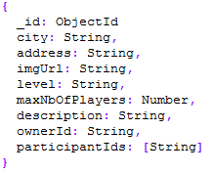

1. User

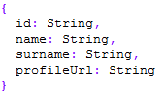

1. Place

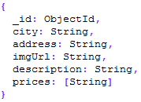

**Static data:**

Cities:

Wrocław, Warszawa, Poznań, Kraków, Trójmiasto, Katowice, Olsztyn, Białystok, Rzeszów, Łódź, Szczecin, Bydgoszcz, Toruń

Games:

Bowling, Pool, Squash, Board games, Basketball, Volleyball, Football, Badminton