BELLABEAT FITNESS TRACKER
Python Analysis — Complete Google Colab Notebook
Fixed Version • 19 cells • 13 charts • 9 Power BI exports
Errors fixed in this version
❌ FileNotFoundError: user_segments.csv → ✅ Derived inside notebook from user_summary
❌ FileNotFoundError: hourly_combined.csv → ✅ Built from peak_hours.csv already uploaded
❌ MessageError: drive.mount credential failed → ✅ Removed — upload files directly
✅ All 9 pbi_ CSV files exported automatically in Cell 18

SECTION 1 — Setup & Configuration
CELL 01 | Install & Import All Libraries
⚠ Note: Run this cell first every Colab session. All libraries are pre-installed in Colab so pip lines are commented out.

# ── Installs (pre-installed in Colab — uncomment ONLY if you get ModuleNotFoundError) ──
# !pip install pandas numpy matplotlib seaborn scipy --quiet

# ── Core libraries ───────────────────────────────────────────────────────────────────
import pandas as pd
import numpy as np
import matplotlib.pyplot as plt
import matplotlib.ticker as mticker
import matplotlib.gridspec as gridspec
import seaborn as sns
from scipy import stats
from scipy.stats import pearsonr, ttest_ind, gaussian_kde
import os, zipfile, warnings
warnings.filterwarnings("ignore")

# ── Global colour palette ────────────────────────────────────────────────────────────
BLUE = '#2563EB'
NAVY = '#1F3864'
RED = '#EF4444'
ORANGE = '#F97316'
GREEN = '#16A34A'
PURPLE = '#4F46E5'
PALETTE = ['#1F3864','#2563EB','#60A5FA','#BFDBFE']

# ── Chart style ──────────────────────────────────────────────────────────────────────
sns.set_theme(style='whitegrid', font_scale=1.05)
plt.rcParams['figure.dpi'] = 150
plt.rcParams['font.family'] = 'DejaVu Sans'
plt.rcParams['axes.spines.top'] = False
plt.rcParams['axes.spines.right'] = False
plt.rcParams['axes.titleweight'] = 'bold'
plt.rcParams['axes.titlesize'] = 13

# Day order constant used throughout notebook
DAY_ORDER = ['Monday','Tuesday','Wednesday','Thursday','Friday','Saturday','Sunday']

print('✅ All libraries loaded successfully')

CELL 02 |  | Load All 7 CSV Files (No drive.mount needed)
 | Files uploaded via the Files panel are at /content/filename.csv automatically. No drive.mount needed — that code is gone.

# ── Load all 7 CSV files ──────────────────────────────────────────────────────────────
# These files must be uploaded first via the Files panel (left sidebar → upload icon).
# After upload they sit at /content/filename.csv — that is the path below.

activity = pd.read_csv('master_user_activity.csv')
user_sum = pd.read_csv('user_summary.csv')
daytrend = pd.read_csv('day_of_week_trends.csv')
hourly = pd.read_csv('peak_hours.csv') # also becomes pbi_hourly_combined
scatter = pd.read_csv('steps_vs_calories.csv')
sleep = pd.read_csv('sleep_analysis.csv')
weekly = pd.read_csv('weekly_trend.csv')

# ── user_segments is NOT a file — built in Cell 09 from user_sum ─────────────────────
# ── hourly_combined is NOT a file — hourly is used directly ─────────────────────────

# ── Parse dates ──────────────────────────────────────────────────────────────────────
activity['activity_date'] = pd.to_datetime(activity['activity_date'])
weekly['week_start'] = pd.to_datetime(weekly['week_start'])

# ── Enforce day-of-week category order ───────────────────────────────────────────────
daytrend['day_of_week'] = pd.Categorical(
daytrend['day_of_week'], categories=DAY_ORDER, ordered=True)
daytrend = daytrend.sort_values('day_of_week').reset_index(drop=True)

# ── Confirm all tables loaded ────────────────────────────────────────────────────────
tables = {'master_user_activity':activity, 'user_summary':user_sum,
'day_of_week_trends':daytrend, 'peak_hours':hourly,
'steps_vs_calories':scatter, 'sleep_analysis':sleep,
'weekly_trend':weekly}
print(f"{'Table':<28} {'Rows':>7} {'Cols':>5}")
print('-'*45)
for name, df in tables.items():
print(f'{name:<28} {len(df):>7,} {df.shape[1]:>5}')
print(f"\nUnique users : {activity['user_id'].nunique()}")
print(f"Date range : {activity['activity_date'].min().date()} → {activity['activity_date'].max().date()}")
print('\n✅ All 7 files loaded — ready to analyse')

Table Rows Cols
---------------------------------------------
master_user_activity 940 20
user_summary 33 12
day_of_week_trends 7 6
peak_hours 24 4
steps_vs_calories 863 7
sleep_analysis 24 7
weekly_trend 5 5

Unique users : 33
Date range : 2016-04-12 → 2016-05-12

✅ All 7 files loaded — ready to analyse

SECTION 2 — Exploratory Data Analysis (EDA)
CELL 03 | Descriptive Statistics — Master Table
⚠ Note: Always run descriptive stats first — reveals range, mean, std dev, and outliers before any plotting.

# ── Key numeric columns ──────────────────────────────────────────────────────────────
NUM_COLS = [
'total_steps','total_distance','calories',
'very_active_minutes','fairly_active_minutes',
'lightly_active_minutes','sedentary_minutes',
'total_active_minutes'
]
print("=== DAILY ACTIVITY — DESCRIPTIVE STATISTICS ===")
print(activity[NUM_COLS].describe().round(2).to_string())

# ── Sleep stats (only rows that have sleep data) ─────────────────────────────────────
SLEEP_COLS = ['total_minutes_asleep','total_time_in_bed',
'minutes_awake_in_bed','sleep_efficiency_pct']
sleep_rows = activity.dropna(subset=['total_minutes_asleep'])
print("\n=== SLEEP — DESCRIPTIVE STATISTICS ===")
print(sleep_rows[SLEEP_COLS].describe().round(2).to_string())

# ── Null counts ──────────────────────────────────────────────────────────────────────
nulls = activity[NUM_COLS + SLEEP_COLS].isnull().sum()
print("\n=== NULL COUNTS (only columns with nulls shown) ===")
print(nulls[nulls > 0])
print(f"\nRows with sleep data : {sleep_rows.shape[0]:,} / {len(activity):,}")
print(f"Users with sleep data: {sleep_rows['user_id'].nunique()} / {activity['user_id'].nunique()}")

=== DAILY ACTIVITY — DESCRIPTIVE STATISTICS ===
total_steps total_distance calories very_active_minutes fairly_active_minutes lightly_active_minutes sedentary_minutes total_active_minutes
count 940.00 940.00 940.00 940.00 940.00 940.00 940.00 940.00
mean 7637.91 5.49 2303.61 21.16 13.56 192.81 991.21 227.54
std 5087.15 3.92 718.17 32.84 19.99 109.17 301.27 121.78
min 0.00 0.00 0.00 0.00 0.00 0.00 0.00 0.00
25% 3789.75 2.62 1828.50 0.00 0.00 127.00 729.75 146.75
50% 7405.50 5.24 2134.00 4.00 6.00 199.00 1057.50 247.00
75% 10727.00 7.71 2793.25 32.00 19.00 264.00 1229.50 317.25
max 36019.00 28.03 4900.00 210.00 143.00 518.00 1440.00 552.00

=== SLEEP — DESCRIPTIVE STATISTICS ===
total_minutes_asleep total_time_in_bed minutes_awake_in_bed sleep_efficiency_pct
count 410.00 410.00 410.00 410.00
mean 419.17 458.48 39.31 91.65
std 118.64 127.46 46.71 8.73
min 58.00 61.00 0.00 49.80
25% 361.00 403.75 17.00 91.20
50% 432.50 463.00 25.50 94.30
75% 490.00 526.00 40.00 96.10
max 796.00 961.00 371.00 100.00

=== NULL COUNTS (only columns with nulls shown) ===
total_minutes_asleep 530
total_time_in_bed 530
minutes_awake_in_bed 530
sleep_efficiency_pct 530
dtype: int64

Rows with sleep data : 410 / 940
Users with sleep data: 24 / 33

CELL 04 | Data Participation — Chart 1 of 13
days_tracked = activity.groupby('user_id')['activity_date'].nunique().sort_values()

fig, axes = plt.subplots(1, 2, figsize=(13, 5))

# Left: days tracked histogram ────────────────────────────────────────────────────────
axes[0].hist(days_tracked.values, bins=10, color=BLUE, edgecolor='white', linewidth=0.9)
axes[0].axvline(days_tracked.median(), color=RED, linestyle='--', linewidth=1.8,
label=f'Median: {days_tracked.median():.0f} days')
axes[0].set_title('Days Tracked per User')
axes[0].set_xlabel('Days'); axes[0].set_ylabel('Number of Users')
axes[0].legend()

# Right: data completeness bar ───────────────────────────────────────────────────────
labels = ['Activity\n(all users)', 'Sleep\n(24/33)', 'Weight\n(8/33)']
counts = [
activity['user_id'].nunique(),
activity.dropna(subset=['total_minutes_asleep'])['user_id'].nunique(),
activity.dropna(subset=['bmi'])['user_id'].nunique()
]
bars = axes[1].bar(labels, counts, color=[NAVY, BLUE, '#93C5FD'], edgecolor='white')
for bar in bars:
axes[1].text(bar.get_x()+bar.get_width()/2, bar.get_height()+.4,
str(int(bar.get_height())), ha='center', fontsize=12,
fontweight='bold', color=NAVY)
axes[1].set_title('Users with Data per Category')
axes[1].set_ylabel('Unique Users'); axes[1].set_ylim(0, 40)

plt.suptitle('Data Participation Overview', fontsize=14, fontweight='bold', y=1.02)
plt.tight_layout()
plt.savefig('chart01_participation.png', bbox_inches='tight', dpi=150)
plt.show()
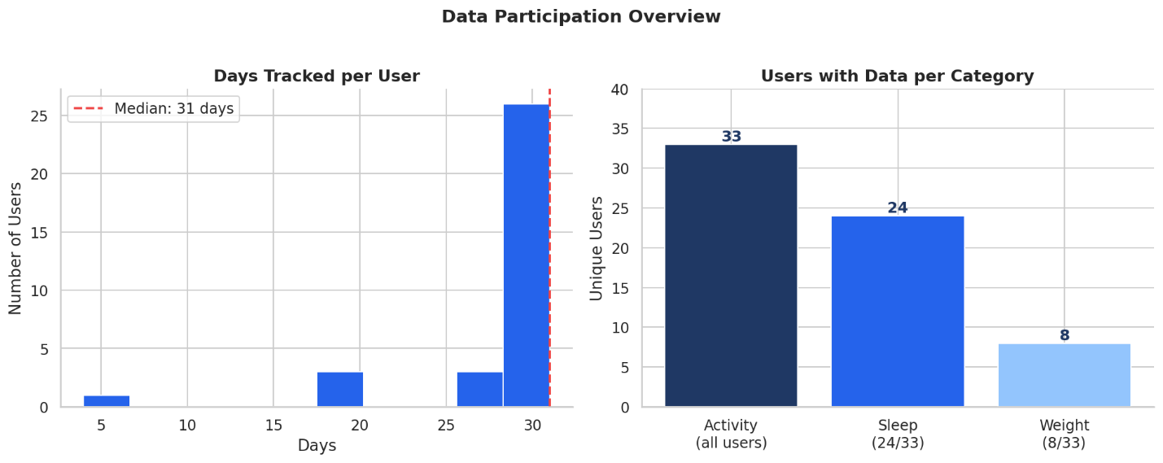
💡 Insight: Only 24/33 users logged sleep and 8/33 logged weight — state this as a data limitation in your presentation. It shows analytical maturity.

CELL 05 | Distribution Plots — 6 Key Metrics — Chart 2 of 13
⚠ Note: Histograms with KDE reveal skewness, outliers, and bimodal patterns. Required for any EDA section.

metrics = {
'total_steps': ('Total Daily Steps', 'Steps', '#2563EB'),
'calories': ('Calories Burned', 'Cal', '#DC2626'),
'sedentary_minutes': ('Sedentary Minutes/Day', 'Min', '#7C3AED'),
'very_active_minutes': ('Very Active Minutes/Day', 'Min', '#16A34A'),
'total_active_minutes': ('Total Active Min/Day', 'Min', '#0891B2'),
'activity_score': ('Activity Score (0-100)', 'Score', '#D97706'),
}

fig, axes = plt.subplots(2, 3, figsize=(15, 9))
axes = axes.flatten()

for i, (col, (title, xlabel, color)) in enumerate(metrics.items()):
data = activity[col].dropna()
axes[i].hist(data, bins=25, color=color, alpha=0.75,
edgecolor='white', linewidth=0.7, density=True)
xs = np.linspace(data.min(), data.max(), 200)
axes[i].plot(xs, gaussian_kde(data)(xs), color="black", linewidth=1.8, label="KDE")
axes[i].axvline(data.mean(), color=RED, linestyle="--", linewidth=1.4,
label=f"Mean {data.mean():,.0f}")
axes[i].axvline(data.median(), color=GREEN, linestyle=":", linewidth=1.4,
label=f"Median {data.median():,.0f}")
axes[i].set_title(title)
axes[i].set_xlabel(xlabel)
axes[i].legend(fontsize=7)

plt.suptitle('Distribution of Key Daily Metrics', fontsize=15, fontweight='bold', y=1.01)
plt.tight_layout()
plt.savefig('chart02_distributions.png', bbox_inches='tight', dpi=150)
plt.show()

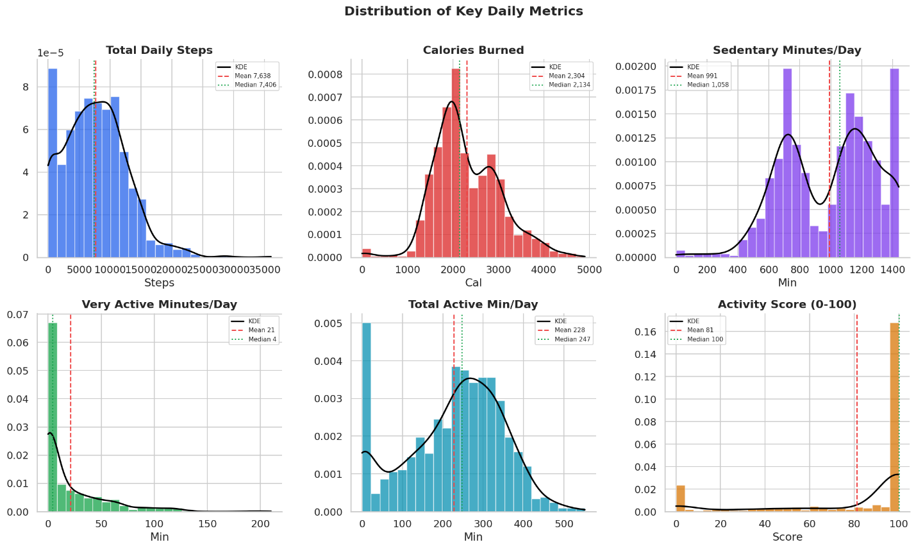

SECTION 3 — Statistical Analysis
CELL 06 | Correlation Matrix — Chart 3 of 13
💡 Insight: The correlation matrix is the centrepiece of a data analyst portfolio — shows all relationships at once and demonstrates statistical thinking.

corr_cols = [
'total_steps','total_distance','calories','very_active_minutes',
'fairly_active_minutes','lightly_active_minutes','sedentary_minutes',
'total_active_minutes','total_minutes_asleep',
'total_time_in_bed','sleep_efficiency_pct','minutes_awake_in_bed'
]
corr_data = activity[corr_cols].dropna(thresh=8)
corr_matrix = corr_data.corr(method="pearson")

fig, ax = plt.subplots(figsize=(13, 10))
mask = np.triu(np.ones_like(corr_matrix, dtype=bool))

sns.heatmap(
corr_matrix, mask=mask, ax=ax,
cmap='coolwarm', vmin=-1, vmax=1, center=0,
annot=True, fmt=".2f", annot_kws={"size":8},
linewidths=0.5, square=True,
cbar_kws={'shrink':0.7, 'label':'Pearson r'}
)
ax.set_title('Correlation Matrix — Daily Fitness Metrics', fontsize=14,
fontweight='bold', pad=16)
ax.set_xticklabels(ax.get_xticklabels(), rotation=40, ha='right', fontsize=9)
ax.set_yticklabels(ax.get_yticklabels(), rotation=0, fontsize=9)
plt.tight_layout()
plt.savefig('chart03_correlation_matrix.png', bbox_inches='tight', dpi=150)
plt.show()

# Print top correlations
pairs = (corr_matrix
.where(np.tril(np.ones(corr_matrix.shape), k=-1).astype(bool))
.stack().reset_index())
pairs.columns = ["var1","var2","r"]
pairs = pairs.reindex(pairs['r'].abs().sort_values(ascending=False).index)
print('Top 8 strongest correlations:')
print(pairs.head(8)[['var1','var2','r']].to_string(index=False))
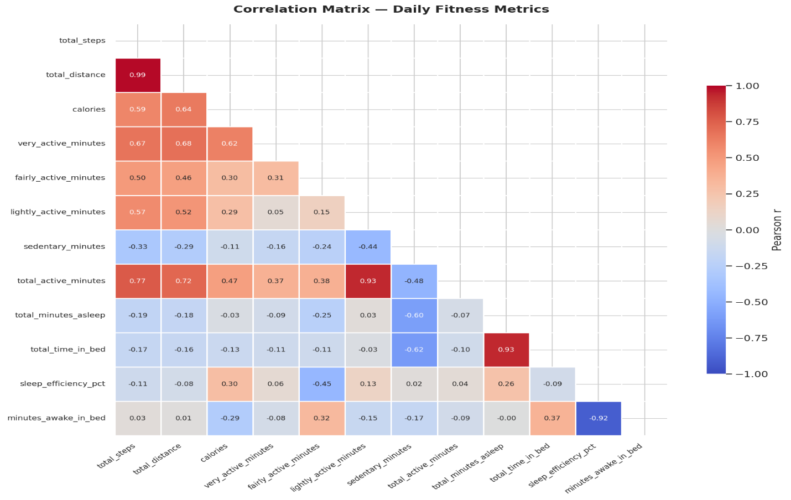

CELL 07 | Steps vs Calories Scatter + Regression — Chart 4 of 13
valid = scatter[(scatter['total_steps']>0) & (scatter['calories']>0)].copy()
r_val, p_val = pearsonr(valid['total_steps'], valid['calories'])
slope, intercept, *_ = stats.linregress(valid['total_steps'], valid['calories'])

seg_colors = {'1_Sedentary':'#BFDBFE', '2_Lightly Active':'#3B82F6',
'3_Fairly Active':'#1D4ED8', '4_Very Active':'#1F3864'}

fig, ax = plt.subplots(figsize=(9, 6))
for seg, grp in valid.groupby('daily_activity_segment'):
ax.scatter(grp['total_steps'], grp['calories'],
color=seg_colors.get(seg,"grey"), alpha=0.45, s=18,
label=seg.replace('_',' ').lstrip('1234_'))

x_range = np.linspace(valid["total_steps"].min(), valid["total_steps"].max(), 300)
ax.plot(x_range, slope*x_range+intercept, color=RED, linewidth=2,
linestyle='--', label=f'OLS trend r={r_val:.3f}')

ax.text(0.03, 0.95,
f'Pearson r = {r_val:.3f}\np-value < 0.001\nn = {len(valid):,}\nR² = {r_val**2:.3f}',
transform=ax.transAxes, fontsize=10, verticalalignment='top',
bbox=dict(boxstyle='round', facecolor='white', alpha=0.85))

ax.set_title(f'Steps vs Calories — R²={r_val**2:.2f}, positive correlation confirmed')
ax.set_xlabel('Total Steps'); ax.set_ylabel('Calories Burned')
ax.legend(title='Segment', fontsize=8)
ax.xaxis.set_major_formatter(mticker.FuncFormatter(lambda x,_: f'{x:,.0f}'))
plt.tight_layout()
plt.savefig('chart04_steps_vs_calories.png', bbox_inches='tight', dpi=150)
plt.show()
print(f'r={r_val:.4f} R²={r_val**2:.4f} p={p_val:.2e}')
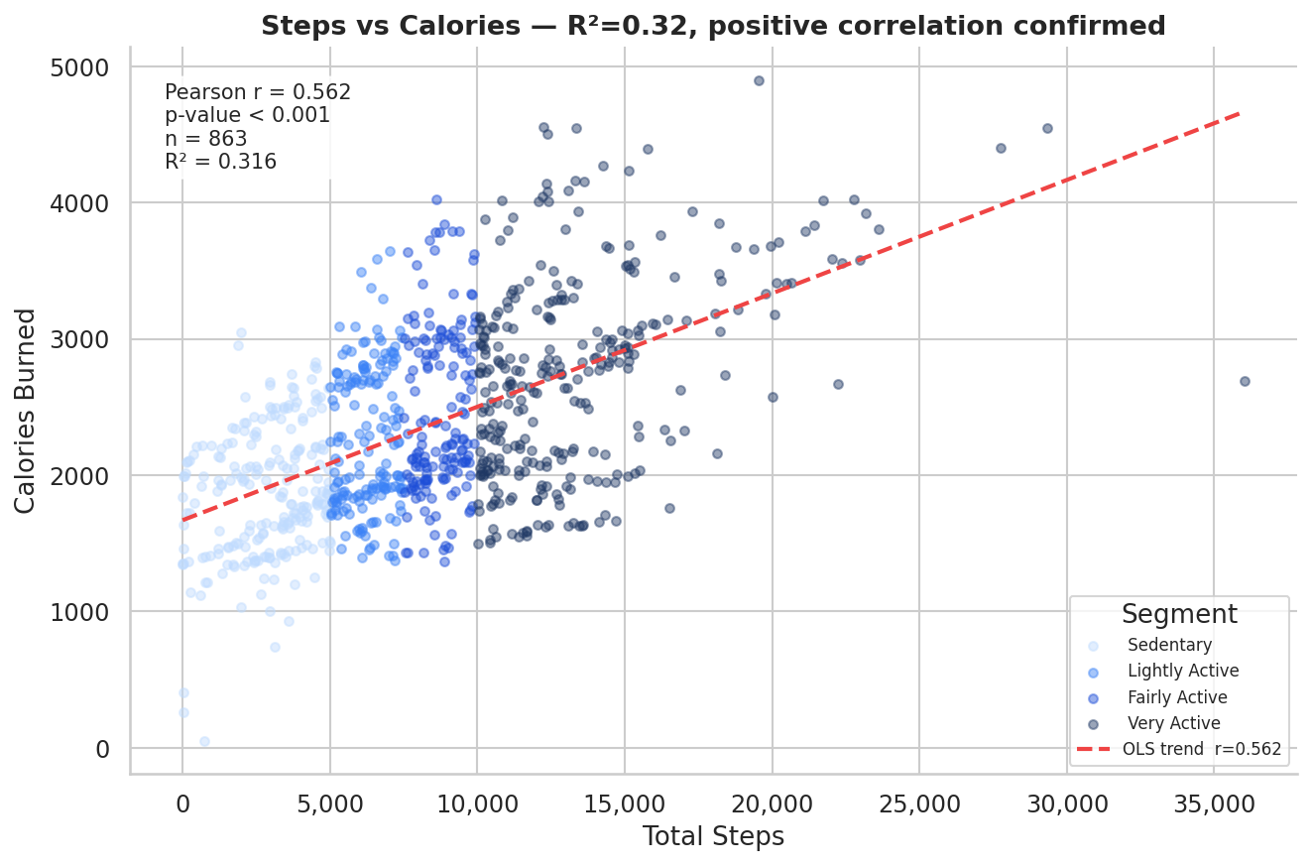

CELL 08 | Welch T-Test — Active vs Sedentary Calories — Chart 5 of 13
⚠ Note: Hypothesis testing shows hiring managers you understand inferential statistics, not just descriptive.

active_ids = user_sum[user_sum['user_segment'].isin(
['Fairly Active','Very Active'])]['user_id']
sed_ids = user_sum[user_sum['user_segment'].isin(
['Sedentary','Lightly Active'])]['user_id']
active_cal = activity[activity['user_id'].isin(active_ids)]['calories'].dropna()
sed_cal = activity[activity['user_id'].isin(sed_ids)]['calories'].dropna()
t_stat, p_val = ttest_ind(active_cal, sed_cal, equal_var=False)

fig, ax = plt.subplots(figsize=(8, 5))
bp = ax.boxplot([active_cal, sed_cal],
labels=['Active\n(Fairly+Very)','Sedentary\n(Sed+Lightly)'],
patch_artist=True, widths=0.5,
medianprops=dict(color='black',linewidth=2))
bp['boxes'][0].set_facecolor(BLUE)
bp['boxes'][1].set_facecolor('#93C5FD')

y_max = max(active_cal.max(), sed_cal.max())
ax.plot([1,1,2,2],[y_max*1.02,y_max*1.06,y_max*1.06,y_max*1.02],'k-',linewidth=1)
sig = '***' if p_val<0.001 else '**' if p_val<0.01 else '*' if p_val<0.05 else 'ns'
ax.text(1.5, y_max*1.08, sig, ha='center', fontsize=16, fontweight='bold')
ax.set_title('Daily Calories: Active vs Sedentary Users')
ax.set_ylabel('Calories Burned')
plt.tight_layout()
plt.savefig('chart05_ttest_calories.png', bbox_inches='tight', dpi=150)
plt.show()
print(f't={t_stat:.3f} p={p_val:.2e} {"SIGNIFICANT" if p_val<0.05 else "ns"}')
print(f'Active mean : {active_cal.mean():,.0f} cal/day')
print(f'Sedentary mean: {sed_cal.mean():,.0f} cal/day')
print(f'Difference : {active_cal.mean()-sed_cal.mean():,.0f} cal/day')

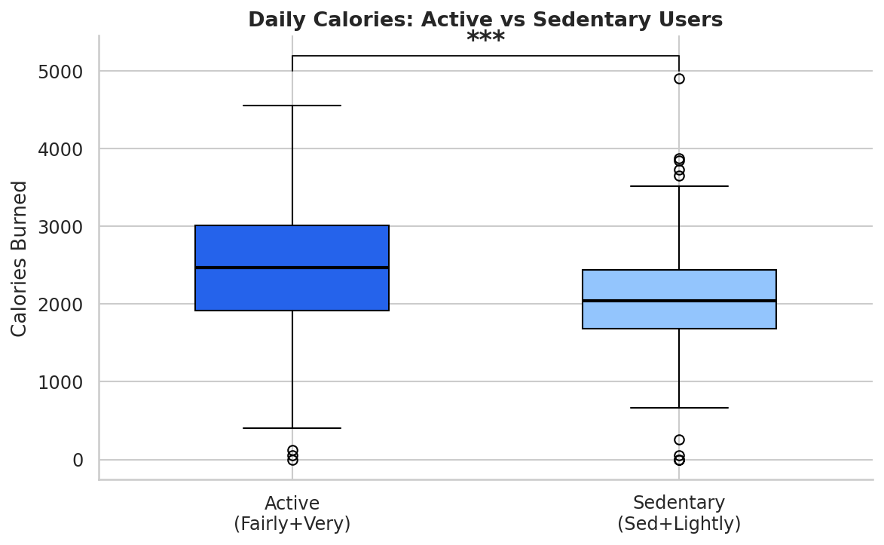

SECTION 4 — Activity Analysis
CELL 09 |  | User Segmentation — Donut + Bar — Chart 6 of 13
 | Segments are built here from user_summary.csv — fixing the FileNotFoundError for user_segments.csv.

# ── Build segment counts from user_summary (no separate file needed) ─────────────────
SEG_ORDER = ['Sedentary','Lightly Active','Fairly Active','Very Active']
SEG_COLORS = ['#BFDBFE','#60A5FA','#2563EB','#1F3864']

seg_counts = user_sum['user_segment'].value_counts().reindex(SEG_ORDER).dropna()

fig, axes = plt.subplots(1, 2, figsize=(13, 6))

# Left: Donut ─────────────────────────────────────────────────────────────────────────
wedges, texts, autotexts = axes[0].pie(
seg_counts.values, labels=seg_counts.index,
autopct='%1.0f%%', colors=SEG_COLORS,
startangle=140, wedgeprops=dict(width=0.55), pctdistance=0.78)
for t in autotexts: t.set_fontsize(11); t.set_fontweight('bold')
for t in texts: t.set_fontsize(10)
axes[0].set_title('User Activity Segments\n(by avg daily steps)', pad=14)

# Right: Grouped bar ─────────────────────────────────────────────────────────────────
seg_stats = (user_sum.groupby('user_segment')
[['avg_daily_steps','avg_daily_calories']]
.mean().reindex(SEG_ORDER).dropna())
x = np.arange(len(seg_stats)); w = 0.35
axes[1].bar(x-w/2, seg_stats['avg_daily_steps']/1000,
width=w, color=BLUE, label='Avg Steps (000s)')
axes[1].bar(x+w/2, seg_stats['avg_daily_calories']/100,
width=w, color=ORANGE, label='Avg Calories (00s)')
axes[1].set_xticks(x)
axes[1].set_xticklabels(seg_stats.index, rotation=20, ha='right')
axes[1].set_title('Steps & Calories by Segment')
axes[1].legend()

plt.suptitle('User Activity Segmentation', fontsize=14, fontweight='bold', y=1.02)
plt.tight_layout()
plt.savefig('chart06_user_segments.png', bbox_inches='tight', dpi=150)
plt.show()

print(user_sum.groupby('user_segment')[
['avg_daily_steps','avg_daily_calories','avg_sedentary_min','avg_activity_score']
].mean().round(0).reindex(SEG_ORDER).to_string())
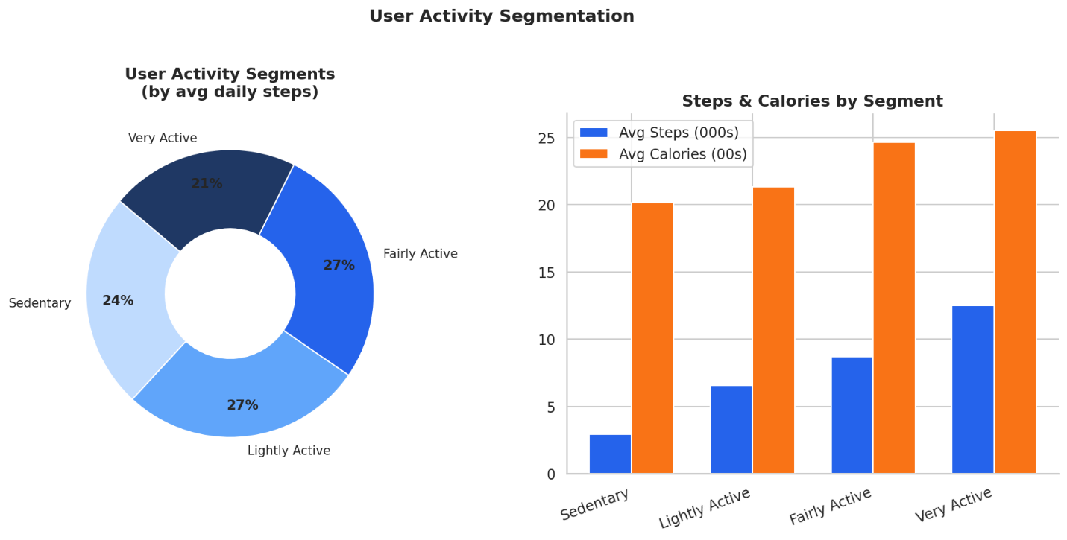

CELL 10 | Active Minutes Stacked Area Chart — Chart 7 of 13
daily_int = activity.groupby('activity_date')[[
'very_active_minutes','fairly_active_minutes',
'lightly_active_minutes','sedentary_minutes']].mean().reset_index()

fig, ax = plt.subplots(figsize=(13, 5))
cols_a = ['sedentary_minutes','lightly_active_minutes',
'fairly_active_minutes','very_active_minutes']
colors_a = ['#BFDBFE','#60A5FA','#2563EB','#1F3864']
labels_a = ['Sedentary','Lightly Active','Fairly Active','Very Active']

ax.stackplot(daily_int["activity_date"],
[daily_int[c] for c in cols_a],
labels=labels_a, colors=colors_a, alpha=0.85)
ax.set_title('Average Daily Activity Intensity Over Time (Stacked)')
ax.set_xlabel('Date'); ax.set_ylabel('Minutes')
ax.legend(loc='upper left', fontsize=9)
ax.xaxis.set_major_formatter(plt.matplotlib.dates.DateFormatter('%b %d'))
plt.xticks(rotation=30)
plt.tight_layout()
plt.savefig('chart07_stacked_activity.png', bbox_inches='tight', dpi=150)
plt.show()
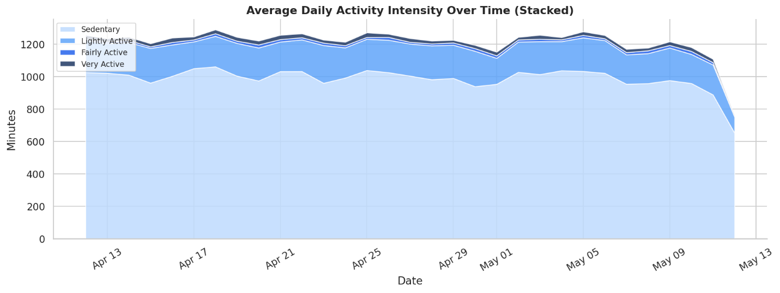

SECTION 5 — Temporal & Hourly Analysis
CELL 11 | Day-of-Week Trends — 3 Charts — Chart 8 of 13
def bar_labeled(ax, x, y, color, title, ylabel):
bars = ax.bar(x, y, color=color, edgecolor="white", linewidth=0.8)
for bar in bars:
ax.text(bar.get_x()+bar.get_width()/2,
bar.get_height()+y.max()*0.01,
f'{bar.get_height():,.0f}',
ha='center', va='bottom', fontsize=8, color=NAVY)
ax.set_title(title); ax.set_ylabel(ylabel)
ax.set_ylim(0, y.max()*1.18)
ax.tick_params(axis='x', rotation=35)
ax.yaxis.set_visible(False) # data labels make Y axis redundant

fig, axes = plt.subplots(1, 3, figsize=(16, 5))
bar_labeled(axes[0], daytrend['day_of_week'], daytrend['avg_steps'],
BLUE, 'Avg Steps by Day of Week', 'Steps')
bar_labeled(axes[1], daytrend['day_of_week'], daytrend['avg_calories'],
ORANGE, 'Avg Calories by Day of Week', 'Calories')
bar_labeled(axes[2], daytrend['day_of_week'], daytrend['avg_very_active_min'],
GREEN, 'Very Active Minutes by Day', 'Minutes')
plt.suptitle('Activity Patterns by Day of Week', fontsize=14, fontweight='bold', y=1.02)
plt.tight_layout()
plt.savefig('chart08_day_of_week.png', bbox_inches='tight', dpi=150)
plt.show()
print(f"Most active day : {daytrend.loc[daytrend['avg_steps'].idxmax(),'day_of_week']}")
print(f"Least active day : {daytrend.loc[daytrend['avg_steps'].idxmin(),'day_of_week']}")
print(f"Step gap : {daytrend['avg_steps'].max()-daytrend['avg_steps'].min():,.0f}")
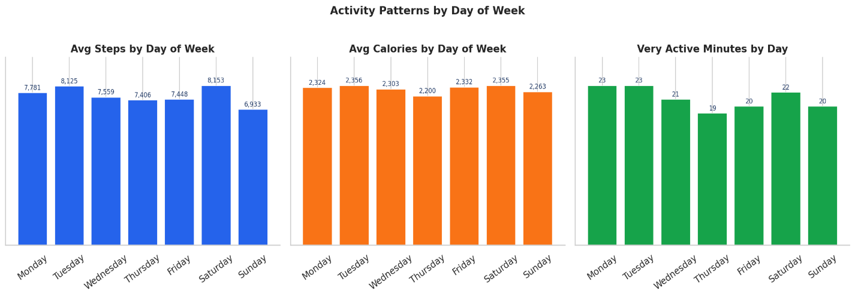

CELL 12 | Peak Activity Hours — Area Chart — Chart 9 of 13
fig, ax = plt.subplots(figsize=(13, 5))
ax.fill_between(hourly['hour_of_day'], hourly['avg_steps'], alpha=0.12, color=BLUE)
ax.plot(hourly['hour_of_day'], hourly['avg_steps'],
color=NAVY, linewidth=2.5, marker='o', markersize=5)

# Shade engagement windows ───────────────────────────────────────────────────────────
ax.axvspan(6, 9, alpha=0.08, color='green', label='Morning window 6-9am')
ax.axvspan(12, 14, alpha=0.08, color=ORANGE, label='Midday window 12-2pm')
ax.axvspan(17, 20, alpha=0.15, color=RED, label='Peak window 5-8pm ★')

peak_hr = hourly.loc[hourly['avg_steps'].idxmax(),'hour_of_day']
peak_val = hourly.loc[hourly['avg_steps'].idxmax(),'avg_steps']
ax.annotate(f'Peak: {peak_hr}:00\n{peak_val:,.0f} avg steps',
xy=(peak_hr, peak_val), xytext=(peak_hr+2, peak_val*1.12),
arrowprops=dict(arrowstyle='->', color='grey', lw=1.2),
fontsize=9,
bbox=dict(boxstyle='round,pad=0.3',facecolor='white',
edgecolor='grey',alpha=0.9))

ax.set_xticks(range(24))
ax.set_xticklabels([f'{h}:00' for h in range(24)], rotation=45, fontsize=8)
ax.set_title('Average Steps by Hour of Day — Activity Engagement Windows')
ax.set_xlabel('Hour of Day'); ax.set_ylabel('Avg Steps')
ax.legend(fontsize=9)
ax.yaxis.set_major_formatter(mticker.FuncFormatter(lambda x,_: f'{x:,.0f}'))
plt.tight_layout()
plt.savefig('chart09_peak_hours.png', bbox_inches='tight', dpi=150)
plt.show()
morning = hourly[hourly['hour_of_day'].between(6,9)]['avg_steps'].mean()
evening = hourly[hourly['hour_of_day'].between(17,20)]['avg_steps'].mean()
print(f'Morning avg (6-9am) : {morning:,.0f} steps')
print(f'Evening avg (5-8pm) : {evening:,.0f} steps ({evening/morning:.1f}x more active)')
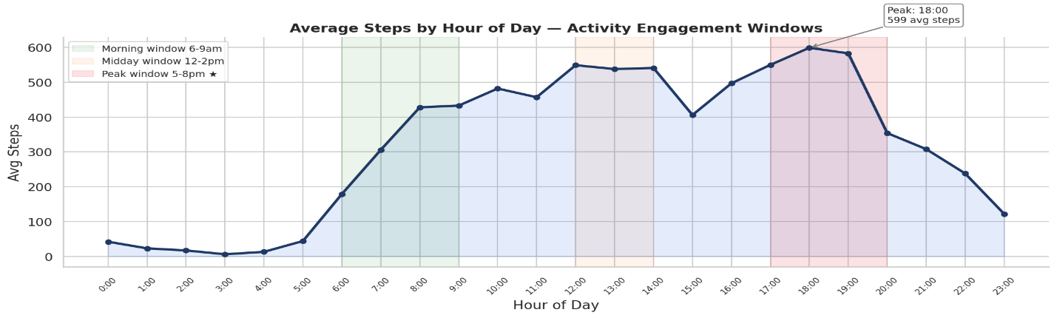

CELL 13 | Weekly Trend — Dual Axis Line Chart — Chart 10 of 13
fig, ax1 = plt.subplots(figsize=(12, 5))
ax1.fill_between(weekly['week_start'], weekly['avg_steps'], alpha=0.1, color=BLUE)
ax1.plot(weekly['week_start'], weekly['avg_steps'],
color=BLUE, linewidth=2.5, marker='o', markersize=7, label='Avg Steps')

ax2 = ax1.twinx()
ax2.plot(weekly['week_start'], weekly['active_users'],
color=ORANGE, linewidth=2, marker='s', markersize=6,
linestyle='--', label='Active Users')
ax2.set_ylabel('Active Users', color=ORANGE)
ax2.tick_params(axis='y', labelcolor=ORANGE)

ax1.set_title('Weekly Trend — User engagement drops over 4 weeks (case for gamification)')
ax1.set_xlabel('Week'); ax1.set_ylabel('Avg Steps', color=BLUE)
ax1.tick_params(axis='y', labelcolor=BLUE)
ax1.yaxis.set_major_formatter(mticker.FuncFormatter(lambda x,_: f'{x:,.0f}'))
lines1,lbl1 = ax1.get_legend_handles_labels()
lines2,lbl2 = ax2.get_legend_handles_labels()
ax1.legend(lines1+lines2, lbl1+lbl2, loc='upper right')
plt.xticks(rotation=30)
plt.tight_layout()
plt.savefig('chart10_weekly_trend.png', bbox_inches='tight', dpi=150)
plt.show()
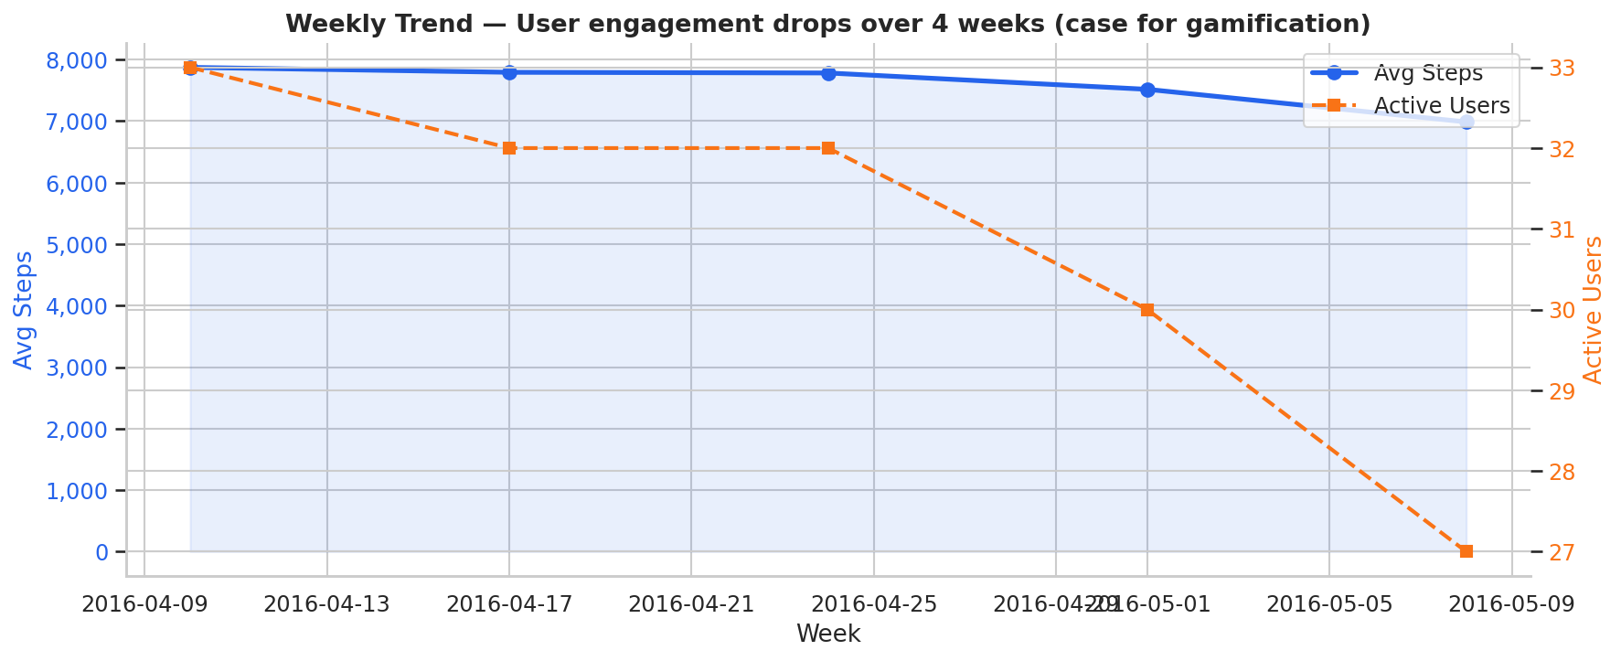

SECTION 6 — Sleep Analysis
CELL 14 | Sleep Dashboard — 4 Panels — Chart 11 of 13
fig = plt.figure(figsize=(14, 10))
gs = gridspec.GridSpec(2, 2, hspace=0.4, wspace=0.35)

# Panel 1: Distribution of avg minutes asleep ────────────────────────────────────────
ax1 = fig.add_subplot(gs[0,0])
ax1.hist(sleep['avg_min_asleep'], bins=14, color=PURPLE, edgecolor='white', linewidth=0.9)
ax1.axvline(360, color=RED, linestyle='--', lw=1.4, label='6 hrs (360 min)')
ax1.axvline(420, color=GREEN, linestyle='--', lw=1.4, label='7 hrs target (420)')
ax1.axvline(480, color=ORANGE, linestyle='--', lw=1.4, label='8 hrs (480 min)')
ax1.set_title('Distribution — Avg Sleep per User')
ax1.set_xlabel('Minutes'); ax1.set_ylabel('Users'); ax1.legend(fontsize=8)

# Panel 2: Sleep efficiency vs duration scatter ───────────────────────────────────────
ax2 = fig.add_subplot(gs[0,1])
sc = ax2.scatter(sleep['avg_min_asleep'], sleep['avg_sleep_efficiency'],
c=sleep['avg_min_wasted'], cmap='RdYlGn_r',
s=70, edgecolors='grey', linewidths=0.4)
fig.colorbar(sc, ax=ax2, label="Avg min awake in bed")
ax2.axhline(85, color=BLUE, linestyle='--', lw=1.2, label='85% efficiency benchmark')
ax2.set_title('Sleep Efficiency vs Duration')
ax2.set_xlabel('Avg Minutes Asleep'); ax2.set_ylabel('Sleep Efficiency (%)')
ax2.legend(fontsize=8)

# Panel 3: % hitting 7hr goal by segment ────────────────────────────────────────────
ax3 = fig.add_subplot(gs[1,0])
merged = user_sum[['user_id','user_segment','avg_min_asleep']].dropna().copy()
merged['enough'] = merged['avg_min_asleep'] >= 420
seg_sl = (merged.groupby('user_segment')['enough'].mean()*100)
seg_sl = seg_sl.reindex(['Sedentary','Lightly Active','Fairly Active','Very Active']).dropna()
b3 = ax3.bar(seg_sl.index, seg_sl.values,
color=['#BFDBFE','#60A5FA','#2563EB','#1F3864'], edgecolor='white')
for bar in b3:
ax3.text(bar.get_x()+bar.get_width()/2, bar.get_height()+0.5,
f'{bar.get_height():.0f}%', ha='center', fontsize=10)
ax3.set_title('% Users Averaging ≥7hrs Sleep by Segment')
ax3.set_ylabel('% Users'); ax3.set_ylim(0,115); ax3.tick_params(axis='x',rotation=20)

# Panel 4: Minutes awake in bed per user ────────────────────────────────────────────
ax4 = fig.add_subplot(gs[1,1])
ss = sleep.sort_values('avg_min_asleep')
ax4.bar(range(len(ss)), ss['avg_min_wasted'], color=PURPLE, alpha=0.7, edgecolor='white')
ax4.axhline(ss['avg_min_wasted'].mean(), color=RED, linestyle='--', lw=1.4,
label=f"Avg {ss['avg_min_wasted'].mean():.0f} min")
ax4.set_title('Minutes Awake in Bed per User (sorted by sleep duration)')
ax4.set_xlabel('Users'); ax4.set_ylabel('Min Awake in Bed'); ax4.legend()

plt.suptitle('Sleep Quality Analysis Dashboard', fontsize=15, fontweight='bold', y=1.01)
plt.savefig('chart11_sleep_dashboard.png', bbox_inches='tight', dpi=150)
plt.show()
print(f"% users ≥7hrs sleep : {(sleep['avg_min_asleep']>=420).mean()*100:.0f}%")
print(f"Avg sleep efficiency: {sleep['avg_sleep_efficiency'].mean():.1f}%")
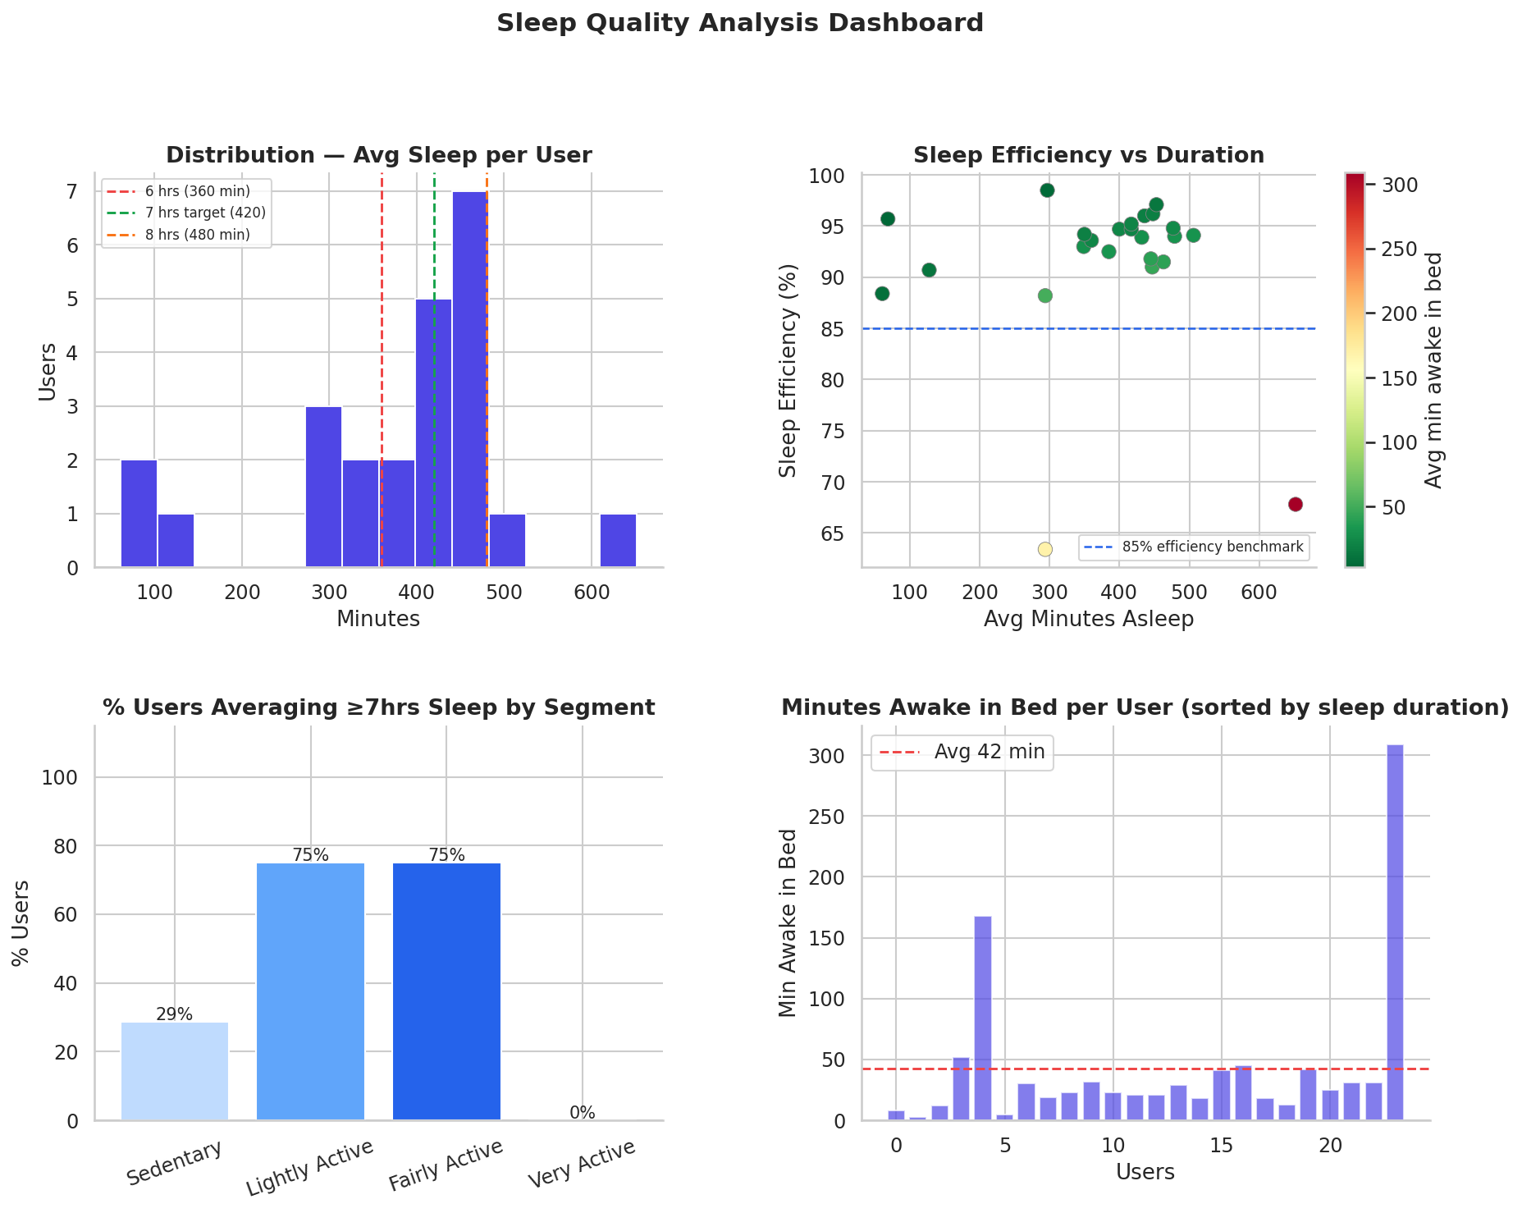

SECTION 7 — Sedentary Behaviour Analysis
CELL 15 | Sedentary Time Deep-Dive — Chart 12 of 13
fig, axes = plt.subplots(1, 3, figsize=(16, 5))

# Panel 1: Sedentary time vs calories ───────────────────────────────────────────────
b1 = activity[['sedentary_minutes','calories']].dropna()
axes[0].scatter(b1['sedentary_minutes'], b1['calories'],
alpha=0.25, s=14, color='#7C3AED')
r1 = pearsonr(b1['sedentary_minutes'], b1['calories'])[0]
axes[0].set_title(f'Sedentary Time vs Calories r={r1:.3f}')
axes[0].set_xlabel('Sedentary Minutes'); axes[0].set_ylabel('Calories')

# Panel 2: Sedentary time vs steps ──────────────────────────────────────────────────
b2 = activity[['sedentary_minutes','total_steps']].dropna()
axes[1].scatter(b2['sedentary_minutes'], b2['total_steps'],
alpha=0.25, s=14, color=RED)
r2 = pearsonr(b2['sedentary_minutes'], b2['total_steps'])[0]
axes[1].set_title(f'Sedentary Time vs Steps r={r2:.3f}')
axes[1].set_xlabel('Sedentary Minutes'); axes[1].set_ylabel('Total Steps')
axes[1].yaxis.set_major_formatter(mticker.FuncFormatter(lambda x,_: f'{x:,.0f}'))

# Panel 3: Sedentary bucket distribution ────────────────────────────────────────────
activity['sed_bucket'] = pd.cut(
activity['sedentary_minutes'],
bins=[0, 600, 900, 1440],
labels=['Low\n(<10hrs)', 'Medium\n(10-15hrs)', 'High\n(>15hrs)'])
bucket = activity['sed_bucket'].value_counts(normalize=True).sort_index() * 100
axes[2].bar(bucket.index, bucket.values,
color=[GREEN, ORANGE, RED], edgecolor='white')
for i,v in enumerate(bucket.values):
axes[2].text(i, v+0.5, f'{v:.0f}%', ha='center', fontsize=12, fontweight='bold')
axes[2].set_title('Sedentary Time Distribution')
axes[2].set_ylabel('% of Days'); axes[2].set_ylim(0, bucket.max()*1.2)

plt.suptitle('Sedentary Behaviour Deep-Dive', fontsize=14, fontweight='bold', y=1.02)
plt.tight_layout()
plt.savefig('chart12_sedentary.png', bbox_inches='tight', dpi=150)
plt.show()
print(f"Days >15hrs sedentary: {(activity['sedentary_minutes']>=900).mean()*100:.0f}%")
print(f"Avg sedentary hrs/day: {activity['sedentary_minutes'].mean()/60:.1f}")
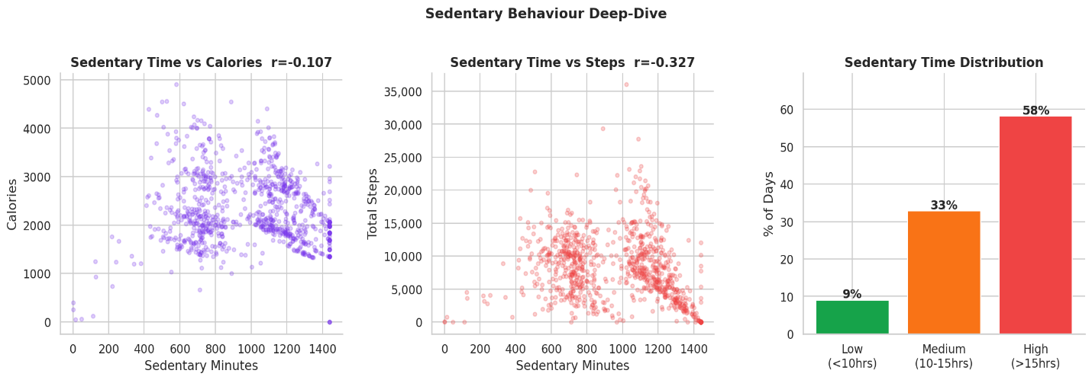

CELL 16 | User Activity Heatmap — Chart 13 of 13
pivot = activity.pivot_table(
index='user_id', columns='day_of_week',
values='total_steps', aggfunc='mean')[DAY_ORDER].fillna(0)
pivot = pivot.loc[pivot.mean(axis=1).sort_values(ascending=False).index]

fig, ax = plt.subplots(figsize=(12, 10))
sns.heatmap(
pivot, ax=ax, cmap='Blues', linewidths=0.4, annot=False,
cbar_kws={'label':'Avg Steps','shrink':0.6},
xticklabels=[d[:3] for d in DAY_ORDER])
ax.set_title('User Activity Heatmap — Avg Steps by User & Day of Week',
fontsize=13, fontweight='bold')
ax.set_xlabel('Day of Week'); ax.set_ylabel('User ID')
ax.set_yticklabels(ax.get_yticklabels(), fontsize=7)
plt.tight_layout()
plt.savefig('chart13_user_heatmap.png', bbox_inches='tight', dpi=150)
plt.show()
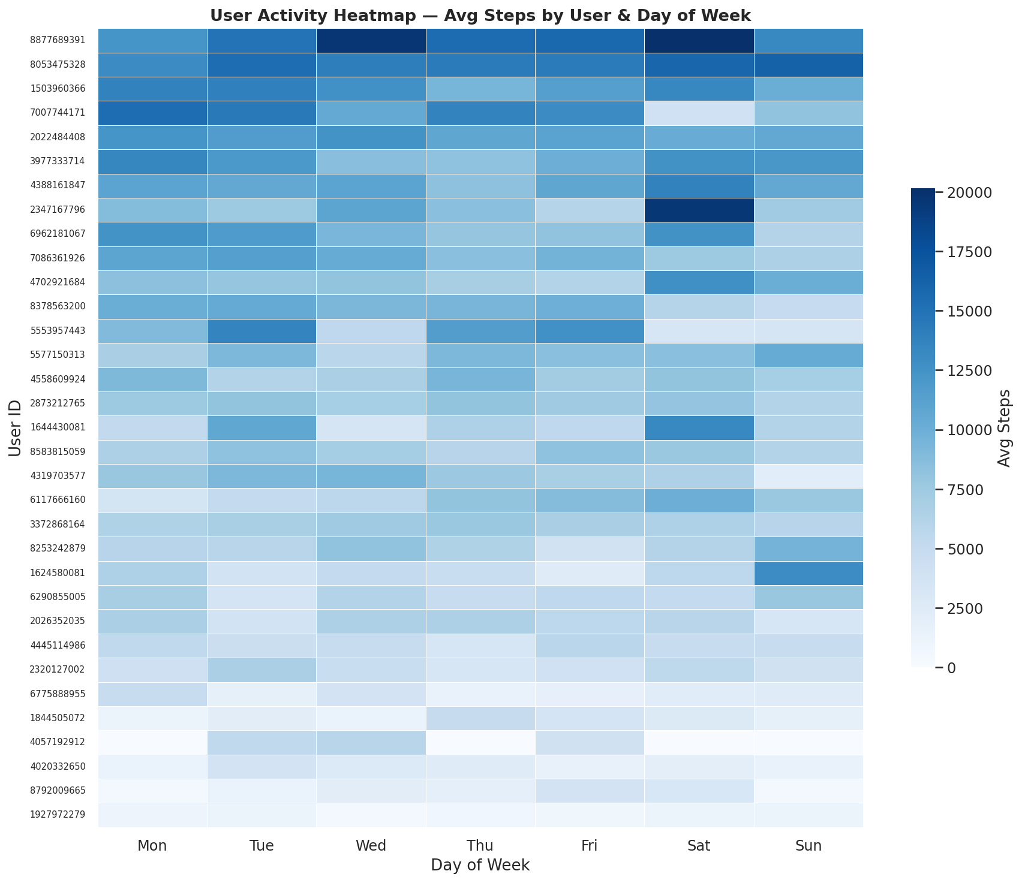

SECTION 8 — Key Findings & Export
CELL 17 | Key Findings Print Report
print('=' * 62)
print(' BELLABEAT FITNESS TRACKER — KEY FINDINGS')
print('=' * 62)

avg_steps = activity['total_steps'].mean()
avg_sed_hr = activity['sedentary_minutes'].mean()/60
pct_10k = (activity['total_steps']>=10000).mean()*100
pct_high_s = (activity['sedentary_minutes']>=900).mean()*100
peak_hour = hourly.loc[hourly['avg_steps'].idxmax(),'hour_of_day']
most_act = daytrend.loc[daytrend['avg_steps'].idxmax(),'day_of_week']
avg_eff = sleep['avg_sleep_efficiency'].mean()
pct_7hrs = (sleep['avg_min_asleep']>=420).mean()*100

print(f'\n📊 ACTIVITY')
print(f' Avg daily steps : {avg_steps:,.0f} (WHO target: 10,000)')
print(f' % days hitting 10k : {pct_10k:.0f}%')
print(f' Most active day : {most_act}')
print(f' Peak activity hour : {peak_hour}:00')
print(f'\n🛋 SEDENTARY BEHAVIOUR')
print(f' Avg sedentary hrs/day : {avg_sed_hr:.1f} hrs')
print(f' Days >15hrs sedentary : {pct_high_s:.0f}%')
print(f'\n😴 SLEEP (24 of 33 users logged sleep)')
print(f' Avg sleep efficiency : {avg_eff:.1f}% (benchmark: 85%)')
print(f' % users avg ≥7hrs : {pct_7hrs:.0f}%')
print(f'\n🎯 BELLABEAT RECOMMENDATIONS')
print(f' 1. Push notifications at {peak_hour}:00 — peak activity window')
print(f' 2. Move-more alerts: {pct_high_s:.0f}% of days exceed 15hrs sedentary')
print(f' 3. Sleep coaching upsell: only {pct_7hrs:.0f}% hit the 7hr sleep goal')
print('=' * 62)

CELL 18 | Export All 9 Power BI CSV Files + Charts
💡 Insight: This single cell produces all 9 pbi_ files needed for your Power BI dashboards. Run it last after all charts are done.

os.makedirs("powerbi_exports", exist_ok=True)

# ── 1. pbi_master_activity.csv ───────────────────────────────────────────────────────
activity.to_csv('powerbi_exports/pbi_master_activity.csv', index=False)

# ── 2. pbi_user_summary.csv ──────────────────────────────────────────────────────────
user_sum.to_csv('powerbi_exports/pbi_user_summary.csv', index=False)

# ── 3. pbi_user_segments.csv (built here — was the missing file) ─────────────────────
seg_export = (user_sum['user_segment']
.value_counts()
.reset_index()
.rename(columns={"user_segment":"user_segment","count":"user_count"}))
# Handle both old and new pandas column naming
if 'index' in seg_export.columns:
seg_export = seg_export.rename(columns={'index':'user_segment','user_segment':'user_count'})
seg_export.to_csv('powerbi_exports/pbi_user_segments.csv', index=False)

# ── 4. pbi_day_trends.csv ────────────────────────────────────────────────────────────
daytrend.to_csv('powerbi_exports/pbi_day_trends.csv', index=False)

# ── 5. pbi_peak_hours.csv ────────────────────────────────────────────────────────────
hourly.to_csv('powerbi_exports/pbi_peak_hours.csv', index=False)

# ── 6. pbi_scatter.csv ───────────────────────────────────────────────────────────────
scatter.to_csv('powerbi_exports/pbi_scatter.csv', index=False)

# ── 7. pbi_sleep.csv ─────────────────────────────────────────────────────────────────
sleep.to_csv('powerbi_exports/pbi_sleep.csv', index=False)

# ── 8. pbi_weekly_trend.csv ──────────────────────────────────────────────────────────
weekly.to_csv('powerbi_exports/pbi_weekly_trend.csv', index=False)

# ── 9. pbi_hourly_combined.csv (same as peak_hours — for D3 notification bar) ─────────
hourly.to_csv('powerbi_exports/pbi_hourly_combined.csv', index=False)

# ── Verify all 9 files ───────────────────────────────────────────────────────────────
expected = ['pbi_master_activity.csv','pbi_user_summary.csv','pbi_user_segments.csv',
'pbi_day_trends.csv','pbi_peak_hours.csv','pbi_scatter.csv',
'pbi_sleep.csv','pbi_weekly_trend.csv','pbi_hourly_combined.csv']
print('✅ Power BI export files:')
for f in expected:
path = f'powerbi_exports/{f}'
kb = os.path.getsize(path)//1024 if os.path.exists(path) else 0
ok = '✅' if os.path.exists(path) else '❌ MISSING'
print(f' {ok} {f:<40} {kb:>5} KB')

CELL 19 | Download Everything as ZIP in One Click
⚠ Note: Run this cell last. It zips all 13 charts + all 9 Power BI CSVs and downloads to your computer automatically.

# ── Create zip file ──────────────────────────────────────────────────────────────────
with zipfile.ZipFile('bellabeat_all_outputs.zip', 'w', zipfile.ZIP_DEFLATED) as zf:
# All 13 chart PNGs
for f in sorted(os.listdir('.')):
if f.startswith('chart') and f.endswith('.png'):
zf.write(f)
print(f' Added chart: {f}')
# All 9 Power BI CSV files
for f in sorted(os.listdir('powerbi_exports')):
zf.write(f'powerbi_exports/{f}', f)
print(f' Added PBI: {f}')

print('\n✅ bellabeat_all_outputs.zip ready')

# ── Auto-download ─────────────────────────────────────────────────────────────────────
from google.colab import files
files.download('bellabeat_all_outputs.zip')
print('Downloading… check your browser downloads folder')
print('Extract the zip — upload the 9 pbi_ files to Power BI Desktop')

APPENDIX — Troubleshooting & Column Reference

Power BI file reference — what each pbi_ file feeds
File | Dashboard | Visual | Key columns used
pbi_user_segments.csv | D1 | Donut chart | user_segment, user_count
pbi_scatter.csv | D1 | Scatter chart | total_steps, calories, daily_activity_segment
pbi_day_trends.csv | D1 | 3 bar charts | day_of_week, avg_steps, avg_calories, avg_very_active_min
pbi_master_activity.csv | D1 D2 D3 | KPI cards + slicer | all columns — primary source
pbi_user_summary.csv | D1 D2 D3 | Slicer + gauge + activity score bar | user_segment, avg_daily_steps, avg_min_asleep, avg_activity_score
pbi_sleep.csv | D2 | Sleep duration bar + efficiency scatter | user_id, avg_min_asleep, avg_sleep_efficiency, avg_min_wasted
pbi_peak_hours.csv | D3 | Area chart | hour_of_day, avg_steps
pbi_hourly_combined.csv | D3 | Notification timing bar | hour_of_day, avg_steps (grouped into windows)
pbi_weekly_trend.csv | D3 | Weekly dual-axis line | week_start, avg_steps, active_users

