🐍 Cyclistic Bike-Share Analysis (Python Documentation)

📌 Step 1: Sample Dataset Creation (BigQuery)
This step creates a 2% sampled dataset for efficient Python-based analysis.
CREATE OR REPLACE TABLE
`model-myth-487516-u3.cyclistic_analysis.cyclistic_python_sample`
AS
SELECT
ride_duration,
distance_miles,
member_casual,
rideable_type,
hour_of_day,
day_of_week,
day_type,
season,
trip_type,
duration_bucket,
time_segment
FROM `model-myth-487516-u3.cyclistic_analysis.cyclistic_2025_cleaned`
TABLESAMPLE SYSTEM (2 PERCENT);

📚 Step 2: Environment Setup & Library Imports
This section initializes required libraries and defines global styling for consistent visualization.
import pandas as pd
import numpy as np
import matplotlib.pyplot as plt
import matplotlib.patches as mpatches
import seaborn as sns
from scipy import stats
from scipy.stats import mannwhitneyu
import warnings
warnings.filterwarnings('ignore')

# ── Global color palette (matches your Tableau dashboard) ──
COLORS = {
'member' : '#E6820E', # orange
'casual' : '#6A73C1', # blue-purple
'both' : ['#6A73C1', '#E6820E'],
'neutral' : '#888780'
}

# ── Global plot style ──
plt.rcParams.update({
'figure.facecolor' : 'white',
'axes.facecolor' : 'white',
'axes.spines.top' : False,
'axes.spines.right': False,
'axes.labelsize' : 12,
'axes.titlesize' : 14,
'axes.titleweight' : 'bold',
'xtick.labelsize' : 10,
'ytick.labelsize' : 10,
'legend.fontsize' : 10,
'font.family' : 'sans-serif'
})

print("✅ Libraries imported successfully")

📥 Step 3: Data Loading & Initial Validation
Load dataset and perform initial sanity checks.
# ── Upload cyclistic_python_sample.csv to Colab first ──
# File → Upload to session storage

df = pd.read_csv('/content/cyclistic_python_sample.csv')

# Quick sanity check
print(f"Shape: {df.shape}")
print(f"Columns: {list(df.columns)}")
print(f"\nRider type split:")
print(df['member_casual'].value_counts())
print(f"\nNull values:")
print(df.isnull().sum())

📊 Step 4: Descriptive Statistics & Data Profiling
Provides statistical overview of ride behavior by user type.
# ── Section 1: Descriptive Statistics ──
print("=" * 55)
print(" DESCRIPTIVE STATISTICS")
print("=" * 55)

# Summary by rider type
summary = df.groupby('member_casual').agg(
total_rides = ('ride_duration', 'count'),
mean_duration = ('ride_duration', 'mean'),
median_duration= ('ride_duration', 'median'),
std_duration = ('ride_duration', 'std'),
min_duration = ('ride_duration', 'min'),
max_duration = ('ride_duration', 'max'),
mean_distance = ('distance_miles', 'mean'),
median_distance= ('distance_miles', 'median')
).round(2)

print(summary.T) # Transpose for readability

# Percentage split
total = len(df)
for rtype, count in df['member_casual'].value_counts().items():
print(f"\n{rtype}: {count:,} rides ({count/total*100:.1f}%)")

=======================================================
DESCRIPTIVE STATISTICS
=======================================================
member_casual casual member
total_rides 45557.00 82838.00
mean_duration 19.47 11.60
median_duration 11.00 8.00
std_duration 38.83 18.95
min_duration 1.00 1.00
max_duration 1428.00 1438.00
mean_distance 1.40 1.41
median_distance 1.04 1.02

member: 82,838 rides (64.5%)

casual: 45,557 rides (35.5%)

🧪 Step 5: Hypothesis Testing & Statistical Validation
This section validates behavioral differences using statistical tests.
# ── Section 2: Hypothesis Testing ──
print("=" * 55)
print(" HYPOTHESIS TESTING")
print("=" * 55)

member = df[df['member_casual'] == 'member']['ride_duration']
casual = df[df['member_casual'] == 'casual']['ride_duration']

# ── Test 1: Welch's t-test (unequal variance) ──
t_stat, p_value = stats.ttest_ind(member, casual, equal_var=False)

print("\n📌 Test 1 — Welch's T-Test (Ride Duration)")
print(f" H0: No difference in mean ride duration")
print(f" H1: Casual riders have longer mean duration")
print(f" T-statistic : {t_stat:.4f}")
print(f" P-value : {p_value:.2e}")
print(f" Result : {'✅ Reject H0 — significant difference' if p_value < 0.05 else '❌ Fail to reject H0'}")

# ── Test 2: Cohen's d (effect size) ──
def cohen_d(a, b):
pooled_std = np.sqrt((np.std(a, ddof=1)**2 + np.std(b, ddof=1)**2) / 2)
return (np.mean(a) - np.mean(b)) / pooled_std

d = cohen_d(member, casual)
magnitude = 'small' if abs(d) < 0.5 else 'medium' if abs(d) < 0.8 else 'large'

print(f"\n📌 Test 2 — Cohen's d (Effect Size)")
print(f" Cohen's d : {d:.4f}")
print(f" Magnitude : {magnitude} effect")
print(f" Interpretation: Members ride {abs(d):.2f} standard deviations")
print(f" shorter than casual riders on average")

# ── Test 3: Mann-Whitney U (non-parametric, more robust) ──
u_stat, p_mw = mannwhitneyu(member, casual, alternative='less')

print(f"\n📌 Test 3 — Mann-Whitney U Test (Non-Parametric)")
print(f" U-statistic : {u_stat:.0f}")
print(f" P-value : {p_mw:.2e}")
print(f" Result : {'✅ Members significantly shorter rides' if p_mw < 0.05 else '❌ No significant difference'}")

# ── Test 4: Distance t-test ──
m_dist = df[df['member_casual'] == 'member']['distance_miles']
c_dist = df[df['member_casual'] == 'casual']['distance_miles']
t_dist, p_dist = stats.ttest_ind(m_dist, c_dist, equal_var=False)

print(f"\n📌 Test 4 — Distance T-Test")
print(f" P-value : {p_dist:.4f}")
print(f" Result : {'Significant' if p_dist < 0.05 else 'Not significant'} difference in distance")
print(f" Note : Mean distance nearly identical")
print(f" Member: {m_dist.mean():.2f} mi | Casual: {c_dist.mean():.2f} mi")
=======================================================
HYPOTHESIS TESTING
=======================================================

📌 Test 1 — Welch's T-Test (Ride Duration)
H0: No difference in mean ride duration
H1: Casual riders have longer mean duration
T-statistic : -40.7002
P-value : 0.00e+00
Result : ✅ Reject H0 — significant difference

📌 Test 2 — Cohen's d (Effect Size)
Cohen's d : -0.2577
Magnitude : small effect
Interpretation: Members ride 0.26 standard deviations
shorter than casual riders on average

📌 Test 3 — Mann-Whitney U Test (Non-Parametric)
U-statistic : 1459368167
P-value : 0.00e+00
Result : ✅ Members significantly shorter rides

📌 Test 4 — Distance T-Test
P-value : 0.0306
Result : Significant difference in distance
Note : Mean distance nearly identical
Member: 1.41 mi | Casual: 1.40 mi

📈 Step 6: Ride Duration Distribution Analysis
Visual comparison of ride duration patterns.
# ── Section 3: Ride Duration Distribution ──
fig, axes = plt.subplots(1, 2, figsize=(14, 5))
fig.suptitle('Ride Duration Analysis: Member vs Casual',
fontsize=15, fontweight='bold', y=1.02)

# Plot 1 — Overlapping histogram with KDE
ax1 = axes[0]
for rtype, color in [('casual', COLORS['casual']),
('member', COLORS['member'])]:
data = df[df['member_casual'] == rtype]['ride_duration']
ax1.hist(data, bins=50, alpha=0.45, color=color,
label=rtype.capitalize(), density=True, range=(0,60))
data.plot.kde(ax=ax1, color=color, linewidth=2.5,
xlim=(0,60))

ax1.axvline(casual.median(), color=COLORS['casual'],
linestyle='--', alpha=0.8, linewidth=1.5,
label=f'Casual median: {casual.median():.0f} min')
ax1.axvline(member.median(), color=COLORS['member'],
linestyle='--', alpha=0.8, linewidth=1.5,
label=f'Member median: {member.median():.0f} min')
ax1.set_title('Ride Duration Distribution (0–60 min)')
ax1.set_xlabel('Ride Duration (minutes)')
ax1.set_ylabel('Density')
ax1.legend()

# Plot 2 — Boxplot
ax2 = axes[1]
bp = ax2.boxplot(
[casual.clip(0,60), member.clip(0,60)],
labels=['Casual', 'Member'],
patch_artist=True,
medianprops=dict(color='white', linewidth=2.5),
whiskerprops=dict(linewidth=1.5),
capprops=dict(linewidth=1.5),
flierprops=dict(marker='o', markersize=2, alpha=0.3)
)
bp['boxes'][0].set_facecolor(COLORS['casual'])
bp['boxes'][1].set_facecolor(COLORS['member'])

ax2.set_title('Ride Duration Boxplot (capped 60 min)')
ax2.set_xlabel('Rider Type')
ax2.set_ylabel('Ride Duration (minutes)')

# Annotate means
for i, (rtype, color) in enumerate(
[('casual', COLORS['casual']), ('member', COLORS['member'])], 1):
mean_val = df[df['member_casual']==rtype]['ride_duration'].mean()
ax2.annotate(f'Mean: {mean_val:.1f}m',
xy=(i, mean_val), xytext=(i+0.22, mean_val),
fontsize=9, color=color, fontweight='bold',
arrowprops=dict(arrowstyle='->', color=color,
lw=1.5))

plt.tight_layout()
plt.savefig('01_ride_duration_distribution.png',
dpi=150, bbox_inches='tight')
plt.show()
print("✅ Saved: 01_ride_duration_distribution.png")
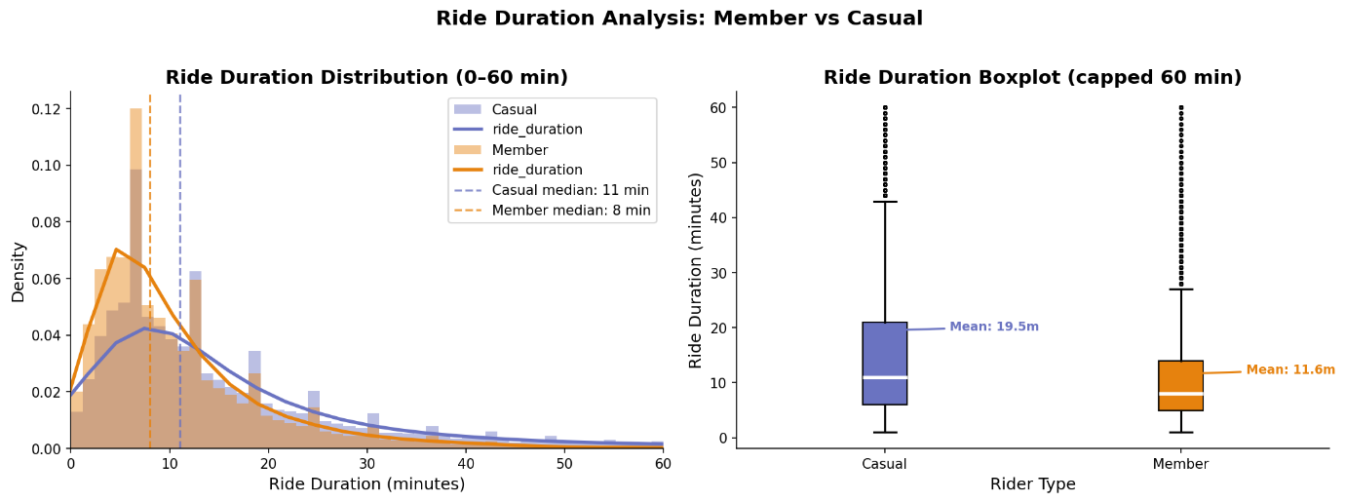

📊 Step 7: Duration Bucket Comparison
Analyzes ride distribution across predefined duration segments.
# ── Section 4: Duration Bucket Comparison ──
bucket_order = ['0–10 min', '11–20 min', '21–40 min', '40+ min']

bucket_data = df.groupby(['member_casual', 'duration_bucket'])\
.size().reset_index(name='rides')
bucket_data['pct'] = bucket_data.groupby('member_casual')['rides']\
.transform(lambda x: x / x.sum() * 100)

fig, ax = plt.subplots(figsize=(11, 6))

x = np.arange(len(bucket_order))
width = 0.35

for i, (rtype, color) in enumerate(
[('casual', COLORS['casual']), ('member', COLORS['member'])]):
vals = []
for b in bucket_order:
row = bucket_data[
(bucket_data['member_casual'] == rtype) &
(bucket_data['duration_bucket'] == b)
]
vals.append(row['pct'].values[0] if len(row) > 0 else 0)

bars = ax.bar(x + (i - 0.5) * width, vals, width,
label=rtype.capitalize(), color=color, alpha=0.88)

for bar, val in zip(bars, vals):
ax.text(bar.get_x() + bar.get_width()/2, bar.get_height() + 0.5,
f'{val:.1f}%', ha='center', va='bottom',
fontsize=9, fontweight='bold', color=color)

ax.set_xticks(x)
ax.set_xticklabels(bucket_order)
ax.set_title('Ride Duration Bucket Distribution by Rider Type')
ax.set_xlabel('Duration Bucket')
ax.set_ylabel('% of Rides (within rider type)')
ax.legend()
ax.set_ylim(0, 75)

plt.tight_layout()
plt.savefig('02_duration_buckets.png', dpi=150, bbox_inches='tight')
plt.show()
print("✅ Saved: 02_duration_buckets.png")
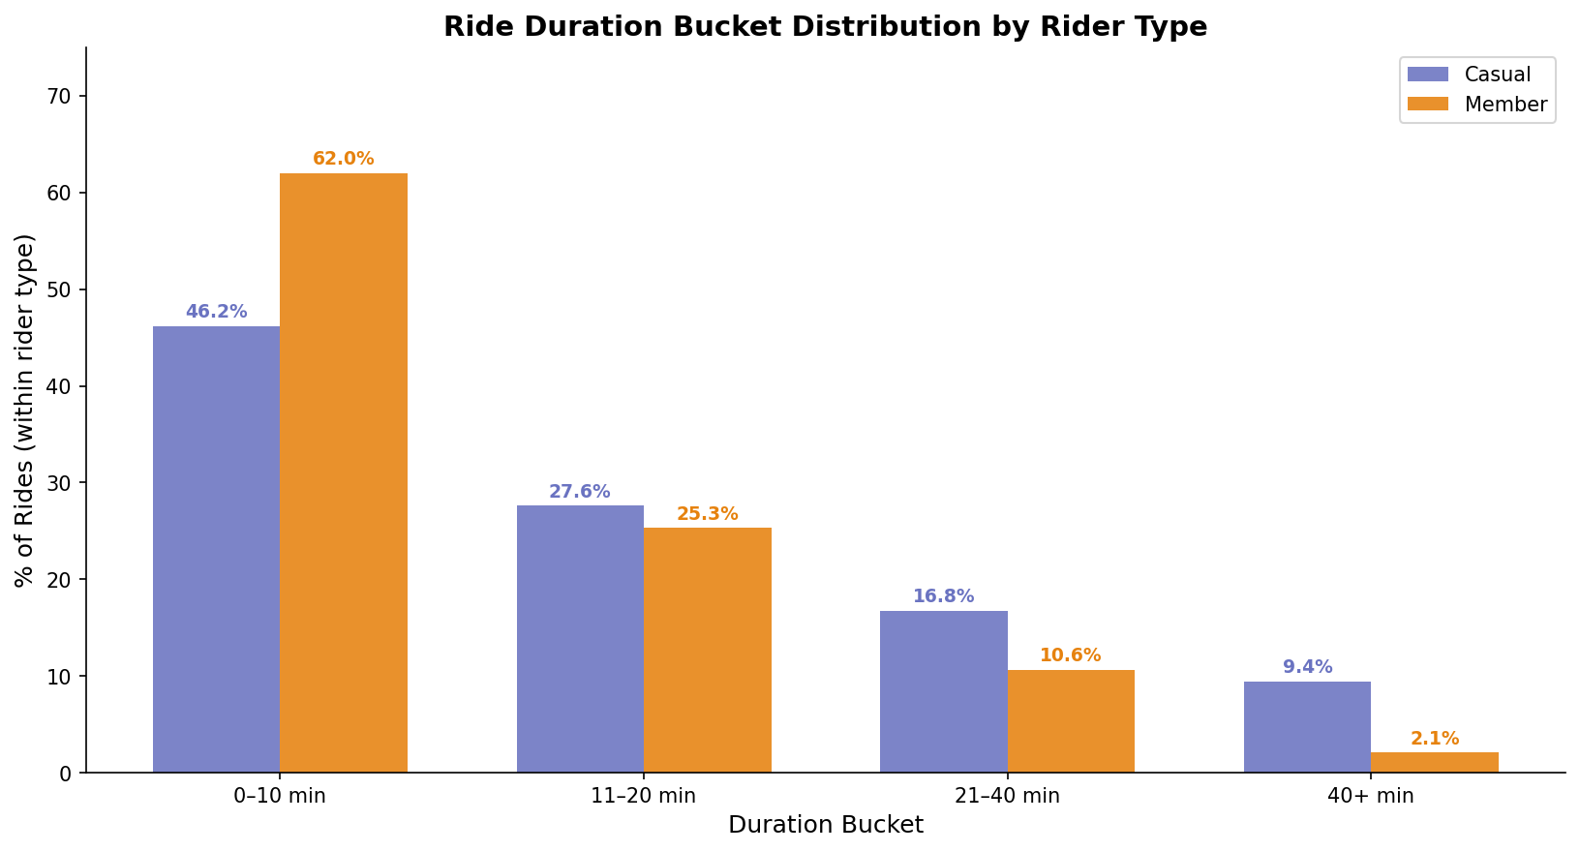

⏰ Step 8: Hourly Ride Pattern Analysis
Examines usage trends across 24-hour cycle.
# ── Section 5: Hourly Pattern ──
hourly = df.groupby(['member_casual', 'hour_of_day'])\
.size().reset_index(name='rides')

fig, ax = plt.subplots(figsize=(13, 6))

for rtype, color in [('casual', COLORS['casual']),
('member', COLORS['member'])]:
data = hourly[hourly['member_casual'] == rtype]
ax.plot(data['hour_of_day'], data['rides'],
color=color, linewidth=2.5, marker='o',
markersize=5, label=rtype.capitalize())
ax.fill_between(data['hour_of_day'], data['rides'],
alpha=0.12, color=color)

# Annotate commute peaks
for hour, label, offset in [(8, 'Morning\nCommute', 15),
(17, 'Evening\nCommute', 15)]:
m_val = hourly[(hourly['member_casual']=='member') &
(hourly['hour_of_day']==hour)]['rides'].values
if len(m_val):
ax.annotate(label,
xy=(hour, m_val[0]),
xytext=(hour, m_val[0] + offset),
fontsize=9, ha='center', color=COLORS['member'],
arrowprops=dict(arrowstyle='->',
color=COLORS['member'], lw=1.2))

ax.set_title('Hourly Ride Pattern: Member vs Casual')
ax.set_xlabel('Hour of Day')
ax.set_ylabel('Number of Rides (sample)')
ax.set_xticks(range(0, 24))
ax.set_xticklabels([f'{h:02d}:00' for h in range(24)],
rotation=45, fontsize=8)
ax.legend()

plt.tight_layout()
plt.savefig('03_hourly_pattern.png', dpi=150, bbox_inches='tight')
plt.show()
print("✅ Saved: 03_hourly_pattern.png")
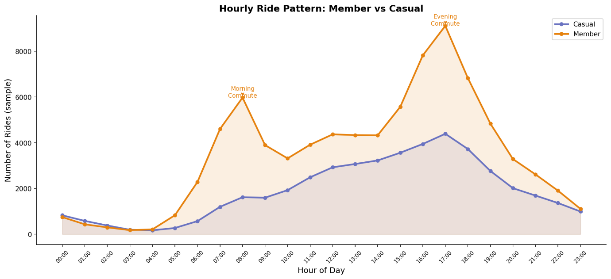

📅 Step 9: Weekly Usage Patterns
Comparison of weekday vs weekend behavior.
# ── Section 6: Day of Week ──
day_order = ['Monday','Tuesday','Wednesday',
'Thursday','Friday','Saturday','Sunday']

daily = df.groupby(['member_casual', 'day_of_week'])\
.size().reset_index(name='rides')

fig, axes = plt.subplots(1, 2, figsize=(14, 5))
fig.suptitle('Weekly Ride Patterns', fontsize=15,
fontweight='bold')

# Plot 1 — Side-by-side bars
ax1 = axes[0]
x = np.arange(len(day_order))
width = 0.38

for i, (rtype, color) in enumerate(
[('casual', COLORS['casual']), ('member', COLORS['member'])]):
vals = [daily[(daily['member_casual']==rtype) &
(daily['day_of_week']==d)]['rides'].values
for d in day_order]
vals = [v[0] if len(v) else 0 for v in vals]
ax1.bar(x + (i-0.5)*width, vals, width,
label=rtype.capitalize(), color=color, alpha=0.88)

ax1.set_xticks(x)
ax1.set_xticklabels([d[:3] for d in day_order])
ax1.set_title('Total Rides by Day')
ax1.set_ylabel('Rides (sample)')
ax1.legend()

# Add weekend shading
ax1.axvspan(4.6, 6.5, alpha=0.07, color='gray',
label='Weekend')
ax1.text(5.5, ax1.get_ylim()[1]*0.95, 'Weekend',
ha='center', fontsize=9, color='gray')

# Plot 2 — Avg duration by day
ax2 = axes[1]
dur_daily = df.groupby(['member_casual','day_of_week'])\
['ride_duration'].mean().reset_index()

for rtype, color in [('casual', COLORS['casual']),
('member', COLORS['member'])]:
vals = [dur_daily[(dur_daily['member_casual']==rtype) &
(dur_daily['day_of_week']==d)]['ride_duration'].values
for d in day_order]
vals = [v[0] if len(v) else 0 for v in vals]
ax2.plot(range(len(day_order)), vals, color=color,
linewidth=2.5, marker='s', markersize=6,
label=rtype.capitalize())

ax2.set_xticks(range(len(day_order)))
ax2.set_xticklabels([d[:3] for d in day_order])
ax2.set_title('Avg Duration by Day')
ax2.set_ylabel('Avg Duration (minutes)')
ax2.legend()
ax2.axvspan(4.6, 6.5, alpha=0.07, color='gray')

plt.tight_layout()
plt.savefig('04_weekly_pattern.png', dpi=150, bbox_inches='tight')
plt.show()
print("✅ Saved: 04_weekly_pattern.png")
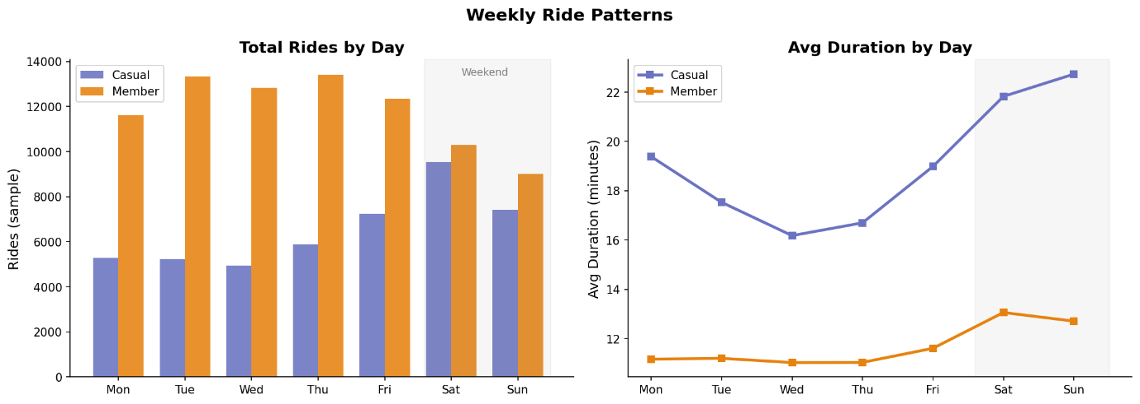

🚲 Step 10: Bike Type Usage Analysis
Examines preference and duration across bike types.
# ── Section 7: Bike Type Analysis ──
bike = df.groupby(['member_casual', 'rideable_type'])\
.agg(rides=('ride_duration','count'),
avg_dur=('ride_duration','mean'))\
.round(2).reset_index()

fig, axes = plt.subplots(1, 2, figsize=(13, 5))
fig.suptitle('Bike Type Usage Analysis', fontsize=15,
fontweight='bold')

bike_types = bike['rideable_type'].unique()
x = np.arange(len(bike_types))
width = 0.38

# Plot 1 — Ride count by bike type
ax1 = axes[0]
for i, (rtype, color) in enumerate(
[('casual', COLORS['casual']), ('member', COLORS['member'])]):
vals = [bike[(bike['member_casual']==rtype) &
(bike['rideable_type']==b)]['rides'].values
for b in bike_types]
vals = [v[0] if len(v) else 0 for v in vals]
ax1.bar(x + (i-0.5)*width, vals, width,
label=rtype.capitalize(), color=color, alpha=0.88)

ax1.set_xticks(x)
ax1.set_xticklabels([b.replace('_', '\n') for b in bike_types])
ax1.set_title('Ride Count by Bike Type')
ax1.set_ylabel('Rides (sample)')
ax1.legend()

# Plot 2 — Avg duration by bike type
ax2 = axes[1]
for i, (rtype, color) in enumerate(
[('casual', COLORS['casual']), ('member', COLORS['member'])]):
vals = [bike[(bike['member_casual']==rtype) &
(bike['rideable_type']==b)]['avg_dur'].values
for b in bike_types]
vals = [v[0] if len(v) else 0 for v in vals]
bars = ax2.bar(x + (i-0.5)*width, vals, width,
label=rtype.capitalize(), color=color, alpha=0.88)
for bar, val in zip(bars, vals):
ax2.text(bar.get_x() + bar.get_width()/2,
bar.get_height() + 0.3,
f'{val:.1f}m', ha='center', va='bottom',
fontsize=9, fontweight='bold', color=color)

ax2.set_xticks(x)
ax2.set_xticklabels([b.replace('_', '\n') for b in bike_types])
ax2.set_title('Avg Duration by Bike Type')
ax2.set_ylabel('Avg Duration (minutes)')
ax2.legend()

plt.tight_layout()
plt.savefig('05_bike_type.png', dpi=150, bbox_inches='tight')
plt.show()
print("✅ Saved: 05_bike_type.png")
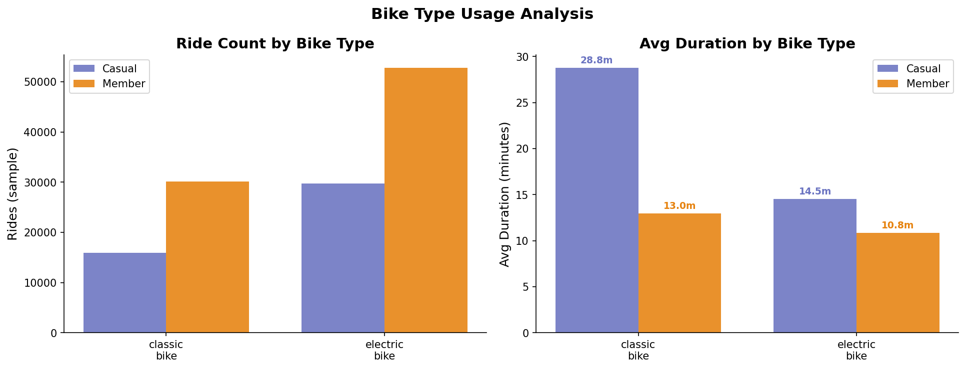

🔁 Step 11: Round Trip vs One-Way Analysis
# ── Section 8: Round Trip Analysis ──
rt = df.groupby(['member_casual', 'trip_type'])\
.size().reset_index(name='rides')
rt['pct'] = rt.groupby('member_casual')['rides']\
.transform(lambda x: x/x.sum()*100)

fig, ax = plt.subplots(figsize=(9, 5))

trip_types = rt['trip_type'].unique()
x = np.arange(len(trip_types))
width = 0.35

for i, (rtype, color) in enumerate(
[('casual', COLORS['casual']), ('member', COLORS['member'])]):
vals = [rt[(rt['member_casual']==rtype) &
(rt['trip_type']==t)]['pct'].values
for t in trip_types]
vals = [v[0] if len(v) else 0 for v in vals]
bars = ax.bar(x + (i-0.5)*width, vals, width,
label=rtype.capitalize(), color=color, alpha=0.88)
for bar, val in zip(bars, vals):
ax.text(bar.get_x() + bar.get_width()/2,
bar.get_height() + 0.5,
f'{val:.1f}%', ha='center', va='bottom',
fontsize=10, fontweight='bold', color=color)

ax.set_xticks(x)
ax.set_xticklabels(trip_types)
ax.set_title('Round Trip vs One-Way: Member vs Casual')
ax.set_xlabel('Trip Type')
ax.set_ylabel('% of Rides (within rider type)')
ax.legend()
ax.set_ylim(0, 110)

# Key insight annotation
ax.annotate('Casual riders take 3.7×\nmore round trips than members\n→ strong leisure signal',
xy=(0, rt[(rt['member_casual']=='casual') &
(rt['trip_type']=='Round Trip')]['pct'].values[0]),
xytext=(0.6, 25),
fontsize=9, color=COLORS['casual'],
arrowprops=dict(arrowstyle='->',
color=COLORS['casual'], lw=1.5),
bbox=dict(boxstyle='round,pad=0.3',
facecolor='white', edgecolor=COLORS['casual'],
alpha=0.8))

plt.tight_layout()
plt.savefig('06_round_trip.png', dpi=150, bbox_inches='tight')
plt.show()
print("✅ Saved: 06_round_trip.png")
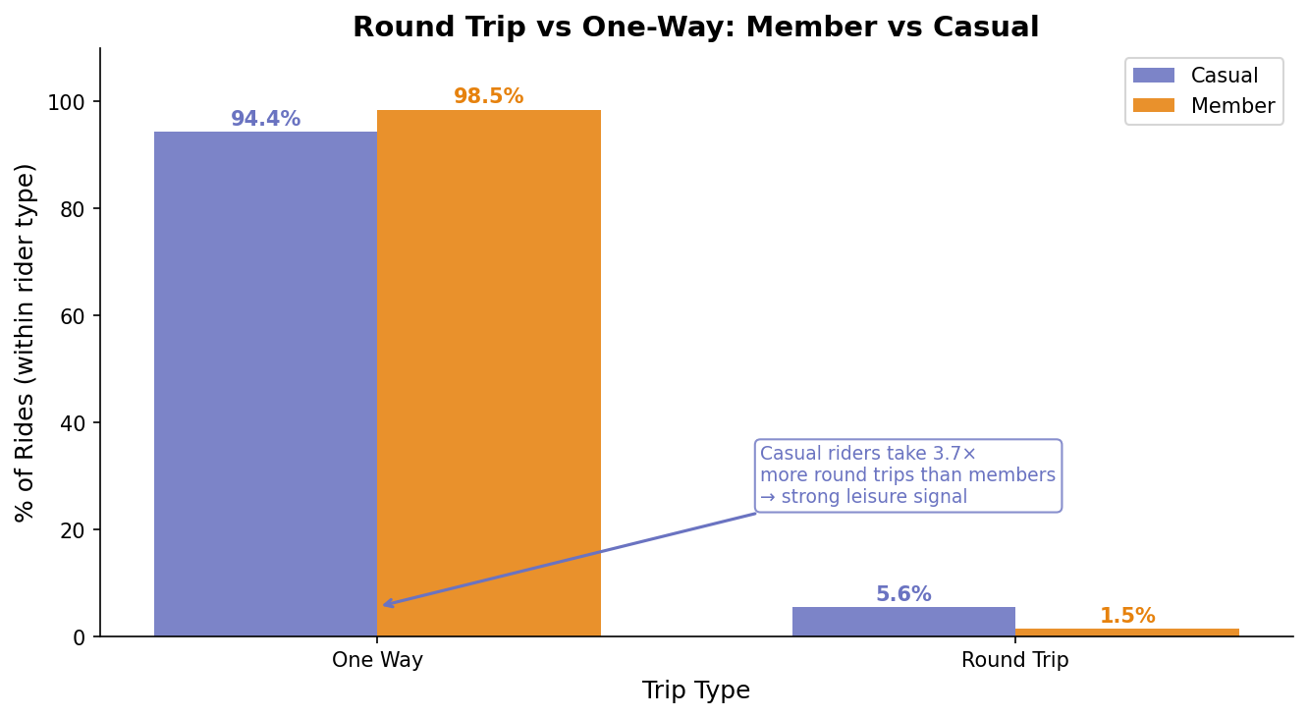

🔗 Step 12: Correlation Analysis
Evaluates relationships between key numeric variables.
# ── Section 9: Correlation Analysis ──
fig, axes = plt.subplots(1, 2, figsize=(13, 5))
fig.suptitle('Correlation Analysis by Rider Type',
fontsize=15, fontweight='bold')

numeric_cols = ['ride_duration', 'distance_miles', 'hour_of_day']

for i, (rtype, color, ax) in enumerate(zip(
['casual', 'member'],
[COLORS['casual'], COLORS['member']],
axes)):

subset = df[df['member_casual'] == rtype][numeric_cols]
corr = subset.corr()

mask = np.triu(np.ones_like(corr, dtype=bool))

sns.heatmap(corr, ax=ax, annot=True, fmt='.2f',
cmap='RdYlBu_r', center=0,
mask=mask,
square=True, linewidths=0.5,
annot_kws={'size': 11, 'weight': 'bold'},
vmin=-1, vmax=1)

ax.set_title(f'{rtype.capitalize()} Riders — Correlation Matrix',
color=color)
ax.set_xticklabels(
[c.replace('_', '\n') for c in numeric_cols],
rotation=0, fontsize=9)
ax.set_yticklabels(
[c.replace('_', '\n') for c in numeric_cols],
rotation=0, fontsize=9)

plt.tight_layout()
plt.savefig('07_correlation_heatmap.png', dpi=150,
bbox_inches='tight')
plt.show()
print("✅ Saved: 07_correlation_heatmap.png")
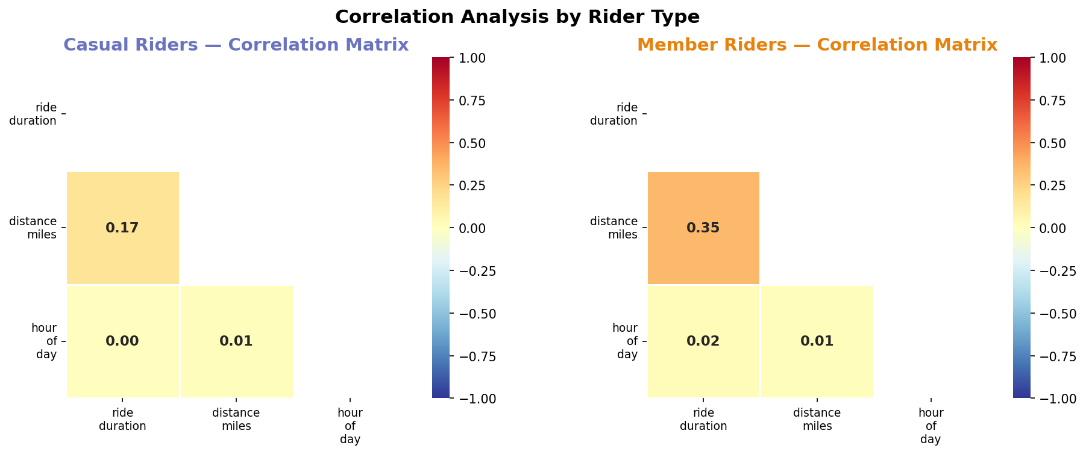

🌦️ Step 13: Seasonal Trend Analysis
# ── Section 10: Season Analysis ──
season_order = ['Spring', 'Summer', 'Autumn', 'Winter']
season_colors = {
'Spring': '#4CAF50', 'Summer': '#FF9800',
'Autumn': '#FF5722', 'Winter': '#2196F3'
}

seasonal = df.groupby(['member_casual', 'season'])\
.agg(rides=('ride_duration','count'),
avg_dur=('ride_duration','mean'))\
.reset_index()

fig, axes = plt.subplots(1, 2, figsize=(14, 5))
fig.suptitle('Seasonal Ride Patterns', fontsize=15,
fontweight='bold')

# Plot 1 — Rides by season
ax1 = axes[0]
x = np.arange(len(season_order))
width = 0.38

for i, (rtype, color) in enumerate(
[('casual', COLORS['casual']), ('member', COLORS['member'])]):
vals = [seasonal[(seasonal['member_casual']==rtype) &
(seasonal['season']==s)]['rides'].values
for s in season_order]
vals = [v[0] if len(v) else 0 for v in vals]
ax1.bar(x + (i-0.5)*width, vals, width,
label=rtype.capitalize(), color=color, alpha=0.88)

ax1.set_xticks(x)
ax1.set_xticklabels(season_order)
ax1.set_title('Total Rides by Season')
ax1.set_ylabel('Rides (sample)')
ax1.legend()

# Plot 2 — Avg duration by season
ax2 = axes[1]
for rtype, color in [('casual', COLORS['casual']),
('member', COLORS['member'])]:
vals = [seasonal[(seasonal['member_casual']==rtype) &
(seasonal['season']==s)]['avg_dur'].values
for s in season_order]
vals = [v[0] if len(v) else 0 for v in vals]
ax2.plot(range(len(season_order)), vals,
color=color, linewidth=2.5, marker='D',
markersize=8, label=rtype.capitalize())

ax2.set_xticks(range(len(season_order)))
ax2.set_xticklabels(season_order)
ax2.set_title('Avg Duration by Season')
ax2.set_ylabel('Avg Duration (minutes)')
ax2.legend()

plt.tight_layout()
plt.savefig('08_seasonal_analysis.png', dpi=150,
bbox_inches='tight')
plt.show()
print("✅ Saved: 08_seasonal_analysis.png")
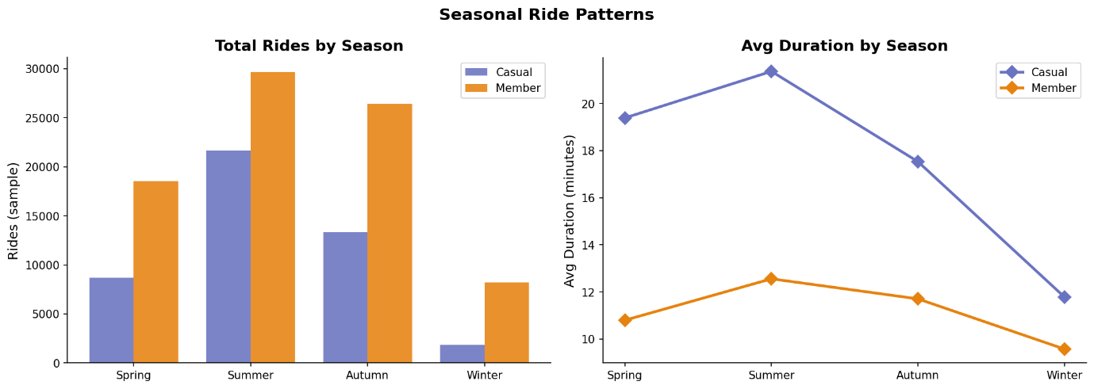

🧾 Step 14: Final Summary Report
Automated reporting of key insights.
# ── Section 11: Summary Statistics Report ──
print("=" * 60)
print(" CYCLISTIC 2025 — PYTHON ANALYSIS SUMMARY REPORT")
print("=" * 60)

m = df[df['member_casual']=='member']
c = df[df['member_casual']=='casual']

print(f"""
DATASET
Total sample rides : {len(df):,}
Members : {len(m):,} ({len(m)/len(df)*100:.1f}%)
Casual riders : {len(c):,} ({len(c)/len(df)*100:.1f}%)

RIDE DURATION
Member — Mean : {m['ride_duration'].mean():.2f} min
Member — Median : {m['ride_duration'].median():.0f} min
Casual — Mean : {c['ride_duration'].mean():.2f} min
Casual — Median : {c['ride_duration'].median():.0f} min
Duration gap : Casual rides {c['ride_duration'].mean()/m['ride_duration'].mean():.1f}x longer (mean)

STATISTICAL SIGNIFICANCE
Welch's T-test p-value : {p_value:.2e}
Cohen's d (effect size): {d:.4f} ({magnitude} effect)
Mann-Whitney p-value : {p_mw:.2e}
Conclusion: Difference in ride duration is STATISTICALLY
SIGNIFICANT (p < 0.001) with a {magnitude} effect size

DISTANCE
Member — Mean : {m['distance_miles'].mean():.2f} miles
Casual — Mean : {c['distance_miles'].mean():.2f} miles
Distance gap : Minimal — behavior differs in TIME not DISTANCE

ROUND TRIPS (leisure signal)
Casual round trip rate : {(c['trip_type']=='Round Trip').mean()*100:.1f}%
Member round trip rate : {(m['trip_type']=='Round Trip').mean()*100:.1f}%

TOP INSIGHTS
1. Casual riders take {c['ride_duration'].mean()/m['ride_duration'].mean():.1f}x longer rides
→ suggests leisure, not commuting
2. Members have clear 8am & 5pm peaks
→ confirms commuter behavior pattern
3. Casual riders prefer weekends; members prefer weekdays
→ different use cases, same product
4. Casual classic bike avg: {c[c['rideable_type']=='classic_bike']['ride_duration'].mean():.1f} min
vs member classic bike: {m[m['rideable_type']=='classic_bike']['ride_duration'].mean():.1f} min
→ largest gap is on classic bikes

FILES SAVED
01_ride_duration_distribution.png
02_duration_buckets.png
03_hourly_pattern.png
04_weekly_pattern.png
05_bike_type.png
06_round_trip.png
07_correlation_heatmap.png
08_seasonal_analysis.png
""")
print("=" * 60)
print(" ✅ ANALYSIS COMPLETE")
print("=" * 60)
============================================================
CYCLISTIC 2025 — PYTHON ANALYSIS SUMMARY REPORT
============================================================

DATASET
Total sample rides : 128,395
Members : 82,838 (64.5%)
Casual riders : 45,557 (35.5%)

RIDE DURATION
Member — Mean : 11.60 min
Member — Median : 8 min
Casual — Mean : 19.47 min
Casual — Median : 11 min
Duration gap : Casual rides 1.7x longer (mean)

STATISTICAL SIGNIFICANCE
Welch's T-test p-value : 0.00e+00
Cohen's d (effect size): -0.2577 (small effect)
Mann-Whitney p-value : 0.00e+00
Conclusion: Difference in ride duration is STATISTICALLY
SIGNIFICANT (p < 0.001) with a small effect size

DISTANCE
Member — Mean : 1.41 miles
Casual — Mean : 1.40 miles
Distance gap : Minimal — behavior differs in TIME not DISTANCE

ROUND TRIPS (leisure signal)
Casual round trip rate : 5.6%
Member round trip rate : 1.5%

TOP INSIGHTS
1. Casual riders take 1.7x longer rides
→ suggests leisure, not commuting
2. Members have clear 8am & 5pm peaks
→ confirms commuter behavior pattern
3. Casual riders prefer weekends; members prefer weekdays
→ different use cases, same product
4. Casual classic bike avg: 28.8 min
vs member classic bike: 13.0 min
→ largest gap is on classic bikes

FILES SAVED
01_ride_duration_distribution.png
02_duration_buckets.png
03_hourly_pattern.png
04_weekly_pattern.png
05_bike_type.png
06_round_trip.png
07_correlation_heatmap.png
08_seasonal_analysis.png

============================================================
✅ ANALYSIS COMPLETE
============================================================

