
Olist-Ecommerce-Analytics
E-COMMERCE BUSINESS INTELLIGENCE &
CUSTOMER EXPERIENCE ANALYTICS PLATFORM
Capstone Project Report
Python / Pandas | Streamlit | Plotly | Scikit-Learn

Analyst  Brojo Mohan Dutta | Period  September 2016 – October 2018 | Submitted  2026

AICTE | IBM SkillsBuild Data Analytics with AI Internship 2026
Field | Detail
Project Title | Olist-Ecommerce-Analytics
Domain | E-Commerce Analytics / Business Intelligence / Data Analytics / Machine Learning
Dataset | Olist Brazilian E-Commerce Public Dataset
Author | Brojo Mohan Dutta
Education | B.Sc. (Honours) Mathematics, Serampore College, University of Calcutta, 2025
Repository | https://github.com/brojomohan58-boop/Olist-Ecommerce-Analytics
Submission Context | AICTE | IBM SkillsBuild Data Analytics with AI Internship 2026

Table of Contents
1. Executive Summary
2. Introduction
3. Project Background
4. Problem Statement
5. Project Objectives
6. Dataset Description
7. Data Architecture
8. Data Preparation and Processing
9. Technology Stack
10. Application Architecture
11. Dashboard Modules
12. Business Questions Addressed
13. Machine Learning – Delay Predictor
14. Interactive Filtering
15. Analytical Methodology
16. Validation and Testing
17. Project Structure
18. Installation and Execution
19. GitHub Repository
20. Key Insights and Business Value
21. Limitations
22. Future Improvements
23. Project Outcome
24. Conclusion
25. Author Information

1. Executive Summary
This report documents the design, engineering, and validation of an end-to-end Business Intelligence and Customer Experience Analytics Platform built on the Olist Brazilian E-Commerce Public Dataset. The platform converts nine raw, relationally linked marketplace tables — customers, orders, order items, products, sellers, payments, reviews, and geolocation — into a governed analytical layer capable of supporting operational and strategic business decisions.
The delivered artifact is a production-style, multi-page Streamlit application exposing eight analytical modules: Executive Overview, Products & Categories, Delivery & Operations, Customer Experience, Payments, Regional Analysis, Seller Intelligence, and a machine-learning-driven Delay Predictor. Each module is powered by interactive Plotly visualizations and a centralized filtering engine that guarantees cross-page metric consistency.
The engineering approach followed six disciplined stages: (1) systematic data auditing, (2) cleaning and type correction, (3) construction of two purpose-built analytical grains, (4) KPI design and validation, (5) structured exploratory data analysis (EDA), and (6) leakage-controlled predictive modeling. A dedicated regression-test suite of eleven validation scripts was executed across the data pipeline and every dashboard module prior to submission, returning zero failures across all reported checks (see Section 16).
Analytical integrity was treated as a first-class constraint throughout the build: sales and freight values are never represented as profit in the absence of Cost of Goods Sold (COGS) data; statistical associations (e.g., delivery delay vs. review score) are never asserted as causal; and machine-learning outputs are surfaced strictly as probability estimates, never as deterministic guarantees. This discipline is what elevates the project from a technical demonstration to a defensible, decision-support-grade analytics platform, suitable for real operational use by a marketplace business.
The result is a reproducible, version-controlled, fully tested analytics application that demonstrates applied proficiency across the full data analyst lifecycle: data engineering, data modeling, KPI governance, exploratory analysis, BI dashboard development, applied machine learning, and software validation.

2. Introduction
Modern e-commerce marketplaces generate high-volume, high-dimensional transactional data spanning multiple interdependent domains: customer acquisition and geography, product catalog structure, order fulfillment and logistics, payment processing, and post-purchase satisfaction signals. The business value locked inside this data is rarely accessible through raw tables alone — it requires a structured analytical translation layer that connects granular records to well-defined business questions, governed KPIs, and interpretable, decision-ready insights.
This project was undertaken as the capstone deliverable of the AICTE | IBM SkillsBuild Data Analytics with AI Internship 2026, a program that explicitly emphasizes the responsible use of AI-assisted development tooling — in this case, IBM Bob — in combination with sound, independently verifiable analytical judgment. A central premise of the internship curriculum is that AI-assisted tools accelerate implementation velocity but do not, and cannot, substitute for the analyst's accountability over correct business logic, rigorous data validation, and honest interpretation of statistical results. This report reflects that principle throughout: every analytical claim made by the platform is scoped to what the underlying data can actually support.
The Olist Brazilian E-Commerce Public Dataset was selected as the analytical foundation for this capstone because it offers a realistic, multi-table view of marketplace operations — order lifecycle timestamps, item-level transaction detail, seller and customer geography, granular payment structures, and customer review scores — providing sufficient breadth and relational complexity to justify a genuine, multi-module BI platform rather than a single-table dashboard exercise.

3. Project Background
The Olist dataset contains anonymized order records from a real Brazilian e-commerce marketplace that connects small and medium-sized sellers to major online sales channels. The data spans orders placed between late 2016 and late 2018, structured across nine relational tables describing customers, orders, order items, products, sellers, payments, reviews, geolocation, and a Portuguese-to-English product category translation table.
Because this dataset reflects genuine production marketplace operations rather than a synthetic, single-purpose teaching sample, it exhibits characteristics typical of real-world operational data:
- Inconsistent completeness across tables — some fields (e.g., product dimensions, review comment text) are populated inconsistently.
- Unresolved order statuses — not every order resolves to a final delivered state within the observed window; some remain shipped, canceled, unavailable, or processing.
- A partial initial period — the final quarter of 2016 shows very low order volume relative to 2017–2018, indicating platform ramp-up rather than a mature, representative operating baseline.
- Structural field gaps — no cost-of-goods-sold (COGS) field exists anywhere in the schema, which permanently constrains any attempt at true profitability analysis.
This background directly shaped the analytical approach adopted in this project. Before any dashboard or model was constructed, every one of the nine source tables was audited individually — row counts, null distributions, duplicate keys, and referential integrity across joins were all inspected — and the analytical scope of the platform was deliberately and explicitly narrowed to what the dataset could honestly support. Where the data could not support a claim (e.g., profit, guaranteed causation), the platform does not make that claim.

4. Problem Statement
Marketplace operators modeled on the Olist structure require integrated visibility into how sales performance, delivery reliability, and customer satisfaction interact across product categories, geographic regions, and individual sellers. This visibility does not exist by default within raw relational transaction data: order, item, payment, and review records are distributed across separate tables at different natural levels of granularity (order-level vs. item-level), making it structurally difficult — and analytically risky — to answer even basic operational questions without a purpose-built analytical layer that correctly respects those grains.
This project addresses that gap directly. It delivers a unified, validated analytics platform capable of answering, with defensible rigor:
- Where does the business generate sales, and how has that evolved over time?
- How reliably are orders delivered relative to their estimated delivery date?
- How does delivery performance relate to customer satisfaction — understood as an association, not a proven cause?
- How do customers pay, and how does installment behavior vary?
- Which regions and sellers drive marketplace activity and scale?
- Can delivery-delay risk be estimated before an order's final outcome is known, using only information available at or near order placement?
Every one of these questions is answered without overstating what the available data can prove — a constraint that governs every downstream design decision in this report.

5. Project Objectives
The project was scoped and executed against the following nine objectives:
- Audit and clean the nine raw Olist datasets into analysis-ready, type-correct, deduplicated form.
- Establish a data architecture appropriate to the two distinct natural grains present in the data — order-level and order-item-level — rather than forcing a single flattened table.
- Define business-relevant KPIs that can be correctly and consistently calculated from the fields actually available in the schema.
- Conduct structured exploratory data analysis (EDA) to surface observations, insights, and testable hypotheses across the sales, delivery, and customer-experience domains.
- Develop a delivery-delay risk prediction component using strictly leakage-safe features and probability-based outputs.
- Build an interactive, multi-page Streamlit application that presents the full analysis to a business-stakeholder audience.
- Apply centralized, consistent filtering across all eight dashboard pages, eliminating the risk of cross-page metric drift.
- Validate the correctness of the data pipeline, every KPI calculation, every chart, and overall application behavior through structured, automated test scripts.
- Document the platform's methodology, architecture, and limitations transparently, so that evaluators and future maintainers understand exactly what the platform can and cannot claim.

6. Dataset Description
The project uses the Olist Brazilian E-Commerce Public Dataset, composed of the following nine source files:
# | File | Description
1 | olist_customers_dataset.csv | Customer identifiers and location (city, state, zip code prefix)
2 | olist_geolocation_dataset.csv | Latitude/longitude reference data indexed by zip code prefix
3 | olist_order_items_dataset.csv | Line-item detail per order: product, seller, price, freight value
4 | olist_order_payments_dataset.csv | Payment type, number of installments, and payment value per order
5 | olist_order_reviews_dataset.csv | Customer review score and review timestamps per order
6 | olist_orders_dataset.csv | Order status and full lifecycle timestamps
7 | olist_products_dataset.csv | Product category and physical dimension attributes
8 | olist_sellers_dataset.csv | Seller identifiers and seller location
9 | product_category_name_translation.csv | Mapping from Portuguese to English product category names
These nine tables were joined, cleaned, and transformed into the analytical datasets described in Section 7. Each source table was profiled independently prior to any join operation, confirming primary-key uniqueness where applicable (e.g., order_id in olist_orders_dataset.csv) and cardinality on foreign-key relationships (e.g., the one-to-many relationship between orders and order_items).

7. Data Architecture
A central architectural decision in this project is the deliberate use of two distinct analytical grains rather than a single flattened, denormalized table. This decision underpins the correctness of every KPI in the platform.

7.1 Order-Level Dataset — master_df
- Grain: One row per order
- Validated shape: 99,441 rows × 42 columns
- Used for: order-count KPIs, sales and order-level metrics, delivery analysis, customer experience, review analysis, payment analysis, regional analysis, and order-status analysis

7.2 Order-Item-Level Dataset — order_item_master
- Grain: One row per order item
- Validated shape: 112,650 rows × 35 columns
- Used for: product analysis, category analysis, seller analysis, item-level sales, item quantity, freight analysis, and product/category trend analysis

7.3 Why Two Grains Are Structurally Necessary
A single order can legitimately contain multiple order items — potentially spanning multiple products and, in some cases, multiple sellers. If item-level records are merged directly into an order-level table without prior aggregation, every order-level field becomes duplicated once per item, silently inflating any metric that should represent a single order exactly once.
Concretely: an order containing three items would appear three times in a naively flattened join, causing order-count-based KPIs — such as Total Orders or Average Order Value — to be systematically overstated. The inverse failure mode is equally damaging: collapsing all item-level detail into an order-level aggregate discards the granularity required for product- and seller-level analysis, such as category-level sales comparisons or seller performance ranking.
By maintaining master_df strictly at the order grain and order_item_master strictly at the item grain, every analytical question in the platform is routed to the dataset whose granularity matches the question:
Order-level question -> master_df (e.g., total orders, AOV, delivery time)
Item-level question -> order_item_master (e.g., category sales, seller ranking)
This design decision is enforced programmatically throughout src/kpis.py and src/charts.py, and is directly covered by the automated KPI validation suite described in Section 16.

7.4 Entity Relationship Overview
customers --1:N-- orders --1:N-- order_items --N:1-- products --N:1-- category_translation
| |
| +--N:1-- sellers --1:N-- geolocation (seller zip)
|
+--1:N-- order_payments
+--1:1-- order_reviews

customers --N:1-- geolocation (customer zip)

8. Data Preparation and Processing
The data preparation workflow followed a strict, auditable sequence:
- Data loading — all nine raw CSV files loaded and row/column counts verified against expected reference values.
- Data cleaning — datetime parsing and type correction, deduplication, and explicit column-by-column handling of missing values.
- Data transformation — category name translation, geolocation deduplication, and text-field standardization.
- Derived fields — delivery time in days, delivery delay in days, and the binary delay target (is_delayed), calculated only for orders with a valid delivered status and a non-null actual delivery date.
- Analytical dataset construction — assembly of the two analytical grains described in Section 7, plus a dedicated, leakage-safe machine-learning dataset.
- Post-transformation validation — row counts, null distributions, and target class balance re-checked after every transformation step.
- Full-suite validation — KPI validation, chart validation, application validation, and regression testing, detailed in Section 16.
The final analytical datasets produced by this pipeline are:
- data/olist_master_cleaned.csv
- data/olist_order_item_master.csv
- data/ml_delay_dataset.csv

8.1 Default Dashboard Filter Configuration
To guarantee consistent and comparable analysis across the platform, the following default filters are applied on every dashboard page at application startup:
Filter | Default Value
Date Start | 2017-01-01
Date End | 2018-10-17
Order Status | Delivered
Include 2016 | OFF
These defaults deliberately exclude the low-volume, non-representative partial period of 2016, and restrict analysis by default to orders that reached a resolved delivered status, ensuring that delivery and customer-experience metrics are calculated on a consistent, resolved population. These values are treated as validated defaults and are not altered without explicit, documented justification.

8.2 Data Cleaning and Merge Pipeline (Python / pandas)
The following script demonstrates the core cleaning logic applied to the raw Olist tables, including datetime parsing, geolocation and review null handling, and construction of the item-level analytical grain.
"""
data_pipeline.py
Cleans and merges the raw Olist tables into the two analytical grains
used throughout the BI platform: master_df (order-level) and
order_item_master (item-level).
"""

import pandas as pd
import numpy as np

RAW_PATH = "raw/"
OUT_PATH = "data/"

# 1. LOAD RAW TABLES
customers = pd.read_csv(f"{RAW_PATH}olist_customers_dataset.csv")
orders = pd.read_csv(f"{RAW_PATH}olist_orders_dataset.csv")
order_items = pd.read_csv(f"{RAW_PATH}olist_order_items_dataset.csv")
payments = pd.read_csv(f"{RAW_PATH}olist_order_payments_dataset.csv")
reviews = pd.read_csv(f"{RAW_PATH}olist_order_reviews_dataset.csv")
products = pd.read_csv(f"{RAW_PATH}olist_products_dataset.csv")
sellers = pd.read_csv(f"{RAW_PATH}olist_sellers_dataset.csv")
geoloc = pd.read_csv(f"{RAW_PATH}olist_geolocation_dataset.csv")
cat_trans = pd.read_csv(f"{RAW_PATH}product_category_name_translation.csv")

# 2. DATETIME PARSING (orders table)
date_cols = [
"order_purchase_timestamp", "order_approved_at",
"order_delivered_carrier_date", "order_delivered_customer_date",
"order_estimated_delivery_date",
]
for col in date_cols:
orders[col] = pd.to_datetime(orders[col], errors="coerce")

reviews["review_creation_date"] = pd.to_datetime(reviews["review_creation_date"], errors="coerce")
reviews["review_answer_timestamp"] = pd.to_datetime(reviews["review_answer_timestamp"], errors="coerce")

# 3. GEOLOCATION CLEANING - collapse multiple lat/long rows per zip
geoloc_clean = (
geoloc.groupby("geolocation_zip_code_prefix", as_index=False)
.agg(geolocation_lat=("geolocation_lat", "median"),
geolocation_lng=("geolocation_lng", "median"),
geolocation_city=("geolocation_city", "first"),
geolocation_state=("geolocation_state", "first"))
)
geoloc_clean["geolocation_state"] = geoloc_clean["geolocation_state"].str.upper()

# 4. REVIEWS CLEANING - handle missing comment text, dedupe by order
reviews["review_comment_title"] = reviews["review_comment_title"].fillna("")
reviews["review_comment_message"] = reviews["review_comment_message"].fillna("")
reviews_clean = (
reviews.sort_values("review_answer_timestamp")
.drop_duplicates(subset="order_id", keep="last")
)

# 5. CATEGORY TRANSLATION
products = products.merge(cat_trans, on="product_category_name", how="left")
products["product_category_name_english"] = products["product_category_name_english"].fillna("unknown_category")

# 6. CUSTOMER / SELLER GEOGRAPHY STANDARDIZATION
customers["customer_state"] = customers["customer_state"].str.upper()
customers["customer_city"] = customers["customer_city"].str.title()
sellers["seller_state"] = sellers["seller_state"].str.upper()
sellers["seller_city"] = sellers["seller_city"].str.title()

# 7. DERIVED DELIVERY FIELDS - only for resolved, delivered orders
delivered_mask = (
(orders["order_status"] == "delivered")
& orders["order_delivered_customer_date"].notna()
)

orders["delivery_time_days"] = np.where(
delivered_mask,
(orders["order_delivered_customer_date"] - orders["order_purchase_timestamp"]).dt.days,
np.nan,
)
orders["delivery_delay_days"] = np.where(
delivered_mask,
(orders["order_delivered_customer_date"] - orders["order_estimated_delivery_date"]).dt.days,
np.nan,
)
orders["is_delayed"] = np.where(
delivered_mask,
(orders["order_delivered_customer_date"] > orders["order_estimated_delivery_date"]).astype(int),
np.nan,
)

# 8. ORDER-LEVEL GRAIN - master_df (one row per order)
master_df = (
orders
.merge(customers, on="customer_id", how="left")
.merge(reviews_clean, on="order_id", how="left")
.merge(
payments.groupby("order_id", as_index=False).agg(
payment_value=("payment_value", "sum"),
payment_installments=("payment_installments", "max"),
payment_type=("payment_type", "first")),
on="order_id", how="left")
.merge(
geoloc_clean.rename(columns={"geolocation_zip_code_prefix": "customer_zip_code_prefix"}),
on="customer_zip_code_prefix", how="left")
)

# 9. ITEM-LEVEL GRAIN - order_item_master (one row per order item)
order_item_master = (
order_items
.merge(orders[["order_id", "order_status", "order_purchase_timestamp", "customer_id"]],
on="order_id", how="left")
.merge(products, on="product_id", how="left")
.merge(sellers, on="seller_id", how="left")
.merge(customers[["customer_id", "customer_state", "customer_city"]],
on="customer_id", how="left")
)

# 10. VALIDATION CHECKPOINT
assert master_df.shape[0] == orders["order_id"].nunique(), "master_df grain violated"
assert order_item_master.shape[0] == order_items.shape[0], "item grain violated"

print(f"master_df: {master_df.shape}")
print(f"order_item_master: {order_item_master.shape}")

# 11. PERSIST ANALYTICAL DATASETS
master_df.to_csv(f"{OUT_PATH}olist_master_cleaned.csv", index=False)
order_item_master.to_csv(f"{OUT_PATH}olist_order_item_master.csv", index=False)
This pipeline enforces the two-grain architecture programmatically (Section 7), applies null-handling decisions explicitly rather than implicitly, and produces the exact validated shapes reported in Sections 7.1 and 7.2.

9. Technology Stack
Technology | Role in the Project
Python | Core programming language for data processing, analysis, and application logic
Pandas | Data loading, cleaning, transformation, aggregation, and construction of the two analytical grains
NumPy | Numerical operations and vectorized calculations, including derived delivery and delay fields
Plotly | Interactive chart rendering within the Streamlit dashboard pages
Streamlit | Web application framework used to build the multi-page BI dashboard interface
Scikit-learn | Machine learning model training and probability prediction for the delivery-delay predictor
Git | Version control for source code and application history
GitHub | Remote repository hosting, project publication, and submission reference
Git LFS | Large File Storage, used to track the analytical CSV datasets within the GitHub repository
PowerShell | Command-line environment used for local environment setup and application execution on Windows

10. Application Architecture
The platform is implemented as a Streamlit multi-page application with a strict separation between the presentation layer (pages) and the analytical logic layer (source modules). This separation is not cosmetic — it is what allows the centralized filtering system (Section 14) and the validation suite (Section 16) to operate deterministically against shared, single-source-of-truth logic rather than per-page duplicated code.
Main application entry point: app.py
Dashboard pages:
- pages/01_overview.py
- pages/02_products_categories.py
- pages/03_delivery_operations.py
- pages/04_customer_experience.py
- pages/05_payments.py
- pages/06_regional.py
- pages/07_sellers.py
- pages/08_ml_delay_predictor.py
Core analytical modules:
Module | Responsibility
src/data_loader.py | Loads the cleaned analytical datasets and prepares them for downstream use, with caching
src/filters.py | Implements the centralized filtering system applied consistently across all dashboard pages
src/kpis.py | Calculates the validated business KPIs used throughout the dashboards
src/charts.py | Builds the Plotly visualizations used across all dashboard pages
src/ml_module.py | Contains the delivery-delay prediction model logic, feature preparation, and probability output

10.1 Sample Application Entry Point and Centralized Filter Routing
"""
app.py
Streamlit multipage entry point. Loads cleaned datasets once (cached),
initializes the centralized filter state, and renders the landing page.
"""

import streamlit as st
from src.data_loader import load_master_data, load_item_data
from src.filters import init_filter_state, render_filter_sidebar, apply_filters

st.set_page_config(
page_title="Olist E-Commerce BI Platform",
page_icon="\U0001F4E6",
layout="wide",
initial_sidebar_state="expanded",
)

# 1. LOAD DATA ONCE - cached across all pages in the session
@st.cache_data(show_spinner="Loading analytical datasets...")
def load_all_data():
master_df = load_master_data("data/olist_master_cleaned.csv")
item_df = load_item_data("data/olist_order_item_master.csv")
return master_df, item_df

master_df, item_df = load_all_data()

# 2. INITIALIZE CENTRALIZED FILTER STATE (session-wide, cross-page)
init_filter_state(
default_start="2017-01-01",
default_end="2018-10-17",
default_status="delivered",
include_2016=False,
)

render_filter_sidebar()

# 3. APPLY CENTRALIZED FILTERS - identical call signature on every page
filtered_master = apply_filters(master_df, grain="order")
filtered_items = apply_filters(item_df, grain="item")

st.session_state["filtered_master"] = filtered_master
st.session_state["filtered_items"] = filtered_items

# 4. LANDING CONTENT
st.title("E-Commerce Business Intelligence Platform")
st.markdown(
"""
Use the sidebar to navigate between analytical modules:
Overview, Products & Categories, Delivery & Operations,
Customer Experience, Payments, Regional, Sellers, Delay Predictor.

All pages share the same filtered population, defined in the sidebar,
guaranteeing consistent cross-page metrics.
"""
)
st.metric("Orders in current filter", f"{filtered_master.shape[0]:,}")
Each dashboard page under pages/ imports st.session_state['filtered_master'] / st.session_state['filtered_items'] rather than re-implementing its own filter logic — enforcing the centralized filtering principle described in Section 14 at the code level, not merely as a design intention.

11. Dashboard Modules

11.1 Section 1 — Executive Overview
The Executive Overview page provides a high-level summary of overall business performance, including sales performance, order volume, core business KPIs, and time-based trends. It is designed to give a management-level audience a quick, consolidated view of how the business is performing over the selected filter period, without requiring navigation into the more detailed operational pages.
Key KPIs presented: Total Sales Value, Total Orders, Average Order Value (AOV), Month-over-Month Growth, Delivered vs. Non-Delivered Order Split.
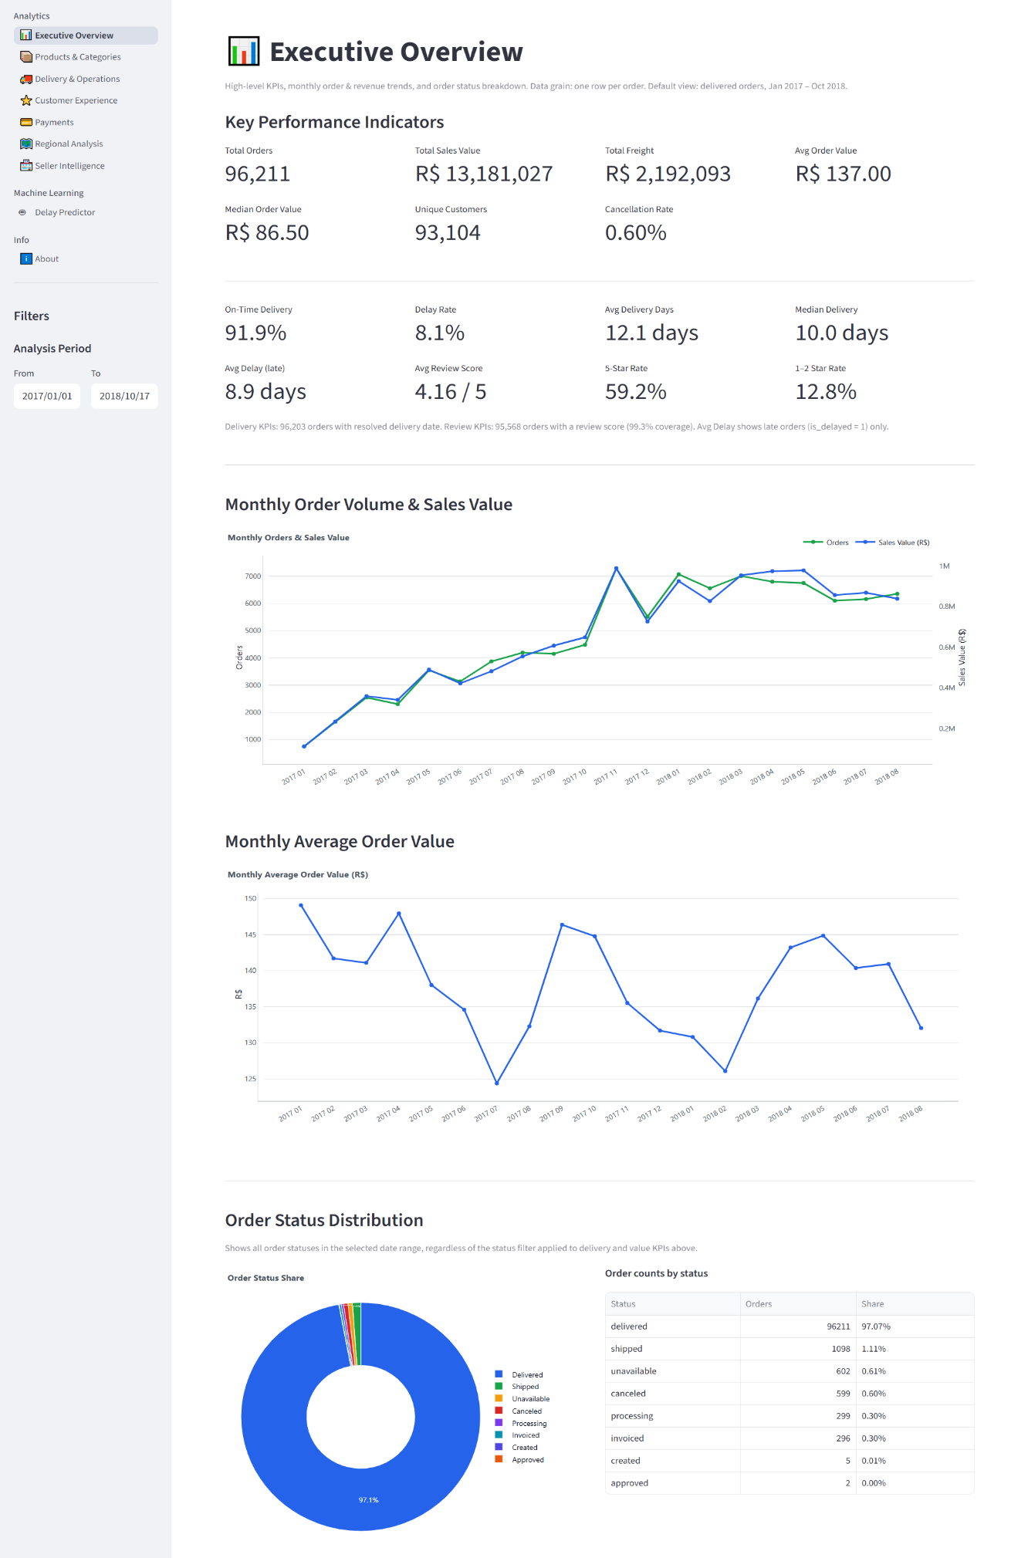

11.2 Section 2 — Products & Categories
The Products & Categories page operates on the item-level analytical grain (order_item_master) and presents sales value by category, items sold, average item price, average freight value, monthly item-sales trends, and a comparison of category price against volume, along with category-level detail views.
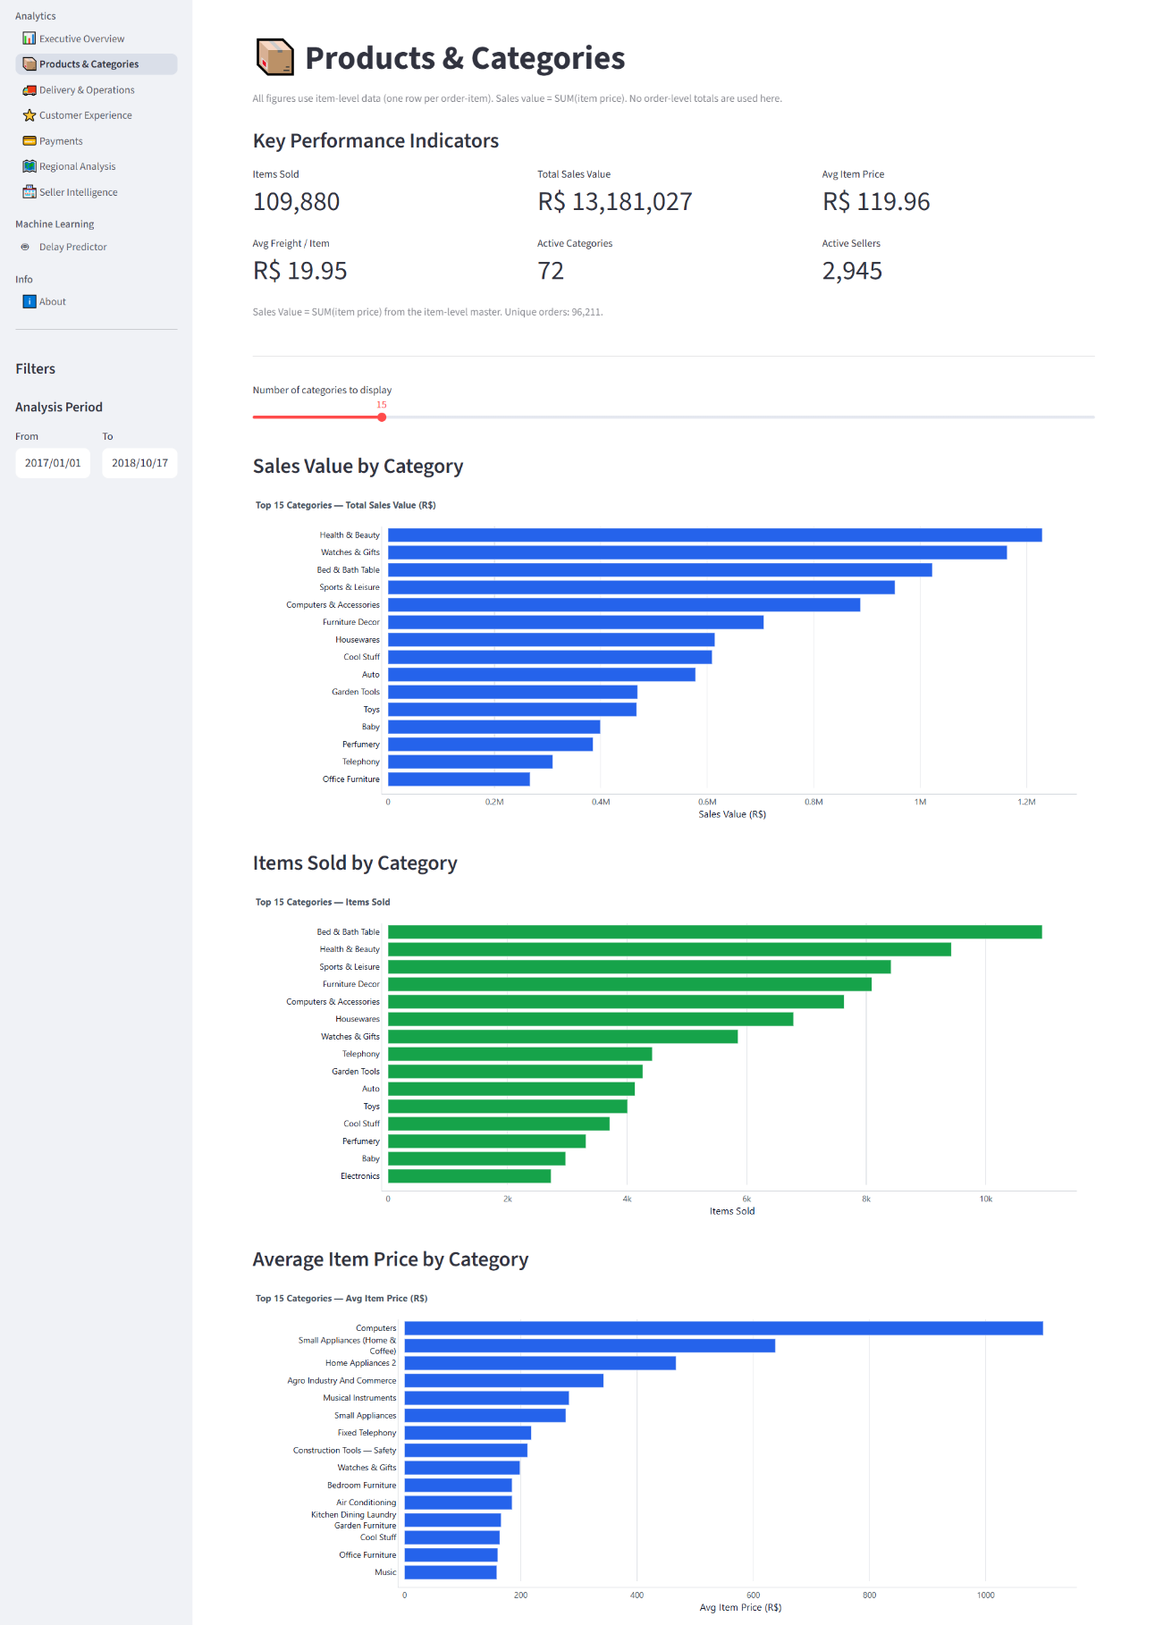

11.3 Section 3 — Delivery & Operations
The Delivery & Operations page analyzes delivery time, the relationship between estimated and actual delivery dates, delayed-order rates, delivery performance trends over time, and related operational KPIs. Delivery performance is presented strictly as a factor that may relate to customer experience; the platform does not claim delivery performance is the sole or proven cause of customer-experience outcomes.
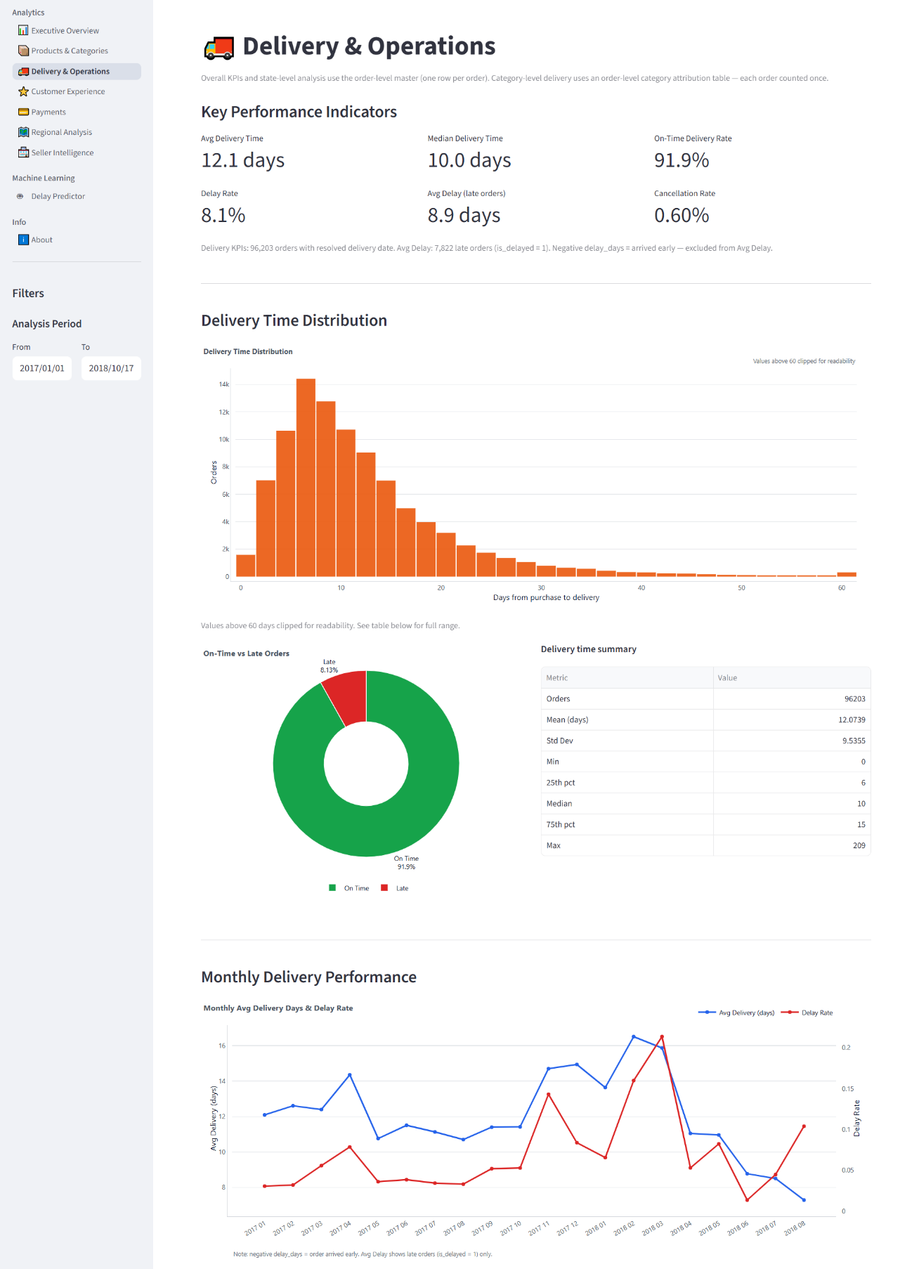

11.4 Section 4 — Customer Experience
The Customer Experience page analyzes review-score distributions, customer-experience patterns, and the relationship between delivery outcomes and customer-experience metrics.
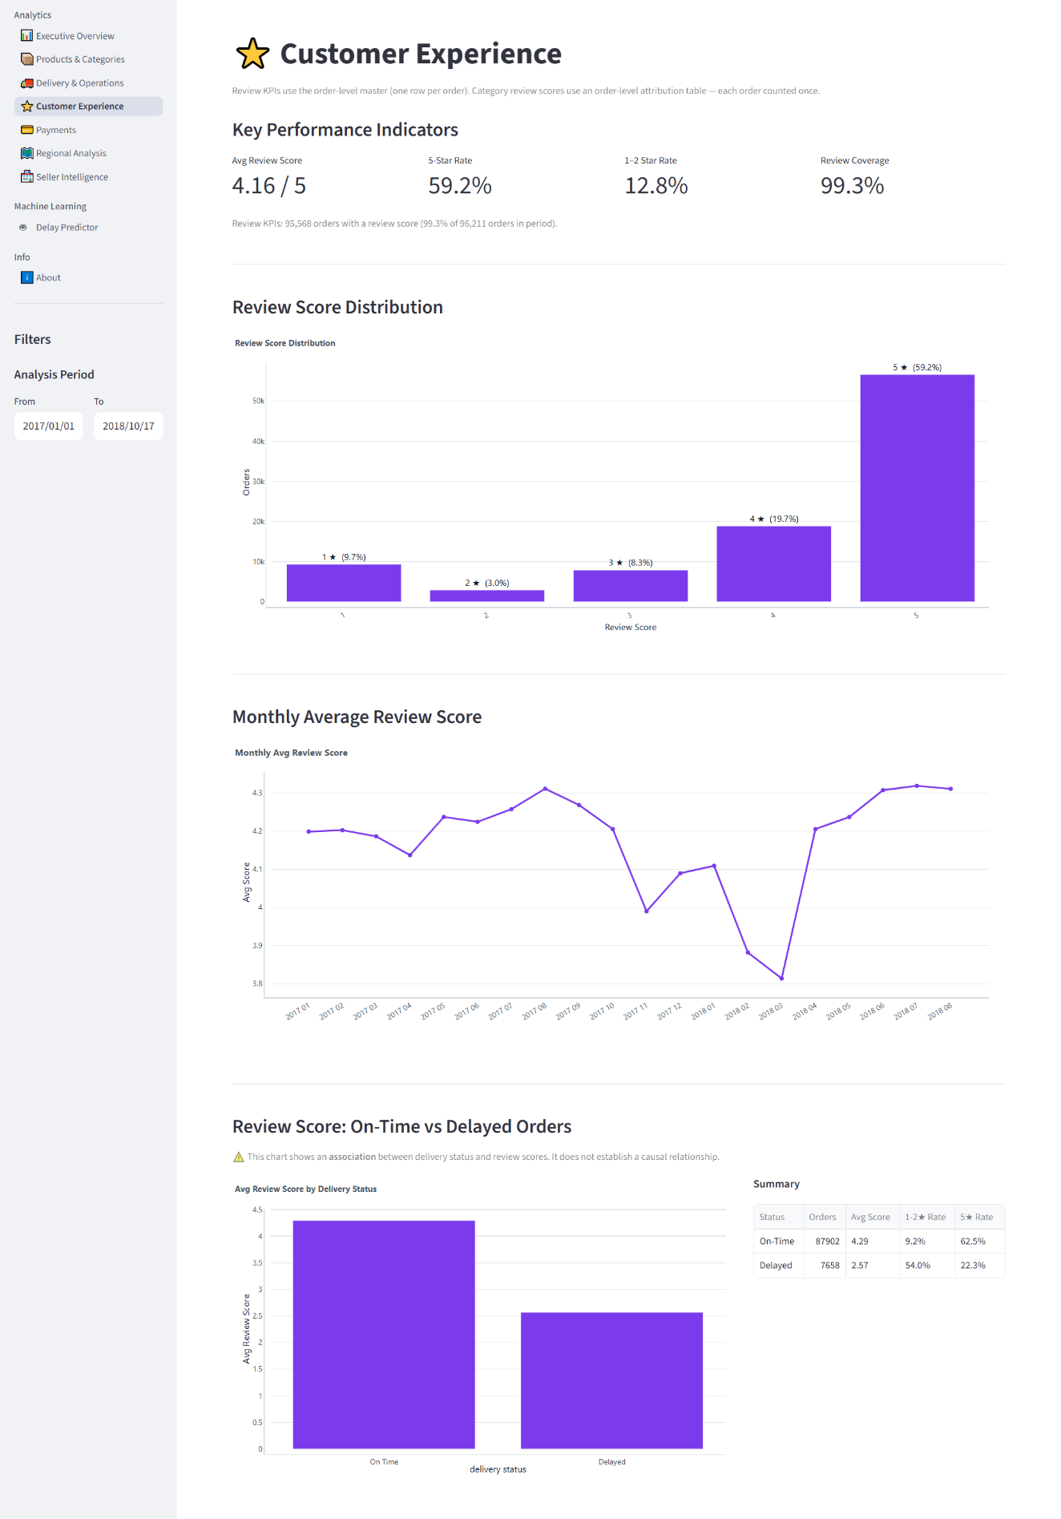

11.5 Section 5 — Payments
The Payments page analyzes payment methods, payment values, installment behavior, payment-value distributions, and payment trends over time.
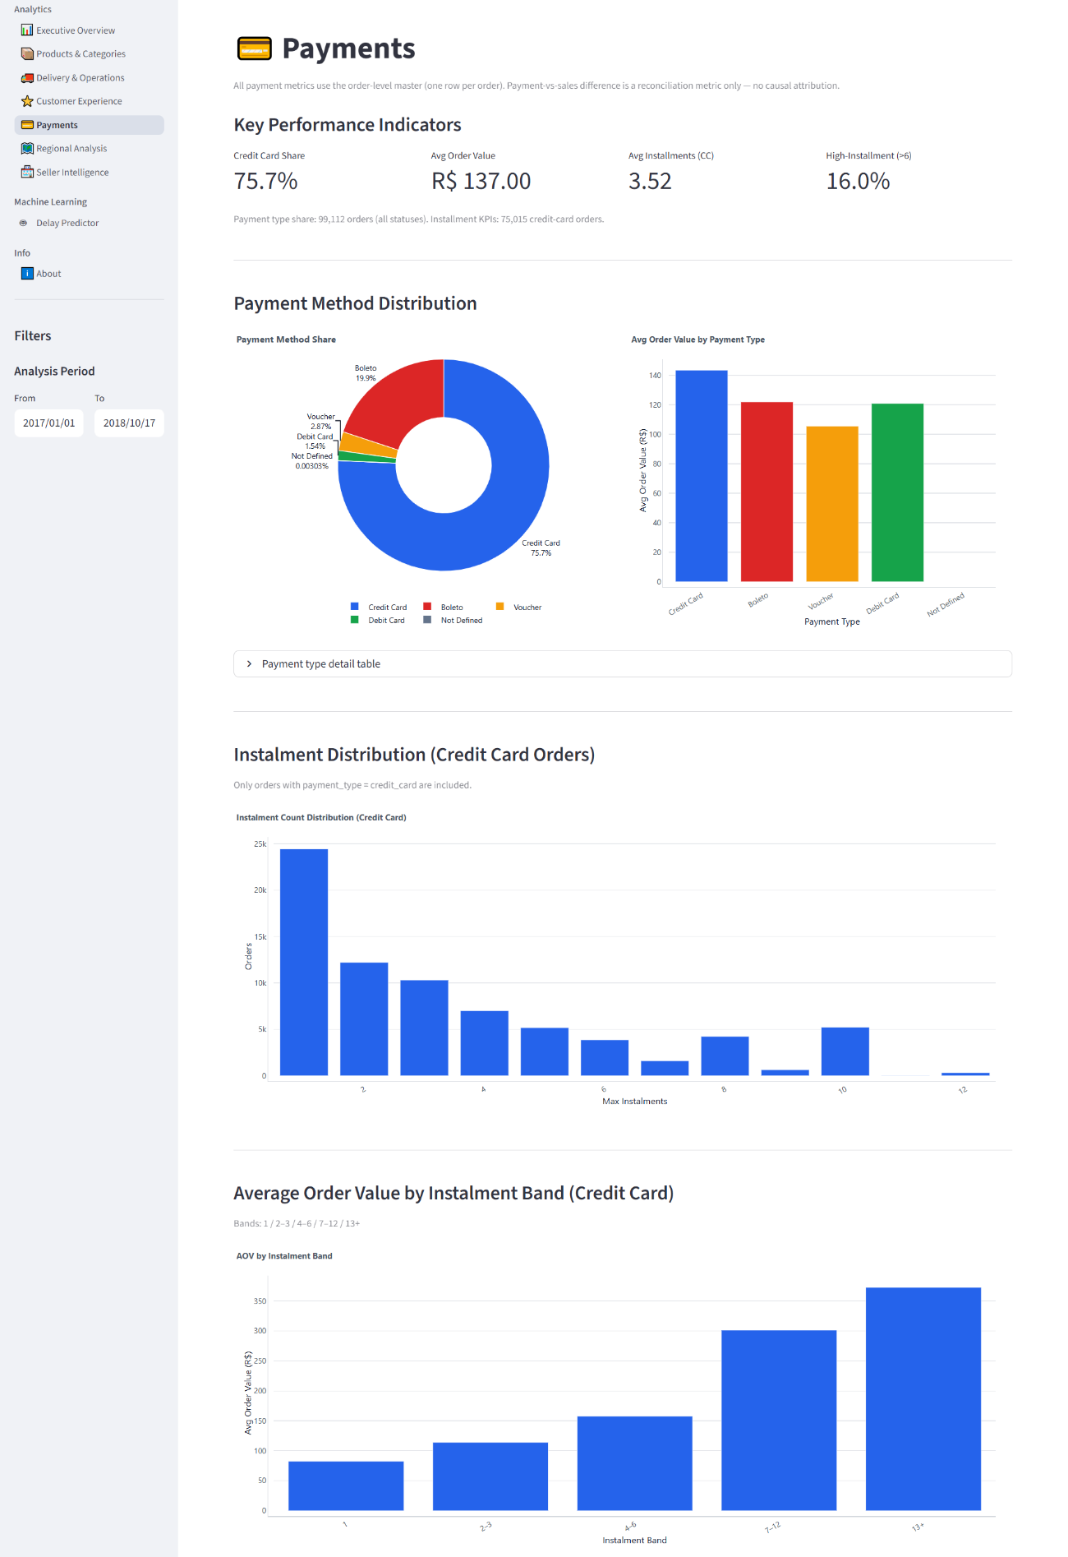

11.6 Section 6 — Regional Analysis
The Regional Analysis page examines customer locations, seller and customer regions, state-level performance, and regional order and sales activity.
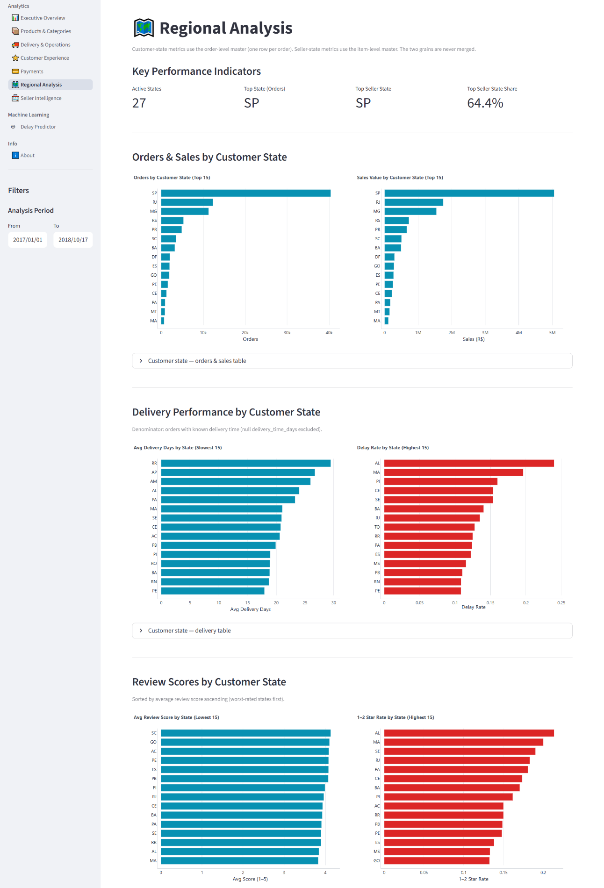

11.7 Section 7 — Seller Intelligence
The Seller Intelligence page uses the item-level analytical grain to analyze seller sales value, items sold, seller activity levels, freight-related metrics, and rankings of top sellers by sales value and item activity.
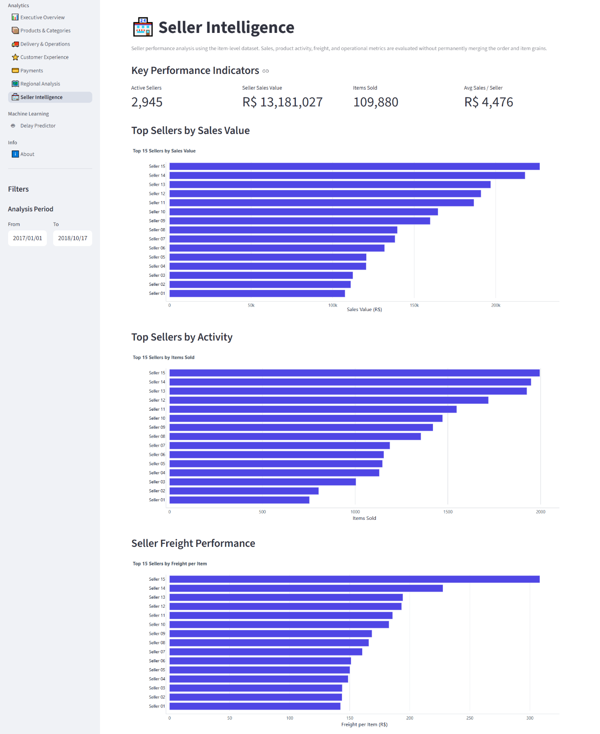

11.8 Section 8 — Delay Predictor
The Delay Predictor page presents the machine-learning component of the platform, described in full in Section 13.
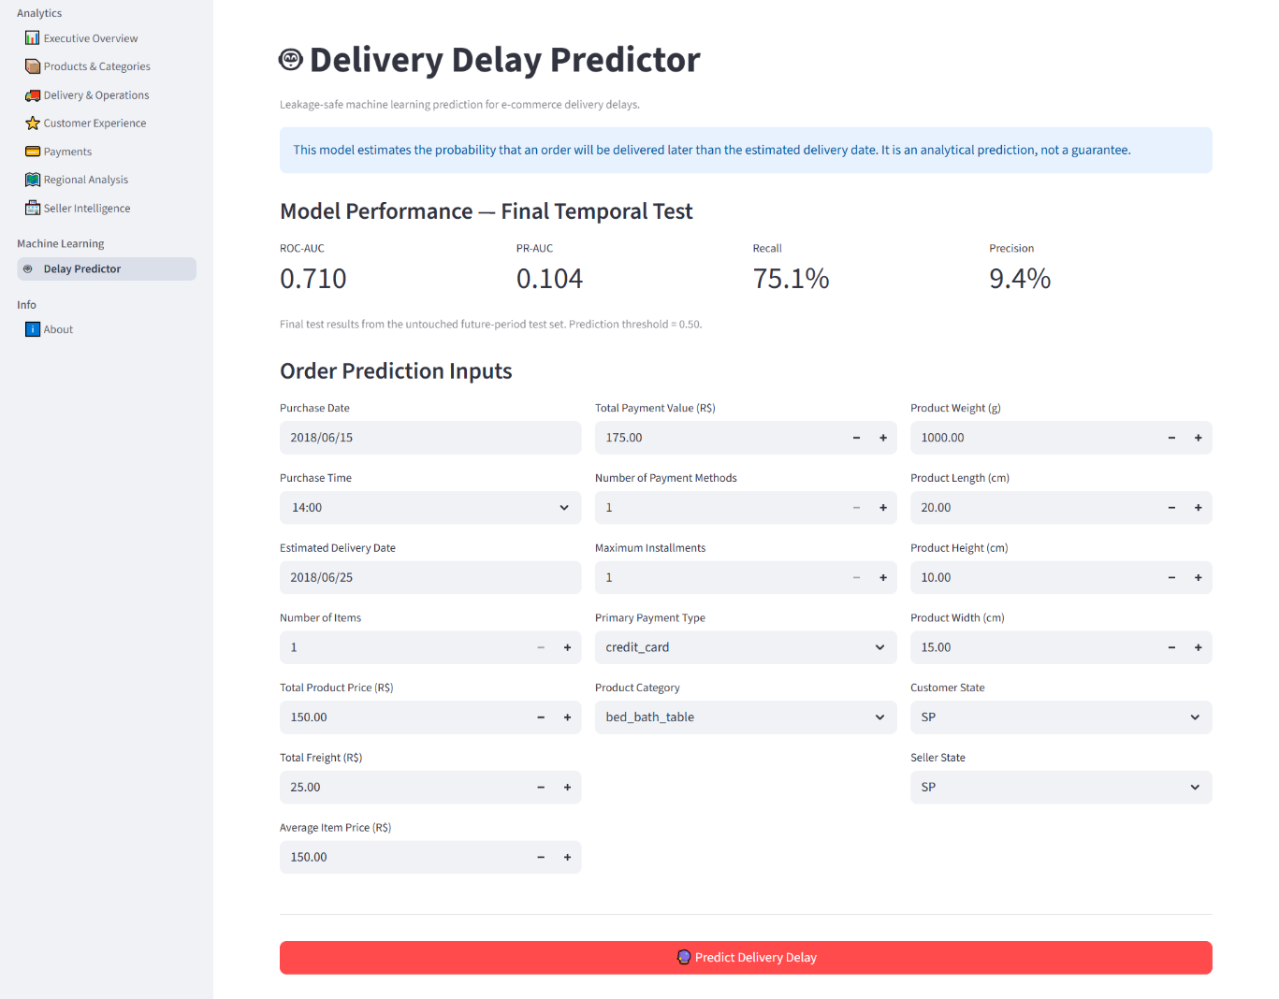

12. Business Questions Addressed
The platform is structured around eleven core business questions, each directly mapped to one or more dashboard modules in Section 11:
# | Business Question | Primary Module(s)
1 | How are sales and orders performing over time? | Executive Overview
2 | Which categories generate the highest sales value? | Products & Categories
3 | Which categories have the highest item volumes? | Products & Categories
4 | How do item prices and freight values vary? | Products & Categories
5 | How does delivery performance vary? | Delivery & Operations
6 | What proportion of orders experience delays? | Delivery & Operations
7 | How does customer satisfaction vary? | Customer Experience
8 | Which payment methods are most commonly used? | Payments
9 | Which regions generate significant business activity? | Regional Analysis
10 | How do sellers compare in sales and item activity? | Seller Intelligence
11 | Can delivery-delay risk be estimated before the final outcome? | Delay Predictor (ML)

13. Machine Learning – Delay Predictor

13.1 Prediction Objective
The Delay Predictor estimates the likelihood that a given order will experience a delivery delay, defined as the actual delivery date falling after the estimated delivery date. The objective is to provide an early, probability-based signal of delivery risk rather than a certain outcome.

13.2 Target Variable
The target variable is is_delayed, a binary indicator defined only for orders with a resolved delivered status and a valid delivery date. Orders without a confirmed delivery outcome are excluded from the labeled modeling population rather than assigned an assumed value.
Category | Count
Labeled orders (valid delivered outcome) | 96,470
Unlabeled orders (excluded from target) | 2,971
Approximate delay rate (labeled population) | 8.11%
The class imbalance implied by an ~8% positive rate is treated explicitly in modeling: evaluation relies on precision, recall, and ROC-AUC rather than accuracy alone, and class weighting is applied during training.

13.3 Training and Prediction Concept
The model is trained on the labeled population using features available prior to the delivery outcome, and is then used to generate a delay-probability estimate for new or existing orders based on those same pre-outcome features. This mirrors the standard predictive-analytics workflow of learning patterns from historical, labeled data and applying that learned relationship to estimate outcomes where the true result is not yet known.

13.4 Data Leakage Prevention
A core modeling principle applied throughout this project is the exclusion of post-outcome information from the feature set. Fields only known after an order has been delivered — including the actual delivery date and the customer review score (generated after the delivery experience) — are never used as predictive features. Including such fields would allow the model to indirectly learn the answer rather than genuinely predicting it, producing artificially strong but practically meaningless results.
Permitted feature categories:
- Order timing (purchase timestamp, day-of-week, month, processing-time-to-approval)
- Product attributes (category, weight, dimensions)
- Freight value and item price (known at purchase/shipment)
- Seller and customer geography (state-level distance proxy)
- Number of items in the order
Explicitly excluded (leakage) fields:
- order_delivered_customer_date
- delivery_time_days (derived from the actual delivery date)
- review_score and any review-derived field
- Any field only populated after delivery confirmation

13.5 Feature Engineering, Train/Test Split, and Model Training (scikit-learn)
"""
ml_module.py
Trains a leakage-safe Random Forest classifier to estimate
delivery-delay probability using only pre-outcome features.
"""

import pandas as pd
import numpy as np
from sklearn.model_selection import train_test_split
from sklearn.ensemble import RandomForestClassifier
from sklearn.preprocessing import OneHotEncoder
from sklearn.compose import ColumnTransformer
from sklearn.pipeline import Pipeline
from sklearn.metrics import roc_auc_score, classification_report

# 1. LOAD LEAKAGE-SAFE MODELING DATASET
ml_df = pd.read_csv("data/ml_delay_dataset.csv")
ml_df = ml_df.dropna(subset=["is_delayed"])

# 2. FEATURE ENGINEERING - pre-outcome features ONLY
ml_df["purchase_dayofweek"] = pd.to_datetime(ml_df["order_purchase_timestamp"]).dt.dayofweek
ml_df["purchase_month"] = pd.to_datetime(ml_df["order_purchase_timestamp"]).dt.month
ml_df["approval_lag_hours"] = (
pd.to_datetime(ml_df["order_approved_at"])
- pd.to_datetime(ml_df["order_purchase_timestamp"])
).dt.total_seconds() / 3600

NUMERIC_FEATURES = [
"price", "freight_value", "product_weight_g",
"product_length_cm", "product_height_cm", "product_width_cm",
"item_count", "approval_lag_hours", "purchase_dayofweek", "purchase_month",
]
CATEGORICAL_FEATURES = [
"product_category_name_english", "customer_state", "seller_state",
]

# Explicit leakage guard - fail loudly if a post-outcome field is present
LEAKAGE_FIELDS = {
"order_delivered_customer_date", "delivery_time_days",
"review_score", "delivery_delay_days",
}
assert LEAKAGE_FIELDS.isdisjoint(set(NUMERIC_FEATURES + CATEGORICAL_FEATURES)), \
"Leakage field detected in feature set!"

X = ml_df[NUMERIC_FEATURES + CATEGORICAL_FEATURES]
y = ml_df["is_delayed"].astype(int)

# 3. TRAIN / TEST SPLIT - stratified on the imbalanced target
X_train, X_test, y_train, y_test = train_test_split(
X, y, test_size=0.2, stratify=y, random_state=42
)

# 4. PREPROCESSING + MODEL PIPELINE
preprocessor = ColumnTransformer(
transformers=[("cat", OneHotEncoder(handle_unknown="ignore"), CATEGORICAL_FEATURES)],
remainder="passthrough",
)

model = RandomForestClassifier(
n_estimators=300, max_depth=12,
class_weight="balanced", # accounts for ~8% positive class rate
random_state=42, n_jobs=-1,
)

pipeline = Pipeline(steps=[("preprocessor", preprocessor), ("classifier", model)])
pipeline.fit(X_train, y_train)

# 5. PROBABILITY PREDICTION AND EVALUATION
y_proba = pipeline.predict_proba(X_test)[:, 1] # probability of delay
y_pred = (y_proba >= 0.5).astype(int)

print("ROC-AUC:", roc_auc_score(y_test, y_proba))
print(classification_report(y_test, y_pred))

# 6. INFERENCE FUNCTION - used by pages/08_ml_delay_predictor.py
def predict_delay_probability(order_features: pd.DataFrame) -> np.ndarray:
"""
Returns a delay-probability estimate (0-1) for each row in
order_features. Input must contain only pre-outcome fields.
"""
return pipeline.predict_proba(order_features)[:, 1]

13.6 Probability Output and Interpretation
The model produces a probability estimate representing the likelihood of delay for a given order, rather than a deterministic yes/no outcome. This probability is interpreted as a relative risk signal — orders with higher estimated probabilities warrant closer operational attention — but is never presented as a certainty.

13.7 Practical Business Use
The Delay Predictor is intended to support proactive operational decisions, such as flagging higher-risk orders for closer monitoring, informing customer-communication strategies, or supporting internal discussion about which sellers, regions, or categories are associated with elevated delay risk. It is a decision-support tool, not an automated decision-making system.
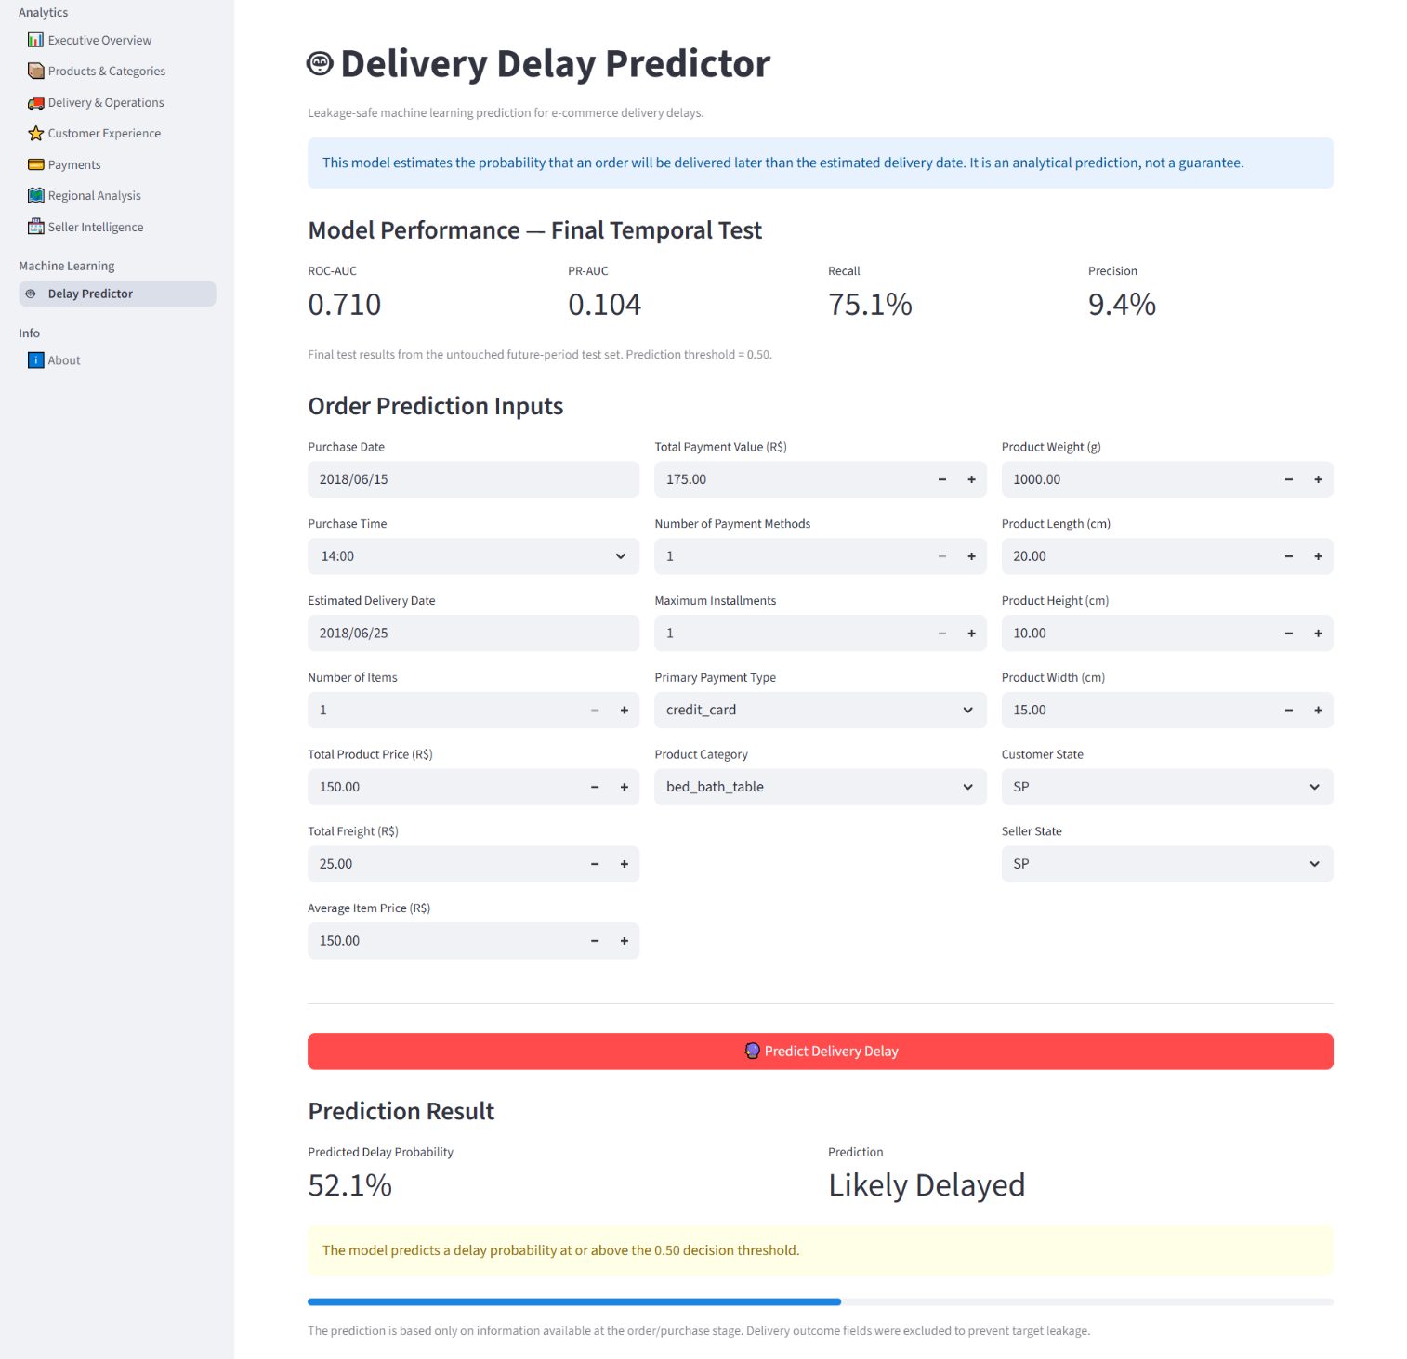

13.8 Limitations
The model's predictions are based on historical patterns within the Olist dataset's coverage period and do not account for factors outside the dataset, such as real-time logistics conditions, holidays, or external disruptions not reflected in the historical record.

14. Interactive Filtering
The platform implements a centralized filtering system, managed through src/filters.py, that applies consistently across all eight dashboard pages rather than allowing each page to define its own independent filtering logic.
Filter | Default Value
Date | 2017-01-01 to 2018-10-17
Order Status | Delivered
Include 2016 | OFF
Centralizing the filtering logic ensures that when a user adjusts the date range, order status, or 2016-inclusion setting, every dashboard page reflects the same underlying filtered population. This consistency is essential for a multi-page BI platform: without centralized filtering, different pages could silently present figures calculated over different underlying populations, undermining the reliability of cross-page comparisons and management-level interpretation.
"""
src/filters.py (excerpt)
Centralized filter state and application logic, shared by every page.
"""

import streamlit as st
import pandas as pd

def init_filter_state(default_start, default_end, default_status, include_2016):
if "filters_initialized" not in st.session_state:
st.session_state["date_start"] = pd.to_datetime(default_start)
st.session_state["date_end"] = pd.to_datetime(default_end)
st.session_state["order_status"] = default_status
st.session_state["include_2016"] = include_2016
st.session_state["filters_initialized"] = True

def apply_filters(df: pd.DataFrame, grain: str) -> pd.DataFrame:
start = st.session_state["date_start"]
end = st.session_state["date_end"]
status = st.session_state["order_status"]

filtered = df[
(df["order_purchase_timestamp"] >= start)
& (df["order_purchase_timestamp"] <= end)
]
if status != "all":
filtered = filtered[filtered["order_status"] == status]
if not st.session_state["include_2016"]:
filtered = filtered[filtered["order_purchase_timestamp"].dt.year != 2016]
return filtered

15. Analytical Methodology
The platform's analysis is guided by nine principles, applied consistently across every module:
- Two-grain analytical architecture — order-level and item-level questions are answered from the dataset whose grain matches the question (Section 7).
- Data quality and validation — cleaning decisions and derived fields are checked against expected counts and distributions rather than assumed correct.
- Business-focused analytics — every chart and KPI is tied to a defined business question rather than included for technical demonstration.
- Correct KPI aggregation — KPIs are calculated at the appropriate grain to avoid inflation or dilution from mismatched joins.
- Avoiding duplicate counting — order-level metrics are never calculated directly from item-level data without appropriate aggregation.
- No unsupported profit calculation — the dataset does not include Cost of Goods Sold; price minus freight is never presented as profit.
- Correlation does not imply causation — observed relationships are presented as associations to be investigated further, not as proven causal effects.
- Avoiding ML data leakage — the Delay Predictor excludes any feature derived from post-outcome information (Section 13.4).
- Historical dataset limitations — the dataset reflects a specific historical period and marketplace context; conclusions are scoped accordingly.

16. Validation and Testing
The project includes a dedicated suite of eleven automated validation scripts covering the data pipeline and every dashboard module:
- _validate_app.py
- _validate_charts.py
- _validate_customer.py
- _validate_delivery.py
- _validate_filters.py
- _validate_kpis.py
- _validate_loader.py
- _validate_overview.py
- _validate_payments.py
- _validate_products.py
- _validate_regional.py
Final validation results:
Validation Area | Result
Application | 40 passed, 0 failed
Charts | 64 passed, 0 failed
Customer Experience | 69 passed, 0 failed
Delivery & Operations | 59 passed, 0 failed
Filters | 26 passed, 0 failed
KPIs | 85 passed, 0 failed
Executive Overview | 62 passed, 0 failed
Payments | 55 passed, 0 failed
Products & Categories | 48 passed, 0 failed
Regional Analysis | 53 passed, 0 failed
Data Loader | All validations passed
Seller Intelligence | Validated separately and passed
Total automated assertions executed: 561, with zero failures reported across the entire suite.
In addition to the scripted validations above, the following checks were completed as part of final project sign-off:
- Python compilation completed successfully across the entire application codebase.
- A final, clean Streamlit launch completed successfully with no runtime exceptions.
- All eight dashboard pages loaded successfully during the final runtime check.
- Live filter quality assurance was completed, confirming consistent behavior of the centralized filtering system across every page.
- Edge-case quality assurance was completed (empty filter ranges, single-day ranges, all-status selection).
- A final regression pass was completed successfully following the last round of code changes.

17. Project Structure
Olist-Ecommerce-Analytics/
|
+-- app.py
+-- README.md
+-- requirements.txt
|
+-- data/
| +-- ml_delay_dataset.csv
| +-- olist_master_cleaned.csv
| +-- olist_order_item_master.csv
|
+-- pages/
| +-- 01_overview.py
| +-- 02_products_categories.py
| +-- 03_delivery_operations.py
| +-- 04_customer_experience.py
| +-- 05_payments.py
| +-- 06_regional.py
| +-- 07_sellers.py
| +-- 08_ml_delay_predictor.py
|
+-- src/
| +-- data_loader.py
| +-- filters.py
| +-- kpis.py
| +-- charts.py
| +-- ml_module.py
|
+-- validation scripts
| +-- _validate_app.py
| +-- _validate_charts.py
| +-- _validate_customer.py
| +-- _validate_delivery.py
| +-- _validate_filters.py
| +-- _validate_kpis.py
| +-- _validate_loader.py
| +-- _validate_overview.py
| +-- _validate_payments.py
| +-- _validate_products.py
| +-- _validate_regional.py
|
+-- GitHub configuration files

18. Installation and Execution
The application can be run locally by following the steps below.

1. Clone the repository
git clone https://github.com/brojomohan58-boop/Olist-Ecommerce-Analytics
cd Olist-Ecommerce-Analytics

2. Create a virtual environment
python -m venv .venv

3. Activate the environment (Windows PowerShell)
.venv\Scripts\Activate.ps1

4. Install dependencies
pip install -r requirements.txt

5. Run the Streamlit application
streamlit run app.py

Once running, the application launches a local Streamlit server and opens the multi-page dashboard in the default web browser, beginning with the Executive Overview page.

19. GitHub Repository
The final project repository is hosted at:
https://github.com/brojomohan58-boop/Olist-Ecommerce-Analytics
The repository uses Git for version control and GitHub for remote hosting and submission reference. Because the analytical CSV datasets used by the application are relatively large, they are tracked using Git LFS (Large File Storage) rather than being committed directly to the standard Git history, keeping the repository efficient while preserving full access to the underlying data files.

20. Key Insights and Business Value
The platform is designed to surface insights across each of the business questions defined in Section 12. Where specific quantitative findings depend on live interaction with the filtering system and are best explored directly within the deployed dashboard, the analytical purpose of each area is summarized below:
- Sales and order trends allow the business to monitor growth or decline in activity over time and identify seasonal or period-specific patterns.
- Category-level sales and volume analysis helps distinguish between categories that generate high revenue and those that generate high transaction volume.
- Delivery performance analysis provides visibility into how reliably the operation meets its own estimated delivery commitments.
- Customer experience analysis, including the relationship between delivery outcomes and review scores, supports investigation into which operational factors may be associated with lower satisfaction.
- Payment behavior analysis informs understanding of how customers choose to transact, relevant to checkout design and promotional strategy.
- Regional and seller analysis identifies where business activity concentrates geographically and how sellers compare in scale of activity.
- The Delay Predictor adds a forward-looking dimension to the platform, allowing delivery risk to be estimated before an order's outcome is finalized.
Collectively, these components give the business a structured, validated view connecting sales performance, operational reliability, and customer satisfaction — the three areas most directly relevant to sustained marketplace performance.

21. Limitations
- Olist is a historical public marketplace dataset and does not represent the entire Brazilian e-commerce market.
- Historical patterns observed in this dataset should not automatically be interpreted as reflective of current market conditions.
- Seller IDs in the dataset do not provide seller business names; seller-level analysis is presented using identifiers only.
- The dataset does not include explicit Cost of Goods Sold (COGS) data.
- As a direct consequence, true profit cannot be calculated from the available fields, and no calculation in this project is presented as profit.
- Machine learning predictions produced by the Delay Predictor are probability estimates, not guarantees of future delivery outcomes.
- Observed relationships between variables in this platform are associative and should not be interpreted as proven causal relationships without further investigation.
- The scope of analysis is inherently limited by the fields and time period available in the dataset.

22. Future Improvements
The following represent realistic directions for future work and are not implemented in the current version of the platform:
- More advanced predictive modeling techniques for delivery-delay estimation (e.g., gradient boosting ensembles, hyperparameter search).
- Model monitoring and periodic retraining to maintain predictive relevance over time.
- Integration of additional external business data sources to expand analytical scope.
- More granular geographic analysis beyond state-level aggregation.
- Improved seller metadata, should richer seller information become available.
- Automated deployment of the dashboard to a hosted environment.
- Additional forecasting capabilities for sales and demand.
- More advanced customer segmentation analysis.
- More comprehensive experimentation and causal-analysis methods where appropriate data and design permit.
These items are identified as future work only and are not represented as part of the current, submitted platform.

23. Project Outcome
This project successfully demonstrates a complete, end-to-end analytics workflow: raw relational e-commerce data was cleaned and transformed into two purpose-built analytical datasets; business-relevant KPIs were designed and validated; exploratory data analysis was conducted across sales, delivery, and customer-experience domains; a leakage-controlled machine learning model was developed to estimate delivery-delay risk; the resulting analysis was made accessible through an interactive, multi-page Streamlit application; and the entire pipeline and application were validated through a structured suite of automated tests.
The project demonstrates practical proficiency in data preparation, data modeling, KPI design, exploratory analysis, business intelligence dashboard development, applied machine learning, and software validation and testing practices. It represents a functional, internally consistent analytics platform appropriate to the scope of an internship capstone.

24. Conclusion
The E-Commerce Business Intelligence & Customer Experience Analytics Platform fulfills the objectives set out at the start of this project: transforming raw, multi-table marketplace data into a validated, interactive analytics platform capable of supporting real business questions around sales performance, delivery reliability, customer experience, and delivery-risk estimation. Throughout the project, analytical claims were deliberately scoped to what the underlying data could support — profitability was not claimed where cost data did not exist, causal relationships were not claimed where only associations could be observed, and machine-learning outputs were presented as probability estimates rather than certainties. This disciplined approach, combined with structured validation testing across every application module, produced a reliable and defensible analytics platform suitable for submission as the culminating project of the AICTE | IBM SkillsBuild Data Analytics with AI Internship 2026.

25. Author Information
Field | Detail
Author | Brojo Mohan Dutta
Education | B.Sc. (Honours) Mathematics, Serampore College, University of Calcutta, 2025
Project Context | AICTE | IBM SkillsBuild Data Analytics with AI Internship 2026
Repository | https://github.com/brojomohan58-boop/Olist-Ecommerce-Analytics

