Retail Sales Performance Analytics
Data Analytics Case Study
Case Study Report
Python / Jupyter Notebook | Pandas, NumPy | Power BI | Git Hub

Analyst  Brojo Mohan Dutta | Period  June – September 2024 | Submitted  2026

1. Introduction
This case study analyzes four months of transactional sales data (June–September 2024) for a retail business selling products across five categories: Storage, Furniture, Electronics, Wearables, and Accessories. The business observed a noticeable slowdown in monthly revenue over this period and required a data-driven investigation into what is driving performance — by time, region, product category, and payment channel — to support Q4 planning decisions.
This report documents the complete analytics workflow: from raw data acquisition through cleaning, exploratory analysis, dashboard construction, and final business recommendations, using the Ask → Prepare → Process → Analyze → Share → Act framework.

2. Ask

Business Task Statement
Formal Business Task
Analyze 60 retail sales transactions from June–September 2024 to identify performance trends over time, regional sales strengths, product category profitability, and payment channel behavior — in order to explain the observed sales decline and recommend concrete Q4 actions.

Business Question
Key Business Questions
• How has revenue trended month-over-month across the analysis period?
• Which regions and product categories generate the most (and least) revenue?
• Are there statistical outliers in transaction value that need investigation?
• Which payment methods underperform, and does that matter?
• What is driving revenue more — order price or order size?

Key Stakeholders
Stakeholder | Role | Interest in This Analysis
Sales Director | Primary decision-maker | Wants clear diagnosis of the revenue decline and actionable next steps
Executive Team | Final approver of strategy | Needs high-level KPIs (Total Sales, Profit, Margin) to assess business health
Regional Managers | Operational stakeholders | Need region-specific performance data to prioritize inventory and marketing
Data Analytics Intern (Author) | Analyst | Responsible for cleaning, analyzing, and presenting findings

3. Prepare

Data Source
The dataset used for this project consists of two related CSV files, sales_fact.csv and products.csv, containing retail transaction and product information. The sales table contains transaction-level records including sale ID, order date, product ID, region, payment method, quantity, and unit price. The product table provides product names, categories, and unit costs.

File | Description | Rows | Columns
sales_fact.csv | Raw transactional sales records. | 61 | 9
products.csv | Product dimension table (category, cost) | 10. | 4

Data Credibility — ROCCC Assessment
Criterion | Assessment | Notes
Reliable | ✅ Yes | Internally sourced transactional data; low bias, but very small sample
Original | ✅ Yes | Primary transaction-level data, not aggregated or third-party
Comprehensive | ✅ Yes | Covers sale ID, date, product, region, payment, quantity, and price — sufficient for the stated business questions
Current | ✅ Yes | Covers June–September 2024, directly relevant to the recent slump under investigation
Cited | ✅ Yes | Internally generated sales records; source and structure are documented in this report

Limitations
- Small sample size: Only 60 transactions across 4 months limits statistical confidence, particularly for category- and region-level breakdowns.
- No customer-level data: Cannot distinguish new vs. repeat customers or segment by demographics.
- Short time window: Four months is insufficient to separate genuine trend from seasonality.
- No external context: Marketing spend, competitor activity, and stock-availability data are not included, limiting root-cause analysis of the sales decline.

4. Process

Tools Selected
Tool | Purpose
Python (Pandas, NumPy) | Data cleaning, transformation, statistical analysis
Matplotlib / Seaborn | Exploratory Data Analysis and Visualizations
Power BI Desktop | Interactive dashboard, DAX measures, business-facing reporting
Git / GitHub | Version control and portfolio documentation

Data Pipeline
The following 10-step Python pipeline was executed in Jupyter Notebook.
Step | Step | Detail
1 | Remove unnecessary column | Dropped notes — placeholder field with no analytical value
2 | Fix data types | Converted order_date to datetime
3 | Standardize text | region column standardized via .str.strip().str.title() (fixed "north", "SOUTH" inconsistencies)
4 | Impute missing values | quantity nulls filled with 5 (column median); unit_price nulls filled with 1999
5 | Correct invalid value | Negative quantity (-3) corrected to positive using .abs()
6 | Recalculate derived field | sales_amount recomputed as quantity * unit_price after all fixes
7 | Merge with dimension table | Left join with products.csv on product_id
8 | Calculate cost & profit | total_cost = quantity * unit_cost; profit = sales_amount - total_cost
9 | Remove duplicates | Dropped 1 duplicate transaction row
10 | Export | Final dataset exported as sales_data_cleaned.csv

Representative Code:

Data Cleaning Pipeline (Cleaning Filters Applied)
df = sales.copy()
df = df.drop(columns=["notes"])
df["order_date"] = pd.to_datetime(df["order_date"])
df["region"] = df["region"].str.strip().str.title()
df["quantity"] = df["quantity"].fillna(5)
df["unit_price"] = df["unit_price"].fillna(1999)
df.loc[df["quantity"] < 0, "quantity"] = df.loc[df["quantity"] < 0, "quantity"].abs()
df["quantity"] = df["quantity"].astype(int)
df["sales_amount"] = df["quantity"] * df["unit_price"]
df = df.drop_duplicates()

df = df.merge(products, on="product_id", how="left")
df["total_cost"] = df["quantity"] * df["unit_cost"]
df["profit"] = df["sales_amount"] - df["total_cost"]
df.to_csv("sales_data_cleaned.csv", index=False)

Data Quality Verification
Check | Before Cleaning | After Cleaning
Rows | 61 | 60
Missing values(quantity/unit_price/sales_amount) | 1 / 1 / 2 | 0 / 0 / 0
Duplicate rows | 1 | 0
Region text variants | 6 (West, North, South, East, north, SOUTH) | 4 (clean)
📸 Raw Dataset: BEFORE CLEANING
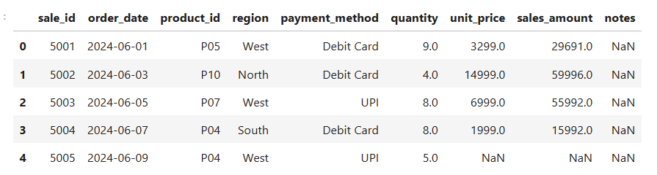
Key Findings: Raw dataset: 61 transactions, with 4 distinct data-quality issues (nulls, a duplicate, and inconsistent text).
📸 Cleaned Dataset: AFTER CLEANING
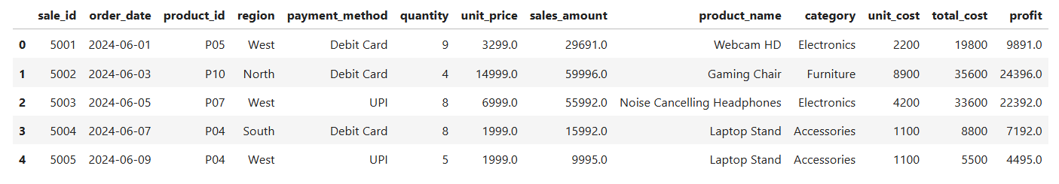

Post-Cleaning Validation Results
Cleaned & merged dataset: 60 transactions, 13 columns, 0 missing values, 0 duplicates, exported as sales_data_cleaned.csv — verified as the exact dataset later used in both the EDA notebook and the Power BI dashboard.

5. Analyze

5.1 Descriptive Statistics

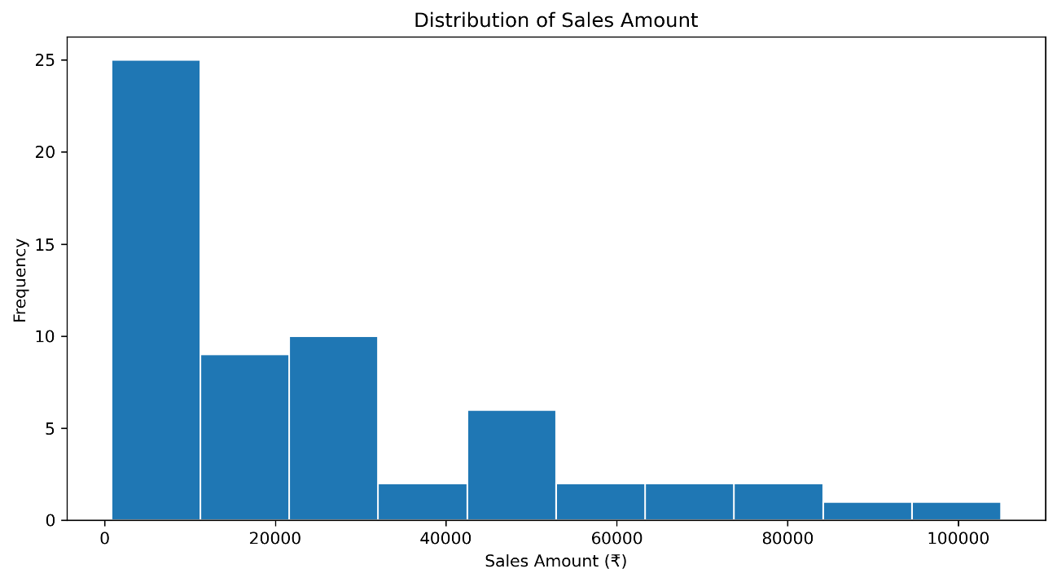
Metric | Quantity | Unit Price (₹) | Sales Amount (₹) | Profit (₹)
Mean | 4.48 | 6,039.00 | 25,030.52 | 10,103.02
Median (50%) | 4.5 | 5,249.00 | 16,743.50 | 7,641.50
Std Dev | 2.76 | 4,553.83 | 24,582.52 | 9,766.51
Min | 1 | 799.00 | 799.00 | 349.00
Max | 9 | 14,999.00 | 104,993.00 | 42,693.00
Finding: The mean sales amount (₹25,030.52) sits well above the median (₹16,743.50), indicating a right-skewed distribution driven by a small number of high-value transactions.

5.2 Correlation Analysis
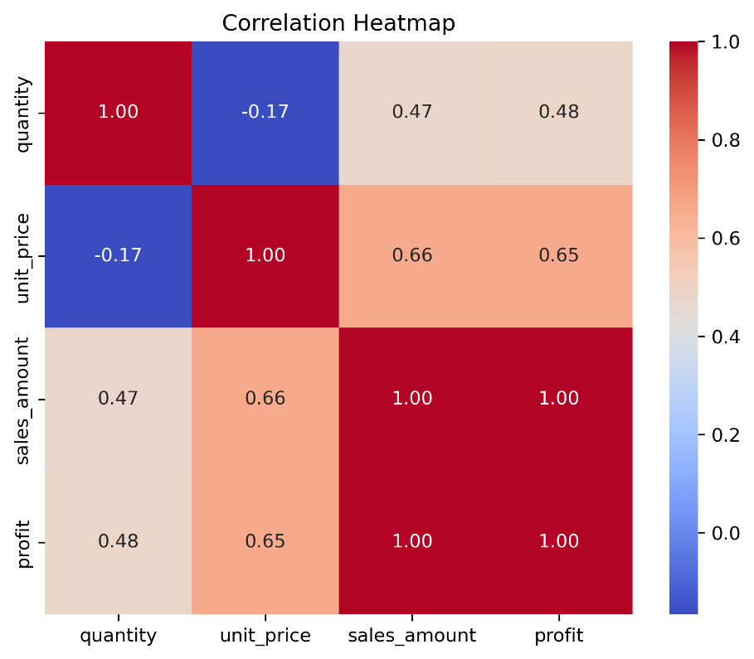
Variable Pair | Correlation
Sales Amount ↔ Profit | 0.998
Unit Price ↔ Sales Amount | 0.656
Quantity ↔ Sales Amount | 0.474
Quantity ↔ Unit Price | -0.165
Finding: Sales Amount and Profit move in near-perfect lockstep (0.998), confirming profit scales directly with revenue. Unit Price is a notably stronger revenue driver (0.656) than Quantity (0.474) — pricing and product mix matter more than order size in this dataset

5.3 Outlier Detection
Sale ID | Product | Quantity | Sales Amount (₹) | IQR Upper Bound
5008 | Gaming Chair | 7 | 104,993 | 77,617.50
5011 | Gaming Chair | 6 | 89,994 | 77,617.50
Finding: Two Gaming Chair transactions exceed the IQR upper bound. Both were retained as legitimate bulk orders rather than removed as errors — a business validation step, not automatic deletion.

5.4 Monthly Trend

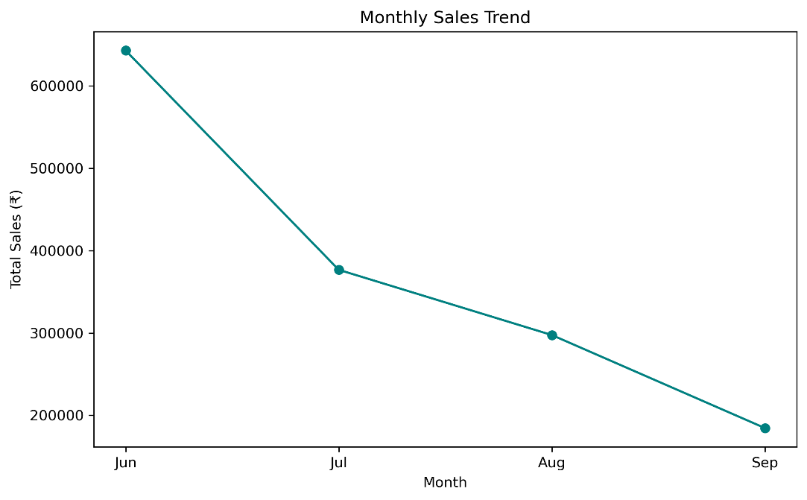
Month | Total Sales (₹)
June | 643,016
July | 376,741
August | 297,530
September | 184,544

Finding: Revenue declined every single month, a drop of approximately 71% from June to September — the single most urgent pattern in the dataset.

5.5 Regional & Category Breakdown
Region | Total Sales (₹) | Category | Total Sales (₹) | Share
South | 414,840 | Storage | 509,940 | 34%
East | 410,239 | Furniture | 329,978 | 22%
West | 342,917 | Electronics | 254,046 | 17%
North | 333,835 | Wearables | 208,981 | 14%
 |  | Accessories | 198,886 | 13%
Finding: South and East together account for over half of total revenue. Storage is the single largest category, contributing over a third of all sales.

5.6 Payment Method Performance

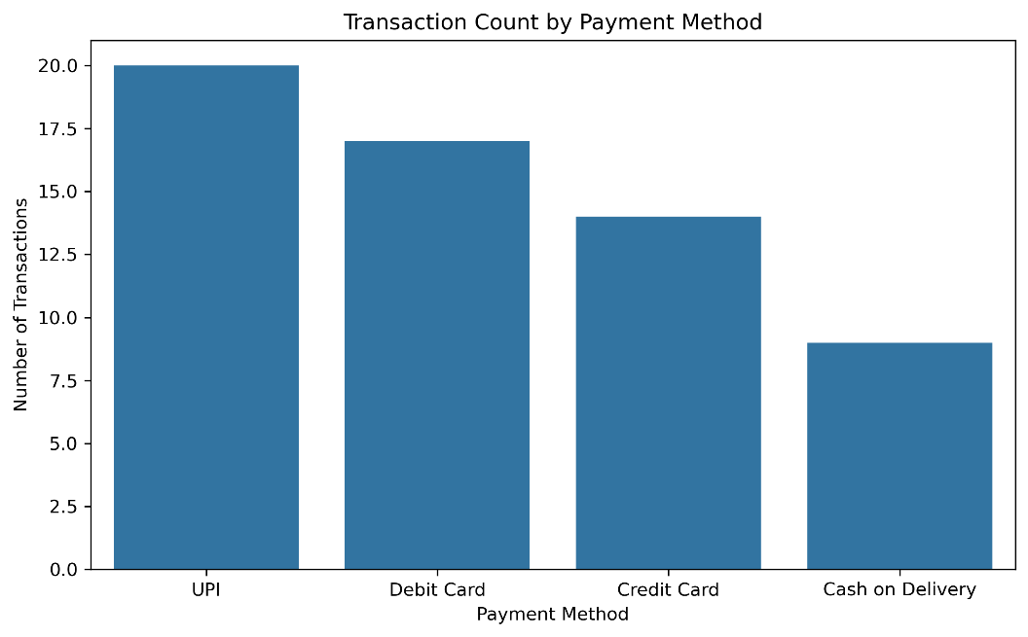
Payment Method | Total Sales (₹)
UPI | 404,902
Debit Card | 403,224
Cash on Delivery | 398,254
Credit Card | 295,451
Finding: Credit Card trails the other three methods by a consistent, meaningful margin (~₹100K+ gap from UPI).

6. Share

Power BI Dashboard Overview
The final deliverable is an interactive Retail Sales Dashboard, built on the same cleaned dataset (sales_data_cleaned) used in the Python analysis above, ensuring both tools produce identical top-line figures.

KPI Cards
KPI | DAX Measure | Result
Total Sales | SUM(sales_data_cleaned[Sales Amount]) | ₹1.50M
Total Profit | SUM(sales_data_cleaned[Profit]) | ₹606.18K
Total Transactions | COUNTROWS(sales_data_cleaned) | 60
Profit Margin | DIVIDE([Total Profit], [Total Sales Amount], 0) | 40.36%

Core Visuals
Visual | Type | Fields
Monthly Sales & Profit Trend | Line Chart | X: Month, Y: Total Sales, Total Profit
Sales by Category | Donut Chart | Legend: Category, Values: Total Sales
Sales by Region | Bar Chart | Y: Region, X: Total Sales
Sales by Payment Method | Column Chart | X: Payment Method, Y: Total Sales
Category × Region Matrix | Matrix | Rows: Category, Columns: Region, Values: Total Sales

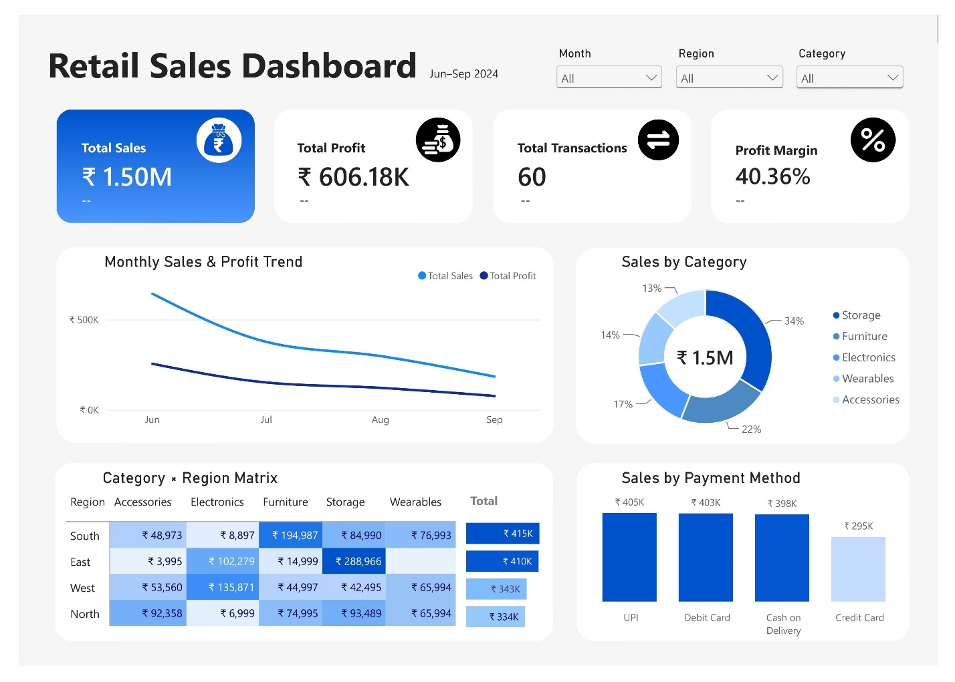

Finding: The mean sales amount (₹25,030.52) sits well above the median (₹16,743.50), indicating a right-skewed distribution driven by a small number of high-value transactions.

7. Act — Recommendations

Recommendation 1: Investigate and Reverse the Q3 Revenue Decline
Evidence: Monthly sales fell every month from June (₹643,016) to September (₹184,544) — a ~71% decline, while profit margin (40.36%) remained healthy, indicating a volume/demand problem rather than a cost problem.

Action: Cross-reference monthly transaction counts against marketing activity, stock availability, and seasonality using the dashboard's Month-over-Month measures to isolate whether the decline is driven by fewer transactions or smaller average order values.

Expected Reach/Timing: Immediate (Q4 planning cycle) — this is the single highest-priority action, as every other recommendation is secondary to stabilizing top-line revenue.

Recommendation 2: Concentrate Inventory and Marketing on Storage in South/East
Evidence: Storage is the top category (34% of revenue, ₹509,940) and South (₹414,840) / East (₹410,239) are the top two regions, together outperforming West and North significantly.

Action: Prioritize stock availability and targeted promotions for Storage products specifically in South and East before expanding investment into lower-performing region-category combinations.

Expected Reach/Timing: Next 4–6 weeks — low-risk, high-confidence action based on proven demand rather than speculative expansion.

Recommendation 3: Diagnose the Credit Card Payment Gap
Evidence: Credit Card generates ₹295,451 versus ₹398K–₹405K for the other three payment methods — a consistent ~27% gap too large to dismiss as random variation.

Action: Audit whether Credit Card transactions face structural friction (processing fees, verification steps, slower confirmation) versus UPI/Debit Card; a targeted UX or incentive fix could recover meaningful revenue share.

Expected Reach/Timing: Within one quarter — requires coordination with payment processing/checkout teams, so timeline is moderate rather than immediate.

8. Additional Data for Future Analysis
To strengthen future iterations of this analysis, the following data would be valuable:
- Customer demographic data (age, location, loyalty tier) to segment revenue drivers beyond region alone
- Marketing spend and campaign data to directly test correlation with the observed monthly decline
- Inventory/stock-level records to distinguish demand-driven decline from stock-availability constraints
- A longer historical time window (12+ months) to separate genuine trend from seasonal effects
- Customer acquisition vs. repeat-purchase data to understand whether the decline stems from fewer new customers or reduced repeat orders
- Competitor pricing or market data for external context on the Q3 slowdown
- Payment processing fee structure to directly test the Credit Card underperformance hypothesis

. Methodology & Reproducibility
Phase | Tool | Script / File |  | Output
Ask | — | This report, Section 2 |  | Business task & stakeholder definition
Prepare | — | sales_fact.csv, products.csv | Raw data inventory & ROCCC assessment
Process | Python (Pandas) | Dataset_Selection_ Data_ Preparation.ipynb |  | sales_data_cleaned.csv (60 rows, 13 columns, 0 nulls, 0 duplicates)
Analyze | Python (Pandas, NumPy) | EDA_Visualizations.ipynb |  | Descriptive stats, correlation matrix, outlier detection, 8 visualizations
Share | Power BI Desktop | Retail Sales Dashboard (.pbix) |  | 4 KPIs, 5 visuals, 3 slicers
Act | — | This report, Section 7 |  | 3 data-driven recommendations
GitHub Repository Link: Retail-Sales-Analysis
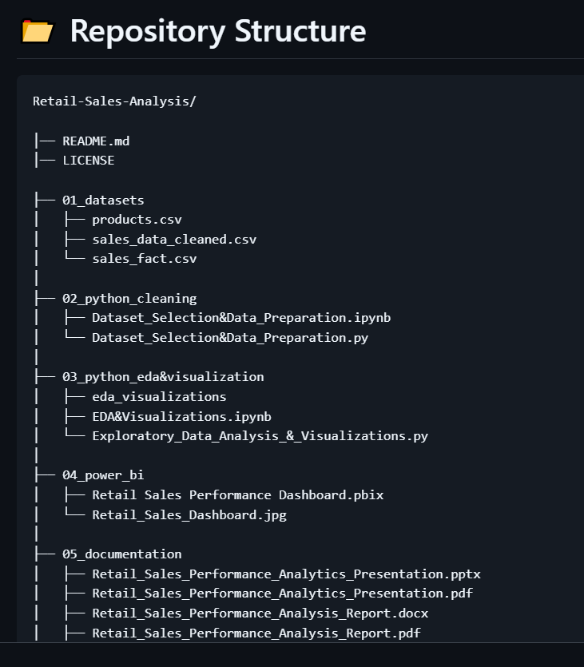
End of Case Study — Retail Sales Performance Analytics
InternNova Data Analytics Internship
Week 6 Assignment: Git, GitHub & Final Data Analytics Project
Prepared by Brojo Mohan Dutta

