SECRETARIA ACADEMICA **P0801-F01**

DIRECCION DE EDUCACION MEDIA SUPERIOR

COORDINACION DE PRÁCTICAS Y VISITAS ESCOLARES

NOMINA DE PRÁCTICAS

ESCUELA: CECYT NO. 8 “NARCISO BASSOLS”

CARRERA:

RELACION DE ALUMNOS PARTICIPANTES EN LA PRACTICA **No.**

FECHA:

LUGAR:

NOMBRE DE LOS PROFESORES: COSTO DE LA PRACTICA: $

PROF. TITULAR PROF. AUXILIAR

LOS QUE FIRMAN SE COMPROMETEN A RESPETAR EL REGLAMENTO VIGENTE DURANTE SU DESARROLLO

|  |  |  |  |  |  |  |
| --- | --- | --- | --- | --- | --- | --- |
| **No.** | **NOMBRE DEL ALUMNO** | **GRUPO** | **No. DE BOLETA** | **IMPORTE** | **FIRMA** | **MATERIA** |
| 1 |  |  |  |  |  |  |
| 2 |  |  |  |  |  |  |
| 3 |  |  |  |  |  |  |
| 4 |  |  |  |  |  |  |
| 5 |  |  |  |  |  |  |
| 6 |  |  |  |  |  |  |
| 7 |  |  |  |  |  |  |
| 8 |  |  |  |  |  |  |
| 9 |  |  |  |  |  |  |
| 10 |  |  |  |  |  |  |
| 11 |  |  |  |  |  |  |
| 12 |  |  |  |  |  |  |
| 13 |  |  |  |  |  |  |
| 14 |  |  |  |  |  |  |
| 15 |  |  |  |  |  |  |
| 16 |  |  |  |  |  |  |

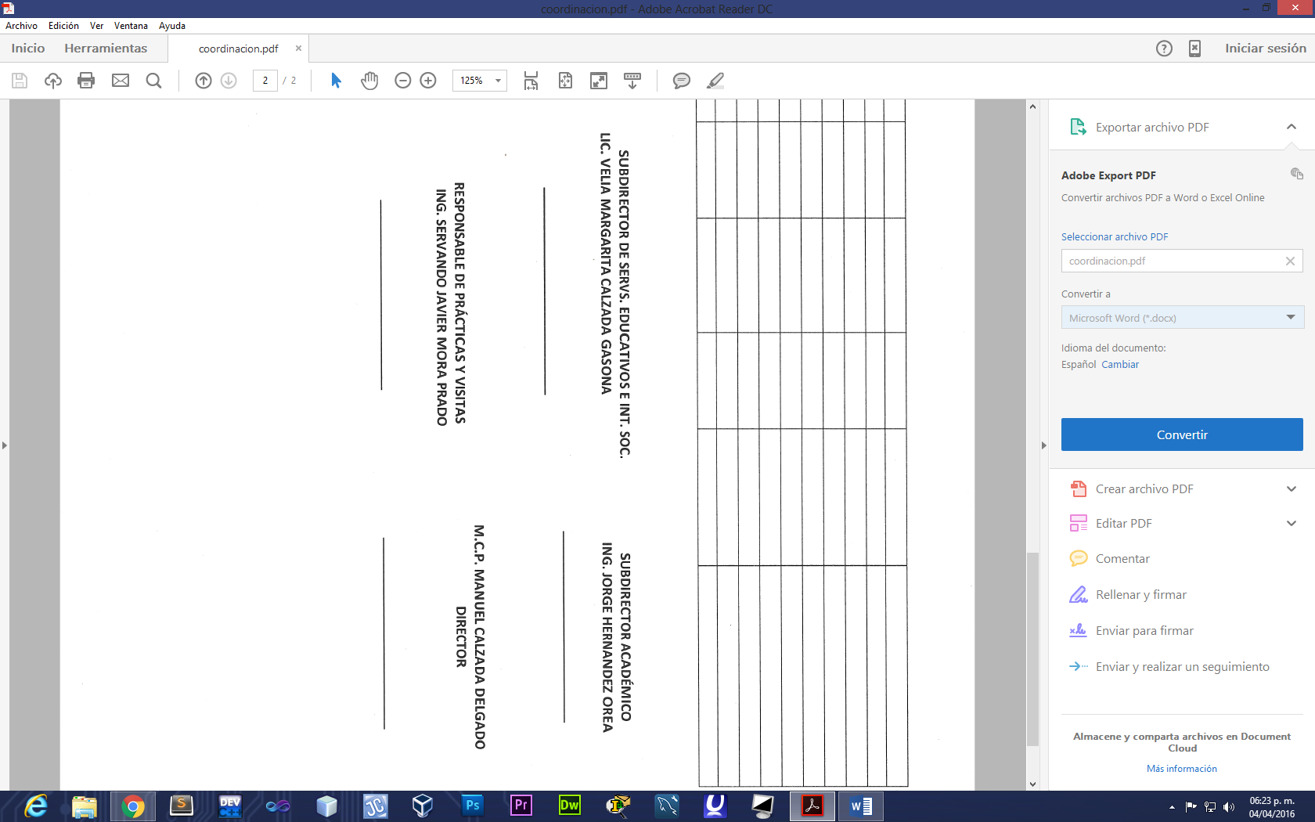

|  |  |  |  |  |  |  |
| --- | --- | --- | --- | --- | --- | --- |
| 17 |  |  |  |  |  |  |
| 18 |  |  |  |  |  |  |
| 19 |  |  |  |  |  |  |
| 20 |  |  |  |  |  |  |
| 21 |  |  |  |  |  |  |
| 22 |  |  |  |  |  |  |
| 23 |  |  |  |  |  |  |
| 24 |  |  |  |  |  |  |
| 25 |  |  |  |  |  |  |
|  |  |  |  |  |  |  |

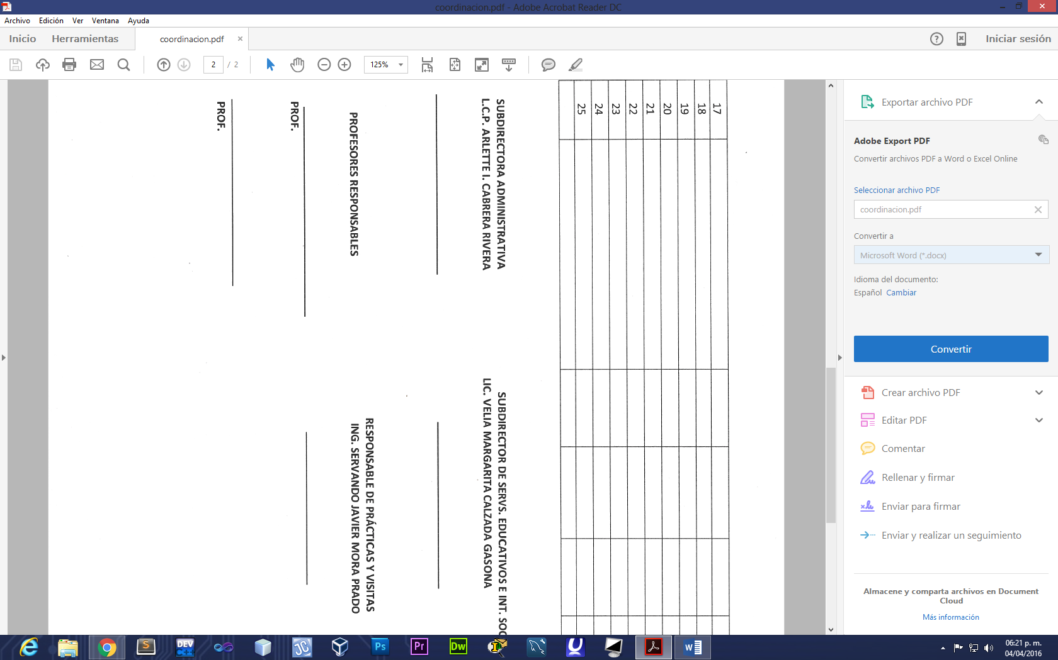

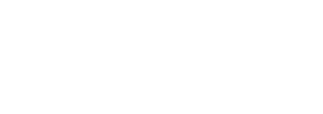







**PROF.**

**PROF.**