**Функция Химмельблау**

**Mutation = 0.5**

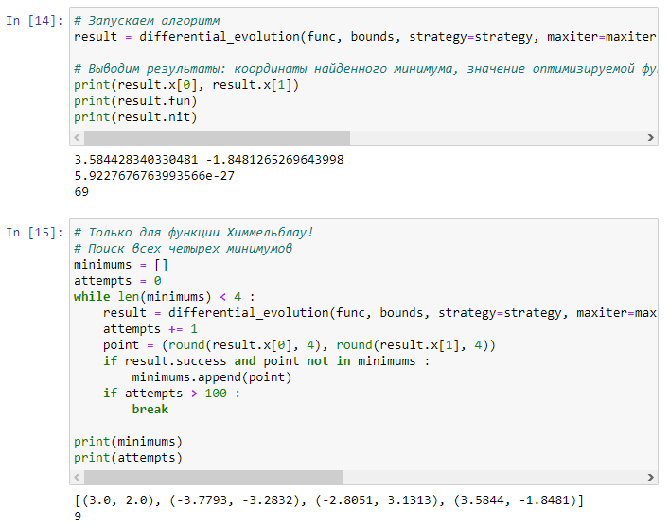

**Mutation = 1**

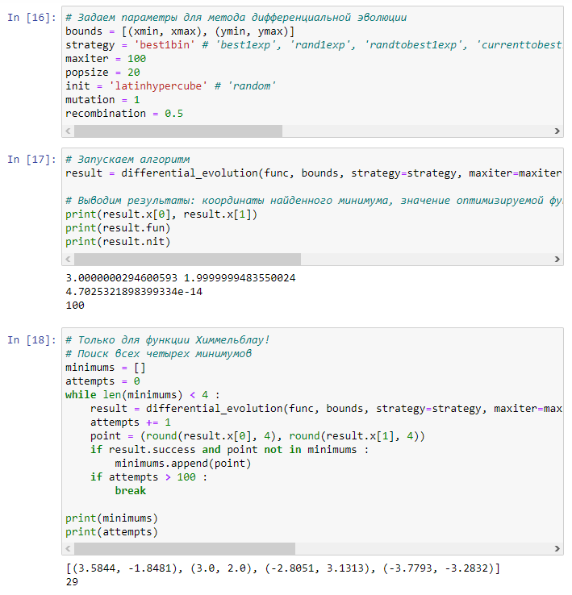

**Mutation = 1.5**

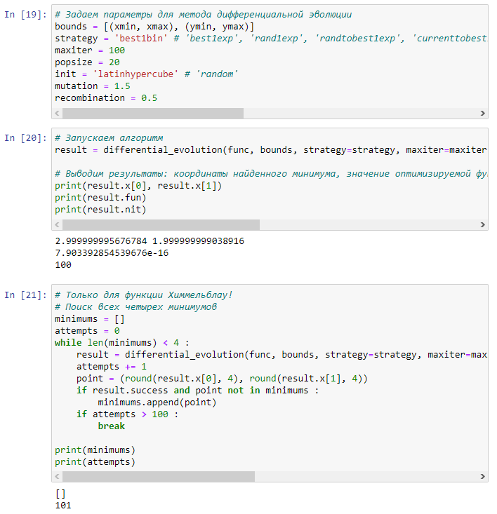

**Mutation = (0.25,0.5)**

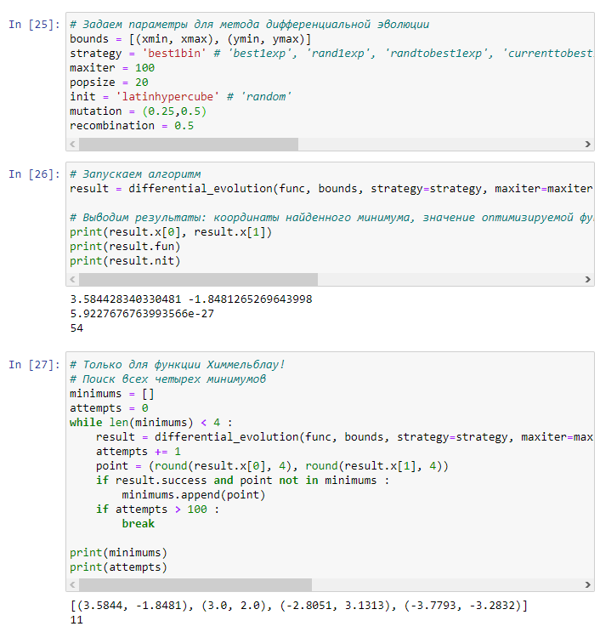

**Mutation = (0.25,0.7)**

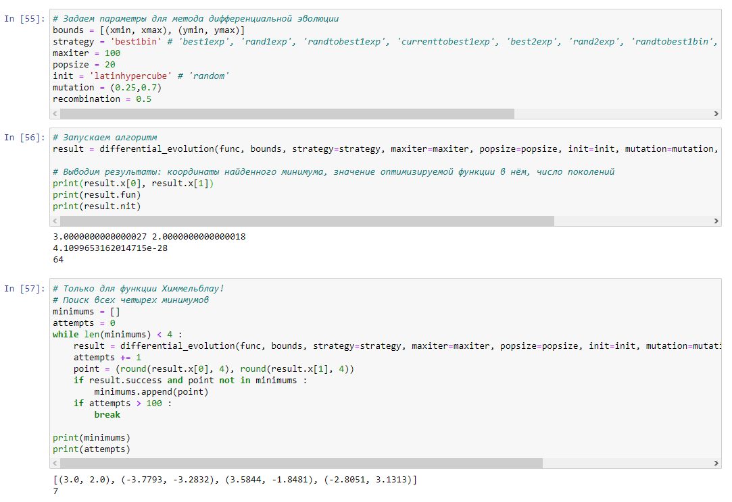

**Mutation = (0.5,0.7)**

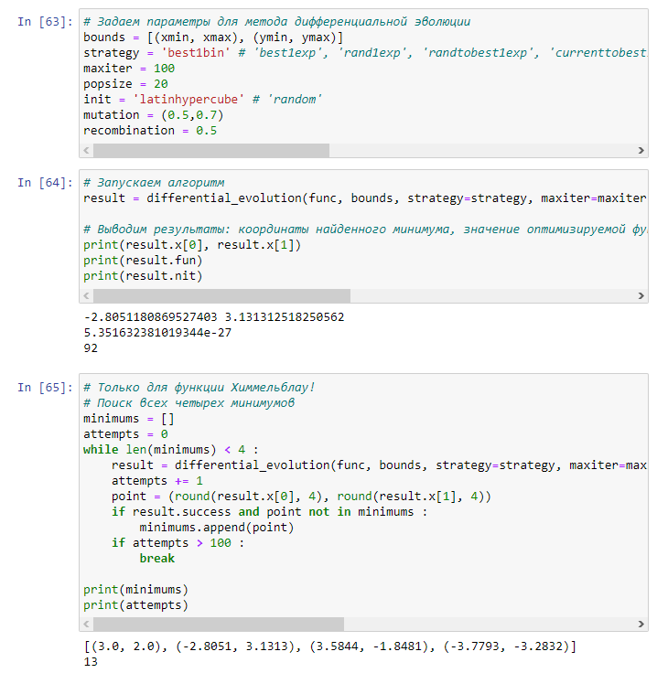

**Увеличивается количество поколений**

**Функция Матьяса**

**recombination = 0.25**

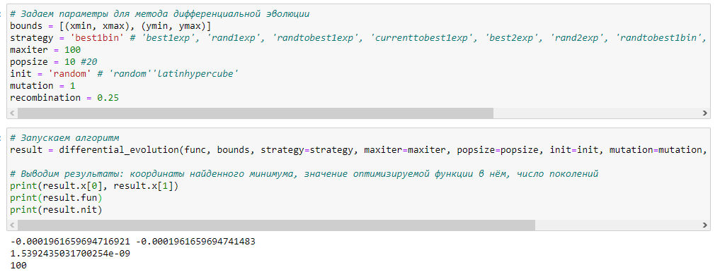

**recombination = 0.5**

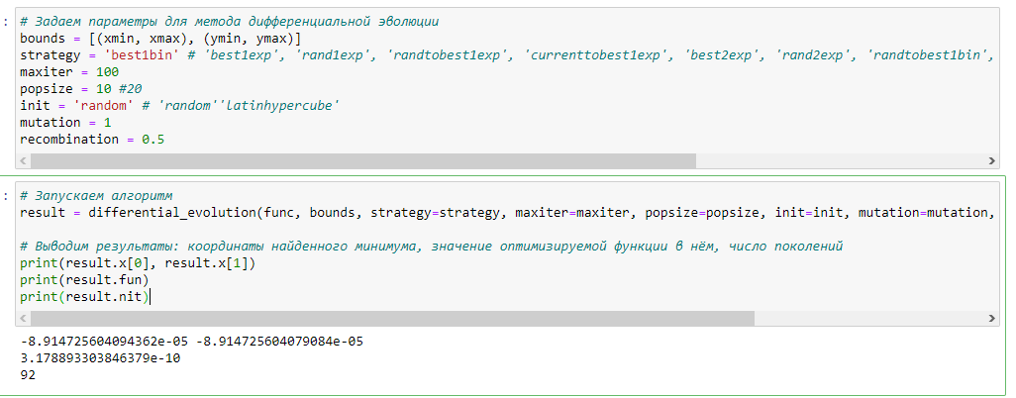

**recombination = 0.75**

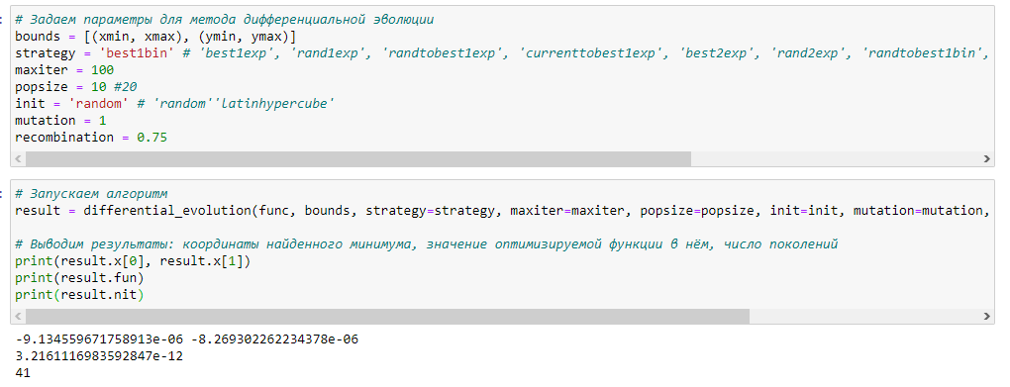

**Увеличивается вероятность получить в результате меньшее количество поколений**

|  |  |  |  |  |  |  |  |  |
| --- | --- | --- | --- | --- | --- | --- | --- | --- |
| |  | | --- | | **mutation = 0.25** | | **recombination = 0.25** | |  | | **mutation = 0.25** | | **recombination = 5** | | **mutation = 0.25** | | **recombination = 0.75** |   **mutation =0.5** |  |
| **recombination = 0.25** | |
|  | |
| |  |  | | --- | --- | | **mutation =0.5** |  | | **recombination = 0.5** | | |  | | | **mutation =0.5** |  | | **recombination = 0.75** | | | |

**При увеличении параметра recombination и при показателе mutation = 0.5 число поколений при заданых параметрах умньшается**

|  |
| --- |
| **mutation = 0.75** |
| **recombination = 0.25** |
|  |
| **mutation = 0.75** |
| **recombination = 0.5** |
| **mutation = 0.75** |
| **recombination = 0.75** |

**При увеличении параметра recombination и при показателе mutation = 0.75 число поколений при заданых параметрах максимально и не меняется**