Visoka škola strukovnih studija za informacione i komunikacione tehnologije

Dokumentacija

(http://interestingfacts.byethost11.com/)

**Predmet:** Web programiranje **Student:** Uros Markov 42/15

Beograd, 2016

Contents

1.0 Uvod 3

1.1. Korišćeni programski jezici 3

1.2. Opis funkcionalnosti 3

1.3. Template 4

1.3.1. index.html 4

1.4 Korišćeni CSS 9

2.0. Organizacija 16

2.1. Organizaciona sema 16

2.2. Mapa sajta 17

2.3. PrintScreen stranica 18

2.3.1 Index.html 18

2.3.2 registration.html 19

2.3.3 quickSurvey.html 20

2.3.4 about.html 21

2.3.5 contact.html 22

3.0 HTML i CSS kodovi 23

3.1 index.html 23

3.2. registration.html 28

3.3 quickSurvey.html 34

3.4author.html 40

3.5 contact.html 45

3.6. CSS kod 50

3.7. XML kod 64

3.7.1 sitemap.xml 64

3.7.2 rss.xml 66

3.7.3 sitemap.xsl 67

3.7.4 rss.xsl 72

3.8. JavaScript i jQuery kodovi 77

3.8.1. scriptjq.js 77

3.8.2 scriptRegExp.js 83

3.8.3. scriptCalendar.js 86

# 1.0 Uvod

## 1.1. Korišćeni programski jezici

Za izradu sajta su korišćeni su sledece tehnologije: HTML, CSS, CSS3, JavaScript, jQuery, XML, XSL.

## 1.2. Opis funkcionalnosti

Sajt ima sledeće funkcionalnosti:

* **Ekspandirajući meni** koji je urađen pomoću JQuery-ja nalazi sena svakoj stranici.
* **Slajder** koji se nalazi na naslovnoj straniurađenjepomoćuJavaScripta.
* **RSS i Sitemap** formatirani pomoću XSL-a. Nalaze se na svakojstranici. Dodatno su stilizovani pomocu CSS-a.
* **Galerija** odrađena pomoću JQuery-ja (korišćen fancybox plugin).
* **Sve slike** na sajtu animirane gore navedenim JQuery plugin-om

## 1.3. Template

### 1.3.1. index.html

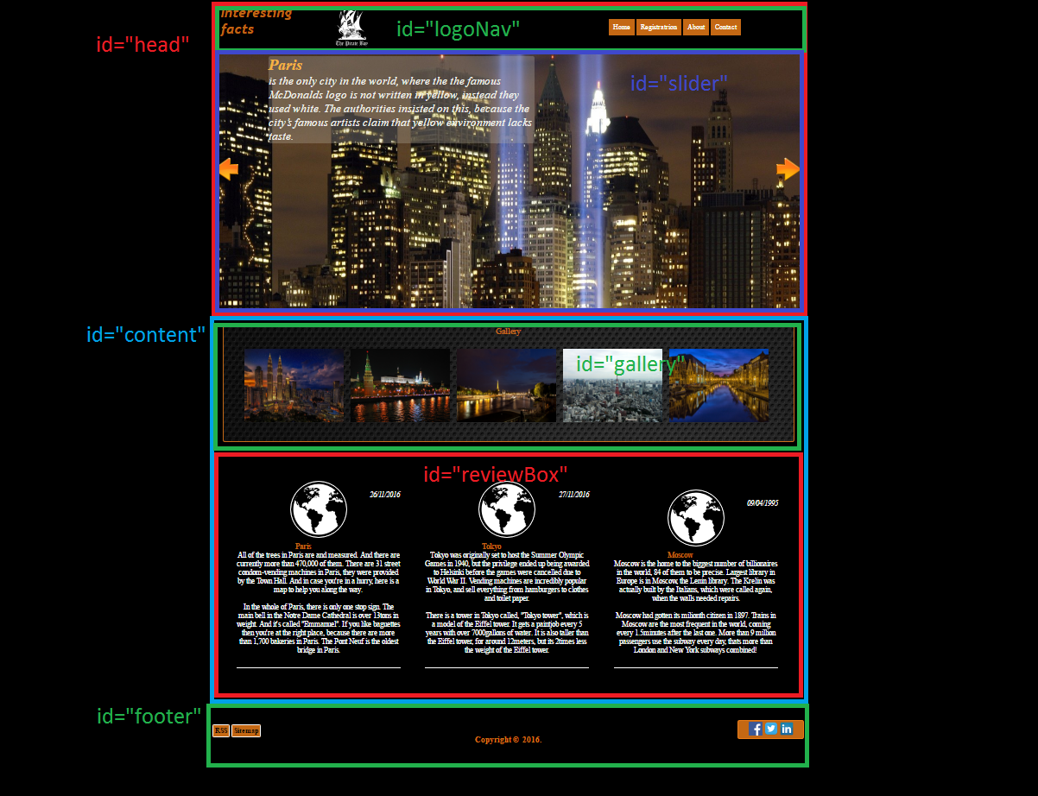<!DOCTYPE HTML PUBLIC "-//W3C//DTD HTML 4.01//EN" "http://www.w3.org/TR/html4/strict.dtd">

<html xmlns="http://www.w3.org/1999/xhtml" >

<head>

<title>Interesting facts about cities</title>

<link rel="icon" type="image/x-icon" href="Pictures/favicon.ico" />

<meta name='author' content='Uros Markov, sombrero9564@hotmail.com'>

<meta name='keywords' content='cities, moscow, paris, tokyo, facts, interesting'>

<meta name='description' content='Here you can read interesting facts about the most popular cities in the world'>

<meta name='language' content='EN'>

<link rel="stylesheet" type="text/css" href="style.css" >

<!-- Add jQuery library -->

<script type="text/javascript" src="http://code.jquery.com/jquery-latest.min.js"></script>

<!-- Add mousewheel plugin (this is optional) -->

<script type="text/javascript" src="fancybox/lib/jquery.mousewheel-3.0.6.pack.js"></script>

<!-- Add fancyBox -->

<link rel="stylesheet" href="fancybox/source/jquery.fancybox.css?v=2.1.5" type="text/css" media="screen" />

<script type="text/javascript" src="fancybox/source/jquery.fancybox.pack.js?v=2.1.5"></script>

<!-- Optionally add helpers - button, thumbnail and/or media -->

<link rel="stylesheet" href="fancybox/source/helpers/jquery.fancybox-buttons.css?v=1.0.5" type="text/css" media="screen" />

<script type="text/javascript" src="fancybox/source/helpers/jquery.fancybox-buttons.js?v=1.0.5"></script>

<script type="text/javascript" src="fancybox/source/helpers/jquery.fancybox-media.js?v=1.0.6"></script>

<link rel="stylesheet" href="fancybox/source/helpers/jquery.fancybox-thumbs.css?v=1.0.7" type="text/css" media="screen" />

<script type="text/javascript" src="fancybox/source/helpers/jquery.fancybox-thumbs.js?v=1.0.7"></script>

<script type="text/javascript">

var $= jQuery.noConflict();

</script>

<script type="text/javascript">

$(document).ready(function() {

$(".fancybox").fancybox();

});

</script>

<meta http-equiv="Content-Type" content="text/html; charset=UTF-8" />

<!--<script type="text/javascript" src="jquery.min.js">-->

<!--<script src="https://ajax.googleapis.com/ajax/libs/jquery/3.1.1/jquery.min.js"></script>-->

<script src="jquery.innerfade.js" type="text/javascript" ></script>

<script src="scriptCalendar.js" type="text/javascript" ></script>

<script src="scriptjq.js"></script>

</script>

</head>

<body onLoad="yearDynamic();" >

<div id="wrapper">

<div id="head">

<div id="logoNav">

<div id="logo">

<a href="index.html"><img src="pictures/tpb.jpg" alt="logo" /><h1>Interesting facts</h1></a>

</div>

<div id="menu">

<ul>

<li><a href="index.html">Home</a></li>

<li id="subMenu"><a href="#">Registratrion</a>

<ul>

<li><a href="registration.html">Register</a></li>

<li><a href="quickSurvey.html">Survey</a></li>

</ul>

</li>

<li><a href="author.html">About</a></li>

<li><a href="contact.html">Contact</a></li>

</ul>

</div>

</div>

<div id="slider">

<div id="middleImg">

<div id="slideFacts">

<ul id="ulFacts">

<li>

<h2>Paris</h2> is the only city in the world, where the the famous McDonalds logo is not written in yellow, instead they used white. The authorities insisted on this, because the city’s famous artists claim that yellow environment lacks taste.

</li><br/>

<li>

<h2>Honk Kong</h2> has the biggest number of Rolls-Royce cars per resident in the entire world.

</li><br/>

<li>

<h2>Vatican City</h2> has the highest crime rate per capita in the world. There are 492 residents in the country, but, for example, in 2006 there were 341 civil processes and 486 administrative processes initiated in the city. Therefore the average number of violations per resident is very high. Truth be told though, most of these criminal cases were initiated against tourists.

</li>

<li>

<h2>Tokyo</h2>

There are almost 3 000 residents in Tokyo’s regions per m2 – it is the most densely populated area in the world. The number of residents including suburbs is 37.5 million people.

</li>

<li>

<h2>Moscow</h2>

Trains in Moscow are the most frequent in the world, coming every 1.5minutes after the last one. More than 9 million passengers use the subway every day, thats more than London and New York subways combined!

</li>

<li>

<h2>Istanbul</h2>

The only city in the world that connects two continents: Asia and Europe.

</li>

<li>

<h2>Tokyo</h2>

There is a tower in Tokyo called, "Tokyo tower", which is a model of the Eiffel tower. It gets a paintjob every 5 years with over 7000gallons of water.

</li>

<li>

<h2>Paris</h2>

In the whole of Paris, there is only one stop sign.

</li>

<li>

<h2>Moscow</h2>

The Krelin was actually built by the Italians, which were called again, when the walls needed repairs.

</li>

</ul>

</div>

<img src="pictures/Fusion3.jpg" />

<div id="previous" onClick="nextPic(600)">

<img src="pictures/previous.png" alt="previous" />

<div id="next" onClick="nextPic(-600)">

<img src="pictures/next.png" alt="next" />

</div>

</div>

</div>

</div>

</div>

<div id="content">

<div id="gallery">

<p>Gallery</p>

<a class="fancybox" rel="group" href="fancybox/demo/kuala.jpg"><img src="fancybox/demo/kuala.jpg" alt="Kuala Lumpur" /></a>

<a class="fancybox" rel="group" href="fancybox/demo/moscow.jpg"><img src="fancybox/demo/moscow.jpg" alt="Moscow kremlin" /></a>

<a class="fancybox" rel="group" href="fancybox/demo/paris.jpg"><img src="fancybox/demo/paris.jpg" alt="Paris" /></a>

<a class="fancybox" rel="group" href="fancybox/demo/tokyo.jpg"><img src="fancybox/demo/tokyo.jpg" alt="Tokyo tower" /></a>

<a class="fancybox" rel="group" href="fancybox/demo/vatican.jpg"><img src="fancybox/demo/vatican.jpg" alt="Kuala Lumpur" /></a>

</div>

<div id="reviewBox">

<div class="reviews">

<div class="reviewL">

</div>

<p class="dateP"><i>26/11/2016</i></p>

<p>

<b>Paris</b><br/>All of the trees in Paris are and measured. And there are currently more than 470,000 of them. There are 31 street condom-vending machines in Paris, they were provided by the Town Hall. And in case you're in a hurry, here is a map to help you along the way.

</p><br/>

<p class="lastPara">

In the whole of Paris, there is only one stop sign. The main bell in the Notre Dame Cathedral is over 13tons in weight. And it's called "Emmanuel". If you like baguettes then you're at the right place, because there are more than 1,700 bakeries in Paris. The Pont Neuf is the oldest bridge in Paris.

</p>

</div>

<div class="reviews">

<div class="reviewL">

</div>

<p class="dateP"><i>27/11/2016</i></p>

<p>

<b>Tokyo</b><br/>Tokyo was originally set to host the Summer Olympic Games in 1940, but the privilege ended up being awarded to Helsinki before the games were cancelled due to World War II. Vending machines are incredibly popular in Tokyo, and sell everything from hamburgers to clothes and toilet paper.

</p><br/>

<p class="lastPara">

There is a tower in Tokyo called, "Tokyo tower", which is a model of the Eiffel tower. It gets a paintjob every 5 years with over 7000gallons of water. It is also taller than the Eiffel tower, for around 12meters, but its 2times less the weight of the Eiffel tower.

</p>

</div>

<div class="reviews">

<div class="reviewL">

</div>

<p class="dateP"><i>09/04/1995</i></p>

<p>

<b>Moscow</b><br/>Moscow is the home to the biggest number of billionaires in the world, 84 of them to be precise. Largest library in Europe is in Moscow, the Lenin library. The Krelin was actually built by the Italians, which were called again, when the walls needed repairs.

</p><br/>

<p class="lastPara">

Moscow had gotten its milionth citizen in 1897. Trains in Moscow are the most frequent in the world, coming every 1.5minutes after the last one. More than 9 million passengers use the subway every day, thats more than London and New York subways combined!

</p>

</div>

</div>

<!--<div id="spaceFacts">

<ul>

<li><h2 id="diff">Mind blowing facts about space!</h2>

<li>1. In space metal sticks together</li>

<li>2. The hottest planet is not the closest planet to the Sun.</li>

<li>3. You become taller in Space.</li>

<li>4. Sun is as big as 1 million Earths put together</li>

<li>5. There is no sound in space, its completely silent.</li>

<li>6. Nasa space suit costs 12,000,000$.</li>

<li>7. Largest known asteroid is 970km wide.</li>

<li>8. Sun accounts for approximately 99.89% of our Solar system's mass</li>

</li>

</ul>

<div id="gallery">

</div>

</div>-->

</div>

<div id="footer">

<div id="contact">

<br/><br/><br/><br/><br/><h3>Copyright &copy;&nbsp; 2016.</h3>

<div id="sitemapRSS" class="indexPos">

<a href="rss.xml" title="rssButton">RSS</a>

<a href="sitemap.xml" title="sitemapButton">Sitemap</a>

</div>

<div id="socialNetworks">

<div id="facebook">

<a href="http://www.facebook.com">A</a>

</div>

<div id="twitter">

<a href="http://www.twitter.com">A</a>

</div>

<div id="linkedin">

<a href="http://www.linkedin.com">A</a>

</div>

</div>

<div id="credits">Icons made by <a href="http://www.freepik.com" title="Freepik">Freepik</a> from <a href="http://www.flaticon.com" title="Flaticon">www.flaticon.com</a> is licensed by <a href="http://creativecommons.org/licenses/by/3.0/" title="Creative Commons BY 3.0" target="_blank">CC 3.0 BY</a></div>

</div>

</div>

</div>

</body>

</html>

## 1.4. Korišćeni CSS

**Fancybox:**

.fancybox-wrap,

.fancybox-skin,

.fancybox-outer,

.fancybox-inner,

.fancybox-image,

.fancybox-wrap iframe,

.fancybox-wrap object,

.fancybox-nav,

.fancybox-nav span,

.fancybox-tmp

{

padding: 0;

margin: 0;

border: 0;

outline: none;

vertical-align: top;

}

.fancybox-wrap {

position: absolute;

top: 0;

left: 0;

z-index: 8020;

}

.fancybox-skin {

position: relative;

background: #f9f9f9;

color: #444;

text-shadow: none;

-webkit-border-radius: 4px;

-moz-border-radius: 4px;

border-radius: 4px;

}

.fancybox-opened {

z-index: 8030;

}

.fancybox-opened .fancybox-skin {

-webkit-box-shadow: 0 10px 25px rgba(0, 0, 0, 0.5);

-moz-box-shadow: 0 10px 25px rgba(0, 0, 0, 0.5);

box-shadow: 0 10px 25px rgba(0, 0, 0, 0.5);

}

.fancybox-outer, .fancybox-inner {

position: relative;

}

.fancybox-inner {

overflow: hidden;

}

.fancybox-type-iframe .fancybox-inner {

-webkit-overflow-scrolling: touch;

}

.fancybox-error {

color: #444;

font: 14px/20px "Helvetica Neue",Helvetica,Arial,sans-serif;

margin: 0;

padding: 15px;

white-space: nowrap;

}

.fancybox-image, .fancybox-iframe {

display: block;

width: 100%;

height: 100%;

}

.fancybox-image {

max-width: 100%;

max-height: 100%;

}

#fancybox-loading, .fancybox-close, .fancybox-prev span, .fancybox-next span {

background-image: url('fancybox_sprite.png');

}

#fancybox-loading {

position: fixed;

top: 50%;

left: 50%;

margin-top: -22px;

margin-left: -22px;

background-position: 0 -108px;

opacity: 0.8;

cursor: pointer;

z-index: 8060;

}

#fancybox-loading div {

width: 44px;

height: 44px;

background: url('fancybox_loading.gif') center center no-repeat;

}

.fancybox-close {

position: absolute;

top: -18px;

right: -18px;

width: 36px;

height: 36px;

cursor: pointer;

z-index: 8040;

}

.fancybox-nav {

position: absolute;

top: 0;

width: 40%;

height: 100%;

cursor: pointer;

text-decoration: none;

background: transparent url('blank.gif'); /* helps IE */

-webkit-tap-highlight-color: rgba(0,0,0,0);

z-index: 8040;

}

.fancybox-prev {

left: 0;

}

.fancybox-next {

right: 0;

}

.fancybox-nav span {

position: absolute;

top: 50%;

width: 36px;

height: 34px;

margin-top: -18px;

cursor: pointer;

z-index: 8040;

visibility: hidden;

}

.fancybox-prev span {

left: 10px;

background-position: 0 -36px;

}

.fancybox-next span {

right: 10px;

background-position: 0 -72px;

}

.fancybox-nav:hover span {

visibility: visible;

}

.fancybox-tmp {

position: absolute;

top: -99999px;

left: -99999px;

visibility: hidden;

max-width: 99999px;

max-height: 99999px;

overflow: visible !important;

}

/* Overlay helper */

.fancybox-lock {

overflow: hidden !important;

width: auto;

}

.fancybox-lock body {

overflow: hidden !important;

}

.fancybox-lock-test {

overflow-y: hidden !important;

}

.fancybox-overlay {

position: absolute;

top: 0;

left: 0;

overflow: hidden;

display: none;

z-index: 8010;

background: url('fancybox_overlay.png');

}

.fancybox-overlay-fixed {

position: fixed;

bottom: 0;

right: 0;

}

.fancybox-lock .fancybox-overlay {

overflow: auto;

overflow-y: scroll;

}

/* Title helper */

.fancybox-title {

visibility: hidden;

font: normal 13px/20px "Helvetica Neue",Helvetica,Arial,sans-serif;

position: relative;

text-shadow: none;

z-index: 8050;

}

.fancybox-opened .fancybox-title {

visibility: visible;

}

.fancybox-title-float-wrap {

position: absolute;

bottom: 0;

right: 50%;

margin-bottom: -35px;

z-index: 8050;

text-align: center;

}

.fancybox-title-float-wrap .child {

display: inline-block;

margin-right: -100%;

padding: 2px 20px;

background: transparent; /* Fallback for web browsers that doesn't support RGBa */

background: rgba(0, 0, 0, 0.8);

-webkit-border-radius: 15px;

-moz-border-radius: 15px;

border-radius: 15px;

text-shadow: 0 1px 2px #222;

color: #FFF;

font-weight: bold;

line-height: 24px;

white-space: nowrap;

}

.fancybox-title-outside-wrap {

position: relative;

margin-top: 10px;

color: #fff;

}

.fancybox-title-inside-wrap {

padding-top: 10px;

}

.fancybox-title-over-wrap {

position: absolute;

bottom: 0;

left: 0;

color: #fff;

padding: 10px;

background: #000;

background: rgba(0, 0, 0, .8);

}

/*Retina graphics!*/

@media only screen and (-webkit-min-device-pixel-ratio: 1.5),

only screen and (min--moz-device-pixel-ratio: 1.5),

only screen and (min-device-pixel-ratio: 1.5){

#fancybox-loading, .fancybox-close, .fancybox-prev span, .fancybox-next span {

background-image: url('fancybox_sprite@2x.png');

background-size: 44px 152px; /*The size of the normal image, half the size of the hi-res image*/

}

#fancybox-loading div {

background-image: url('fancybox_loading@2x.gif');

background-size: 24px 24px; /*The size of the normal image, half the size of the hi-res image*/

}

}

# 2.0. Organizacija

# 2.1. Organizaciona sema

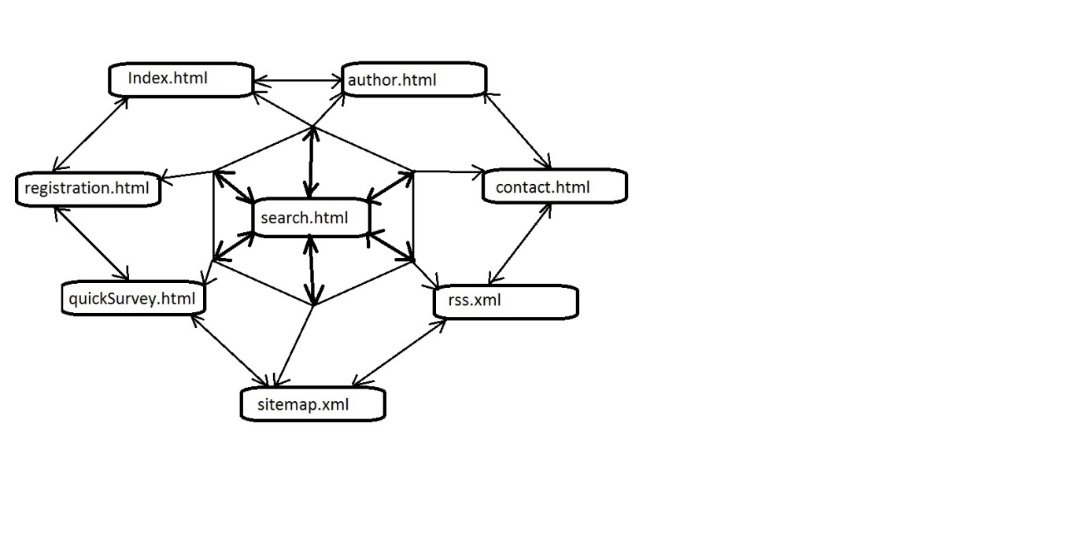

## 2.2. Mapa sajta

<?xml version="1.0" encoding="UTF-8"?>

<?xml-stylesheet type="text/xsl" href="sitemap.xsl"?>

<urlset>

<url>

<loc>http://interestingfacts.byethost11.com/index.html</loc>

<lastmod>2016-04-12</lastmod>

<changefreq>Monthly</changefreq>

<priority>1</priority>

</url>

<url>

<loc>http://interestingfacts.byethost11.com/registration.html</loc>

<lastmod>2016-04-12</lastmod>

<changefreq>Monthly</changefreq>

<priority>0.9</priority>

</url>

<url>

<loc>http://interestingfacts.byethost11.com/quickSurvey.html</loc>

<lastmod>2016-04-12</lastmod>

<changefreq>yearly</changefreq>

<priority>0.9</priority>

</url>

<url>

<loc>http://interestingfacts.byethost11.com/author.html</loc>

<lastmod>2016-04-12</lastmod>

<changefreq>yearly</changefreq>

<priority>0.8</priority>

</url>

<url>

<loc>http://interestingfacts.byethost11.com/contact.html</loc>

<lastmod>2016-04-12</lastmod>

<changefreq>yearly</changefreq>

<priority>0.8</priority>

</url>

</urlset>

## 2.3. PrintScreen stranica

### 2.3.1. Index.html

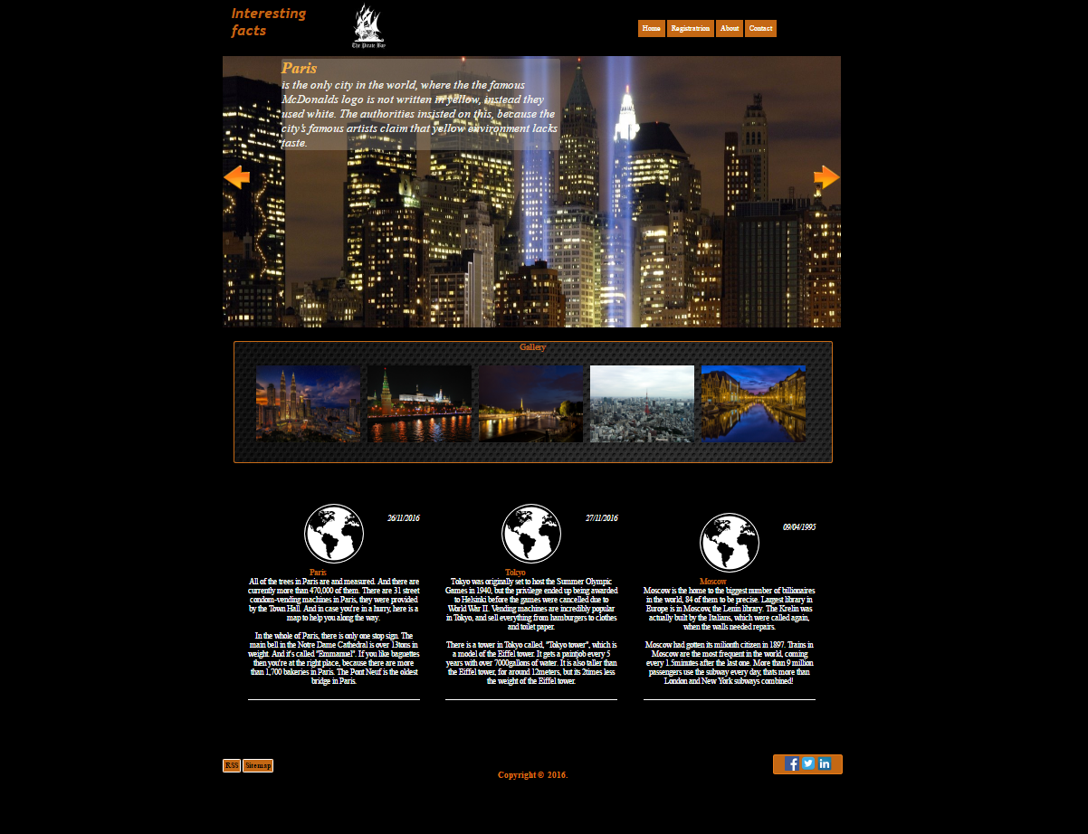

### 2.3.2. registration.html

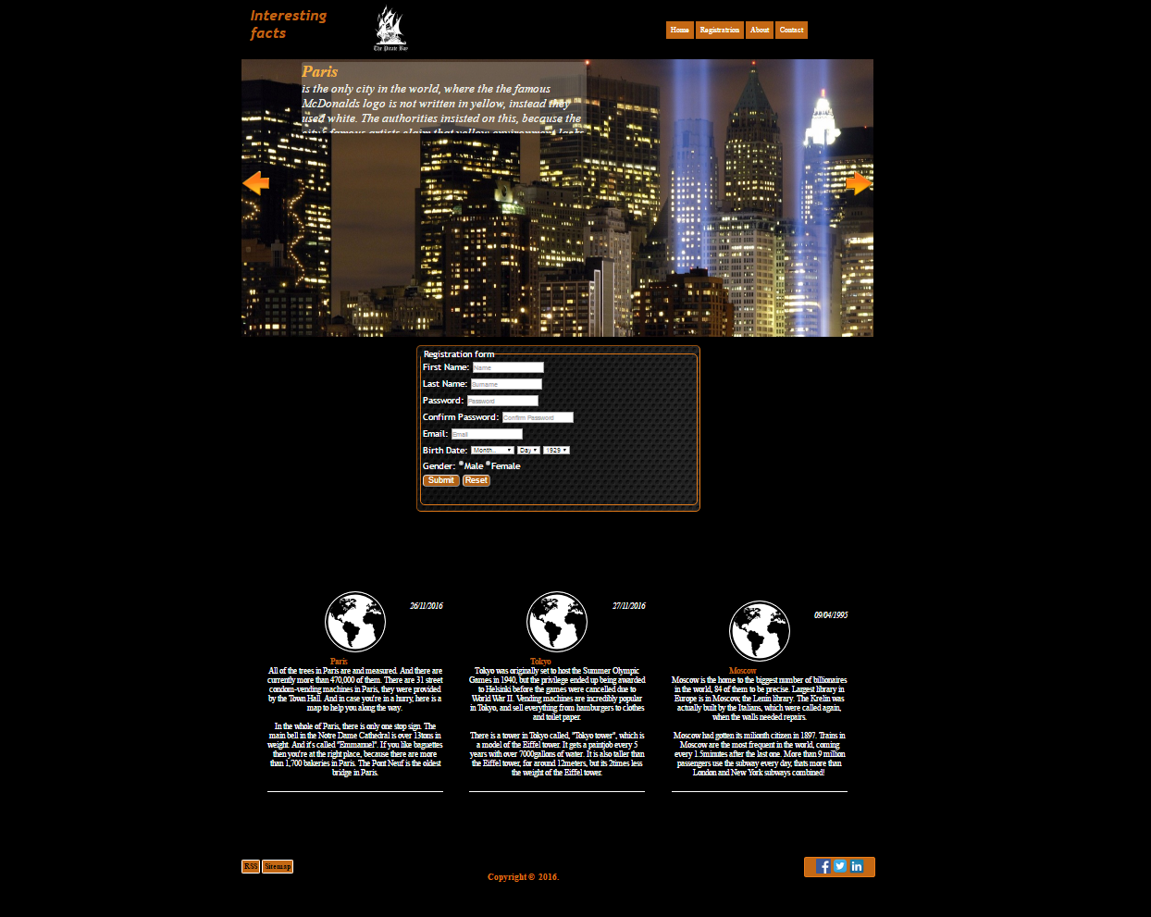

### 2.3.3. quickSurvey.html

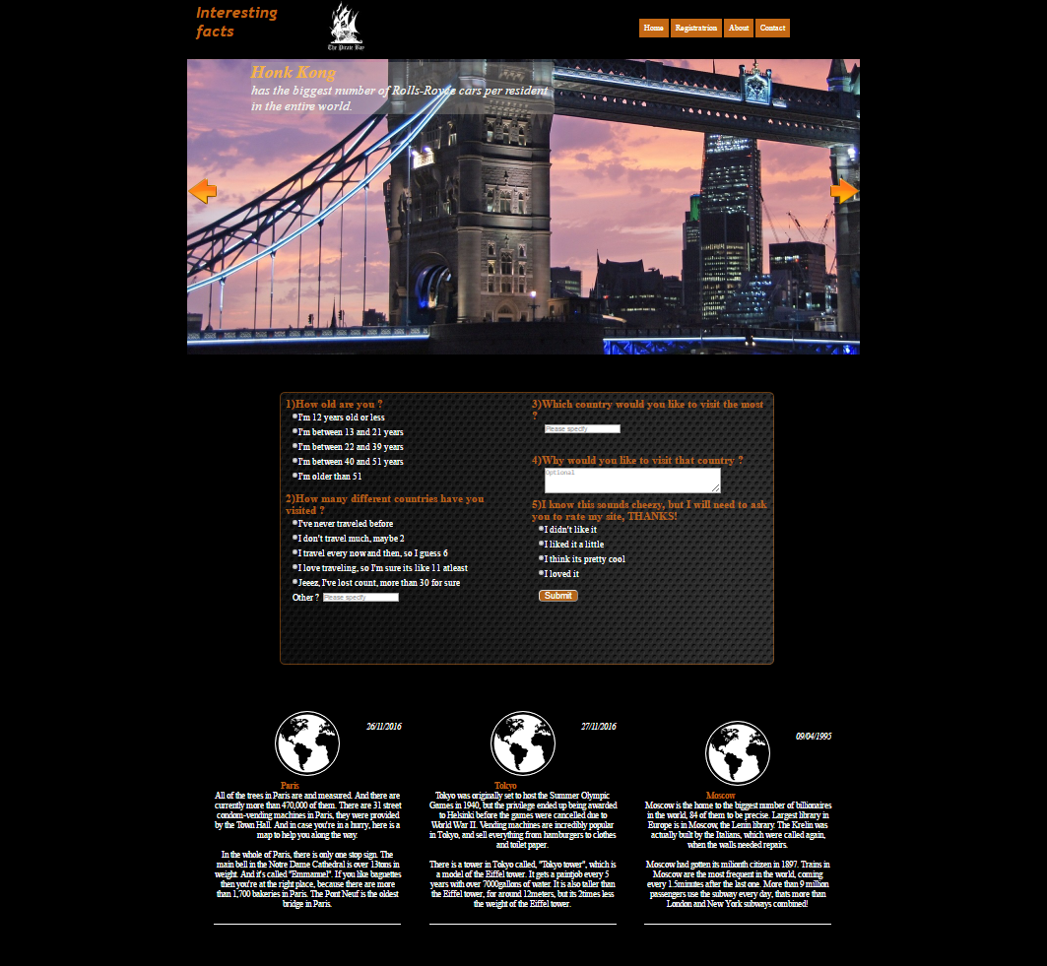

### 2.3.4. about.html

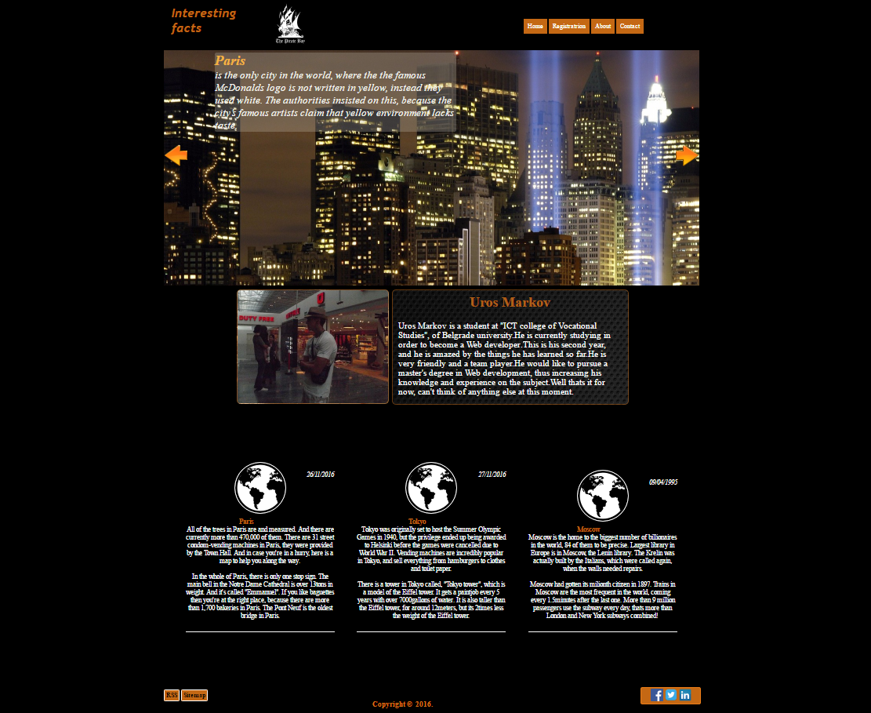

### 2.3.5. contact.html

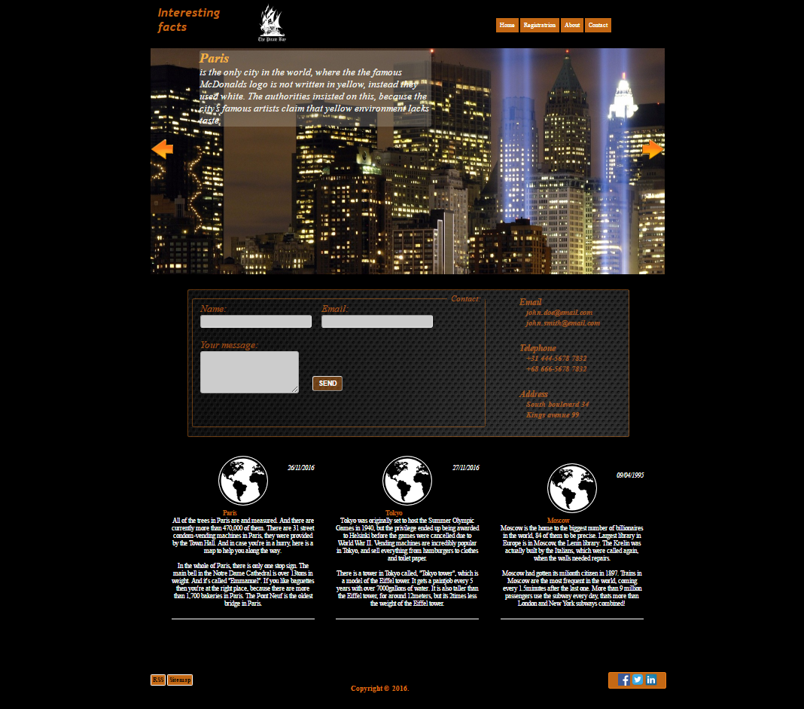

# 3.0. HTML i CSS kodovi

## 3.1. index.html

<!DOCTYPE HTML PUBLIC "-//W3C//DTD HTML 4.01//EN" "http://www.w3.org/TR/html4/strict.dtd">

<html xmlns="http://www.w3.org/1999/xhtml" >

<head>

<title>Interesting facts about cities</title>

<link rel="icon" type="image/x-icon" href="Pictures/favicon.ico" />

<meta name='author' content='Uros Markov, [sombrero9564@hotmail.com](mailto:sombrero9564@hotmail.com)'>

<meta name="copyright" content="Uros Markov"/>

<meta name='keywords' content='cities, moscow, paris, tokyo, facts, interesting'>

<meta name='description' content='Here you can read interesting facts about the most popular cities in the world'>

<meta name='language' content='EN'>

<link rel="stylesheet" type="text/css" href="style.css" >

<!-- Add jQuery library -->

<script type="text/javascript" src="http://code.jquery.com/jquery-latest.min.js"></script>

<!-- Add mousewheel plugin (this is optional) -->

<script type="text/javascript" src="fancybox/lib/jquery.mousewheel-3.0.6.pack.js"></script>

<!-- Add fancyBox -->

<link rel="stylesheet" href="fancybox/source/jquery.fancybox.css?v=2.1.5" type="text/css" media="screen" />

<script type="text/javascript" src="fancybox/source/jquery.fancybox.pack.js?v=2.1.5"></script>

<!-- Optionally add helpers - button, thumbnail and/or media -->

<link rel="stylesheet" href="fancybox/source/helpers/jquery.fancybox-buttons.css?v=1.0.5" type="text/css" media="screen" />

<script type="text/javascript" src="fancybox/source/helpers/jquery.fancybox-buttons.js?v=1.0.5"></script>

<script type="text/javascript" src="fancybox/source/helpers/jquery.fancybox-media.js?v=1.0.6"></script>

<link rel="stylesheet" href="fancybox/source/helpers/jquery.fancybox-thumbs.css?v=1.0.7" type="text/css" media="screen" />

<script type="text/javascript" src="fancybox/source/helpers/jquery.fancybox-thumbs.js?v=1.0.7"></script>

<script type="text/javascript">

var $= jQuery.noConflict();

</script>

<script type="text/javascript">

$(document).ready(function() {

$(".fancybox").fancybox();

});

</script>

<meta http-equiv="Content-Type" content="text/html; charset=UTF-8" />

<!--<script type="text/javascript" src="jquery.min.js">-->

<!--<script src="https://ajax.googleapis.com/ajax/libs/jquery/3.1.1/jquery.min.js"></script>-->

<script src="jquery.innerfade.js" type="text/javascript" ></script>

<script src="scriptCalendar.js" type="text/javascript" ></script>

<script src="scriptjq.js"></script>

</script>

</head>

<body onLoad="yearDynamic();" >

<div id="wrapper">

<div id="head">

<div id="logoNav">

<div id="logo">

<a href="index.html"><img src="pictures/tpb.jpg" alt="logo" /><h1>Interesting facts</h1></a>

</div>

<div id="menu">

<ul>

<li><a href="index.html">Home</a></li>

<li id="subMenu"><a href="#">Registratrion</a>

<ul>

<li><a href="registration.html">Register</a></li>

<li><a href="quickSurvey.html">Survey</a></li>

</ul>

</li>

<li><a href="author.html">About</a></li>

<li><a href="contact.html">Contact</a></li>

</ul>

</div>

</div>

<div id="slider">

<div id="middleImg">

<div id="slideFacts">

<ul id="ulFacts">

<li>

<h2>Paris</h2> is the only city in the world, where the the famous McDonalds logo is not written in yellow, instead they used white. The authorities insisted on this, because the city’s famous artists claim that yellow environment lacks taste.

</li><br/>

<li>

<h2>Honk Kong</h2> has the biggest number of Rolls-Royce cars per resident in the entire world.

</li><br/>

<li>

<h2>Vatican City</h2> has the highest crime rate per capita in the world. There are 492 residents in the country, but, for example, in 2006 there were 341 civil processes and 486 administrative processes initiated in the city. Therefore the average number of violations per resident is very high. Truth be told though, most of these criminal cases were initiated against tourists.

</li>

<li>

<h2>Tokyo</h2>

There are almost 3 000 residents in Tokyo’s regions per m2 – it is the most densely populated area in the world. The number of residents including suburbs is 37.5 million people.

</li>

<li>

<h2>Moscow</h2>

Trains in Moscow are the most frequent in the world, coming every 1.5minutes after the last one. More than 9 million passengers use the subway every day, thats more than London and New York subways combined!

</li>

<li>

<h2>Istanbul</h2>

The only city in the world that connects two continents: Asia and Europe.

</li>

<li>

<h2>Tokyo</h2>

There is a tower in Tokyo called, "Tokyo tower", which is a model of the Eiffel tower. It gets a paintjob every 5 years with over 7000gallons of water.

</li>

<li>

<h2>Paris</h2>

In the whole of Paris, there is only one stop sign.

</li>

<li>

<h2>Moscow</h2>

The Krelin was actually built by the Italians, which were called again, when the walls needed repairs.

</li>

</ul>

</div>

<img src="pictures/Fusion3.jpg" />

<div id="previous" onClick="nextPic(600)">

<img src="pictures/previous.png" alt="previous" />

<div id="next" onClick="nextPic(-600)">

<img src="pictures/next.png" alt="next" />

</div>

</div>

</div>

</div>

</div>

<div id="content">

<div id="gallery">

<p>Gallery</p>

<a class="fancybox" rel="group" href="fancybox/demo/kuala.jpg"><img src="fancybox/demo/kuala.jpg" alt="Kuala Lumpur" /></a>

<a class="fancybox" rel="group" href="fancybox/demo/moscow.jpg"><img src="fancybox/demo/moscow.jpg" alt="Moscow kremlin" /></a>

<a class="fancybox" rel="group" href="fancybox/demo/paris.jpg"><img src="fancybox/demo/paris.jpg" alt="Paris" /></a>

<a class="fancybox" rel="group" href="fancybox/demo/tokyo.jpg"><img src="fancybox/demo/tokyo.jpg" alt="Tokyo tower" /></a>

<a class="fancybox" rel="group" href="fancybox/demo/vatican.jpg"><img src="fancybox/demo/vatican.jpg" alt="Kuala Lumpur" /></a>

</div>

<div id="reviewBox">

<div class="reviews">

<div class="reviewL">

</div>

<p class="dateP"><i>26/11/2016</i></p>

<p>

<b>Paris</b><br/>All of the trees in Paris are and measured. And there are currently more than 470,000 of them. There are 31 street condom-vending machines in Paris, they were provided by the Town Hall. And in case you're in a hurry, here is a map to help you along the way.

</p><br/>

<p class="lastPara">

In the whole of Paris, there is only one stop sign. The main bell in the Notre Dame Cathedral is over 13tons in weight. And it's called "Emmanuel". If you like baguettes then you're at the right place, because there are more than 1,700 bakeries in Paris. The Pont Neuf is the oldest bridge in Paris.

</p>

</div>

<div class="reviews">

<div class="reviewL">

</div>

<p class="dateP"><i>27/11/2016</i></p>

<p>

<b>Tokyo</b><br/>Tokyo was originally set to host the Summer Olympic Games in 1940, but the privilege ended up being awarded to Helsinki before the games were cancelled due to World War II. Vending machines are incredibly popular in Tokyo, and sell everything from hamburgers to clothes and toilet paper.

</p><br/>

<p class="lastPara">

There is a tower in Tokyo called, "Tokyo tower", which is a model of the Eiffel tower. It gets a paintjob every 5 years with over 7000gallons of water. It is also taller than the Eiffel tower, for around 12meters, but its 2times less the weight of the Eiffel tower.

</p>

</div>

<div class="reviews">

<div class="reviewL">

</div>

<p class="dateP"><i>09/04/1995</i></p>

<p>

<b>Moscow</b><br/>Moscow is the home to the biggest number of billionaires in the world, 84 of them to be precise. Largest library in Europe is in Moscow, the Lenin library. The Krelin was actually built by the Italians, which were called again, when the walls needed repairs.

</p><br/>

<p class="lastPara">

Moscow had gotten its milionth citizen in 1897. Trains in Moscow are the most frequent in the world, coming every 1.5minutes after the last one. More than 9 million passengers use the subway every day, thats more than London and New York subways combined!

</p>

</div>

</div>

<!--<div id="spaceFacts">

<ul>

<li><h2 id="diff">Mind blowing facts about space!</h2>

<li>1. In space metal sticks together</li>

<li>2. The hottest planet is not the closest planet to the Sun.</li>

<li>3. You become taller in Space.</li>

<li>4. Sun is as big as 1 million Earths put together</li>

<li>5. There is no sound in space, its completely silent.</li>

<li>6. Nasa space suit costs 12,000,000$.</li>

<li>7. Largest known asteroid is 970km wide.</li>

<li>8. Sun accounts for approximately 99.89% of our Solar system's mass</li>

</li>

</ul>

<div id="gallery">

</div>

</div>-->

</div>

<div id="footer">

<div id="contact">

<br/><br/><br/><br/><br/><h3>Copyright &copy;&nbsp; 2016.</h3>

<div id="sitemapRSS" class="indexPos">

<a href="rss.xml" title="rssButton">RSS</a>

<a href="sitemap.xml" title="sitemapButton">Sitemap</a>

</div>

<div id="socialNetworks">

<div id="facebook">

<a href="http://www.facebook.com">A</a>

</div>

<div id="twitter">

<a href="http://www.twitter.com">A</a>

</div>

<div id="linkedin">

<a href="http://www.linkedin.com">A</a>

</div>

</div>

<div id="credits">Icons made by <a href="http://www.freepik.com" title="Freepik">Freepik</a> from <a href="http://www.flaticon.com" title="Flaticon">www.flaticon.com</a> is licensed by <a href="http://creativecommons.org/licenses/by/3.0/" title="Creative Commons BY 3.0" target="_blank">CC 3.0 BY</a></div>

</div>

</div>

</div>

</body>

</html>

## 3.2. registration.html

<!DOCTYPE HTML PUBLIC "-//W3C//DTD HTML 4.01//EN" "http://www.w3.org/TR/html4/strict.dtd">

<html xmlns="http://www.w3.org/1999/xhtml" >

<head>

<title>Interesting facts about cities</title>

<link rel="icon" type="image/x-icon" href="Pictures/favicon.ico" />

<meta name='author' content='Uros Markov, sombrero9564@hotmail.com'>

<meta name="copyright" content="Uros Markov"/>

<meta name='keywords' content='cities, moscow, paris, tokyo, facts, interesting'>

<meta name='description' content='Here you can read interesting facts about the most popular cities in the world'>

<meta name='language' content='EN'>

<link rel="stylesheet" type="text/css" href="style.css" >

<!--<script type="text/javascript" src="jquery.min.js">-->

<script src="https://ajax.googleapis.com/ajax/libs/jquery/3.1.1/jquery.min.js"></script>

<script src="jquery.innerfade.js" type="text/javascript" ></script>

<script src="scriptRegExp.js" type="text/javascript"></script>

<script src="scriptjq.js"></script>

</script>

</head>

<body onLoad="document.regFormm.ddMonth.selectedIndex=0;yearDynamic();" >

<div id="wrapper">

<div id="head">

<div id="logoNav">

<div id="logo">

<a href="index.html"><img src="pictures/tpb.jpg" alt="logo" /><h1>Interesting facts</h1></a>

</div>

<div id="menu">

<ul>

<li><a href="index.html">Home</a></li>

<li id="subMenu"><a href="#">Registratrion</a>

<ul>

<li><a href="registration.html">Register</a></li>

<li><a href="quickSurvey.html">Survey</a></li>

</ul>

</li>

<li><a href="author.html">About</a></li>

<li><a href="contact.html">Contact</a></li>

</ul>

</div>

<!--<div id="searchDiv">

<div id="tbSearchDiv">

<input type="text" id="tbSearch" placeholder="Search" />

</div>

<div id="btSearchDiv">

<input type="button" id="btSearch" />

</div>

</div>-->

</div>

<div id="slider">

<div id="slideFacts">

<ul id="ulFacts">

<li>

<h2>Paris</h2> is the only city in the world, where the the famous McDonalds logo is not written in yellow, instead they used white. The authorities insisted on this, because the city’s famous artists claim that yellow environment lacks taste.

</li><br/>

<li>

<h2>Honk Kong</h2> has the biggest number of Rolls-Royce cars per resident in the entire world.

</li><br/>

<li>

<h2>Vatican City</h2> has the highest crime rate per capita in the world. There are 492 residents in the country, but, for example, in 2006 there were 341 civil processes and 486 administrative processes initiated in the city. Therefore the average number of violations per resident is very high. Truth be told though, most of these criminal cases were initiated against tourists.

</li>

<li>

<h2>Tokyo</h2>

There are almost 3 000 residents in Tokyo’s regions per m2 – it is the most densely populated area in the world. The number of residents including suburbs is 37.5 million people.

</li>

<li>

<h2>Moscow</h2>

Trains in Moscow are the most frequent in the world, coming every 1.5minutes after the last one. More than 9 million passengers use the subway every day, thats more than London and New York subways combined!

</li>

<li>

<h2>Istanbul</h2>

The only city in the world that connects two continents: Asia and Europe.

</li>

<li>

<h2>Tokyo</h2>

There is a tower in Tokyo called, "Tokyo tower", which is a model of the Eiffel tower. It gets a paintjob every 5 years with over 7000gallons of water.

</li>

<li>

<h2>Paris</h2>

In the whole of Paris, there is only one stop sign.

</li>

<li>

<h2>Moscow</h2>

The Krelin was actually built by the Italians, which were called again, when the walls needed repairs.

</li>

</ul>

</div>

<div id="middleImg">

<img src="pictures/Fusion2.jpg" />

</div>

<div id="previous" onClick="nextPic(600)">

<img src="pictures/previous.png" alt="previous" />

<div id="next" onClick="nextPic(-600)">

<img src="pictures/next.png" alt="next" />

</div>

</div>

</div>

</div>

<div id="content">

<div id="form"><br/>

<form id="regForm" name="regFormm" method="POST" action="/">

<fieldset>

<legend>&nbsp;Registration form</legend>

<div>

<label for="tbName">First Name:</label>

<input type="text" id="tbName" placeholder="Name" onBlur="checkForm();" />

<span id="spanName"></span>

</div><br/>

<div>

<label for="tbLastName">Last Name:</label>

<input type="text" id="tbLastName" placeholder="Surname" onBlur="checkForm();"/>

<span id="spanLastName"></span>

</div><br/>

<div>

<label for="tbPass">Password:</label>

<input type="password" id="tbPass" placeholder="Password" onBlur="checkForm();"/>

<span id="spanPass"></span>

</div><br/>

<div>

<label for="tbPass2">Confirm Password:</label>

<input type="password" id="tbPass2" placeholder="Confirm Password" onBlur="checkForm();"/>

<span id="spanConfirmPass"></span>

</div><br/>

<div>

<label for="tbEmail">Email:</label>

<input type="text" id="tbEmail" placeholder="Email" onBlur="checkForm();"/>

<span id="spanEmail"></span>

</div><br/>

<div>

<label for="ddDay">Birth Date:</label>

<select name="ddMonth" onChange="fillUp(this)">

<option value="errorValue">Month..</option>

<option value="0">Januray</option>

<option value="1">February</option>

<option value="2">March</option>

<option value="3">April</option>

<option value="4">May</option>

<option value="5">June</option>

<option value="6">July</option>

<option value="7">August</option>

<option value="8">September</option>

<option value="9">October</option>

<option value="10">November</option>

<option value="11">December</option>

</select>

<select name="ddDay">

<option value="errorValue">Day</option>

</select>

<select id="ddYear">

<option value="errorValue" selected>Year</option>

</select>

<span id="spanBirthDate"></span>

</div><br/>

<div>

<label for="rbMale">Gender:</label>

<input type="radio" name="rbGender" id="rbMale" />Male

<input type="radio" name="rbGender" id="rbFemale" />Female

<span id="spanGender"></span>

</div><br/>

<div>

<input type="button" onClick="checkForm();" value="Submit" id="btSubmit" />

<input type="reset" value="Reset" id="btReset"/>

</div>

</fieldset>

</form>

</div>

<div id="reviewBox">

<div class="reviews">

<div class="reviewL">

</div>

<p class="dateP"><i>26/11/2016</i></p>

<p>

<b>Paris</b><br/>All of the trees in Paris are and measured. And there are currently more than 470,000 of them. There are 31 street condom-vending machines in Paris, they were provided by the Town Hall. And in case you're in a hurry, here is a map to help you along the way.

</p><br/>

<p class="lastPara">

In the whole of Paris, there is only one stop sign. The main bell in the Notre Dame Cathedral is over 13tons in weight. And it's called "Emmanuel". If you like baguettes then you're at the right place, because there are more than 1,700 bakeries in Paris. The Pont Neuf is the oldest bridge in Paris.

</p>

</div>

<div class="reviews">

<div class="reviewL">

</div>

<p class="dateP"><i>27/11/2016</i></p>

<p>

<b>Tokyo</b><br/>Tokyo was originally set to host the Summer Olympic Games in 1940, but the privilege ended up being awarded to Helsinki before the games were cancelled due to World War II. Vending machines are incredibly popular in Tokyo, and sell everything from hamburgers to clothes and toilet paper.

</p><br/>

<p class="lastPara">

There is a tower in Tokyo called, "Tokyo tower", which is a model of the Eiffel tower. It gets a paintjob every 5 years with over 7000gallons of water. It is also taller than the Eiffel tower, for around 12meters, but its 2times less the weight of the Eiffel tower.

</p>

</div>

<div class="reviews">

<div class="reviewL">

</div>

<p class="dateP"><i>09/04/1995</i></p>

<p>

<b>Moscow</b><br/>Moscow is the home to the biggest number of billionaires in the world, 84 of them to be precise. Largest library in Europe is in Moscow, the Lenin library. The Krelin was actually built by the Italians, which were called again, when the walls needed repairs.

</p><br/>

<p class="lastPara">

Moscow had gotten its milionth citizen in 1897. Trains in Moscow are the most frequent in the world, coming every 1.5minutes after the last one. More than 9 million passengers use the subway every day, thats more than London and New York subways combined!

</p>

</div>

</div>

<!--<div id="spaceFacts">

<ul>

<li><h2 id="diff">Mind blowing facts about space!</h2>

<li>1. In space metal sticks together</li>

<li>2. The hottest planet is not the closest planet to the Sun.</li>

<li>3. You become taller in Space.</li>

<li>4. Sun is as big as 1 million Earths put together</li>

<li>5. There is no sound in space, its completely silent.</li>

<li>6. Nasa space suit costs 12,000,000$.</li>

<li>7. Largest known asteroid is 970km wide.</li>

<li>8. Sun accounts for approximately 99.89% of our Solar system's mass</li>

</li>

</ul>

<div id="gallery">

</div>

</div>-->

</div>

<div id="footer">

<div id="contact">

<div id="sitemapRSS">

<a href="rss.xml" title="rssButton">RSS</a>

<a href="sitemap.xml" title="sitemapButton">Sitemap</a>

</div>

<div id="socialNetworks" class="test33">

<div id="facebook">

<a href="http://www.facebook.com">A</a>

</div>

<div id="twitter">

<a href="http://www.twitter.com">A</a>

</div>

<div id="linkedin">

<a href="http://www.linkedin.com">A</a>

</div>

</div>

<br/><br/><br/><br/><br/><h3>Copyright &copy;&nbsp 2016.</h3>

<div id="credits">Icons made by <a href="http://www.freepik.com" title="Freepik">Freepik</a> from <a href="http://www.flaticon.com" title="Flaticon">www.flaticon.com</a> is licensed by <a href="http://creativecommons.org/licenses/by/3.0/" title="Creative Commons BY 3.0" target="_blank">CC 3.0 BY</a></div>

</div>

</div>

</div>

</body>

</html>

## 3.3. quickSurvey.html

<!DOCTYPE HTML PUBLIC "-//W3C//DTD HTML 4.01//EN" "http://www.w3.org/TR/html4/strict.dtd">

<html xmlns="http://www.w3.org/1999/xhtml" >

<head>

<title>Interesting facts about cities</title>

<link rel="icon" type="image/x-icon" href="Pictures/favicon.ico" />

<meta name='author' content='Uros Markov, sombrero9564@hotmail.com'>

<meta name="copyright" content="Uros Markov"/>

<meta name='keywords' content='cities, moscow, paris, tokyo, facts, interesting'>

<meta name='description' content='Here you can read interesting facts about the most popular cities in the world'>

<meta name='language' content='EN'>

<link rel="stylesheet" type="text/css" href="style.css" >

<!--<script type="text/javascript" src="jquery.min.js">-->

<script src="https://ajax.googleapis.com/ajax/libs/jquery/3.1.1/jquery.min.js"></script>

<script src="jquery.innerfade.js" type="text/javascript" ></script>

<script src="scriptRegExp.js" type="text/javascript"></script>

<script src="scriptjq.js"></script>

</script>

</head>

<body onLoad="yearDynamic();" >

<div id="wrapper">

<div id="head">

<div id="logoNav">

<div id="logo">

<a href="index.html"><img src="pictures/tpb.jpg" alt="logo" /><h1>Interesting facts</h1></a>

</div>

<div id="menu">

<ul>

<li><a href="index.html">Home</a></li>

<li id="subMenu"><a href="#">Registration</a>

<ul>

<li><a href="registration.html">Register</a></li>

<li><a href="quickSurvey.html">Survey</a></li>

</ul>

</li>

<li><a href="author.html">About</a></li>

<li><a href="contact.html">Contact</a></li>

</ul>

</div>

<!--<div id="searchDiv">

<div id="tbSearchDiv">

<input type="text" id="tbSearch" placeholder="Search" />

</div>

<div id="btSearchDiv">

<input type="button" id="btSearch" />

</div>

</div>-->

</div>

<div id="slider">

<div id="slideFacts">

<ul id="ulFacts">

<li>

<h2>Paris</h2> is the only city in the world, where the the famous McDonalds logo is not written in yellow, instead they used white. The authorities insisted on this, because the city’s famous artists claim that yellow environment lacks taste.

</li><br/>

<li>

<h2>Honk Kong</h2> has the biggest number of Rolls-Royce cars per resident in the entire world.

</li><br/>

<li>

<h2>Vatican City</h2> has the highest crime rate per capita in the world. There are 492 residents in the country, but, for example, in 2006 there were 341 civil processes and 486 administrative processes initiated in the city. Therefore the average number of violations per resident is very high. Truth be told though, most of these criminal cases were initiated against tourists.

</li>

<li>

<h2>Tokyo</h2>

There are almost 3 000 residents in Tokyo’s regions per m2 – it is the most densely populated area in the world. The number of residents including suburbs is 37.5 million people.

</li>

<li>

<h2>Moscow</h2>

Trains in Moscow are the most frequent in the world, coming every 1.5minutes after the last one. More than 9 million passengers use the subway every day, thats more than London and New York subways combined!

</li>

<li>

<h2>Istanbul</h2>

The only city in the world that connects two continents: Asia and Europe.

</li>

<li>

<h2>Tokyo</h2>

There is a tower in Tokyo called, "Tokyo tower", which is a model of the Eiffel tower. It gets a paintjob every 5 years with over 7000gallons of water.

</li>

<li>

<h2>Paris</h2>

In the whole of Paris, there is only one stop sign.

</li>

<li>

<h2>Moscow</h2>

The Krelin was actually built by the Italians, which were called again, when the walls needed repairs.

</li>

</ul>

</div>

<div id="middleImg">

<img src="pictures/Fusion2.jpg" />

</div>

<div id="previous" onClick="nextPic(600)">

<img src="pictures/previous.png" alt="previous" />

<div id="next" onClick="nextPic(-600)">

<img src="pictures/next.png" alt="next" />

</div>

</div>

</div>

</div>

<div id="content">

<div id="survey">

<div id="surveyCentered">

<div id="surveyLeft">

<form name="surveyLeft" id="surveyL" method="POST" action="/">

<div id="ageRadio">

<label for="rbAge">1)How old are you ?</label><br/>

<p><input type="radio" name="rbAge" value="0" />I'm 12 years old or less</p>

<p><input type="radio" name="rbAge" value="1" />I'm between 13 and 21 years</p>

<p><input type="radio" name="rbAge" value="2" />I'm between 22 and 39 years</p>

<p><input type="radio" name="rbAge" value="3" />I'm between 40 and 51 years</p>

<p><input type="radio" name="rbAge" value="4" />I'm older than 51</p>

</div><br/>

<div id="countryRadio">

<label for="rbCountry">2)How many different countries have you visited ?</label><br/>

<p><input type="radio" name="rbCountry" value="0" />I've never traveled before</p>

<p><input type="radio" name="rbCountry" value="1" />I don't travel much, maybe 2</p>

<p><input type="radio" name="rbCountry" value="2" />I travel every now and then, so I guess 6</p>

<p><input type="radio" name="rbCountry" value="3" />I love traveling, so I'm sure its like 11 atleast</p>

<p><input type="radio" name="rbCountry" value="4" />Jeeez, I've lost count, more than 30 for sure</p>

<p>Other ?&nbsp;&nbsp;<input type="text" id="tbCountry" placeholder="Please specify" /></p>

</div>

</form>

</div>

<div id="surveyRight">

<form name="surveyRight" id="surveyR" method="POST" action="/">

<div id="countryWish">

<label>3)Which country would you like to visit the most ?</label>

<p>&nbsp;&nbsp;&nbsp;<input type="text" id="tbCountryWish" placeholder="Please specify"/></p><br/><br/>

<label>4)Why would you like to visit that country ?</label>

<p>&nbsp;&nbsp;&nbsp;<textarea id="taCommentCountry" cols="40" rows="3" placeholder="Optional"></textarea></p>

</div>

<div id="finalRating">

<label>5)I know this sounds cheezy, but I will need to ask you to rate my site, THANKS!</label>

<p><input type="radio" name="rbRating" value="0"/>I didn't like it</p>

<p><input type="radio" name="rbRating" value="0"/>I liked it a little</p>

<p><input type="radio" name="rbRating" value="0"/>I think its pretty cool</p>

<p><input type="radio" name="rbRating" value="0"/>I loved it</p>

</div><br/>

<div>

<input type="button" id="btSurveySubmit" onClick="completedSurvey();" value="Submit"/>

<!--<div class="submitDiv"><br/>

<p>Thank you for completing this survey!</p>

</div>-->

</div>

</form>

</div>

</div>

</div>

<div id="reviewBox">

<div class="reviews">

<div class="reviewL">

</div>

<p class="dateP"><i>26/11/2016</i></p>

<p>

<b>Paris</b><br/>All of the trees in Paris are and measured. And there are currently more than 470,000 of them. There are 31 street condom-vending machines in Paris, they were provided by the Town Hall. And in case you're in a hurry, here is a map to help you along the way.

</p><br/>

<p class="lastPara">

In the whole of Paris, there is only one stop sign. The main bell in the Notre Dame Cathedral is over 13tons in weight. And it's called "Emmanuel". If you like baguettes then you're at the right place, because there are more than 1,700 bakeries in Paris. The Pont Neuf is the oldest bridge in Paris.

</p>

</div>

<div class="reviews">

<div class="reviewL">

</div>

<p class="dateP"><i>27/11/2016</i></p>

<p>

<b>Tokyo</b><br/>Tokyo was originally set to host the Summer Olympic Games in 1940, but the privilege ended up being awarded to Helsinki before the games were cancelled due to World War II. Vending machines are incredibly popular in Tokyo, and sell everything from hamburgers to clothes and toilet paper.

</p><br/>

<p class="lastPara">

There is a tower in Tokyo called, "Tokyo tower", which is a model of the Eiffel tower. It gets a paintjob every 5 years with over 7000gallons of water. It is also taller than the Eiffel tower, for around 12meters, but its 2times less the weight of the Eiffel tower.

</p>

</div>

<div class="reviews">

<div class="reviewL">

</div>

<p class="dateP"><i>09/04/1995</i></p>

<p>

<b>Moscow</b><br/>Moscow is the home to the biggest number of billionaires in the world, 84 of them to be precise. Largest library in Europe is in Moscow, the Lenin library. The Krelin was actually built by the Italians, which were called again, when the walls needed repairs.

</p><br/>

<p class="lastPara">

Moscow had gotten its milionth citizen in 1897. Trains in Moscow are the most frequent in the world, coming every 1.5minutes after the last one. More than 9 million passengers use the subway every day, thats more than London and New York subways combined!

</p>

</div>

</div>

<!--<div id="spaceFacts">

<ul>

<li><h2 id="diff">Mind blowing facts about space!</h2>

<li>1. In space metal sticks together</li>

<li>2. The hottest planet is not the closest planet to the Sun.</li>

<li>3. You become taller in Space.</li>

<li>4. Sun is as big as 1 million Earths put together</li>

<li>5. There is no sound in space, its completely silent.</li>

<li>6. Nasa space suit costs 12,000,000$.</li>

<li>7. Largest known asteroid is 970km wide.</li>

<li>8. Sun accounts for approximately 99.89% of our Solar system's mass</li>

</li>

</ul>

<div id="gallery">

</div>

</div>-->

</div>

<div id="footer">

<div id="contact">

<div id="sitemapRSS">

<a href="rss.xml" title="rssButton">RSS</a>

<a href="sitemap.xml" title="sitemapButton">Sitemap</a>

</div>

<div id="socialNetworks" class="test33">

<div id="facebook">

<a href="http://www.facebook.com">A</a>

</div>

<div id="twitter">

<a href="http://www.twitter.com">A</a>

</div>

<div id="linkedin">

<a href="http://www.linkedin.com">A</a>

</div>

</div>

<br/><br/><br/><br/><br/><h3>Copyright &copy;&nbsp 2016.</h3>

<div id="credits">Icons made by <a href="http://www.freepik.com" title="Freepik">Freepik</a> from <a href="http://www.flaticon.com" title="Flaticon">www.flaticon.com</a> is licensed by <a href="http://creativecommons.org/licenses/by/3.0/" title="Creative Commons BY 3.0" target="_blank">CC 3.0 BY</a></div>

</div>

</div>

</div>

</body>

</html>

## 3.4. author.html

<!DOCTYPE HTML PUBLIC "-//W3C//DTD HTML 4.01//EN" "http://www.w3.org/TR/html4/strict.dtd">

<html xmlns="http://www.w3.org/1999/xhtml" >

<head>

<title>Interesting facts about cities</title>

<link rel="icon" type="image/x-icon" href="Pictures/favicon.ico" />

<meta name='author' content='Uros Markov, sombrero9564@hotmail.com'>

<meta name="copyright" content="Uros Markov"/>

<meta name='keywords' content='cities, moscow, paris, tokyo, facts, interesting'>

<meta name='description' content='Here you can read interesting facts about the most popular cities in the world'>

<meta name='language' content='EN'>

<link rel="stylesheet" type="text/css" href="style.css" >

<!--<script type="text/javascript" src="jquery.min.js">-->

<script src="https://ajax.googleapis.com/ajax/libs/jquery/3.1.1/jquery.min.js"></script>

<script src="jquery.innerfade.js" type="text/javascript" ></script>

<script src="scriptCalendar.js" type="text/javascript" ></script>

<script src="scriptjq.js"></script>

</script>

</head>

<body onLoad="yearDynamic();" >

<div id="wrapper">

<div id="head">

<div id="logoNav">

<div id="logo">

<a href="index.html"><img src="pictures/tpb.jpg" alt="logo" /><h1>Interesting facts</h1></a>

</div>

<div id="menu">

<ul>

<li><a href="index.html">Home</a></li>

<li id="subMenu"><a href="#">Registration</a>

<ul>

<li><a href="registration.html">Register</a></li>

<li><a href="quickSurvey.html">Survey</a></li>

</ul>

</li>

<li><a href="author.html">About</a></li>

<li><a href="contact.html">Contact</a></li>

</ul>

</div>

<!--<div id="searchDiv">

<div id="tbSearchDiv">

<input type="text" id="tbSearch" placeholder="Search" />

</div>

<div id="btSearchDiv">

<input type="button" id="btSearch" />

</div>

</div>-->

</div>

<div id="slider">

<div id="slideFacts">

<ul id="ulFacts">

<li>

<h2>Paris</h2> is the only city in the world, where the the famous McDonalds logo is not written in yellow, instead they used white. The authorities insisted on this, because the city’s famous artists claim that yellow environment lacks taste.

</li><br/>

<li>

<h2>Honk Kong</h2> has the biggest number of Rolls-Royce cars per resident in the entire world.

</li><br/>

<li>

<h2>Vatican City</h2> has the highest crime rate per capita in the world. There are 492 residents in the country, but, for example, in 2006 there were 341 civil processes and 486 administrative processes initiated in the city. Therefore the average number of violations per resident is very high. Truth be told though, most of these criminal cases were initiated against tourists.

</li>

<li>

<h2>Tokyo</h2>

There are almost 3 000 residents in Tokyo’s regions per m2 – it is the most densely populated area in the world. The number of residents including suburbs is 37.5 million people.

</li>

<li>

<h2>Moscow</h2>

Trains in Moscow are the most frequent in the world, coming every 1.5minutes after the last one. More than 9 million passengers use the subway every day, thats more than London and New York subways combined!

</li>

<li>

<h2>Istanbul</h2>

The only city in the world that connects two continents: Asia and Europe.

</li>

<li>

<h2>Tokyo</h2>

There is a tower in Tokyo called, "Tokyo tower", which is a model of the Eiffel tower. It gets a paintjob every 5 years with over 7000gallons of water.

</li>

<li>

<h2>Paris</h2>

In the whole of Paris, there is only one stop sign.

</li>

<li>

<h2>Moscow</h2>

The Krelin was actually built by the Italians, which were called again, when the walls needed repairs.

</li>

</ul>

</div>

<div id="middleImg">

<img src="pictures/Fusion2.jpg" />

</div>

<div id="previous" onClick="nextPic(600)">

<img src="pictures/previous.png" alt="previous" />

<div id="next" onClick="nextPic(-600)">

<img src="pictures/next.png" alt="next" />

</div>

</div>

</div>

</div>

<div id="content">

<div id="authorWrapper">

<div id="aboutAuthor">

<div id="imgAuthor">

</div>

<div id="smallBioAuthor">

<h2>Uros Markov</h2>

<p>Uros Markov is a student at "ICT college of Vocational Studies", of Belgrade university.He is currently studying in order to become a Web developer.This is his second year, and he is amazed by the things he has learned so far.He is very friendly and a team player.He would like to pursue a master's degree in Web development, thus increasing his knowledge and experience on the subject.Well thats it for now, can't think of anything else at this moment.</p>

</div>

</div>

</div>

<div id="reviewBox">

<div class="reviews">

<div class="reviewL">

</div>

<p class="dateP"><i>26/11/2016</i></p>

<p>

<b>Paris</b><br/>All of the trees in Paris are and measured. And there are currently more than 470,000 of them. There are 31 street condom-vending machines in Paris, they were provided by the Town Hall. And in case you're in a hurry, here is a map to help you along the way.

</p><br/>

<p class="lastPara">

In the whole of Paris, there is only one stop sign. The main bell in the Notre Dame Cathedral is over 13tons in weight. And it's called "Emmanuel". If you like baguettes then you're at the right place, because there are more than 1,700 bakeries in Paris. The Pont Neuf is the oldest bridge in Paris.

</p>

</div>

<div class="reviews">

<div class="reviewL">

</div>

<p class="dateP"><i>27/11/2016</i></p>

<p>

<b>Tokyo</b><br/>Tokyo was originally set to host the Summer Olympic Games in 1940, but the privilege ended up being awarded to Helsinki before the games were cancelled due to World War II. Vending machines are incredibly popular in Tokyo, and sell everything from hamburgers to clothes and toilet paper.

</p><br/>

<p class="lastPara">

There is a tower in Tokyo called, "Tokyo tower", which is a model of the Eiffel tower. It gets a paintjob every 5 years with over 7000gallons of water. It is also taller than the Eiffel tower, for around 12meters, but its 2times less the weight of the Eiffel tower.

</p>

</div>

<div class="reviews">

<div class="reviewL">

</div>

<p class="dateP"><i>09/04/1995</i></p>

<p>

<b>Moscow</b><br/>Moscow is the home to the biggest number of billionaires in the world, 84 of them to be precise. Largest library in Europe is in Moscow, the Lenin library. The Krelin was actually built by the Italians, which were called again, when the walls needed repairs.

</p><br/>

<p class="lastPara">

Moscow had gotten its milionth citizen in 1897. Trains in Moscow are the most frequent in the world, coming every 1.5minutes after the last one. More than 9 million passengers use the subway every day, thats more than London and New York subways combined!

</p>

</div>

</div>

<!--<div id="spaceFacts">

<ul>

<li><h2 id="diff">Mind blowing facts about space!</h2>

<li>1. In space metal sticks together</li>

<li>2. The hottest planet is not the closest planet to the Sun.</li>

<li>3. You become taller in Space.</li>

<li>4. Sun is as big as 1 million Earths put together</li>

<li>5. There is no sound in space, its completely silent.</li>

<li>6. Nasa space suit costs 12,000,000$.</li>

<li>7. Largest known asteroid is 970km wide.</li>

<li>8. Sun accounts for approximately 99.89% of our Solar system's mass</li>

</li>

</ul>

<div id="gallery">

</div>

</div>-->

</div>

<div id="footer">

<div id="contact">

<div id="sitemapRSS">

<a href="rss.xml" title="rssButton">RSS</a>

<a href="sitemap.xml" title="sitemapButton">Sitemap</a>

</div>

<div id="socialNetworks" class="test33">

<div id="facebook">

<a href="http://www.facebook.com">A</a>

</div>

<div id="twitter">

<a href="http://www.twitter.com">A</a>

</div>

<div id="linkedin">

<a href="http://www.linkedin.com">A</a>

</div>

</div>

<br/><br/><br/><br/><br/><h3>Copyright &copy;&nbsp 2016.</h3>

<div id="credits">Icons made by <a href="http://www.freepik.com" title="Freepik">Freepik</a> from <a href="http://www.flaticon.com" title="Flaticon">www.flaticon.com</a> is licensed by <a href="http://creativecommons.org/licenses/by/3.0/" title="Creative Commons BY 3.0" target="_blank">CC 3.0 BY</a></div>

</div>

</div>

</div>

</body>

</html>

## 3.5. contact.html

<!DOCTYPE HTML PUBLIC "-//W3C//DTD HTML 4.01//EN" "http://www.w3.org/TR/html4/strict.dtd">

<html xmlns="http://www.w3.org/1999/xhtml" >

<head>

<title>Interesting facts about cities</title>

<link rel="icon" type="image/x-icon" href="Pictures/favicon.ico" />

<meta name='author' content='Uros Markov, sombrero9564@hotmail.com'>

<meta name="copyright" content="Uros Markov"/>

<meta name='keywords' content='cities, moscow, paris, tokyo, facts, interesting'>

<meta name='description' content='Here you can read interesting facts about the most popular cities in the world'>

<meta name='language' content='EN'>

<link rel="stylesheet" type="text/css" href="style.css" >

<!--<script type="text/javascript" src="jquery.min.js">-->

<script src="https://ajax.googleapis.com/ajax/libs/jquery/3.1.1/jquery.min.js"></script>

<script src="jquery.innerfade.js" type="text/javascript" ></script>

<script src="scriptCalendar.js" type="text/javascript" ></script>

<script src="scriptjq.js"></script>

</script>

</head>

<body onLoad="yearDynamic();" >

<div id="wrapper">

<div id="head">

<div id="logoNav">

<div id="logo">

<a href="index.html"><img src="pictures/tpb.jpg" alt="logo" /><h1>Interesting facts</h1></a>

</div>

<div id="menu">

<ul>

<li><a href="index.html">Home</a></li>

<li id="subMenu"><a href="#">Registratrion</a>

<ul>

<li><a href="registration.html">Register</a></li>

<li><a href="quickSurvey.html">Survey</a></li>

</ul>

</li>

<li><a href="author.html">About</a></li>

<li><a href="contact.html">Contact</a></li>

</ul>

</div>

<!--<div id="searchDiv">

<div id="tbSearchDiv">

<input type="text" id="tbSearch" placeholder="Search" />

</div>

<div id="btSearchDiv">

<input type="button" id="btSearch" />

</div>

</div>-->

</div>

<div id="slider">

<div id="slideFacts">

<ul id="ulFacts">

<li>

<h2>Paris</h2> is the only city in the world, where the the famous McDonalds logo is not written in yellow, instead they used white. The authorities insisted on this, because the city’s famous artists claim that yellow environment lacks taste.

</li><br/>

<li>

<h2>Honk Kong</h2> has the biggest number of Rolls-Royce cars per resident in the entire world.

</li><br/>

<li>

<h2>Vatican City</h2> has the highest crime rate per capita in the world. There are 492 residents in the country, but, for example, in 2006 there were 341 civil processes and 486 administrative processes initiated in the city. Therefore the average number of violations per resident is very high. Truth be told though, most of these criminal cases were initiated against tourists.

</li>

<li>

<h2>Tokyo</h2>

There are almost 3 000 residents in Tokyo’s regions per m2 – it is the most densely populated area in the world. The number of residents including suburbs is 37.5 million people.

</li>

<li>

<h2>Moscow</h2>

Trains in Moscow are the most frequent in the world, coming every 1.5minutes after the last one. More than 9 million passengers use the subway every day, thats more than London and New York subways combined!

</li>

<li>

<h2>Istanbul</h2>

The only city in the world that connects two continents: Asia and Europe.

</li>

<li>

<h2>Tokyo</h2>

There is a tower in Tokyo called, "Tokyo tower", which is a model of the Eiffel tower. It gets a paintjob every 5 years with over 7000gallons of water.

</li>

<li>

<h2>Paris</h2>

In the whole of Paris, there is only one stop sign.

</li>

<li>

<h2>Moscow</h2>

The Krelin was actually built by the Italians, which were called again, when the walls needed repairs.

</li>

</ul>

</div>

<div id="middleImg">

<img src="pictures/Fusion2.jpg" />

</div>

<div id="previous" onClick="nextPic(600)">

<img src="pictures/previous.png" alt="previous" />

<div id="next" onClick="nextPic(-600)">

<img src="pictures/next.png" alt="next" />

</div>

</div>

</div>

</div>

<div id="content">

<div id="contactMe">

<div id="contactMeLeft">

<form id="contactForm" method="POST" action="/">

<fieldset>

<legend>Contact:</legend>

<div class="testDivs">

<label for="tbContactName">Name:</label><br/>

<input type="text" id="tbContactName" name="tbContactName2"/>

</div>

<div class="testDivs">

<label for="tbContactEmail">Email:</label><br/>

<input type="email" id="tbContactEmail" name="tbContactEmail2"/>

</div><br/>

<div class="testDivs" id="testDiv2">

<label for="taContactMessage">Your message:</label><br/>

<textarea id="taContactMessage" cols="28" rows="6"></textarea>

</div>

<div class="testDivs">

<input type="submit" id="btContactMe" value="SEND"/>

</div>

</fieldset>

</form>

</div>

<div id="contactMeRight">

<div id="marginDiv">

<ul id="ulEmail"><p>Email</p>

<li>john.doe@email.com</li>

<li>john.smith@email.com</li>

</ul>

</div><br/>

<div>

<ul id="ulTelephone"><p>Telephone</p>

<li>+31 444-5678 7832</li>

<li>+68 666-5678 7832</li>

</ul>

</div><br/>

<div>

<ul id="ulAddress"><p>Address</p>

<li>South boulevard 34</li>

<li>Kings avenue 99</li>

</ul>

</div><br/>

</div>

</div>

<div id="reviewBox">

<div class="reviews">

<div class="reviewL">

</div>

<p class="dateP"><i>26/11/2016</i></p>

<p>

<b>Paris</b><br/>All of the trees in Paris are and measured. And there are currently more than 470,000 of them. There are 31 street condom-vending machines in Paris, they were provided by the Town Hall. And in case you're in a hurry, here is a map to help you along the way.

</p><br/>

<p class="lastPara">

In the whole of Paris, there is only one stop sign. The main bell in the Notre Dame Cathedral is over 13tons in weight. And it's called "Emmanuel". If you like baguettes then you're at the right place, because there are more than 1,700 bakeries in Paris. The Pont Neuf is the oldest bridge in Paris.

</p>

</div>

<div class="reviews">

<div class="reviewL">

</div>

<p class="dateP"><i>27/11/2016</i></p>

<p>

<b>Tokyo</b><br/>Tokyo was originally set to host the Summer Olympic Games in 1940, but the privilege ended up being awarded to Helsinki before the games were cancelled due to World War II. Vending machines are incredibly popular in Tokyo, and sell everything from hamburgers to clothes and toilet paper.

</p><br/>

<p class="lastPara">

There is a tower in Tokyo called, "Tokyo tower", which is a model of the Eiffel tower. It gets a paintjob every 5 years with over 7000gallons of water. It is also taller than the Eiffel tower, for around 12meters, but its 2times less the weight of the Eiffel tower.

</p>

</div>

<div class="reviews">

<div class="reviewL">

</div>

<p class="dateP"><i>09/04/1995</i></p>

<p>

<b>Moscow</b><br/>Moscow is the home to the biggest number of billionaires in the world, 84 of them to be precise. Largest library in Europe is in Moscow, the Lenin library. The Krelin was actually built by the Italians, which were called again, when the walls needed repairs.

</p><br/>

<p class="lastPara">

Moscow had gotten its milionth citizen in 1897. Trains in Moscow are the most frequent in the world, coming every 1.5minutes after the last one. More than 9 million passengers use the subway every day, thats more than London and New York subways combined!

</p>

</div>

</div>

<!--<div id="spaceFacts">

<ul>

<li><h2 id="diff">Mind blowing facts about space!</h2>

<li>1. In space metal sticks together</li>

<li>2. The hottest planet is not the closest planet to the Sun.</li>

<li>3. You become taller in Space.</li>

<li>4. Sun is as big as 1 million Earths put together</li>

<li>5. There is no sound in space, its completely silent.</li>

<li>6. Nasa space suit costs 12,000,000$.</li>

<li>7. Largest known asteroid is 970km wide.</li>

<li>8. Sun accounts for approximately 99.89% of our Solar system's mass</li>

</li>

</ul>

<div id="gallery">

</div>

</div>-->

</div>

<div id="footer">

<div id="contact">

<div id="sitemapRSS">

<a href="rss.xml" title="rssButton">RSS</a>

<a href="sitemap.xml" title="sitemapButton">Sitemap</a>

</div>

<div id="socialNetworks" class="test33">

<div id="facebook">

<a href="http://www.facebook.com">A</a>

</div>

<div id="twitter">

<a href="http://www.twitter.com">A</a>

</div>

<div id="linkedin">

<a href="http://www.linkedin.com">A</a>

</div>

</div>

<br/><br/><br/><br/><br/><h3>Copyright &copy;&nbsp 2016.</h3>

<div id="credits">Icons made by <a href="http://www.freepik.com" title="Freepik">Freepik</a> from <a href="http://www.flaticon.com" title="Flaticon">www.flaticon.com</a> is licensed by <a href="http://creativecommons.org/licenses/by/3.0/" title="Creative Commons BY 3.0" target="_blank">CC 3.0 BY</a></div>

</div>

</div>

</div>

</body>

</html>

## 3.6. CSS kod

*{padding:0px;margin:0px;}

body{width:1370px;margin:0 auto;background-color:black;}

#wrapper{

position:relative;

}

#logo{

border:1px solid #000;

float:left;

width:400px;

}

#logo a{

text-decoration:none;

color:rgba(246, 131, 25, 0.8);

}

#logo h1{

padding:15px;

font-style:italic;

font-family:'Trebuchet MS'

}

#logo img{

float:right;

height:128px;

}

#logoNav{

border:1px solid #000;

height:130px;

background-color:#000; /*---------------*/

}

#menu{

float:right;

width:450px;

top:50px;

position:relative;

}

#menu ul{

list-style: none;

}

#menu ul li{

display:inline-block;

background-color:rgba(246, 131, 25, 0.8);

text-align: left;

padding: 10px 10px;

cursor:pointer;

}

#menu a{

text-decoration:none;

color:#FFF;

}

#subMenu ul{

width:80px;

position:absolute;

top:38px;

}

#subMenu ul li{

border-top:1px solid #000;

width:100%;

padding:10px 5px;

}

input[id="btSearch"]{

background-image:url('pictures/search2.png');

width:123px;

height:30px;

}

input[id="tbSearch"]{

height:26px;

margin-top:0px;

}

#tbSearchDiv{

float:left;

}

#btSearchDiv{

display:inline;

}

/*----------SLIDER CSS---------- */

#slider{

width:1366px;

height:600px;

overflow:hidden;

}

#previous img{

width:64px;

height:64px;

cursor:pointer;

}

#next img{

width:64px;

height:64px;

cursor:pointer;

}

#next img:hover{

border-left:3px solid rgba(214, 158, 55, 0.5);

border-right:0px !important;

}

#previous img:hover{

border-right:3px solid rgba(214, 158, 55, 0.5);

}

#previous{

width:1366px;

position:absolute;

top:370px;

}

#next{

float:right;

}

#ulFacts{

position:relative;

color:#f3f4ef;

font-size:26px;

width:50%;

font-style:italic;

}

#ulFacts li{

list-style-type:none;

background-color:rgba(191, 183, 170, 0.3);

border-radius:5px;

}

#ulFacts h2{

font-size:36px;

color:#f4b342;

font-weight:bold;

}

#slideFacts{

position:absolute;

width:90%;

left:130px;

top:140px;

}

/*------------END SLIDER-----------*/

/*------------CONTENT (LEFT AND RIGHT)------*/

#gallery{

margin-top:30px !important;

width:1320px;

margin:0 auto;

color:rgba(246, 131, 25, 0.8);

font-size:20px;

border:1px solid rgba(246, 131, 25, 0.8);

border-radius:5px;

text-align:center;

background-image:url('pictures/formBG.jpg');

}

#gallery img:hover{

width:240px;

height:176px;

padding:5px;

}

#gallery img{

padding-top:30px;

padding-bottom:40px;

margin-right:10px;

width:230px;

height:170px;

}

#reviewBox{

width:1366px;

height:500px;

margin:0 auto;

background-color:#000;

margin-top:90px;

}

.reviews{

width:380px;

margin-left:53px;

display:inline-block;

text-align:center;

color:#FFF;

font-size:17px;

border-bottom:2px solid #FFF;

transition:0.5s;

}

.dateP{

float:right;

position:relative;

top:-120px;

}

.reviews b{

color:rgba(246, 131, 25, 0.8);

}

.lastPara{

padding-bottom:30px;

}

.reviewL{

width:128px;

height:128px;

margin:0 auto;

margin-bottom:10px;

background-image:url('pictures/earthlogo.png');

background-color:#FFF;

border-radius:50%;

-webkit-border-radius:50%;

-moz-border-radius:50%;

border:1px solid #FFF;

transition:1s;

}

#content{

width:1366px;

margin:0 auto;

background-color:black;

}

#spaceFacts{

width:1366px;

margin:0 auto;

background-image:url('pictures/space2.jpg');

color:#FFF;

background-repeat:no-repeat;

}

#spaceFacts li{

font-size:23px;

list-style:none;

margin:5px;

padding:10px;

width:650px;

margin:0 auto;

}

#spaceFacts h2{

background-color:rgba(214, 158, 55, 0);

}

/*

.zebraOrange{

background-color:rgba(214, 158, 55, 0.2);

border-radius:8px;

border:1px solid rgba(90, 169, 196, 0.3);

}

.zebraBlue{

//background-color:rgba(61, 63, 63, 0.5);

background-color:rgba(90, 169, 196, 0.2);

border-radius:8px;

border:1px solid rgba(214, 158, 55, 0.3);

}

*/

.zebraHover{

opacity: 0.8;

filter: alpha(opacity=90);

background-color:rgba(214, 158, 55, 0.2);

}

/*------------CONTENT END------*/

#footer{

height:130px;

}

#contact h3{

color:rgba(246, 131, 25, 0.9);

text-align:center;

bottom:140px;

}

#credits a{

color:#000;

font-size:1px;

}

#socialNetworks{

width:150px;

height:40px;

border:1px solid #FFF;

position:relative;

top:-75px;

float:right;

background-color:rgba(246, 131, 25, 0.8);

border:1px solid rgba(246, 131, 25, 0.8);

border-radius:5px;

text-align:center;

}

#socialNetworks a{

padding:14px;

font-size:0px;

}

.test33{

margin-top:130px;

}

#facebook{

margin-top:3px;

display:inline-block;

width:32px;

height:32px;

background-image:url('pictures/fb2.png');

}

#twitter{

display:inline-block;

width:32px;

height:32px;

background-image:url('pictures/twitter2.png');

}

#linkedin{

display:inline-block;

width:32px;

height:32px;

background-image:url('pictures/linkedin2.png');

}

/*--------------FORMA REG----*/

#form{

color:#FFF;

width:800px;

margin:0 auto;

background-color:#000;

height:460px !important;

}

#regForm{

font-size:20px;

width:600px;

margin:0 auto;

padding:5px;

border:3px ridge rgba(246, 131, 25, 0.9);

background-image:url('pictures/formBG.jpg');

border-radius:10px;

font-family:"Trebuchet MS", "Tahoma";

height:345px;

}

#regForm div{

display:inline-block;

padding:5px;

}

#regForm input{

height:20px;

}

#regForm fieldset{

height:335px;

width:596px;

border-radius:10px;

-webkit-border-radius:10px;

-moz-border-radius:10px;

border:2px solid rgba(246, 131, 25, 0.9);

}

[id="btSubmit"]{

background-color:rgba(246, 131, 25, 0.7);

width:80px;

color:#FFF;

font-size:18px;

height:25px !important;

border-radius:8px;

-webkit-border-radius:8px;

-moz-border-radius:8px;

}

[id="btReset"]{

background-color:rgba(246, 131, 25, 0.7);

width:60px;

color:#FFF;

height:25px !important;

font-size:18px;

border-radius:8px;

-webkit-border-radius:8px;

-moz-border-radius:8px;

}

/*--------------FORMA REG END---*/

/*---------QUICK SURVEYS------*/

#survey{

margin-top:70px;

color:#FFF;

width:1366px;

padding:5px;

}

#surveyCentered{

height:550px;

width:1000px;

margin:0 auto;

border-radius:10px;

-webkit-border-radius:10px;

-moz-border-radius:10px;

border:1px solid rgba(246, 131, 25, 0.4);

background-image:url('pictures/formBG.jpg');

}

#surveyLeft{

padding:10px;

width:450px;

float:left;

}

#surveyRight{

width:480px;

float:right;

padding:10px;

}

#surveyCentered label{

color:rgba(246, 131, 25, 0.7);

font-size:22px;

font-weight:bold;

}

#surveyCentered p{

padding:5px;

font-size:18px;

margin-left:10px;

}

input[id="btSurveySubmit"]{

background-color:rgba(246, 131, 25, 0.7);

width:80px;

color:#FFF;

margin-left:15px;

font-size:18px;

height:25px !important;

border-radius:8px;

-webkit-border-radius:8px;

-moz-border-radius:8px;

}

/*.submitDiv{

height:64px;

background-repeat:no-repeat;

background-image:url('pictures/correct64.png');

}

.submitDiv p{

margin-left:60px;

font-size:20px;

}*/

/*---------QUICK SURVEY END----*/

/*---------ABOUT AUTHOR--------*/

#authorWrapper{

width:1366px;

height:350px;

margin:0 auto;

}

#aboutAuthor{

width:1000px;

height:330px;

margin:0 auto;

margin-top:10px;

}

#imgAuthor{

width:384px;

height:288px;

background-image:url('pictures/Me2.jpg');

float:left;

border-radius:10px;

-webkit-border-radius:10px;

-moz-border-radius:10px;

border:1px solid rgba(246, 131, 25, 0.4);

}

#smallBioAuthor{

width:600px;

height:290px;

float:right;

background-image:url('pictures/formBG.jpg');

border:1px solid rgba(246, 131, 25, 0.4);

border-radius:10px;

-webkit-border-radius:10px;

-moz-border-radius:10px;

}

#smallBioAuthor h2{

padding:10px;

text-align:center;

font-size:36px;

color:rgba(246, 131, 25, 0.7);

}

#smallBioAuthor p{

padding:15px;

font-size:22px;

color:#FFF;

}

/*--------ABOUT AUTHOR END------*/

/*--------CONTACT ME PAGE-------*/

#contactMe{

position:relative;

top:40px;

width:1170px;

height:388px;

margin:0 auto;

background-image:url('pictures/formBG.jpg');

border:1px solid rgba(246, 131, 25, 0.4);

border-radius:5px;

-webkit-border-radius:5px;

-moz-border-radius:5px;

}

#contactMeLeft{

width:800px;

float:left;

color:#FFF;

display:inline-block;

}

#contactMeLeft input{

height:30px;

font-size:24px;

border-radius:6px;

background-color:#CCC;

}

#contactMeLeft textarea{

font-size:16px;

border-radius:6px;

background-color:#CCC;

}

#testDiv2{

margin-top:30px;

}

#contactForm{

font-size:26px;

margin-left:10px;

margin-right:10px;

color:rgba(246, 131, 25, 0.6);

font-style:italic;

}

#contactForm legend{

padding-left:10px;

padding-right:10px;

font-size:22px;

text-align:right;

font-style:italic;

}

#contactForm fieldset{

margin-top:10px;

height:350px;

border:1px solid rgba(246, 131, 25, 0.4);

border-radius:5px;

-webkit-border-radius:5px;

-moz-border-radius:5px;

}

.testDivs{

display:inline-block;

padding-left:20px;

}

#contactMeRight{

width:350px;

font-size:20px;

font-weight:bold;

font-style:italic;

color:rgba(246, 131, 25, 0.6);

display:inline-block;

}

#contactMeRight p{

font-size:23px;

}

#contactMeRight p:nth-child(1){

margin-top:20px;

}

#contactMeRight div{

width:190px;

margin:0 auto;

}

#contactMeRight li{

list-style:none;

padding:3px;

margin-left:15px;

}

[id="btContactMe"]{

position:relative;

bottom:20px;

left:10px;

font-size:18px !important;

font-weight:bold;

color:#FFF;

background-color:rgba(246, 131, 25, 0.4) !important;

height:40px !important;

width:80px;

}

/*--------END CONTACT ME-------*/

/*-----------SITEMAP RSS------*/

#sitemapRSS{

position:relative;

top:85px;

}

.indexPos{

position:relative;

top:-40px !important;

}

.test23{

margin-right:5px !important;

}

[title="rssButton"]{

text-decoration:none;

border:1px solid #FFF;

border-radius:3px;

font-weight:bold;

color:#000;

background-color:rgba(246, 131, 25, 0.8);

padding:4px;

}

[title="sitemapButton"]{

text-decoration:none;

border:1px solid #FFF;

border-radius:3px;

font-weight:bold;

color:#000;

background-color:rgba(246, 131, 25, 0.8);

padding:4px;

}

/*------END SITEMAP RSS------*/

.xmltable{

margin-top:50px;

width:900px;

height:400px;

background-image:url('pictures/formBG.jpg');

font-size:20px;

}

.xmltable thead{

background-color:rgba(246, 131, 25, 0.5);

}

table {

color:#fff;

}

.margins22 li{

margin-right:4px;

}

## 3.7. XML kod

### 3.7.1. sitemap.xml

<?xml version="1.0" encoding="UTF-8"?>

<?xml-stylesheet type="text/xsl" href="sitemap.xsl"?>

<urlset>

<url>

<loc>http://interestingfacts.byethost11.com/index.html</loc>

<lastmod>2016-04-12</lastmod>

<changefreq>Monthly</changefreq>

<priority>1</priority>

</url>

<url>

<loc>http://interestingfacts.byethost11.com/registration.html</loc>

<lastmod>2016-04-12</lastmod>

<changefreq>Monthly</changefreq>

<priority>0.9</priority>

</url>

<url>

<loc>http://interestingfacts.byethost11.com/quickSurvey.html</loc>

<lastmod>2016-04-12</lastmod>

<changefreq>yearly</changefreq>

<priority>0.9</priority>

</url>

<url>

<loc>http://interestingfacts.byethost11.com/author.html</loc>

<lastmod>2016-04-12</lastmod>

<changefreq>yearly</changefreq>

<priority>0.8</priority>

</url>

<url>

<loc>http://interestingfacts.byethost11.com/contact.html</loc>

<lastmod>2016-04-12</lastmod>

<changefreq>yearly</changefreq>

<priority>0.8</priority>

</url>

</urlset>

### 3.7.2. rss.xml

<?xml-stylesheet type="text/xsl"

href="rss.xsl"?>

<rss version="2.0">

<channel>

<item>

<title>Interesting facts about cities</title>

<link>http://interestingfacts.byethost11.com/index.html</link>

<description>Read interesting facts here</description>

</item>

<item>

<title>Interesting facts | Register</title>

<link>http://interestingfacts.byethost11.com/registration.html</link>

<description>You can register yourself here</description>

</item>

<item>

<title>Interesting facts | Quick survey to help us!</title>

<link>http://interestingfacts.byethost11.com/quickSurvey.html</link>

<description>Answer these questions to help us out</description>

</item>

<item>

<title>Interesting facts | About author</title>

<link>http://interestingfacts.byethost11.com/author.html</link>

<description>Quick bio about the author of the site</description>

</item>

<item>

<title>Interesting facts | Contact me</title>

<link>http://interestingfacts.byethost11.com/contact.html</link>

<description>If you have any questions, you can contact me</description>

</item>

</channel>

</rss>

### 3.7.3. sitemap.xsl

<?xml version="1.0" encoding="utf-8"?>

<xsl:stylesheet version="1.0"

xmlns:xsl="http://www.w3.org/1999/XSL/Transform"

xmlns:jn="http://www.sitemaps.org/schemas/sitemap/0.9">

<xsl:template match="/">

<html>

<head>

<title>Interesting facts about cities</title>

<link rel="icon" type="image/x-icon" href="Pictures/favicon.ico" />

<link rel="stylesheet" type="text/css" href="style.css" />

<meta http-equiv="Content-Type" content="text/html; charset=UTF-8" />

<!--<script type="text/javascript" src="jquery.min.js">-->

<script src="https://ajax.googleapis.com/ajax/libs/jquery/3.1.1/jquery.min.js"></script>

<script src="jquery.innerfade.js" type="text/javascript" ></script>

<script src="scriptCalendar.js" type="text/javascript" ></script>

<script src="scriptjq.js"></script>

</head>

<body>

<div id="wrapper">

<div id="head">

<div id="logoNav">

<div id="logo">

<a href="index.html"><img src="pictures/tpb.jpg" alt="logo" /><h1>Interesting facts</h1></a>

</div>

<div id="menu">

<ul class="margins22">

<li><a href="index.html">Home</a></li>

<li id="subMenu"><a href="#">Registratrion</a>

<ul>

<li><a href="registration.html">Register</a></li>

<li><a href="quickSurvey.html">Survey</a></li>

</ul>

</li>

<li><a href="author.html">About</a></li>

<li><a href="contact.html">Contact</a></li>

</ul>

</div>

</div>

<div id="slider">

<div id="middleImg">

<div id="slideFacts">

<ul id="ulFacts">

<li>

<h2>Paris</h2> is the only city in the world, where the the famous McDonalds logo is not written in yellow, instead they used white. The authorities insisted on this, because the city’s famous artists claim that yellow environment lacks taste.

</li><br/>

<li>

<h2>Honk Kong</h2> has the biggest number of Rolls-Royce cars per resident in the entire world.

</li><br/>

<li>

<h2>Vatican City</h2> has the highest crime rate per capita in the world. There are 492 residents in the country, but, for example, in 2006 there were 341 civil processes and 486 administrative processes initiated in the city. Therefore the average number of violations per resident is very high. Truth be told though, most of these criminal cases were initiated against tourists.

</li>

<li>

<h2>Tokyo</h2>

There are almost 3 000 residents in Tokyo’s regions per m2 – it is the most densely populated area in the world. The number of residents including suburbs is 37.5 million people.

</li>

<li>

<h2>Moscow</h2>

Trains in Moscow are the most frequent in the world, coming every 1.5minutes after the last one. More than 9 million passengers use the subway every day, thats more than London and New York subways combined!

</li>

<li>

<h2>Istanbul</h2>

The only city in the world that connects two continents: Asia and Europe.

</li>

<li>

<h2>Tokyo</h2>

There is a tower in Tokyo called, "Tokyo tower", which is a model of the Eiffel tower. It gets a paintjob every 5 years with over 7000gallons of water.

</li>

<li>

<h2>Paris</h2>

In the whole of Paris, there is only one stop sign.

</li>

<li>

<h2>Moscow</h2>

The Krelin was actually built by the Italians, which were called again, when the walls needed repairs.

</li>

</ul>

</div>

<img src="pictures/Fusion3.jpg" />

<div id="previous" onClick="nextPic(600)">

<img src="pictures/previous.png" alt="previous" />

<div id="next" onClick="nextPic(-600)">

<img src="pictures/next.png" alt="next" />

</div>

</div>

</div>

</div>

<div id="content1">

<center><div id="xmltabela">

<table border="1" class="xmltable">

<thead class="thead">

<tr>

<th>Location</th>

<th>Last modified</th>

<th>Change Frequency</th>

<th>Priority</th>

</tr>

</thead>

<tbody class="tbody">

<xsl:for-each select="urlset/url">

<tr>

<td><xsl:value-of select="loc"/></td>

<td><xsl:value-of select="lastmod"/></td>

<td><xsl:value-of select="changefreq"/></td>

<td><xsl:value-of select="priority"/></td>

</tr>

</xsl:for-each>

</tbody>

</table>

</div>

</center>

</div>

</div>

<div id="footer">

<div id="contact">

<br/><br/><br/><br/><br/><h3>Copyright 2016.</h3>

<div id="sitemapRSS" class="indexPos">

<a href="rss.xml" title="rssButton" class="test23">RSS</a>

<a href="sitemap.xml" title="sitemapButton">Sitemap</a>

</div>

<div id="credits">Icons made by <a href="http://www.freepik.com" title="Freepik">Freepik</a> from <a href="http://www.flaticon.com" title="Flaticon">www.flaticon.com</a> is licensed by <a href="http://creativecommons.org/licenses/by/3.0/" title="Creative Commons BY 3.0" target="_blank">CC 3.0 BY</a></div>

</div>

</div>

</div>

</body>

</html>

</xsl:template>

</xsl:stylesheet>

### 3.7.4. rss.xsl

<?xml version="1.0" encoding="utf-8"?>

<xsl:stylesheet version="1.0"

xmlns:xsl="http://www.w3.org/1999/XSL/Transform"

xmlns:jn="http://www.sitemaps.org/schemas/sitemap/0.9">

<xsl:template match="/">

<html>

<head>

<title>Interesting facts about cities</title>

<link rel="icon" type="image/x-icon" href="Pictures/favicon.ico" />

<link rel="stylesheet" type="text/css" href="style.css" />

<meta http-equiv="Content-Type" content="text/html; charset=UTF-8" />

<!--<script type="text/javascript" src="jquery.min.js">-->

<script src="https://ajax.googleapis.com/ajax/libs/jquery/3.1.1/jquery.min.js"></script>

<script src="jquery.innerfade.js" type="text/javascript" ></script>

<script src="scriptCalendar.js" type="text/javascript" ></script>

<script src="scriptjq.js"></script>

</head>

<body>

<div id="wrapper">

<div id="head">

<div id="logoNav">

<div id="logo">

<a href="index.html"><img src="pictures/tpb.jpg" alt="logo" /><h1>Interesting facts</h1></a>

</div>

<div id="menu">

<ul class="margins22">

<li><a href="index.html">Home</a></li>

<li id="subMenu"><a href="#">Registratrion</a>

<ul>

<li><a href="registration.html">Register</a></li>

<li><a href="quickSurvey.html">Survey</a></li>

</ul>

</li>

<li><a href="author.html">About</a></li>

<li><a href="contact.html">Contact</a></li>

</ul>

</div>

</div>

<div id="slider">

<div id="middleImg">

<div id="slideFacts">

<ul id="ulFacts">

<li>

<h2>Paris</h2> is the only city in the world, where the the famous McDonalds logo is not written in yellow, instead they used white. The authorities insisted on this, because the city’s famous artists claim that yellow environment lacks taste.

</li><br/>

<li>

<h2>Honk Kong</h2> has the biggest number of Rolls-Royce cars per resident in the entire world.

</li><br/>

<li>

<h2>Vatican City</h2> has the highest crime rate per capita in the world. There are 492 residents in the country, but, for example, in 2006 there were 341 civil processes and 486 administrative processes initiated in the city. Therefore the average number of violations per resident is very high. Truth be told though, most of these criminal cases were initiated against tourists.

</li>

<li>

<h2>Tokyo</h2>

There are almost 3 000 residents in Tokyo’s regions per m2 – it is the most densely populated area in the world. The number of residents including suburbs is 37.5 million people.

</li>

<li>

<h2>Moscow</h2>

Trains in Moscow are the most frequent in the world, coming every 1.5minutes after the last one. More than 9 million passengers use the subway every day, thats more than London and New York subways combined!

</li>

<li>

<h2>Istanbul</h2>

The only city in the world that connects two continents: Asia and Europe.

</li>

<li>

<h2>Tokyo</h2>

There is a tower in Tokyo called, "Tokyo tower", which is a model of the Eiffel tower. It gets a paintjob every 5 years with over 7000gallons of water.

</li>

<li>

<h2>Paris</h2>

In the whole of Paris, there is only one stop sign.

</li>

<li>

<h2>Moscow</h2>

The Krelin was actually built by the Italians, which were called again, when the walls needed repairs.

</li>

</ul>

</div>

<img src="pictures/Fusion3.jpg" />

<div id="previous" onClick="nextPic(600)">

<img src="pictures/previous.png" alt="previous" />

<div id="next" onClick="nextPic(-600)">

<img src="pictures/next.png" alt="next" />

</div>

</div>

</div>

</div>

<div id="content1">

<center><div id="xmltabela">

<table border="1" class="xmltable">

<thead class="thead">

<tr>

<th>Title</th>

<th>Channel</th>

<th>Description</th>

</tr>

</thead>

<tbody class="tbody">

<xsl:for-each select="rss/channel/item">

<tr>

<td><xsl:value-of select="title"/></td>

<td><xsl:value-of select="link"/></td>

<td><xsl:value-of select="description"/></td>

</tr>

</xsl:for-each>

</tbody>

</table>

</div>

</center>

</div>

</div>

<!--<div id="spaceFacts">

<ul>

<li><h2 id="diff">Mind blowing facts about space!</h2>

<li>1. In space metal sticks together</li>

<li>2. The hottest planet is not the closest planet to the Sun.</li>

<li>3. You become taller in Space.</li>

<li>4. Sun is as big as 1 million Earths put together</li>

<li>5. There is no sound in space, its completely silent.</li>

<li>6. Nasa space suit costs 12,000,000$.</li>

<li>7. Largest known asteroid is 970km wide.</li>

<li>8. Sun accounts for approximately 99.89% of our Solar system's mass</li>

</li>

</ul>

<div id="gallery">

</div>

</div>-->

<div id="footer">

<div id="contact">

<br/><br/><br/><br/><br/><h3>Copyright 2016.</h3>

<div id="sitemapRSS" class="indexPos">

<a href="rss.xml" title="rssButton" class="test23">RSS</a>

<a href="sitemap.xml" title="sitemapButton">Sitemap</a>

</div>

<div id="credits">Icons made by <a href="http://www.freepik.com" title="Freepik">Freepik</a> from <a href="http://www.flaticon.com" title="Flaticon">www.flaticon.com</a> is licensed by <a href="http://creativecommons.org/licenses/by/3.0/" title="Creative Commons BY 3.0" target="_blank">CC 3.0 BY</a></div>

</div>

</div>

</div>

</body>

</html>

</xsl:template>

</xsl:stylesheet>

## 3.8. JavaScript i jQuery kodovi

### 3.8.1. scriptjq.js

//SLIDER ~~~

setInterval(function(){

nextPic(-600)

},5000);

n = 0;

function nextPic(x){

n = n + x;

if(n < -1200){

n = 0;

}

if(n > 0){

n = - 1200;

}

$('#middleImg').css('margin-top', n);

}

$(document).ready(function(){

$('#slideFacts ul').innerfade({

animationtype: 'slide',

speed: 2550,

timeout: 3000,

type: 'sequence'

});

});

//SLIDER END ~~~~

$(document).ready(function(){

$('#spaceFacts ul li').mouseover(function(){

$(this).addClass('zebraHover');

});

$('#spaceFacts ul li').mouseout(function(){

$(this).removeClass('zebraHover');

});

});

//HOVER REVIEW BOXES

$(document).ready(function(){

$('#reviewBox div').mouseover(function(){

$(this).css({"border-color" : "rgba(246, 131, 25, 0.9)", "border-bottom" : "2px solid rgba(246, 131, 25, 0.9)"}).mouseout(function(){

$(this).css({"border-color" : "#FFF", "border-bottom" : "2px solid"});

});

});

});

//HOVER MAIN MENU ~~~~FADE~~~~

$(document).ready(function(){

$('#menu li').mouseover(function(){

$(this).css({"border-color" : "rgba(246, 131, 25, 0.9)", "border-left" : "2px solid #FFF", "border-top" : "1px solid #000"}).mouseout(function(){

$(this).css({"border-color" : "#0", "border-top" : "1px solid", "border-left" : "0px"});

});

});

});

//SUB MENU ~~~~~~

$(document).ready(function(){

$('#mainMenu li #subMenu li').mouseover(function(){

$(this).css({"border-color" : "rgba(246, 131, 25, 0.9)", "border-left" : "2px solid #FFF"}).mouseout(function(){

$(this).css({"border-color" : "red", "border-left" : "0px"});

});

});

});

//YEAR DYNAMIC LIST

function yearDynamic(){

for(var i=0;i+1929<2017;i++){

document.regFormm.ddYear.options[i]=new Option(1929+i,1929+i);

}

document.regFormm.ddYear.selectedIndex = "firstTxt";

}

//DAY DYNAMIC LIST

var numberOfDays = new Array(31, 28, 31, 30, 31, 30, 31, 31, 30, 31, 30, 31);

function fillUp(x){

var month = x.options[x.selectedIndex].value;

if(month != ""){

var month1 = parseInt(month);

document.regFormm.ddDay.options.length = 0;

for(var i = 0; i < numberOfDays[month1]; i++){

document.regFormm.ddDay.options[i] = new Option(i + 1);

}

}

}

//SURVEY CHECK~~~~~~

/*function completedSurvey(){

var checkedSolution = 0;

var radioAge = document.surveyLeft.rbAge;

var radioCountry = document.surveyLeft.rbCountry;

var visitC = document.getElementById('tbCountryWish');

var surveyRating = document.surveyRight.rbRating;

for(var i = 0; i < radioAge.length; i++){

if(radioAge[i].checked){

checkedSolution = checkedSolution + 1;

}

}

for(var i = 0; i < radioCountry.length; i++){

if(radioCountry[i].checked){

checkedSolution = checkedSolution + 1;

}

}

if(visitC.value.length == 0){

checkedSolution = checkedSolution + 1;

}

for(var i = 0; i < surveyRating.length; i++){

if(surveyRating[i].checked){

checkedSolution = checkedSolution + 1;

}

}

if(checkedSolution == 0){

alert("desi");

$('#submitDiv').removeClass('hideThanks');

$('#submitDiv').fadeIn('slow')

}

else{

$()

$('#submitDiv').removeClass('hideThanks');

}

}*/

//Drop down menu

$(document).ready(function(){

$('#menu li ul').css({

display: "none",

left: "auto"

});

$('#menu li').hover(function() {

$(this)

.find('ul')

.stop(true, true)

.slideDown('fast');

}, function() {

$(this)

.find('ul')

.stop(true,true)

.fadeOut('fast');

});

});

// building select nav for mobile width only

$(function(){

// building select menu

$('<select />').appendTo('nav');

// building an option for select menu

$('<option />', {

'selected': 'selected',

'value' : '',

'text': 'Choise Page...'

}).appendTo('nav select');

$('nav ul li a').each(function(){

var target = $(this);

$('<option />', {

'value' : target.attr('href'),

'text': target.text()

}).appendTo('nav select');

});

// on clicking on link

$('nav select').on('change',function(){

window.location = $(this).find('option:selected').val();

});

});

//end

// show and hide sub menu

$(function(){

$('nav ul li').hover(

function () {

//show its submenu

$('ul', this).slideDown(150);

},

function () {

//hide its submenu

$('ul', this).slideUp(150);

}

);

});

//end

$(function(){

// building select menu

$('<select />').appendTo('nav');

// building an option for select menu

$('<option />', {

'selected': 'selected',

'value' : '',

'text': 'Choise Page...'

}).appendTo('nav select');

$('nav ul li a').each(function(){

var target = $(this);

$('<option />', {

'value' : target.attr('href'),

'text': target.text()

}).appendTo('nav select');

});

// on clicking on link

$('nav select').on('change',function(){

window.location = $(this).find('option:selected').val();

});

});

// show and hide sub menu

$(function(){

$('nav ul li').hover(

function () {

//show its submenu

$('ul', this).slideDown(150);

},

function () {

//hide its submenu

$('ul', this).slideUp(150);

}

);

});

### 3.8.2 scriptRegExp.js

function checkForm(){

var firstName = document.getElementById('tbName');

var lastName = document.getElementById('tbLastName');

var pass = document.getElementById('tbPass');

var passConfirm = document.getElementById('tbPass2');

var email = document.getElementById('tbEmail');

var gender = document.regFormm.rbGender;

var information = new Array();

var errors = new Array();

var reFirstName = /^[A-z]{1,20}\s*$/;

var reLastName = /^[A-z]{1,20}\s*$/;

var rePass = /^[A-z]{6,}[0-9]{1,}$/;

var reEmail = /^[a-z0-9=+-_&^%]{3,20}@([a-z]{2,8}\.[a-z]{2,6}|[a-z]{2,8}\.[a-z]{2,4}\.[a-z]{2,4})$/;

//First name check

if(firstName.value.match(reFirstName)){

document.getElementById('spanName').innerHTML = "Good!";

document.getElementById('spanName').style.color = "#00FF00";

}

else{

document.getElementById('spanName').innerHTML = "A-z characters allowed";

document.getElementById('spanName').style.color = "#FF0000";

}

//Last name check

if(lastName.value.match(reLastName)){

document.getElementById('spanLastName').innerHTML = "Looks OK!";

document.getElementById('spanLastName').style.color = "#00FF00";

}

else{

document.getElementById('spanLastName').innerHTML = "A-z characters allowed";

document.getElementById('spanLastName').style.color = "#FF0000";

}

//Password check

if(pass.value.match(rePass)){

document.getElementById('spanPass').innerHTML = "Nice!";

document.getElementById('spanPass').style.color = "#00FF00";

}

else{

document.getElementById('spanPass').innerHTML = "Must have min 6 letters and a digit";

document.getElementById('spanPass').style.color = "#FF0000";

}

//Password again

if(pass.value == passConfirm.value){

document.getElementById('spanConfirmPass').innerHTML = "Passwords match!";

document.getElementById('spanConfirmPass').style.color = "#00FF00";

}

else{

document.getElementById('spanConfirmPass').innerHTML = "Passwords don't match!";

document.getElementById('spanConfirmPass').style.color = "#FF0000";

}

//Email

if(email.value.match(reEmail)){

document.getElementById('spanEmail').innerHTML = "Nice!";

document.getElementById('spanEmail').style.color = "#00FF00";

}

else{

document.getElementById('spanEmail').innerHTML = "Invalid email adress";

document.getElementById('spanEmail').style.color = "#FF0000";

}

//Gender

var genderStatus = "";

for(var i = 0; i < gender.length; i++ ){

if(gender[i].checked){

genderStatus = gender[i].value;

}

}

if(genderStatus == ""){

document.getElementById('spanGender').innerHTML = "Select your gender.";

document.getElementById('spanGender').style.color = "#FF0000";

}

else{

document.getElementById('spanGender').innerHTML = "You're good to go!";

document.getElementById('spanGender').style.color = "#00FF00";

}

//birth date check

var ddlDay = document.regFormm.ddDay.options[document.regFormm.ddDay.selectedIndex];

var ddlMonth = document.regFormm.ddMonth.options[document.regFormm.ddMonth.selectedIndex];

if(ddlDay.value == "errorValue" && ddlMonth.value == "errorValue"){

document.getElementById('spanBirthDate').innerHTML = "Select your birth date";

document.getElementById('spanBirthDate').style.color = "#FF0000";

}

else{

document.getElementById('spanBirthDate').innerHTML = "Yay!";

document.getElementById('spanBirthDate').style.color = "#00FF00";

}

}

function checkSurvey(){

var age = document.surveyLeft.rbAge;

var country = document.surveyLeft.rbCountry;

var pleaseWork = document.surveyRight.rbRating;

var countryWish = document.getElementById('tbCountryWish');

var ageChoice = "";

for(var i = 0; i < age.length; i++){

if(age[i].checked){

ageChoice = age[i].value;

}

}

var countryChoice = "";

for(var i = 0; i < country.length; i++){

if(country[i].checked){

countryChoice = country[i].value;

}

}

var choice = "";

for(var j = 0; j < pleaseWork.length; j++){

if(pleaseWork[j].checked){

choice = pleaseWork[j].value;

}

}

if(ageChoice == "" || countryChoice == "" || countryWish.value == "" || choice == ""){

document.getElementById('spanSurvey').innerHTML = "Please complete first!";

document.getElementById('spanSurvey').style.color = "#FF0000";

}

else{

document.getElementById('spanSurvey').innerHTML = "Thank you for your time!";

document.getElementById('spanSurvey').style.color = "#00FF00";

}

}

### 3.8.3. scriptCalendar.js

var days = new Array(31, 28, 31, 30, 31, 30, 31, 31, 30, 31, 30, 31);

function fillUp(chosenMonth){

var month = chosenMonth.options[chosenMonth.selectedIndex].value;

if(month != ""){

var month1 = parseInt(month);

document.regFormm.day.options.length = 0;

for(var i = 0; i < days[mesec1]; i++){

document.regFormm.day.options[i] = new Option(i + 1);

}

}

}