502 Project Phase 2
Bromley Thornton
2026-03-02

Introduction
The objective of Phase 2 is to build predictive models to see if a product will fail.
This analysis includes: - Data preparation - Factor conversion - Missing value handling - Train/test split - Multiple predictive models - Model comparison - Kaggle submission generation

Load Libraries
library(tidyverse)
library(caret)
library(rpart)
library(rpart.plot)
library(randomForest)
library(pROC)
library(naniar)
set.seed(502)

Load Data
train <- read.csv("train.csv")
test <- read.csv("test.csv")

Convert Character Variables to Factors
train <- train %>%
mutate_if(is.character, as.factor)
test <- test %>%
mutate_if(is.character, as.factor)
str(train)
## 'data.frame': 26570 obs. of 26 variables:
## $ id : int 0 1 2 3 4 5 6 7 8 9 ...
## $ product_code : Factor w/ 5 levels "A","B","C","D",..: 1 1 1 1 1 1 1 1 1 1 ...
## $ loading : num 80.1 84.9 82.4 101.1 188.1 ...
## $ attribute_0 : Factor w/ 2 levels "material_5","material_7": 2 2 2 2 2 2 2 2 2 2 ...
## $ attribute_1 : Factor w/ 3 levels "material_5","material_6",..: 3 3 3 3 3 3 3 3 3 3 ...
## $ attribute_2 : int 9 9 9 9 9 9 9 9 9 9 ...
## $ attribute_3 : int 5 5 5 5 5 5 5 5 5 5 ...
## $ measurement_0 : int 7 14 12 13 9 11 12 4 9 10 ...
## $ measurement_1 : int 8 3 1 2 2 4 2 8 6 4 ...
## $ measurement_2 : int 4 3 5 6 8 0 4 8 5 7 ...
## $ measurement_3 : num 18 18.2 18.1 17.3 19.3 ...
## $ measurement_4 : num 12.5 11.5 11.7 11.2 12.9 ...
## $ measurement_5 : num 15.7 17.7 16.7 18.6 17 ...
## $ measurement_6 : num 19.3 17.9 18.2 18.3 15.7 ...
## $ measurement_7 : num 11.7 12.7 12.7 12.6 11.3 ...
## $ measurement_8 : num 20.2 17.9 18.3 19.1 18.1 ...
## $ measurement_9 : num 10.7 12.4 12.7 12.5 10.3 ...
## $ measurement_10: num 15.9 17.9 15.6 16.3 17.1 ...
## $ measurement_11: num 17.6 17.9 NA 18.4 19.9 ...
## $ measurement_12: num 15.2 11.8 13.8 10 12.4 ...
## $ measurement_13: num 15 14.7 16.7 15.2 16.2 ...
## $ measurement_14: num NA 15.4 18.6 15.6 12.8 ...
## $ measurement_15: num 13 14.4 14.1 16.2 13.2 ...
## $ measurement_16: num 14.7 15.6 17.9 17.2 16.4 ...
## $ measurement_17: num 764 682 663 826 580 ...
## $ failure : Factor w/ 2 levels "No","Yes": 1 1 1 1 1 1 2 2 1 1 ...

Missing Data Analysis
colSums(is.na(train))
## id product_code loading attribute_0 attribute_1
## 0 0 250 0 0
## attribute_2 attribute_3 measurement_0 measurement_1 measurement_2
## 0 0 0 0 0
## measurement_3 measurement_4 measurement_5 measurement_6 measurement_7
## 381 538 676 796 937
## measurement_8 measurement_9 measurement_10 measurement_11 measurement_12
## 1048 1227 1300 1468 1601
## measurement_13 measurement_14 measurement_15 measurement_16 measurement_17
## 1774 1874 2009 2110 2284
## failure
## 0
vis_miss(train)
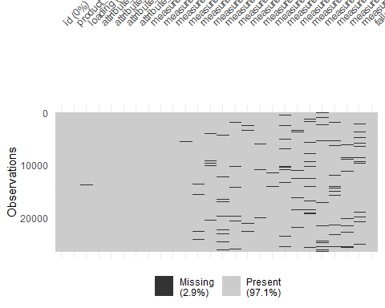

Missing Data Imputation (Median)
preproc <- preProcess(train, method = "medianImpute")
train_imputed <- predict(preproc, train)
test_imputed <- predict(preproc, test)
colSums(is.na(train_imputed))
## id product_code loading attribute_0 attribute_1
## 0 0 0 0 0
## attribute_2 attribute_3 measurement_0 measurement_1 measurement_2
## 0 0 0 0 0
## measurement_3 measurement_4 measurement_5 measurement_6 measurement_7
## 0 0 0 0 0
## measurement_8 measurement_9 measurement_10 measurement_11 measurement_12
## 0 0 0 0 0
## measurement_13 measurement_14 measurement_15 measurement_16 measurement_17
## 0 0 0 0 0
## failure
## 0

Train/Test Split (70/30)
trainIndex <- createDataPartition(train_imputed$failure,
p = 0.70,
list = FALSE)
train_set <- train_imputed[trainIndex, ]
test_set <- train_imputed[-trainIndex, ]

Cross-Validation Setup (5-Fold)
control <- trainControl(method = "cv",
number = 3,
classProbs = TRUE,
summaryFunction = twoClassSummary)

Logistic Regression
log_model <- train(failure ~ . -id,
data = train_set,
method = "glm",
family = binomial,
trControl = control,
metric = "ROC")
log_probs <- predict(log_model, test_set, type = "prob")[,2]
log_pred <- ifelse(log_probs > 0.5, "Yes", "No")
log_pred <- as.factor(log_pred)
confusionMatrix(log_pred, test_set$failure)
## Confusion Matrix and Statistics
##
## Reference
## Prediction No Yes
## No 6270 1687
## Yes 6 7
##
## Accuracy : 0.7876
## 95% CI : (0.7784, 0.7965)
## No Information Rate : 0.7875
## P-Value [Acc > NIR] : 0.4956
##
## Kappa : 0.005
##
## Mcnemar's Test P-Value : <2e-16
##
## Sensitivity : 0.999044
## Specificity : 0.004132
## Pos Pred Value : 0.787985
## Neg Pred Value : 0.538462
## Prevalence : 0.787453
## Detection Rate : 0.786700
## Detection Prevalence : 0.998369
## Balanced Accuracy : 0.501588
##
## 'Positive' Class : No
##
roc_log <- roc(test_set$failure, log_probs)
## Setting levels: control = No, case = Yes
## Setting direction: controls < cases
auc_log <- auc(roc_log)
auc_log
## Area under the curve: 0.5826

Classification Tree
tree_model <- train(failure ~ . -id,
data = train_set,
method = "rpart",
trControl = control,
metric = "ROC")
rpart.plot(tree_model$finalModel)
## Warning: labs do not fit even at cex 0.15, there may be some overplotting
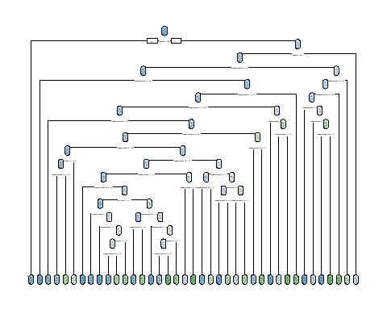
tree_probs <- predict(tree_model, test_set, type = "prob")[,2]
tree_pred <- ifelse(tree_probs > 0.5, "Yes", "No")
tree_pred <- as.factor(tree_pred)
confusionMatrix(tree_pred, test_set$failure)
## Confusion Matrix and Statistics
##
## Reference
## Prediction No Yes
## No 6194 1662
## Yes 82 32
##
## Accuracy : 0.7812
## 95% CI : (0.7719, 0.7902)
## No Information Rate : 0.7875
## P-Value [Acc > NIR] : 0.9163
##
## Kappa : 0.0088
##
## Mcnemar's Test P-Value : <2e-16
##
## Sensitivity : 0.98693
## Specificity : 0.01889
## Pos Pred Value : 0.78844
## Neg Pred Value : 0.28070
## Prevalence : 0.78745
## Detection Rate : 0.77716
## Detection Prevalence : 0.98570
## Balanced Accuracy : 0.50291
##
## 'Positive' Class : No
##
roc_tree <- roc(test_set$failure, tree_probs)
## Setting levels: control = No, case = Yes
## Setting direction: controls < cases
auc_tree <- auc(roc_tree)
auc_tree
## Area under the curve: 0.5481

Random Forest
rf_model <- train(failure ~ . -id,
data = train_set,
method = "rf",
trControl = control,
metric = "ROC",
importance = TRUE,
ntree = 100)
varImp(rf_model)
## rf variable importance
##
## only 20 most important variables shown (out of 28)
##
## Importance
## loading 100.00
## measurement_17 61.31
## attribute_1material_6 41.52
## measurement_8 39.90
## attribute_1material_8 34.09
## product_codeB 26.48
## measurement_2 25.03
## measurement_5 24.98
## product_codeD 24.78
## product_codeC 23.00
## product_codeE 22.28
## measurement_11 21.84
## measurement_6 19.73
## attribute_3 17.64
## measurement_1 17.43
## attribute_2 17.33
## measurement_7 15.44
## measurement_14 15.11
## measurement_4 13.83
## measurement_3 13.70
rf_probs <- predict(rf_model, test_set, type = "prob")[,2]
rf_pred <- ifelse(rf_probs > 0.5, "Yes", "No")
rf_pred <- as.factor(rf_pred)
confusionMatrix(rf_pred, test_set$failure)
## Confusion Matrix and Statistics
##
## Reference
## Prediction No Yes
## No 6264 1688
## Yes 12 6
##
## Accuracy : 0.7867
## 95% CI : (0.7775, 0.7957)
## No Information Rate : 0.7875
## P-Value [Acc > NIR] : 0.5716
##
## Kappa : 0.0026
##
## Mcnemar's Test P-Value : <2e-16
##
## Sensitivity : 0.998088
## Specificity : 0.003542
## Pos Pred Value : 0.787726
## Neg Pred Value : 0.333333
## Prevalence : 0.787453
## Detection Rate : 0.785947
## Detection Prevalence : 0.997742
## Balanced Accuracy : 0.500815
##
## 'Positive' Class : No
##
roc_rf <- roc(test_set$failure, rf_probs)
## Setting levels: control = No, case = Yes
## Setting direction: controls < cases
auc_rf <- auc(roc_rf)
auc_rf
## Area under the curve: 0.5486

Model Comparison
results <- data.frame(
Model = c("Logistic Regression",
"Classification Tree",
"Random Forest"),
AUC = c(auc_log,
auc_tree,
auc_rf)
)
results
## Model AUC
## 1 Logistic Regression 0.5825844
## 2 Classification Tree 0.5480898
## 3 Random Forest 0.5486491

Kaggle Submission File
# Make sure test has same factor levels as original training data
for(col in names(train_imputed)){
if(is.factor(train_imputed[[col]]) && col %in% names(test_imputed)){
levels(test_imputed[[col]]) <- levels(train_imputed[[col]])
}
}
# Generate predictions
final_probs <- predict(rf_model, test_imputed, type = "prob")[,2]
final_pred <- ifelse(final_probs > 0.5, "Yes", "No")
submission <- data.frame(
id = test$id,
failure = final_pred
)
write.csv(submission, "submission.csv", row.names = FALSE)

Conclusion
AUC was used to make three different predictive models.
The final predictive model for Kaggle submission is the one with the highest AUC.

