
TALENT STUDIO

Title: Grouping of Questionnaires
Customer: Zynap
Author: Taulant Bajraktari
Version: 1.0
Status: Confidential
Date: 26 January 2009

Contents

Contents 2
Document Control 3
Change History 3
Validation History 3
STARTING OF INSTALLATION PROCESS 4
Setting up environment 4
PREPARING ORACLE SES 4
INSTALLING ORACLE SES 5
Click next to proceedCHECKING REQUIREMENTS 5
CHECKING REQUIREMENTS 6
The next following screens is the status of oracle SES being installed 6
START/CONFIGURE ORALCE SEARCH 9
STARTING/STOPING ORACLE SES 9
CONFIGURING OF SCHEMAS 9
CONFIGURING SES SEARCH ATTRIBUTES 11
CONFIGURING SES SOURCES FOR SUBJECT 13
CONFIGURING SES SOURCES FOR POSITION 16
SCHEDULING ACTIVITY 17
CREATING GROUPS 18
VERIFYING ALL WORK DONE 20

Document Control

Change History

Version | Date | Author | Description
1.0 | 29/01/2009 | T Bajraktari | Initial Draft

Validation History

Version | Date | Validated By

STARTING OF INSTALLATION PROCESS

This installation is directed to unix (redhat) and Oracle SES version 10182. This process assumes basic knowledge of shell including ssh connecting to and some remote level to access the system either via xwindows (via cygwin) or vnc etc.

The installation process is run on a very low spec machine so setting up variables will only mentioned on basic level.

Setting up environment

Create user oracle and group oinstall if you don’t already have them – they will be there if another oracle product is installed

Login into the system via as oracle user

Create a folder’s under directory /data01/product/10.1.8/oses notice product/10.1.8 may be another oracle product and grouping them may be more ideal.

If you create the folders as an oracle user ensure that they have user oracle and oinstall as group under permission.

Depending on the machine you are installing and unix environment capability if the following settings do not work reefer to this documentation http://download.oracle.com/docs/cd/E10502_01/doc/install.1018/e10463/toc.htm

PREPARING ORACLE SES

Download the oracle ses into the computer and unzip the archive into /data01/install/ses_10182_linux.

After successful unwrapping the oracle ses you should have a directory listing as following.

drwxr-xr-x 7 oracle oinstall 4096 Sep 25 2007 doc
drwxr-xr-x 4 oracle oinstall 4096 Sep 23 2007 install
drwxr-xr-x 2 oracle oinstall 4096 Sep 23 2007 response
-rwxr-xr-x 1 oracle oinstall 5003 Sep 23 2007 runInstaller
drwxr-xr-x 7 oracle oinstall 4096 Sep 23 2007 stage
-rw-r--r-- 1 oracle oinstall 4479 Sep 24 2007 welcome.html

INSTALLING ORACLE SES

Login into the system as remote user via your xwindow or vnc client and go to /data01/install/ses_10182_linux

Type the following command to get the installer running sh ./runInstaller

The following screen will appear.

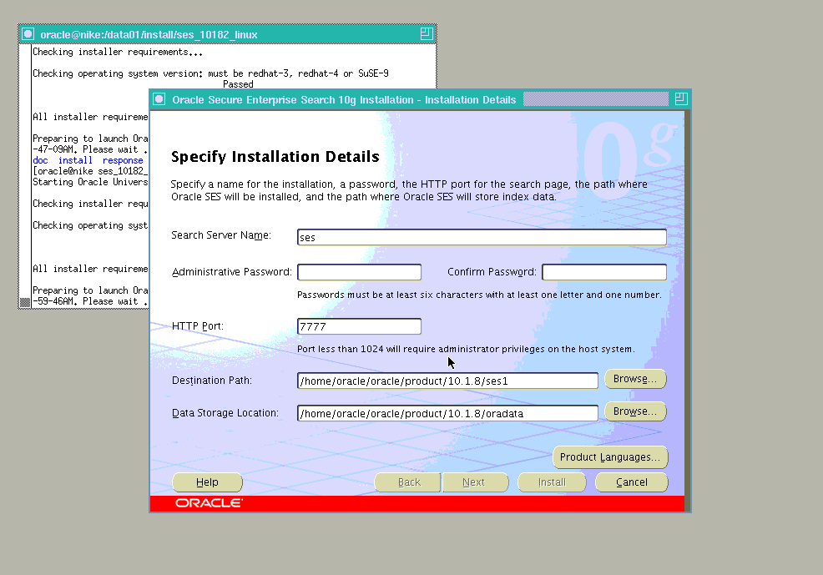

Change some of the settings such as (this can be what you want to use – commonly used are below)

- SEARCH SERVER NAME : ses
- Administrative password : ta13ntman
- PORT : 7777
- Destination path : /data01/product/10.1.8/ses
- Date Storage path : /data01/product/10.1.8/oradata

Click next to proceed

CHECKING REQUIREMENTS

Checking requirements – ensure that all of the requirements are successes

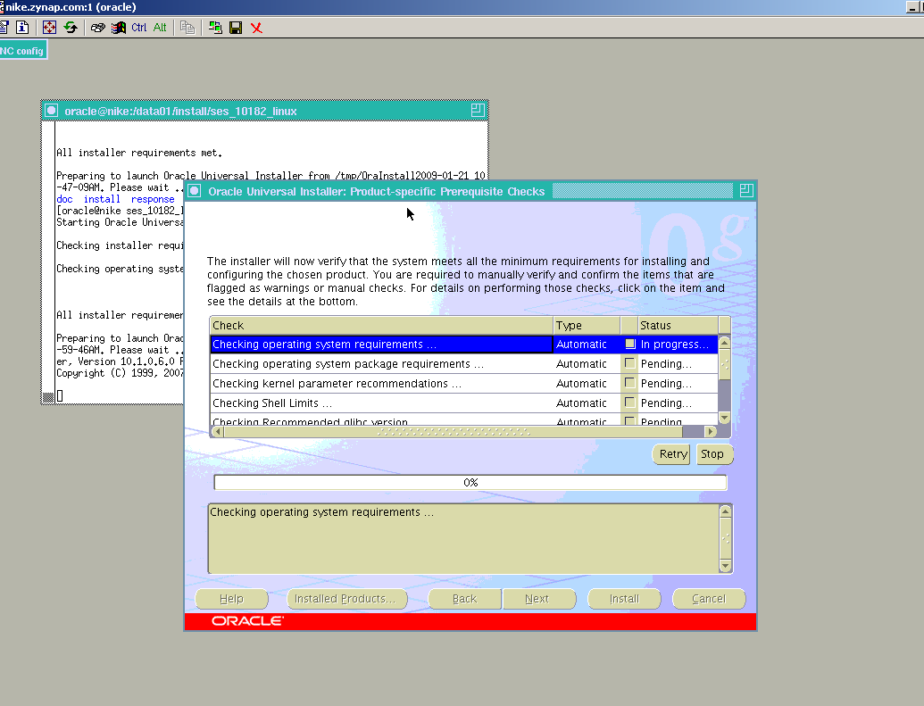

After the requirements have passed, click next to proceed. Should any issues occur here go to setting up the environment?

The next following screens is the status of oracle SES being installed

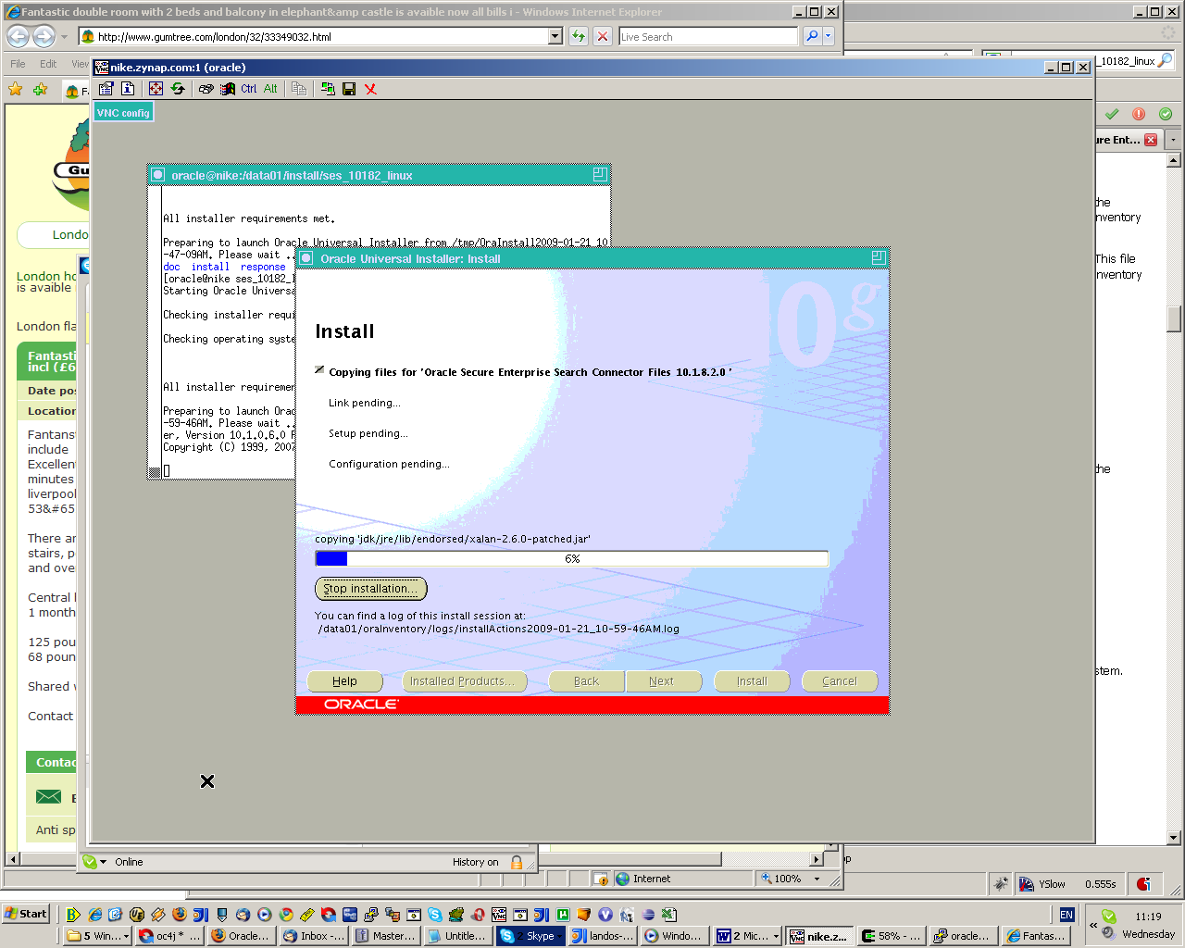

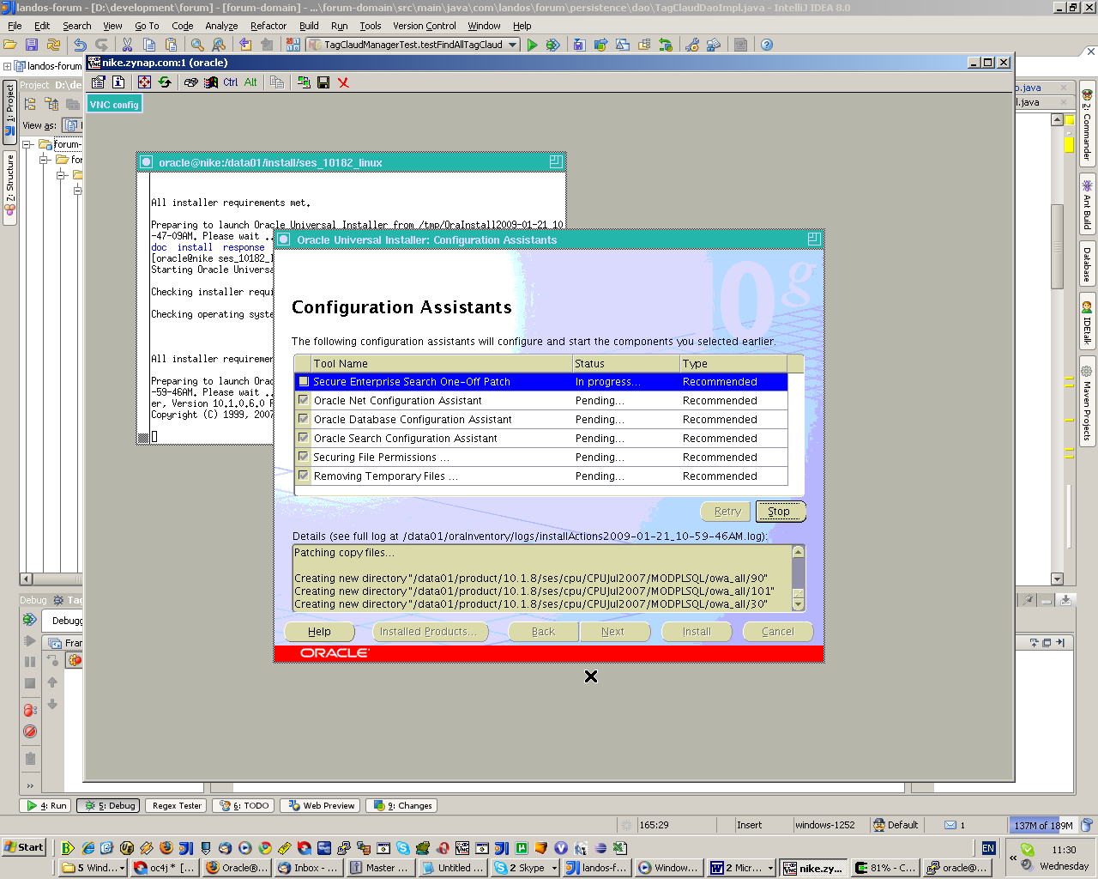

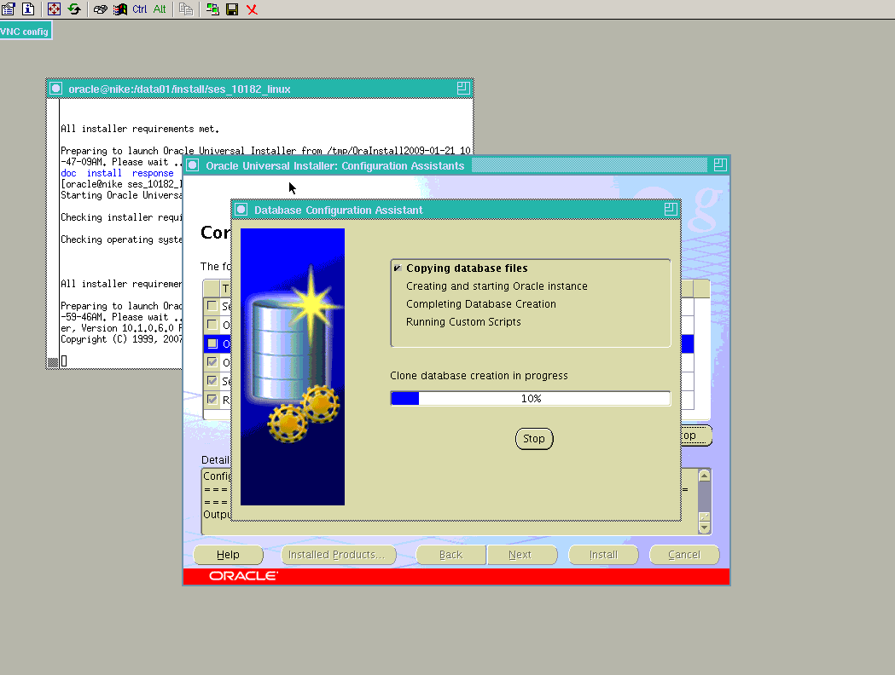

When you have reached this screen, congratulation you have successfully installed oracle SES

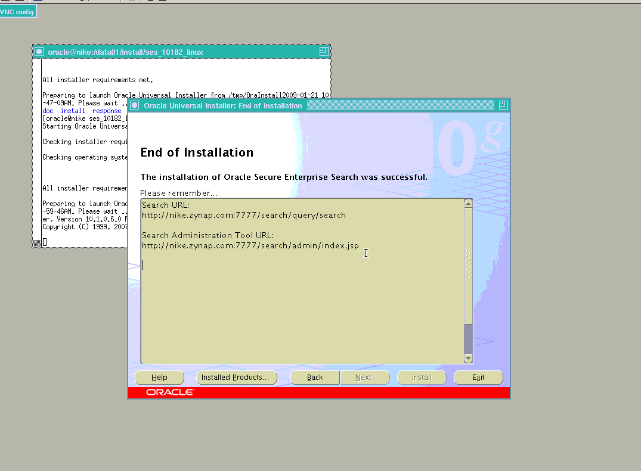

START/CONFIGURE ORALCE SEARCH

After a successful installation, its time to start oracle search and configure the schemas to be crawled.

ORACLE SES NECESSARY URL’S

Accessing the site you will need the following :

Search URL:
http://nike.zynap.com:7777/search/query/search

Search Administration Tool URL:
http://nike.zynap.com:7777/search/admin/index.jsp

But before you can do that you first need to start the oracle search engine.

STARTING/STOPING ORACLE SES

To start the oracle search go to directory /data01/product/10.1.8/ses/bin and then type

- To start sh ./searchctl startall
- To stop sh ./searchctl stopall

In both cases the password is going to be requested, the password is going to be the one entered in the beging.

CONFIGURING OF SCHEMAS

After the successful installation the application schemas are ready to be configured.

Open a browser and type http://170.170.1.34:7777/search/admin/control/login.jsp

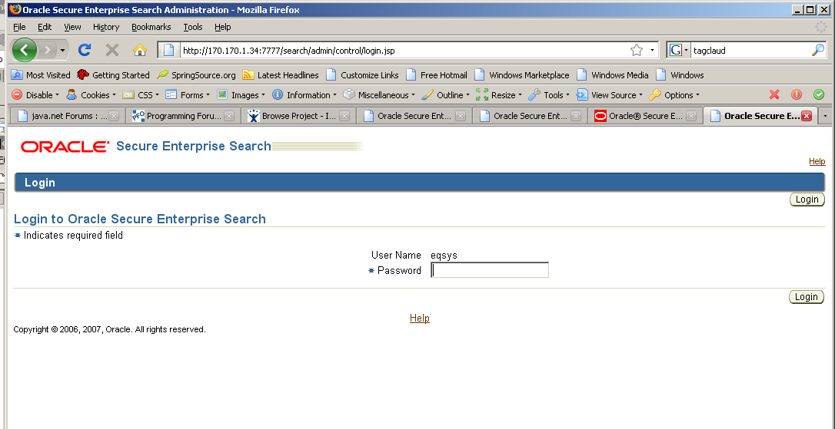

Enter the password entered to start the search engine; the username is the default name. After successful login you should now be logged in and see the same screen as the one below.

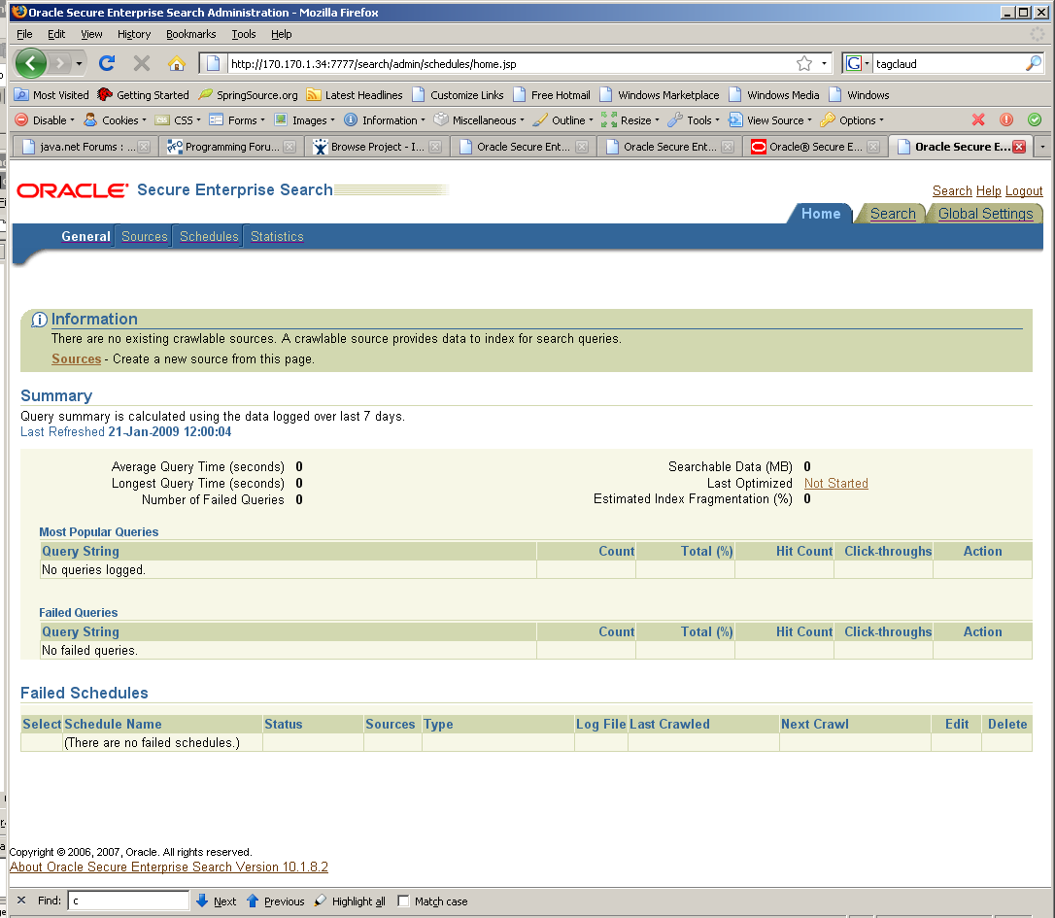

Before starting the create schemas and doing anything you like there is some of the steps that need to be followed.

- Define search attributes that will be searched
- Add sources (i.e. tables that are going to be searched)
- Setup schedules (how often to crawl the tables for changes this can be a scheduled activity)
- Group sources (group the sources together)

CONFIGURING SES SEARCH ATTRIBUTES

The below list of attributes are the existing ones that come as default with the application.
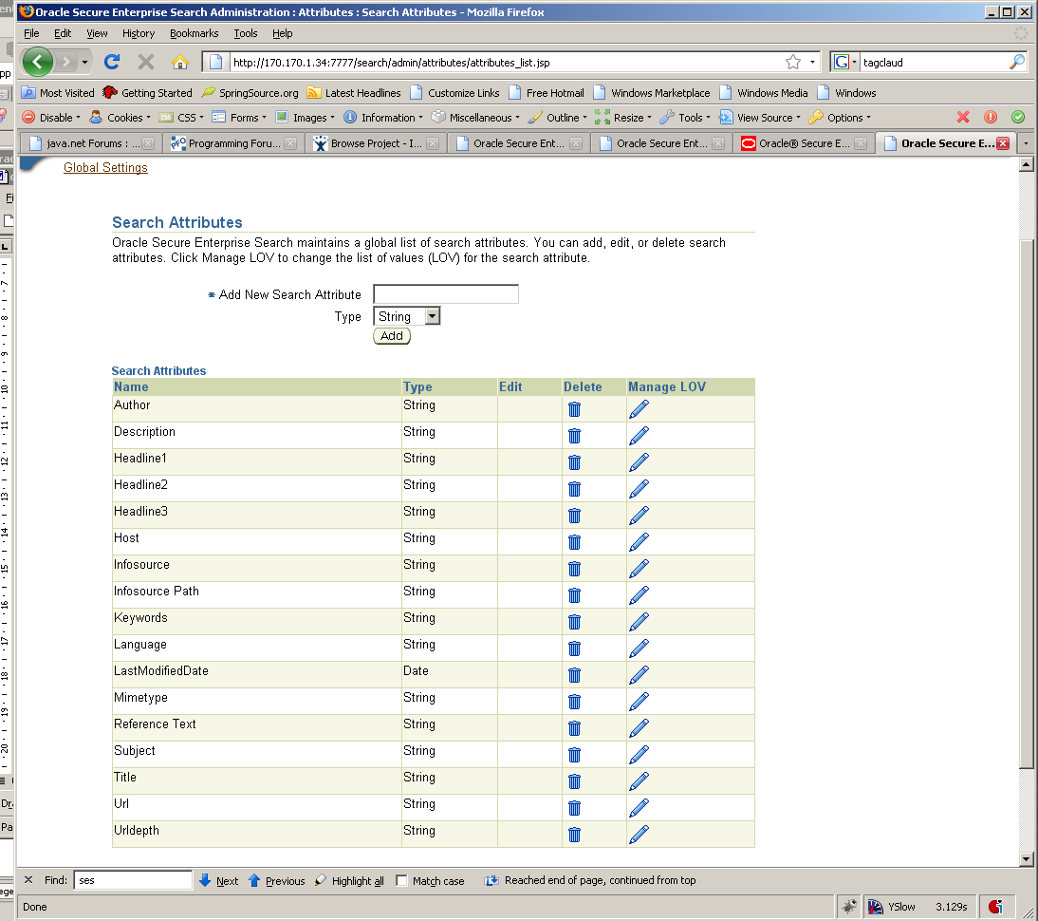

The extra parameters that are required are as following

Name | Type
ARTEFACT_ID | Number
ARTEFACT_TYPE | String
CONTENT_TYPE_ID | String
FILE_SIZE | Number
ID | Number
OWNER_ID | Number
SCOPE | String
TYPE | String
FILE_EXTENSION | String
CONTENT_TITLE | String

After entering the data you should have similar view to the one below with added new attributes
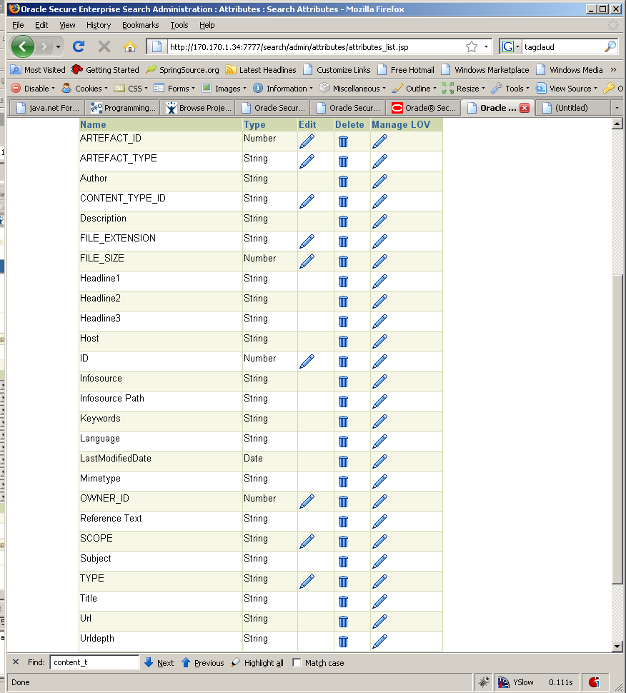

- After adding the search attributes click on home, then general

- Click sources and then select source type to be table press the create button. After pressing create the following screen should appear.

When creating table – I am going to create one for subject and another one for position.

- SUBJECT_FILEITEM_AUTONOMY_VIEW
- POS_FILEITEM_AUTONOMY_VIEW

CONFIGURING SES SOURCES FOR SUBJECT

Enter the details as below

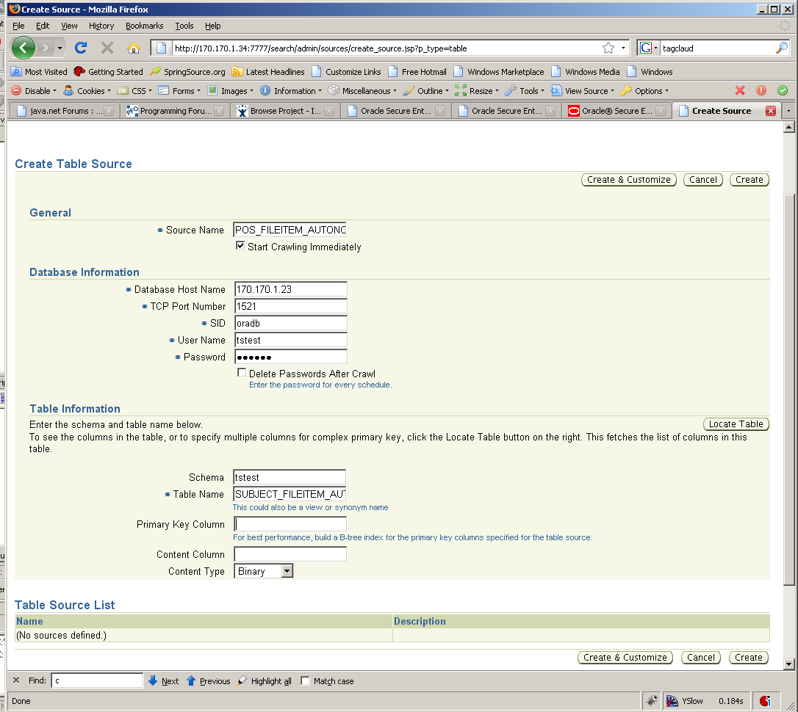

Use table to locate the table and the fields
When the table has been located follow the screen below

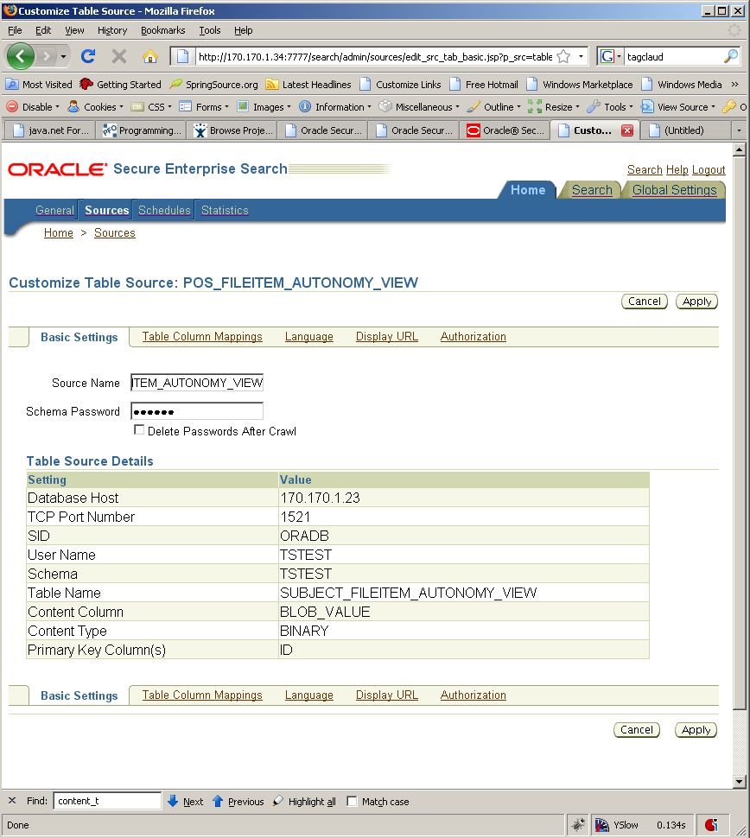

Ensure that the content column is correctly specified.

Click create and customize and basic details that you entered will be displayed, click Table Column Mappingsto link search attributes together

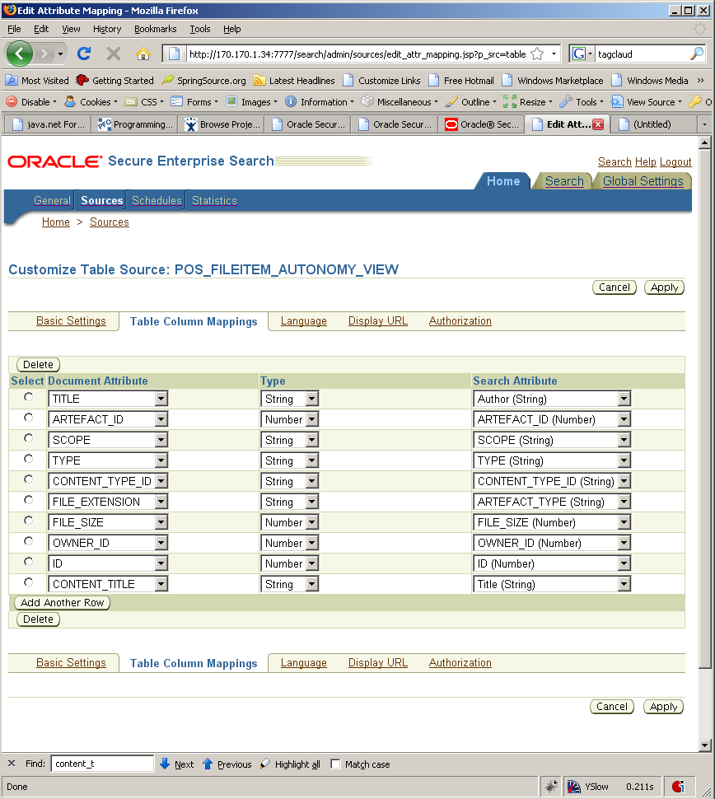

After entering the details click apply for the settings to be effective.

CONFIGURING SES SOURCES FOR POSITION

Configuring position source is the same as subject.

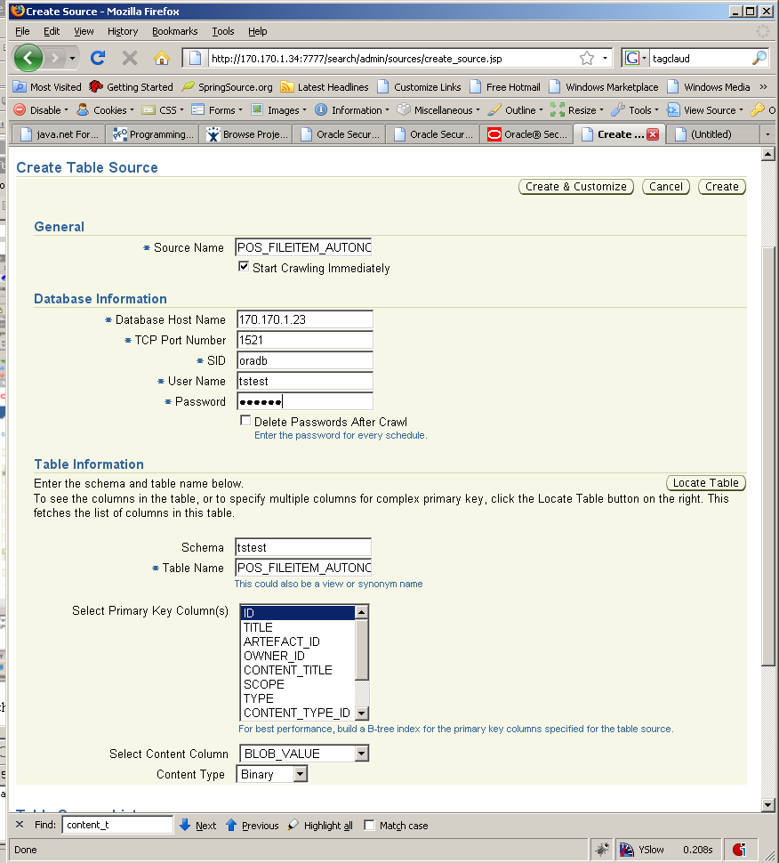

Click create and customize and basic details that you entered will be displayed, click Table Column Mappingsto link search attributes together

SCHEDULING ACTIVITY

Click on schedule and set the time schedule for the crawler to run. The schedule can be run daily hourly – depends on how often you like to run it

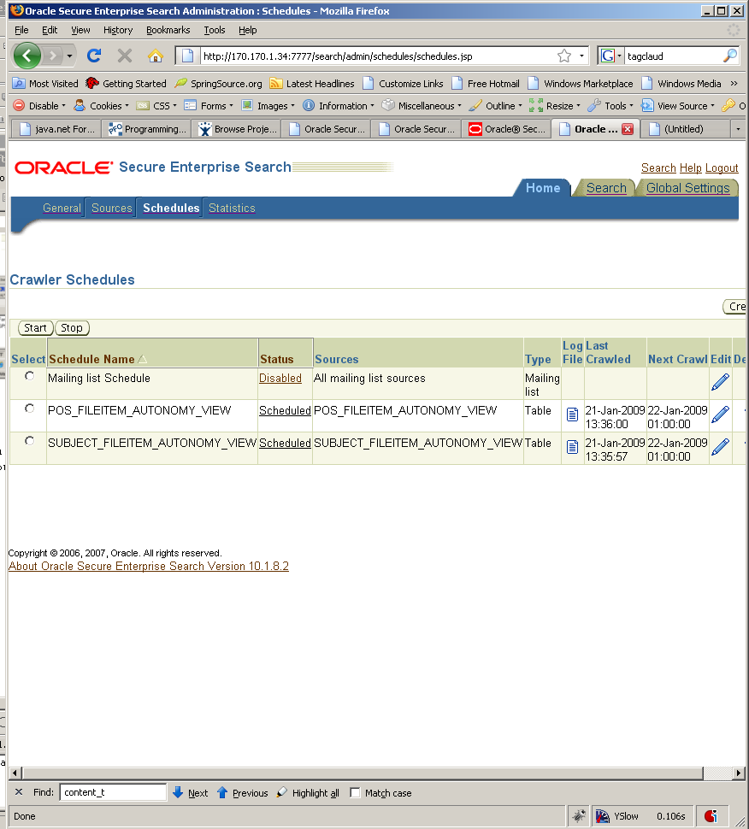

CREATING GROUPS

On the top right hand menu click on search and the select the source group to group the sources to a correct group

Create a subject group and a position group
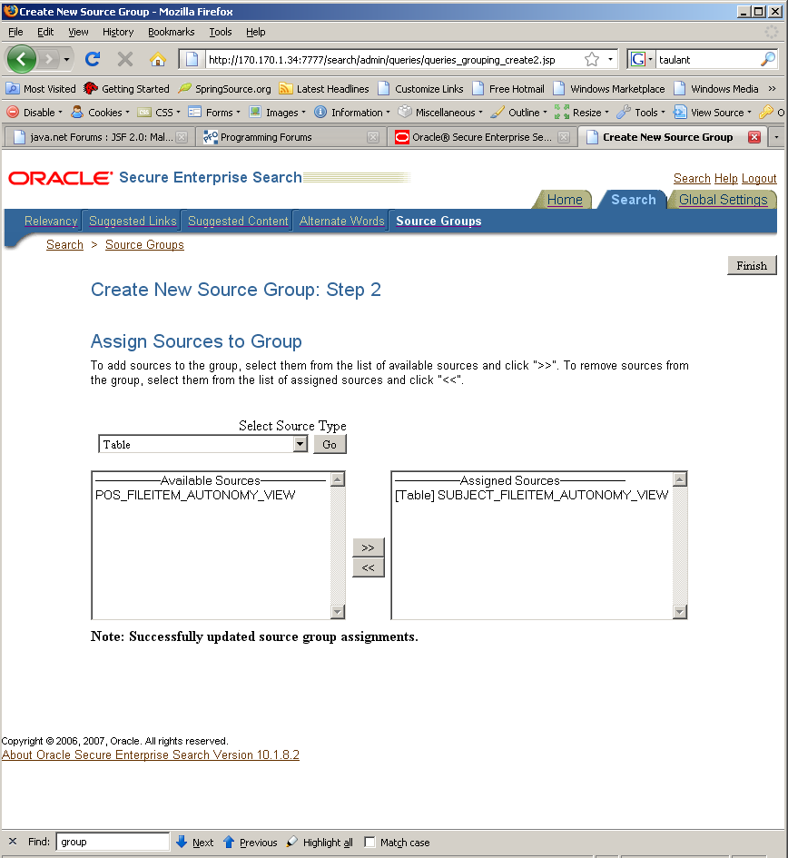

click on source groups to verify the groups created.
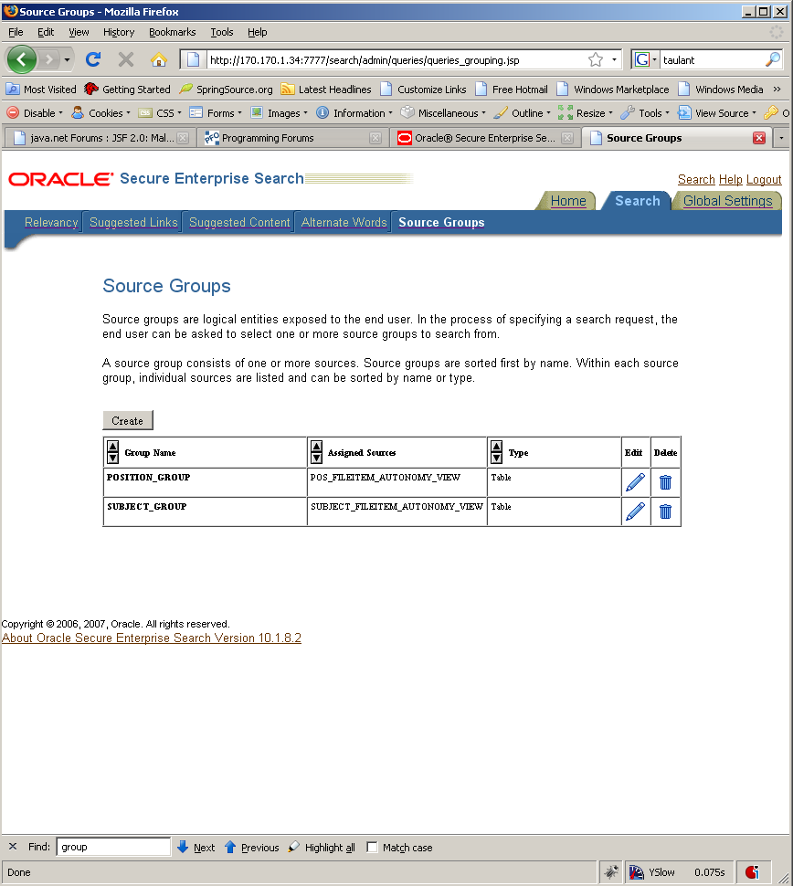

VERIFYING ALL WORK DONE

After the indexing is run you can go to

http://170.170.1.34:7777/search/query/search to do the searches

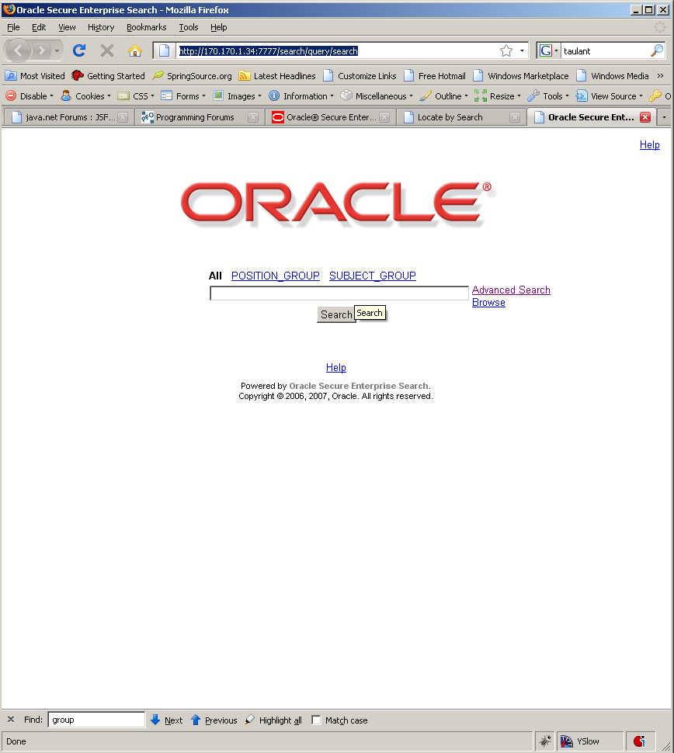

As you can notice the groups we created the search can be based on group for all.

And enter you search query and the following result will appear

