FLEXI PLACEMENT MANAGER USER GUIDE

Logging in to Talent Studio
Data Protection and Privacy Policy
Filling in the Flexi Placement Manager Evaluation

Logging in to Talent Studio

To login to Talent Studio you will need the URL (Internet address), and a username and password that will have been provided to you separately.

Click on the URL link (or type the URL into your browser’s menu bar) to navigate to the login page.
https://www.zynaphosting.com/nhs

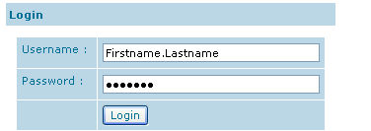

Enter your Username and Password and click Login to login to Talent Studio.

Please note that these details are case sensitive and need to be entered exactly as provided. If the incorrect details are entered more than three times in one session your user account will be locked and you will need to get your password reset.

For any problems logging in please contact gradschemefaq@institute.nhs.uk

Data Protection and Privacy Policy

Once logged in you will be asked to agree to the Data Protection and Privacy Policy.

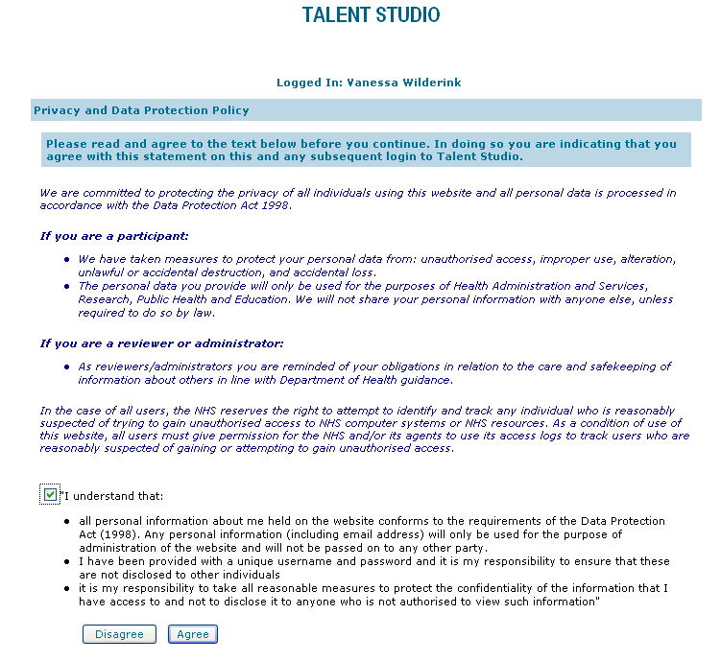
Read and agree the Privacy and Data Protection Policy. If you click Disagree you will be taken back to the login screen where you will need to enter your login details again.

This has to be done each time you log in to the system. It is to remind people that they are accessing people’s private and confidential data and what this responsibility entails.

Top Tip: Instead of using your mouse to check the box and click Agree, press your Space Bar followed by the Enter key.

Filling in the Flexi Placement Manager Evaluation

Once logged in to Talent Studio you will find the feedback form by clicking on the Reviews link on the left hand menu under the Lists heading. You will then see the details relating to the form with the available options. The Evaluatee name listed should be that of your trainee.

To open the form and start adding your feedback click Answer.

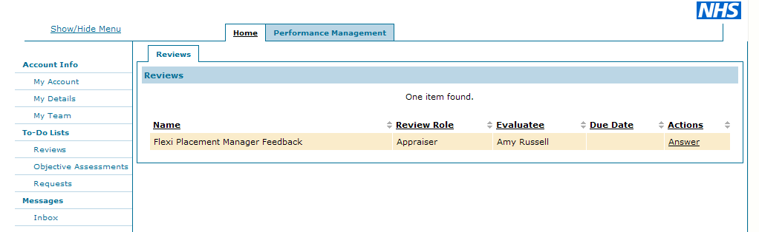

Enter your responses and click Done. Your answers will be automatically saved.

Choose Close to return to the menu, or Edit to open the form in Edit mode.

If you wish to add or amend your responses click Edit, or if you have completed the form click Complete.

Once you have clicked Complete the form will be closed for entry and you will not be able to amend the form further.

