Talent Studio User Guide
For Administrators
NHS Graduate Management Training Scheme
Version 1.0

Contents

1 Guide Overview 2
2 Talent Studio User Groups and Positions 2
3 Organisation Structure and Picker 2
4 Organisation Tab/ Administration Tasks 5
4.1 Adding a new Organisation 5
4.2 Adding a new Position 6
4.3 Adding a new Person 7
4.4 Deleting a Person 10
4.5 Searching for People 11
4.6 Adding a new Position to a Person 11
4.7 Changing Reporting Position 13
4.8 Updating a Person – new password, new user name, Home page etc 14
4.9 Updating/ changing a Person’s email address 15
4.10 Browsing Positions within an Organisation 15
4.11 Replacement or Additional Manager (same placement) 16
4.12 New Placement with a new Placement Manager 18
4.13 Trainee status has changed i.e. left the scheme early,maternity, long term sick 19
4.14 Trainee has transferred to another area 20
4.15 Adding a User Account to an existing person 21
5 Scheme Details Tab 22
6 Running Reports 24
6.1 To run a report from the menu 24
6.2 To run a report with a different population 24
6.3 To export the results to an Excel spreadsheet 24
7 Frequently Asked Questions 25
7.1 I can’t log in/ I get an error when I log in 25
7.2 How to Generate a Password 26
7.3 My Programme/ Placement Manager has changed 26
7.4 I haven’t received any login details for Talent Studio 26
7.5 Talent Studio Login details – Email Text: 26
7.6 Re-issue of a Password – Email text 27
7.7 System Errors 27
7.8 I can’t write anything in my Performance Review form 28
7.9 My Manager is unable to Save their ratings on my Competency Forms 28
7.10 My Manager is not receiving emails from Talent Studio 28
7.11 Where do trainees enter information about their Mentor? 29
7.12 My trainee has additional holiday entitlement/ balances to carry over 29
7.13 How do I take a screen shot? 29
7.14 I am having problems with my Institute email address/ accessing my Inbox 29
7.15 How to access the Gradscheme FAQ Inbox 30
7.16 What is the Gradscheme FAQ process? 30
8 Worked Example of Changing a Programme Manager 32

Guide Overview
This guide should be used in addition to the latest Talent Studio User Guide for Trainees, Managers and Scheme Staff which describes the main functionality within Talent Studio and the configuration that has been implemented to support the Graduate Management Training Scheme.

This guide is designed to support the main administration tasks that Area Offices may be required to perform in their day to day activities and as a result of emails requesting Talent Studio support through the gradschemefaq email address.

Administrators also have access to the Analyser tab which allows the design of reports from Talent Studio in addition to the standard reports that have already been set up. This functionality is not described here.

Hyperlinks have been included in the document to allow you to cross reference different tasks.

Talent Studio User Groups and Positions
There are five main Talent Studio user groups:

- Trainees
- Placement and Programme Managers
- Leadership Development Managers
- Administrators
- Senior Scheme Managers

Administrators and Senior Users have access to information according to their security domain and do not have positions or profiles on Talent Studio.

Placement/ Programme and Leadership Development Managers have access to information according to their assigned position on Talent Studio.

Positions in Talent Studio determine access rights and permissions. If a position has another position reporting in to it (a ‘subordinate’), then this position (or the person assigned to it) is deemed to be a Manager in the eyes of Talent Studio. That means that that person is allowed to see details about the subordinate position and the person assigned to it.

NHS Graduate Scheme positions have been set up to satisfy the following requirements:

- Different managers in different organisations need to be able to access and edit information about the trainee at any time

- These different relationships need to be visible to the different people accessing trainee records i.e. who is the LDM, Programme and Placement Manager for a particular trainee and what organisations do they belong to?

A trainee holds three different positions to describe the relationship that they have with the LDM area, Programme Manager organisation and Placement organisation.

There may be a cross over between first and second placement organisation if the first Placement Manager still needs access when the second Placement has started.

Trainee
Held by trainee

Programme
Held by trainee
(subordinate)
Placement (One)
Held by trainee
LDM
Held by LDM

Programme Manager
Held by person in the role of Programme Manager
Placement Manager
Held by person/s in the role of Placement Manager
Placement Manager
Held by person/s in the role of Placement Manager
Placement (Two)
Held by trainee

Every position has to report in to another, so for the purposes of Talent Studio the Placement Manager reports to the Programme Manager, and the Programme Manager reports to the LDM.

In some cases other managers within an organisation need to have the same access rights as the official Programme Manager or Placement Manager and these positions will then have more than one person assigned to them.

The position name has to be indicative of the role that that person has with regard to the scheme. Their actual job title should not be used.

A person may have more than one position on Talent Studio.

Position Naming Convention

A Placement or Programme Manager should always have the words ‘Placement Manager’ or ‘Programme Manager’ in their position title. This may be supplemented with other information such as the placement number. i.e. Second Placement Manager

A trainee’s Placement or Programme position should always have the words ‘Placement’ or ‘Programme’ in their position title. This may be supplemented with other information such as the placement number. i.e. First Placement

Organisation Structure and Picker
Positions have to be assigned to an Organisation.

The organisation structure within Talent Studio has to reflect that the database caters for other NHS Users.

All organisations that relate to the Graduate Scheme can be found under NHS Institute. There you will find all areas and localities, and within these you should find the organisations where the trainees are placed.

In all cases where you need to select an organisation you will use the Talent Studio Organisation Picker.

The Organisation Picker works in the following way:
Select the grey button to the right hand side of the organisation field.

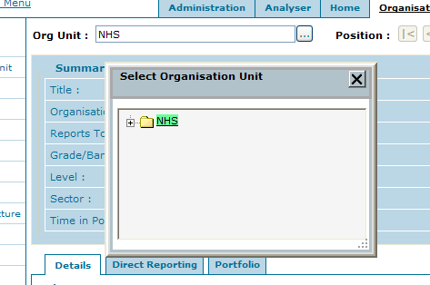

A box will open, with the NHS as the default organisation unit. Click on the ‘plus’ sign to open up the next level of the organisation structure.
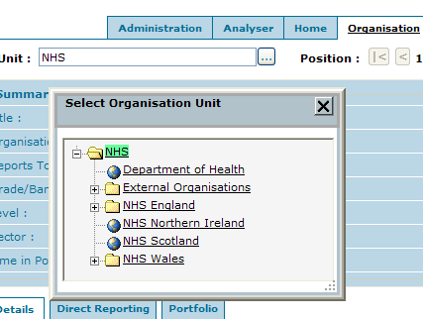

- Select NHS England
- Select NHS Institute
- Select NHS Graduates
- Then select appropriate area and organisation

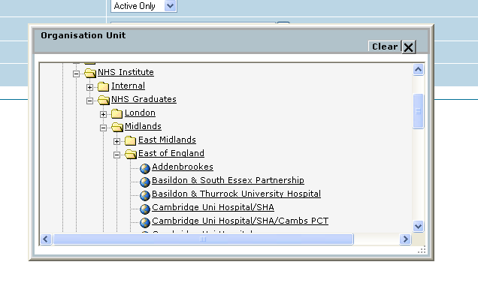
If you wish to close the box click Clear at the top right hand of the box.

Please note:
The NHS Institute organisation unit is almost a mirror of the other organisation units within the NHS - it is very important that you select organisation units within the NHS Institute area when assigning all graduate scheme positions. Placing positions in the incorrect organisation may mean that other NHS users have access to trainee details when they shouldn’t.

This box is expandable and can be moved around the screen:

To expand the box:
Put your cursor over the grey dotted area in the right hand corner of the box. You will see a black double ended arrow. Click your mouse and then move the cursor in the direction that you wish the box to expand. You can make the box smaller in the same way.

To move the box:
Put your cursor in the grey area at the top of the box. You will see a black four ended arrow. Click your mouse and then drag the box to where you want it to go.

Organisation Tab/ Administration Tasks
Rather than go through each menu item available through the Organisation tab this guide takes the approach of describing each action you might want to do as an Administrator. The majority of these tasks can be done in the Organisation tab.

Please note that the screen shots used in the guide may contain more tabs on the top bar than you may be able to view but this should not make any difference to the actions that you can perform.

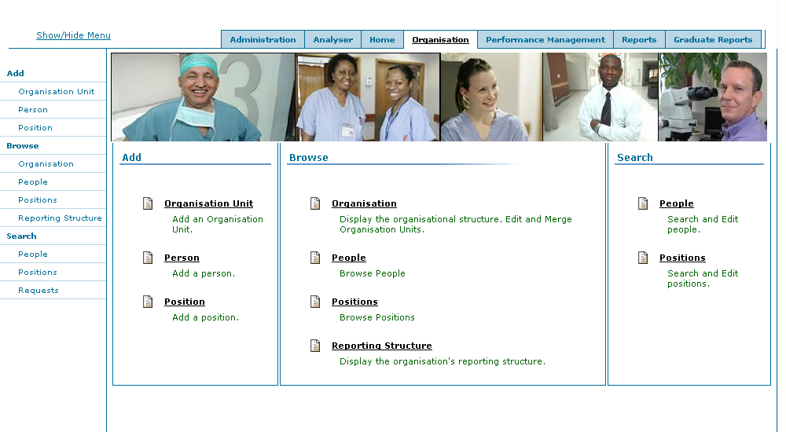

Adding a new Organisation

- Select the Organisation tab
- Click Add Organisation on the left hand menu

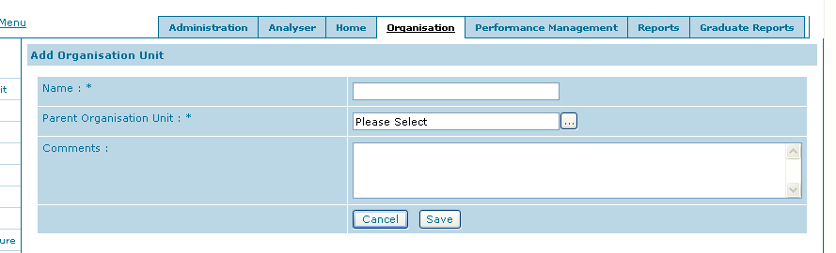

- Enter organisation Name
- Select the Organisation that is the parent of the new organisation (this will always be an area such as North West, or South East Coast etc) using the Organisation picker
- Add any comments that you think are relevant
- Click Save

Adding a new Position
Please note that when you add a position the ‘Reporting to’ position has to exist first.
e.g. If you are adding a new Placement position for a trainee, the Placement Manager position has to be created first.

- Select the Organisation tab
- Click Add Position on the left hand menu

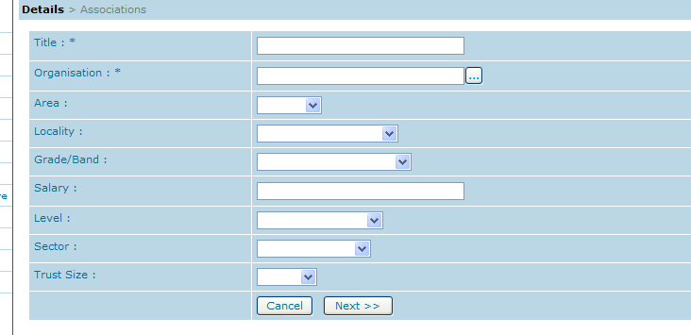

- Add position Title
- Then click on the grey box to show the organisation picker:
- Select NHS England
- Select NHS Institute
- Select NHS Graduates
- Then select appropriate area and organisation (if the organisation does not exist then you will need to add it (see Adding a New Organisation)
- Add Area and Locality – select from the pick list
- Click Next
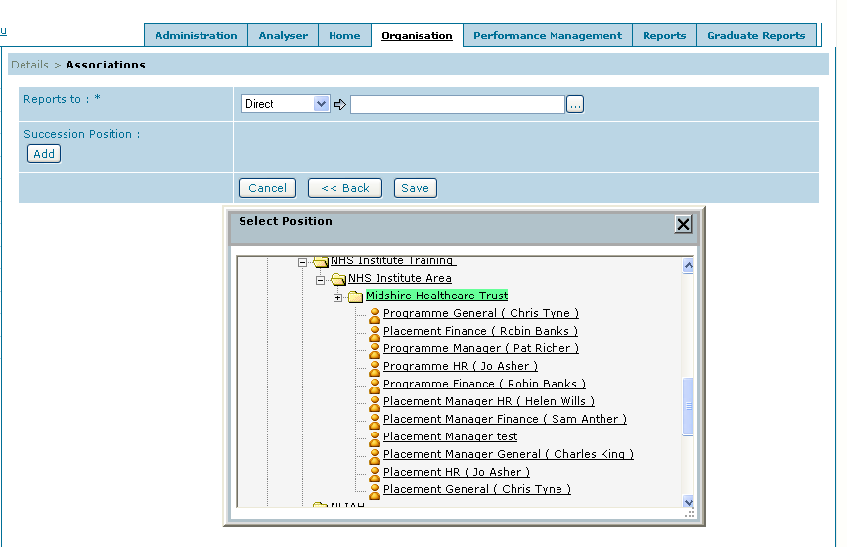
- Select Direct
- Then click on the grey box to show the organisation picker:
- Select NHS England
- Select NHS Institute
- Select NHS Graduates
- Then select appropriate area and organisation
- A list of positions will appear with the position holders names in brackets
- Select the Position that the new position reports to e.g.
  - if new Programme Manager than select the appropriate LDM
  - if new Placement Manager then select the appropriate Programme Manager

- Click Save

NB: You cannot add a position without assigning it to an organisation or having it report in to another position.
(See Talent Studio User Groups and Positions for a more detailed explanation)

Adding a new Person
- Check first that the organisation and position exist on Talent Studio (see Browsing Positions within an Organisation).
- If not add where necessary (see Adding a new Organisation or Adding a new Position)
- Click on the Organisation tab
- Click Add Person from the left hand menu

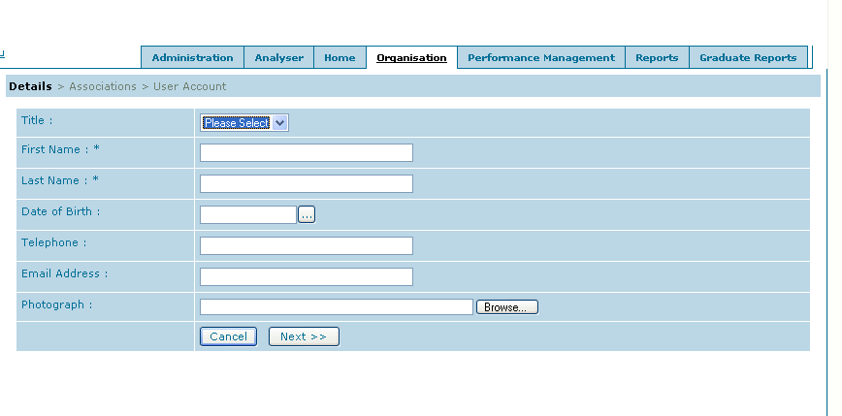
- Enter details. First Name and Last Name are mandatory but also you should never set up a new person without an email address.
- Click Next
- Click Add to add an association (position)

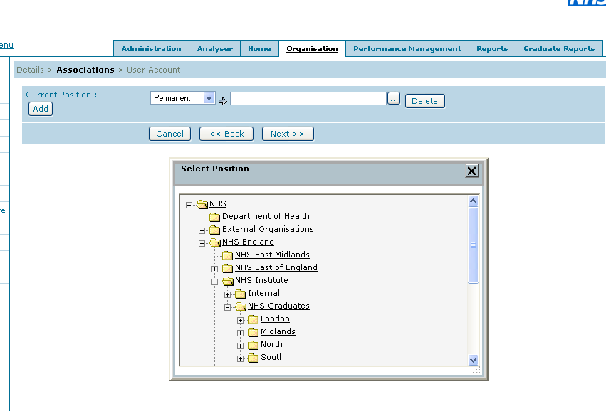

- Select Permanent from the drop down box if adding a Placement, Programme Manager, or LDM
- Then click on the grey box to show the organisation picker:
- Select NHS England
- Select NHS Institute
- Select NHS Graduates
- Then select appropriate area and organisation
  - Note: If you put your cursor on the corners of this box and click you are able to resize the box

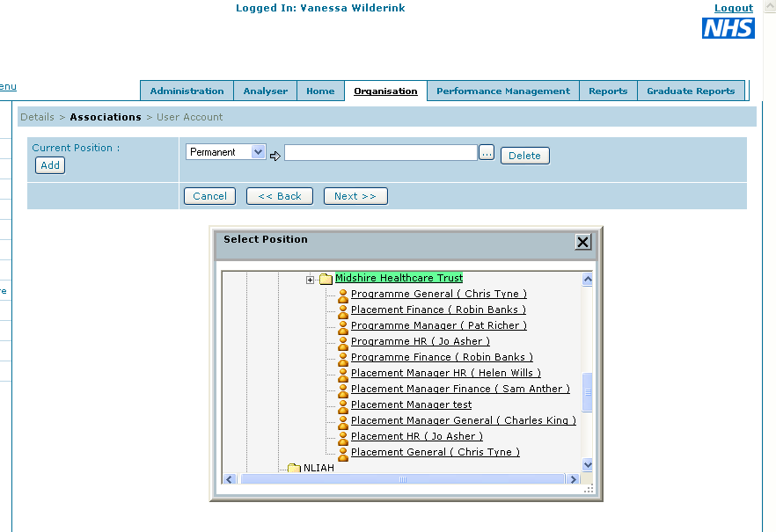

- A list of positions will appear with the position holders names in brackets
- Select the correct position for the new person
- Click Next

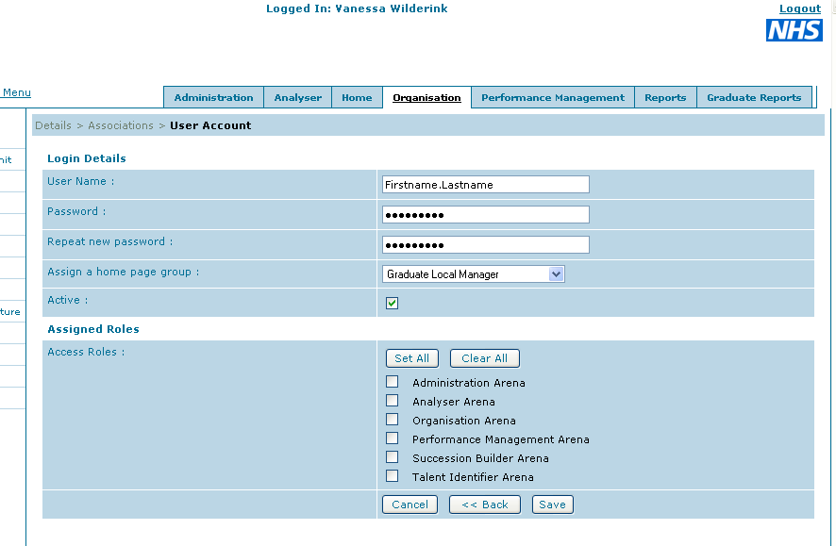

- Add username and password (see How to Generate a Password)

- Assign them to the appropriate home page
  - if Placement/Programme Manager = Grad Local Manager,
  - LDM = Grad Area Manager

- Ensure that the Active box is ticked – this allows people to log in to the system

- Assign them to the appropriate roles:
  - Placement/Programme Manager – do not select anything for this
  - LDM – select Succession Builder Arena only

- Click Save

NB: You cannot add a new person without assigning them to a position.
Administrators and Trainees need to be added by the system administrator (currently Vanessa Wilderink).

Deleting a Person

- Deleting a Person is a two step process
- Find the person that you want to delete (see Searching for People)
- Click on that person’s User Details tab

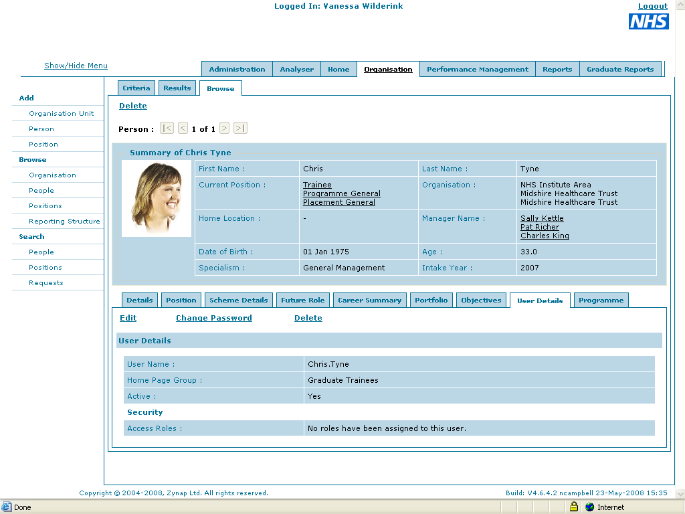

- Then delete their User Account by clicking Delete
- Then click Delete on the top left hand side of the person’s Summary
- You will be asked to confirm deletion

All Placement and Programme Managers should be fully deleted from the system when they no longer have any trainees, even if there is a possibility that they may have more trainees in the future.

Searching for People

- Click on the Organisation tab
- Click Search People on the left hand menu

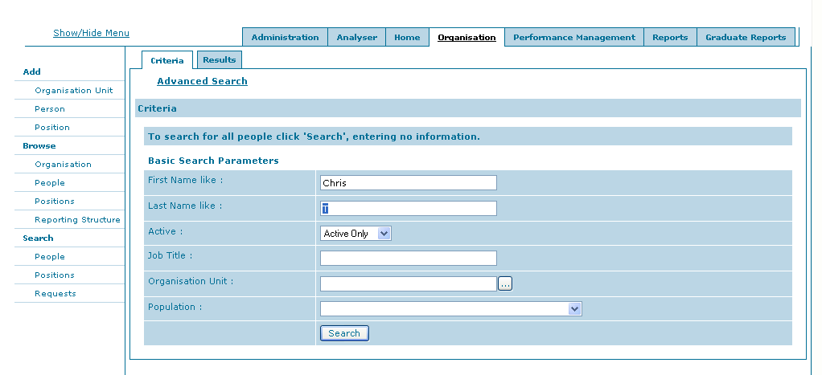

- Enter your Search criteria
- You can search by Name, Organisation, or Population
- Click Search
- The next screen will then display all the search results
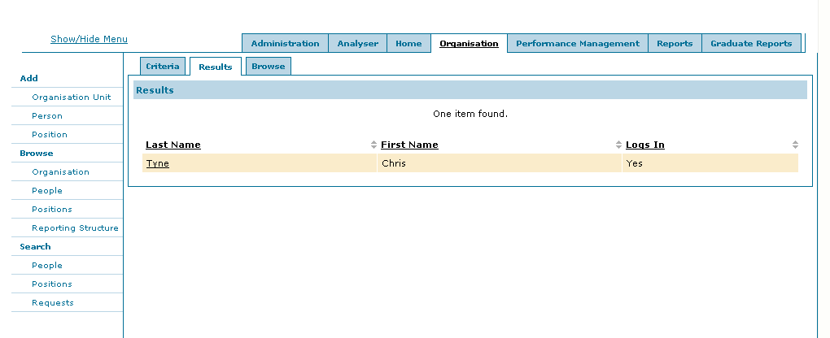

- Click on the hyperlinked Last Name to go to that person’s details, or alternatively select the Browse tab to scroll through the different results.

Adding a new Position to a Person

- Find the person who’s position you are changing (see Searching for People)
- From their profile click on the Position tab
- Click on Edit

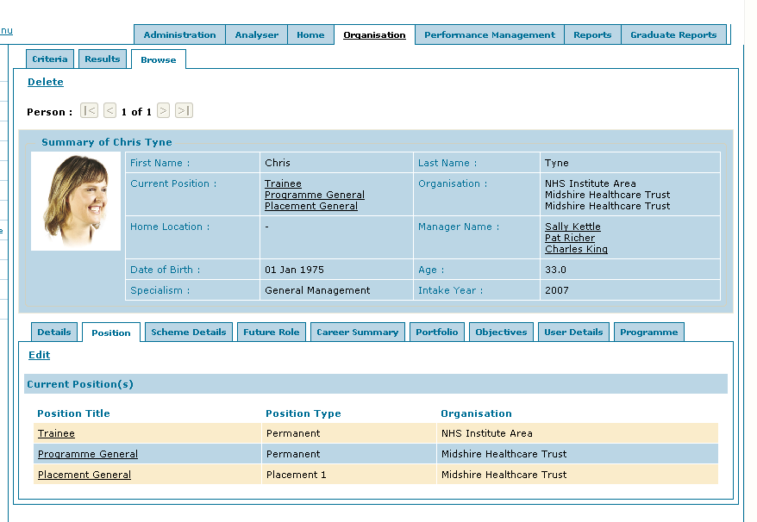

- Click Add to add a new Position
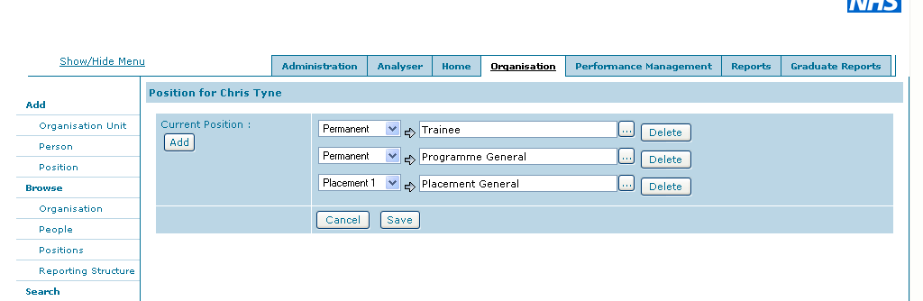

- Add the information for your new position
- From the drop down select:
  - Permanent if it is a new Programme position.
  - Select Placement One, Two etc if it is a new Placement Position.
- Then using the Organisation picker, select the position that is being added.
- If the position does not exist yet see Adding a New Position

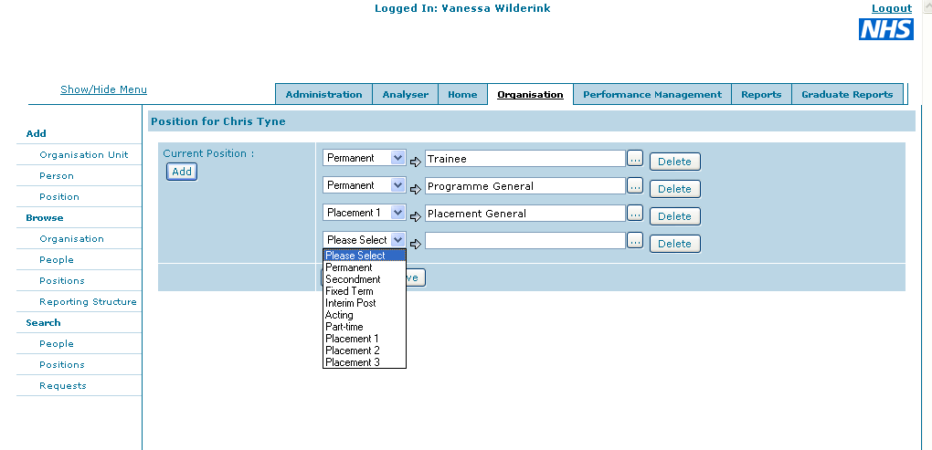

Changing Reporting Position

- Find the person who’s position you are changing (see Searching for People)
- From their profile click on the Position tab
- Click on the position that you wish to change

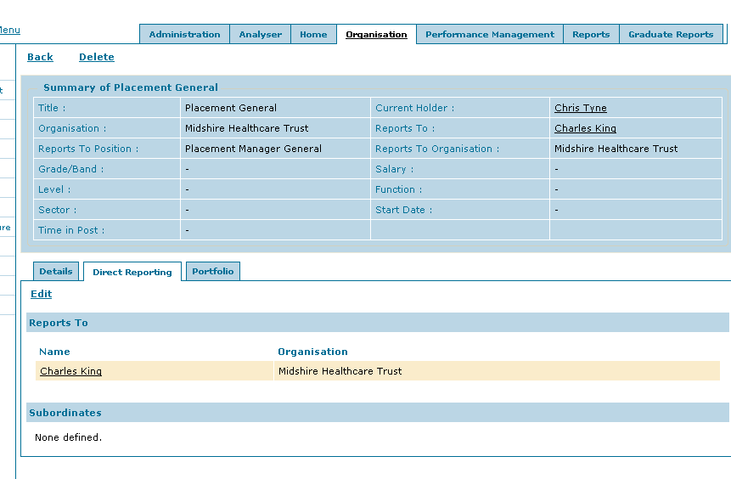

- Click Edit
- Should see Direct Reporting for the positions held by that person.

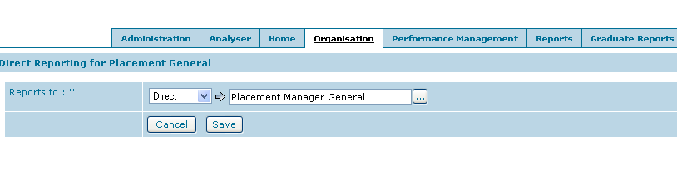
- Click on the grey box to show the organisation picker:
- Select NHS England
- Select NHS Institute
- Select NHS Graduates
- Then select the new position in the appropriate area and organisation
- If anyone is assigned to the position they will be listed in brackets after the position name
- Click Save
.

Updating a Person – new password, new user name, Home page etc
- Find the person (see Searching for People)
- Click on the User Details tab
- Click Edit on this page to update a user name or home page group
- Click Change Password on this page to change their password

- Please note that current passwords are not displayed; if a person has forgotten their password you will need to enter a new one.
- Select Save to save your changes

Please Note: Clicking Delete on this page will only make them non-active; to properly delete a user please see Deleting a Person

Updating/ changing a Person’s email address
- Find the person (see Searching for People)
- Look on the Details tab for that person
- Click Edit
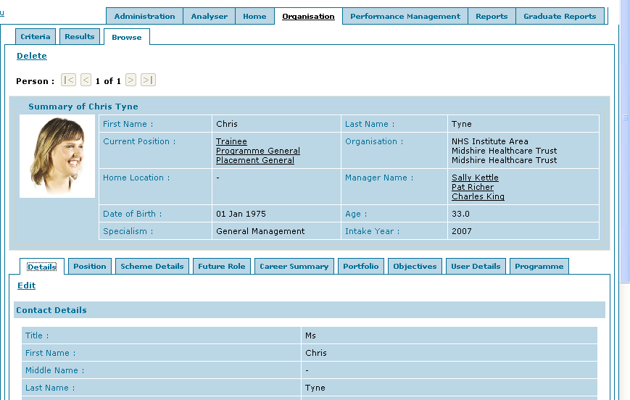

- Make the changes as necessary
- Click Save at the bottom of the form

Browsing Positions within an Organisation
- Click on the Organisation tab
- Click on Browse Position on the left hand menu

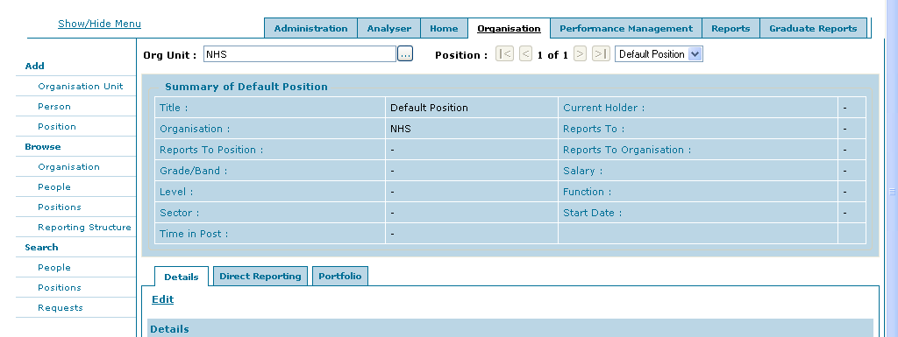

- Select your Organisation from the Organisation Picker
- If the organisation is not there it will need to be added (see Adding a new Organisation)

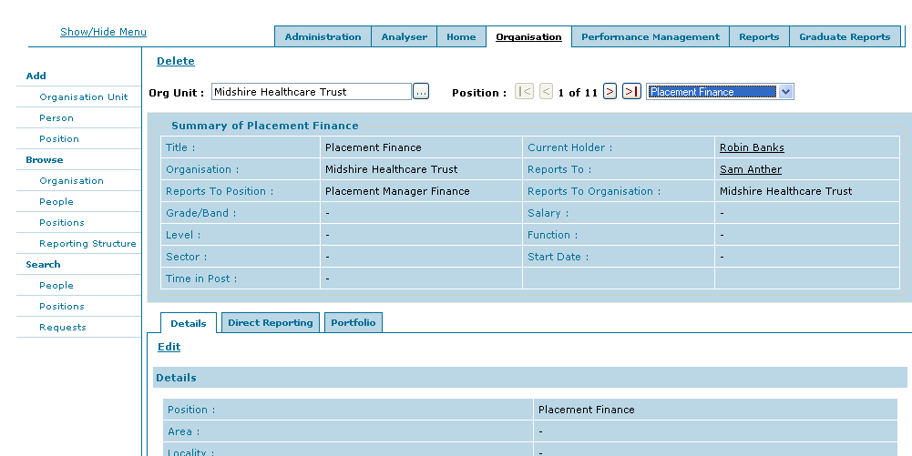

- You will then be able to scroll through or select from the drop down all the positions that exist within that organisation and see details about who holds the position and who that position reports to.
- Click on Edit to change the title of the Position
- Click on the tab Direct Reporting to see who the positions reports to, and whether it has any subordinates
- Click on Edit in this tab to change who the position reports to. Note it is not possible to change who the subordinates are; this can only be done by making changes to the subordinates positions directly.
- Clicking on the hyperlinked names will take you to that person’s details

Replacement or Additional Manager (same placement)
- Check that the new manager is not on the system already (see Searching for People)
- If the Manager is not on the system already, find the relevant trainee (see Searching for People)
- Click on the name of the current Manager

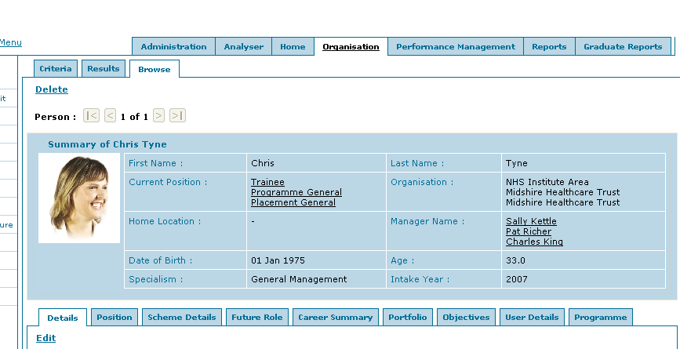

- Click on Current Position

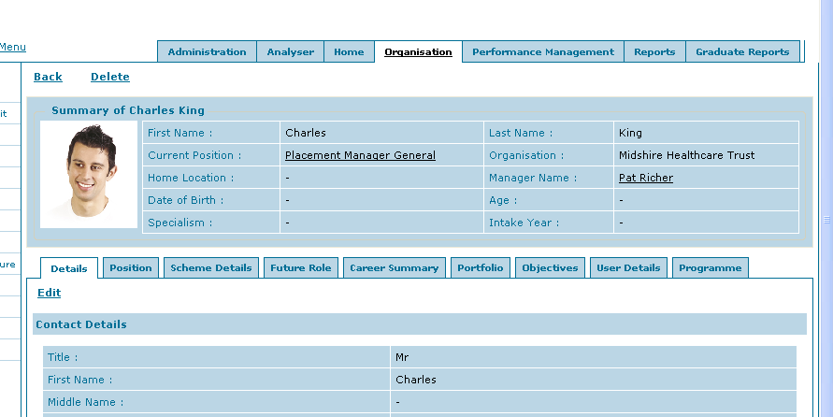

- Click on tab labelled Direct Reporting
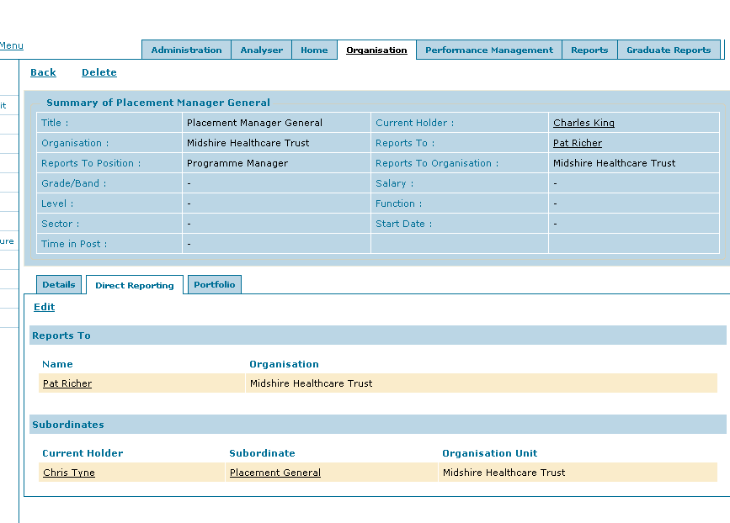

- Is there more than one trainee listed in the Subordinates section i.e. does this person manage more than one trainee?
- Will this Manager need access to all the trainees listed as subordinates?

YES – the new manager will need access to all the trainees listed as subordinates:
This is just a direct replacement/ addition of a new Manager

- Add the new Manager (see Adding a new Person) – you will be adding this new Manager to the same position as the old manager

- When complete, delete the previous manager ONLY if you are replacing the manager. See Deleting a Person

- Send the new Manager their login details using the email template provided
NO – the new manager will not need access to all the trainees listed as subordinates:
- You will need to add a new Position to Talent Studio (see Adding a new Position)

- Add the new Manager (see Adding a new Person) and assign them to this new position

- Send the new Manager their login details using the email template provided

- If this is an additional manager rather than a replacement make sure that the current Manager is also assigned to this role

- Make sure that the corresponding trainee/s position reports in to this new position (see how to Change Reporting Position)

- Is the previous Manager still managing the other trainees? (subordinates)

YES – they are still managing other trainees

- Do not delete the previous Manager as they will still need access to the other trainees

NO – they are not managing trainees anymore

- Delete the previous manager (see Deleting a Person) and add their new manager when their details are known.

New Placement with a new Placement Manager

- Check that the new manager is not on the system already (see Searching for People)

- Add a new position for the Placement Manager in the new placement organisation ensuring that it reports in to the appropriate Programme Manager for that trainee

- Add a new position for the trainee in the new placement organisation ensuring that the new position reports in to the new position just added for the Placement Manager

- Add the new Manager (see Add a new Person) to Talent Studio assigning them to this new position

- Assign the trainee to their new position (changing position)

- Send the new Manager their new login details (see Email text)

- When the previous Placement is complete and the manager no longer needs access then delete the manager ONLY if they do not need to access other trainees (see Deleting a Person )

Trainee status has changed i.e. left the scheme early, on maternity leave or long term sickness
- Find the trainee using Searching for People

- Click on the tab called Scheme Details

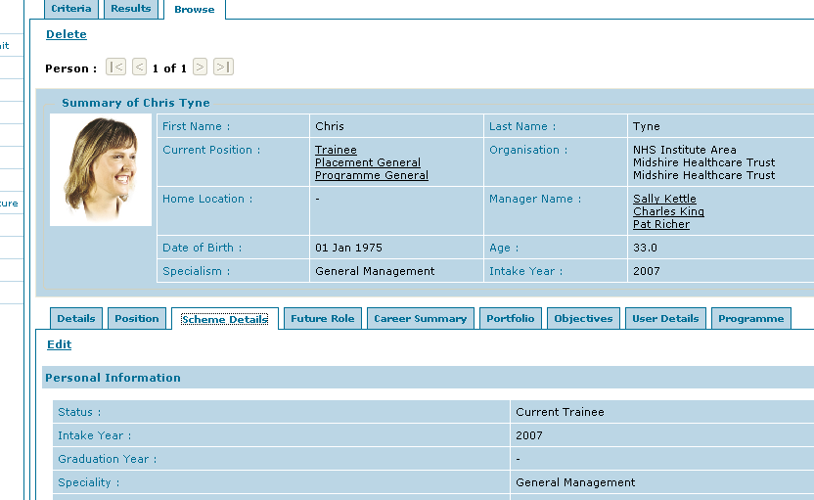

- Click Edit

- Select the new Status of the trainee and click Save at the bottom of the form

If the trainee has left the scheme early:

Remember to delete their user account so they can no longer log in.

- To do this click on the tab called User Details

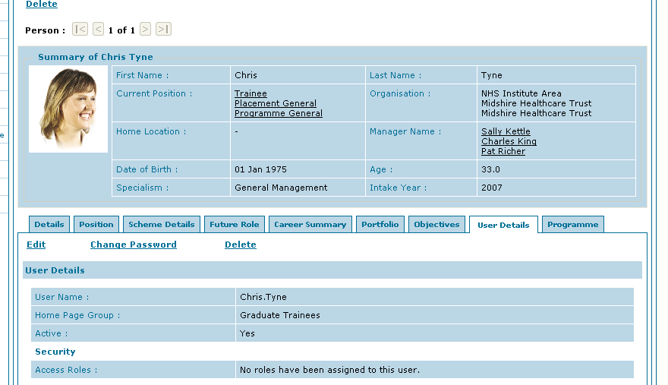

- Click Edit and deselect the Active box.

Delete any managers associated with this trainee who will no longer need access to Talent Studio.

Trainee has transferred to another area
- Find the trainee using Searching for People

- Click on the tab called Scheme Details

- Click Edit

- Edit the following fields:

Foundation Group – select the new region (if applicable)
Local Induction Group - select the new area
Transferred from – select the area that the trainee is transferring from
Transfer Date – select the date of transfer

- Make changes to the Programme and Placement Managers as applicable (see New Placement)

- Reassign the trainee to the relevant LDM. Click Edit on the Position tab.

- Click the grey box to the right of the Trainee position.

- Select the Trainee position in the area that they transferring to and then click Save.

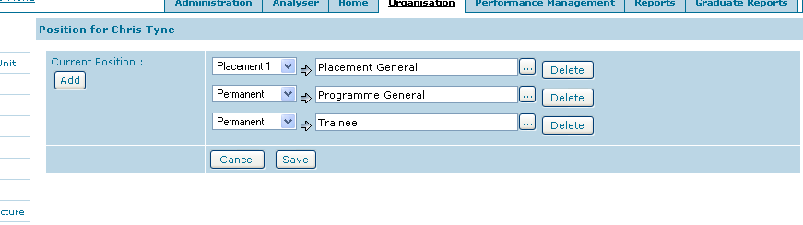

Adding a User Account to an existing person
- Find the person (see Searching for People)
- Click on the User Details tab

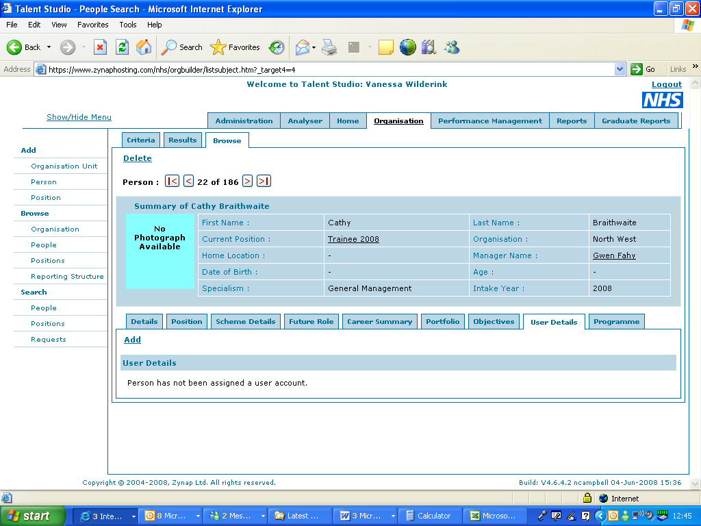

- Click Add on this page to update a user name or home page group

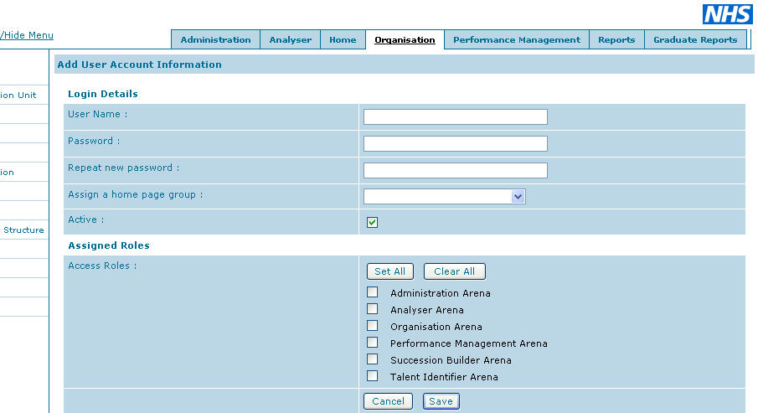

- Add username and password (see Updating a Person – new password, new user name, Home page etc)

- Assign them to the appropriate home page

  - Trainee – select appropriate Graduate Trainee Intake
  - if Placement/Programme Manager = Grad Local Manager,
  - LDM = Grad Area Manager

- Ensure that the Active box is ticked – this allows people to log in to the system

- Assign them to the appropriate roles:
  - Trainee – do not select anything for this
  - Placement/Programme Manager – do not select anything for this
  - LDM – select Succession Builder Arena only

- Click Save

Scheme Details
When viewing people’s profile you will see that you have an additional tab called Scheme Details available to you other than the Details, Position and Portfolio tabs.

Scheme Details is only available to Scheme Staff i.e. LDMs and Administrators. Trainees, Placement and Programme Managers do not have access to this tab.

This tab holds all details relevant to the trainee on the Scheme e.g. Intake year, specialism, education provider details etc.

To Edit any of the details on this form click the Edit button.
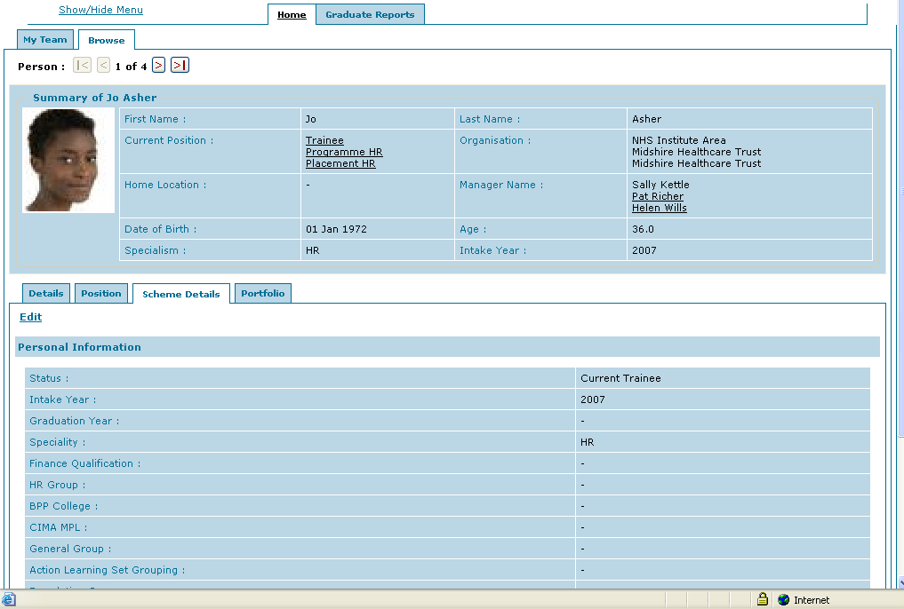
Field Details and their options:

Status | Future Intake | Trainee due to start in the next intake
Status | Current Trainee | Trainee currently on the Scheme
Status | Graduate | Trainee who has successfully graduated the first part of the Scheme
Status | Alumni | Alumni
Status | Non-graduate | Trainee who has not successfully graduated the first part of the Scheme
Status | Maternity | Trainee on authorised maternity leave
Status | Long Term Sickness | Trainee still on Scheme but signed off as long term sick
Status | Ex-trainee – not completed Scheme | Trainee who has resigned from the Scheme early
Intake Year | Should be pre-populated | Year that the trainee joined the Scheme
Graduation Year | Select from a list of years | Year that the trainee graduates from the first part of the Scheme
Specialism | Should be pre-populated but can be amended | Specialism i.e. HR, Finance or General Management  Note: because this is a shared database this field might contain options that do not relate to the Graduate Scheme
Finance Qualification | Select CIMA or CIPFA
HR Group | Select from the list of a or b
BPP College | Select from a list of BPP Colleges
CIMA MPL | Select from Certificate, Managerial, Strategic or TOPCIMA | Applicable to Finance trainees only
General Group | Select from a list of numbers
Action Learning Set Group | Select from a list of numbers
Foundation Group | Select from a list of regions
Local Induction Group | Select from a list of areas | This field should reflect the trainees’ Locality
Middlesex University | Free text field | Student ID  Applicable to HR trainees only
CIMA Candidate ID | Free text field | Student ID  Applicable to Finance trainees only
Birmingham University | Free text field | Student ID  Applicable to General Management trainees only
Transferred from | A list of Institute Areas | This field is to be used when a trainee transfers to a different area
Transfer Date | Select a date | This should note the effective date of transfer
Click Save when you have made your change.

Running Reports

To run a report from the menu
Select the report that you wish to run from either the Home Page left hand menu or the Graduate Reports left hand menu.
The report will run automatically using the default population and the results will be displayed on the screen.
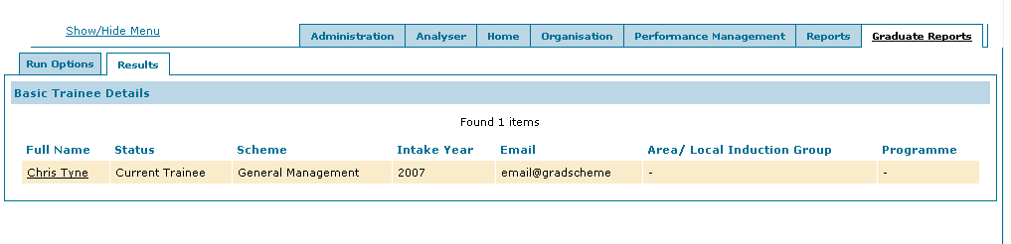
Click on hyperlinks from within the report to go to that person or positions details.

To run a report with a different population
To change Population:

Click on the Run Options tab
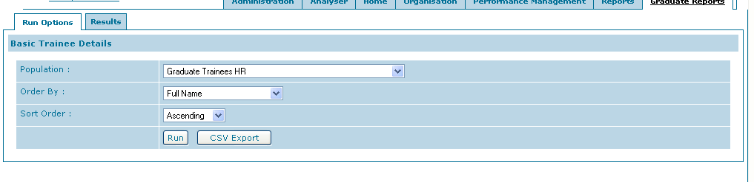
Select from the drop down list which population you wish to include in the results.
If you want to change how the report is ordered you can change the Order By and Sort Order.
Click Run to display the results of the new report on the screen.

To export the results to an Excel spreadsheet
To download the report to Excel

Click CSV export

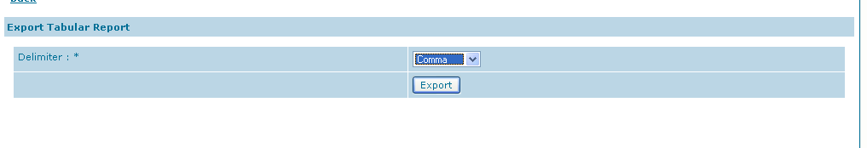
Click Export

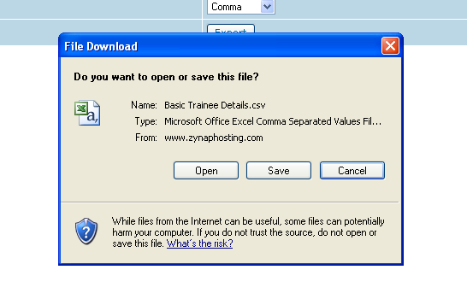
Follow the instructions in the window dependent on whether you want to Open or Save your report.

If you choose to open your report a new excel window will be opened containing the results of your report.

Remember to save your file as an excel file i.e. .xls

Frequently Asked Questions

I can’t log in/ I get an error when I log in

System Messages on Login and what they mean

Invalid login. Please make sure that you have entered a correct username and password.

The user has entered an incorrect username or password

You have exceeded the maximum number of attempts allowed to login.

An incorrect username or password can only be entered three times in one go before the user account is locked.
The password will have to reset and re-issued – see Updating a User – new password, new user name, Home page etc

You could not be logged on to Outlook Web Access. Make sure your domain\user name and password are correct, and then try again

It means the user has clicked the Zynap URL from within an email being viewed in Webmail. They need to cut and paste the URL in to the address bar of Internet Explorer and they should then be able to access Talent Studio.

3 The page cannot be displayed
The page you are looking for is currently unavailable. The Web site might be experiencing technical difficulties, or you may need to adjust your browser settings.

This could mean a number of things but one thing to check is that they have entered the URL correctly i.e.

https://www.zynaphosting.com/nhs

Please note particularly the ‘S’ in https – they will not be able to get access to the login page if this s is missing.

How to Generate a Password

Passwords can be generated automatically by the following website:

http://www.pctools.com/guides/password/

Click on Generate Password and a password will be randomly generated. Cut and paste this in to the persons account details. (see Updating a User – new password, new user name, Home page etc)

TIP: Save this URL to your Favourites in Internet Explorer so that it is handy at all times.

My Programme/ Placement Manager has changed

Please see the sections called Replacement or Additional Manager (same placement) or New Placement with a new Placement Manager dependent on the circumstances.

I haven’t received any login details for Talent Studio

Check that this person is actually on Talent Studio - see Searching for People

If they are, check that we hold a valid email address for them, update where necessary.

Reset the password and send them their login details using the email template.

If they are not on Talent Studio add them as a new person but check to see what positions they need to be assigned to and what trainees they should have access to.

Note: Administrators and Trainees need to be added by the system administrator (currently Vanessa Wilderink)

Talent Studio Login details – Email Text:

Please use this template when issuing login details to Programme or Placement Managers:

Dear <Programme/Placement Manager Name>

We have been notified that you will be the <Programme/Placement> Manager for <trainee name> from the NHS Graduate Management Training Scheme.

Talent Studio is an on-line performance management tool that holds your trainee’s performance portfolio. This develops as they progress through the scheme, capturing information such as performance reviews, progress in their specialism competencies, placement planning, placement job descriptions and objectives, personal development plans, academic achievements and feedback from the Assessment Centre.

You can access Talent Studio through the following link https://www.zynaphosting.com/nhs/login.htm

Your Login Details are as follows (please enter them exactly as you see them):

Username:
Password:

Please do not divulge this password to anyone as Talent Studio contains personal information.

The Talent Studio User Guide can be found on the home page of Talent Studio and also as an appendix to the Scheme Handbook which is available here: http://www.institute.nhs.uk/graduate/general/graduate_trainee_-_handbook.html. You will need a user account to access this part of the website. Please call 0845 300 8027 in order to have this set up.

If you require any further information please do not hesitate to contact us on gradschemefaq@institute.nhs.uk

Regards
The NHS Graduate Scheme Team

Re-issue of a Password – Email text

Please use this email text when sending out re-set passwords.

Dear <name>

Your password has been reset to: <new password>

Once logged in please do change your password to something more secure.

Regards

System Errors

Very occasionally the user will get a system error.

They will see something like this:

A System Error has occurred and a message has been sent to support.
Please contact your system administrator and report the error details displayed and the steps that lead to the error occurring.
Click here to view details of the error.

Even though an email is automatically sent to Zynap we still need to capture more information.

Ask the user what they were doing at the time of the error

If they are still able to ask them to view the details of the error and cut and paste it in to an email

Send the above to Zynap Support along with the name of the person who had the error.

I can’t write anything in my Performance Review form

Is this question coming from a trainee?

If so, the majority of the form is manager-write only (for obvious reasons!). Trainees can only complete the section called Meeting Details. The rest of the form needs to be completed by a manager.

Is this question coming from a manager?

There have been a few instances where Managers have been unable to write in the Comments boxes on the form. We think it is due to the browser they are using; it seems to be solved by performing the following steps:

- Open the form in Edit mode
- Open a Comments box (the small square box with dots)
- Click on the top of the box and ‘drag’ it to the middle of the screen)
- The user should then be able to add Comments.

My Manager is unable to Save their ratings on my Competency Forms

This is possibly because the trainee has entered too much evidence on the Competency form.

There is a limit to the amount of text that can be entered here; and this was formalised at the beginning of February 2008. Before that time there was a system limit that if exceeded caused Talent Studio to produce a system error. The formal limit (slightly smaller than the system limit) was introduced so that the limit could be handled correctly. If the trainee has large amounts of evidence they now have the option to upload a document containing full evidence in to their portfolio. They have to summarise the evidence on the competency form and state they have uploaded further evidence in to their portfolio.

If the trainee entered their evidence before this was done they would probably have been able to save their evidence without an error (provided they didn’t exceed the system limit). Now that the limit has been formalised we potentially have an issue with managers going back in to the form, making a change and then trying to save.

In this case, the trainee will have to follow the new process above i.e. cut and paste the evidence in to a word document; upload this in to their portfolio, and summarise this in their competency

My Manager is not receiving emails from Talent Studio

Firstly check that their Manager is actually on Talent Studio (see Searching for People)

If they are then make sure that they have a valid email address on the system. In order to send emails Talent Studio requires an email address, and obviously this needs to be correct. Check the spelling if there is already an email address held.

Update the email address if necessary (see Updating/ changing a users email address)

If they are not on Talent Studio and they should be, then Add them as a New Person

Where do trainees enter information about their Mentor?

Mentor information can be entered on the form called Personal Information. This is found in the group called Background Information in the trainee Portfolio.

My trainee has additional holiday entitlement or has balances to carry over from the previous year
- Find the trainee using Searching for People

- Click on the tab called Portfolio

- In the group called Administration open the form called Annual Leave Entitlement

- Update the appropriate fields

- Add any comments as necessary.

How do I take a screen shot?

  - Make sure that what you need a screen shot of is displayed on the screen
  - Hit the Print Screen key (typically at the top of your keyboard)
  - Open a word document
  - Right click your mouse and select Paste

I am having problems with my Institute email address/ accessing my Inbox

Please reply to the email copying in Support@gradscheme.institute.nhs.uk

Remind the trainee that any problems of this nature should be directed to that email address.

The people that monitor that email address are generally really quick at dealing with their support emails.

You can use the following email template:

Hi <trainee name>

You need to contact support@gradscheme.institute.nhs.uk if you have problems with your institute email.

I have copied them in on this email so hopefully they will be able to help you.

Kind regards

How to access the Gradscheme FAQ Inbox

There are 2 ways of doing this:

Webmail:

  - Go to the URL https://extra.institute.nhs.uk/exchange/

  - Enter the username: gradschemefaq

  - Enter the password: gradfaq

TIP: Add the URL to your favourites in Internet Explorer so that you always have it handy.

What is the Gradscheme FAQ process?

A person is assigned to oversee the inbox for a certain period of time. This person needs to have global access rights to Talent Studio.

This person monitors the inbox and reviews the content of each email.

The email is dealt with accordingly:

Email Content – numbers relate to the section headings in this document | Action
I can’t log in etc  System Errors  I can’t write anything in my performance review  Unable to save changes to Competency forms  Mentor Information  Problems accessing Institute email | Deal with directly
My Manager has changed  No login details for Talent Studio  Not receiving emails from Talent Studio | Look up the person on Talent Studio, find out what area they are in and file the email appropriately.  Make sure that the email is marked as unread so that it is clear to the area person that there is a new email to be dealt with.

Each area has a separate person assigned to their area inbox.

Once queries have been dealt with they need to be filed in the Dealt With folder. This ensures that they don’t get dealt with again.

Other scheme enquiries that do not relate to Talent Studio should be redirected to the appropriate place. In many cases it is simply a matter of referring them to the Handbook on the Gradscheme website.

Worked Example of Changing a Programme Manager

Trainee
CHRIS TYNE

Programme
CHRIS TYNE

Placement (One)
CHRIS TYNE

LDM
SALLY KETTLE
Programme Manager
Held by person in the role of Programme Manager
PAT RICHER
Placement Manager
Held by person in the role of Placement Manager
CHARLES KING
Receive a communication from Chris Tyne that her Programme Manager is changing (currently Pat Richer).

New Programme Manager is called James Bradford. He is based at Midshire Healthcare Trust.

Check that the new manager is not on the system already (see Searching for People)

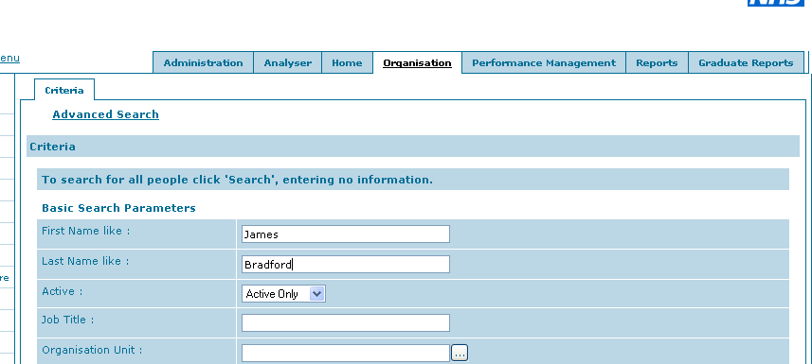

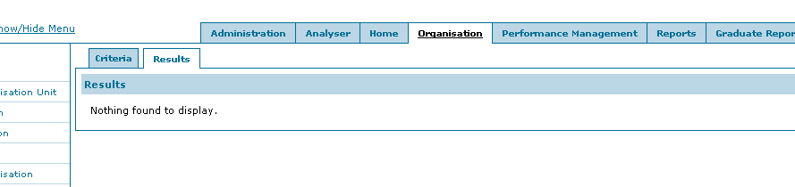

He is not on the system already so find the trainee who’s Manager has been replaced (see Searching for People)

Click on the name of the Manager who is being replaced i.e. Pat Richer

Click on Current Position

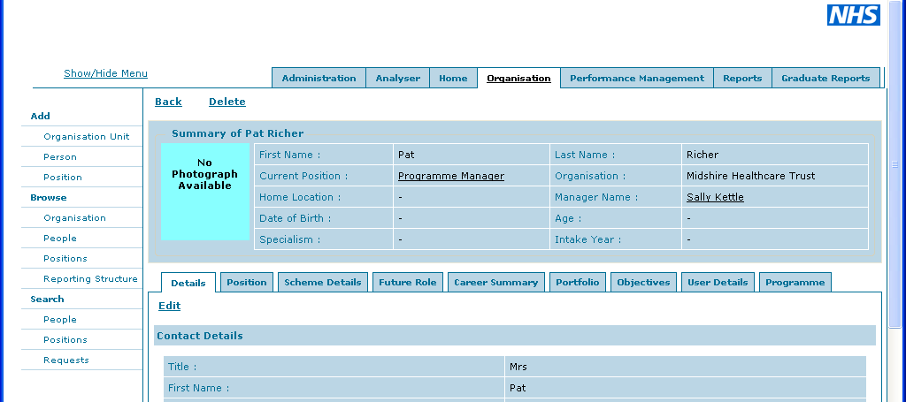

Click on tab labelled Direct Reporting

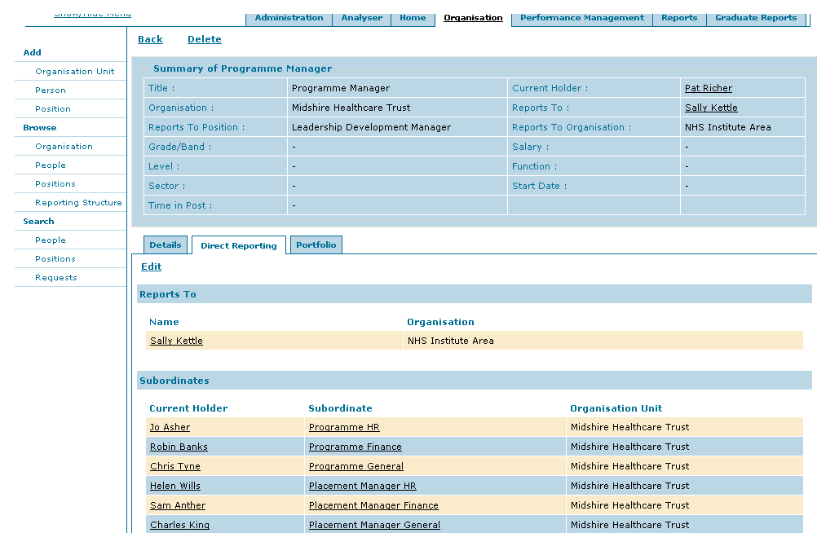

Is there more than one trainee listed in the Subordinates section i.e. does this person manage more than one trainee?

Yes, there are currently three trainess: Jo Asher, Chris Tyne, and Robin Banks

Will the new Manager need access to all the trainees listed as subordinates?

In this case No

NO – the new manager will not need access to all the trainees listed as subordinates:
- You will need to add a new Position to Talent Studio (see Adding a new Position)

In this case you will need to set up a second Programme Manager position in the organisation called Midshire Healthcare Trust

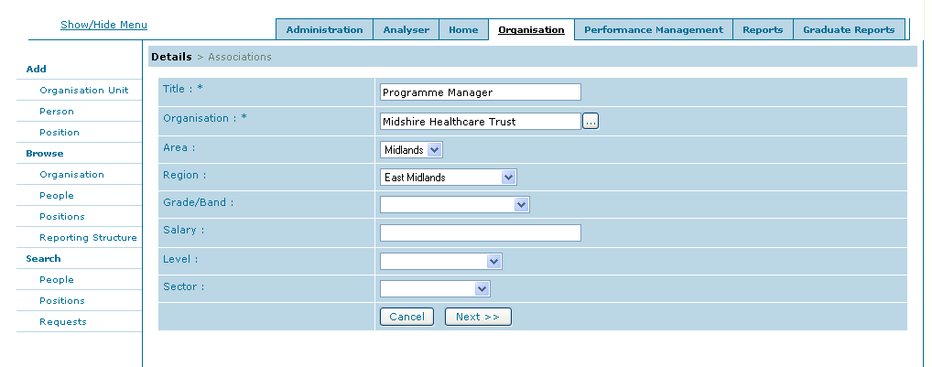

- Add the new Manager (see Adding a new Person) and assign them to this new position
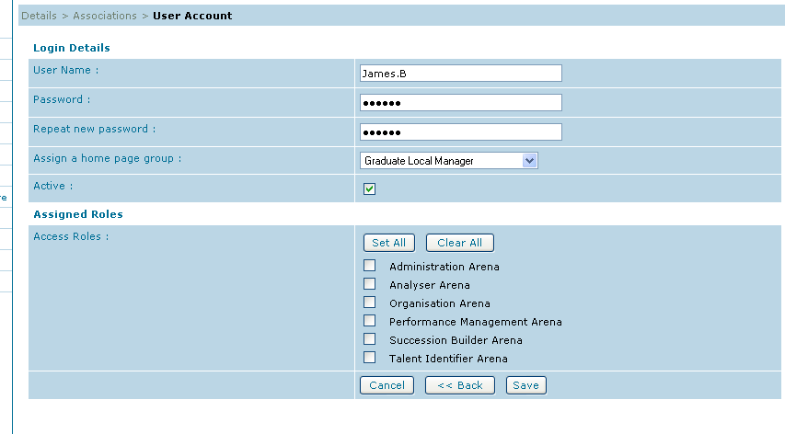

- Send the new Manager their login details using the email template provided

- Make sure that the corresponding trainee/s position reports in to this new position (see how to Change Reporting Position)

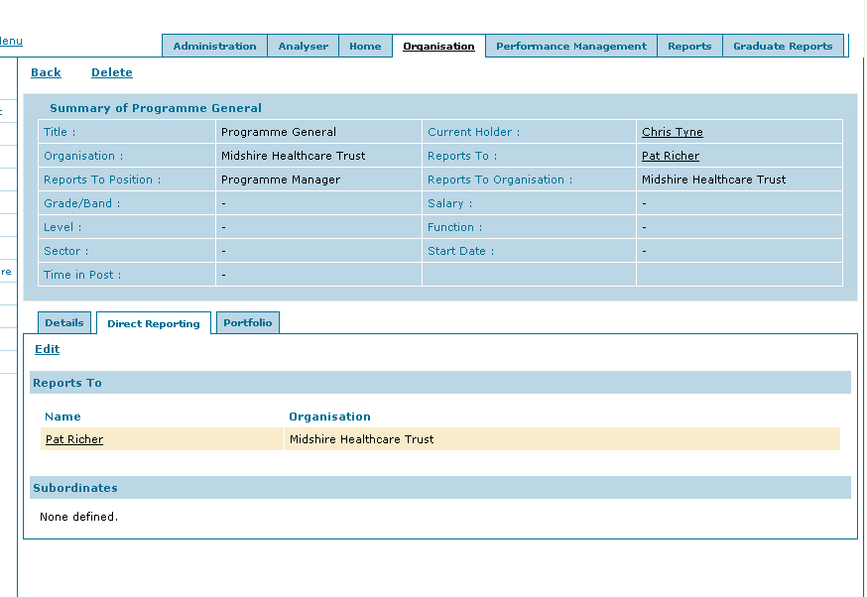

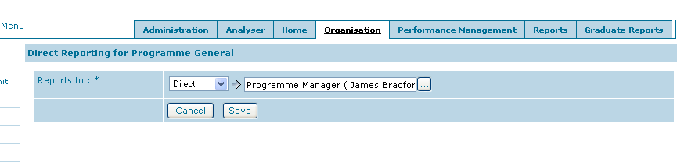

You can see that you have correctly assigned the position as James Bradford is listed in brackets next to the position

You can now see on Chris Tyne’s Summary that James Bradford is now her Programme Manager
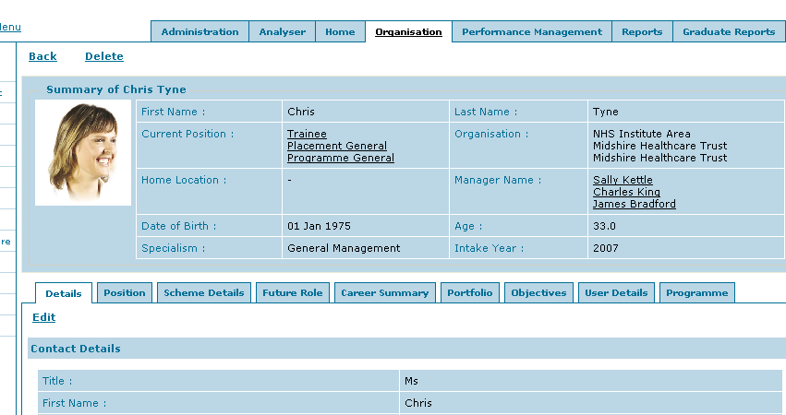

Is the Pat Richer still managing the other trainees? (subordinates)

Yes she is

We will not delete Pat Richer as she still needs access to Jo Asher and Robin Banks.

