Music Player using Python

Rony Benny 501750 IT SEMESTER IV

*Department of Information Technology, Fr. Conceicao Rodrigues Institute of Technology, Vashi Navi Mumbai, Maharashtra 400703 India*

[ronybenny2812@gmail.com](mailto:ronybenny2812@gmail.com)

***Abstract -*** We all know that music is essential part of our life. Every person on earth like to listen music. Here I just want to make a player which can reproduce some good music saved in digital format. We make use of Tkinter for GUI and to play music we use pygame-mixer and mutagen packages. This project only supports .*wav* and *.mp3* files, as these two formats are used most. The reason for taking this project is because I have special attachment towards music. And there’s nothing better than making a music player once self. The whole project is made using Python and all audio related packages.

## Keywords: music player, pygame, pyaudio, wav, mp3.

1. **TYPES OF MUSIC FILE**
2. **WAV**

A file with the .wav or .wave file extension is a Waveform Audio Format.  It’s a container audio file that stores data in segments. It was created by Microsoft and IBM and has become the standard PC audio file format.

The format uses containers to store audio data, track numbers, sample rate, and bit rate. WAV files are uncompressed [lossless audio](https://www.howtogeek.com/142174/what-lossless-file-formats-are-why-you-shouldnt-convert-lossy-to-lossless/) and as such can take up quite a bit of space, coming in around 10 MB per minute with a maximum file size of 4 GB.

TO read .wav file, we use pygame – mixer class. The mixer class has various functions such as open. The music module is closely tied to [pygame.mixer pygame module for loading and playing sounds](https://www.pygame.org/docs/ref/mixer.html#module-pygame.mixer). Use the music module to control the playback of music in the sound mixer.

The difference between the music playback and regular Sound playback is that the music is streamed, and never actually loaded all at once. The mixer system only supports a single music stream at once. Be aware that MP3 support is limited.

1. **MP3**

This type of music format is used most. MP3 (MPEG-1 Audio Layer-3) is a standard technology and format for [compressing](https://searchstorage.techtarget.com/definition/compression) a sound sequence into a very small file (about one-twelfth the size of the original file) while preserving the original level of sound quality when it is played.

The MP3 format is a [compression](https://computer.howstuffworks.com/file-compression.htm) system for music. The goal of using MP3 is to compress a CD-quality song by a factor of 10 to 14 without noticeably affecting the CD-quality sound. With MP3, a 32-megabyte song on a CD compresses down to about 3 MB. This lets you download a song much more quickly, and store hundreds of songs on your computer's [hard disk](https://computer.howstuffworks.com/hard-disk.htm).

In this project, mutagen.mp3 package is used to read mp3 file.

# LITERATURE SURVEY

1. **FEATURES**

The music player has all the basic functionalities a player must have.

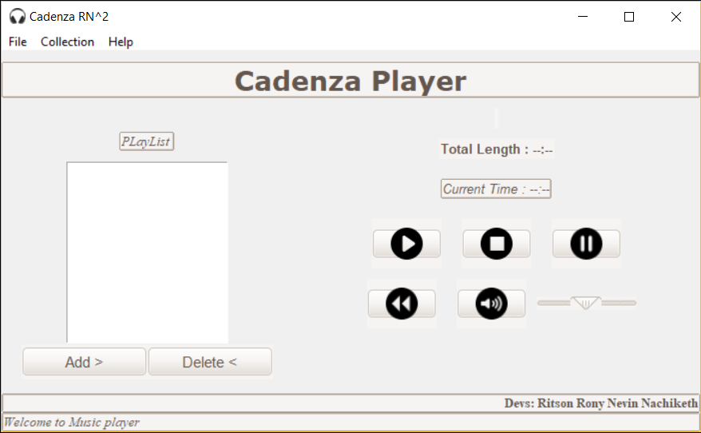

## Fig 1: Cadenza Player

The player has a playlist textbox, where new songs can be added and deleted. The music will only play once a song is selected from the playlist.

The player also provides with total duration of selected song and the current running time.

The status bar gives the status of which song is playing currently, whether music is paused, stopped or rewind etc.

1. **Advantages of Cadenza Player**
2. Capable of playing .mp3 and .wav format music.
3. Has a playlist option with add and delete features.
4. Show the total play length of the song and current run time of the song
5. Has a audio visualizer running on command prompt, which records real time voice and shows the range of the voice on command prompt window.
6. **Drawbacks of Cadenza Player**
7. No other music file format are playable.
8. Songs in the playlist cannot be set in repeat mode.
9. There’s no automatic play next song feature.
10. The audio visualizer plots only in command prompt window.
11. As of now, nothing has been added in Collection Submenu.

# PROPOSED SYSTEM



**Fig 2: Cadenza Player**

The Music player has simple GUI with play, pause, stop, rewind, mute and volume buttons.

The status bar displays the name of the developers and also updates with the current status of the player. For example, if a music is played, the status bar will show which music is being played and if it is stopped, then the status bar will show “Music Stopped”. The default volume is set to 50.

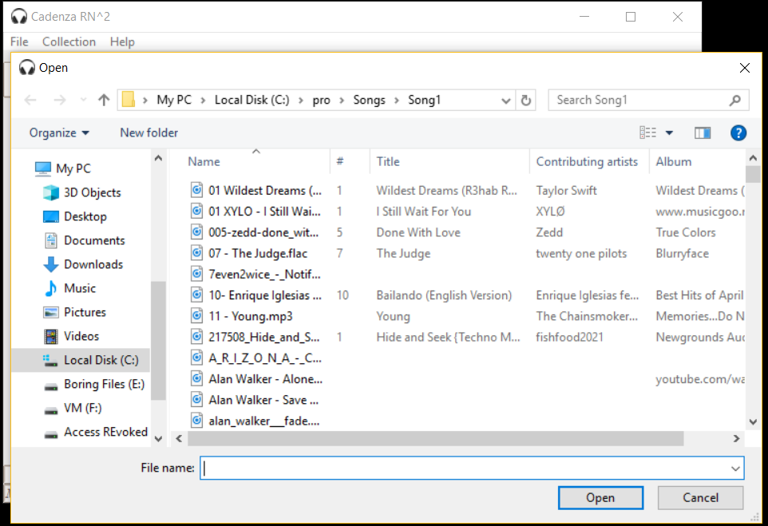

**Fig 3: Screenshot of Adding a song**

Fig 3 shows us the demonstration of what happens when ADD button is clicked. Now we select the song from our Song directory in PC and the song gets loaded onto the playlist as show in Fig 4. If more songs are to be added onto playlist, then repeat the process.

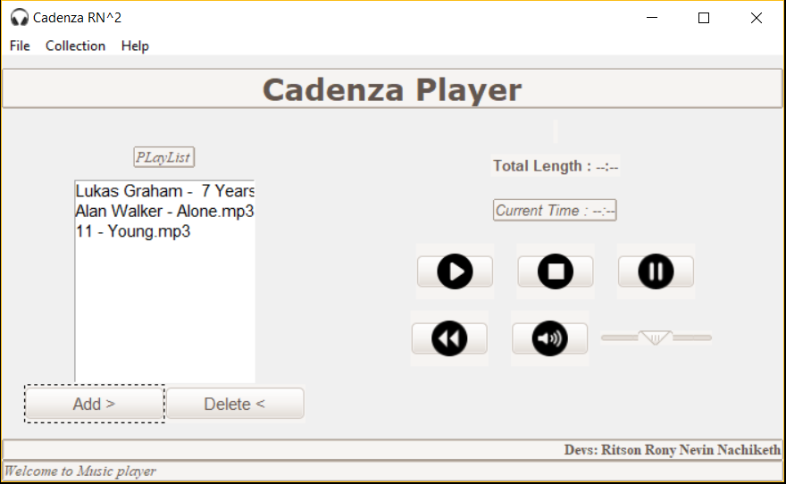

**Fig 4: Songs loaded onto the playlist**

Now select the song file and click on play button. The song will get loaded into the mixer and song will start playing. All the details of the song like total length of song, name of the song will be displayed at the top of player as shown in Fig 5. If no song is selected before clicking on Play Button, then a prompt window appears displaying “Select the File”.

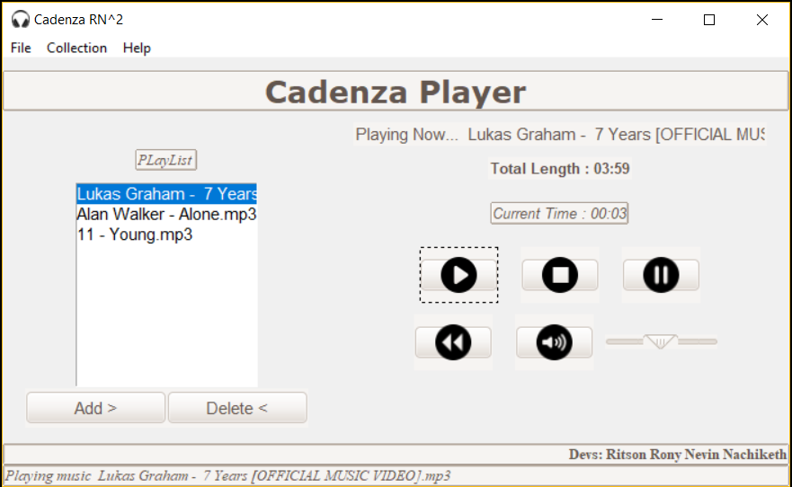

**Fig 5: Playing a selected song**

The player has the feature of deleting a song from the playlist. Select the song from the playlist which is to be removed and click on Delete Button(Fig 6).

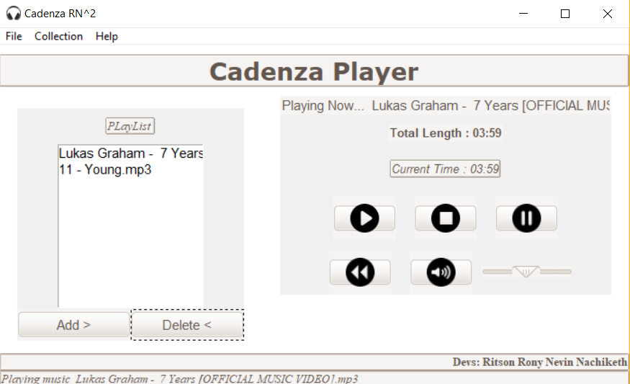

**Fig 6: Deleting a song from playlist**

The player also provides with a feature of applying background, for effective GUI. It’s not a major feature though. To apply background. Go to File Menu > Click on BgColor > Select the color. The color of the player changes accordingly(Fig )

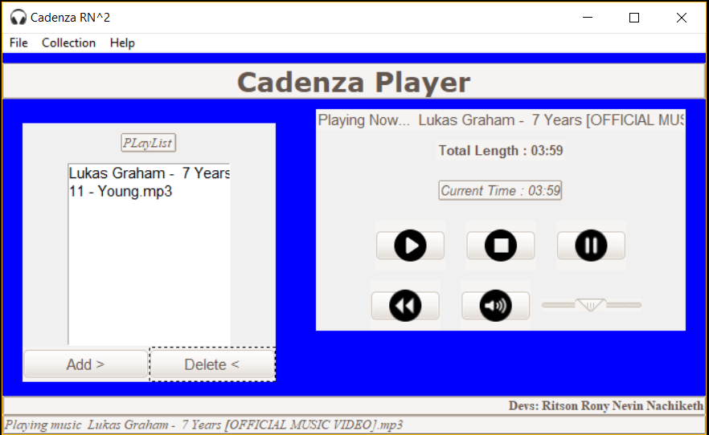 **Fig 7: Applying background to the player**

Another feature of the player is that, it supports audio visualizer. The audio visualizer reads voice inputs from user

and plot the horizontal wavelength simultaneously. To use visualizer: Go to File Menu > Click on Audio Visualizer.

Command prompt window will appear and the graph will start plotting based on the intensity of voice.

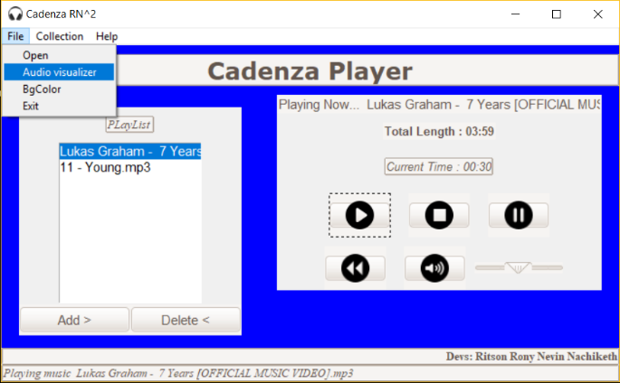

**Fig 8: Audio Visualizer**

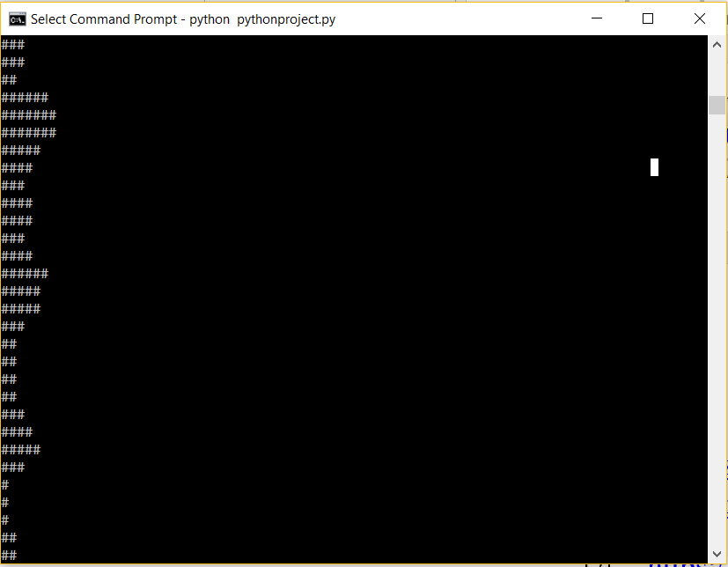

**Fig 9: Graph plotted on the command prompt**

1. **CONCLUSION**

This project was taken as my Python Mini Project. It had the perfect blend i.e. Python and my love for music. While researching to the progress of this project, I have learnt many functionalities of various packages and concepts. The pygame, pyaudio module have high scope and more ideas can be implemented using both. This paper highlights all the required concepts and steps to work on any other music player.

There is more to be done to achieve more polished functionality of the project by overcoming the drawbacks and supporting other music formats. All source code and the documentation is freely available on my GitHub profile at <https://github.com/brony28/Cadenza-Music-Player>

REFERENCES

1. <http://students.iitk.ac.in/eclub/assets/documentations/summer11/WAV.pdf>
2. <https://www.howtogeek.com/392504/what-are-wav-and-wave-files-and-how-do-i-open-them/>
3. <https://whatis.techtarget.com/fileformat/MP3-MPEG-Audio-Layer-3-AC3-file>
4. <https://www.youtube.com/channel/UCirPbvoHzD78Lnyll6YYUpg>