1 2 3

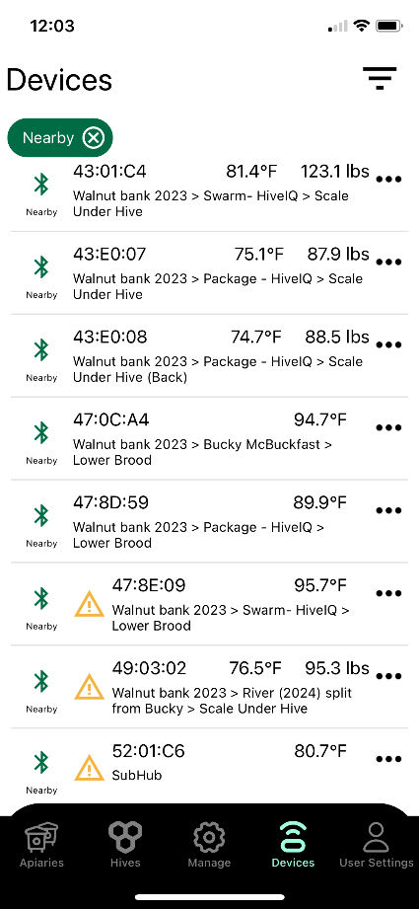

1 2 3

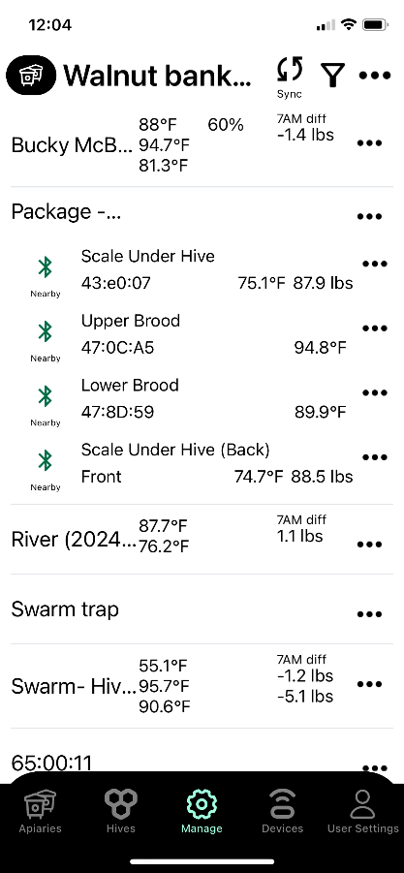 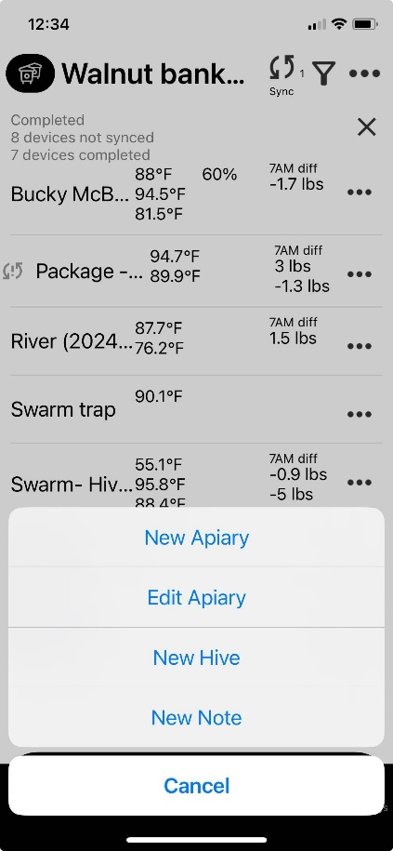 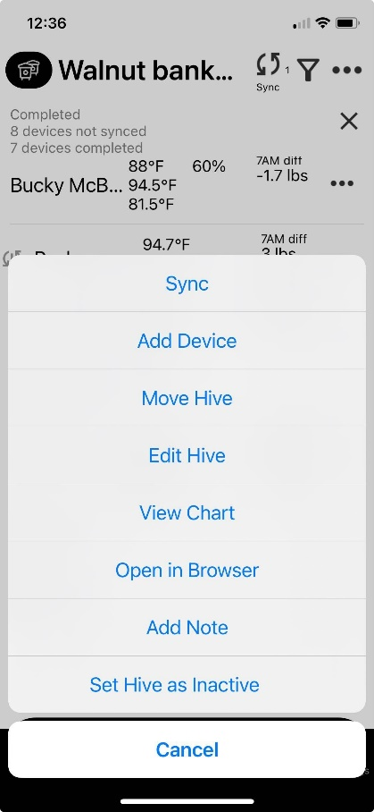

1 2 3

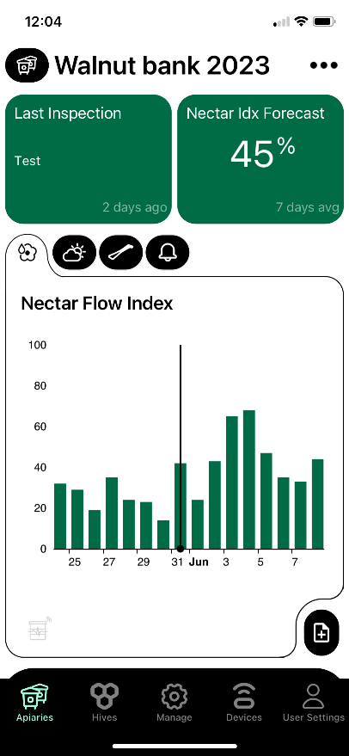 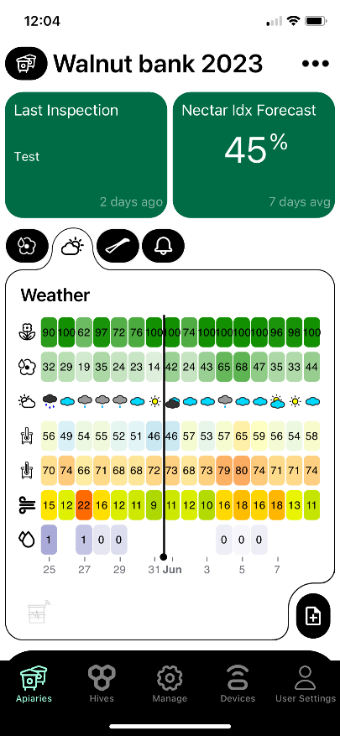 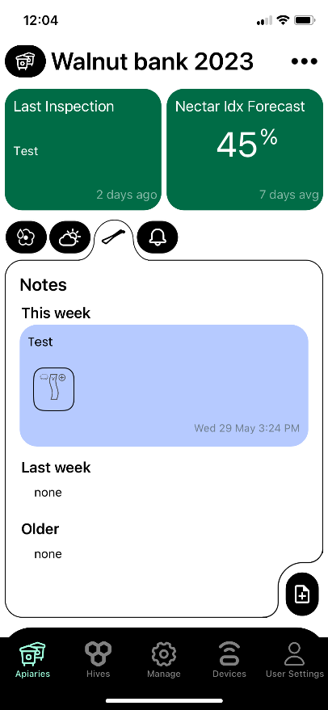

1 2 3

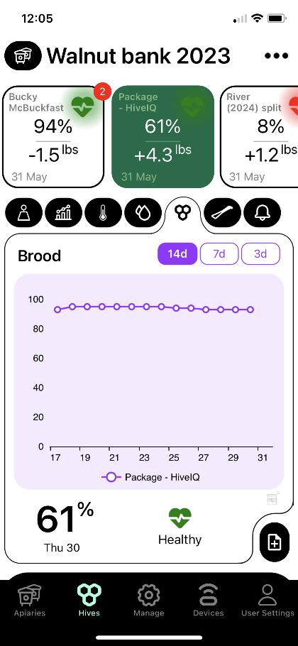

1 2 3

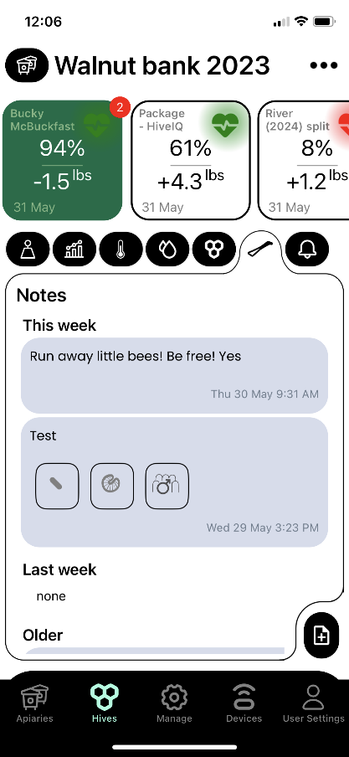 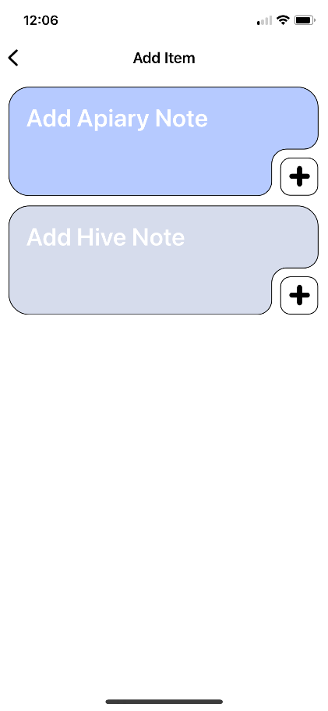

1 2 3