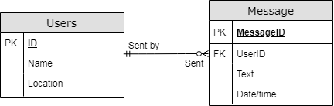

**The reason for this design is because it seems like it would be the most straight forward way to model the data. We would want to have a row for each message but would not want to repeat the user information on each row. This is why we have separate User table where each User can be identified by their ID.**

**Relational Notation**

**USER(UserID, Name, Location)**

**MESSAGE(UserID, MessageID, Date/Time, Text)**

**We still need the Date and time information as well as the content of each message on each row. We have simplified the user identification into an ID that we can use to look up more information in the User table.**