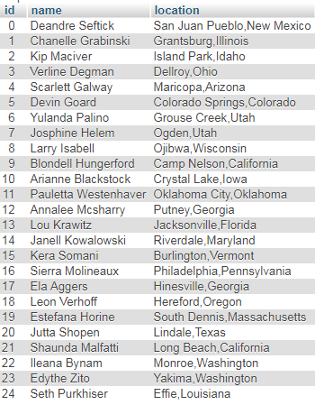**C was used to take the data files and create two csv files. Luckily, the user csv was small enough to be uploaded in one go. However, the messages CSV needed to be broken up into 20 pieces since there was a file size limit, and a time limit for upload. This was done using a program called CSV chunker. Each file was of size ~780KB.**

