PHP:

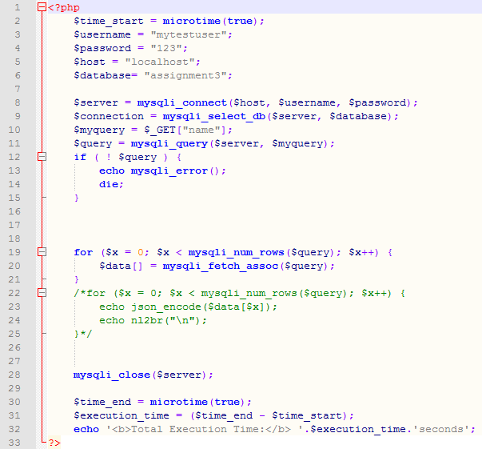

HTML:



QUERIES:

1. [SELECT](http://localhost/phpmyadmin/url.php?url=https://dev.mysql.com/doc/refman/5.5/en/select.html) * FROM `user` WHERE location [LIKE](http://localhost/phpmyadmin/url.php?url=https://dev.mysql.com/doc/refman/5.5/en/string-comparison-functions.html#operator_like) '%nebraska%'
2. [select](http://localhost/phpmyadmin/url.php?url=https://dev.mysql.com/doc/refman/5.5/en/select.html) * from [user](http://localhost/phpmyadmin/url.php?url=https://dev.mysql.com/doc/refman/5.5/en/information-functions.html#function_user) where [user](http://localhost/phpmyadmin/url.php?url=https://dev.mysql.com/doc/refman/5.5/en/information-functions.html#function_user).id [in](http://localhost/phpmyadmin/url.php?url=https://dev.mysql.com/doc/refman/5.5/en/comparison-operators.html#function_in) ( [select](http://localhost/phpmyadmin/url.php?url=https://dev.mysql.com/doc/refman/5.5/en/select.html) messages.user_id from messages where time_stamp [LIKE](http://localhost/phpmyadmin/url.php?url=https://dev.mysql.com/doc/refman/5.5/en/string-comparison-functions.html#operator_like) '% 08:%' [or](http://localhost/phpmyadmin/url.php?url=https://dev.mysql.com/doc/refman/5.5/en/logical-operators.html#operator_or) time_stamp [LIKE](http://localhost/phpmyadmin/url.php?url=https://dev.mysql.com/doc/refman/5.5/en/string-comparison-functions.html#operator_like) '% 09:00:00%' )
3. [select](http://localhost/phpmyadmin/url.php?url=https://dev.mysql.com/doc/refman/5.5/en/select.html) * from [user](http://localhost/phpmyadmin/url.php?url=https://dev.mysql.com/doc/refman/5.5/en/information-functions.html#function_user) where [user](http://localhost/phpmyadmin/url.php?url=https://dev.mysql.com/doc/refman/5.5/en/information-functions.html#function_user).id [in](http://localhost/phpmyadmin/url.php?url=https://dev.mysql.com/doc/refman/5.5/en/comparison-operators.html#function_in) ( [select](http://localhost/phpmyadmin/url.php?url=https://dev.mysql.com/doc/refman/5.5/en/select.html) messages.user_id from messages where time_stamp [LIKE](http://localhost/phpmyadmin/url.php?url=https://dev.mysql.com/doc/refman/5.5/en/string-comparison-functions.html#operator_like) '% 08:%' [or](http://localhost/phpmyadmin/url.php?url=https://dev.mysql.com/doc/refman/5.5/en/logical-operators.html#operator_or) time_stamp [LIKE](http://localhost/phpmyadmin/url.php?url=https://dev.mysql.com/doc/refman/5.5/en/string-comparison-functions.html#operator_like) '% 09:00:00%' ) [and](http://localhost/phpmyadmin/url.php?url=https://dev.mysql.com/doc/refman/5.5/en/logical-operators.html#operator_and) location [LIKE](http://localhost/phpmyadmin/url.php?url=https://dev.mysql.com/doc/refman/5.5/en/string-comparison-functions.html#operator_like) '%nebraska%'
4. select user_id from (select user_id , count(*) from messages where user_id in (select id from user where user.id in ( select messages.user_id from messages where time_stamp LIKE '% 08:%' or time_stamp LIKE '% 09:00:00%' ) and location LIKE '%nebraska%') group by user_id) as alias ORDER BY `count(*)` DESC limit 1

Resulting page before clicking submit:

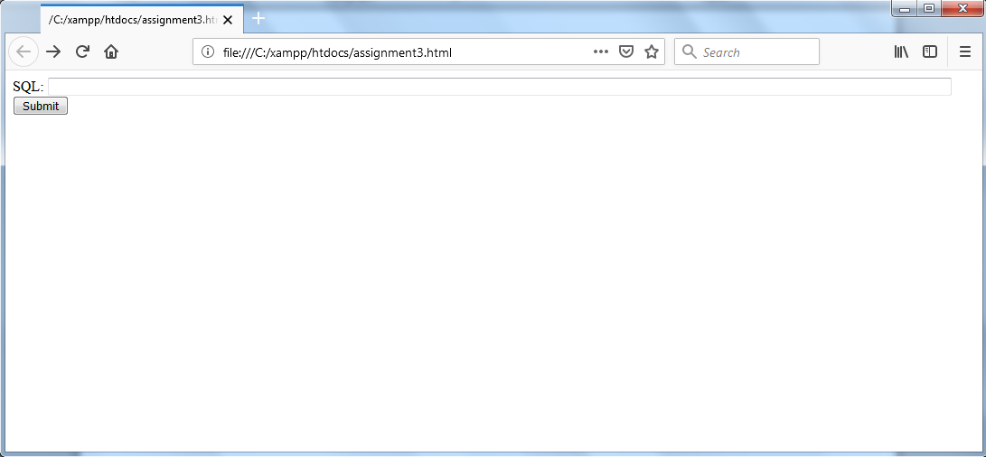

Results from each of the queries:

Query 1:

**Total Execution Time:** 0.015599966049194seconds

Query 2:

**Total Execution Time:** 0.20580005645752seconds

Query 3:

**Total Execution Time:** 0.21619987487793seconds

Query 4:

**Total Execution Time:** 0.28180003166199seconds

The first one is faster because we are using a table and not having to go into each file. The last 3 are about twice as slow but this is probably due to having to go through the messages table which is close to 100,000 rows.