Query a)

select distinct friendid from friends where friends.personid in (select id from persons where state="nebraska") order by friendid asc

Showing rows 0 - 24 (70 total, Query took 0.0060 seconds.)

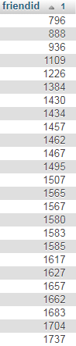 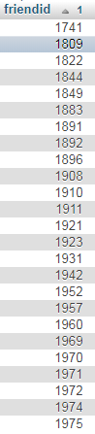 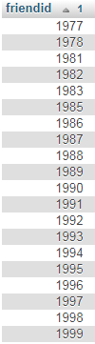

Query b) [select](http://localhost/phpmyadmin/url.php?url=https://dev.mysql.com/doc/refman/5.5/en/select.html) distinct friendid from friends where friends.personid [in](http://localhost/phpmyadmin/url.php?url=https://dev.mysql.com/doc/refman/5.5/en/comparison-operators.html#function_in) ([select](http://localhost/phpmyadmin/url.php?url=https://dev.mysql.com/doc/refman/5.5/en/select.html) id from persons where state="nebraska") [and](http://localhost/phpmyadmin/url.php?url=https://dev.mysql.com/doc/refman/5.5/en/logical-operators.html#operator_and) [year](http://localhost/phpmyadmin/url.php?url=https://dev.mysql.com/doc/refman/5.5/en/date-and-time-types.html) >=2005 order by friendId asc

Showing rows 0 - 24 (49 total, Query took 0.0080 seconds.)

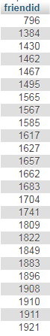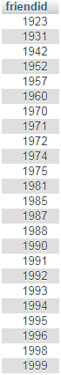

Query C

[select](http://localhost/phpmyadmin/url.php?url=https://dev.mysql.com/doc/refman/5.5/en/select.html) personid, [count](http://localhost/phpmyadmin/url.php?url=https://dev.mysql.com/doc/refman/5.5/en/group-by-functions.html#function_count)(*) as c from friends where friends.personid [in](http://localhost/phpmyadmin/url.php?url=https://dev.mysql.com/doc/refman/5.5/en/comparison-operators.html#function_in) ([select](http://localhost/phpmyadmin/url.php?url=https://dev.mysql.com/doc/refman/5.5/en/select.html) id from persons where state="nebraska") [and](http://localhost/phpmyadmin/url.php?url=https://dev.mysql.com/doc/refman/5.5/en/logical-operators.html#operator_and) [year](http://localhost/phpmyadmin/url.php?url=https://dev.mysql.com/doc/refman/5.5/en/date-and-time-types.html) >=2005 group by personId order by c desc limit 1

Showing rows 0 - 0 (1 total, Query took 0.0120 seconds.)



Query D

[select](http://localhost/phpmyadmin/url.php?url=https://dev.mysql.com/doc/refman/5.5/en/select.html) personId, [count](http://localhost/phpmyadmin/url.php?url=https://dev.mysql.com/doc/refman/5.5/en/group-by-functions.html#function_count)(*) as c FROM friends GROUP BY personId ORDER BY c DESC LIMIT 1

 Showing rows 0 - 0 (1 total, Query took 0.0030 seconds.)

