Computer Science Pong Lab – THE GAME

Lab Goal : This lab was designed to teach you more object oriented programming and how to write a very simple game.

Lab Description : Now that Block, Ball, and Paddle have all been tested numerous times, we can put them all together to make the Pong Game. The hardest part of the game is getting the paddles to hit the ball. I am giving you some logic to make the Ball hit the left paddle. You must then create the logic to make the Ball hit the right paddle. You will use Pong.java to write the final game. Use TheGame.java as your tester.

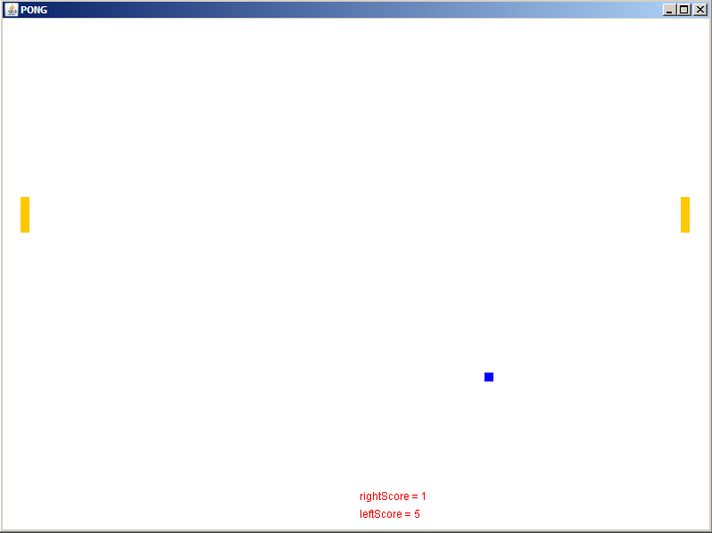

PONG GAME REQUIREMENTS

1. Get the Ball to bounce off the left paddle and right paddle with no bugs. If the Ball sticks to the paddle at any time, that is a BUG.

PONG GAME EXTENSIONS (optional)

1. Create a Wall class that is an extension of Block. Then, make new instance variables for all 4 Walls. Finally, rewrite your code so
that you actually check to see if the Ball collides with the Walls rather than will fixed number boundaries.

2. Save a copy of your Pong game and turn it into BreakOut. BreakOut was a game with a field of Blocks at the top, a ball,
and a paddle that moved across the bottom of the screen. The ball bounced off of the paddle and hit the Blocks. Once a Block was hit, that Block would disappear.

3. Save a copy of your Pong game and turn it into AirHockey. AirHockey is a game with Paddles that can move up, down,
left, and right. Goals are placed on each side and scoring occurs when the puck makes it into a goal.

