数据结构与算法课程实验报告

实验题目：作业 |  | 学号：202400390068
日期：2025-9-5 | 班级： 1班 | 姓名： 胡克岩
Email：brookehu01@gmail.com
实验目的：
回顾C++

实验软件和硬件环境：
IDE：Visual Studio 2022 操作系统： Window 11
CPU：AMD RYZEN AI 9 HX 370 GPU：RTX 4060 100W ARM：32G

实验步骤与内容：
第16题：
Currency.h
#include <iostream>

enum signType{plus, minus};

class currency
{
public:
currency(signType theSign = plus, unsigned long theDollars = 0, unsigned int theCents = 0);
~currency(){}
void setValue(signType, unsigned long, unsigned int);
void setValue(double);
signType getSign() const {return sign;}
unsigned long getDollars() const {return cents;}
currency add(const currency&) const;
currency& increment(const currency&);
void output() const;

void input();
substract(const currency& x);
persent();
multiply();
divide();
private:
signType sign;
unsigned long dollars;
unsigned int cents;
};

Currency.cpp
#include "currency.h"
#include "illegalParameterValue.h"
#include <string>

currency::currency(signType theSign, unsigned long theDollars, unsigned int theCents){
setValue(theSign, theDollars, theCents);
}

void currency::setValue(signType theSign, unsigned long theDollars, unsigned int theCents)
{
if(theCents > 99)
throw illegalParameterValue("Cents should be < 100");

sign = theSign;
dollars = theDollars;
cents = theCents;
}

void currency::setValue(double theAmount){
if(theAmount < 0){
sign = minus;
theAmount *= -1;
}else sign = plus;
dollars = (unsigned long) theAmount;
cents = (unsigned int) ((theAmount + 0.001 - dollars)*100);
}

currency currency::add(const currency& x) const{
long a1, a2, a3;
currency result;

a1 = x.dollars*100+x.cents;
if (x.sign == minus) a1 *= -1;

a2 = dollars*100+cents;
if (sign == minus) a2 *= -1;

a3 = a1 + a2;
if(a3 < 0){
result.sign = minus;
a3 *= -1;
}else result.sign = plus;
result.dollars = a3/100;
result.cents = a3 - result.dollars * 100;

return result;

}

currency& currency::increment(const currency& x){
*this = add(x);
return *this;
}

void currency::output() const{
if(sign == minus) std::cout << '-';
std::cout << "$" << dollars << ".";
if(cents < 10) std::cout << 0;
std::cout << cents;
}

illegalParameterValue.h
#include <string>
#include <iostream>

class illegalParameterValue
{
public:
illegalParameterValue():
message("Illegal parameter value"){}
illegalParameterValue(std::string theMessage)
{message = theMessage;}
void outputMessage(){std::cout << message << std::endl;}
private:
std::string message;
};

Main.cpp
#include <iostream>
#include "currency.h"
#include "illegalParameterValue.h"

int main(){

currency g, h(plus, 3, 50), i, j;

//使用两种形式的setValue来赋值
g.setValue(minus, 2, 25);
i.setValue(-6.45);

//调用成员你函数add和output
j = h.add(g);
h.output();
std::cout << " + ";
g.output();
std::cout << " = ";
j.output();
std::cout << std::endl;

//连续调用两次成员函数add
j = i.add(g).add(h);
j.output();

//调用成员函数increment和add
j = i.increment(g).add(h);
j.output();

//测试异常
std::cout << "Attempting to initialize with cents = 152" << std::endl;
try{
i.setValue(plus, 3, 152);
} catch(illegalParameterValue e)
{
std::cout << "Caught thrown exception" << std::endl;
e.outputMessage();
}

return 0;
}

第23题：
1）10；14
2）x mod y <= x 且 x mod y < y
故令x_0 = x , x_1 = y, x_2 = x mod y, x_3 = y mod (x mod y) …
由x mod y < y， y mod (x mod y) < x mod y …
可知x_1 > x_2 > x_3 > … > x_n
所以x_1 <= x_2 - 1，x_2 <= x_3 – 1
所以令N = x1， 存在n，当n >= N时， x_n <= 0，又x_n >= 0，故x_n = 0
3）代码如下：
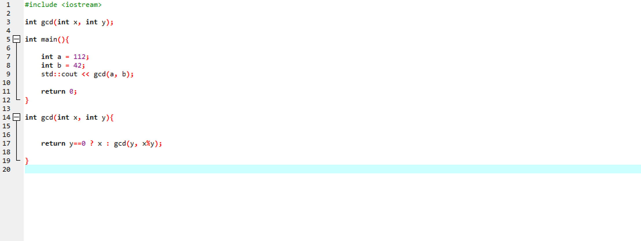
输出如下：

第24题：
代码如下
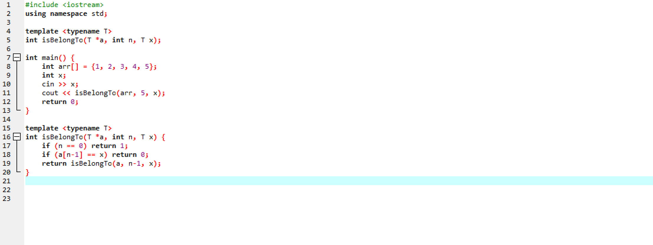
运行结果：

