Manuscript Title: Shifting to recommended diets in the US improves health outcomes, but has differing environmental, social, and economic impacts

Authors and Affiliations:
Brooke M. Bell¹*, Frederick Cudhea¹, Kyra Battaglia¹, Alejandra S. Marquez¹, Emma Morris¹, Julia C. Nelson¹, Edgar Rodríguez-Huerta², Bethany Jackson³, Lu Wang¹, Zach Conrad^{4,5}, Jessica L. Decker Sparks¹, Hanqi Luo⁶, Katherine Fuller^{1,7}, Shijun Gao^{1,8}, Becket Harney¹, Sean B. Cash¹, Patrick Webb¹, Fang Fang Zhang¹^, Nicole Tichenor Blackstone¹^

¹ Friedman School of Nutrition Science and Policy, Tufts University, USA
² Rights Lab, University of Nottingham, UK
³ School of Geography, University of Nottingham, UK
⁴ Department of Health Sciences, William & Mary, USA
⁵ Global Research Institute, William & Mary, USA
⁶ Hubert Department of Global Health, Rollins School of Public Health, Emory University, USA
⁷ Department of Applied Economics, Oregon State University, USA
⁸ Department of Agricultural Economics and Agribusiness, University of Arkansas, USA

^ Contributed equally as co-senior authors
* Corresponding author

Abstract
Current diets are unsustainable from environmental, health, economic, and social perspectives, with numerous challenges cutting across these dimensions. Historically, research has evaluated individual dimensions in siloes. This paper estimates the combined environmental, health, economic, and labor effects of shifting US adult diets to five recommended dietary patterns. Impacts were calculated using life cycle assessment datasets, relative risk of disease estimates, food cost estimates, and forced labor risk estimates. With greater compliance to dietary recommendations, all modeled shifts resulted in decreased cardiometabolic mortality and cancer incidence but also increased water scarcity. Shifting to healthy vegetarian and vegan patterns resulted in decreased greenhouse gas emissions, energy demand, food costs, and forced labor risk; conversely, healthy US- and Mediterranean-style patterns increased these outcomes. These findings highlight the sustainability tradeoffs of dietary transitions that policies must consider to improve conditions across all four dimensions.

Introduction
Dietary trends over the past century have led to intersecting environmental and human health crises that increasingly burden the global population¹. Yet, healthy diets that would yield better nutritional and environmental outcomes are unaffordable for many populations^{2,3}. Moreover, current diets can perpetuate social inequities through their reliance on supply chains characterized by high levels of corporate concentration and power⁴, high-risk and low-wage labor⁵, and animals kept in low welfare conditions⁶.
Food system research that integrates interacting health, environmental, economic, and social considerations simultaneously is needed to fully understand the complex impacts of dietary patterns⁷. Among these dimensions, social sustainability (e.g., food accessibility and human rights) has historically been underrepresented in analyses of sustainable dietary transitions⁷. This underrepresentation is driven by measurement complexity, limited data, and limited awareness of the intersections of food consumption and human rights⁸. That said, the EAT Lancet 2.0 Commission’s introduction of social foundations for food systems, corresponding to the rights to decent work, food, and a healthy environment, as well as individual and collective agency, represents a major advance⁹. For labor specifically, recent modeling studies have explored how dietary transitions may affect agricultural labor demand¹⁰ and forced labor risk⁵, highlighting major differences by dietary pattern and geography, as well as tensions and synergies with other sustainability domains. These findings underscore the need for holistic, context-specific analyses of dietary changes as policymakers in the US and internationally seek to design programs that can support their citizens’ health while minimizing negative side-effects in other domains of concern.
To support the transition toward sustainable diets, effective policy instruments are also needed. National food-based dietary guidelines (FBDGs) offer principles for healthy lifestyles, while also responding to a specific country’s priorities¹¹. FBDGs also guide public procurement, a key mechanism to increase demand for healthy, sustainable diets, which is especially important in high and upper middle-income countries given disproportionate dietary contributions to environmental harm. Countries have begun to recognize that FBDGs can be used to promote sustainability, with 95 countries referencing environmental sustainability in their guidelines as of 2022¹². Regardless of whether FBDGs incorporate sustainability concerns, understanding what synergies and tradeoffs exist between human health and the other three dimensions of sustainability diet transitions is vital. These analyses can inform the development of tailored policy bundles that amplify synergies and mitigate tradeoffs across sustainability dimensions⁹.
Here, we demonstrate the potential impacts of shifting from current to recommended diets, using a four-dimensional framework that incorporates health, environmental, economic, and social outcomes. We focus on the US, a high-income nation where diet quality is low on average¹³, and where national FBDGs (The Dietary Guidelines for Americans, 2020-2025, hereafter DGAs) provide a variety of healthy food pattern archetypes that reflect diverse preferences. By providing a modeling framework that illustrates the impacts of shifting to a range of diets and embracing a holistic definition of sustainability, this research offers a comprehensive understanding of key benefits and tradeoffs associated with dietary shifts.

Results
We estimated the sustainability impacts of the US adult population shifting from their current diet to the following five recommended dietary patterns: (1) the Healthy US-Style (HUS), (2) the Healthy Mediterranean-Style (MED), and (3) the Healthy Vegetarian (VEG) patterns from the 2020-2025 DGAs; (4) the Healthy Vegan (VGN) pattern, which was replaced with the MED pattern in the last two versions of the DGAs (2015-2020 and 2020-2025), and is included here for comprehensiveness; and (5) the Chronic Disease Prevention (CDP) pattern, which we constructed based on the dietary recommendations of the American Heart Association (AHA), the American Cancer Society (ACS), and the World Cancer Research Fund/American Institute for Cancer Research (WCRF/AICR) (Table 1).

Our health modeling used Comparative Risk Assessment (CRA), which robustly estimates the cancer and cardiometabolic disease impacts from population-wide dietary shifts. Our environmental, cost, and forced labor risk modeling reflects current economic conditions (e.g., markets, trade, prices) and production practices, which can validly estimate the impacts of small changes, but the validity for large dietary shifts and unintended consequences is less certain. We therefore present absolute annual results (1) per the total US population for health outcomes (Table 2) and (2) per capita for environmental, food cost, and forced labor risk outcomes (Table 3). We also include an analysis of shifting approximately 1% of the US adult population toward these reference diets, reflecting the magnitude of adults fed by current US public feeding programs (see Methods) (Table 4).

Impacts of Shifting to Recommended Diets
Shifting from the current diet towards the five recommended diets led to improved health outcomes across all diets, to varying degrees, with greater relative reductions in cardiometabolic disease (CMD) mortality than cancer incidence. The largest estimated number of annual CMD deaths prevented was associated with shifting to the CDP pattern (-366,991 deaths) (Table 2), representing a -49.2% decrease in CMD mortality (Figure 1). For cancer, the largest estimated number of preventable cancer cases was associated with shifting to the VEG pattern (-82,986) (Table 2), representing a -8.2% decrease in cancer incidence (Figure 1).
Shifting to all five recommended diets increased water scarcity, an environmental outcome that reflects the potential negative impact of water withdrawals (i.e., irrigation), accounting for scarcity in underlying watersheds. Shifting to the MED pattern resulted in the greatest increase in water scarcity (33.4%), while the VEG pattern resulted in the smallest increase (2.6%) (Figure 1).
Across the five recommended patterns, the VGN and VEG patterns were the only two that improved outcomes across all four sustainability dimensions—health, environment, economic, and social. Reductions in cumulative energy demand (CED) (-55.0% vs. -28.3%), greenhouse gas emissions (GHG) (-67.8% vs. -44.3%), and food costs (-32.7% vs. -11.6%) were greater for the VGN than the VEG pattern (Figure 1; Table 3). There were two outcomes for which the VEG pattern outperformed the VGN pattern: forced labor risk (-10.0% vs. -5.4%) and prevented cancer cases (-8.2% vs. -7.4%) (Figure 1).
Of the three remaining diets, the MED pattern led to the largest relative increases in environmental, economic, and social impacts per capita: 10.6% in GHG, 60.9% in CED, 37.2% in food cost, and 38.3% in forced labor risk (Figure 1). The HUS pattern led to the second largest increases: 8.2% in GHG, 34% in CED, 24.8% in food cost, and 26% in forced labor risk (Figure 1).
Shifting to the CDP pattern, by contrast, led to more trade-offs. There were notable reductions in GHG (-24.8%), and the greatest reductions in CMD mortality compared to the other patterns; coupled with increases in annual per capita CED (9.8%), water scarcity (12.3%), food costs (11.7%), and to a lesser extent, forced labor risk (3.7%) (Figure 1; Table 2).

Findings by Food Subgroup
Differing intake recommendations by food subgroup (Table 1) were drivers of differences in outcomes across patterns (Figure 2). The shift toward increased whole fruit intake was the largest contributor to annual per capita increases in water scarcity and food cost for all patterns (except for seafood in the MED pattern) and forced labor risk for two of the patterns (CDP and MED). Alternatively, increased seafood intake in the MED pattern was associated with the largest increase in CED (3,803 MJ/capita/year), forced labor risk (43 mrh-eq/capita/year), and food cost (1,451 USD/capita/year) (Figure 2; Supplementary Table 1).
Increased dairy intake was the largest annual contributor to increased GHG for HUS, VEG, and CDP (annual 203 kgCO₂-eq/capita, for each). Alternatively, VGN saw a decrease in milk-attributable GHG (-119 kgCO₂-eq/capita) due to its recommendation of fortified soy milk products instead of animal-sourced dairy products. On the other hand, a shift toward 3 cups-eq of soy-based dairy intake for the VGN pattern was associated with the second largest increase in forced labor risk across all food group-dietary pattern combinations (35 mrh-eq/capita).
The decrease in red meat intake for the VGN and VEG patterns was associated with the largest annual per capita decreases in all environmental, economic, and social outcomes: CED (-1,694 MJ), GHG (-735 kgCO₂-eq), water scarcity (-217,587 L-eq), food cost (-1,033 USD), and forced labor risk (-59 mrh-eq) (Figure 2).
Increased whole grain intake was the largest contributor to decreased cancer incidence for all patterns (-30,722 cases, for each), and decreased sugar-sweetened beverage (SSB) intake was the largest contributor to decreased CMD mortality for CDP (-76,236 deaths). For the CDP, VGN, and VEG patterns, increased consumption of nuts and seeds contributed to a reduction in -68,826 CMD deaths/year, compared to a reduction of -18,775 deaths/year for the HUS and MED, due to lower recommended intake values for these two patterns. Similarly, decreased consumption of processed meat (to zero intake) in the CDP, VGN, and VEG patterns led to a reduction in -65,566 CMD deaths, while it led to about one-quarter of that (-19,528) in the HUS and MED patterns.

Findings by Sex and Age
Shifts in men’s diets to all five patterns, especially the VGN, VEG, and CDP patterns, led to the greatest improvements across all outcomes, while the shift in women’s diets to the MED pattern led to the greatest adverse impacts and least improvements for all but one outcome (CMD deaths) (Supplementary Figure 1; Supplementary Table 2). For most outcomes and patterns, shifts in younger age groups’ diets had greater adverse impacts compared to older age groups (Supplementary Figure 1). More detailed results are presented in the Supplementary Results.

Findings Associated with a 1% Shift
We estimate that approximately 2.52 million (1%) of US adults in 2018 were served by federal feeding programs (see Methods). Shifting 1% of the US population to the HUS and MED patterns would lead to increases across all environmental, economic, and social outcomes (Table 4). Conversely, shifting to the VGN, VEG, and CDP patterns would lead to reductions in annual GHG emissions (-2.59 million; -1.69 million; and -949,727 tonnes CO₂-eq, respectively); this is equivalent to removing approximately 200,000 to 600,000 passenger vehicles from the road annually¹⁴. The VGN and VEG patterns would also lead to decreases in annual CED (-10 and -5 billion MJ, respectively); forced labor risk (-28 and -53 million mrh-eq, respectively); and food cost (-5 and -2 billion USD, respectively). In contrast, shifting to the CDP pattern would lead to increases in annual CED (2 billion MJ), forced labor risk (20 million mrh-eq), and food cost (2 billion USD).
Shifting to any of the five patterns would lead to improvements in CMD mortality and cancer incidence. The CDP, VEG, and VGN patterns would lead to the most CMD deaths prevented (-3,786; -3,504; and -3,504, respectively) and cancer cases prevented (-832; -856; -777, respectively).

Discussion
Using the US and specific indicators as an example, we demonstrate the impacts of shifting from current to recommended dietary patterns across all four dimensions of sustainability. We begin to address a major gap in sustainable diet transitions research by including empirical impacts on food system workers—an integral component of the social dimension of sustainable diets⁶—in the same analysis as planetary, economic, and human health outcomes.
Health improvements were seen by shifting to all recommended patterns at differing magnitudes based on underlying recommendations. Water scarcity was the only environmental outcome that increased across all patterns, reinforcing prior research of the water scarcity impacts of healthy diets in the US^{15,16}. In addition to water scarcity, further environmental burdens were created by shifting to the HUS and MED patterns, whereas environmental benefits were seen by shifting to the CDP, VEG, and VGN patterns. When shifting to the VGN and VEG patterns, food cost and forced labor risk decreased, whereas shifting to the CDP, HUS, and MED patterns led to increased cost and risk. These findings add nuance to recent US research that found that increasing adherence to several healthy diets decreased GHGs, while increasing water scarcity and diet costs¹⁵. Our results align with recent US research demonstrating that plant-based diets have low carbon footprints and costs^{17,18} and that vegan, vegetarian, and flexitarian diets best optimize planetary and human health outcomes¹⁹.
The DGAs are a cornerstone of US food policy, guiding consumer education, industry action, and public procurement. Given our findings, the DGAs should place greater emphasis on plant-forward patterns, which consistently performed well across all dimensions and most outcomes; the reintroduction of the VGN pattern may be warranted in future guidelines. This suggestion is supported by the 2025 Dietary Guidelines Advisory Committee, which emphasized the important role of legumes for health promotion in its scientific report²⁰. The recently published 2025-2030 DGA, however, did not adopt this stance, instead prioritizing animal-based sources of protein both in its narrative and new food guide pyramid²¹.
While our results point to some co-benefits of recommending plant-forward patterns, feasibility and potential tradeoffs must be considered. Widespread adoption of the VEG and VGN patterns may present social and cultural challenges, especially in populations where animal-sourced foods are central to traditional food practices²². Additionally, adoption of these patterns may require careful planning to ensure adequate intake of essential nutrients, such as vitamin B12, omega-3 fatty acids, iron, and zinc, especially for vulnerable groups²³. Among the patterns that include meat (HUS, MED, and CDP), the CDP emerges as a more favorable option across sustainability dimensions. We developed the CDP to harmonize dietary recommendations across leading national health organizations, including the AHA, ACS, and WCF/AICR (see Methods). This pattern offers relatively greater health benefits and imposes a lower environmental burden, economic cost, and risk of forced labor compared to the MED and HUS patterns, though it does not have the same benefits as the VEG or VGN patterns.
The MED pattern should be revised or removed from consideration due to its higher environmental impacts, cost, and forced labor risk, without delivering significantly greater health benefits. The MED pattern in the DGAs is essentially a variation of the HUS pattern with increased recommendations for seafood in addition to other protein foods, coupled with increases in fruit and reductions in dairy. Adherence to the Mediterranean diet, as defined by the Mediterranean Diet Foundation, has been found to have lower environmental impacts and a lower cost when compared to western diets²⁴. More recent US research identified lower greenhouse gas emissions, but increased water scarcity and diet costs with increasing adherence to Mediterranean diets, partially aligning with our findings^{15,16}. As with all healthy diets, the sustainability implications of a Mediterranean diet depend on the context and how the pattern is defined. Modifications to the DGA-defined MED pattern, such as replacing red meat with seafood and further decreasing dairy recommendations, could yield larger benefits across sustainability domains.
Beyond the DGAs, coherence is needed across spheres of policymaking that affect upstream conditions in food supply chains and thus, dietary patterns more broadly. With increased adherence to nearly any recommended dietary pattern, the potential for increased water scarcity to occur, primarily driven by increased intake of fruits and vegetables, needs to be addressed in agricultural production—for example, by funding and implementing water conservation practices through extant working lands conservation programs run by the US Department of Agriculture. Furthermore, policies need to be in place to protect workers, and they need to be appropriately enforced. To mitigate forced labor risk in domestic production, labor policies need to address legal exclusions and ensure full and equal labor market protections are afforded to all workers. For import risks, improved detection and enforcement would strengthen the use of trade measures. Additionally, existing dietary interventions focused on human health (e.g., produce prescription programs) and/or planetary health (e.g., shifting to plant-based default meals) could be adapted to incorporate worker-driven solutions through collaboratively developed procurement standards and strategies focused on achieving decent work.
A further innovation of our approach is exploring how sustainability outcomes differ across subpopulations within a country, using representative intake data, contrasting with numerous modelling studies⁷ that focus on country- or region-level estimates. We find that shifts in men’s diets led to the greatest improvements for every outcome assessed (i.e., resulting in the largest decreases in environmental impacts, forced labor risk, food cost, and health burden) (Supplementary Table 2), primarily driven by decreases in red meat intake. This finding is in line with other studies that have found men’s diets typically have higher environmental impacts due to higher meat content^{25,26} and could open pathways for more effective food-based interventions and policies. For example, research by Rose et al. found that beef substitutions can substantially reduce environmental impacts while maintaining dietary quality²⁷, and evaluated in the context of our study, suggests that focusing on men’s red meat intake may yield multi-dimensional benefits without the need to drastically alter diets.
Our approach has several strengths. This study is the first to evaluate the impact of population-level diet shifts on four key sustainability dimensions in a nationally representative sample in the US. We also incorporate, for the first time, the risk of forced labor in an analysis exploring multi-dimensional tradeoffs and synergies of changing diets. To do this, we bring to bear new data and methods that have been developed by our team^{5,28–31}. Our flexible modeling approach allowed us to translate these impacts to the level of food, diet, and population subgroup. Additionally, the food cost³², water scarcity³³, and forced labor risk⁵ datasets used here are based on national averages (including domestic production and trade), providing high resolution, representative data for our study population.
At the same time, this study is not without limitations. Methodologically, our counterfactual model uses CRA and relative risks to estimate impacts, therefore the results are based on assumptions and simulations, and are not reflective of direct real-world observations. However, CRA models are often used in the literature to estimate health impacts from dietary shifts^{31,34}. Additionally, there are several limitations in the datasets used. NHANES provides self-reported food intake data, introducing measurement bias and uncertainty. NHANES, however, is the most comprehensive, nationally representative food intake dataset, and adjustments were made to address some of these limitations (Methods). Our forced labor risk estimates are produced using secondary datasets of varying quality (e.g., risk assessed at commodity, sector, or country level)³⁰, with particular uncertainties around risk embedded in feed and seafood⁵. While the GHG and CED datasets³⁵ used are based on global averages, they are the best available datasets with NHANES compatibility. Lastly, the water scarcity dataset used has several limitations, including uncertainties in modeling water use and water scarcity, neither of which have available standard errors³³.
In conclusion, we find that shifting recommended diets in the US creates sustainability synergies and tradeoffs. Revising the DGAs to emphasize plant-forward patterns and a new omnivorous pattern (CDP) would result in greater chronic disease prevention benefits and the least sustainability tradeoffs. Combined with complementary efforts to ensure affordability through the social safety net, mitigate agricultural resource use, and end labor exploitation in food systems, national dietary guidelines are critical strategies to help transform food systems.

Methods

Study Overview
We modeled five scenarios in which the current US adult diet shifts to the (1) HUS, (2) MED, and (3) VEG dietary patterns, as defined by the DGAs; (4) the VGN dietary pattern; and (5) the CDP dietary pattern constructed based on the dietary recommendations of the AHA, the ACS, and the WCRF/AICR. We evaluated the environmental, health, cost, and labor impacts of these shifts.

Data

Current US Diets
We used national food consumption data from two recent waves of the National Health and Nutrition Examination Survey (NHANES, 2015-2016 and 2017-2018) to establish a baseline US adult dietary pattern. We included NHANES participants in the sample if they were 20 years of age or older (n=9,759). Individual-level intake was adjusted for total energy intake (kilocalories) using the residual method to reduce measurement error.
We applied the National Cancer Institute (NCI) method to estimate the usual intake distributions of 20 food subgroups among population subgroups jointly stratified by sex, age, and race and ethnicity (Supplementary Table 3).
We utilized the Simulating Intake of Micronutrients for Policy Learning and Engagement (SIMPLE) SAS macro, a ‘wrapper’ for the National Cancer Institute MIXTRAN, DISTRIB, and INDIVINT macros). Standard errors were calculated using the Balanced Repeated Replication (BRR) method³⁶ due to skewed intake distributions.
The SIMPLE macro was adapted to additionally estimate the standard deviations of intake means (see Supplementary Methods, pp. 5-7). Standard deviations were only utilized in the CRA models (described in ‘Statistical Analysis’ below).
All intake calculations were done using SAS 9.4.

Recommended Dietary Patterns
Five dietary patterns at the 2,000 kilocalorie per day level were selected as ‘counterfactual’ patterns (i.e., hypothetical intake scenarios). The first three of these included the HUS, MED, and VEG patterns defined in the 2020-2025 DGAs³⁷. In some cases, the recommended amount for a specific food was embedded within a larger food group or subgroup. For instance, the DGA-recommended poultry intake was included within the broader ‘meat, poultry, and eggs’ food group, rather than being presented as a standalone recommendation. The process for disaggregating the DGA food group recommendations into more granular intake amounts for the 20 food subgroup categories used in our analysis is described in the Supplementary Methods, pp. 8-9.
The 2020-2025 DGAs do not provide recommendation levels for a plant-based dietary pattern, therefore, the fourth Healthy Vegan (VGN) pattern was taken from Hess 2022, which presents a nutritionally adequate vegan adaptation of the DGA’s VEG pattern that was constructed using similar food pattern modeling procedures as the 2020 DGA³⁸. Of note, a plant-based vegan dietary pattern had been included in previous versions of the DGAs, but was replaced with the MED pattern in the last two versions of the DGAs (2015-2020 and 2020-2025).
Finally, we included a ‘Chronic Disease Prevention’ (CDP) pattern designed to be broadly aligned with dietary recommendations from the AHA, the ACS, and the WCRF/AICR. The method for constructing this pattern is described in the Supplementary Methods, pp. 10-11.

Food Waste and Inedible Portions
The average amounts of plate waste and inedible food for each food subgroup were estimated using similar methodology as described in Conrad et al. 2021³⁹ and Rodríguez-Huerta & Bell et al. 2025⁵.
In summary, food waste and inedible coefficients from the USDA Loss-adjusted Food Availability data series were applied to the consumed amounts of individual foods in the NHANES dataset to obtain the corresponding wasted and inedible amounts. Then, we calculated the average amounts of consumed, inedible, and wasted food, by food subgroup, accounting for the complex survey design of NHANES. Lastly, we calculated food subgroup-level wasted and inedible proportions using the following equations:
Specifically, for a given food subgroup  and demographic subgroup ,
and
where 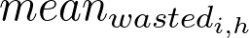 is the average wasted amount of food for food subgroup  and subgroup , 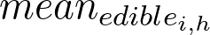 is the average edible amount of food, 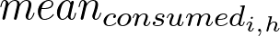 is the average consumed amount of food, 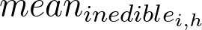 is the average amount of inedible food, and 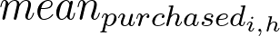 is the average purchased amount of food.
These proportions were utilized in the models (described in ‘Statistical Analysis’ below) to calculate the additional impacts of the amounts of food that were inedible and wasted by the consumer, representing the impacts of the total food production requirements for each pattern.
The average amounts of food consumed, wasted, and inedible, for each food subgroup, are provided in Supplementary Table 5.

Health-Related Data

Outcomes
Two health variables were included as primary outcomes in the CRA models: CMD mortality and cancer incidence. The total annual number of observed disease-specific CMD deaths in 2018, stratified by sex, age, and race and ethnicity, were obtained from the Center for Disease Control and Prevention’s WONDER Online Database (Underlying Cause of Death, 1999-2020). The number of newly diagnosed cancers by cancer type, sex, age, and race and ethnicity in 2018 were obtained from the National Cancer Institute’s Surveillance, Epidemiology, and End Results (SEER) Database (2018 Cancer Incidence). SEER data is collected from cancer registries covering approximately 45.9% of the US population. Therefore, to estimate the number of newly diagnosed cancers for the entire US adult population, we converted the counts to incidence rates per 100,000 people, and then applied them to the 2018 population estimates from the US Census Bureau to obtain annual cancer incidence stratified by sex, age, and race and ethnicity.

Etiological Effects
The CRA model also used the following etiological effects to estimate the attributable mortality and incidence of deviation from the recommended patterns. In brief, we used relative risk estimates from published meta-analyses of prospective cohorts or randomized clinical trials evaluating the direct etiological associations between diet and disease, including the effect sizes for associations between (i) food subgroups and cardiometabolic risk by age and (ii) food subgroups and cancer risk.
We separately accounted for BMI-mediated effects on disease outcomes, based on multi-variable adjusted associations of changes in diet intake with changes in BMI stratified by overweight status, using the following inputs:
- Effect size of food subgroups and BMI;
- BMI and CMD risk;
- BMI and cancer risk;
- Sex-, age-, and race and ethnicity-specific overweight (BMI > 25.0) prevalence (calculated from the NHANES 2015-2016 cycle).
All of these effects are described in detail in the Supplementary Methods, pp. 24-30.
The number of direct and indirect (i.e., BMI-mediated) cancer cases and CMD deaths are presented in Supplementary Table 6.

Theoretical Minimum Risk Exposure Level
Likewise, the CRA model uses the theoretical minimum risk exposure distribution (TMRED), the optimal intake distribution in which risk attributable to exposure is zero, for each food subgroup. For each food subgroup, TMREDs are assumed to follow a normal distribution with means set to the theoretical minimum risk exposure levels (TMREL) from the Global Burden of Disease 2019⁴⁰ and standard deviations set to 10% of the mean.

Environmental Outcomes
Three environmental outcomes were included in this analysis: GHG (kgCO₂-eq), CED (MJ), and water scarcity (L-eq). We used the Database of Food Impacts on the Environment for Linking to Diets (dataFIELD)⁴¹ to obtain GHG and CED impact factors (per 100 grams of consumed food), and a dataset from Heller et al. 2021³³ to obtain water scarcity impact factors (per 100 grams of consumed food), for all foods and beverages in our analysis.
In brief, these datasets aggregate data on the GHG, CED, and water scarcity associated with production of specific foods and assigns those impact factors to 332 food commodities in the Food Commodity Intake Database (FCID)⁴² to facilitate linkages with NHANES dietary intake data^{33,35}.
These impact factors, when applied to amounts of consumed food, provide estimates of environmental impact from cradle-to-farm or processor gate, and are adjusted to incorporate the impact for inedible portions of food (e.g., peels, rinds, cores, etc.) as well. We additionally adjusted for plate waste in our modeling process (described below).

Economic Outcomes
The daily cost of the various dietary patterns, including food consumed at home (FAH) and away from home (FAFH), was estimated based on two datasets. The first dataset, Purchase to Plate National Average Prices 2017-2018³², was obtained from the USDA. This dataset provides unit price estimates for the foods that participants reported eating in What We Eat in America (WWEIA), the dietary component of NHANES. These price estimates come from retail grocery scanner data, and therefore only reflect the cost of food items purchased from grocery and similar stores. In order to additionally calculate the price of food consumed away from home, we used the National Household Food Acquisition and Purchase Survey (FoodAPS)⁴³ to compute the ratio of FAFH-to-FAH expenditures for each food subgroup (see Supplementary Methods, pp. 14-15).

Social Outcome
One social outcome was included in the models: the total risk of forced labor attributable to the foods and drinks that make up different dietary patterns. Forced labor is defined by the International Labor Organization as “all work or service which is exacted from any person under the menace of any penalty and for which the said person has not offered himself voluntarily”, which can include violence or intimidation, debt, retention of identity documents, or threats⁴⁴.
We obtained forced labor risk impact factors (per 100 grams of consumed food) for all foods and beverages in our analysis from Rodríguez-Huerta & Bell et al.⁵, which provides estimates of the risk of forced labor per kilogram of food consumed in the US, based on the geographic distribution of the food supply and a qualitative risk coding based on international reports and investigative journalism documenting known occurrences of and government responses to forced labor in different regions. Risk is quantified in the unit medium risk hours-equivalent (mrh-eq), which combines data on risk of forced labor and working hours^{5,30}.

Food Subgroups
Due to differences in the two modeling approaches (see ‘Statistical Analysis’ below), there were slight differences in the food subgroups that were included in each model (Supplementary Table 7).
All the models included the following food subgroups: dark green vegetables, red and orange vegetables, starchy vegetables, other vegetables, whole fruits (excluding juice), 100% fruit juice, whole grains, refined grains, eggs, seafood, nuts and seeds, legumes, and unsaturated fat (oil).
In the CRA (i.e., health model), meat was represented by three subgroups: (1) unprocessed poultry, (2) unprocessed red meat, and (3) processed poultry and red meat. In contrast, in the environment, economic, and social (i.e., non-health) models, meat was represented by two subgroups: (1) unprocessed and processed poultry, and (2) unprocessed and processed red meat.
We used ‘sugar-sweetened beverages’ as a proxy for added sugar in the health model.
Lastly, ‘saturated fat’ was included as a separate food subgroup in the non-health models.

Data Processing
In preparation of modeling the shifts from current US adult diets to the five recommended patterns, we developed comprehensive impact factors across environmental, social, and economic domains.
In brief, we calculated food subgroup-level impact factors that were weighted by the average per capita consumption of the individual foods within each subgroup.
Average food consumption was derived from the USDA's WWEIA survey, integrated with detailed food composition data from the Food and Nutrient Database for Dietary Studies (FNDDS). Because the environmental and social impact factors provide estimates of the combined impact for both the consumed and inedible amounts of food, we also utilized the inedible food coefficients described in more detail above.
Multiple data crosswalks were constructed in order to calculate the impact factors described below. See the Supplementary Methods, pp. 35-37 for information on how these crosswalks were constructed.

Environment and Social Impact Factors
The datasets we chose to represent the environment and social impacts of food were originally provided at the food commodity level (e.g., asparagus, quinoa, etc.). To obtain the impacts of food subgroups (e.g., dark-green vegetables, whole grains), which is the level at which the dietary pattern recommendations are provided, we converted these ‘commodity-specific impact factors’ to ‘food subgroup-level impact factors’ for the following sustainability outcomes: GHG, CED, water scarcity, and forced labor risk.
The first step was to convert the impact factors from their original units (described in ‘Data’ above) to the impact per 1 gram of consumed food. For example, we converted the GHG impact factor for cashews from 5 kgCO₂-eq/kilogram to 0.005 kgCO₂-eq/gram of consumed cashew.
Second, we utilized the FNDDS-to-FCID crosswalk (see Supplementary Methods, p. 38) to map the commodity-specific impact factors (at the FCID food code level) to the consumed amounts of food in the NHANES dataset (at the FNDDS food code level). The impact factors (per 1 gram of consumed food) were multiplied by the consumed amounts (in grams) of each FCID food code to obtain the total impact per FCID-level commodity, per day, per NHANES participant. For example, if a participant consumed one serving (28 grams) of cashews on Day 1, the total GHG impact for that participant from cashews on Day 1 would be calculated by multiplying these values:
Then, because some participants had two days of dietary recall, we calculated the average impact across the two days for each FCID food code, per participant. If a participant only had one day of recall, then we used that to represent the average. Following the same example from above, if a participant consumed cashews on both days, the average GHG impact would be the sum of the two days divided by two.
Next, we utilized the FCID-to-food-subgroup crosswalk (see Supplementary Methods, p. 35) to calculate across the whole sample:
- The average daily consumed amount of each food subgroup (e.g., nuts/seeds).
- The average daily inedible amount of each food subgroup (e.g., nuts/seeds).
- The average daily environmental and social impact of each food subgroup (e.g., nuts/seeds).
These averages were all calculated accounting for NHANES sampling weights and survey design parameters.
The final step was, for each food subgroup, to calculate the impact per 1 gram of food, with the intention of applying these impact factors to the consumed, inedible, and wasted amounts of food later in the modeling. This was done by dividing the food subgroup’s average daily amount of impact by its average daily amount of consumed and inedible food.
Using GHG as an illustrative example, the final impact factors for each food subgroup were calculated as:
For food subgroup $i$,
where 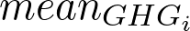 is the average daily GHG impact and is the average daily amount of consumed and inedible food.
Lastly, the unit of the impact factors was converted from grams to food pattern equivalents using the conversion factors published in Blackstone & Conrad 2020⁴⁵.
The final list of impact factors is reported in Supplementary Tables 8-9.

Food Cost Impact Factors
A similar approach was taken to calculate food subgroup-level impact factors for food cost. However, unlike the impact factors described above that were provided at the FCID food code level, the original cost impact factors were provided at the FNDDS food code level, which allowed us to directly multiply them by the FNDDS food codes in the WWEIA dataset without having to use a crosswalk.
Note that “mixed dishes” (identified via FNDDS food code), which typically represent larger dishes that incorporate many different food groups, were excluded from the WWEIA dataset in order to obtain the food price of whole foods that correspond with the food subgroups in the DGA dietary patterns.
Then, similar to the approach taken above, we utilized the FNDDS-to-food-subgroup crosswalk (see Supplementary Methods, pp. 36-37) to calculate across the whole sample:
- The average daily consumed amount of each food subgroup.
- The average daily food cost of each food subgroup.
These averages were all calculated accounting for NHANES sampling weights and survey design parameters.
Then, for each food subgroup, we calculated the food cost per 1 gram of food. This was done by dividing the food subgroup’s average daily cost by its average daily consumed amount of food.
The final cost impact factors for each food subgroup were calculated as:
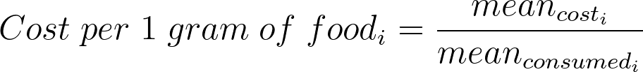
where 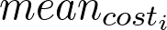 is the average daily cost of food subgroup and 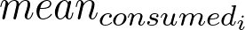 is the average daily amount of consumed food of food subgroup .
The unit of the cost impact factors was converted from grams to food pattern equivalents using the same conversion factors noted above.

Statistical Analysis
For each sustainability domain (health, economic, environmental, social), we used two different approaches to estimate the theoretical burden of the current US adult diet pattern compared to the five alternative patterns described above: (1) Linear Impact Attribution (LIA) models for the environmental, social, and economic domains and (2) CRA for the health domain.
All estimates were stratified by sex, age, and race and ethnicity. Uncertainty around all data inputs was propagated via Monte Carlo simulations. Impacts were calculated for each food subgroup and demographic subgroup and were combined to assess the pattern’s cumulative impact as well.

LIA
For environmental, social, and economic outcomes, we estimated the difference between current impact (Supplementary Table 10) and alternative scenario impact (Supplementary Table 10) based on estimates for current mean intake, alternative scenario intake, impact factor estimates, and estimated inedible and wasted proportions of food subgroups.
Specifically, for a given food subgroup  and demographic subgroup ,

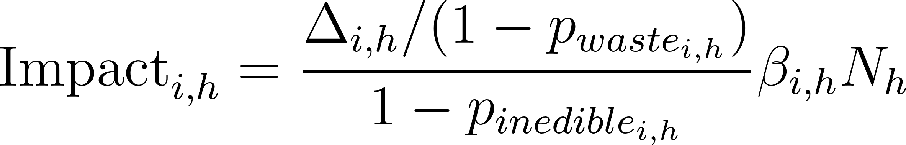
where  is the difference in means of intake of food subgroup  for subgroup ,  is the plate waste proportion,  is the inedible proportion,  is the impact factor, and  is the population count of subgroup .
Note that the results shown in Tables 2-3 and Figures 1-2 represent the combined impacts of the consumed, inedible, and wasted amounts of food. Total impact estimates, stratified by pattern scenario, food subgroup, and food portion (consumed, inedible, and wasted) are shown in Supplementary Table 11.

CRA
For health outcomes, we estimated the number of CMD deaths and cancer cases averted under each alternative dietary scenario (i.e., counterfactual) compared to the current diet by using CRA models and incorporating direct etiologic effects of diet change as well as BMI-mediated effects. For each diet-pathway-disease combination (e.g., direct effect of fruit on IHD risk) and each sex, age, and race and ethnicity demographic subgroup, we calculated the potential impact fraction (PIF), which represents the proportional difference in outcomes between the current intake distribution and the counterfactual distribution. This calculation utilized estimates of current mean intake, relative risks, and counterfactual intake levels for each demographic subgroup, following the standard formula:
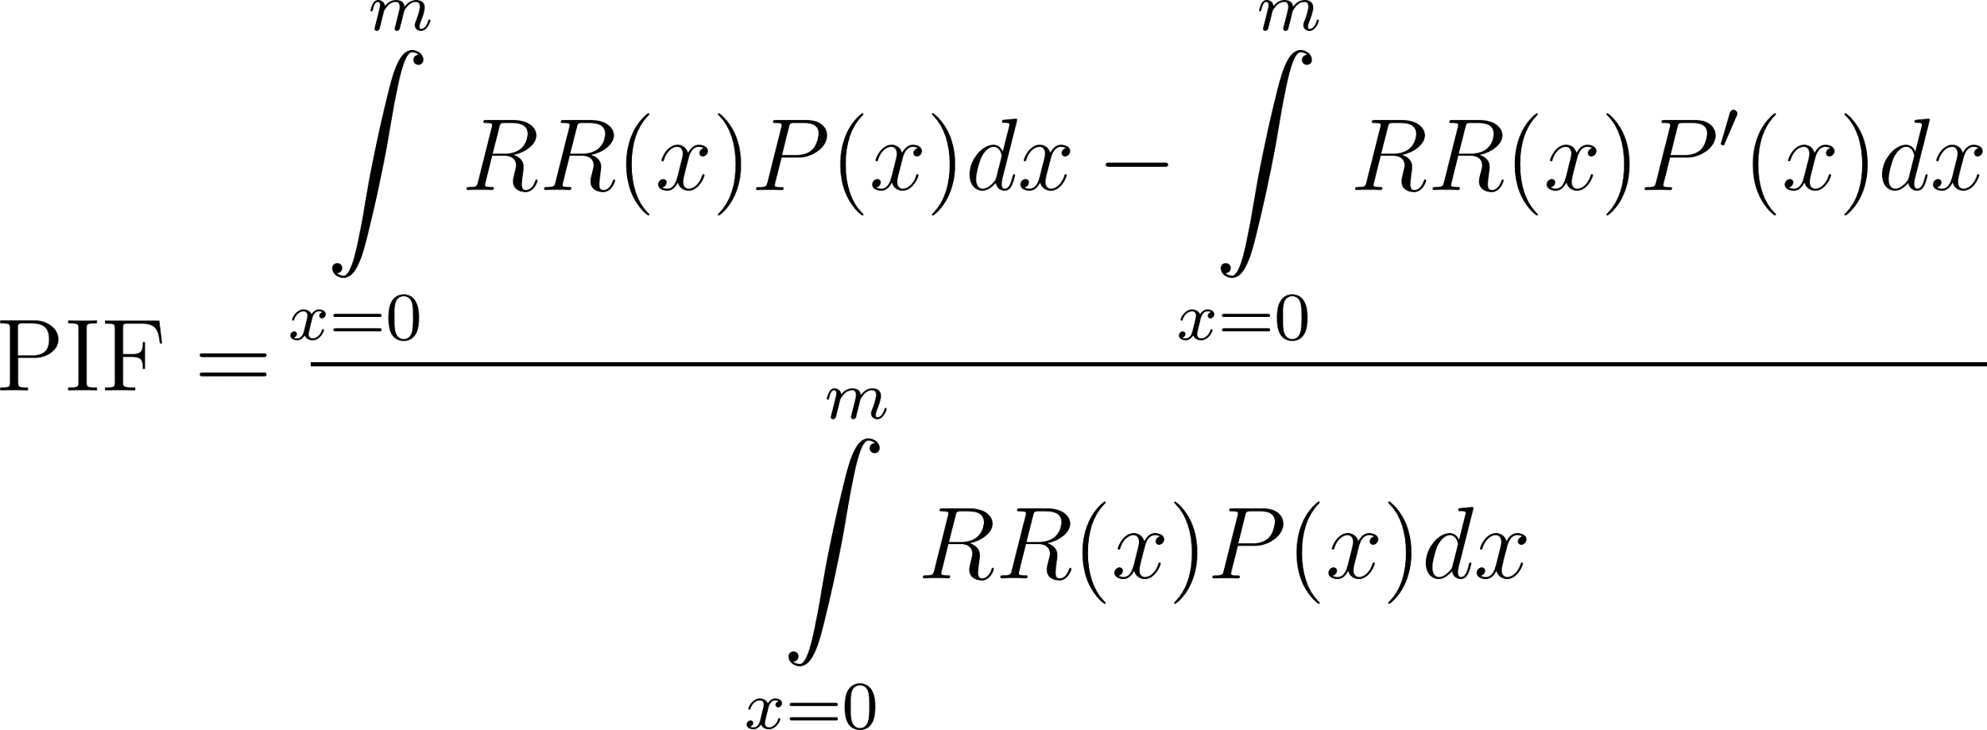
where 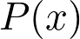 is the current usual intake distribution, 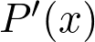 is the counterfactual usual intake distribution, and 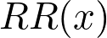 is the relative risk of the health outcome, using the TMRED as the reference, where risk attributable to exposure is 0.  and  both follow gamma distributions (to allow for skew), with gamma parameters derived from mean and standard deviation estimates. For , these were estimated from NHANES. For , the mean intake was derived from the alternative recommended dietary pattern, and the standard deviation was set to 10% of the mean.
To model the joint impact of all dietary changes, we calculate the joint PIF assuming independence of exposures:
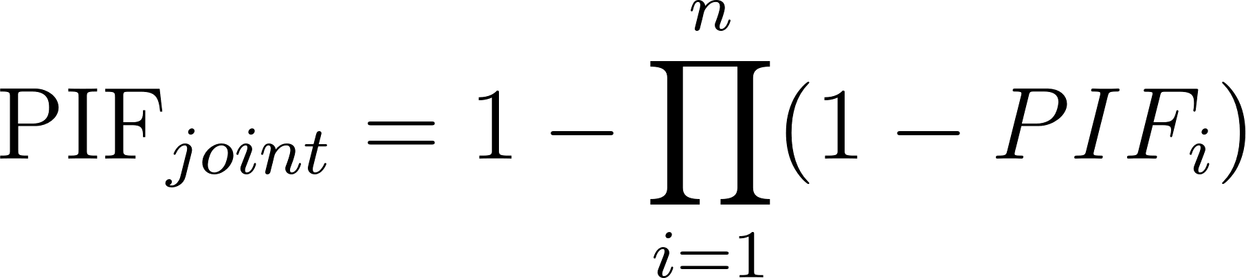
where is the number of food subgroups.
Outcomes averted for a particular demographic subgroup were calculated by multiplying the corresponding PIF with the estimated count of outcomes for that demographic subgroup in 2018 (reference year).
Note that the results shown in Tables 2-3 and Figures 1-2 only represent the health impacts of the consumed amounts of food.
Detailed calculation methods are described in the Supplementary Methods, pp. 39-42.

Monte Carlo Simulations
For both CRA and LIA models, we propagated uncertainty around inputs using Monte Carlo simulations, using standard errors to quantify uncertainty around mean estimates. For each input parameter for which we had a corresponding standard error, we took 1,000 random draws from the sampling distributions of the estimates. These draws were used to calculate the outcomes 1,000 times, of which we report the median as our central estimate, and the 2.5th and 97.5th percentiles as the 95% uncertainty interval.
Estimates for which we have corresponding standard errors include: current mean intake of food subgroups, mean cost of food subgroups, and all population-level estimates and etiologic effects used in the CRA model, including CMD mortality, cancer incidence, overweight prevalence, per unit increases in log relative risks for a given diet-disease pair, per unit increases in log relative risks for a given outcome from BMI, and per unit changes in BMI from change in food subgroup intake. Note that the counterfactual intake means for the recommended patterns are purely hypothetical, not estimates from data, so there is no uncertainty associated with these values.
Uncertainty around estimates for environmental and forced labor impact factors were not propagated into model results because standard errors were not available for these estimates.
All impact calculations used R version 4.3.0.

Federal Programs Sub-Analysis
We estimated the total number of US adults in 2018 who received meals via federal food assistance programs directly aligned with the DGAs. We then analyzed the impact of shifting these adults to the five reference dietary patterns.
There were three federal programs for adults that were identified as being directly aligned with the DGAs:
- The Child and Adult Care Food Program (the ‘Adult Day Care’ portion)
- The Congregate Nutrition Services Program (part of the Older Americans Act Nutrition Services Program)
- Home-Delivered Nutrition Services Program (part of the Older Americans Act Nutrition Services Program)
The number of adults who were served through these programs were obtained from data published by the USDA Food and Nutrition Service⁴⁶ and the US Administration for Community Living⁴⁷ (see Supplementary Table 16). Note that these counts are for fiscal year 2018 (October 1, 2017 to September 30, 2018).
The number of adults served across these three programs were summed to obtain the total number of adults served (2,525,869). We divided this number by the total US adult population (244,878,034) to estimate the percentage of US adults who were served by the programs: 2,525,869 / 244,878,034 = 0.0103 = 1.03%.
To calculate the health impacts of this subpopulation shift, we multiplied this percentage by the estimated annual population change in health outcomes (i.e., Table 2).
To calculate the environment, social, and economic impacts, we multiplied the total number of adults served (2,525,869) by the estimated annual per capita change in environment, social, and economic outcomes (i.e., Table 3).
The subpopulation impacts are presented in Table 4.

Data Availability
The detailed results and background data files are available for download at [insert DOI upon acceptance].

Code Availability
R scripts are available for download at [insert DOI upon acceptance]. The associated GitHub repository is located at https://github.com/brookembell/us-diet-shifts.

Acknowledgements
This research was supported by the Interdisciplinary Research Innovation Fund (RAFINS) at the Friedman School of Nutrition Science and Policy at Tufts University. KB was supported by the Friedman Nutrition and Citizenship Doctoral Fellowship from the Friedman School of Nutrition Science and Policy at Tufts University. BJ is funded by a Nottingham Research Fellowship awarded by the University of Nottingham (2024-2027).

Author Contributions
Author contributions are listed alphabetically within each category. FFZ and NTB conceptualized the study, with input from PW and SBC. BMB, FC, FFZ, and NTB designed the methodology. HL and ZC provided expert input on the methodology. BMB, LW, and FC developed the code. ASM, BMB, FC, and KB collected and analyzed the data. BMB, EM, FC, JN, KB, and NTB wrote the original draft. All authors edited, reviewed, and approved the final manuscript. FFZ and NTB supervised and administered the project. Both FFZ and NTB contributed equally as senior authors and have the right to list their name last on their CV.

Corresponding Author
Dr. Brooke M. Bell
Brooke.Bell@tufts.edu

Tables

Table 1. Current and recommended dietary pattern intake levels, by food subgroup

 |  | Recommended Dietary Patterns (2,000 kcal/day)
Food Subgroup | Current Intake (n=9,759) | HUS | MED | VEG | VGN | CDP
 | Mean (SD)
Vegetables, cup-eq
Dark-green vegetables | 0.15 (0.17) | 0.21 (0.021) | 0.21 (0.021) | 0.21 (0.021) | 0.21 (0.021) | 0.21 (0.021)
Red and orange vegetables | 0.36 (0.15) | 0.79 (0.079) | 0.79 (0.079) | 0.79 (0.079) | 0.79 (0.079) | 0.79 (0.079)
Starchy vegetables | 0.43 (0.20) | 0.71 (0.071) | 0.71 (0.071) | 0.71 (0.071) | 0.71 (0.071) | 0.71 (0.071)
Other vegetables | 0.51 (0.25) | 0.57 (0.057) | 0.57 (0.057) | 0.57 (0.057) | 0.57 (0.057) | 0.57 (0.057)
Fruit, cup-eq¹
Whole fruits, excluding juice | 0.68 (0.54) | 1.54 (0.154) | 1.92 (0.192) | 1.54 (0.154) | 1.54 (0.154) | 2.00 (0.20)
100% fruit juice | 0.23 (0.32) | 0.46 (0.046) | 0.58 (0.058) | 0.46 (0.046) | 0.46 (0.046) | 0 (0)
Grains, oz-eq
Whole grains | 0.87 (0.59) | 3.00 (0.30) | 3.00 (0.30) | 3.50 (0.35) | 3.50 (0.35) | 3.50 (0.35)
Refined grains | 5.23 (1.66) | 3.00 (0.30) | 3.00 (0.30) | 3.00 (0.30) | 3.00 (0.30) | 2.50 (0.25)
Dairy, cup-eq | 1.39 (0.62) | 3.00 (0.30) | 2.00 (0.20) | 3.00 (0.30) | 3.00 (0.30) | 3.00 (0.30)
Protein, oz-eq²
Eggs | 0.64 (0.60) | 0.48 (0.048) | 0.48 (0.048) | 0.43 (0.043) | 0 (0) | 0.25 (0.025)
Poultry, unprocessed | 1.53 (0.78) | 1.27 (0.127) | 1.27 (0.127) | 0 (0) | 0 (0) | 1.00 (0.10)
Red meat, unprocessed | 1.45 (0.70) | 1.21 (0.121) | 1.21 (0.121) | 0 (0) | 0 (0) | 0.50 (0.05)
Processed meat | 0.94 (0.57) | 0.74 (0.074) | 0.74 (0.074) | 0 (0) | 0 (0) | 0 (0)
Seafood | 0.52 (0.55) | 1.14 (0.114) | 2.14 (0.214) | 0 (0) | 0 (0) | 1.00 (0.10)
Nuts and seeds³ | 0.67 (0.72) | 0.63 (0.063) | 0.63 (0.063) | 1.00 (0.10) | 1.14 (0.114) | 1.00 (0.10)
Legumes³ | 0.53 (0.52) | 0.92 (0.092) | 0.92 (0.092) | 2.86 | 3.13 | 1.75
Oil (unsaturated fat), g | 27.73 (8.98) | 27 (0.27) | 27 (0.27) | 27 (0.27) | 27 (0.27) | 27 (0.27)
Limit on calories for other uses
Saturated fat, g⁴ | 26.03 (5.65) | 13.33 (1.333) | 13.33 (1.333) | 13.89 (1.389) | 13.89 (1.389) | 13.89 (1.389)
Added sugar, tsp⁴ | 15.70 (8.37) | 7.14 (0.714) | 7.14 (0.714) | 7.44 (0.744) | 7.44 (0.744) | 7.44 (0.744)
Sugar-sweetened beverage, cup-eq⁵ | 1.25 (1.09) | 0.54 (0.054) | 0.54 (0.054) | 0.54 (0.054) | 0.54 (0.054) | 0 (0)
¹The HUS, MED, VEG, and VGN recommended values for ‘fruit’ were disaggregated into whole fruit and 100% fruit juice based on the intake distribution of these items estimated from NHANES 2015-2016, 2017-2018.
²The HUS, MED, and VEG recommended values for ‘meats, poultry, and eggs’ were disaggregated into red meat, poultry, and eggs based on the intake distribution of these items estimated from NHANES 2015-2016, 2017-2018.
³The HUS and MED recommended values for ‘nuts, seeds, and soy products’ were disaggregated into nuts and seeds; and soy products based on the intake distribution of these items estimated from NHANES 2015-2016, 2017-2018. The recommended value for soy products was added to the legumes food subgroup.
⁴The HUS and MED recommended values for the ‘Limit on Calories for Other Uses’ category is 240 kcal/day (for the 2,000 kcal/day pattern). In absence of a recommendation from the DGA on how to split this up between added sugar and saturated fat, we assigned half (120 kcal) to added sugar and the other half (120 kcal) to saturated fat. The same approach was used to derive the recommended amounts for the VEG and VGN patterns (260 kcal/day).
⁵‘Sugar-sweetened beverages’ (SSB) was used as a proxy for the ‘added sugar’ food subgroup in the CRA model. To obtain a recommendation value for SSB, we first calculated the proportion of average daily sugar intake directly from SSB (29.64 g; 47%) using NHANES 2015-2016, 2017-2018 data. Then, we calculated the recommended amount of sugar directly from SSB as 47% of the recommended total added sugar amount (described in Footnote 4). Lastly, assuming 1 fl oz of SSB contains 3.25 g added sugar, we converted the amount of sugar directly from SSB to cup-eq of SSB.

Table 2. Estimated annual population-level change in health outcomes among U.S. adults, by dietary pattern

 |  | Dietary Patterns
Outcome | Unit | HUS | MED | VEG | VGN | CDP
 |  | Median (95% UI)¹
Health
CMD mortality | Deaths (prevented) | -233,331  (-243,220, -224,067) | -252,218  (-262,214, -243,018) | -339,695  (-350,103, -328,917) | -339,695  (-350,103, -328,917) | -366,991  (-377,880, -355,715)
Cancer incidence | Cases (prevented) | -58,691  (-61,607, -56,134) | -56,106  (-59,154, -53,326) | -82,986  (-86,134, -80,031) | -75,320  (-78,528, -72,213) | -80,631  (-83,830, -77,762)
¹The negative sign (-) preceding the values signifies an estimated decrease in CMD deaths and cancer cases.

Table 3. Estimated annual per capita change in environment, social, and economic outcomes, by dietary pattern

 |  | Dietary Patterns
Outcome | Unit | HUS | MED | VEG | VGN | CDP
 |  | Median (95% UI)¹
Environment
Water scarcity | L-eq | 236,793  (230,215, 244,276) | 299,067  (291,642, 306,122) | 110,635  (104,124, 118,807) | 22,774  (15,753, 29,895) | 109,938  (102,481, 117,278)
Greenhouse gas emissions | kgCO₂-eq | 123 (110, 138) | 161 (145, 175) | -672 (-685, -657) | -1,027  (-1,041, -1,013) | -376 (-390, -361)
Cumulative energy demand | MJ | 2,393  (2,326, 2,455) | 4,296  (4,235, 4,358) | -1,998  (-2,060, -1,930) | -3,881  (-3,944, -3,815) | 693 (628, 760)
Social
Risk of forced labor | mrh-eq | 54 (52, 56) | 79 (78, 81) | -21 (-22, -19) | -11 (-13, -10) | 8 (6, 9)
Economic
Food cost | USD | 1,605  (1,558, 1,654) | 2,405  (2,360, 2,452) | -750  (-794, -700) | -2,116  (-2,161, -2,068) | 757  (710, 804)
¹The negative sign (-) preceding the values signifies an estimated decrease in the respective outcomes.

Table 4. Estimated annual population-level change in sustainability outcomes for the subpopulation of adults who received meals in 2018 via federal food assistance programs directly aligned with the DGAs.

 |  | Dietary Patterns
Outcome | Unit | HUS | MED | VEG | VGN | CDP
 |  | Median (95% UI)¹
Health
CMD mortality | Deaths (prevented) | -2,407  (-2,509, -2,312) | -2,602  (-2,705, -2,507) | -3,504  (-3,612, -3,393) | -3,504  (-3,612, -3,393) | -3,786  (-3,898, -3,670)
Cancer incidence | Cases (prevented) | -606 (-636, -580) | -579 (-611, -551) | -856 (-889, -826) | -777 (-811, -745) | -832 (-865, -803)
Environment
Water scarcity | billion L-eq | 598.1 (581.5, 617.0) | 755.4 (736.6, 773.2) | 279.4 (263.0, 300.1) | 57.5 (39.8, 75.5) | 277.7 (258.9, 296.2)
Greenhouse gas emissions | tonnes CO₂-eq | 310,681.9  (277,845.6, 348,569.9) | 406,664.9  (366,251.0, 442,027.1) | -1,697,384.0  (-1,730,220.3,  -1,659,495.9) | -2,594,067.5  (-2,629,429.6,  -2,558,705.3) | -949,726.7  (-985,088.9,  -911,838.7)
Cumulative energy demand | billion MJ | 6.0 (5.9, 6.2) | 10.9 (10.7, 11.0) | -5.0 (-5.2, -4.9) | -9.8 (-10.0, -9.6) | 1.8 (1.6, 1.9)
Social
Risk of forced labor | million mrh-eq | 136.4 (131.3, 141.4) | 199.5 (197.0, 204.6) | -53.0 (-55.6, -48.0) | -27.8 (-32.8, -25.3) | 20.2 (15.2, 22.7)
Economic
Food cost | billion USD | 4.1 (3.9, 4.2) | 6.1 (6.0, 6.2) | -1.9 (-2.0, -1.8) | -5.3 (-5.5, -5.2) | 1.9 (1.8, 2.0)
¹The negative sign (-) preceding the values signifies an estimated decrease in the respective outcomes.

Figures

Figure 1. Percent change in sustainability outcomes compared to current diet, by dietary pattern
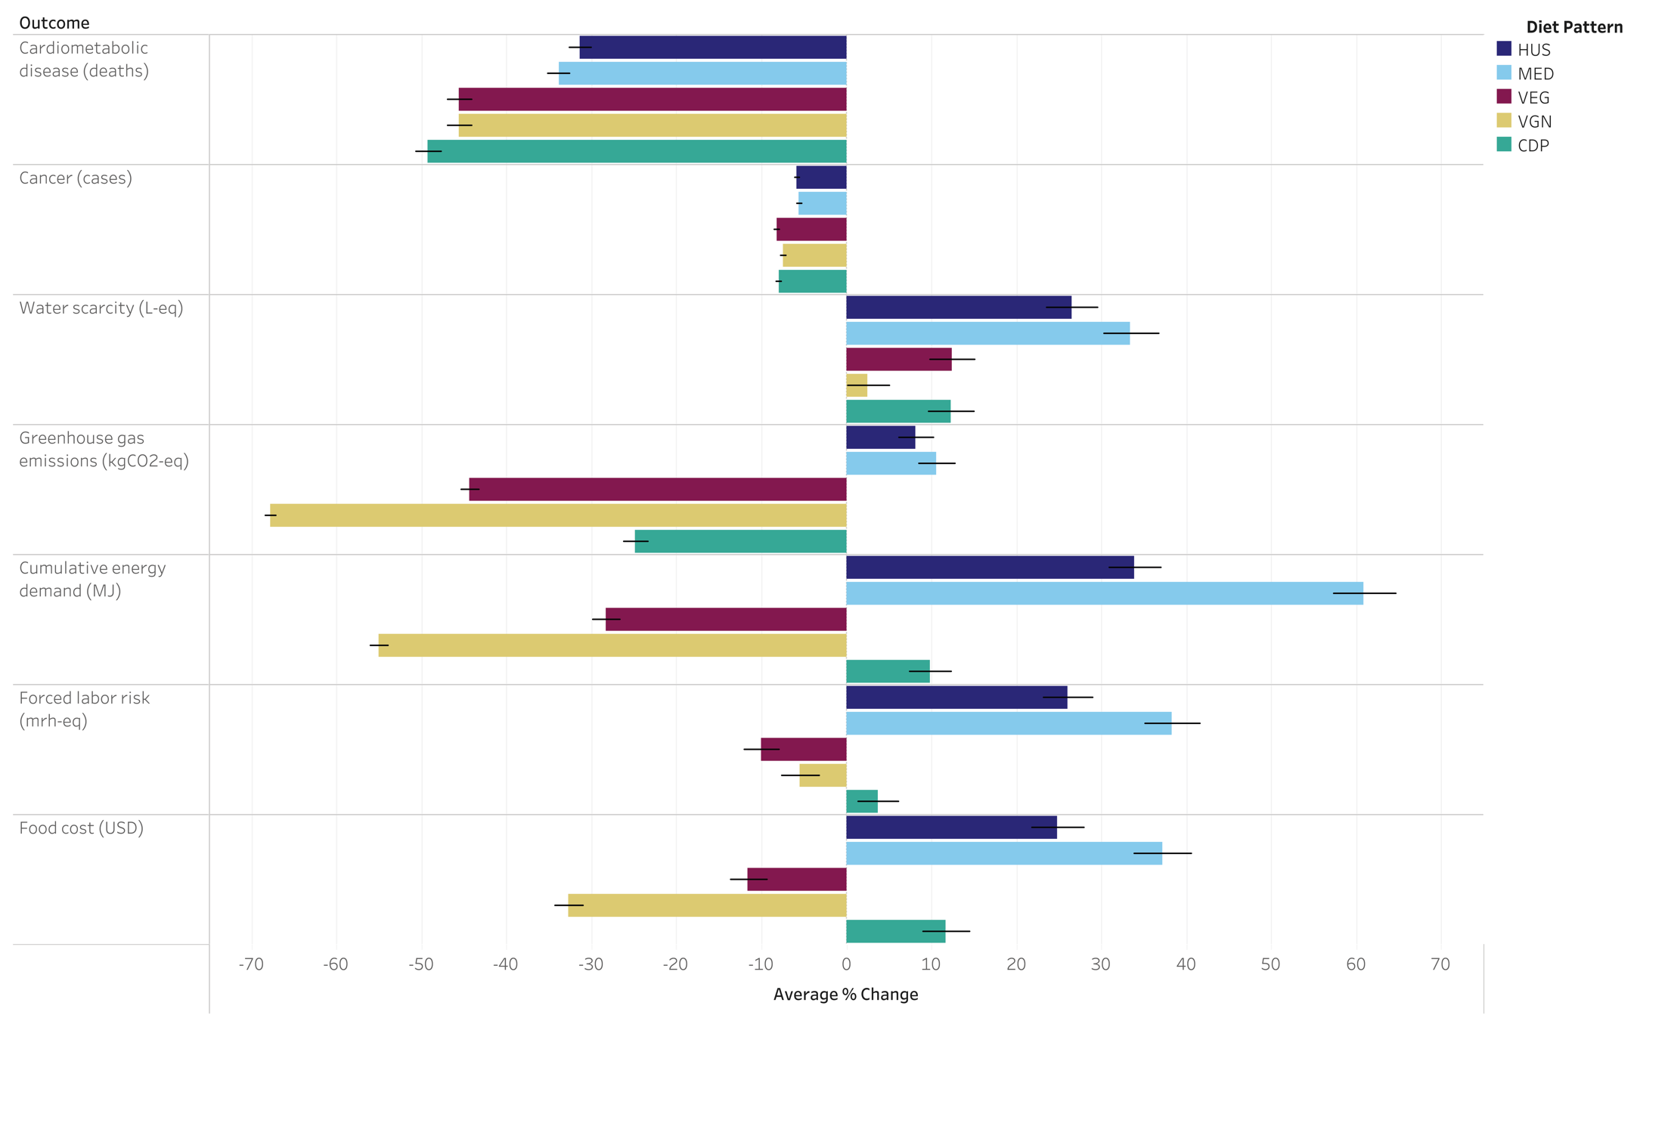

Figure 2. Annual per-capita change in sustainability outcomes and total population change in health outcomes by food subgroup^{1,2,3,4}
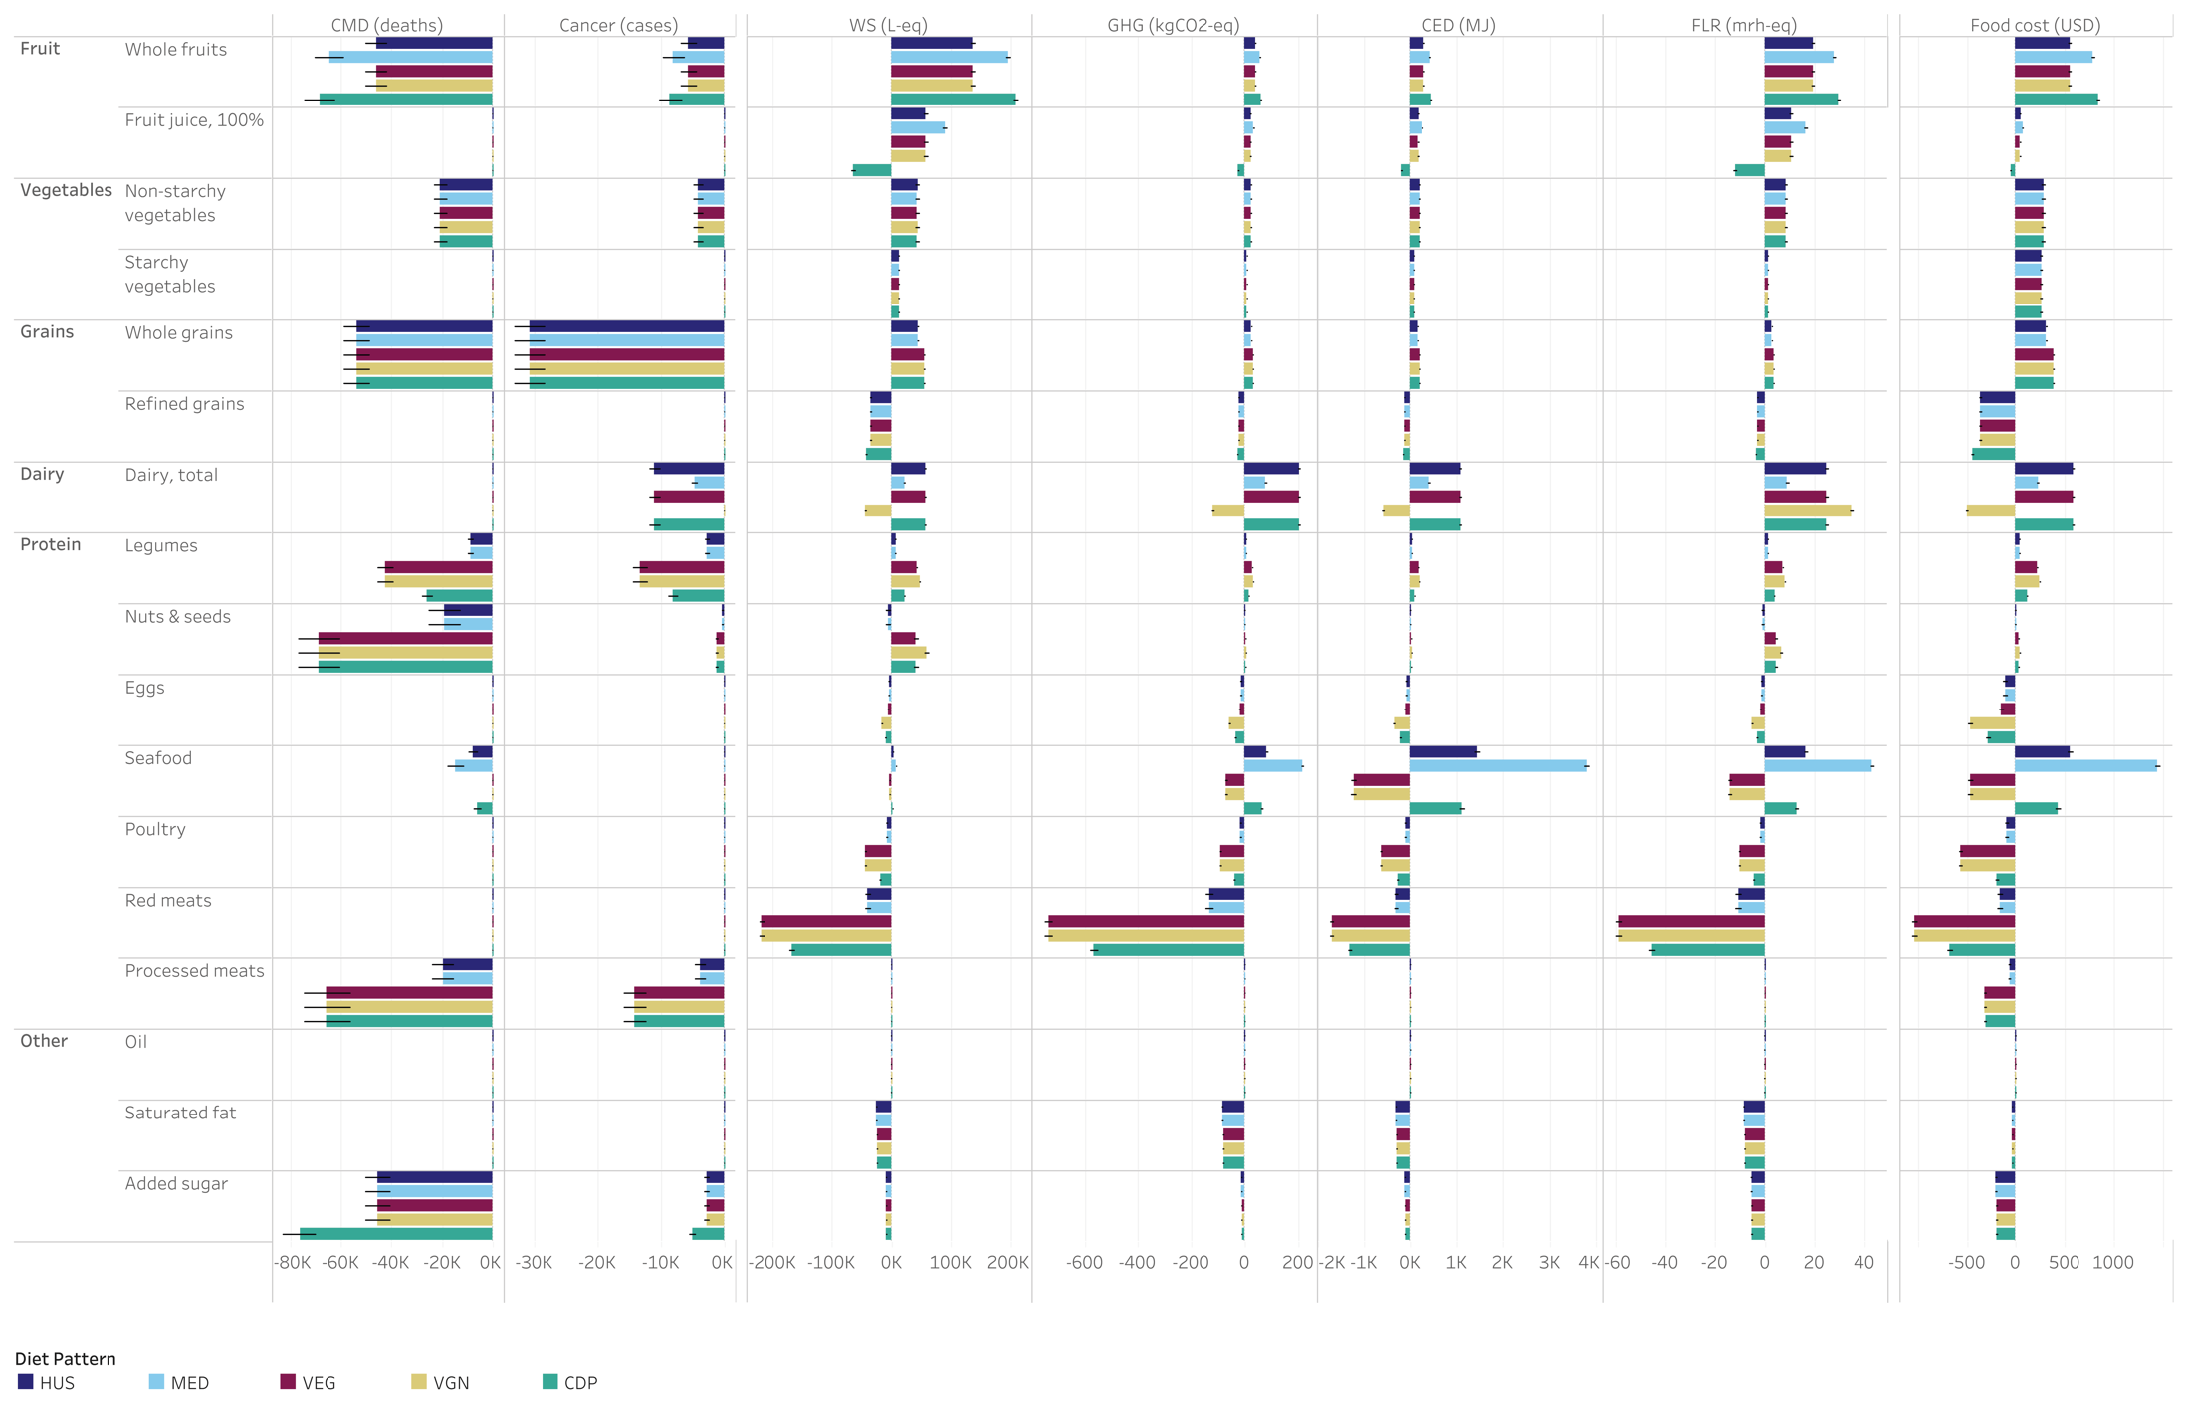
¹For the health and economic outcomes, there are three meat groups (unprocessed red meat, unprocessed poultry, and processed meat). For the environmental and social outcomes, there are only two meat groups (total red meat and total poultry), which is why there are no impacts for processed meat shown for these outcomes.
²The health impacts shown for ‘added sugar’ represent the impacts of shifting from the current intake of SSB to the recommended intake of SSB.
³The ‘Dairy, total’ food subgroup refers to both animal- and soy-based dairy (i.e., total milk, yogurt, cheese, and whey; and calcium-fortified soy milk).
⁴Abbreviations: cardiometabolic disease (CMD), water scarcity (WS), greenhouse gas emissions (GHG), cumulative energy demand (CED), forced labor risk (FLR).

References
1. Dietz, W. H. & Pryor, S. How Can We Act to Mitigate the Global Syndemic of Obesity, Undernutrition, and Climate Change? Curr. Obes. Rep. 11, 61–69 (2022).
2. He, P., Feng, K., Baiocchi, G., Sun, L. & Hubacek, K. Shifts towards healthy diets in the US can reduce environmental impacts but would be unaffordable for poorer minorities. Nat. Food 2, 664–672 (2021).
3. Pancrazi, R., van Rens, T. & Vukotić, M. How distorted food prices discourage a healthy diet. Sci. Adv. 8, eabi8807 (2022).
4. Clapp, J. et al. Corporate concentration and power matter for agency in food systems. Food Policy 134, 102897 (2025).
5. Rodríguez-Huerta, E. et al. Current and recommended diets in the USA have embedded forced labour risk. Nat. Food 6, 1042–1053 (2025).
6. Blackstone, N. T. et al. Diets cannot be sustainable without ensuring the well-being of communities, workers and animals in food value chains. Nat. Food 5, 818–824 (2024).
7. Webb, P. et al. Measurement of diets that are healthy, environmentally sustainable, affordable, and equitable: A scoping review of metrics, findings, and research gaps. Front. Nutr. 10, 1125955 (2023).
8. Nicholls, J. & Drewnowski, A. Toward Sociocultural Indicators of Sustainable Healthy Diets. Sustainability 13, 7226 (2021).
9. Rockström, J. et al. The EAT–Lancet Commission on healthy, sustainable, and just food systems. The Lancet 406, 1625–1700 (2025).
10. Vittis, Y., Obersteiner, M., Godfray, H. C. J. & Springmann, M. Labour requirements for healthy and sustainable diets at global, regional, and national levels: a modelling study. Lancet Planet. Health 9, 101342 (2025).
11. Food-based dietary guidelines. Food and Agriculture Organization of the United Nations http://www.fao.org/nutrition/education/food-dietary-guidelines/background/en/.
12. James-Martin, G. et al. Environmental sustainability in national food-based dietary guidelines: a global review. Lancet Planet. Health 6, e977–e986 (2022).
13. Liu, J. & Mozaffarian, D. Trends in Diet Quality Among U.S. Adults From 1999 to 2020 by Race, Ethnicity, and Socioeconomic Disadvantage. Ann. Intern. Med. 177, 841–850 (2024).
14. U.S. Environmental Protection Agency. Greenhouse Gas Equivalencies Calculator. https://www.epa.gov/energy/greenhouse-gas-equivalencies-calculator (2024).
15. Conrad, Z. et al. Are healthier diets more sustainable? A cross-sectional assessment of 8 diet quality indexes and 7 sustainability metrics. Am. J. Clin. Nutr. 121, 315–323 (2025).
16. Conrad, Z., Korol, M., DiStaso, C. & Wu, S. Greater adherence to the Mediterranean diet pattern in the United States is associated with sustainability trade-offs. Nutr. J. 23, 159 (2024).
17. Conrad, Z., Drewnowski, A., Belury, M. A. & Love, D. C. Greenhouse gas emissions, cost, and diet quality of specific diet patterns in the United States. Am. J. Clin. Nutr. 117, 1186–1194 (2023).
18. O’Malley, K., Willits-Smith, A. & Rose, D. Popular diets as selected by adults in the United States show wide variation in carbon footprints and diet quality. Am. J. Clin. Nutr. 117, 701–708 (2023).
19. Gebara, C. H., Berthet, E., Vandenabeele, M. I. D., Jolliet, O. & Laurent, A. Diets can be consistent with planetary limits and health targets at the individual level. Nat. Food 6, 466–477 (2025).
20. 2025 Dietary Guidelines Advisory Committee. Scientific Report of the 2025 Dietary Guidelines Advisory Committee: Advisory Report to the Secretary of Health and Human Services and the Secretary of Agriculture. https://doi.org/10.52570/DGAC2025 (2024).
21. U.S. Department of Agriculture & U.S. Department of Health and Human Services. Dietary Guidelines for Americans, 2025-2030. https://realfood.gov/.
22. Jayasinghe, S., Byrne, N. M. & Hills, A. P. Cultural influences on dietary choices. Prog. Cardiovasc. Dis. 90, 22–26 (2025).
23. Hunt, J. R. Bioavailability of iron, zinc, and other trace minerals from vegetarian diets. Am. J. Clin. Nutr. 78, 633S-639S (2003).
24. Bôto, J. M., Rocha, A., Miguéis, V., Meireles, M. & Neto, B. Sustainability Dimensions of the Mediterranean Diet: A Systematic Review of the Indicators Used and Its Results. Adv. Nutr. 13, 2015–2038 (2022).
25. Rippin, H. L. et al. Variations in greenhouse gas emissions of individual diets: Associations between the greenhouse gas emissions and nutrient intake in the United Kingdom. PLOS ONE 16, e0259418 (2021).
26. Wollmar, M., Post, A. & Sjöberg, A. Food choice, activity level, and carbon footprint: exploring potential for sustainable food consumption practices in young adults. Front. Nutr. 11, 1449054 (2024).
27. Rose, D., Willits-Smith, A. M. & Heller, M. C. Single-item substitutions can substantially reduce the carbon and water scarcity footprints of US diets. Am. J. Clin. Nutr. 115, 378–387 (2022).
28. Wang, L. et al. Estimating the Health Impact of Aligning US Diets with the Dietary Guidelines for Americans. Preprint at https://dx.doi.org/10.2139/ssrn.5193171.
29. Blackstone, N. T., Norris, C. B., Robbins, T., Jackson, B. & Decker Sparks, J. L. Risk of forced labour embedded in the US fruit and vegetable supply. Nat. Food 2, 692–699 (2021).
30. Blackstone, N. T. et al. Forced labour risk is pervasive in the US land-based food supply. Nat. Food 4, 596–606 (2023).
31. Zhang, F. F. et al. Preventable Cancer Burden Associated With Poor Diet in the United States. JNCI Cancer Spectr. 3, pkz034 (2019).
32. U.S. Department of Agriculture, Economic Research Service. Purchase to Plate National Average Prices from the Purchase to Plate Suite. (2023).
33. Heller, M. C., Willits-Smith, A., Mahon, T., Keoleian, G. A. & Rose, D. Individual US diets show wide variation in water scarcity footprints. Nat. Food 2, 255–263 (2021).
34. Micha, R. et al. Association Between Dietary Factors and Mortality From Heart Disease, Stroke, and Type 2 Diabetes in the United States. J. Am. Med. Assoc. 317, 912–924 (2017).
35. Heller, M. C., Willits-Smith, A., Meyer, R., Keoleian, G. A. & Rose, D. Greenhouse gas emissions and energy use associated with production of individual self-selected US diets. Environ. Res. Lett. 13, 044004 (2018).
36. Herrick, K. A., Rossen, L. M., Parsons, R. & Dodd, K. W. Estimating Usual Dietary Intake From National Health and Nutrition Examination Survey Data Using the National Cancer Institute Method. Vital Health Stat. 2, 1–63 (2018).
37. U.S. Department of Agriculture & U.S. Department of Health and Human Services. Dietary Guidelines for Americans, 2020-2025. https://www.dietaryguidelines.gov/resources/2020-2025-dietary-guidelines-online-materials.
38. Hess, J. M. Modeling Dairy-Free Vegetarian and Vegan USDA Food Patterns for Nonpregnant, Nonlactating Adults. J. Nutr. 152, 2097–2108 (2022).
39. Conrad, Z., Reinhardt, S., Boehm, R. & McDowell, A. Higher-diet quality is associated with higher diet costs when eating at home and away from home: National Health and Nutrition Examination Survey, 2005-2016. Public Health Nutr. 24, 5047–5057 (2021).
40. Murray, C. J. L. et al. Global burden of 87 risk factors in 204 countries and territories, 1990–2019: a systematic analysis for the Global Burden of Disease Study 2019. Lancet 396, 1223–1249 (2020).
41. Center for Sustainable Systems, University of Michigan. Database of Food Impacts on the Environment for Linking to Diets (dataFIELD). (2023).
42. U.S. Environmental Protection Agency. Food Commodity Intake Database (FCID), 2005–2010.
43. U.S. Department of Agriculture, Economic Research Service. National Household Food Acquisition and Purchase Survey, 2012–2013.
44. International Labor Organization. ILO Indicators of Forced Labour. https://www.ilo.org/publications/ilo-indicators-forced-labour (2012).
45. Blackstone, N. T. & Conrad, Z. Comparing the Recommended Eating Patterns of the EAT-Lancet Commission and Dietary Guidelines for Americans: Implications for Sustainable Nutrition. Curr. Dev. Nutr. 4, (2020).
46. U.S. Department of Agriculture, Economic Research Service. USDA’s Child and Adult Care Food Program Served More than 4.3 Million Children in 2018. https://ers.usda.gov/data-products/charts-of-note/chart-detail?chartId=93592 (2019).
47. Administration for Community Living. Aging, Independence, and Disability (AGID) Data Portal. https://agid.acl.gov/data-explorer.

Dark green vegetables, red and orange vegetables, starchy vegetables, other vegetables, whole fruits (excluding juice), 100% fruit juice, whole grains, refined grains, dairy, eggs, poultry, red meat, processed meat, seafood, nuts and seeds, legumes, unsaturated fat (oil), saturated fat, added sugar, and sugar-sweetened beverages.
The list of 48 demographic subgroups is provided is Supplementary Table 4.
The environmental and social impact factors account for both the consumed and inedible amounts of food. If you multiply the impact factor by a consumed amount of food, the result is the impact for both the consumed and inedible portions combined.

