**P5: Putting it All Together Description**

Team Members: Lindsey Stowell, Brooke White

Dataset Chosen: Aircraft Incidents

List of Analytic Tasks Supported by Assignment:

* Low Level:
  + Retrieve Value (can find attributes of specific cases such as year of accident, can retrieve details on demand for data point)
  + Find Extremum (can identify extreme values from visualizations)
  + Determine Range (can identify span of values within the visuals)
  + Find anomalies (can identify outliers in data from visuals)
* High Level:
  + Seek/Elaborate/Question/Preserve/Compare a frame based on the data visualizations displayed
  + Exploit the information (can recognize patterns in the data)
* Interaction Based:
  + Select (can select a data point to highlight the corresponding one in the other graph on the bubble visualization, can scroll over a point to see details on demand)
  + Explore (direct walk through different visualizations showing linkages between cases)
  + Abstract/Elaborate (can scroll over point to get details on demand or just look at visualization as an overview)
  + Connect (can click on one data point to see same point in other graph on bubble visualizations)

Design Overview:

Our project includes three different visualizations with two other transitions that highlight essential elements of the first graph. We aimed to manipulate our information displays primarily for browsing data in order to find patterns and relationships in the data rather than searching for specific answers to predetermined questions. As such, each visualization gives an overview of the data surrounding airplane incidents from 1995 to 2016 by focusing on the distribution of certain attributes through the years. The intention of our project is to provide the user with a story to follow surrounding the data. Each visualization includes relevant information and key points in the text above it. When the user is finished with one page, they can advance to the next visual using the “Next” button or return to a past visual by clicking the “Previous” button.

First, a line graph showing the number of crashes per year is displayed. This is meant to provide an overview of the data and give context for later relationships. You can mouse over a specific data point to get details on demand about it and answer any questions you may have 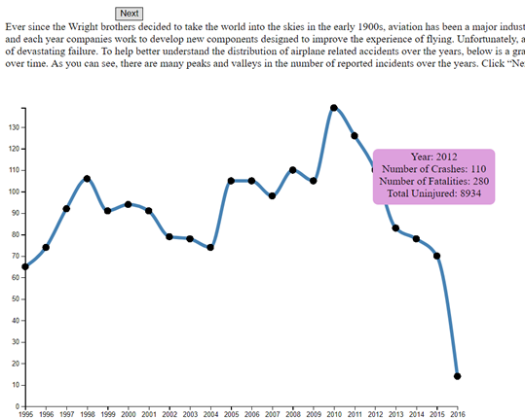about a given year.

If you hit the “Next” button, the graph transitions to highlight the data points that increase in the number of crashes from the previous year. The graph shows the distribution of increases over the given years. This is designed to answer questions such as “Which year had the most plane accidents compared to the year before it?” and “Which year had the most plane accidents overall?”. You can mouse over any point to get details on demand about the point and keypoints from the data can be seen in the text above the graph.

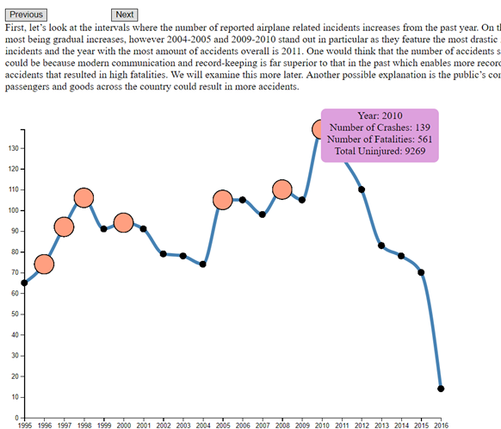

Next is a very similar graph with only the decreases in number of crashes from the previous year highlighted. This graph aims to answer similar questions as the previous one, except dealing with decreases in accidents and having the least amount of plane incidents. As it operates in the same way as the previous visual, you can also get details on demand from hovering over a particular point.

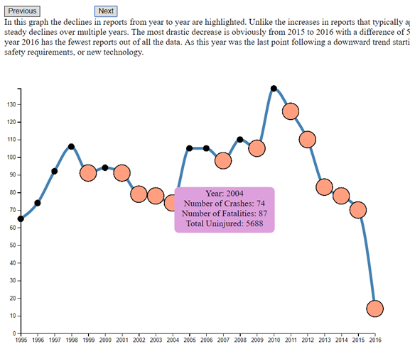

The visualization technique that appears next are two bubble distributions, one showing years with the most fatalities and one showing years with the most uninjured. You can click on one year’s circle in one visual to see the corresponding year’s circle in the other. Scrolling over data points on either graph results in details on demand for that particular year. This visualization is meant to allow comparison of results of the accidents concerning the people aboard. Users can answer questions such as “Is there a connection between years with more accidents and the number of fatalities versus uninjured?” or “Which year had the most accident-related fatalities?”. Patterns between the number of fatalities, the number of uninjured, and the number of accidents reported can be interpreted through analysis of this visualization combined with information from the earlier ones.

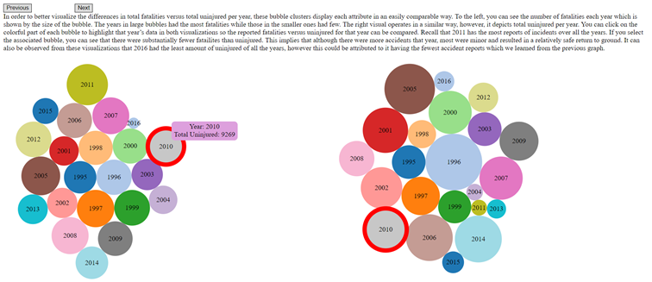

The final visualization is a area graph featuring two lines: accidents reported that resulted in minor damage and those reported severe. The coloring underneath the lines helps users understand the differences in numbers between the two lines. This design technique is meant to help users analyze relationships between the number of minor incidents versus severe accidents. It addresses questions such as “Which year had the most airplane accidents that resulted in major damage” or “Do years with high fatalities have more severe incident reports?”. Just like with the previous graphs, a user can scroll over particular data points to view details on demand.

