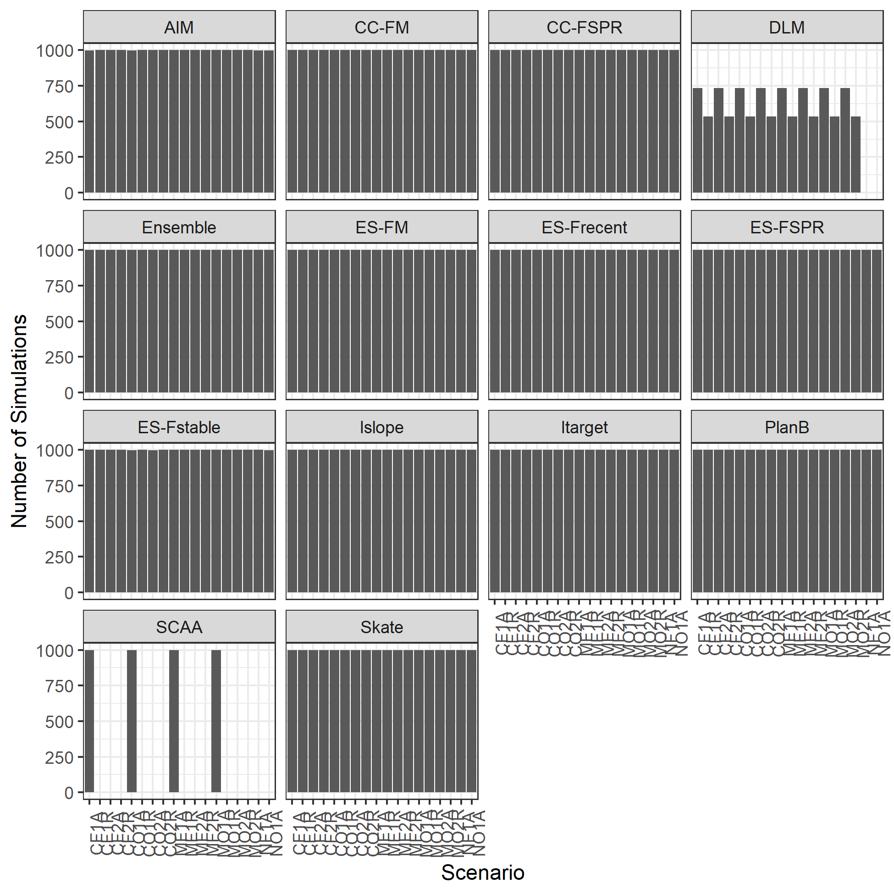

Figure A6.1. Number of successfull simulations by scenario.

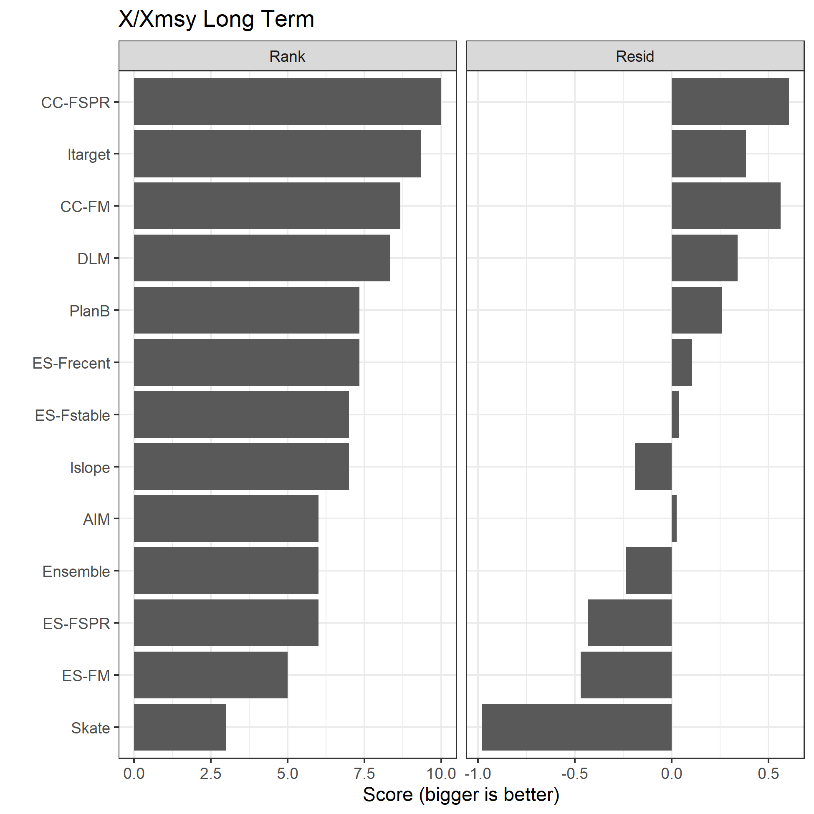

Figure A6.2. Two sets of scores, Rank and Resid, for the base analyses for the 3 metrics of SSB, F, and Catch relative to their MSY reference points (denoted X/Xmsy) in the long term.

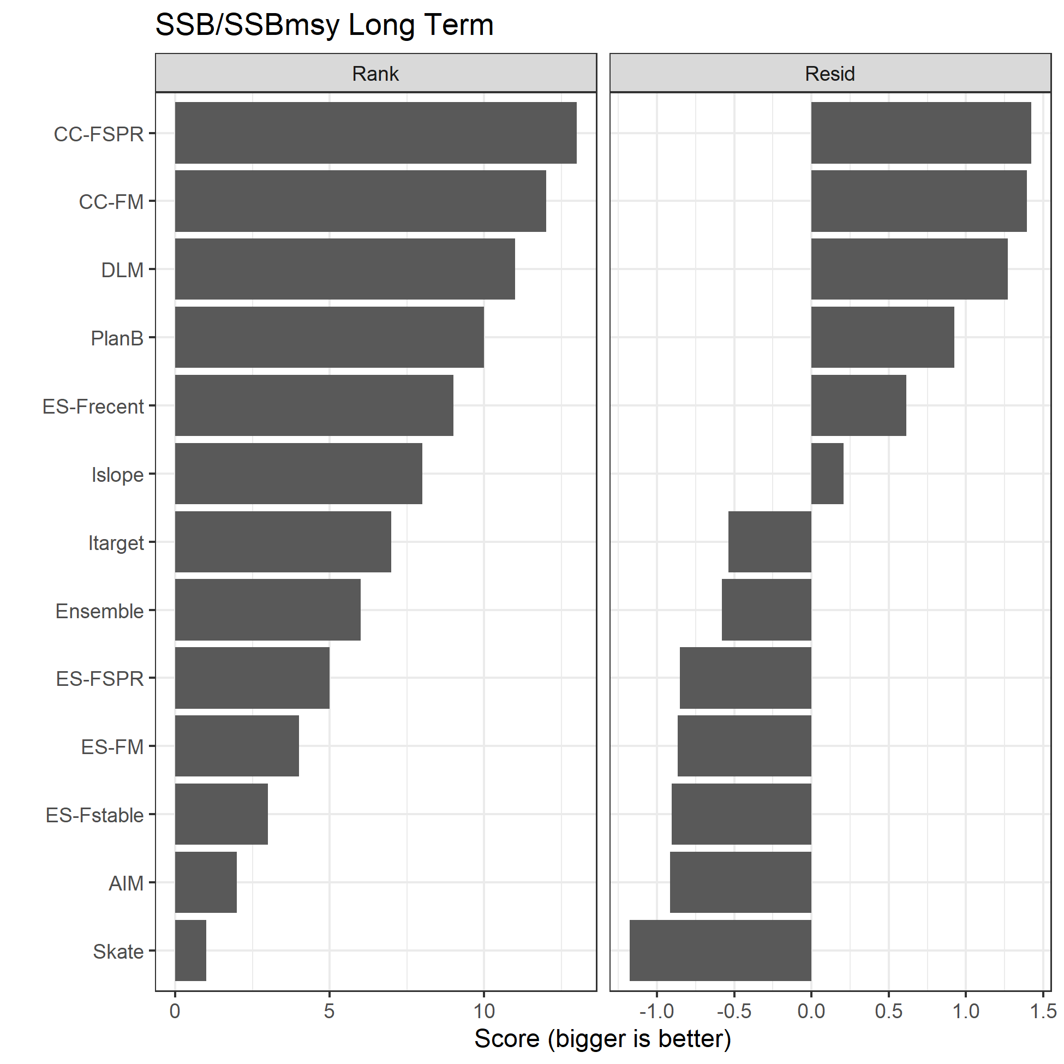

Figure A6.3. Two sets of scores, Rank and Resid, for the base analyses for the SSB relative to SSBmsy in the long term.

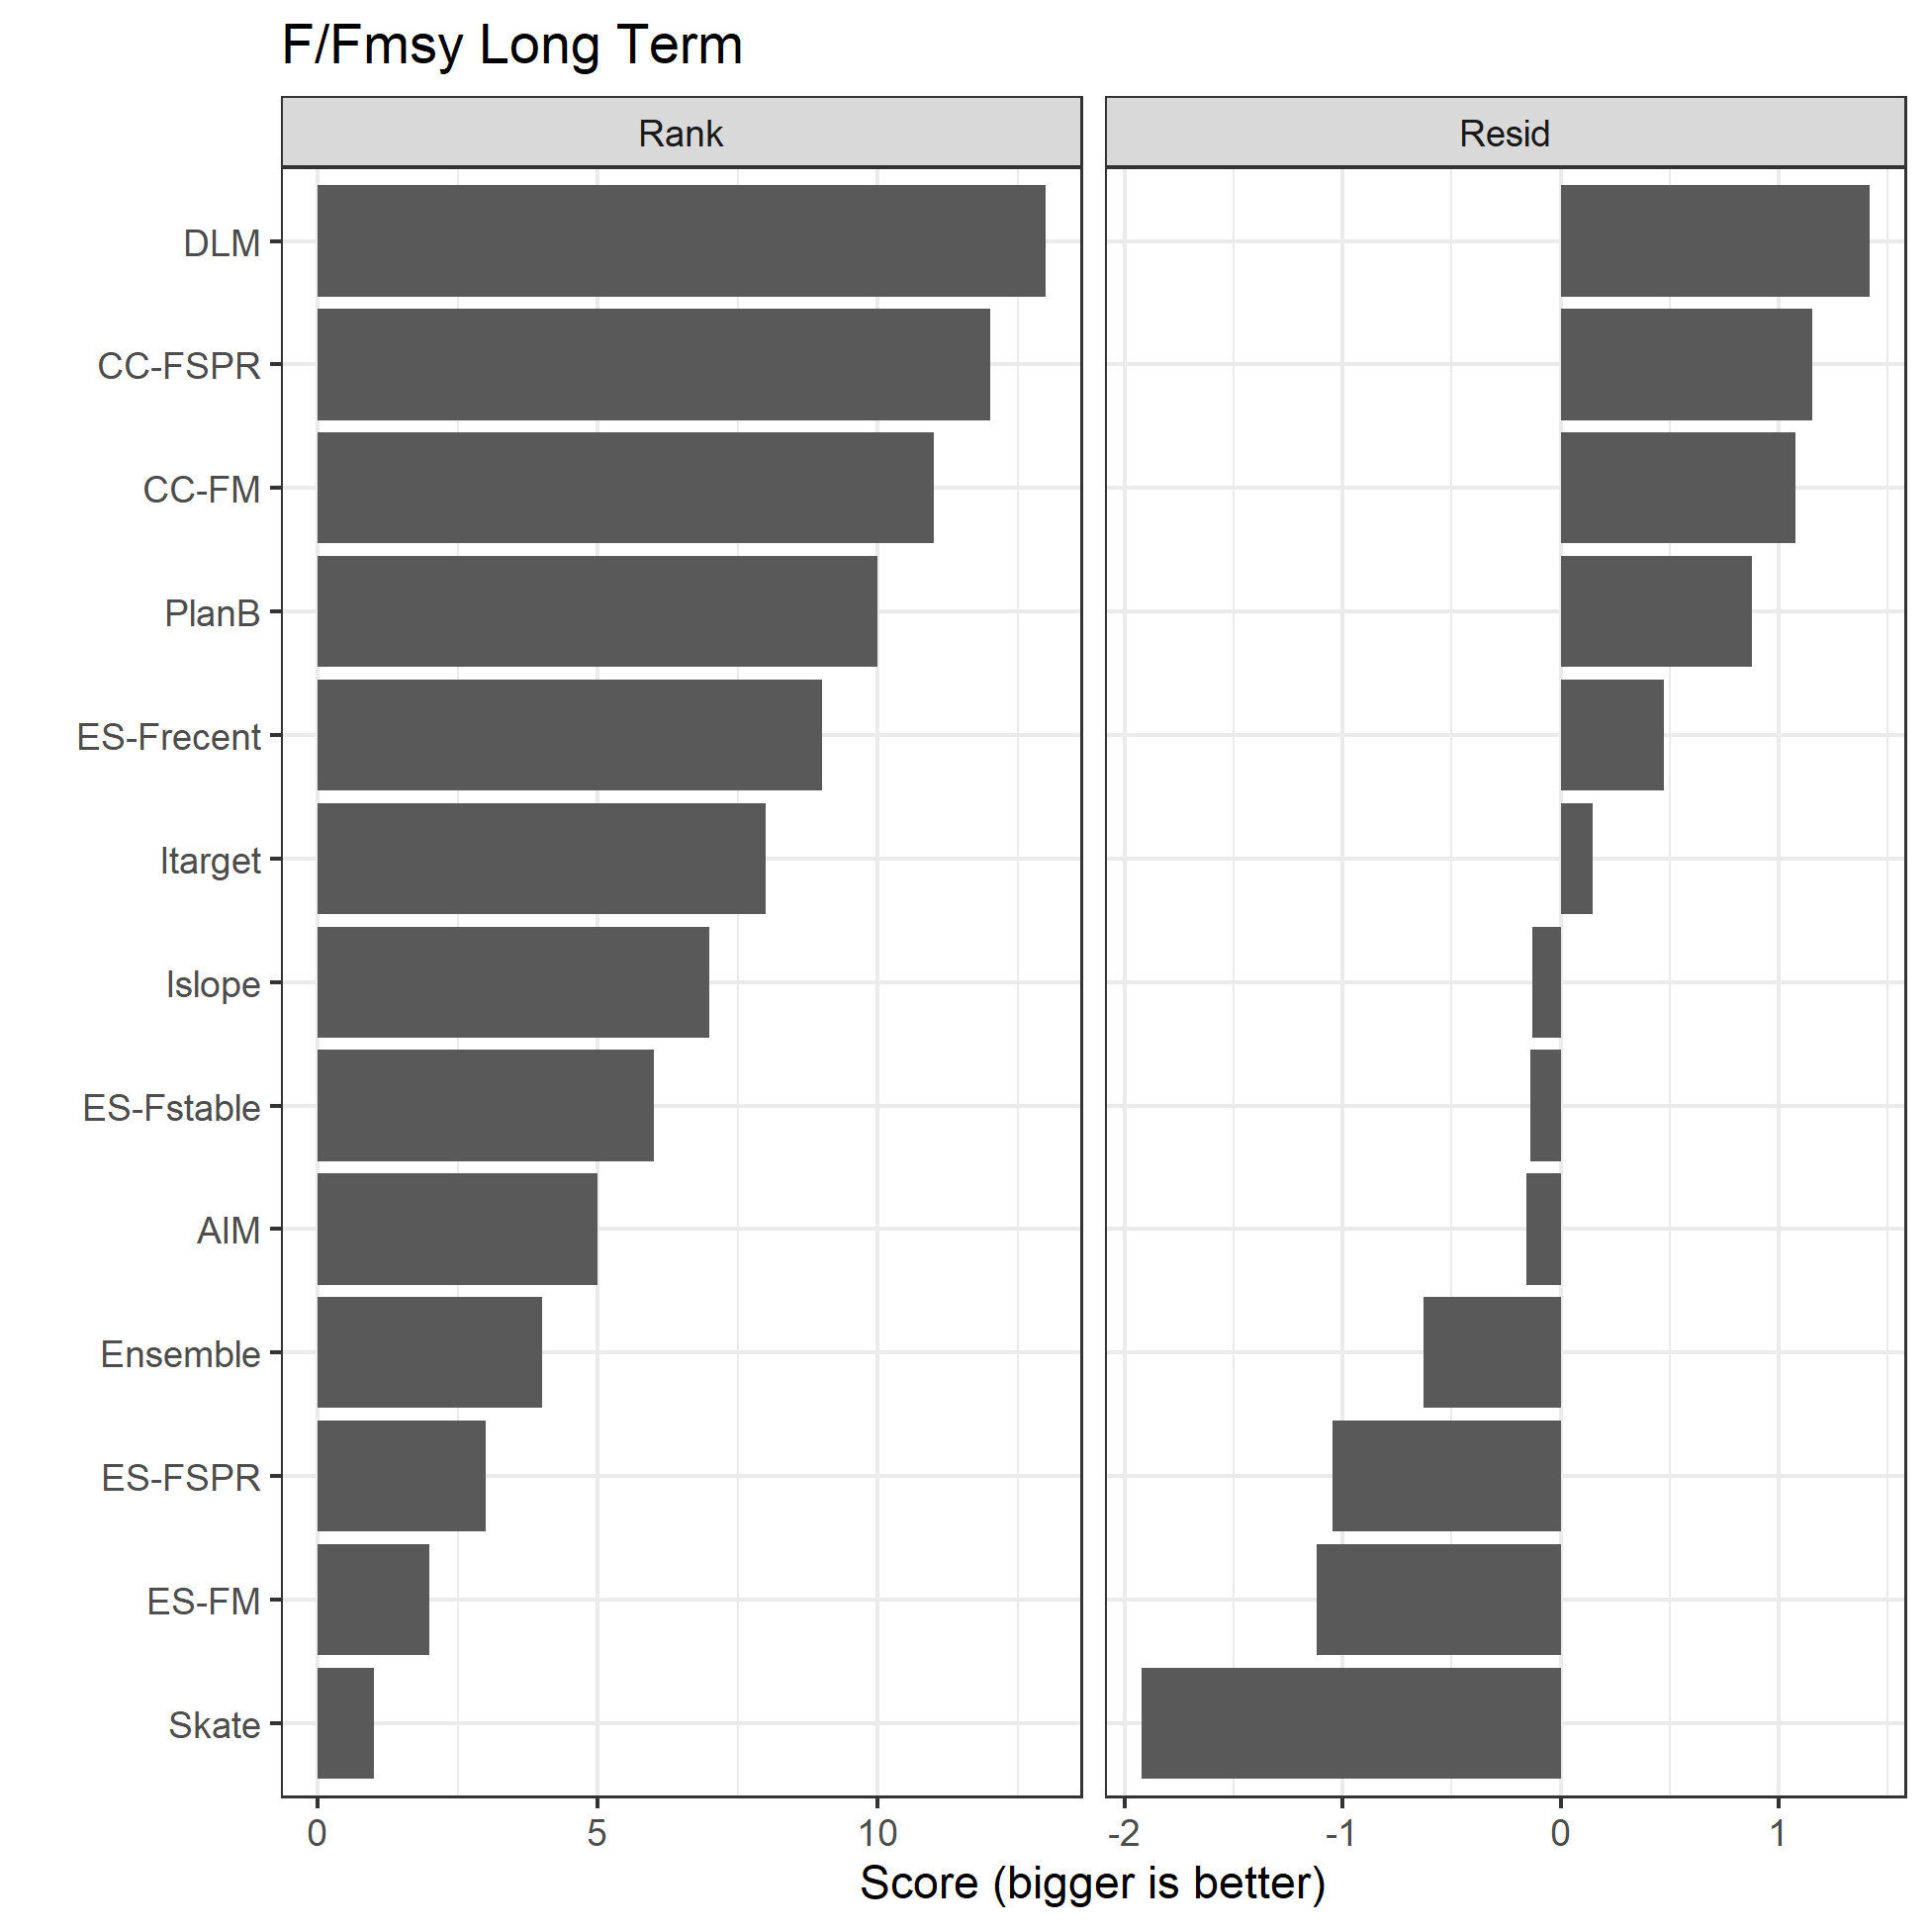

Figure A6.4. Two sets of scores, Rank and Resid, for the base analyses for the F relative to Fmsy in the long term.

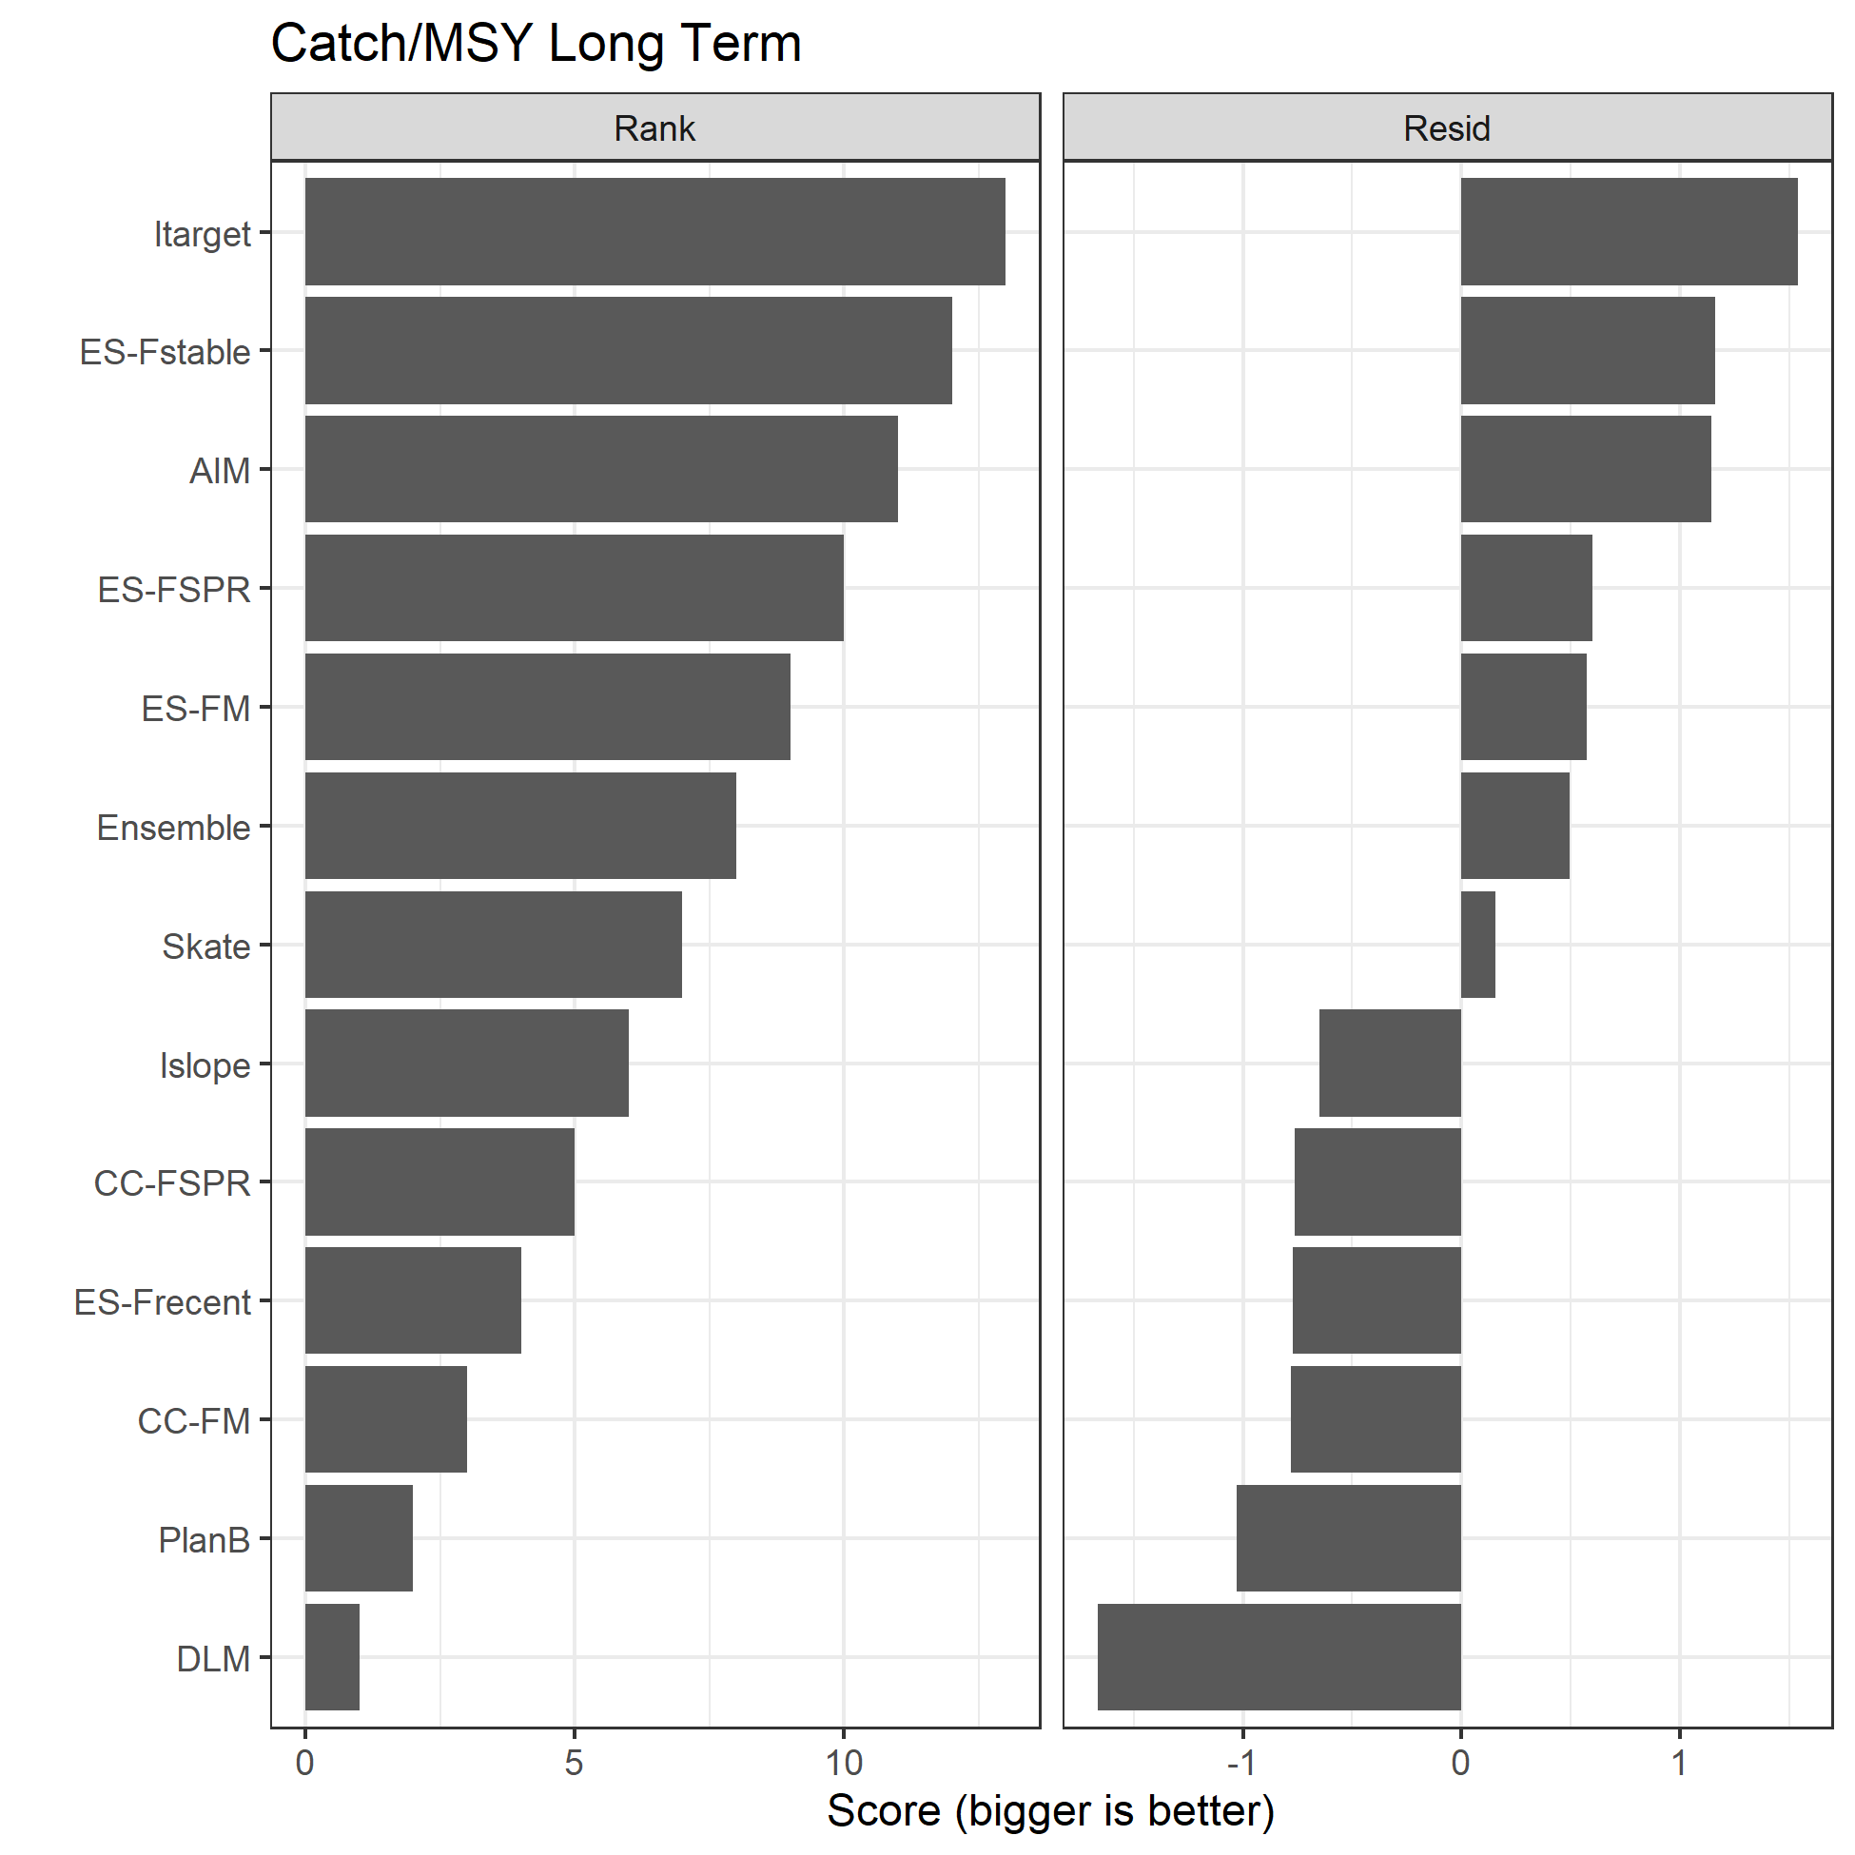

Figure A6.5. Two sets of scores, Rank and Resid, for the base analyses for the catch relative to MSY in the long term.

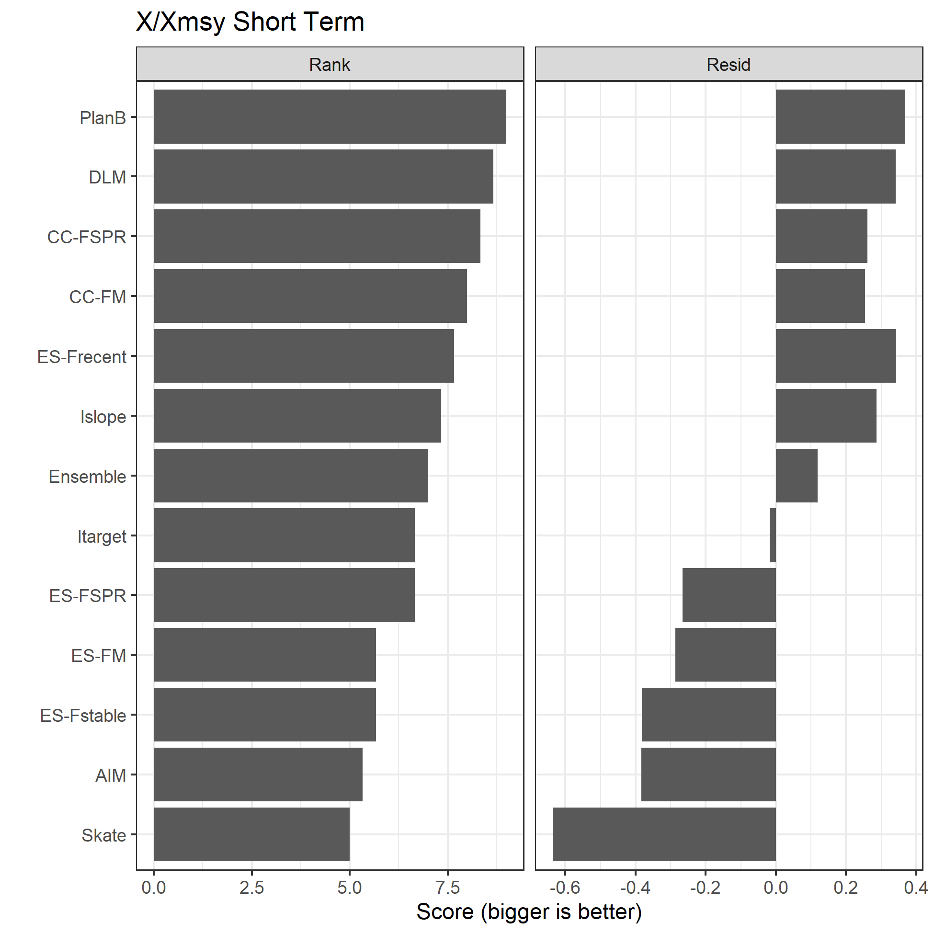

Figure A6.6. Two sets of scores, Rank and Resid, for the base analyses for the 3 metrics of SSB, F, and Catch relative to their MSY reference points (denoted X/Xmsy) in the short term.

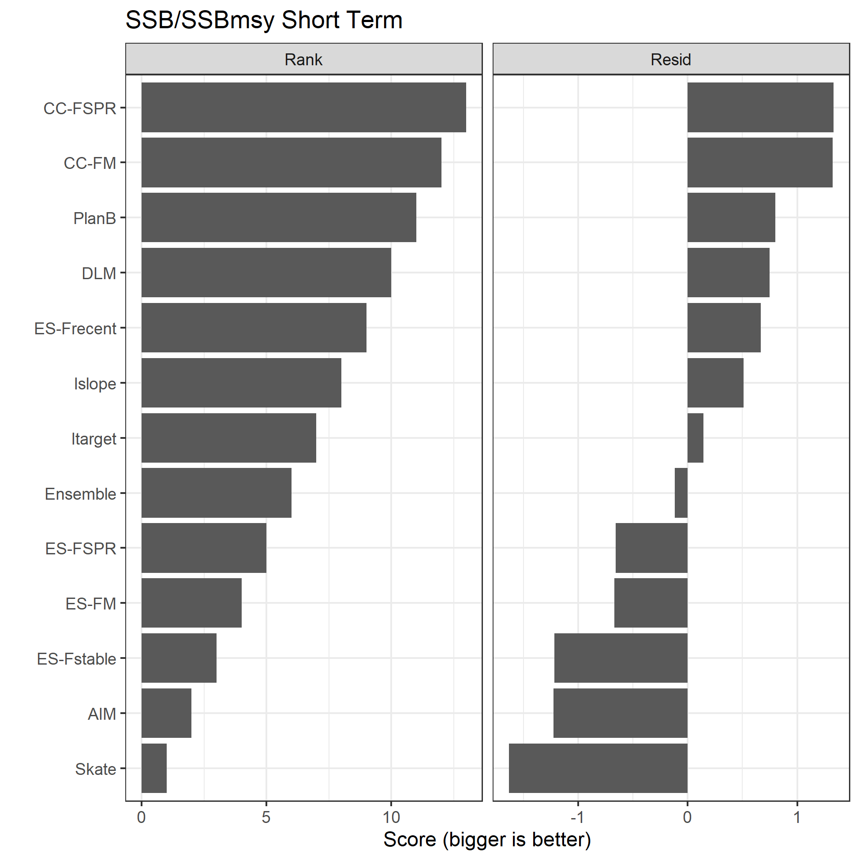

Figure A6.7. Two sets of scores, Rank and Resid, for the base analyses for the SSB relative to SSBmsy in the short term.

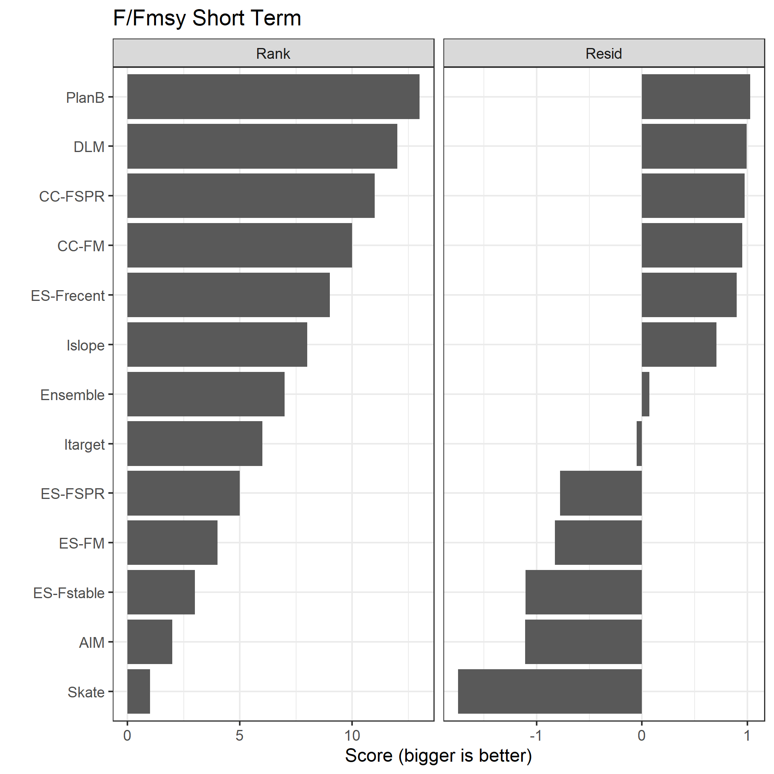

Figure A6.8. Two sets of scores, Rank and Resid, for the base analyses for the F relative to Fmsy in the short term.

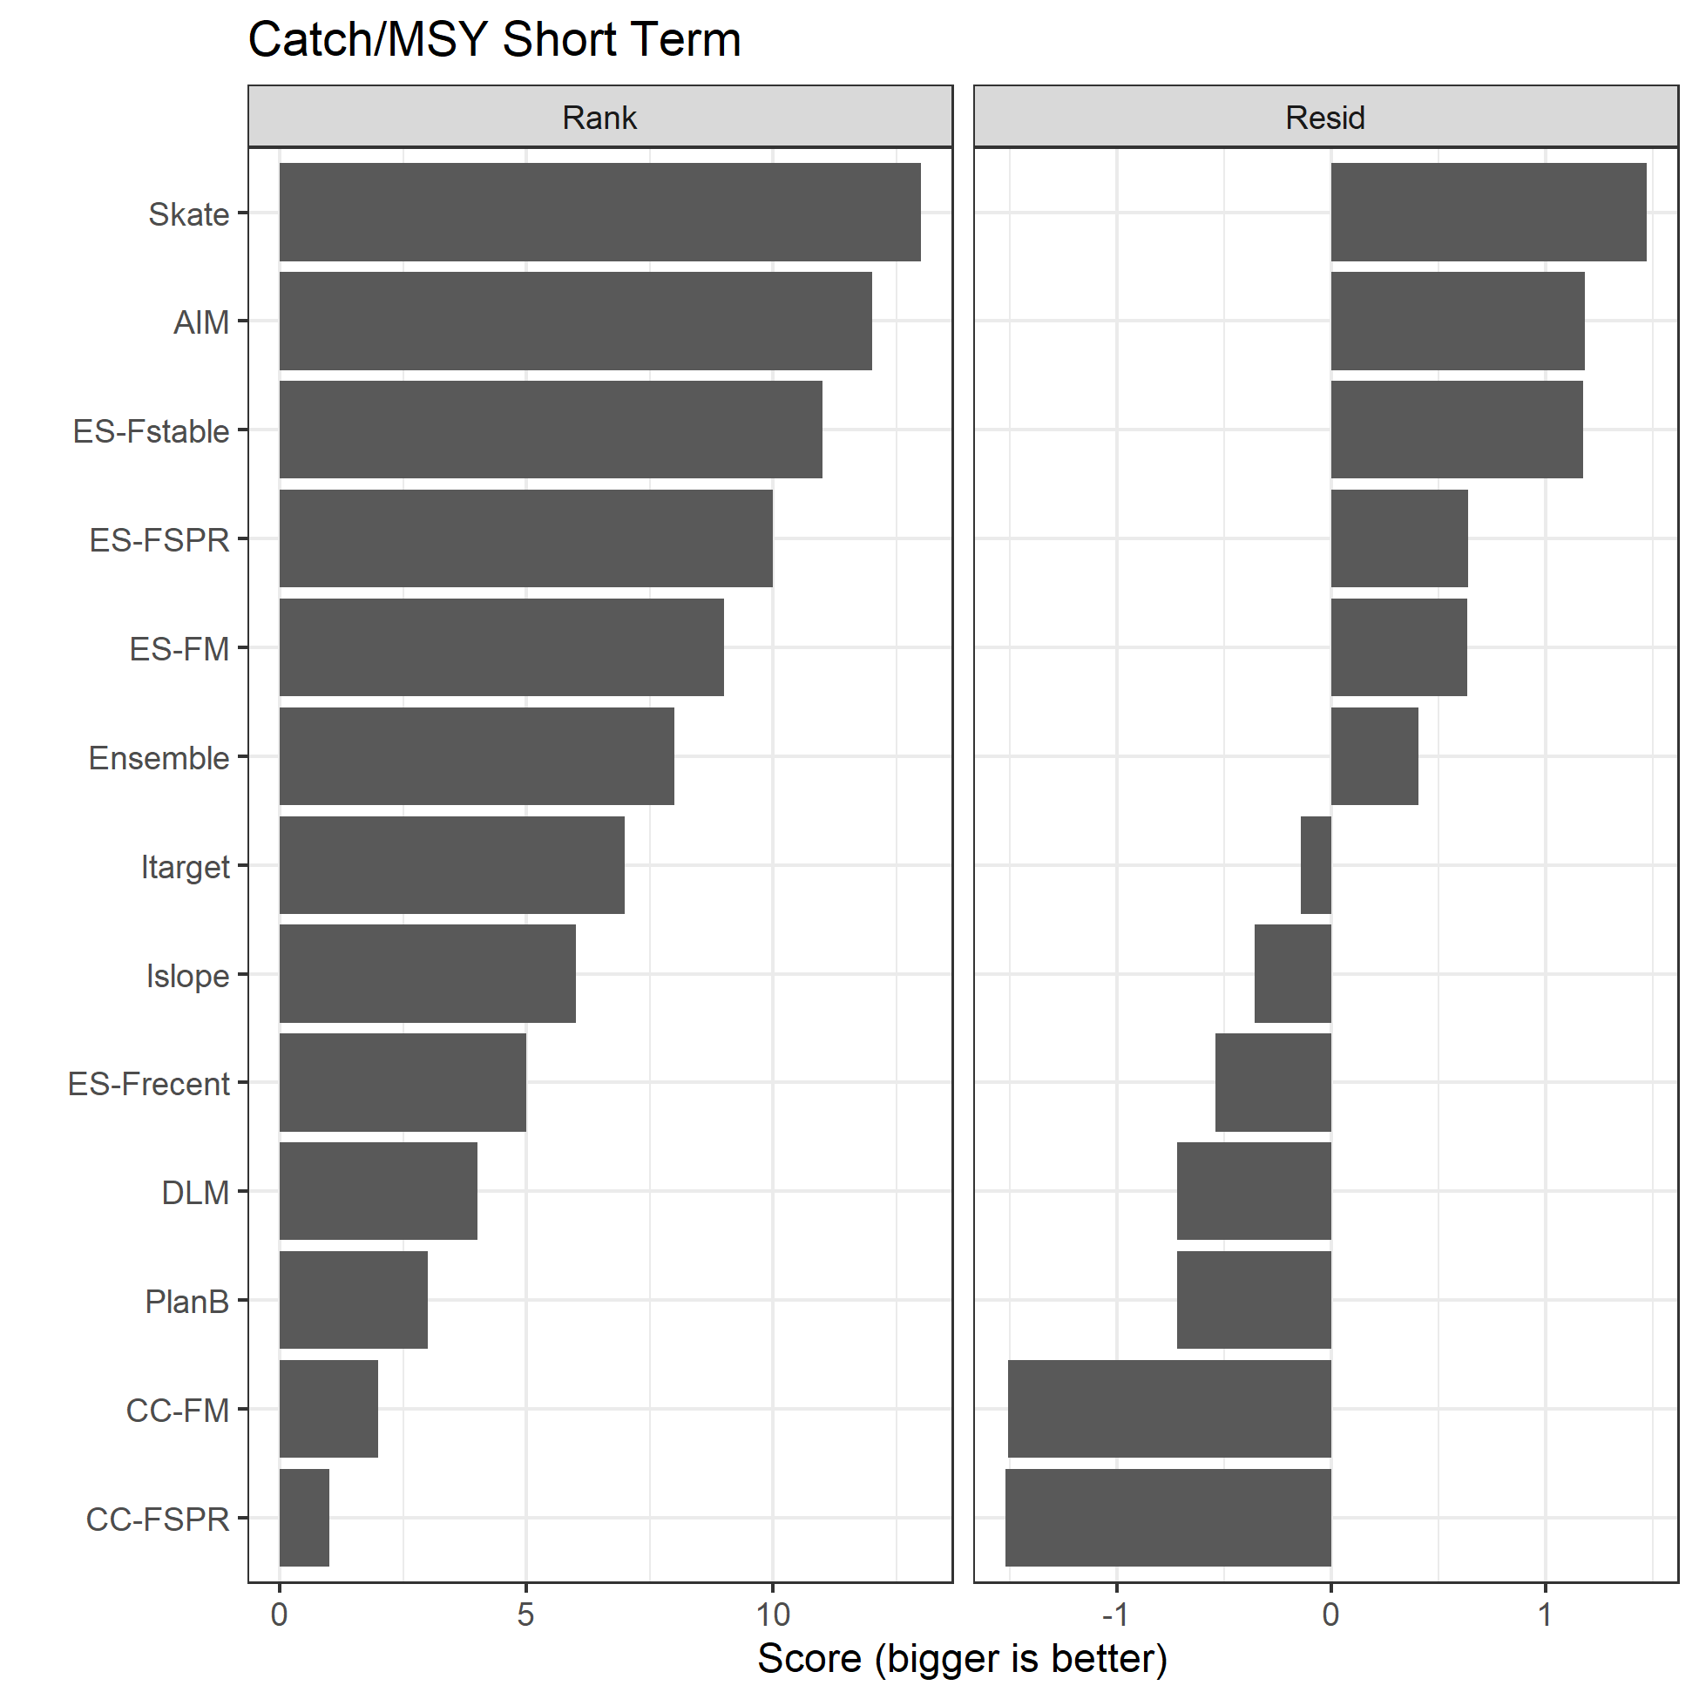

Figure A6.9. Two sets of scores, Rank and Resid, for the base analyses for the catch relative to MSY in the short term.

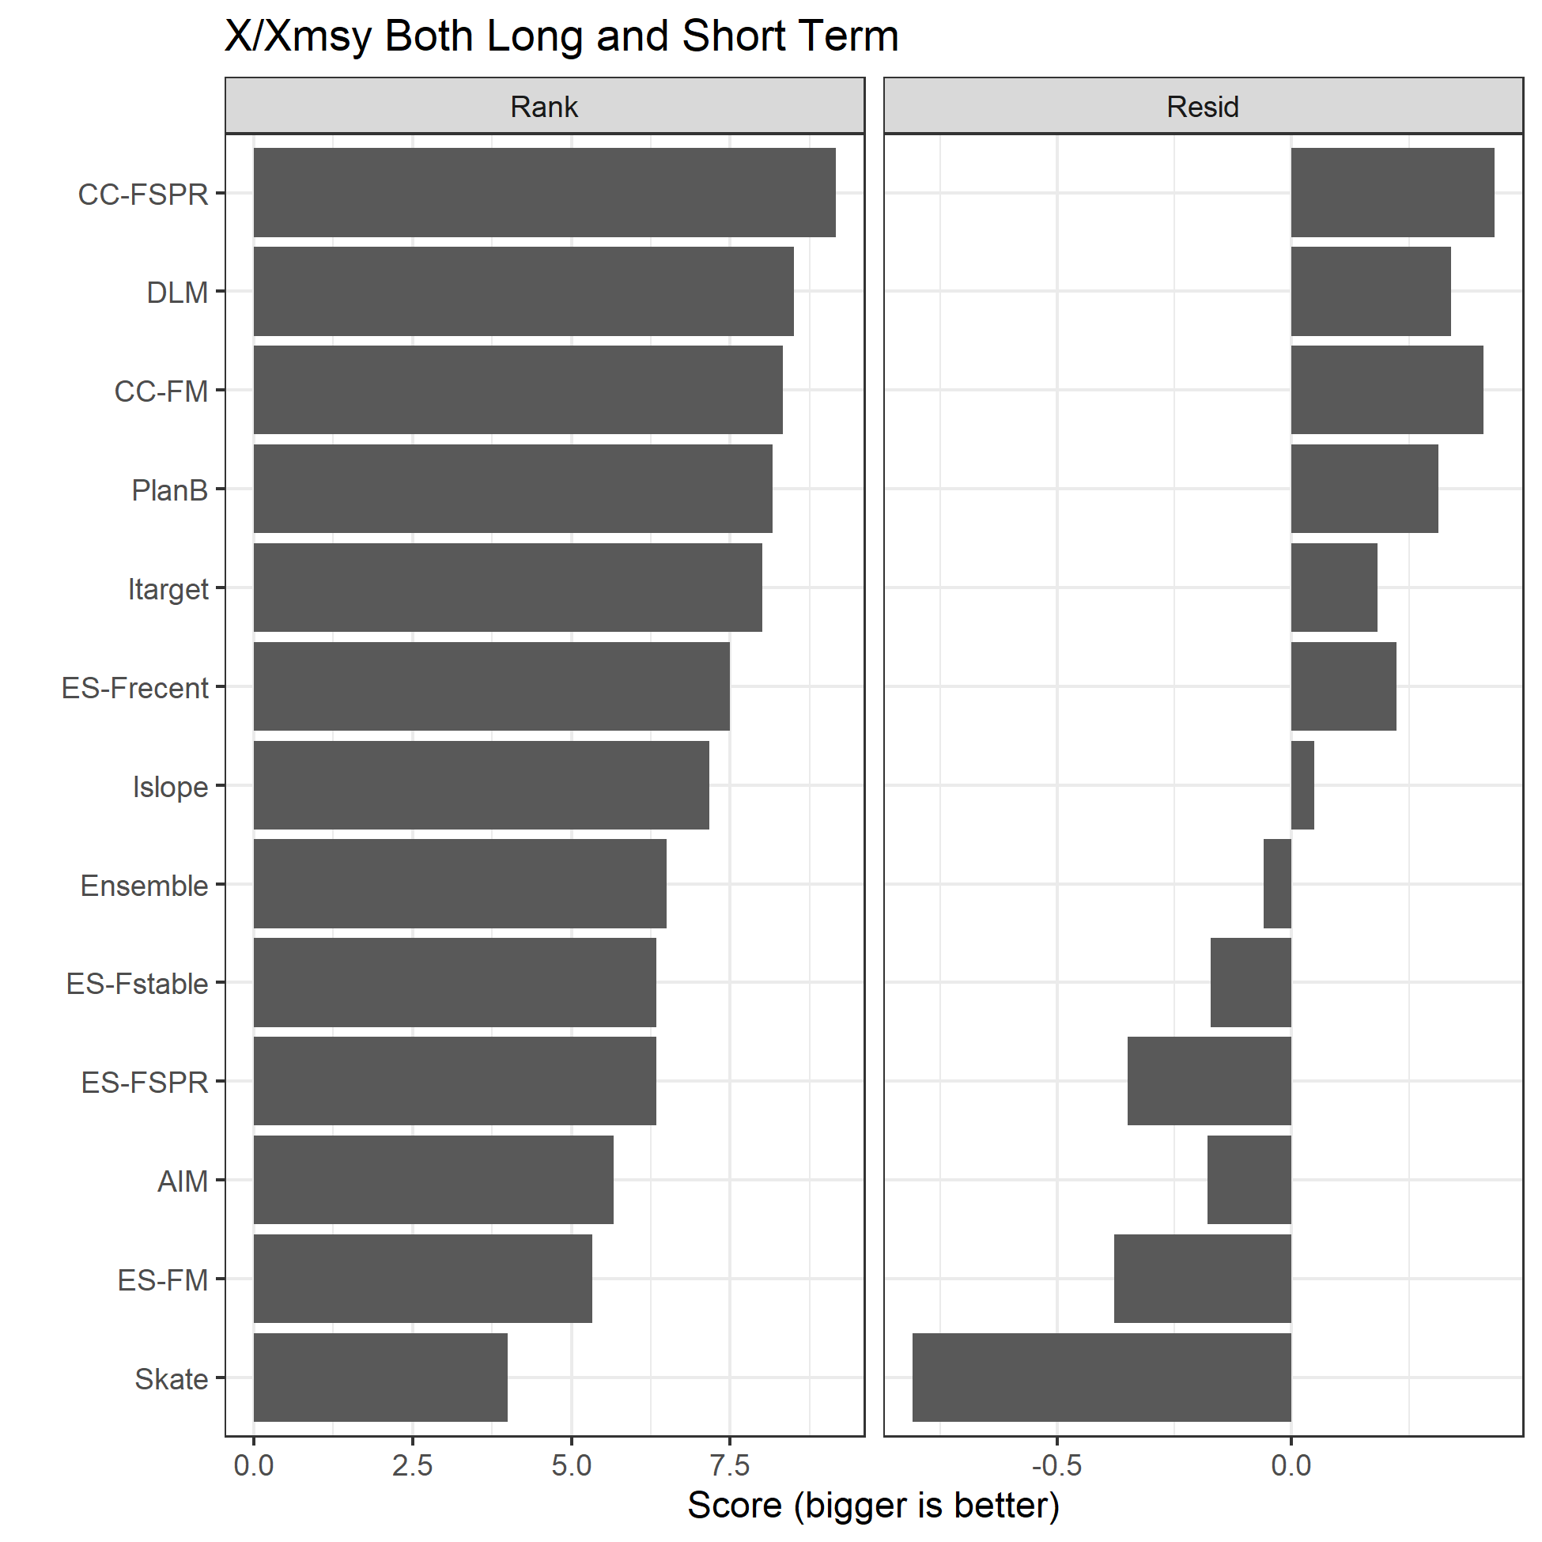

Figure A6.10. Two sets of scores, Rank and Resid, for the base analyses for the 3 metrics of SSB, F, and Catch relative to their MSY reference points (denoted X/Xmsy) in both the long and short term.

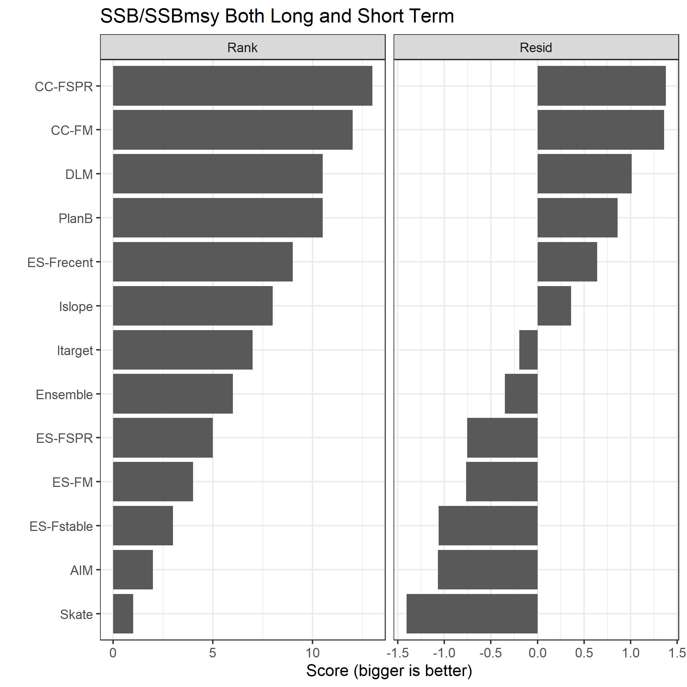

Figure A6.11. Two sets of scores, Rank and Resid, for the base analyses for the SSB relative to SSBmsy in both the long and short term.

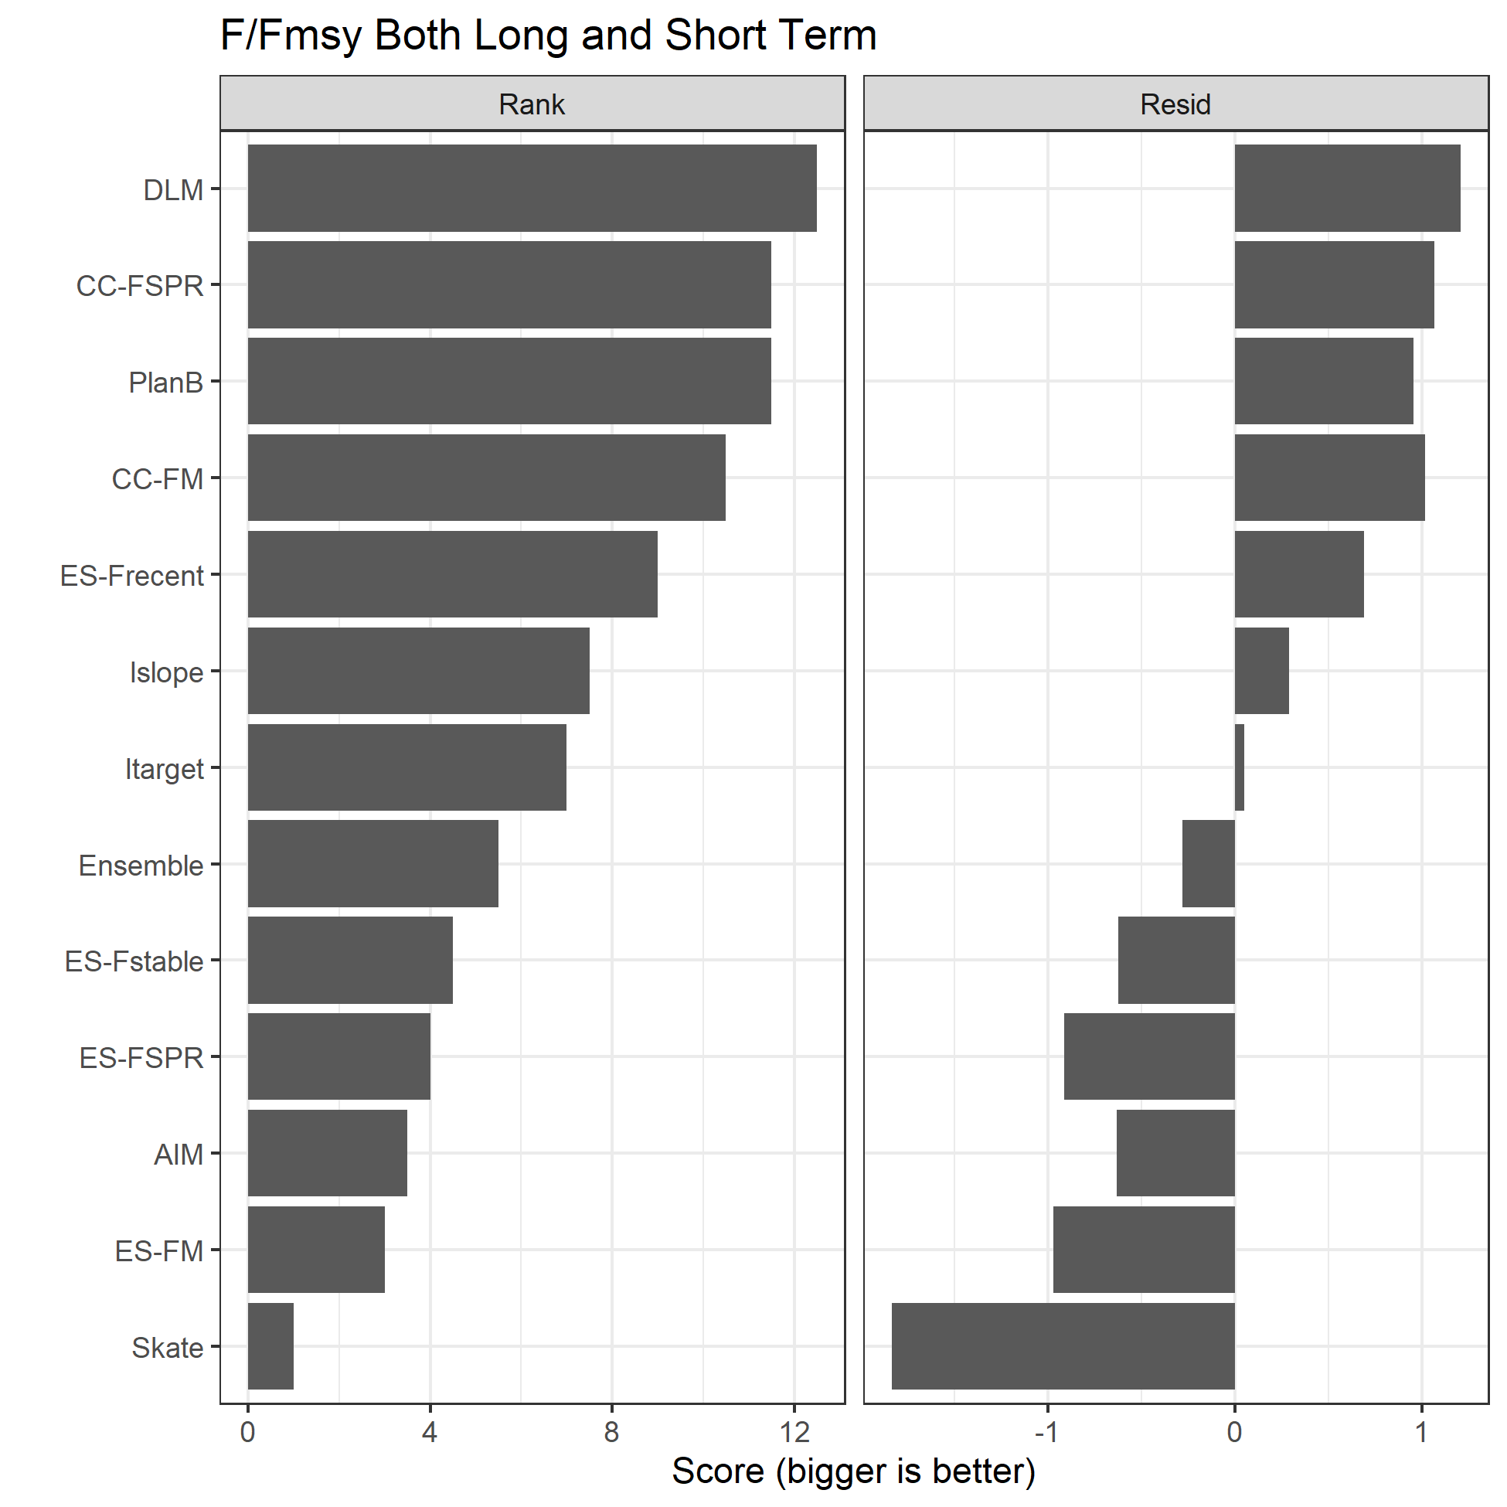

Figure A6.12. Two sets of scores, Rank and Resid, for the base analyses for the F relative to Fmsy in both the long and short term.

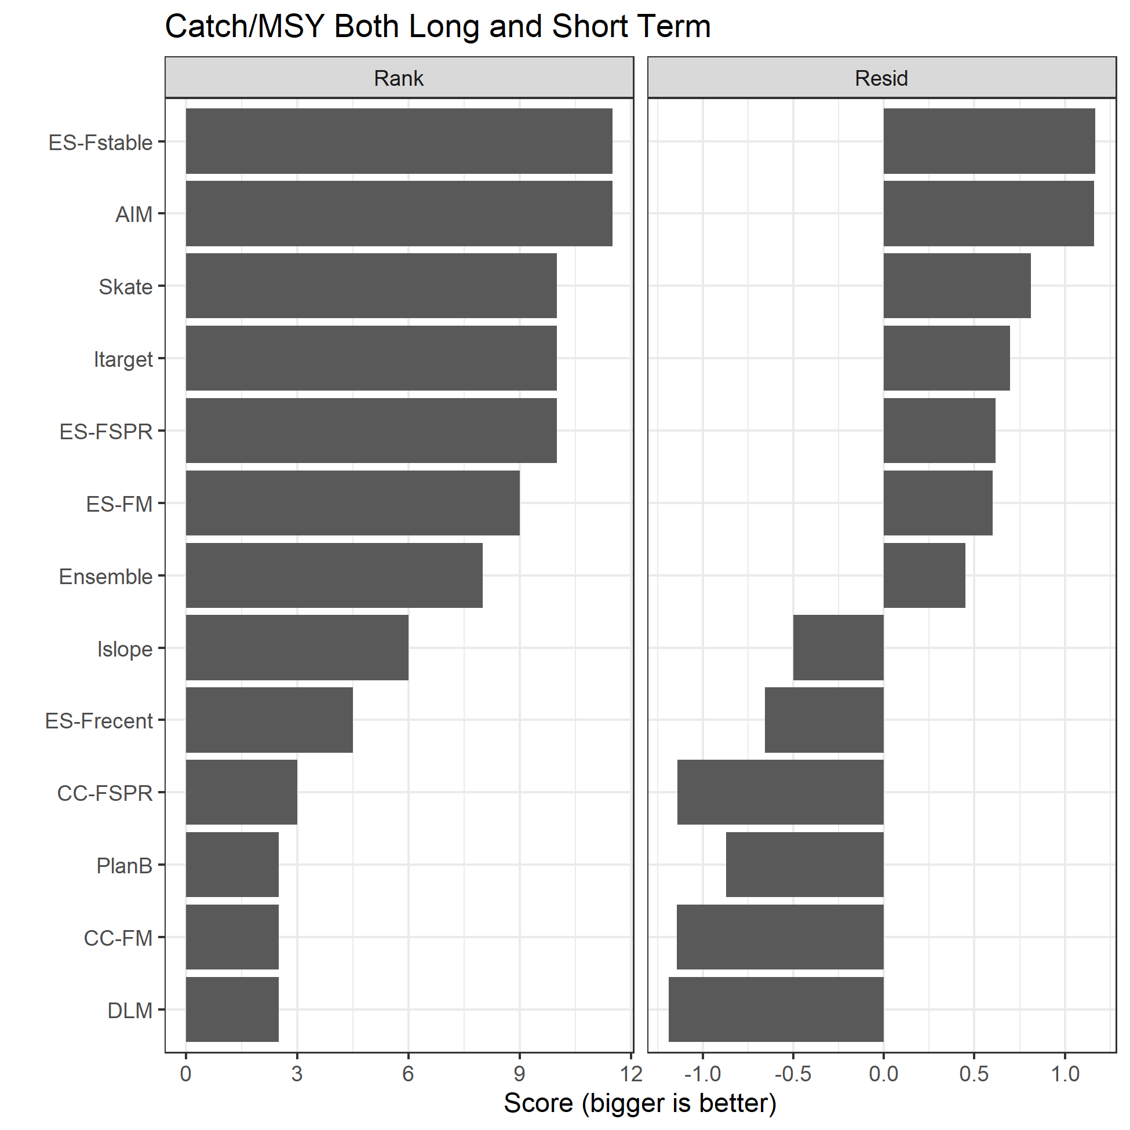

Figure A6.13. Two sets of scores, Rank and Resid, for the base analyses for the catch relative to MSY in both the long and short term.

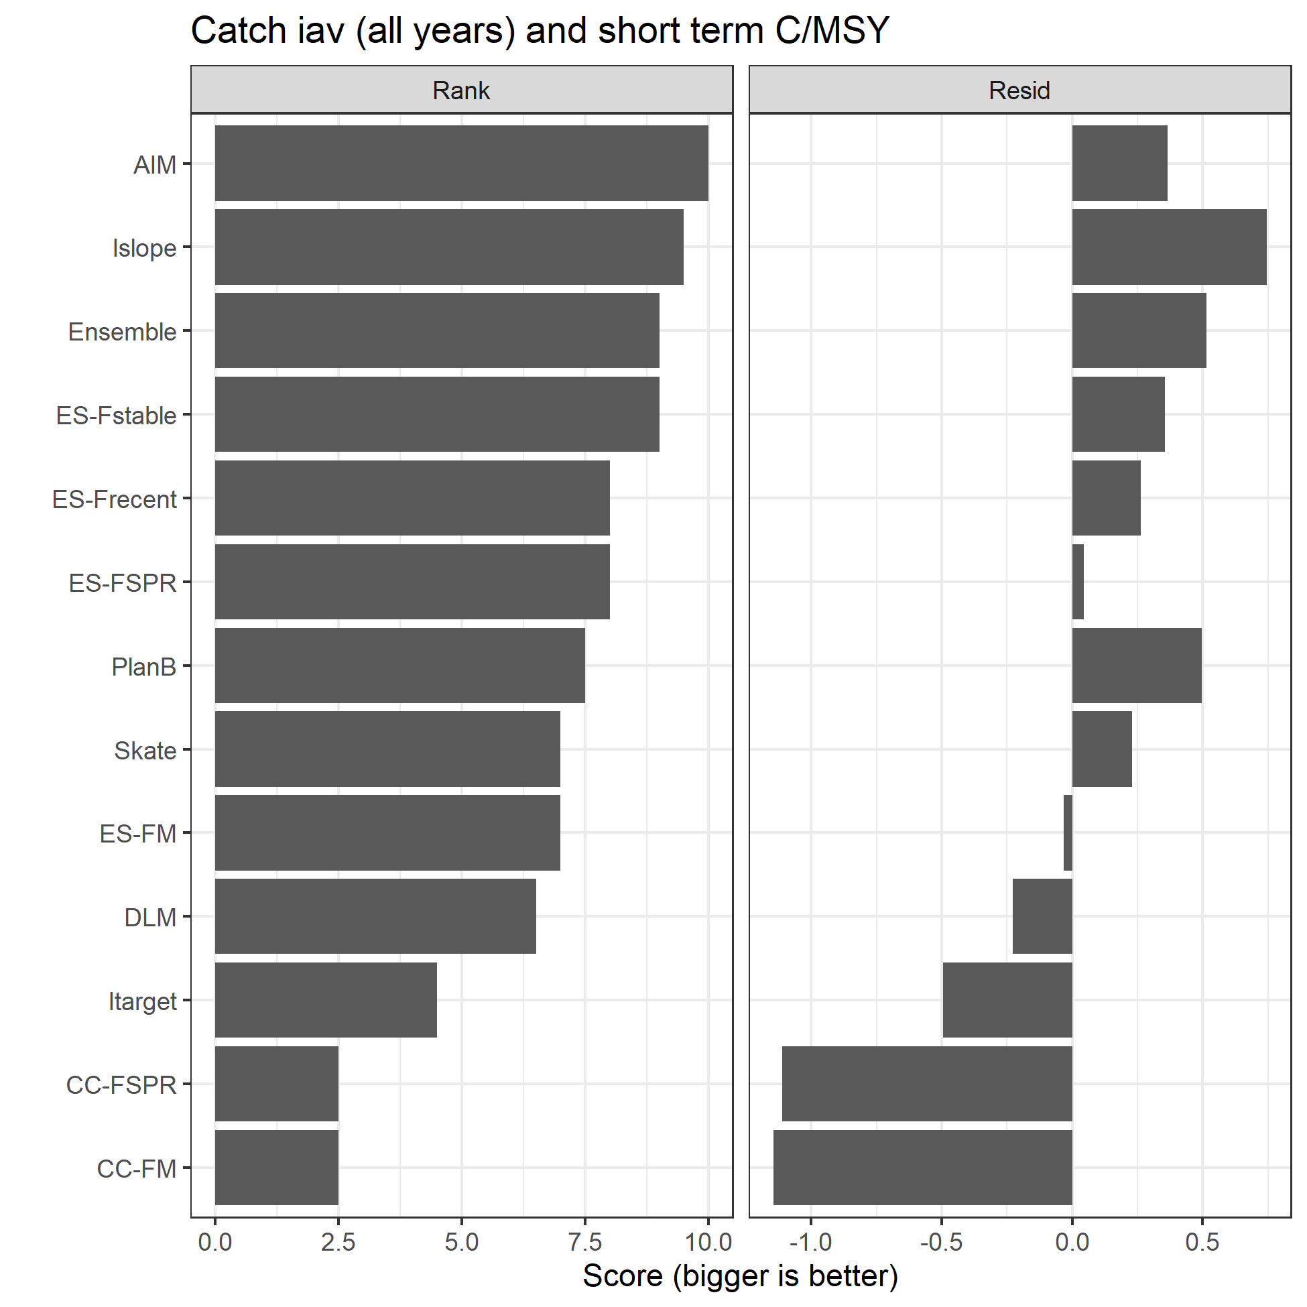

Figure A6.14. Two sets of scores, Rank and Resid, for the base analyses for the 2 metrics of interannual variability in catch over the entire feedback period and the short term mean Catch/MSY.