**Homework Jan-16: Updated Model Diagram**

7 points total

By 9am on Tuesday, January 16, please upload a Word document with your file to the corresponding Canvas assignment. Please follow the naming convention:

**HW_Jan16_UpdatedModelDiagram_LastName_FirstName.doc/docx**

Assignment details (see example on page two):

* On the top half of the page, present a repeat of the homework assignment from January 15, including any edits you made after Monday’s ‘Model Telephone’ session. *(2 points)*
* On the bottom half of the page, write out a detailed model description based on your experience in class on Monday. *(5 points)*

**Example:**

**Can the Malagasy black rat (*Rattus rattus)* population independently maintain transmission of the plague bacterium, *Yersinia pestis?***

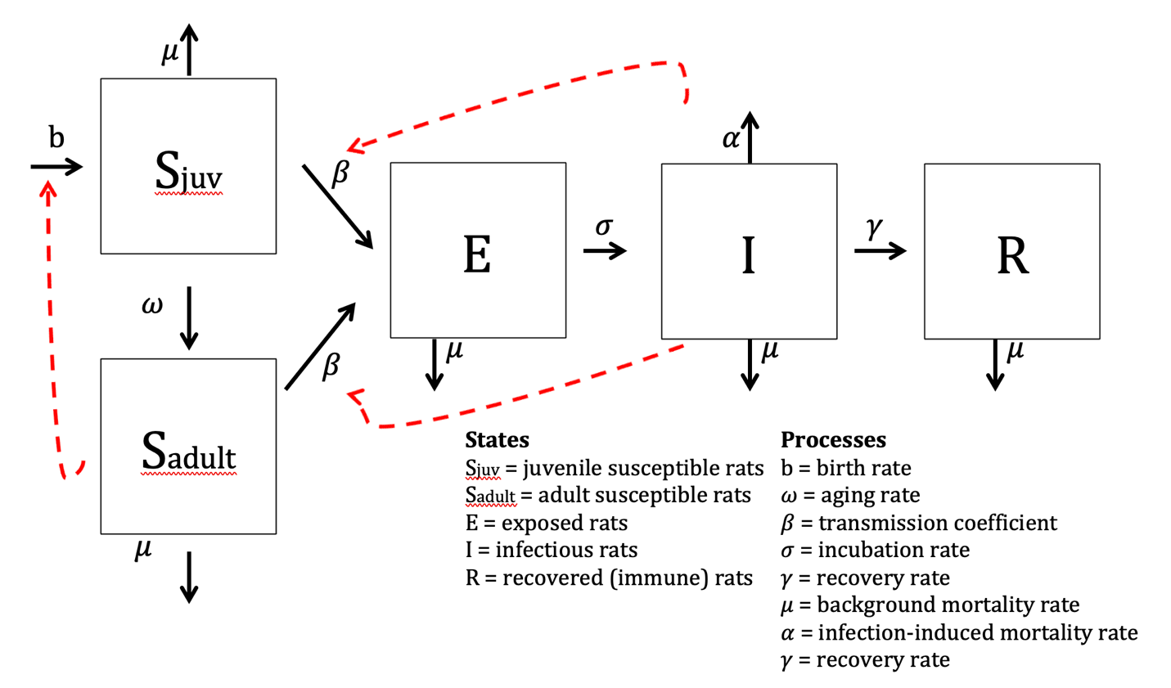

**Model Description:**

Susceptible juvenile rats enter the population through birth, at rate *b,* which is influenced by the proportion of uninfected (susceptible) adult rats in the population at a given time. Juvenile rats age into the adult class, on average 1/ $ω$ time units after they are born. Both juvenile and adult susceptible rats can be infected by contact with infectious rats of any age, based on a force of infection proportional to the prevalence of infectious rats in the population. Once infected, rats enter the exposed class. The incubation period is 1/ $σ$ time units (on average), after which the animals develop clinical plague, which is equivalent to transitioning from the exposed class to the infectious class. A subset of rats recover from plague to become immune, based on rate $γ$. All rats in the population experience background mortality with hazard *μ*, and infectious rats experience an additional disease-induced hazard of mortality, *α*.