Certificate of Completion

for

*E2M2: Ecological and Epidemiological Modeling in Madagascar*

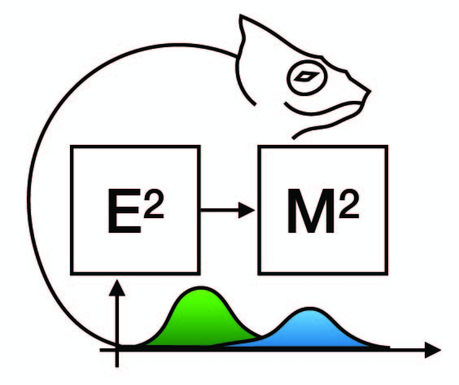

RAHERINANDRASANA Antso Hasina

January 13-21, 2019

Ranomafana, Madagascar



Cara Brook Fidisoa Rasambainarivo