Certificate of Completion

for

*E2M2: Ecological and Epidemiological Modeling in Madagascar*

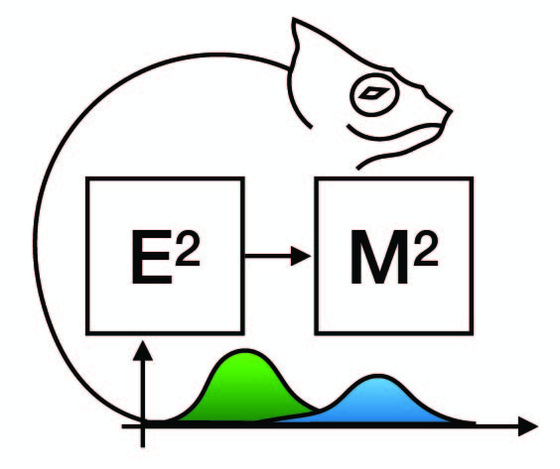

RAKOTOMANGA Solotahiana Barison

December 10-17, 2022

Ranomafana, Madagascar

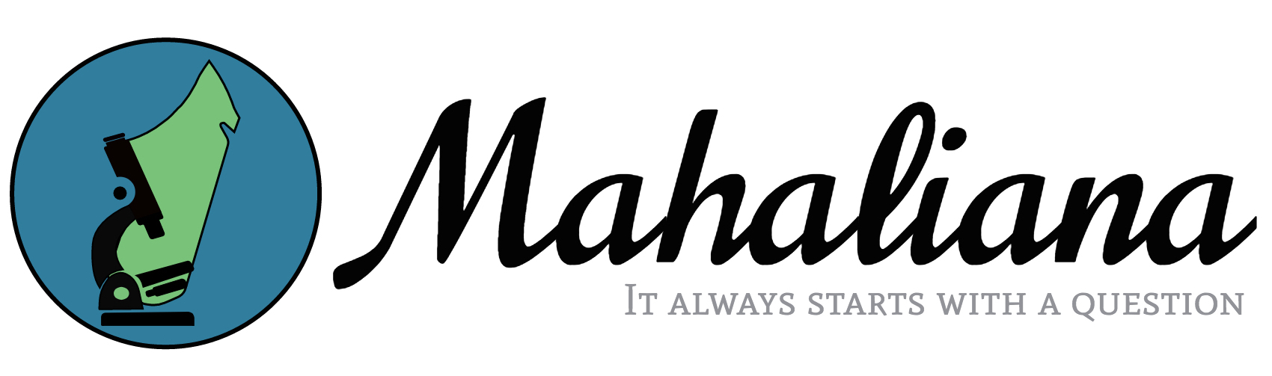

Cara Brook Hafaliana Christian Ranaivoson