Certificate of Completion

for

*E2M2: Ecological and Epidemiological Modeling in Madagascar*

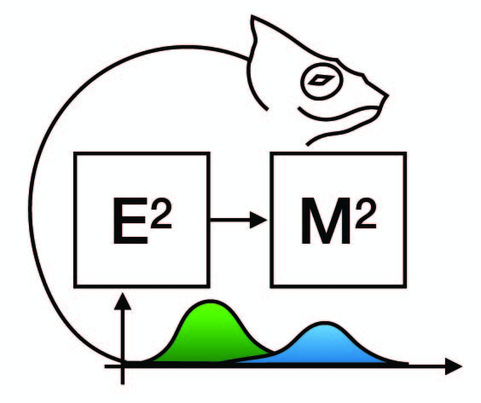

RATOVONJANAHARY Ny Ony Lalaina

December 10-17, 2022

Ranomafana, Madagascar



Cara Brook Hafaliana Christian Ranaivoson