Certificate of Completion

for

*E2M2: Ecological and Epidemiological Modeling in Madagascar*

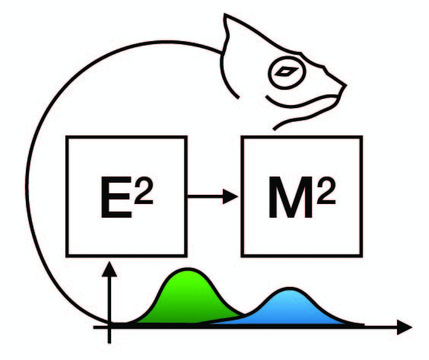

RANAMPY Fabien Florian

May 18-26, 2025

Andasibe, Madagascar

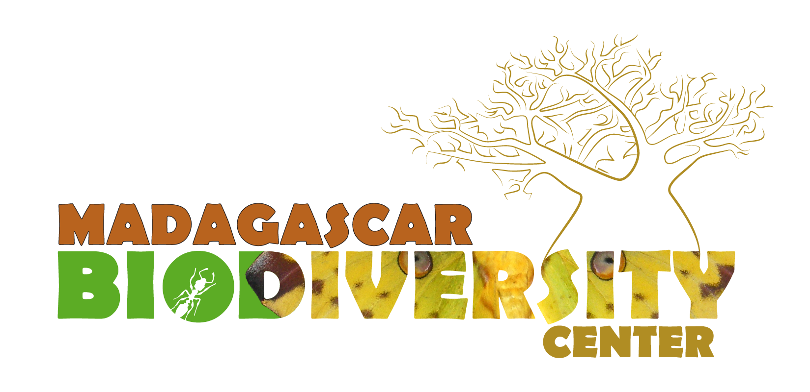 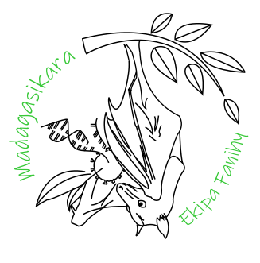 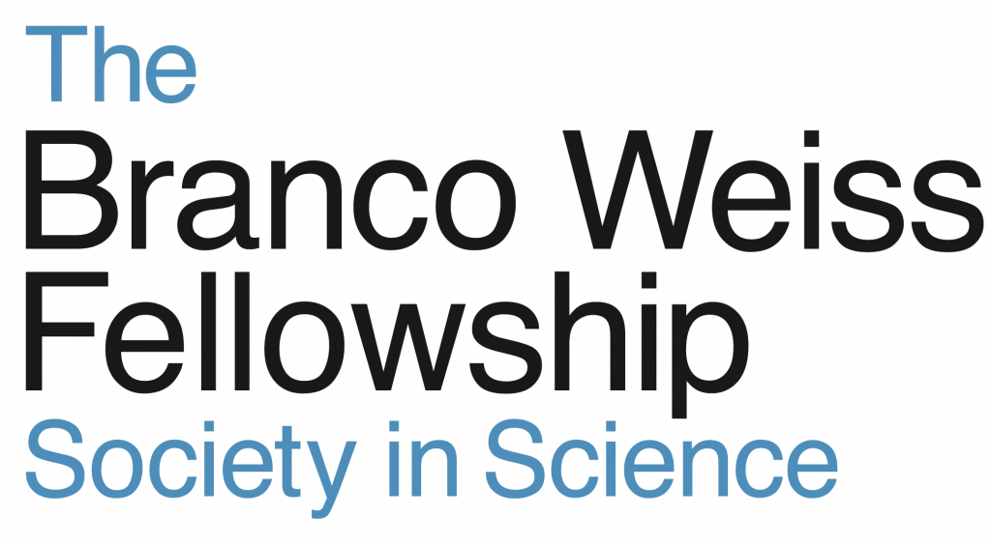

|  |  |  |
| --- | --- | --- |
| Cara E. Brook | Sophie Lockwood | Hafaliana Christian Ranaivoson |