Requirements List: Campus Service Request System
Student Role (Requester)
- The system must allow students to submit a new service request.
- When submitting a request, students must be able to describe the specific issue and its location (e.g., "Broken chair in classroom").
- The system must allow students to view a general list of requests.
- The system must allow students to select a specific request to view its full details.
Staff Role (Reviewer)
- The system must categorize administrative users under a "Staff" role.
- The system must allow staff members to access and review the list of all submitted requests.
- The system must allow staff members to view the detailed information of any individual request.
- The system must allow staff members to update the status of a request.
- The system must restrict the status updates to three predefined states: Pending, In Progress, and Done.
General System Workflows
- The system must enforce distinct access and permissions based on the two primary user roles: Student and Staff.
- The system must automatically assign an initial status of "Pending" to all newly submitted requests.
- The system must require all necessary details to be filled out before a request can be successfully submitted to ensure staff can take action.
User roles:
- Student: This role is responsible for creating and submitting new service requests, such as reporting broken equipment or requesting access to labs.
- Staff: This role is responsible for reviewing the submitted service requests and updating their status (e.g., from Pending to In Progress or Done).

Use cases:

Use Case 1: Submit a request
- Use Case Name: Submit a Service Request
- Actor: Student
- Trigger: A student needs to report an issue on campus, such as a broken projector or a need for lab access.
- Main Flow (3-6 steps):
  - The student navigates to the request submission page.
  - The student fills out the form with the issue details and location.
  - The student clicks the submit button.
  - The system validates that all required fields are filled.
  - The system saves the new request to the database with a default status of "Pending".
- Alternative Flow (optional): If the form is incomplete, the system displays an error message prompting the student to fill in the missing details.
- Success Outcome: A new service request is successfully created and added to the system for staff review.

Use Case 2: View a list of requests
- Use Case Name: View List of Requests
- Actor: Student or Staff
- Trigger: The user wants to see an overview of submitted service requests.
- Main Flow (3-6 steps):
  - The user navigates to the requests dashboard or index page.
  - The system queries the database for the list of requests.
  - The system displays a summary list of the requests, including basic information like the title and current status.
- Alternative Flow (optional): If there are no requests in the system, the interface displays a "No requests found" message.
- Success Outcome: The user successfully views the summarized list of all active or past campus service requests.

Use Case 3: View request details
- Use Case Name: View Request Details
- Actor: Student or Staff
- Trigger: The user wants to see the full information of a specific request from the list.
- Main Flow (3-6 steps):
  - The user clicks on a specific request from the list view.
  - The system retrieves the full record for that specific request from the database.
  - The system loads a dedicated details page showing the complete description, location, and status.
- Alternative Flow (optional): If the user attempts to view a request ID that does not exist or was deleted, the system displays a "404 Not Found" error.
- Success Outcome: The user successfully reads all the details pertaining to the selected service request.

Use Case 4: Update request status
- Use Case Name: Update Request Status
- Actor: Staff
- Trigger: A staff member has reviewed a request, begun working on it, or finished resolving the issue.
- Main Flow (3-6 steps):
  - The staff member navigates to the details page of a specific request.
  - The staff member selects a new status from a dropdown menu (Pending, In Progress, or Done).
  - The staff member submits the status update.
  - The system updates the request's status in the database.
  - The system refreshes the page to show the newly updated status.
- Alternative Flow (optional):
- Success Outcome: The request accurately reflects its new state (e.g., changing from Pending to In Progress) for all users viewing the system.

SRP Class Responsibility Table

Class name | Responsibility (1 sentence) | Reason to change (1 reason only)
Request | Stores the campus service request data (e.g., title, description, location, and status). | The data fields or attributes defining a request change.
RequestRepository | Reads and writes the service requests to the underlying database storage. | The database type or storage method changes.
RequestService | Applies business rules, such as validating allowed status transitions (e.g., Pending to In Progress). | The business rules or request workflows change.
RequestValidator | Validates incoming student input to ensure all required fields are filled out. | The validation rules or input requirements change.
RequestController | Coordinates HTTP requests, calls the appropriate service, and selects the proper view to display. | The application routes or controller actions change.
ViewRenderer | Loads the specific HTML template and passes the provided variables into it for display. | The template rendering method or engine changes.

UML Diagram
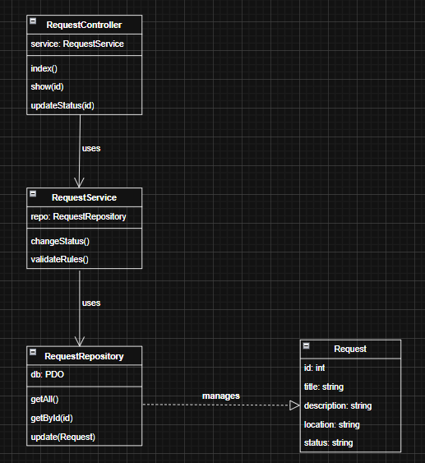

MVC Mapping Table
Item | MVC Layer | Why?
Request (data + status) | Model | Represents the core application data and state.
RequestRepository | Model | Accesses the underlying data source (database) to save or retrieve requests.
RequestService | Model | Contains the business logic and rules (fits within the broader "Model" layer of MVC).
RequestController@index | Controller | Receives the user's HTTP request, fetches data, and chooses which view to show.
RequestController@updateStatus | Controller | Processes the staff's input to change a status, coordinates with the service, and redirects the user.
requests/index.php | View | Displays the HTML user interface for the list of requests.
requests/show.php | View | Displays the HTML user interface for a specific request's details.

Route Table

HTTP | URL | Controller@Action | Purpose
GET | /requests | RequestController@index | Display the list of service requests.
GET | /requests/create | RequestController@create | Show the HTML form to submit a new request.
POST | /requests | RequestController@store | Save the submitted form data as a new request.
GET | /requests/{id} | RequestController@show | Display the full details of a specific request.
POST | /requests/{id}/status | RequestController@updateStatus | Process a staff member's status update.
GET | /staff/requests | RequestController@staffIndex | Display a specialized list of requests for staff review.

Minimal Skeleton (Pseudocode)

1. Front Controller (Entry Point)
// File: public/index.php

echo "Hello MVC"
- initialize Router
- match URL to Route Table
- dispatch to the correct Controller
2. Model Layer
// File: app/Models/Request.php

class Request:
properties: id, title, description, location, status

class RequestRepository:
method getAll():
- return list of Request objects from database

class RequestService:
method changeStatus(id, newStatus):
- validate the status transition
- repository.updateStatus(id, newStatus)
3. Controller Layer
// File: app/Controllers/RequestController.php

class RequestController:

method index():
- requests = repository.getAll()
- render view 'requests/index' with requests data

method show(id):
- requestData = repository.getById(id)
- render view 'requests/show' with requestData

method updateStatus(id):
- read newStatus from POST request
- service.changeStatus(id, newStatus)
- redirect browser to /requests/{id}

method staffIndex():
- requests = repository.getAll()
- render view 'staff/index'
4. View Layer
// File: app/Views/requests/index.php

<h1>Campus Service Requests</h1>
<ul>
- loop through requests data
- print request title and status
- link to /requests/{id}
</ul>

// File: app/Views/requests/show.php

<h1>Request Details</h1>
- print request description and location
- print current status

<form action="/requests/{id}/status" method="POST">
- select dropdown for new status (Pending, In Progress, Done)
- submit button
</form>

1. Which parts of your design are Model, View, and Controller?
A:
    - Model: The Request class, the RequestRepository and the RequestService
    - View: The HTML template files like requests/index.php and requests/show.php
    - Controller: The RequestController
2. Where should validation happen, and why?

A:
validation should happen in a dedicated RequestValidator class, before any data is sent to the Model/Repository. Catching errors early protects your database from bad data and keeps your Request model completely focused on representing data, rather than checking if that data is correct

3. What would break if you put SQL inside a View file?
A:
If you placed SQL queries directly inside a View file (like requests/index.php), you would immediately break the Single Responsibility Principle and the entire purpose of the MVC architecture.

4. What code do you expect to write next week to make this real?

A:
Next week, to transition this design into a working application, the focus will shift from planning to writing the actual PHP code to connect all the pieces together. Specifically, this will involve:
- Implementing a functional Router that reads the Route Table to direct incoming traffic.
- Writing the actual Controller actions that call the services and models to fetch or update data.
- Coding the HTML and PHP loops inside the Views to display the lists and details to the users.
- Setting up autoloading so all these separate classes can automatically load and interact with one another without needing manual require statements.

