**REST Countries**

Table of Contents

**1. Purpose** 2

**2. Design** 2

**2.1. Architecture** 2

**2.2. Technologies used** 2

**3. Usage** 2

**3.1. Installation** 2

**3.2. Running the Application** 2

**4. Reference** 4

**1. Purpose**

The REST Countries application is a web-based application that allows users to access information about countries across the world. It serves as a convenient tool for users interested in learning about various countries, including details like population, capital, languages, currencies, and more. The application provides a user-friendly interface for easy navigation and exploration of country data.

**2. Design**

**2.1. Architecture**

The REST Countries application uses a client-server architecture. The client side being the user’s device and the server being accessed through RESTful API’s get method.

**2.2. Technologies used**

* **Front-end** 
  + **React –** for building the user interface
* **Back-end**
  + **RESTful API**

**3. Usage**

**3.1. Installation**

1. Clone the repository
2. Open the directory
3. Run ‘npm install’ command

**3.2. Running the Application**

To run the application, use the ‘npm run’ command.

**View all countries**

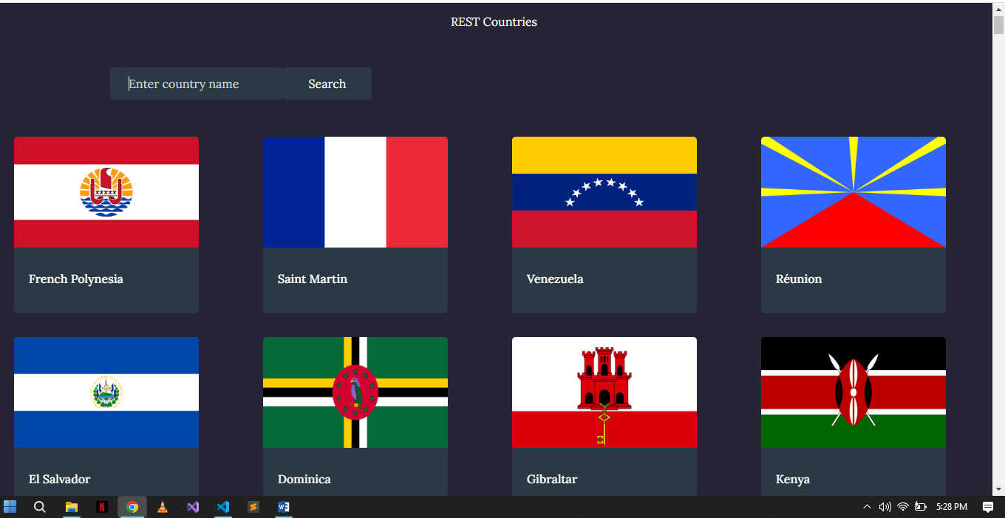

**Search country**

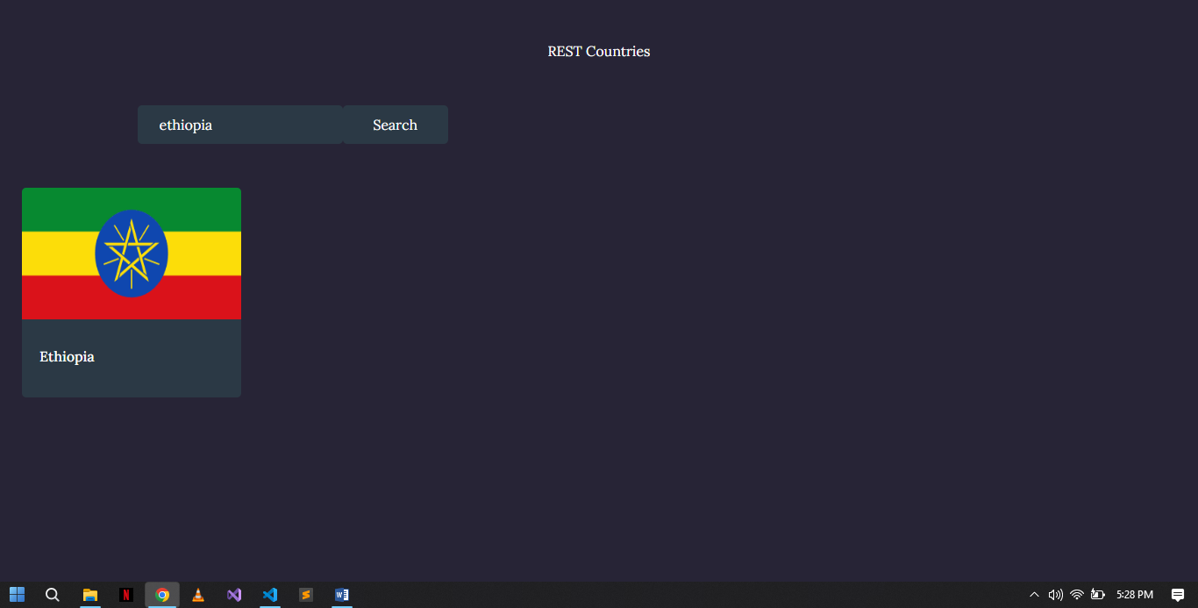

**View country**

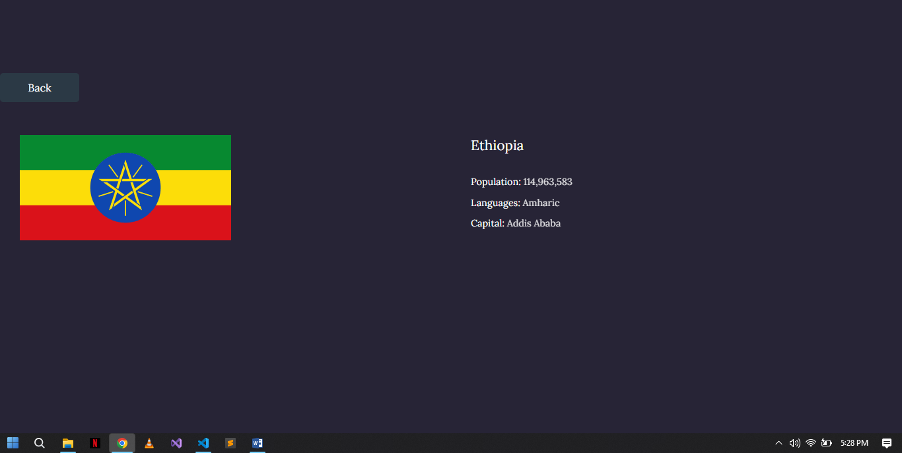

**4. Reference**

1. <https://dev.to/nabillatrisnani/frontend-mentor-rest-countries-api-with-color-theme-switcher-510n>

I have used this as a reference but is not a direct copy of the repositories. I have used it for the card layouts/CSS and have made several changes to it.